Toad genome 17-mer analysis
——by Liu Binghang 2010.3.2

Introduction:
To estimate the genome size with sequenced reads, we suggest using kmer analysis. Kmer means a part of sequence with the length of k, which is always set as 17.
There are two basic hypothesis for kmer analysis:
(1) All the possible kmers of the genome is contained in the kmer set.
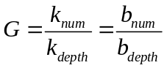
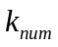 is the total kmer number, 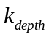 is the expect kmer depth, 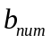 is the total base number, 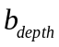is the expect base depth.
(2) The kmer depth distribution follows a Poission distribution. Then we use the peek position depth as the expected kmer depth.
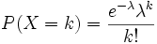
λ is used as the expect kmer depth .
There are two basic definition for kmer analysis:
Depth distribution curve: Using kmer depth ~ frequency, the peek position depth is the expect depth of kmer.
Depth product curve: Using kmer depth ~ depth*frequence, the peek position depth is the 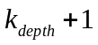.

To Estimate of genome size
We read all the short insert sequenced reads, including Cane_Toad_460bp_PE and Dataset2_Cane_Toad_460bp_PE. After filtered the reads including ‘N’, we get 27Gb bases in total, and the expect depth of the 17-mer is 5(Table 1 and Fig 2).
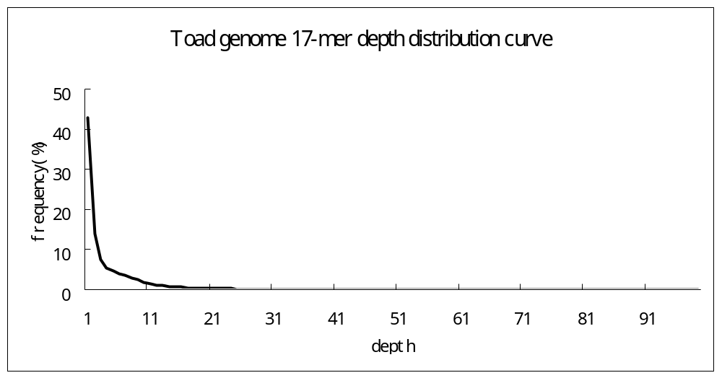
Fig. 1 The 17-mer depth distribution curve of toad genome. The figure shows no peek, which suggest that the sequencing depth is too low.

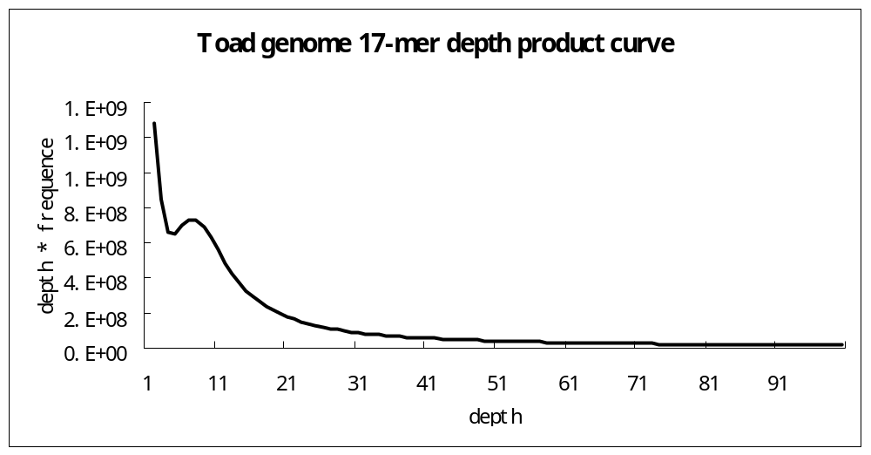
Fig. 2 The 17-mer depth product curve of toad genome. The figure shows the peek depth 6, so the 17-mer expect depth is 5.

Table 1 the statistics of 17-mer analysis.
kmer | kmer_num | depth | genome_size | used_base | used_read | X | read_len
17 | 25292265306 | 5 | 5058453061 | 27467944042 | 135979921 | 5.43 | 202
Genome_size=kmer_num/depth, X=used_base/genome_size, read_len is the average read length of the sequencing reads.
When the kmer depth is 6, the genome size may be 4.2G. We need the expected depth more than ten to estimate more precisely.

Conclusion:
The toad genome size is about 4G~5G. Because the sequencing depth is too low( just 5X can be used here), we can not estimate the genome size exactly.
For more knowledge about kmer analysis:

Effect of repeat on the kmer depth distribution:

We used human X chromosome as reference sequence to create solexa 100bp reads randomly with 20X in total and 0.3% sequence false ratio. Then the reference genome was added segement duplication with the segement length increasing from 30%, 50% to 70% of the reference sequence to create reads respectively. After the reads produced, we calculated the 17-mer frequence, and found that segment duplicate produce peeks at the integral multiple sits of expected 17-mer depth, of which we focused on the diploid sits(Fig 3).
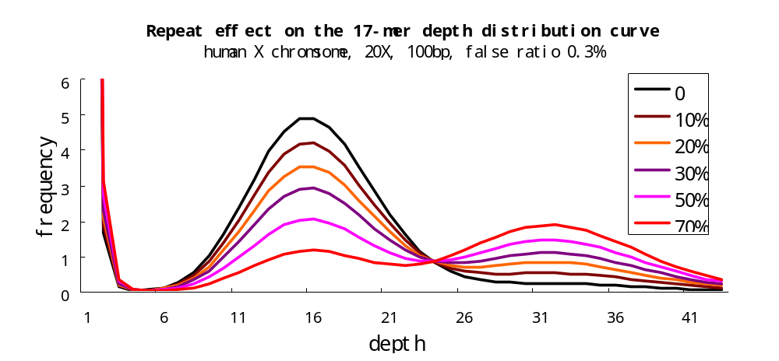
Fig.3 Repeat effect on the 17-mer depth distribution curve. The expect 17-mer depth was 16, and there is no peek at depth 32 when repeat ratio was 0. With the added segment length increasing from 30%, 50% to 70% of the reference sequence, the peek at depth 32 emerges more clearly, which means segment duplication causes the peak at the diploid site of expected 17-mer depth.

Effect of hybrid on the kmer depth distribution:

We used the Arabidopsis genome sequence as reference to create 20X solexa 100bp reads with 0.3% false ratio randomly, adding hybrid ratio 0, 0.1%, 0.3%, 0.5% and 1% respectively. Then we calculated the 17-mer frequence and got the 17-mer depth distribution curve (Fig 4).
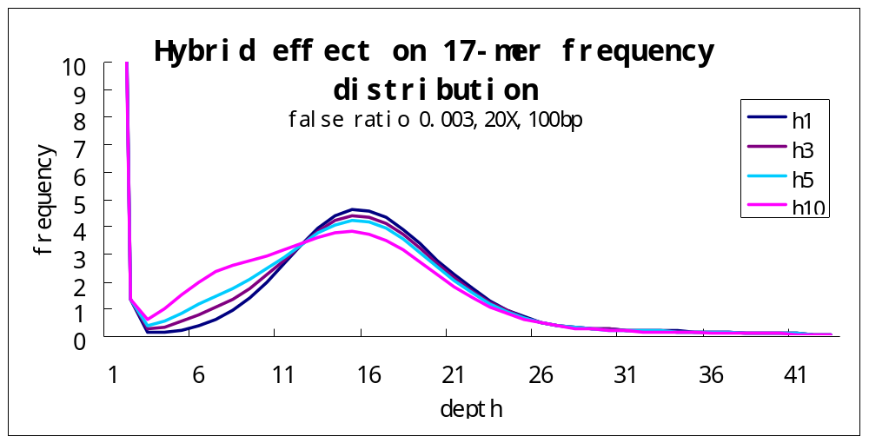Fig.4 Effect of hybrid on the 17-mer distribution curve. The expected 17-mer depth is 16, and there is no distinct peek at the half depth site 8 when no hybrid (h0) was added. While after add hybrid ratio from 0.3% (h3), 0.5% (h5) to 1% (h10), the peek at depth site 8 appeared more clearly, which means the hybrid cause peek at half of expected 17-mer depth.

