Table of Contents:

**Alternakraft Data Types**

Data Types

**Alternakraft Constraints**

Business Logic Constraints

**Task Decomposition with Abstract Code:**

Login

Main Menu

View Profile

…etc.

**Data Types:**

# Household

|  |  |  |
| --- | --- | --- |
| **Attribute** | **Data type** | **Nullable** |
| Email | String | Not Null |
| Square_Footage | Int | Not Null |
| Household_type | String | Not Null |
| Degrees for heating | Int | Null |
| Degrees for cooling | Int | Null |
| Postal_code | Int | Not Null |
| Power_Generation | String | Null |

# Geolocation

|  |  |  |
| --- | --- | --- |
| Attribute | Data type | Nullable |
| Postal_code | Int | Not Null |
| City | String | Not Null |
| State | String | Not Null |
| Latitude | Float | Not Null |
| Longitude | Float | Not Null |

# Public Utilities

|  |  |  |
| --- | --- | --- |
| Attribute | Data type | Nullable |
| Email | String | Not Null |
| Public_utilities | String | Not Null |

# Air Handler

|  |  |  |
| --- | --- | --- |
| Attribute | Data type | Nullable |
| Email | String | Not Null |
| Order | Int | Not Null |
| BTU rating | Int | Not Null |
| RPM | Int | Not Null |
| Method | String | Not Null |
| Manufacture | String | Not Null |
| Model | String | Not Null |

# Air Conditioner

|  |  |  |
| --- | --- | --- |
| Attribute | Data type | Nullable |
| Email | String | Not Null |
| Order | Int | Not Null |
| EER | Float | Not Null |

# Heater

|  |  |  |
| --- | --- | --- |
| Attribute | Data type | Nullable |
| Email | String | Not Null |
| Order | Int | Not Null |
| Energy source | String | Not Null |

# Heat Pump

|  |  |  |
| --- | --- | --- |
| Attribute | Data type | Nullable |
| Email | String | Not Null |
| Order | Int | Not Null |
| SEER | Float | Not Null |
| HSPF | Float | Not Null |

# Water Heater

|  |  |  |
| --- | --- | --- |
| Attribute | Data type | Nullable |
| Email | String | Not Null |
| Order | Int | Not Null |
| BTU rating | Int | Not Null |
| Manufacture | String | Not Null |
| Model | String | Not Null |
| Tank size | Float | Not Null |
| temperature | Int | Not Null |
| Energy source | String | Not Null |

# Power Generation

|  |  |  |
| --- | --- | --- |
| Attribute | Data type | Nullable |
| Email | String | Not Null |
| Order | Int | Not Null |
| Power_type | String | Not Null |
| Avg_Kilowatt_monthly | Int | Not Null |
| Battery_capacity | Int | Null |

**Business Logic Constraints:**

# Alternakraft Household

* Postal code should be validated. Entering an invalid postal code should be rejected.
* The value of household type must be within a specified range of values listed below.

House, apartment, townhome, condominium, modular home, or tiny house

* The value of public utilities must be within a specified range of values listed below.

electric, gas, steam, and/or liquid fuel

* A household that does not use any utilities is considered “off-the-grid”.
* …

Main Menu

Task Decomp

**

# Number of Locks: Single

**Enabling Conditions:** None, it will present by default.

**Frequency**: High

**Consistency (ACID):** not critical, order is not critical.

**Subtasks:** Mother Task is not needed. No decomposition needed.

Abstract Code

* There are two links in the main menu: “enter household information” and “view

Reports”.

* When ***“***enter household information” link is clicked, the user will be provided with the interface to enter their household information into the system
* When “View reports” link is clicked, a list with links to generate each report will be displayed.

Household Information

Task Decomp

**Lock Types**: Read-Write lock for ***validate user input***, read-only for ***Get list of Home Type*** and write lock for ***Enter required info***.

# Number of Locks: Several different schema constructs are needed

**Enabling Conditions:** Trigger by ‘Next’ button.

**Frequency:** High.

**Consistency (ACID)**: critical.

**Subtasks:** validate user input, Get list of Home Type and Enter required info.

Abstract Code

* User enters *email* ('$Email'), *postal code* ('$ *postal_code* ') input fields.
  + If Email already exists, error message should be displayed
  + If postal code validation failed, error message should be displayed
* Users choose home type from dropdown list
* User enters square footage.
* User enters heating/cooling thermostat entry.
  + If any of them are not provided, require validating whether user check ‘No heat’/’No cooling’ box. Display error message if user not check related box.
* User select Public Utilities or leave it as unchecked.
* User click Next button to go to next form **add appliance**.

Add Appliance

Task Decomp

**Lock Types**: 3 read-only lookups of List Appliance type, List manufacturer, List Energy Source and a write lock of Enter appliance info.

**Number of Locks:** Several different schema constructs are needed

**Enabling Conditions:** After user enter household info and enter to add appliance interface.

**Frequency**: High

**Consistency (ACID):** critical

**Subtasks:** List Appliance type, List manufacturer, List Energy Source and Enter appliance info.

Abstract Code

* User selects Appliance types.
* If user select Air Handler,
  + user select Manufacturer from dropdown list
  + user enter BTUs number
  + user enter Model name
  + user select method which allow multiple values (Air conditioner, Heater, Heat pump)
* If user select Air conditioner, user need to enter Energy efficiency ratio (EER), decimal number (to the tenth decimal point).
* If user select Heater, user need to select Energy source: Electric, gas, or thermosolar.
* If user select Heat pump, Seasonal energy efficiency rating (SEER), decimal number (to the tenth decimal point) and Heating seasonal performance factor (HSPF), decimal number (to the tenth decimal point) are required to be filled in.
  + user select energy source from dropdown list.
  + User enter RPMs
* If user select water heater
  + user select Manufacturer from dropdown list
  + user enter BTUs number
  + user enter Model name
  + user enter Tank size in gallons, decimal value (to the tenth decimal point).
  + user enter the Temperature.
  + user select energy source from dropdown list.
* User click Add button to inset a record in DB.
* After adding an appliance, the **appliance listing** is shown.

View Appliance listing

Task Decomp

**Lock Types**: Read-only lookup of Appliances listing, read-write lock for delete appliance.

**Number of Locks:** 2

**Enabling Conditions:** After user add an appliance.

**Frequency**: High

**Consistency (ACID):** critical

**Subtasks:** Delete appliance.

Abstract Code

* After adding an appliance, the appliance listing will list each appliance's details.
* There will be a view of listed appliances include appliance number, Type, Manufacturer and Model shown in the interface.
* There is a delete button in the last column on each row . If user click delete button, it will update DB to remove this record.
* If user click button of Add another appliance, it will link to **Add appliance** form.
* If user click Next button, it will jump to next form **Add power generation.**

Add power generation

Task Decomp

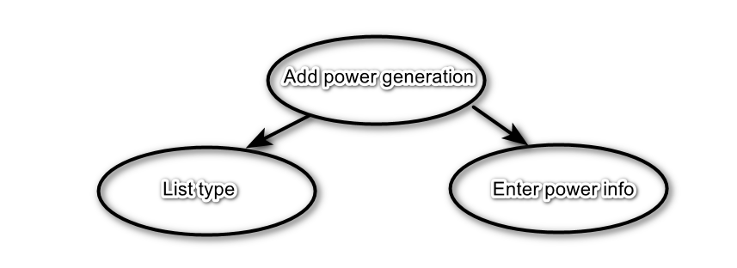

**Lock Types**: Read-only lookup of List type, write lock for Enter power info.

**Number of Locks:** 2

**Enabling Conditions:** After user created appliance or user click ‘Add more power’ button on **Power generation listing interface**.

**Frequency**: High

**Consistency (ACID):** critical

**Subtasks:** List type and Enter power generation information.

Abstract Code

* If a household is NOT “off-the-grid”, the user will have an option to skip this screen and finish submitting their data.
* If a house is “off-the-grid”, no option for skipping should be presented.
* If the user enters data,
  + User select type from dropdown list.
  + User enter monthly kwh value
  + User enter storage kwh value
* If the user enters data on this form, hitting “next” will save the entered data and take them to the **power generation listing**.

View Power generation listing

Task Decomp

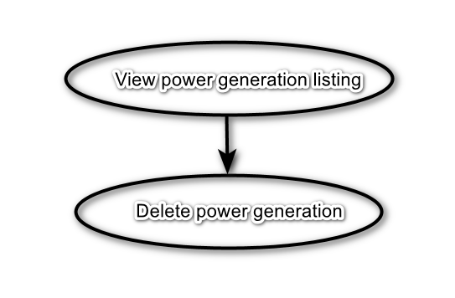

**Lock Types**: Read-only lookup of power generation listing, read-write lock for delete power generation.

**Number of Locks:** 2

**Enabling Conditions:** This form will be displayed after adding a power generation method in form **Add power generation**.

**Frequency**: High

**Consistency (ACID):** critical

**Subtasks:** Delete power generation.

Abstract Code

* View power generation: lookup power generation records and show a table includes columns of the generator type, monthly kilowatt hours, and battery storage capacity.
* There is a delete button in the last column on each row. If user click delete button, it will update DB to remove this record.
* If the user clicks the button Add more power, it will link to form **Add power generation**.
* If the user clicks Next button, validate whether all generators are deleted and household is “off-the-grid”
  + If all generators are deleted and the household is “off-the-grid”, the user cannot leave this screen until at least one generator has been added.
  + Else user will move to form **Wrapping Up.**

Wrapping up

Task Decomp

**Lock Types**: Read-only.

**Number of Locks:** 0

**Enabling Conditions:** This form will be displayed after the user has finished adding or has skipped power

generation information.

**Frequency**: High

**Consistency (ACID):** NA

**Subtasks:** NA.

Abstract Code:

* After the user has finished adding or has skipped power generation information:
  + A thank you message should be displayed to them
  + If user click the link to the main menu, it will return to form **Main Menu**.