Table of Contents:

**Alternakraft Data Types**

Data Types

**Alternakraft Constraints**

Business Logic Constraints

**Task Decomposition with Abstract Code:**

Main Menu

Household Information

Add Appliance

View Appliance listing

Add power generation

View Power generation listing

Wrapping up

Reports-Top 25 popular manufacturers

Reports- Manufacturer/model search

Reports-Heating/cooling method details

Reports-Water heater statistics by state

Reports-Off-the-grid household dashboard

Reports-Household averages by radius

# Data Types:

**Household**

|  |  |  |
| --- | --- | --- |
| **Attribute** | **Data type** | **Nullable** |
| Email | String | Not Null |
| Square_Footage | Int | Not Null |
| Household_type | String | Not Null |
| Degrees for heating | Int | Null |
| Degrees for cooling | Int | Null |
| Postal_code | Int | Not Null |
| Power_Generation | String | Null |

**Geolocation**

|  |  |  |
| --- | --- | --- |
| Attribute | Data type | Nullable |
| Postal_code | Int | Not Null |
| City | String | Not Null |
| State | String | Not Null |
| Latitude | Float | Not Null |
| Longitude | Float | Not Null |

**Public Utilities**

|  |  |  |
| --- | --- | --- |
| Attribute | Data type | Nullable |
| Email | String | Not Null |
| Public_utilities | String | Not Null |

**Air Handler**

|  |  |  |
| --- | --- | --- |
| Attribute | Data type | Nullable |
| Email | String | Not Null |
| Order | Int | Not Null |
| BTU rating | Int | Not Null |
| RPM | Int | Not Null |
| Method | String | Not Null |
| Manufacture | String | Not Null |
| Model | String | Not Null |

**Air Conditioner**

|  |  |  |
| --- | --- | --- |
| Attribute | Data type | Nullable |
| Email | String | Not Null |
| Order | Int | Not Null |
| EER | Float | Not Null |

**Heater**

|  |  |  |
| --- | --- | --- |
| Attribute | Data type | Nullable |
| Email | String | Not Null |
| Order | Int | Not Null |
| Energy source | String | Not Null |

**Heat Pump**

|  |  |  |
| --- | --- | --- |
| Attribute | Data type | Nullable |
| Email | String | Not Null |
| Order | Int | Not Null |
| SEER | Float | Not Null |
| HSPF | Float | Not Null |

**Water Heater**

|  |  |  |
| --- | --- | --- |
| Attribute | Data type | Nullable |
| Email | String | Not Null |
| Order | Int | Not Null |
| BTU rating | Int | Not Null |
| Manufacture | String | Not Null |
| Model | String | Not Null |
| Tank size | Float | Not Null |
| temperature | Int | Not Null |
| Energy source | String | Not Null |

**Power Generation**

|  |  |  |
| --- | --- | --- |
| Attribute | Data type | Nullable |
| Email | String | Not Null |
| Order | Int | Not Null |
| Power_type | String | Not Null |
| Avg_Kilowatt_monthly | Int | Not Null |
| Battery_capacity | Int | Null |

Business Logic Constraints:

Household Information

* Postal code should be validated. Entering an invalid postal code should be rejected.
* The value of household type must be within a specified range of values listed below.

House, apartment, townhome, condominium, modular home, or tiny house

* The value of public utilities must be within a specified range of values listed below.

electric, gas, steam, and/or liquid fuel

* A household that does not use any utilities is considered “off-the-grid”.

Appliance

* Each appliance should have a unique model name.
* The BTU (British Thermal Unit) value for each appliance should be within a certain range.
* The fan rotations per minute (RPM) value for air handlers should be within a certain range.
* The heating/cooling method(s) for each appliance should be selected from a predefined list.
* The attributes for each heating/cooling method should be entered in a specific format.
* In the “appliance listing” interface, if all appliances are deleted, the user cannot leave this screen until at least one appliance has been added.
* In the “appliance listing” interface, if an appliance is deleted, the number should not be reused.

Power generation

* The power generation value for each household should be within a certain range.
* The battery storage capacity value for each household should be within a certain range.
* Only households with corresponding attributes should be included in the averages.
* If an attribute is not present for all households within the search radius, no value should be displayed for that attribute.
* Optional unless a household is “off-the-grid”. If a house is “off-the-grid”, no option for skipping the “add power generation” should be presented.

Main Menu

Task Decomp

**

**Number of Locks:** 0

**Enabling Conditions:** None, it will present by default.

**Frequency**: High

**Consistency (ACID):** not critical, order is not critical.

**Subtasks:** Mother Task is not needed. No decomposition needed.

Abstract Code

* There are two links in the main menu: “enter household information” and “view

Reports”.

* When ***“***enter household information” link is clicked, the user will be provided with the interface to enter their household information into the system
* When “View reports” link is clicked, a list with links to generate each report will be displayed.

Household Information

Task Decomp

**Lock Types**: Read-Write lock for ***validate user input***, read-only for ***Get list of Home Type*** and write lock for ***Enter required info***.

**Number of Locks:** 3

**Enabling Conditions:** Trigger by ‘Next’ button.

**Frequency:** High.

**Consistency (ACID)**: critical.

**Subtasks:** validate user input, Get list of Home Type and Enter required info.

Abstract Code

* User enters *email* ('$Email'), *postal code* ('$ *postal_code* ') input fields.
  + If Email already exists, error message should be displayed
  + If postal code validation failed, error message should be displayed
* Users choose home type from dropdown list
* User enters square footage.
* User enters heating/cooling thermostat entry.
  + If any of them are not provided, require validating whether user check ‘No heat’/’No cooling’ box. Display error message if user not check related box.
* User select Public Utilities or leave it as unchecked.
* User click Next button to go to next form **add appliance**.

Add Appliance

Task Decomp

**Lock Types**: 3 read-only lookups of List Appliance type, List manufacturer, List Energy Source and a write lock of Enter appliance info.

**Number of Locks:** Several different schema constructs are needed

**Enabling Conditions:** After user enter household info and enter to add appliance interface.

**Frequency**: High

**Consistency (ACID):** critical

**Subtasks:** List Appliance type, List manufacturer, List Energy Source and Enter appliance info.

Abstract Code

* User selects Appliance types.
* If user select Air Handler,
  + user select Manufacturer from dropdown list
  + user enter BTUs number
  + user enter Model name
  + user select method which allow multiple values (Air conditioner, Heater, Heat pump)
* If user select Air conditioner, user need to enter Energy efficiency ratio (EER), decimal number (to the tenth decimal point).
* If user select Heater, user need to select Energy source: Electric, gas, or thermosolar.
* If user select Heat pump, Seasonal energy efficiency rating (SEER), decimal number (to the tenth decimal point) and Heating seasonal performance factor (HSPF), decimal number (to the tenth decimal point) are required to be filled in.
  + user select energy source from dropdown list.
  + User enter RPMs
* If user select water heater
  + user select Manufacturer from dropdown list
  + user enter BTUs number
  + user enter Model name
  + user enter Tank size in gallons, decimal value (to the tenth decimal point).
  + user enter the Temperature.
  + user select energy source from dropdown list.
* User click Add button to inset a record in DB.
* After adding an appliance, the **appliance listing** is shown.

View Appliance listing

Task Decomp

**Lock Types**: Read-only lookup of Appliances listing, read-write lock for delete appliance.

**Number of Locks:** 2

**Enabling Conditions:** After user add an appliance.

**Frequency**: High

**Consistency (ACID):** critical

**Subtasks:** Delete appliance.

Abstract Code

* After adding an appliance, the appliance listing will list each appliance's details.
* There will be a view of listed appliances include appliance number, Type, Manufacturer and Model shown in the interface.
* There is a delete button in the last column on each row . If user click delete button, it will update DB to remove this record.
* If user click button of Add another appliance, it will link to **Add appliance** form.
* If user click Next button, it will jump to next form **Add power generation.**

Add power generation

Task Decomp

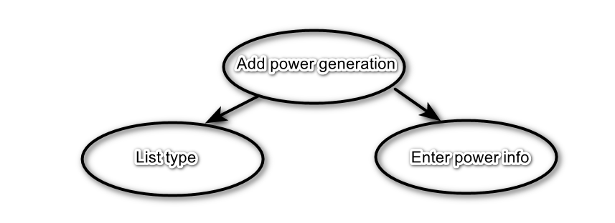

**Lock Types**: Read-only lookup of List type, write lock for Enter power info.

**Number of Locks:** 2

**Enabling Conditions:** After user created appliance or user click ‘Add more power’ button on **Power generation listing interface**.

**Frequency**: High

**Consistency (ACID):** critical

**Subtasks:** List type and Enter power generation information.

Abstract Code

* If a household is NOT “off-the-grid”, the user will have an option to skip this screen and finish submitting their data.
* If a house is “off-the-grid”, no option for skipping should be presented.
* If the user enters data,
  + User select type from dropdown list.
  + User enter monthly kwh value
  + User enter storage kwh value
* If the user enters data on this form, hitting “next” will save the entered data and take them to the **power generation listing**.

View Power generation listing

Task Decomp

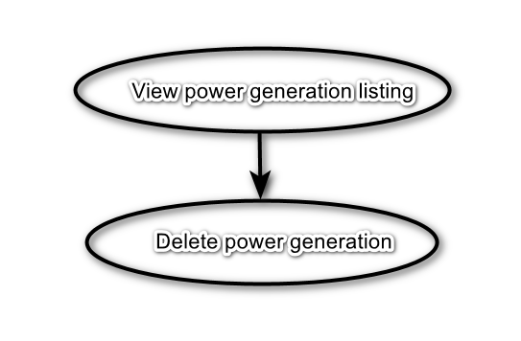

**Lock Types**: Read-only lookup of power generation listing, read-write lock for delete power generation.

**Number of Locks:** 2

**Enabling Conditions:** This form will be displayed after adding a power generation method in form **Add power generation**.

**Frequency**: High

**Consistency (ACID):** critical

**Subtasks:** Delete power generation.

Abstract Code

* View power generation: lookup power generation records and show a table includes columns of the generator type, monthly kilowatt hours, and battery storage capacity.
* There is a delete button in the last column on each row. If user click delete button, it will update DB to remove this record.
* If the user clicks the button Add more power, it will link to form **Add power generation**.
* If the user clicks Next button, validate whether all generators are deleted and household is “off-the-grid”
  + If all generators are deleted and the household is “off-the-grid”, the user cannot leave this screen until at least one generator has been added.
  + Else user will move to form **Wrapping Up.**

Wrapping up

Task Decomp

**Lock Types**: NA.

**Number of Locks:** 0

**Enabling Conditions:** This form will be displayed after the user has finished adding or has skipped power

generation information.

**Frequency**: High

**Consistency (ACID):** NA

**Subtasks:** NA.

Abstract Code:

* After the user has finished adding or has skipped power generation information:
  + A thank you message should be displayed to them
  + If user click the link to the main menu, it will return to form **Main Menu**.

Reports-Top 25 popular manufacturers

Task Decomp

**Lock Types**: Write lock and read lock.

**Number of Locks:** 2

**Enabling Conditions:** This form will be displayed after the user clicks report link of Top 25 popular manufacturers.

**Frequency**: Low

**Consistency (ACID):** Not critical

**Subtasks:** Drilldown report for a particular manufacturer.

Abstract Code:

* Lookup and count the appliances number of each manufacturer.
* Order top 25 manufacturer by the number of appliances.
* The output will be presented by each manufacturer name and count of appliances for that manufacturer (as an integer), ordered by count descending.
* There is a link back to main menu, user click it to go back to interface **Main Menu.**
* There is a button from the parent report’s row for that manufacturer to provide an option to view a drilldown report for a particular manufacturer.
  + When user click the drilldown button, it will look up the appliances produced by certain manufacturer name.
  + Count appliances belonging to each appliance type produced by that manufacturer (as an integer)
  + Display the manufacturer name at the top, with a table listing the count of

appliances belonging to each appliance type produced by that manufacturer.

Reports- Manufacturer/model search

Task Decomp

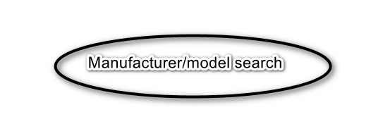

**Lock Types**: Read-only.

**Number of Locks:** 1

**Enabling Conditions:** This form will be displayed after the user clicks report link of Manufacturer/model search.

**Frequency**: Low

**Consistency (ACID):** Not critical

**Subtasks:** NA

Abstract Code:

* User enter string value.
* User click search button:
  + lookup all the manufacturer or model match this value.
  + Retrieve all manufacturers or models that match the entered value.
  + Select all models from the found manufacturers.
  + Order the models in ascending order by manufacturer.
  + Select the manufacturers of all the found models.
  + Order the manufacturers in ascending order by model**.**
* Display the resulting manufacturers and models.
* If user click the link to go back to the main menu, return to the Main Menu.

Reports-Heating/cooling method details

Task Decomp

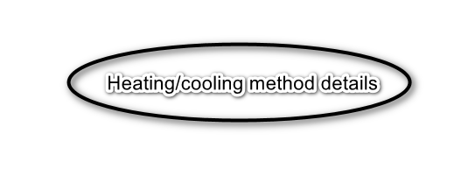

**Lock Types**: Write lock and read lock.

**Number of Locks:** 2

**Enabling Conditions:** This form will be displayed after the user clicks report link of Heating/cooling method details.

**Frequency**: Low

**Consistency (ACID):** Not critical

**Subtasks:** NA

Abstract Code:

* Lookup records grouped and ordered by household type
  + Count air conditioners, average air conditioner BTUs (as a whole number, rounded), average RPM (as adecimal number, rounded to tenths) and the average EER (as a decimal number, rounded to tenths)
  + count of heaters, average heater BTUs (as a whole number, rounded), average RPM (as a decimal number, rounded to tenths) and the most common energy source
  + Count of heat pumps, average heat pump BTUs (as a whole number, rounded), average RPM (as a decimal number, rounded to tenths), the average SEER (as a decimal number, rounded to tenths) and the average HSPF(as a decimal number, rounded to tenths)
* Display count output and household email information on a table.
* If user click the link to go back to the main menu, return to the Main Menu.

Reports-Water heater statistics by state

Task Decomp

**Lock Types**: Write lock and read lock.

**Number of Locks:** 2

**Enabling Conditions:** This form will be displayed after the user clicks report link of Water heater statistics by state.

**Frequency**: Low

**Consistency (ACID):** Not critical

**Subtasks:** generate drilldown report for a particular state

Abstract Code:

* Look up all records in water heater appliance type and group by state
  + Calculate the average water heater tank size (a whole number, rounded),
  + Calculate the average water heater BTUs (a whole number, rounded),
  + Calculate the average water heater temperature setting (a decimal number, rounded to tenths)
  + count of water heaters where a temperature setting has been provided,
  + count of water heaters where no temperature setting has been provided,
  + Display all output in a table and sorted by state abbreviation ascending
* User click button from the parent report’s row for that state to generate a drilldown report for that particular state
  + Select this particular state as report header group by energy source
  + Calculate the minimum water heater tank size (a whole number, rounded)
  + Calculate the average water heater tank size (a whole number, rounded)
  + Calculate the maximum water heater tank size (a whole number, rounded)
  + Calculate the minimum temperature setting
  + Calculate maximum temperature setting
  + Calculate the average temperature setting (decimal number, rounded to tenths)
  + Energy sources should be ordered in ascending order.
* If user click the link to go back to the main menu, return to the Main Menu.

Reports-Off-the-grid household dashboard

Task Decomp

**Lock Types**: Write lock and read lock.

**Number of Locks:** 2

**Enabling Conditions:** This form will be displayed after the user clicks report link of Off-the-grid household dashboard.

**Frequency**: Low

**Consistency (ACID):** Not critical

**Subtasks:** 6 task.

1. Lookup the state with the most off-the-grid households will be listed, along with the count of its off-the-grid

households.

1. Calculate the average battery storage capacity per battery
2. Calculate the percentages (as decimal numbers, rounded to tenths) for each power generation type (solar, wind-turbine, or mixed).
3. Calculate the percentages (as decimal numbers, rounded to tenths) for each household type
4. Display the average water heater tank size for all water heaters
5. Lists the minimum, average and maximum (as whole numbers, rounded) BTU values for all off-thegrid

households’ appliances

Abstract Code:

* Look up the state with the most off-the-grid households and calculate its count
* Retrieve all the off-the-grid households:
  + Calculate the average battery storage capacity.
  + Calculate the percentages for each power generation type.
  + Calculate the percentages for each power generation type
  + Calculate the average water heater gallon capacity.
  + Calculate the minimum, average, and maximum BTU values.
  + Calculate the average water heater gallon capacity.
* If user click the link to go back to the main menu, return to the Main Menu.

Reports-Household averages by radius

Task Decomp

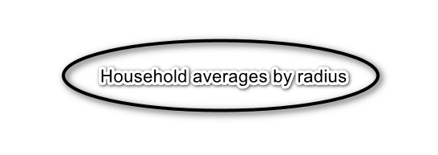

**Lock Types**: Write lock and read lock.

**Number of Locks:** 2

**Enabling Conditions:** This form will be displayed after the user clicks report link of Household averages by radius.

**Frequency**: Low

**Consistency (ACID):** Not critical

**Subtasks:** NA

Abstract Code:

* User enter the postal code to center the search on, and the search radius (a whole number, with the following choices available: 0, 5, 10, 25, 50, 100, and 250).
* User click search to trigger validation for both the postal code and radius input fields
  + If validation succeed,
* Retrieve the longitude and latitude data from the postal code table
* Calculate the distances between the postal codes using the haversine formula
* Lookup all households whose postal codes in calculated range
  + If the data validation fails for any of the input fields, an error message is displayed.
* If user click the link to go back to the main menu, return to the Main Menu.