**DWMA Detector**

(Version Beta 07-30-2024)

DWMA detector is a software package (Matlab-based), designed to automatically detect diffuse white matter abnormality (DWMA), aka., diffuse excessive high signal intensity (DEHSI), on T2-weighted MRI brain images of neonatal infants. Please cite our original publication:

He, L., and N. A. Parikh. "Atlas-Guided Quantification of White Matter Signal Abnormalities on Term-Equivalent Age MRI in Very Preterm Infants." (2013).

**Index**

1. Preparation for DWMA Detection

2. DWMA Detection

https://lh3.googleusercontent.com/OC0QsSYhHvXJBNrXHD9PprZilFVxYv6rvTZYEUYpQG9t6vNKeBPQfAePecTrQJ-zoRIIb6veDGLWGvmnZSN79q9Fu3RH14TgnLjTiR4jOysJ6snz4Z3y6ExBL1Ox9Omx0JKWbx-u

**1. Preparation for Detection**

* Data organization

This software is designed for the following data organization structure:

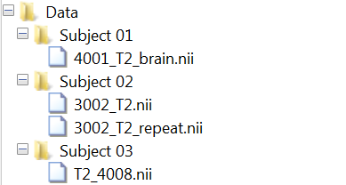

* Pre-requisite software
  + Matlab (2016a or newer)
  + SPM12
* Pre-requisite brain templates

Infant gray matter/ white matter/ CSF atlas (pre-installed in /func with DEHSI detector)

* Re-orientation

(1). Open “matlab” and start SPM12.

(2). Choose option tab “fMRI”.

(3). Click ‘Display’ and input T2 images, and click ‘Done’

(4). Set origin for the image as in MNI space. Blue lines cross should match “crosshair origin”. Follow the crosshair origin as in the figure below in MNI space.

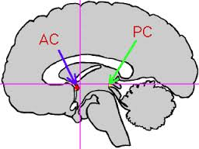

In the SPM graphics window, we can manually adjust AC-PC position. Modify Yaw/Pitch/roll {Rad} to maximally match the AC-PC line to the reference AC-PC figure below.

(5). Click “Set origin”. Then, choose “Reorient” and load images to reorient. It will rewrite original T2 images with new orientation. (No need to save matrix)

https://lh3.googleusercontent.com/OC0QsSYhHvXJBNrXHD9PprZilFVxYv6rvTZYEUYpQG9t6vNKeBPQfAePecTrQJ-zoRIIb6veDGLWGvmnZSN79q9Fu3RH14TgnLjTiR4jOysJ6snz4Z3y6ExBL1Ox9Omx0JKWbx-u

https://lh3.googleusercontent.com/OC0QsSYhHvXJBNrXHD9PprZilFVxYv6rvTZYEUYpQG9t6vNKeBPQfAePecTrQJ-zoRIIb6veDGLWGvmnZSN79q9Fu3RH14TgnLjTiR4jOysJ6snz4Z3y6ExBL1Ox9Omx0JKWbx-u

**2. DWMA detection**

* Get Started

Within Matlab, go to DWMA app folder, and type “DWMA” in the command window of Matlab.

Select tasks to proceed.

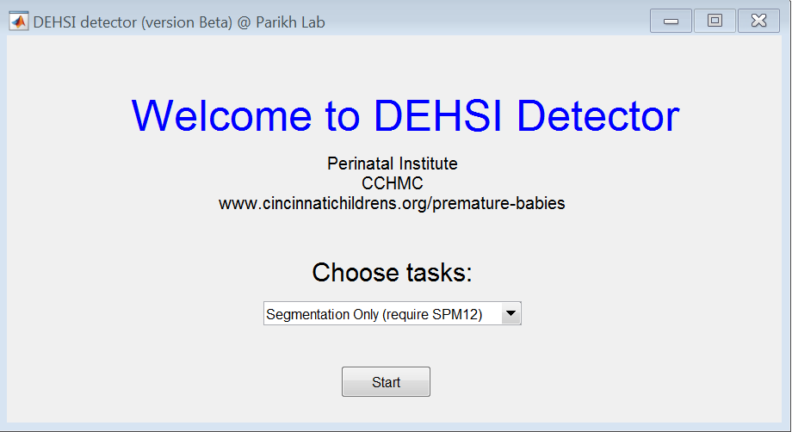

* Segmentation

(1) Select “segmentation” and click “Start”

(2) Select the folder with T2w images of interested subjects, and click “Select Folder”

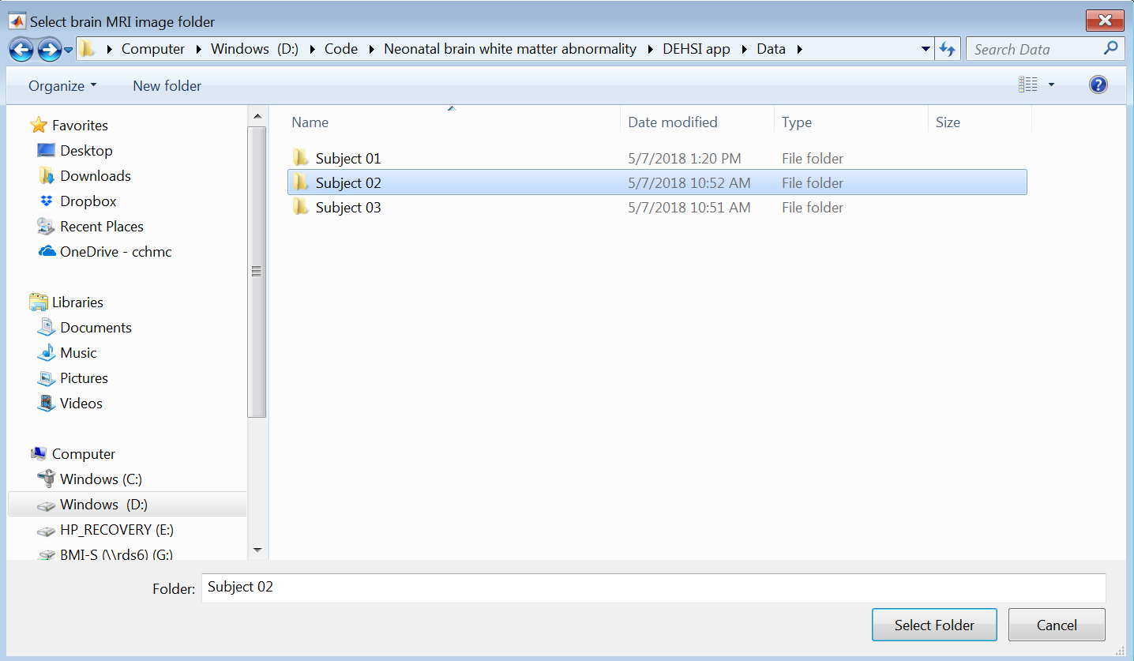

* Detection

(1) Select “Detection” and click “Start”

(2) Select the folder with segmented T2w images of interested subjects, and click “Select Folder”

(3) Input parameters for automated detection and click “OK”

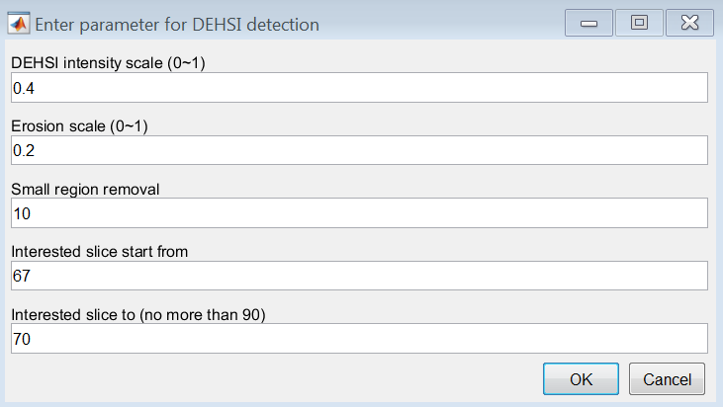

* + - DEHSI intensity scale (0~1): to reflect the intensity scale (mild ~ severe) of DEHSI
    - Erosion scale (0~1): Erode image to ignore uninterested regions. (0 no erode, 1 max erode)
    - Small region removal: remove small DEHSI regions due to signal abnormality
    - Interested slice: set interested slice of T2w brain images

(4) Results demo

