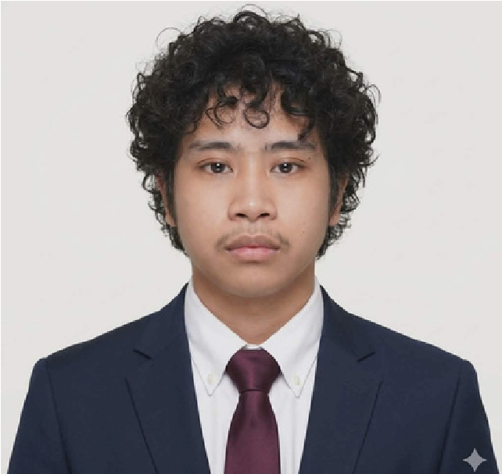
09654263831
Bachelor of Science in
Information Technology

marcdango@gmail.com
Father Selga St. Davao City
01
, June
2001

JUNE MARC M. DANGO
ABOUT ME
I am a detail-oriented and responsible professional with experience as a Manual Validator at DITO Telecommunity. In this role, I handled customer verification processes by carefully reviewing and validating KYC (Know Your Customer) information to ensure accuracy and compliance with company standards. I assessed submitted documents such as IDs and selfies, approving applications that met the requirements and rejecting those with unclear or incorrect details. My work required strong attention to detail, consistency, and the ability to make accurate decisions under time pressure.
EDUCATION
John paul college II davao
Bachelor of science in technology
2025-
present
Matina drive, ecoland davao city
Rizal memorial colleges
general academic strand
2018-2020
Lopez jaena street f torres davao city
Rizal memorial colleges

2014-2018
Lopez jaena street f torres davao city
SKILLS
EXPERIENCE
Manual validator | sixeleven global services

march 2024- may 2025
* Manual Validator at DITO Telecommunity, handling
customer verification and KYC (Know Your Customer)
processes
* Reviewed and validated customer-submitted information
to ensure accuracy and compliance with company
standards
* Assessed documents such as IDs and selfies, approving
qualified applications and rejecting those with unclear or
incorrect details
* Ensured strict adherence to verification guidelines and
data quality requirements
* Maintained high accuracy and consistency while working
under time pressure
* Demonstrated strong attention to detail, decision-
making, and responsibility in handling sensitive customer
data
Soft Skills
Attention to Detail

Analytical Thinking
Time Management
Adaptability
Prolem-Solving Ability
Hard Skills
Proficiency in Microsoft Office and Google
Suite
Bookkeeping
AR/AP Reconciliation

