1. **INTRODUCTION**

Nowadays, people from almost all over the world have their eyes set on what technology will bring this time. Every now and then, people wait for the release of new gadgets, newer versions of such gadgets or versions of operating systems that run on those different gadgets from the different companies. Not only those gadgets or operating systems are the ones being awaited by the “techie” people who are knowledgeable with technology but also the applications that run from those gadgets and OS. But what catches the attention of most consumers are the designs and user-interface of these gadgets. In the world of technology, judging what a gadget looks like does matter. The outer design of a gadget should be attractive and different from the others to give the consumers a different option on which they can stand out from the other products produced by the competing companies. Some companies strive hard to give their products a distinctive look in a way that when a consumer looks at the products, they would easily be recognized as the properties of a specific company. Change is always inevitable. People look for something new and since what is trending nowadays is revolving around technology, companies which are “built from technology” are now competing in the market to get the consumers’ attention in their new innovations.

A few months ago, a rumor that was spread like wildfire was taken seriously by “netizens” all over the world that Samsung sent over thirty truckloads of more than one billion dollars in American nickel coins to the Apple Company as compensation for Samsung’s recent and controversial copyright infringement. This would have been hilarious if it were not for the fact that this rumor is nothing but balderdash. Never mind the rumor, what is more controversial is the fact that Apple started suing Samsung Electronics for copying their legal patents. Samsung had paid an estimate of 1 billion dollars to Apple as a compensation for being guilty of patent infringement according to the court and that was way back April 2011 [1]. Having their patents copied by other rival companies may be a very small or nonsense issue for most of the people but it is a big deal for Apple because they had spent years in trying to think of new ideas that could make the consumers alive once again because of new innovations. Despite the people who do not mind whether their gadget’s features were only copied from others or not, there are also these people who are curious about which of these intellectual properties are being copied from Apple.

Up until now, the battle between the two mentioned giant companies has not ended yet. Apple sues Samsung, wins in the court, the court rejects their lawsuit, and Samsung sues Apple back. This means endless paper works for court and endless confusion for the consumers.

1. **THE CONTENDERS**

Two of the racing companies competing against each other’s innovations are Apple Inc. which is widely known as Apple and Samsung Electronics Co. Ltd., which is also known as Samsung.

Apple Inc. introduced its own line of smartphone, the iPhone. The iPhone, though not the very first smartphone, it instantly became widely popular. A hot “commodity” as others would say. And like any real business tycoon, Steve Jobs, struck the iron while it is hot. Through the iPhone’s popularity, Apple Inc. released new versions of the iPhone periodically, making people who already own the older versions wanting for more. Each new versions of the iPhone comes with few improvements from the older versions, which is a good marketing strategy because people would want the new, better, upgraded version of their phone no matter how very little improvement there is. Take into consideration, the iPhone5 for example. The only major improvement it has included is its longer 4-inch screen. Still, with very little to show for, the iPhone5 stayed as one of the highest-selling smartphones of the year in the US [2].

Apple’s iPhone is a small and very light handheld device. It has a multi-touch screen that lets the users swipe or slide their fingers in the screen to navigate their phones. It has a distinguishing user interface, icons and attractive displays which gave it a distinctive look from other smartphones in the market. This feature was adapted by the iPod Touch which created a hybrid between some features of an iPhone except its capability of being a cellular phone. After the iPod, Apple introduced a line of computer tablets, the iPad. The iPad also adapted the features from the iPhone and iPod touch where the difference is that it is being a computer tablet, meaning, bigger dimension.

On the other hand, Samsung had also introduced its own line of smartphones and computer tablets called Galaxy that uses Android, a mobile operating system which is provided by Google Inc. These mobile computing devices also have multi-touch features and can be navigated or controlled by the user by sliding or swiping their finger/fingers on the screen.

1. **APPLE AND SAMSUNG BEFORE THE “WAR”**

Back at the year 2005, Apple and Samsung were partner companies [3]. Apple teamed up with Samsung for it to be a stable supplier of flash memory after abandoning the hard disk drives for iPod shuffle, iPod nano and the upcoming iPhone at that time. The memory sales in the market on the same year were unsteady and Apple wanted to have a stable supplier that was financially reliable, according to the people who are familiar with the relationship of Apple and Samsung [4]. The Apple-Samsung deal became successful and later on made Samsung the supplier of the application processes for iPhone and iPad. Originally, the two companies developed the processors with the help of each other but eventually, Apple took full control of the development of the chips [5]. The partnership between the two companies served as a way to bear each other’s insights about the strategies and operation by each company. Samsung, being the solitary iPhone processors supplier, just had an idea on how enormous the smartphone in the market was going to be for Apple.

1. **THE COMPLAINT**

Due to its success and achievements, Apple had resulted in protecting its intellectual property rights for its revolutions such as utility and design patents, trademarks, and trade dress. Nevertheless, their competitors are still imitating the company’s inventions. Apple claims that Samsung is one of the major imitators. Samsung also introduced their own line of smartphones and computer tablets to compete with Apple’s iPhone and iPod.

The following are Apple’s complaints against Samsung which were stated from their lawsuit [6] and was summarized [7]:

“ **4.1 Trade Dress Infringement**

4.1.1 Hardware and software trade dress claims

* a rectangular product shape with all four corners uniformly rounded;
* the front surface of the product dominated by a screen surface with black borders;
* as to the iPhone and iPod touch products, substantial black borders above and below the screen having roughly equal width and narrower black borders on either side of the screen having roughly equal width;
* as to the iPad product, substantial black borders on all sides being roughly equal in width;
* a metallic surround framing the perimeter of the top surface;
* a display of a grid of colorful square icons with uniformly rounded corners;
* a bottom row of square icons (the "Springboard") set off from the other icons and that do not change as the other pages of the user interface are viewed.
  + 1. Packaging trade dress claims
* a rectangular box with minimal metallic silver lettering and a large front-view picture of the product prominently on the top surface of the box;
* a two-piece box wherein the bottom piece is completely nested in the top piece; and
* use of a tray that cradles products to make them immediately visible upon opening the box.
  1. **Federal trade dress infringement**
* [U.S. Registration No. 3,470,983](http://tarr.uspto.gov/servlet/tarr?regser=serial&entry=77303282) is for the overall design of the product, including the rectangular shape, the rounded corners, the silver edges, the black face, and the display of sixteen colorful icons.
* [U.S. Registration No. 3,457,218](http://tarr.uspto.gov/servlet/tarr?regser=serial&entry=77303256) is for the configuration of a rectangular handheld mobile digital electronic device with rounded corners.
* [U.S. Registration No. 3,475,327](http://tarr.uspto.gov/servlet/tarr?regser=serial&entry=77303049) is for a rectangular handheld mobile digital electronic device with a gray rectangular portion in the center, a black band above and below the gray rectangle and on the curved corners, and a silver outer border and side.
  1. **Federal trademark infringement**
* No. [3,886,196](http://tarr.uspto.gov/servlet/tarr?regser=serial&entry=85019804) is the iOS phone app icon.
* No. [3,889,642](http://tarr.uspto.gov/servlet/tarr?regser=serial&entry=85018959) is the iOS messaging app icon.
* No. [3,886,200](http://tarr.uspto.gov/servlet/tarr?regser=serial&entry=85019831) is the iOS photos app icon.
* No. [3,889,685](http://tarr.uspto.gov/servlet/tarr?regser=serial&entry=85020006) is the iOS settings app icon.
* No. [3,886,169](http://tarr.uspto.gov/servlet/tarr?regser=serial&entry=85019396) is the iOS notes app icon.
* No. [3,886,197](http://tarr.uspto.gov/servlet/tarr?regser=serial&entry=85019809) is the iOS contacts icon.
* Pending No. [85/041,463](http://tarr.uspto.gov/servlet/tarr?regser=serial&entry=85041463) is the iTunes icon, which is a riff on U.S. Registration No.[2,935,038](http://tarr.uspto.gov/servlet/tarr?regser=serial&entry=78382867), the desktop iTunes logo.

**4.4 Common law trademark infringement**

This one's a catch-all — it's there to pick up the pieces from the federal trademark claims and to strengthen the claim on the iTunes icon, which is still pending registration.

* 1. **Unfair business practices under the California Business and Professions Code**

This is a state-level version of the trade dress and trademark claims - it's there to pick up the pieces in case the federal claims somehow don't pass muster.

**4.6 Unjust enrichment**

Yet another state-level claim that feels like a catch-all in case everything else fails — Apple's arguing that whether or not Samsung's conduct rose to actual infringement its trade dress, trademarks, and patents, Samsung still unfairly profited by copying Apple's work.

**4.7 Infringement of design patents**

* **Patent #**[**D627,790**](http://www.google.com/patents/about?id=odPbAAAAEBAJ&dq=D627,790)**: Graphical User Interface For a Display Screen or Portion Thereof.**This is the iOS homescreen — the grid of icons.
* **Patent #**[**D602,016**](http://www.google.com/patents/about?id=_SopAQAAEBAJ&dq=D602,016)**: Electronic Device.**  The broken lines that form the screen and the button aren't part of the patent, just the device's shell, so any button or screen size differences on Samsung's devices don't matter.
* **Patent**[**#D618,677**](http://www.google.com/patents/about?id=bRvVAAAAEBAJ&dq=d618,677)**: Electronic Device.** This is the opposite of '677 — it's the screen and button design of the iPhone. The broken lines that form the case aren't part of the patent.

**4.8 Infringement of the '002 patent**

* [Patent #6,493,002](http://www.google.com/patents/about?id=QUILAAAAEBAJ&dq=6,493,002), delightfully titled **Method and Apparatus for Displaying and Accessing Control and Status Information in a Computer System**, is new to the Apple / Android litigation party. It covers a system that pops open a window to show multiple interactive control widgets.

**4.9 Infringement of the '381 patent**

* [Patent #7,469,381](http://www.google.com/patents/about?id=n7WxAAAAEBAJ&dq=7,469,381): **List Scrolling and Document Translation, Scaling and Rotation on a Touch-Screen Display**. '381 is one of Apple's first iOS-related patents — it covers the "bounce" effect you get on iOS when you scroll to the top or bottom of a list.

**4.10 Infringement of the '134 patent**

* [Patent #7,669,134](http://www.google.com/patents/about?id=ezbNAAAAEBAJ&dq=7,669,134) is titled **Method and Apparatus For Displaying Information During An Instant Messaging Session**, and that's no lie — it covers arranging incoming messages in a communications session in a timeline that's horizontally spaced.

**4.11 Infringement of the '828 patent**

* [Patent #7,812,828](http://www.google.com/patents/about?id=LWnXAAAAEBAJ&dq=7,812,828) is a wonky technical patent related to touchscreen input — titled **Ellipse Fitting For Multi-Touch Surfaces**, it covers taking touch impressions mapping them to ellipses.

**4.12 Infringement of the '915 patent**

* [Patent #7,844,915](http://www.google.com/patents/about?id=2MbdAAAAEBAJ&dq=7,844,915) is titled **Application programming interfaces for scrolling operations**, and it covers deciding when a user is using one finger to scroll a view versus two or more fingers to scale that same view.

**4.13 Infringement of the '891 patent**

* [Patent #7,853,891](http://www.google.com/patents/about?id=dLnlAAAAEBAJ&dq=7,853,891), titled **Method and apparatus for displaying a window for a user interface**, covers displaying an overlay window over the standard UI in response to a keystroke and having it disappear automatically after some predefined amount of time.

**4.14 Infringement of the '533 patent**

* [Patent #7,863,533](http://www.google.com/patents/about?id=AivxAAAAEBAJ&dq=7,863,533) is an old-school hardware patent. Titled **Cantilevered push button having multiple contacts and fulcrums**, it covers the volume rocker on the iPhone 3G and 3GS — a volume rocker that looks quite like the one on Samsung's various Galaxy S devices.”

Some of the intellectual properties which were claimed by Apple as infringed by Samsung sound silly for these two giant technology-based companies to fight with each other. But for some reasons, Apple had made a strategy where they will make their products as distinctive as possible from the other products and sue every company that they think, copies their distinct design, patents, and trademarks. This is not the first time that Apple sued its rival company.

Although Apple had included a number of complaints about Samsung’s infringements, the jury didn’t approve all of these claims. The claims mentioned above were not so comprehensive and of course, not all people could relate or understand the patents being claimed as copied by Samsung if they do not have their own piece of Apple or Samsung’s products. Here are some of the patents which people can easily recognize as Apple’s intellectual property (IP) and which the jury says that Samsung really infringed [8]:

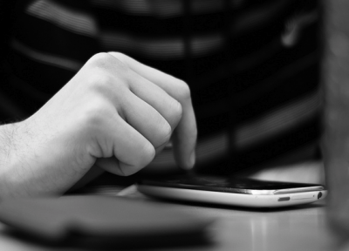

Figure 1 Utility Patent 163: Enlarging documents by tapping the screen

(Source: [www.flickr.com](http://www.flickr.com))

The jury had agreed that Samsung violated Apple’s patent by copying it. When the user double-taps the screen, the text or document will either be centered or enlarged.

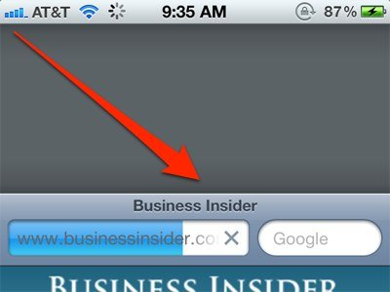

Figure 2 Utility Patent 381: List Scrolling and Document Translation, Scaling and Rotation on a Touch-Screen Display

(Source: [www.businessinsider.com](http://www.businessinsider.com))

When the user scrolls to the top or to the bottom of the list, a bounce effect happens on the page. This patent of Apple is also known as the “rubber band” patent.

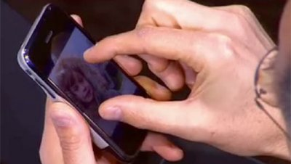

Figure 3 Utility Patent 915: Application programming interfaces for scrolling operations

(Source: [www.businessinsider.com](http://www.businessinsider.com))

This patent includes the ability of a device to recognize whether a user is using a single finger or more to scroll a view. Pinch-to-zoom is an example of this.

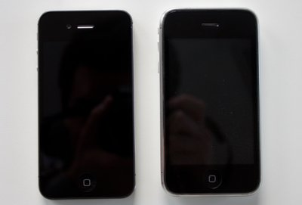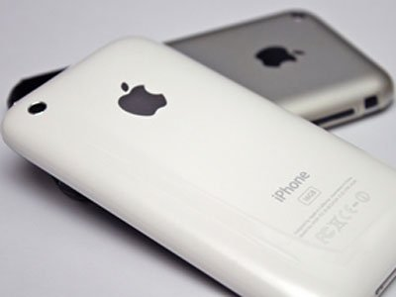

Figure 4 Design Patent 087 and 677: Ornamental Design of the iPhone (white and black)

(Source: [www.businessinsider.com](http://www.businessinsider.com))

Apple had reserved its rights for the shape and color of its own iPhone. The rectangular shape with rounded corners belong to Apple and according to them, Samsung had violated it.

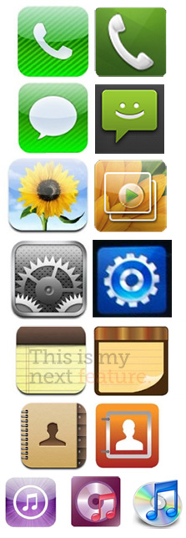

Design Patent 305: Rounded Square Icons in the Interface

(Source: [www.theverge.com](http://www.theverge.com))

This patent seems like the most obvious if a company would dare to infringe Apple’s designs. The icons from the left are iOS icons while the icons from the right are TouchWiz’s icons. Obviously, the icons have the same shape and designs but also unbelievably, yes, Apple did reserve its rights for the shape and design of the icons.

These are few of the patents that Apple claims to be infringed by Samsung and they demand the rival company to ban the products that have the patents mentioned above. But aside from the number of infringed patents according to Apple, the jury also rejected some of Apple’s claims. Some patents were agreed by the court that they were not infringed willfully by Samsung. Why?

1. **WHY SOME OF APPLE’S COMPLAINTS WERE REJECTED**

As stated in the earlier part of the paper, Samsung Electronics Co Ltd uses the Android operating system provided by Google Inc. to be able for their tech products such as smartphones and tablets to operate. Some of the patent claims of Apple were rejected by the jury and agreed to the court that Samsung did not willfully infringed the patents of Apple. The court said that the patents of Apple such as pinch-to-zoom and the rubber band effect are from the Android OS and thus, Google Inc. is the one responsible for them.

1. **CONCLUSIONS**

While the two technology giants are having their own battle, they also affect the world. Not only the people are affected individually but also their companies especially those small companies that make their own local gadgets. At first, people would think that copying ideas from others are really not appreciated by the public. But then, almost all of the great people or great companies were also imitators. For example, when the famous Steve Jobs visited a research center, he saw a Xerox prototype being used with a mouse and graphical user interface. After seeing it, he then got an idea and applied it in Macintosh. As for Samsung being proved guilty for imitating some of Apple’s patents, it would be good for other companies because it yields competition to their rival companies. Copying could help with the enhancement of creativity of ideas. Though it has both negative and positive effects, because of innovation, the positive effects remain strong.

For small companies that dwell on local places, this patent war between the two giant companies gives them a positive outcome, not only to them but also to the consumers. The public will probably find some new designs or functions from a device where they could be sure that these were not copied from either Apple or Samsung. This is where the other companies could enter. By now, they should have been thinking of new innovations or design or functionalities and put it into their products where consumers could be curious on how different it will be from Apple and Samsung’s products. Some examples are the makers of Cherry Mobile. Although some complaints of Apple were directed to Samsung, these were rejected because its mobile operating system, the Android, is the one responsible for those complaints. Cherry Mobile also uses the open-source operating system but even so, it has its own unique style. Some people might not recognize a Cherry Mobile device easily but when a user holds it, some differences from other devices could be distinguished. Because of its cheap cost, compared to Apple or Samsung’s products, people from the Philippines tend to choose Cherry Mobile instead of the two said companies. Not only Cherry Mobile is the one that has been progressing but also other local companies. Thanks to Android as an open-source mobile operating system, people need not worry about which gadgets to buy, except from those who are really meticulous about a device’s hardware components. But not only could those small, local companies gain positive effects from the two battling companies but also their own rivalries. Nokia, which uses Microsoft’s newly, released Windows 8 catches people’s attention by trying to be different in terms of the user interface and also the physical form and shape of the devices. Without imitation, maybe there would not be any big innovations or breakthrough. Some great people and great companies seek “inspiration” from others and thus, produce a more developed output.

1. **AREAS FOR FUTURE STUDY**

Until now, the two giant companies have been piling up the court with lots of paperwork for the jury to read, analyze and judge their complaints against each other. As stated on the latter part of this paper, some of Apple’s complaints were rejected because the intellectual properties that they believe was copied from them was agreed by the jury that it was not Samsung’s responsibility but the producer of Android operating system, Google Inc. The researcher therefore recommends further studying of how the jury had found out that Google’s Android was the one with copyright issues and not Samsung’s products. Before this “battle” for intellectual property rights, Apple had been suing other companies for the same complaints. The researcher also recommends going back to these older issues and determines how different it was from the present one.

**REFERENCES**

[1] Nation Multimedia, “Apple wins 1 billion dollars in Samsung patent case” The Nation. [Online]. Available: <http://nationmultimedia.com/breakingnews/Apple-wins-1-billion-dollars-in-Samsung-patent-cas-30189066.html>. [Accessed: February 10, 2013]

# [2] C. Lee, “[Apple overtakes Samsung as top US mobile phone vendor](http://www.idownloadblog.com/2013/02/01/apple-top-mobile-phone-vendor/)” [Online]. Available: <http://www.idownloadblog.com/2013/02/01/apple-top-mobile-phone-vendor/>. [Accessed: February 10, 2013]

# [3, 4, 5] The Economic Times, “Tech giants, Apple and Samsung, frenemies for life” [Online]. Available: <http://articles.economictimes.indiatimes.com/2013-02-10/news/37020557_1_samsung-last-year-apple-and-samsung-smartphones>. [Accessed: February 1-, 2013]

[6] Apple Inc., “Complaint For Patent Infringement, Federal False Designation Of Origin And Unfair Competition, Federal Trademark Infringement, State Unfair Competition, Common Law Trademark Infringement, And Unjust Enrichment”, Apple Incorporation, 2011. [Online]. Available: <http://cdn0.sbnation.com/podcasts/apple-samsung-lawsuit.pdf>. [Accessed: January 13, 2013]

[7] N. Patel, “Apple sues Samsung: a complete lawsuit analysis” [Online]. Available: <http://www.theverge.com/2011/04/19/apple-sues-samsung-analysis/>. [Accessed: January 13, 2013]

[8] K. Smith, “These Are The 6 Apple Patents Samsung Violated” [Online]. Available: <http://www.businessinsider.com/apple-versus-samsung-2012-8?op=1>. [Accessed: January 14, 2013]