Gym安装

Linux版本：Ubuntu 16.04

创建环境

conda create -n gymlib python=3

source activate gymlib

source deactivate gymlib

安装包

sudo apt-get install -y python-numpy python-dev cmake zlib1g-dev libjpeg-dev xvfb libav-tools xorg-dev python-opengl libboost-all-dev libsdl2-dev swig

安装gym

git clone https://github.com/openai/gym.git

cd gym

pip install -e .[all]

修改setup.py

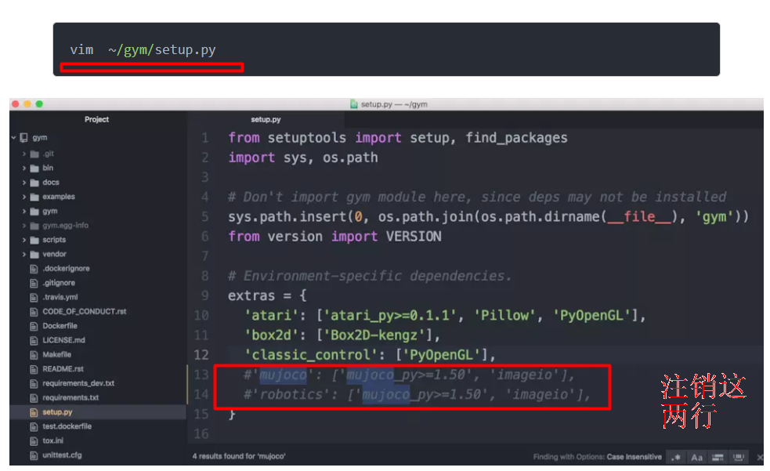

测试gym

import gym

env = gym.make('Hero-ram-v0')

for i_episode in range(20):

observation = env.reset()

for t in range(100):

env.render()

print(observation)

action = env.action_space.sample()

observation, reward, done, info = env.step(action)

if done:

print("Episode finished after {} timesteps".format(t+1))

break