Linux常见软件安装

## Linux常用配置-centos

### 1.配置dns

添加dns地址

vi /etc/resolv.conf



重启网络

service network restart

### 2.yum配置

下载阿里的CentOS-Base.repo 到/etc/yum.repos.d/

cd /etc/yum.repos.d/

wget -O /etc/yum.repos.d/CentOS-Base.repo http://mirrors.aliyun.com/repo/Centos-7.repo

运行yum clean all 清除缓存

运行 yum makecache 生成新的缓存

## 1-java安装

vim /etc/profile

export JAVA_HOME=/root/threeline/env/jdk1.8.0_201

export CLASSPATH=.:$JAVA_HOME/lib/dt.jar:$JAVA_HOME/lib/tools.jar

export PATH=$JAVA_HOME/bin:$PATH

source /etc/profile

## 2-mysql5.7安装

### 压缩包安装

注意

mysql 不能在家目录安装

版本: mysql-5.7.24-linux-glibc2.12-x86_64.tar

参考地址

<https://cloud.tencent.com/developer/article/2080858>

<https://blog.csdn.net/qq_20780541/article/details/122035569>

编译和初始化成功

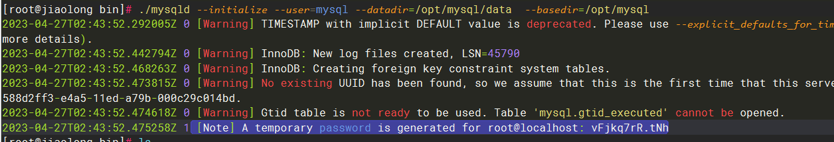

修改密码

set password for 'root'@'%'=password('vFjkq7rR.tNh_Srv4Sht2Ruc_90von71');

flush privileges;

<https://blog.csdn.net/qq_33472557/article/details/77726094>

安装手册



### Yum安装



## 3-openoffice安装

安装教程

<https://developer.aliyun.com/article/791858>

### 安装rpm1

cd zh-CN/RPMS/

yum localinstall *.rpm

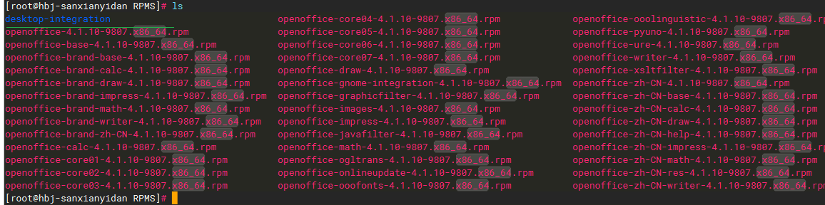

### 安装rpm2

cd desktop-integration/

yum localinstall openoffice4.1.10-redhat-menus-4.1.10-9807.noarch.rpm

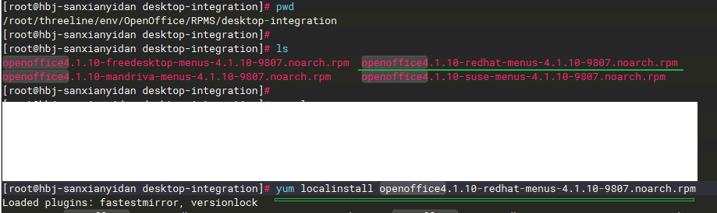

### 安装依赖

yum install libXext.x86_64

yum groupinstall "X Window System"

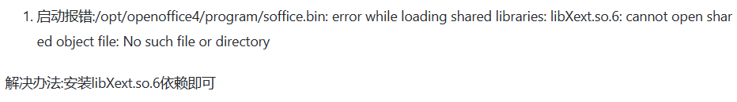

### 启动

nohup /opt/openoffice4/program/soffice -headless -accept="socket,host=127.0.0.1,port=8100;urp;" -nofirststartwizard &

查看

netstat -lnp |grep 8100

根据端口查引用pid

lsof -i :8100

