1.解决调试jdk源码时无法看到变量值

2.添加java源代码

## 1.解决调试jdk源码时无法看到变量值

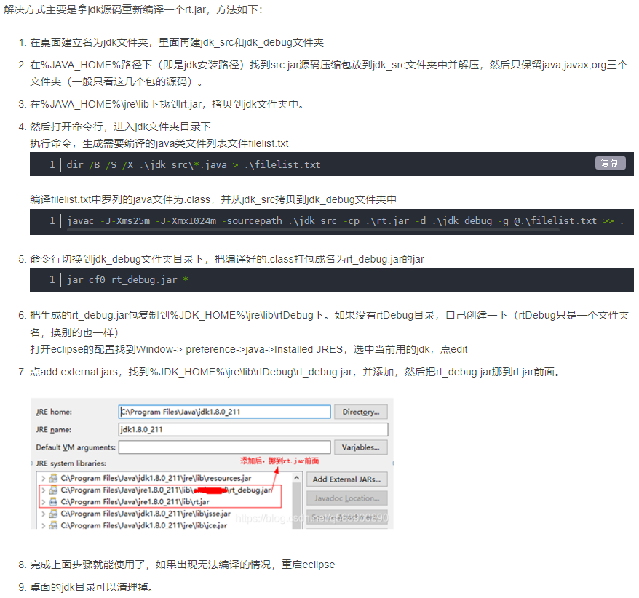

**命令**

dir /B /S /X .\jdk_src\*.java > .\filelist.txt

javac -J-Xms25m -J-Xmx1024m -sourcepath .\jdk_src -cp .\rt.jar -d .\jdk_debug -g @.\filelist.txt >> .\log.txt 2>&1

jar cf0 rt_debug.jar *

**网址**

<https://blog.csdn.net/q583900890/article/details/115351790>

## 2.添加java源代码

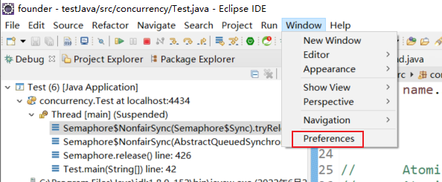

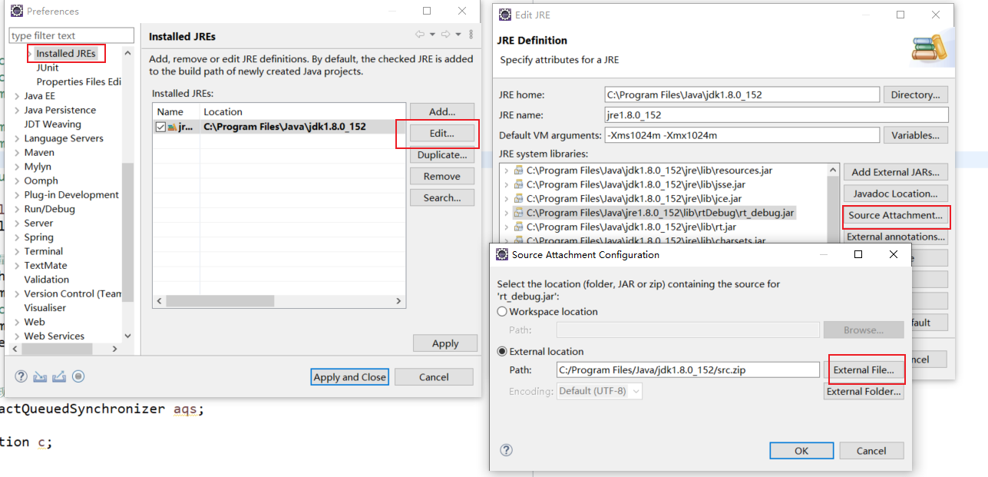

[eclipse Ctrl +左键查看源代码Source not found-百度经验 (baidu.com)](https://jingyan.baidu.com/article/11c17a2c6fa27af446e39dac.html)