## IDEA配置

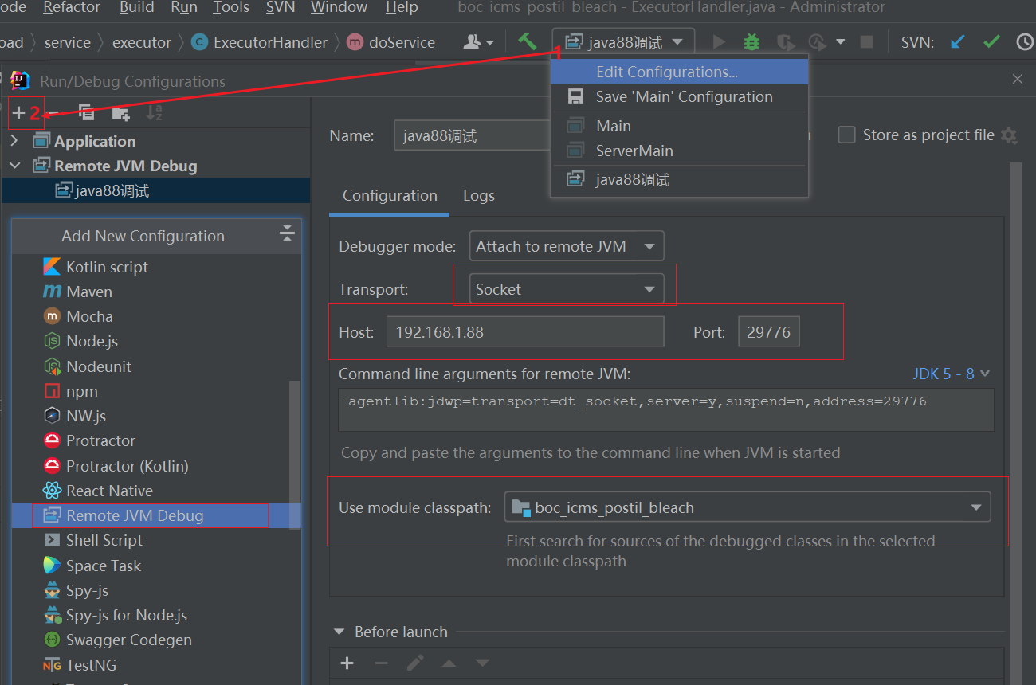

## 命令配置

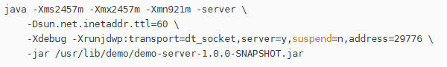

java -Xms2457m -Xmx2457m -Xmn921m

**-server \**

**-Dsun.net.inetaddr.ttl=60 \**

**-Xdebug -Xrunjdwp:transport=dt_socket,server=y,suspend=n,address=29776**

-jar /usr/lib/demo/demo-server-1.0.0-SNAPSHOT.jar