## 甘特图软件对比

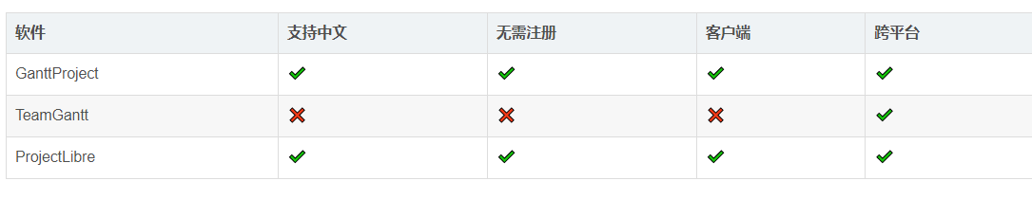

<https://blog.csdn.net/weixin_37865166/article/details/112730330>

## NO.1 GanttProject

## NO.2 ProjectLibre