# 源码环境搭建

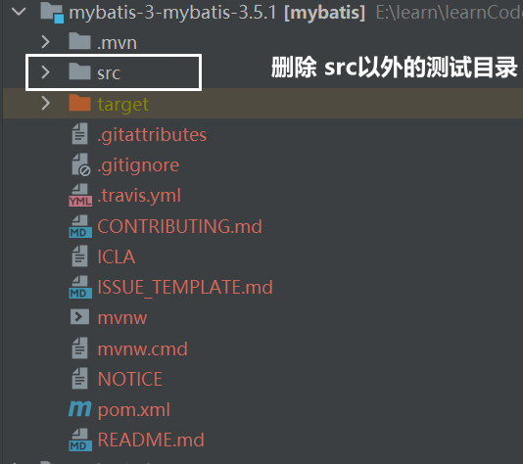

Mybatis版本为：3.5.1



**测试demo中需要补充如下依赖**

<dependency>

<groupId>ognl</groupId>

<artifactId>ognl</artifactId>

<version>3.2.10</version>

<scope>compile</scope>

<optional>true</optional>

</dependency>

<dependency>

<groupId>org.javassist</groupId>

<artifactId>javassist</artifactId>

<version>3.24.1-GA</version>

<scope>compile</scope>

<optional>true</optional>

</dependency>

[MyBatis 源码环境搭建](https://www.cnblogs.com/vic-tory/p/17977034)