mybatis-generator-core-操作手册

# 如何执行

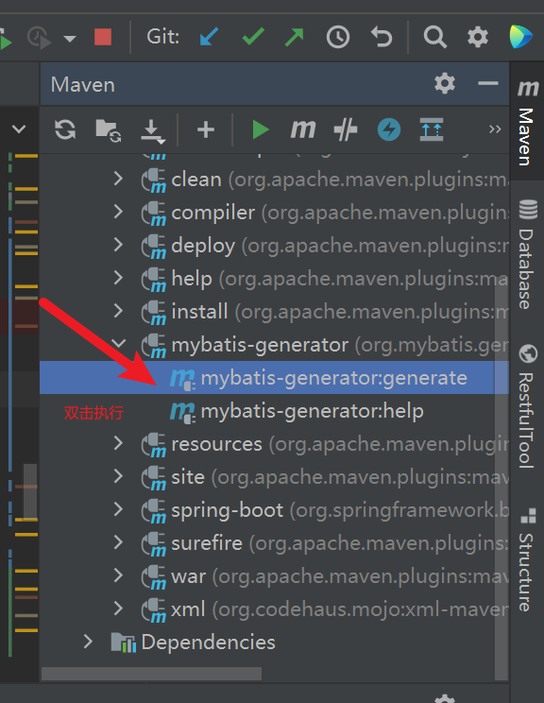

# Maven中的配置

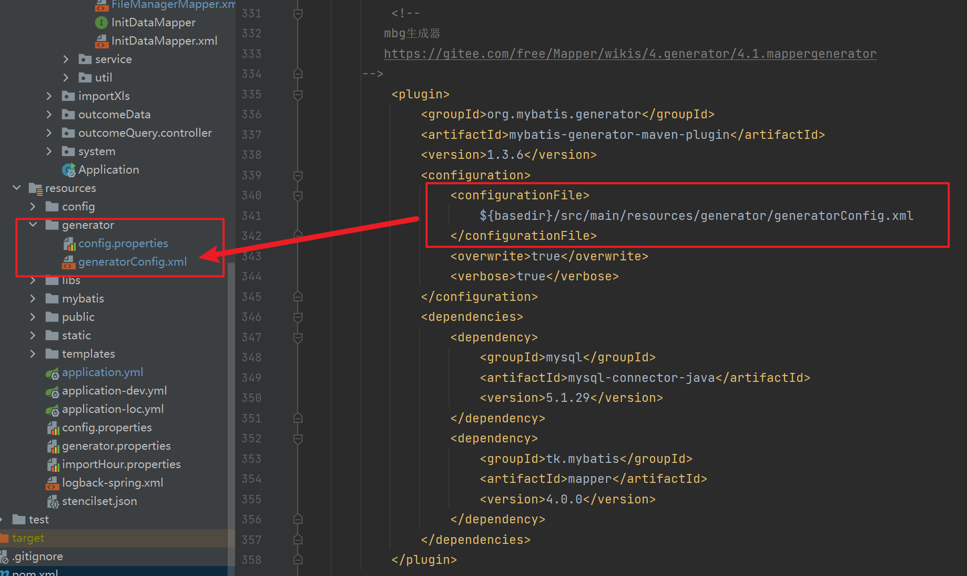

# 具体配置信息

<!--  
 mbg生成器  
 https://gitee.com/free/Mapper/wikis/4.generator/4.1.mappergenerator  
-->  
 <plugin>  
 <groupId>org.mybatis.generator</groupId>  
 <artifactId>mybatis-generator-maven-plugin</artifactId>  
 <version>1.3.6</version>  
 <configuration>  
 <configurationFile>  
 ${basedir}/src/main/resources/generator/generatorConfig.xml  
 </configurationFile>  
 <overwrite>true</overwrite>  
 <verbose>true</verbose>  
 </configuration>  
 <dependencies>  
 <dependency>  
 <groupId>mysql</groupId>  
 <artifactId>mysql-connector-java</artifactId>  
 <version>5.1.29</version>  
 </dependency>  
 <dependency>  
 <groupId>tk.mybatis</groupId>  
 <artifactId>mapper</artifactId>  
 <version>4.0.0</version>  
 </dependency>  
 </dependencies>  
 </plugin>

