# 常用命令

获取shjd数据库配置信息

db2 get db cfg for shjd

释放数据库连接

db2 connect reset

查询表空间

db2 list tablespaces

查看实例

db2 list db directory

--查询数据库配置信息

db2 get db cfg for shjd

# 导出表结构

 db2look命令生成表结构的DLL脚本

**db2look -d** **db_name** **-i** **user_name** **-w** **password** **-a -e -o d:\script.sql**

db_name 是指数据库的名字，

user_name 是数据库用户名，

password是数据库密码

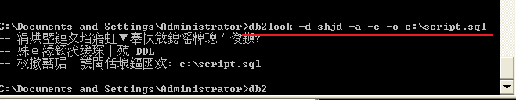

db2look -d shjd -a -e -o d:\script.sql

# 创建数据库语法

db2 create db databaseName using codeset utf-**8** territory CN

db2 create db shjdgbk using codeset GBK territory CN

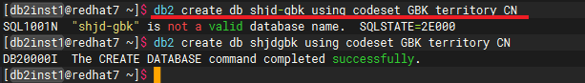

# 表空间

查询

db2 list tablespaces

查询-显示存放路径

db2 list tablespace containers for ID show detail

创建

连接数据库

db2 connect to shjd

删除

db2 drop tablespace 表空间名, 表空间名

创建语句

db2 "create regular tablespace 表空间名 pagesize 32k managed by database using(file '/home/db2inst1/tablespace/ts' 5g) bufferpool bp32k"

eg-指定大小:

db2 create bufferpool bp32k all nodes size -1 pagesize 32k

db2 "create regular tablespace TBSPCUSTOMER pagesize 32k managed by database using(file '/home/db2inst1/tablespace/ts1' 5g) bufferpool bp32k"

db2 "create regular tablespace TBSPBILL pagesize 32k managed by database using(file '/home/db2inst1/tablespace/ts2' 5g) bufferpool bp32k"

eg-自动存储:

db2 "create regular tablespace TBSPCUSTOMER pagesize 32k managed by automatic storage bufferpool bp32k"

db2 "create regular tablespace TBSPBILL pagesize 32k managed by automatic storage bufferpool bp32k"

db2 "create regular tablespace TBSPTMP pagesize 32k managed by automatic storage bufferpool bp32k"

db2 "create regular tablespace TBSPREPORT pagesize 32k managed by automatic storage bufferpool bp32k"

db2 "create regular tablespace TBSPOTHER pagesize 32k managed by automatic storage bufferpool bp32k"

# 授权用户

--授权用户

db2 "CREATE USER jiaolong WITHOUT SYSADM AUTHORITY"

db2 "GRANT CONNECT ON DATABASE TO USER jaiolong"

--授予用户所有权限

db2 "GRANT DBADM WITH DATAACCESS ON DATABASE TO USER jiaolong"

jiaolong是linux的用户

# 创建SCHEMA

创建SCHEMA

CREATE SCHEMA "ADMINISTRATOR" AUTHORIZATION "ADMINISTRATOR";

CREATE SCHEMA schema_name AUTHORIZATION user_name

查看数据库中的 Schema：

SELECT SCHEMANAME FROM SYSCAT.SCHEMATA;

# 参考

[导出db2数据库的表结构和数据](https://www.cnblogs.com/xitingxie/p/5753093.html)

[db2创建数据库常用命令](https://www.cnblogs.com/oath-keeper/p/9985093.html)

[db2创建数据库](https://www.cnblogs.com/oath-keeper/p/9985093.html)

[DB2数据库-库级别配置-编码、schema以及表空间配置](https://blog.csdn.net/weixin_43740223/article/details/85251507)