## Tomcat 配置jdk

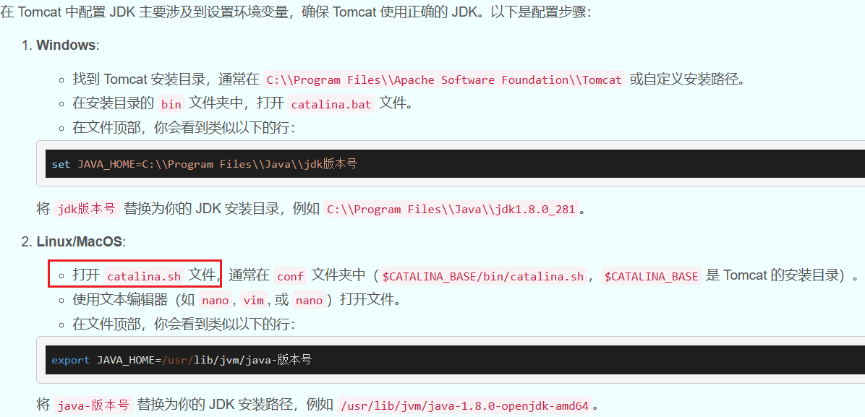

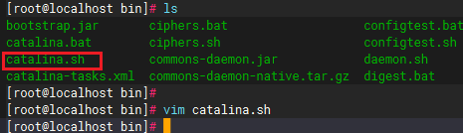

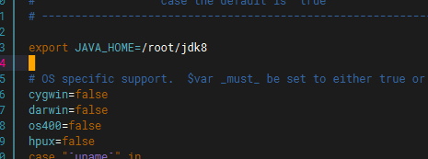

export JAVA_HOME=/root/jdk8

## 删除tomcat 缓存

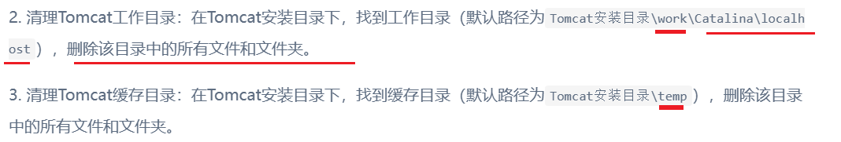

## 请求信息添加特殊字符

tomcat/conf/server.xml

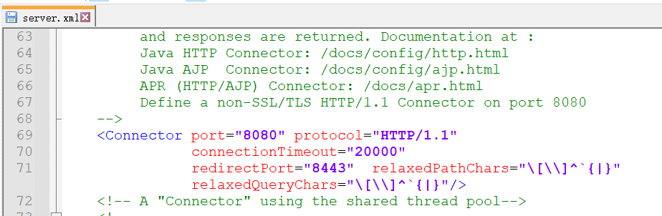

<Connector port="8080" protocol="HTTP/1.1"

connectionTimeout="20000"

redirectPort="8443"

relaxedPathChars="\[\\]^`{|}"

relaxedQueryChars="\[\\]^`{|}"

/>

<Connector port="8080" protocol="HTTP/1.1"

connectionTimeout="20000"

redirectPort="8443"

maxParameterCount="1000"

relaxedPathChars=":\|{}[],%"

relaxedQueryChars=":\|{}[],%"

/>

# 显示控制台日志

