**2014 JUNIOR DUCK STAMP COMPETITION**

**Jiao Ying Art School**

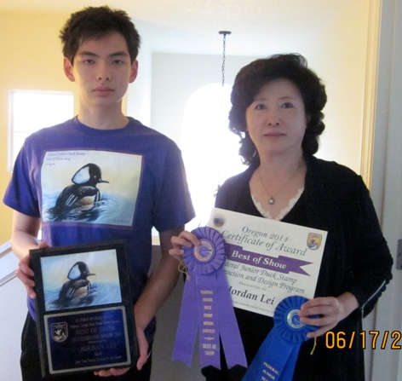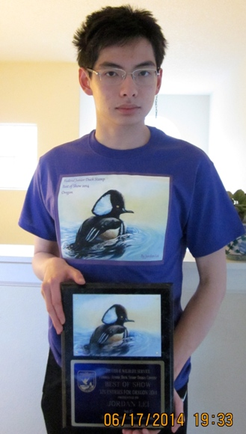

焦莹老师和州际冠军雷昊川 同学 **Best of Show: Jordan Lei, Age 15**

Teacher Jiao Ying and Jordan

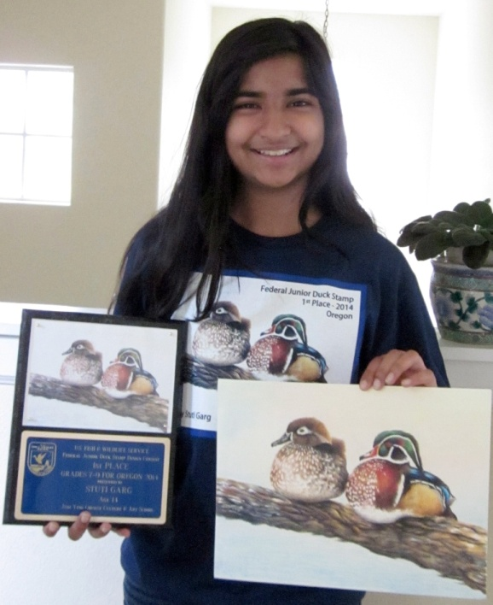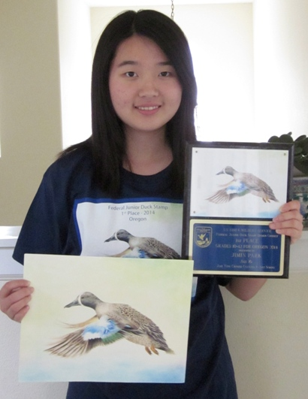

**1st Place: GRADES 7-9** Stuti Garg, Age 14,

**1st Place: GRADES 10-12** Jimin Park, Age 16,

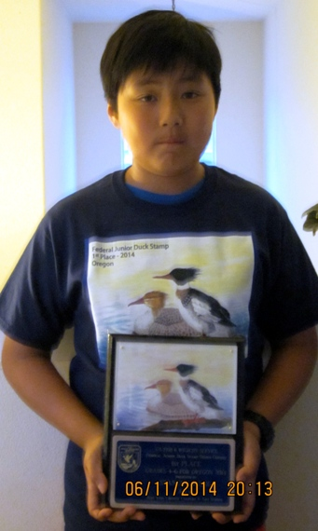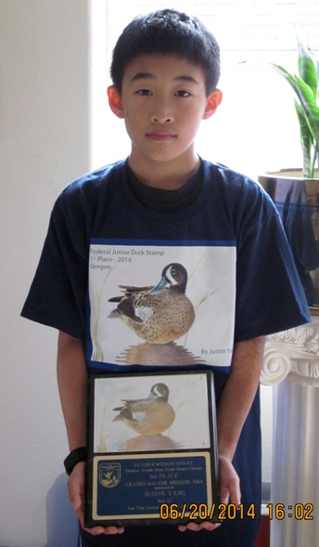

**1st Place: GRADES 4-6 1st Place: GRADES 4-6**

Stanley Wang, Age 11, Justin Yang, Age 12,

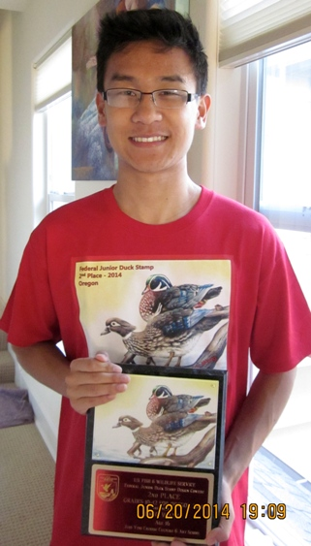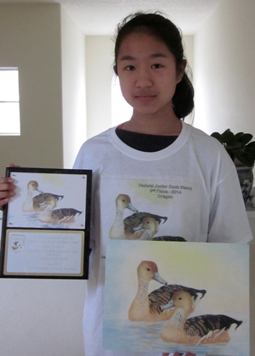

**2nd Place: GRADES 10-12** **3rd Place: GRADES 7-9**

Eric Wang, Age 16, Jennifer Zhu, Age 12,

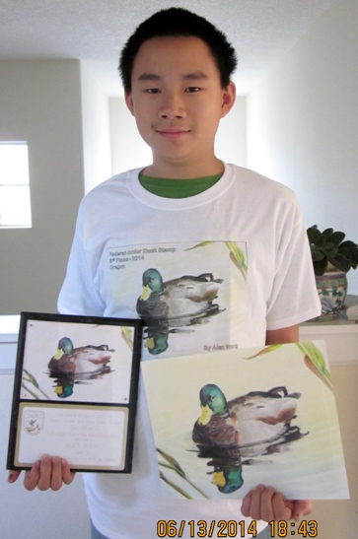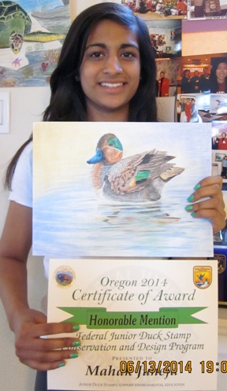

**3rd Place:** **GRADES 7-9,** **HM Place: GRADES** 7-9

Alex Wang, Age 14, MahakJuneja

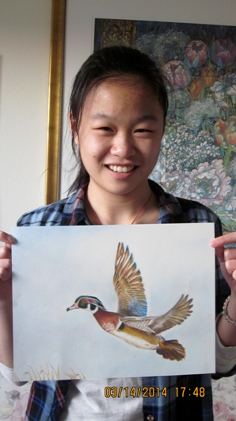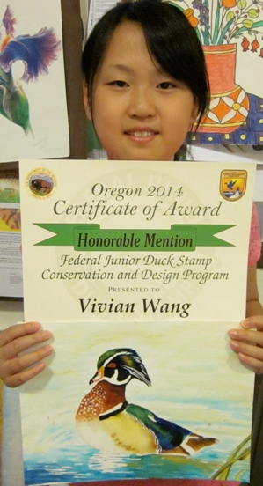

**HM Place: GRADES 10-12, HM Place: GRADES** 4‐6

KatherineYang VivianWang

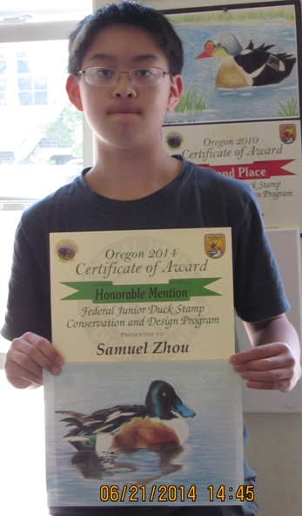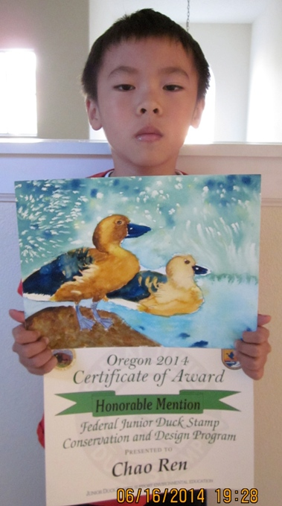

**HM Place: GRADES 7-9, HM Place: GRADES K-3,**

Samuel Zhou Chao Ren

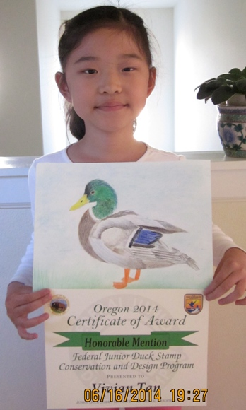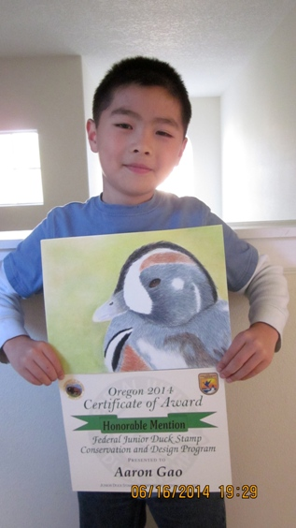

**HM Place: GRADES K-3,** **HM Place: GRADES K-3,**

**Vivian Tan** Aaron Gao

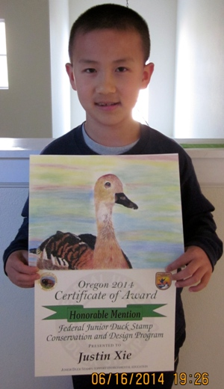 **HM Place: GRADES K-3,**  JustinXie