**AN IMPLEMENTATION OF LOCATION BASED SERVICE (LBS) FOR COMMUNITY TRACKING**

**Budi Yulianto1; Rita Layona2**

1, 2 Computer Science Department, School of Computer Science, Bina Nusantara University Jln. K.H. Syahdan No 9, DKI Jakarta 11480, Indonesia

1laboratory@binus.ac.id; [2](mailto:2rlayona@binus.ac.id)[rlayona@binus.ac.id](mailto:rlayona@binus.ac.id)

**Received:** 19th Desember 2016/ **Revised:** 8th March 2017/ **Accepted:** 15th March 2017

***Abstract* -** The case of lost or missing children when people go traveling or in the hustle often occurs due to lack of parental supervision. These problems can be solved using Global Position System (GPS)-based navigation technology Location Based Service (LBS). This research aimed to determine the position of members of the community (such as family) who were lost or missing by using mobile devices. Rapid Application Development (RAD) was used for system development, which comprised the step of requirement or planning, system design, development, and cutover. The result of this research is a GPS-based application that is able to display the position of members of the community, the route to the location, and the media discussion (comments). The conclusions show that the application provides an easy and useful function in finding the location of the community member, displays the route to the location, and allows the interaction in the form of communication.

***Keywords:*** Location Based Service (LBS), family tracking, community tracking

# INTRODUCTION

The rapid development of information technology has made many people use it to support their daily activities. It can be said that, information technology becomes an important support for them. With the information technology, user gets the ease and comfort. The comfort aspect includes safe feeling from the unexpected things such as people who get lost in an area and they do not know the location of a place, or parents who want to find their separated children (Iskandar, 2008). Moreover, the cases of loss occurred in the Eid holiday in 2012. At that time, there are 166 cases of missing children separated from their parents that are handled by Water Tourism Rescue Agency (Balawista) Pangandaran (Pikiran Rakyat, 2012).

To solve and prevent losses issues, people requires a Location Based Service (LBS) based on location tracking technology using Global Position System (GPS). GPS is a satellite navigation system that determines the location, speed and direction through a signal received over 24- 32 satellites orbiting 20.000 km (11.000 nautical miles) above the earth. By using GPS, the position of an object can be determined appropriately (Yulianto, 2010). GPS is divided into three parts, namely space segment, control segment, and user segment. Space segment is part of the GPS consisting of a series of satellites orbiting the earth. Then, control segment consists of several stations that are in the earth to control and make corrections to the satellite orbit. Meanwhile, user segment in GPS receiver is a device

that receives data from the satellite and translates them into a set of position coordinates of the earth, as seen in Figure 1.

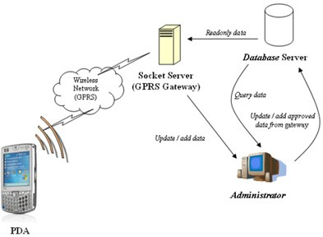

Figure 1 GPS System

By using GPS technology, users can easily find out the location of police stations, hospitals, restaurants, and the nearest bank or ATM. The main function of GPS is to determine the position of an object on the Earth’s surface or the travel route by looking for the fastest and shortest path (Triandi, 2010). Based on the data obtained from ABI Research, there were at least 315 million people who already used GPS technology in 2011 (Mokbel, 2009). The data show the importance of the use of GPS technology.

Table 1 Length of Time in Using GPS

|  |  |  |
| --- | --- | --- |
| **No.** | **Data** | **Number of People** |
| 1 | Mobile phone users worldwide | 5.000.000.000 |
| 2 | Smartphone users | 1.080.000.000 |
| 3 | Case of lost smartphone | 9.000.000 |
| 4 | Users of smartphones that use the  device throughout the day | 961.200.000 |

From the exposure data in Table 1, it shows that 21,6% of mobile phone users are smartphone users. 1,08 of 5 billion smartphone users worldwide use their smartphone all the day (GO-Gulf, 2012). Moreover, the rapid development and improvement of the user have made GPS as a feature that is often found on smartphones (Lestariya, 2008). Therefore, the tracking of the position of their smartphones is also tracking the users. In addition to a navigation system, the

smartphone is also widely used for social media activities through internet access (Ipsos, 2012). More than a half of smartphone users also access certain social media sites in a month via smartphone (ComScore, 2011).

The number of smartphone users around the world indirectly affect the case of loss of a smartphone. This is seen from the survey results obtained from Lookout (2012). There were about 9 million people lost smartphones in 2011. It can be said that the case of lost smartphone is also fairly large.

Some researches regarding the implementation of navigation technology have been done before. Lai *et al*. (2007) developed a GPS-based application that displayed the location on a map on the mobile device. Moreover, Williams (2008) also developed an application that could track the coordinates of the user. Feng (2009) had research in the searching application on a regional basis. Similarly, Yulianto (2010) had an application that showed the route from the user’s position to the destination. Meanwhile, there is also improvised navigation application with the addition of graphical map (Chu, 2011), and the location of two- dimensional graphics (Ruotsalainen, 2011).

There is also recent research regarding this topic. For example, Edwards (2013) added transport information that could be used in the system, and Shimizu (2014) added passing towards a location. The other researchers develop a nearest location searching system based on the radius (Yulianto, 2015), rating and comment (Layona, 2016a), and based on the user’s desired criteria (Layona, 2016b). Their research is for the development of application aiming to track the user’s position in the community (friends, colleagues, or families) with location tagging and comment which resemble a wall-post social media.

Based on the issues described and supported with navigation technology, the researchers conduct research for the development of an application that implements a GPS- based LBS technology and integrates it with communication interactions resembling a wall-post on social media. The result of this research is a mobile based application (Android) and web application to find out the location of the community members (friends, colleagues, or families), and communication interaction. In addition to members’ detection (for being lost or kidnapped), this application can also be used to locate a lost smartphone. This is based on data from Lookout (2012), there are 9 million smartphones lost every year.

# METHODS

This research uses Rapid Application Development (RAD) for system development. According to Shelly and Rosenblatt (2009), RAD is a model of software development processes which belong to the multilevel techniques. Modeling of RAD emphasizes on software development cycle which is short, concise, and fast. RAD uses iterative methods in the development of the system. It is a working model of the system which is constructed in the early stages of development to determine the needs of users. Moreover, RAD method makes application processing time faster and have better results because there is a user control on the development of the system. However, the cost is greater and requires good management

The stages of the method start from the requirement or planning stage to define user needs and scope of the system. This stage is a combination of elements of system design and analysis phases of the System Development Life Cycle (SDLC). This phase discusses program needs

and finds solutions for system design. The requirements are gathered from questionnaires distributed to 50 respondents. The next stage is the system design to create a design screen illustrating the critical components of the system. This phase consists of systems analysis and development, and prototype models that describe the whole system in the program including input, process, and output. The system is designed with Unified Modeling Language (UML) that consist of class diagram, use case diagram, and sequence diagram. Next is the stage of development. This is the application developed by using the reference of the previous processes. It describes the focus of the program and the development of applications such as SDLC. It focuses on programming, the integration of the unit, and system testing. At the final stage, cutover is the implementation of the system that has created and performed a series of system tests. This is the final stage which includes implementation, data conversion, final testing on the system, and training users. The stage of RAD can be seen in Figure 2.

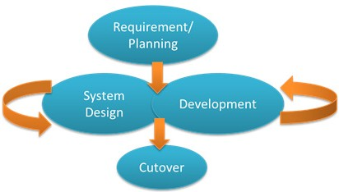

Figure 2 Rapid Application Development

# RESULTS AND DISCUSSIONS

This developed mobile based application runs on a smartphone with several specifications. There is HSPA+ network specification with 850/900/1900/2100 MHzdata connectivity, 1 GB of RAM; 5 MB of storage memory, Sensor Assisted GPS, and the Android operating system with a minimal version of 4 (Ice Cream Sandwich). The web-based application can run on a computer with minimum specifications. It has Intel Duo Core processor, a memory of 512 MB, 1.50 Mbps of internet connection, and Mozilla Firefox web browser version 45 or equivalent. The result of the system development is shown.

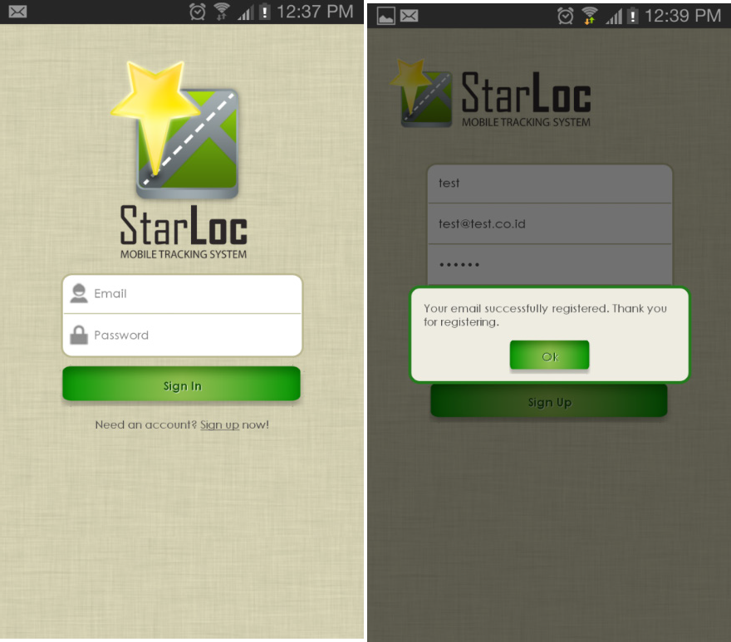

* 1. (b)

Figure 3 (a) Home, (b) Error Message Dialog

In Figure 3a, the system displays the initial page. It is for the users to log in by entering their email address and password. If there are errors in filling the email or password, the system displays an error message. It can be seen in Figure 3b.

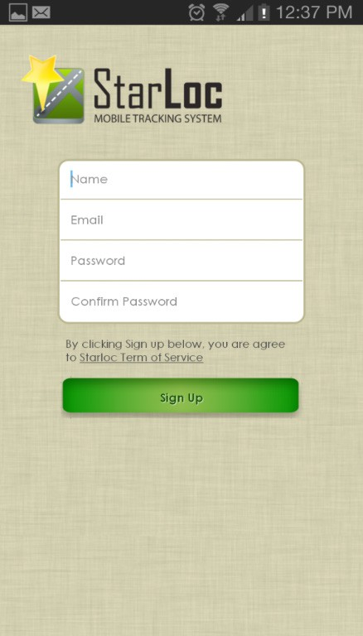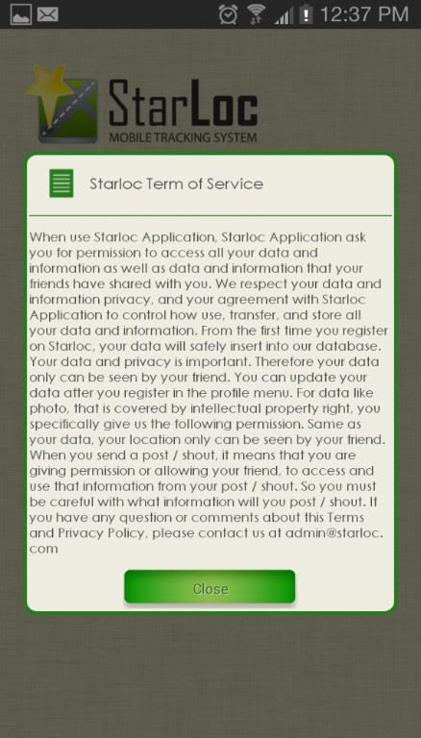

* + 1. (b)

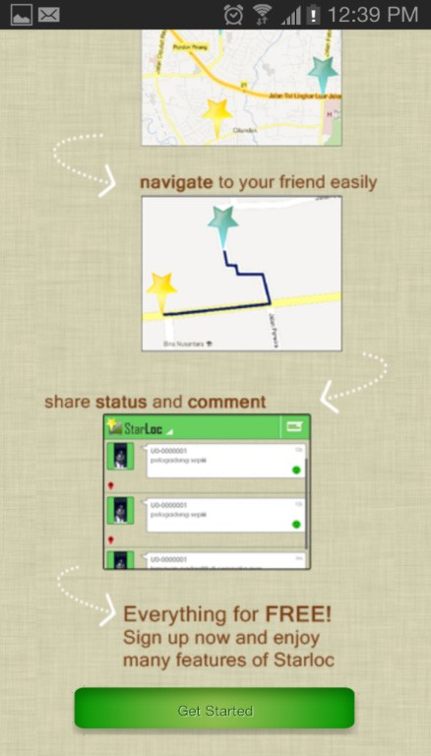

(c)

Figure 4 (a) Registration, (b) Term of Service, and (c) Manual

When users do not have an account, they can register by pressing the sign up on the home page as seen in Figure 3a. Figure 4a shows that users must enter their username, email address, password, and confirm their password to register. After that, the user can read the terms of service as shown in Figure 4b by pressing Terms of Service which is above the Sign-Up button. After registration, the system will display the manual page. This page displays a brief graphical guide about the application. The user can press the get started button to go to the map page. It is shown in Figure 4c.

Figure 5 describes the map menu. It has four main menus in the bottom. There are Map, List, Group, and Notification. Then, there are also shout button to leave a comment in the top right and additional menu button in the top left. In the upper right (three dots icon), there are features about navigation, checking in, layers, and favorite. Moreover, the is user position which is useful for directing a map to where the user is located. Hence, the users can find the location of other community members on the map page. In addition, users can enlarge and reduce the size of the map (zoom in or zoom out) on the map by using two fingers.

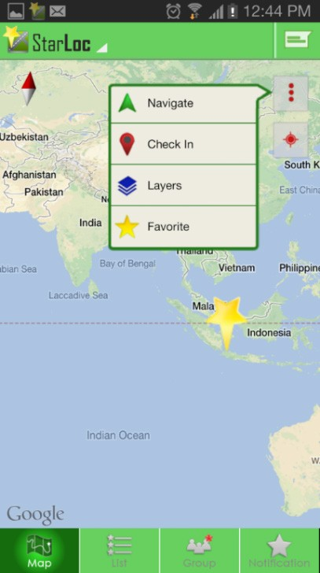

Figure 5 Map Menu

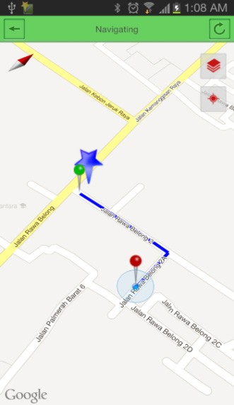

(a) (b)

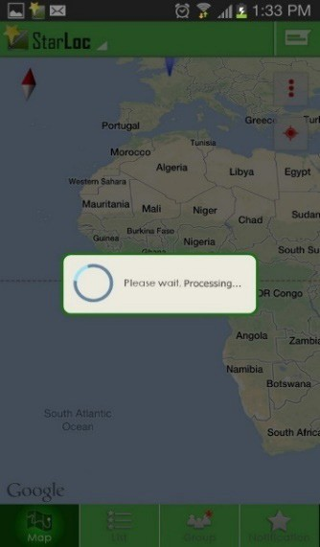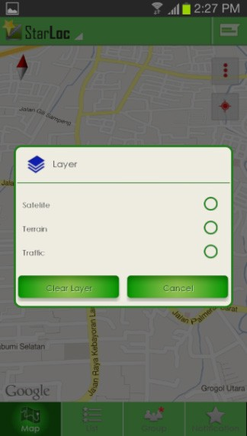

(c) (d)

Figure 6 (a) Selecting Member, (b) Navigation Menu,

(c) Check in Menu, and (d) Layer Menu

In Figure 6a, users can select the member of the community whom they want to track. Then, the system displays the route to the location of the member as shown in Figure 6b. Users can also mark a location that is accessible through Check-In feature. Figure 6c shows the feature. The check-in process is required to update the users’ position if the position obtained from the GPS or BTS is inaccurate. Similarly, the users can change the map display mode into terrain, traffic, and satellite. It is shown in Figure 6d.

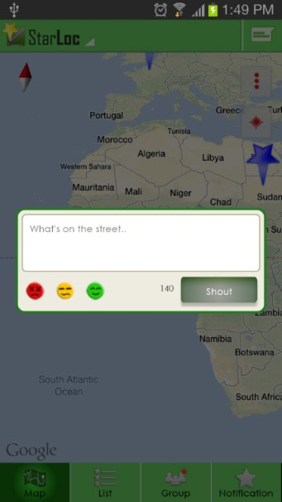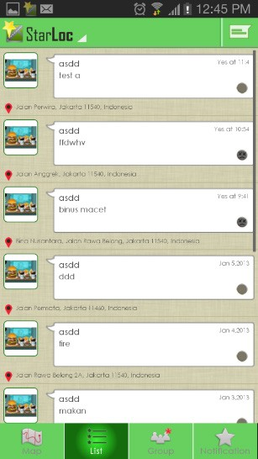Other than that, users can add or invite other community members in a group as shown in Figure 8a. Each group has a name that is defined by the user. This allows users to create a group for each category such as family, school friends, or couples, if they have approved it. Moreover, searching other users can be done on the search feature. The users who gets the invitation in a group can accept or reject. The example is in Figure 8b. Next, the additional menu in the application can be accessed under the title of the application. These additional menu settings contain of Profile, Settings, Help, Minimize, and Logout as shown in Figure 8c.

1. 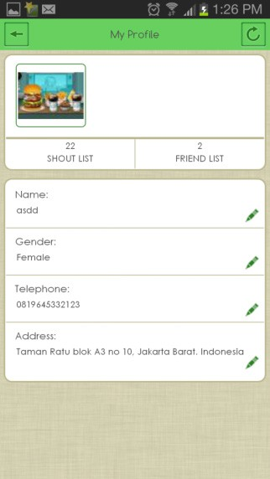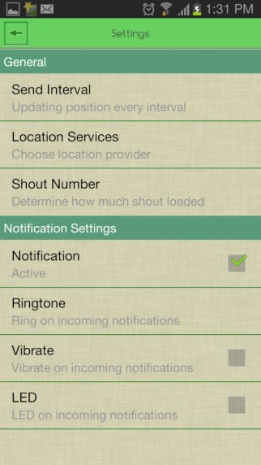(b)

Figure 7 (a) Shout Dialog and (b) Shout List

Figure 7a shows that users can leave a comment (shout) in a location that has been checked in. Users can add emoticons. There are the red icon (not good), yellow (regular), or green (good). Moreover, the emoticon can be used as a description of traffic. Red means high, yellow is moderate, and green represents quiet or smooth. Then, user can leave comments like the wall post on social media. It is illustrated in Figure 7b.

* 1. 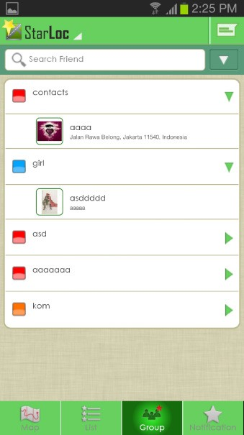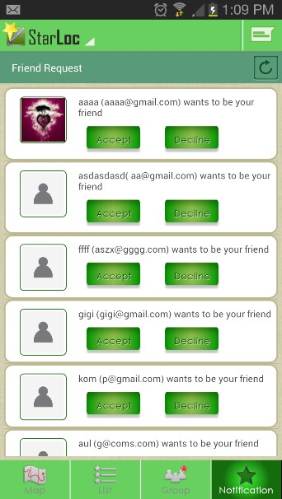(b)

(a) (b)

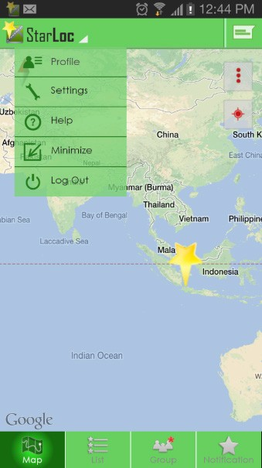

(c)

Figure 8 (a) Community Menu, (b) Invitation, and (c) Additional Menu

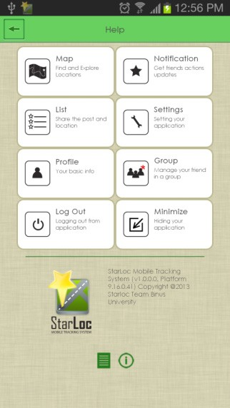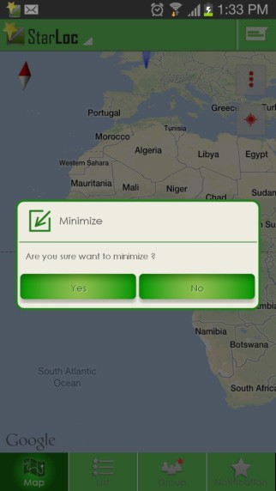(c) (d)

Figure 9 (a) My Profile, (b) Setting,

(c) Help, and (d) Minimize

On My Profile page, there are user data, a back button located at the top left of this page, and refresh button at the top right of this page. If the user wants to change the data, then the users can press the data that they want to change and it will prompt changes to the data. When the user wants to refresh the data, they can press the refresh button. The users can go back to the previous page by pressing the back button. For example, the illustration of my profile can be seen in Figure 9a. There are list of applications and back buttons located at the top left of the settings menu page. Users can change the application settings on this page such as setting the refresh interval to set the refresh time, setting location service to manage how applications get user location with GPS or base stations, and more. If the users want to go back

to the previous page, the users can press the back button. The Setting menu is in Figure 9b. Furthermore, there is also Help menu as shown in Figure 9c. It contains menu on this application, and back buttons in the top left of this page. Users can view information from the menu by pressing the menu box. Then, information and the information dialog are displayed. Similarly, in Figure 9d, there are two buttons on Minimize menu, namely the yes and no button. The users can minimize this application by pressing the yes button, and close it by pressing the no button.

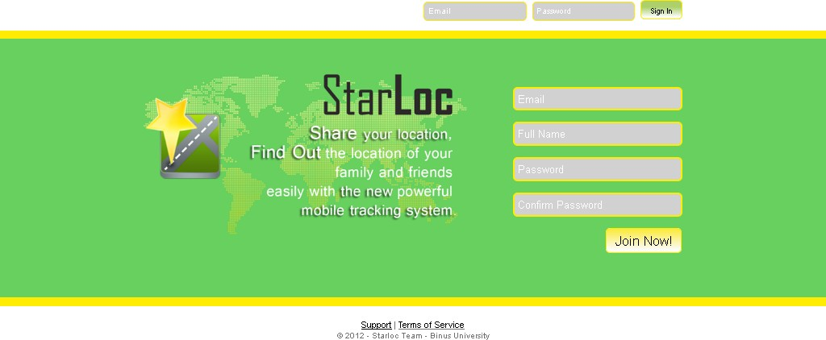

Figure 10 The Home Page of Web-Based Application

In the home page web-based application, the user can login or register as shown in Figure 10. In the index page, there is a column to log in at the top right corner for users who already have an account. In addition, there is also a form for registration located below the login fields for users who do not have an account. At the bottom, there is Support and Terms of Service menu. The Support menu contains of descriptions of the application and how to use them. Meanwhile, Terms of Service menu is about what should not be done to the user’s application.

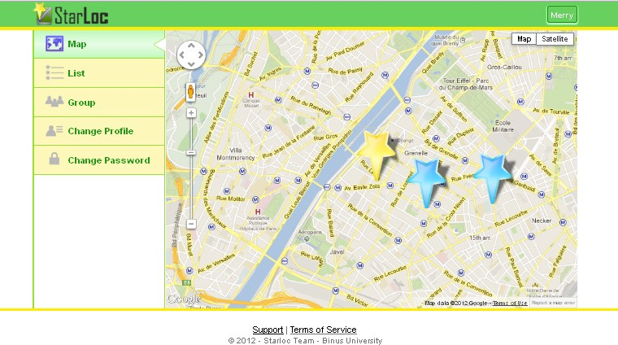

Figure 11 Map Page

After logging in, the user can perform another user tracking in a community. In Figure 11, users can see the position of themselves and their friends. A yellow star indicates the position of the users. While the other colored star indicates the position of the friends.

As for the comment page (shout), it resembles a wall-post contained on the list menu in Figure 12. List menu contains the status of the users and their friends. In list menu, there is photograph, name, status, the date when the status is made, the reported conditions, and the address where the users make such status.

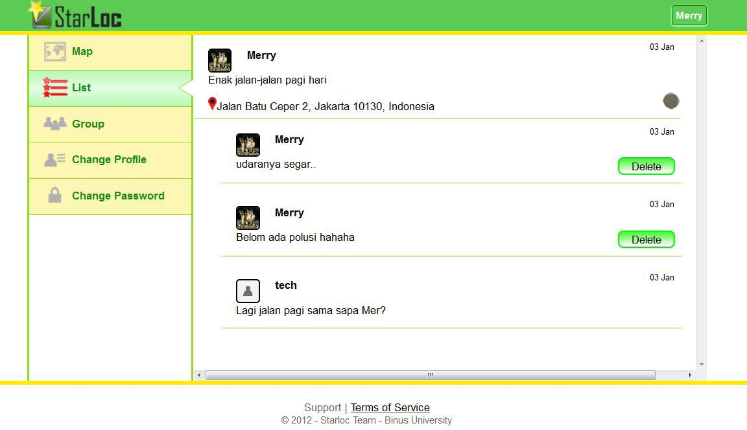

Figure 12 Comment Page

In this application development, interface designs both on the smartphone application and website follow the rules of the eight golden rules by Shneiderman dan Plaisant (2010). The results of the evaluation of the Starloc application by eight golden rules are divided into several points. First, it is consistency. This application provides a consistent view. This is shown by the display of layout, colors, headers, and font that remains consistent between menu pages. Second, it meets the universal usability. This application makes it easy for users to use it. In this application, users can easily access the existing menu. Third, it provides informative feedback. This application is designed to homepage informative feedback for every action taken by the user. For example, when the user refreshes the data on the profile, this application will give the closing message in the form of profile that it has been successfully refreshed.

Fourth, it is about designing the dialogue to produce a closure. This application will give a message to the user that shows the results for the closure of the action by the user. After the users refresh the data on the profile, this application will give the closing message. Fifth, it provides error handling. This application will give the users an error message when they make a mistake. Sixth, it is easy in repeating actions. This application will make it easy for the user to do the looping action. For example, there is a button to return to the previous page or action. Seventh, it supports internal locus of control. This application gives freedom to the user to navigate as their desire. This is indicated that the users have the freedom to make the adjustment to the application. Eighth, it reduces the burden of short- term memory. This application uses icons, so it does not confuse the users. Then, the menus are easy to understand and remember. This can be seen in the view dialog having a display that is easy to understand and use the same key.

After the implementation, the evaluation of application is done through a connection test of navigation and user interface. The application connection test is done by using the Samsung Galaxy smartphone to calculate the length of time that the application needs to determine the location of the user. The test results are shown in Table 2. Based on the result obtained, the average time required to obtain the location of users by using GPS is 11-12 seconds in the building, and 2,0-2,5 seconds in the highway. The result is similar to the use of BTS in Table 3. The time required to obtain the location in the building is longer because of the space covered by the roof of the building.

Table 2 Length of Time by Using GPS

|  |  |  |
| --- | --- | --- |
| **Test** | **Building** | **Highway** |
| 1 | 12 Seconds | 2,65 Seconds |
| 2 | 11,75 Seconds | 2,30 Seconds |
| 3 | 12,5 Seconds | 2,103 Seconds |
| Average | 12,083 Seconds | 2,351 Seconds |

Tablel 3 Length of Time by Using BTS

|  |  |  |
| --- | --- | --- |
| **Test** | **Building** | **Highway** |
| 1 | 10,7 Seconds | 2,97 Seconds |
| 2 | 12 Seconds | 2,54 Seconds |
| 3 | 10,2 Seconds | 3,33 Seconds |
| Average | 10,966 Seconds | 2,947 Seconds |

Moreover, the user evaluation is conducted by distributing questionnaires to 50 people who have tried this application. Referring to the mobile based application, the results of the questionnaire shows that 92% of respondents agree that the users are easy to operate the features in this application. Then, 96% of the respondents state that the features contained in the application are in conformity with their expectation. 94% of the respondents say that this application allows them to search for the community members, and 83% agree that the application interface is good. Next, 100% say that the application is useful to solve the loss of members. 96% agree the speed (performance) application is already good, and 98% will recommend the applications to colleagues. Moreover, the results of the questionnaire for the evaluation of web-based applications show that 82% of respondents agree that the existence of web-based applications can be useful and can replace the existing features on a mobile based application. In addition, 90% agree that the application is easy to use as well as mobile-based application.

From the results of the questionnaire distributed to

50 who have tried this application, the researchers find that this application meets five measurable human factors by Shneiderman and Plaisant (2010). First, time to learn. The time needed to learn the user’s application is quick or take a short time. 92% of respondents say that they are easy to learn this application. Second, speed performance. 94% of respondents answer it is easy to find a fellow user. It can be concluded that the ease of finding fellow users shows rapid speed of the application performance. Third, the level of user error. The level of user error in this application is small which 61% of respondents give eight out of ten for the performance of this application. Fourth, user memory. The way to use this application is easy to remember. This is seen from 92% of respondents who answer this app is easy to use. Fifth, subjective satisfaction. Subjective satisfaction on this application is satisfactory. This is shown from the results of the answers to the questionnaire. 98% of respondents will recommend this application to his colleagues. The number of respondents who will recommend this application are high because the respondents are satisfied with this application.

# CONCLUSIONS

Based on the implementation and evaluation, the researchers conclude several things. First, this mobile application can help the user to track the position of another

user within one community (family or colleague) or the mobile device. Second, the application can be a guide to the location of other users or his/her mobile device. Third, the web-based application can replace the function on the mobile especially if a user loses the mobile device. Fourth, the application allows the user to interact or communicate through the media wall-post or comments resembling a social media. Fifth, the length of time or the performance required by the application to track the position can be accepted by the user.

Moreover, there are suggestions for the further development of this research. First, it is the addition of features to review the locations. Hence, the locations that have been checked in by the user can be read by other users. Second, the application developed can be applied to other mobile device operating systems such as iOS.

# REFERENCES

Chu, T. H., Lin, M. L., Chang, C. H., & Chen, C. W. (2011).

Developing a tour guiding information system for tourism service using mobile GIS and GPS techniques. *Advances in Information Sciences and Service Sciences, 3*(6), 49-58.

ComScore. (2011). *It’s a social world: Social networking leads as top online activity globally, accounting for 1 in every 5 online minutes*. Retrieved November 21st, 2016 from <http://www.comscore.com/Insights/> Press_Releases/2011/12/Social_Networking_ Leads_as_Top_Online_Activity_Globally

Edwards, D., & Griffin, T. (2013). Understanding tourists’ spatial behaviour: GPS tracking as an aid to sustainable destination management. *Journal of Sustainable Tourism, 21*(4), 580-595.

Feng, Y., Rizos, C., Higgins, M., Lim, S., & Tang, M. (2009). Developing regional precise positioning services using the legacy and future GNSS receivers. *Journal of Global Positioning Systems, 8*(1), 17-25.

Go-Gulf. (2012). *Smartphone users around the world – statistics and facts*. Retrieved November 20th, 2016 [from http://www.go-gulf.com/blog/smartphone/](http://www.go-gulf.com/blog/smartphone/)

Ipsos. (2012). *Interconnected world: Communication & social networking*. Retrieved November 22nd, 2016 from <http://www.ipsos-na.com/news-polls/> pressrelease.aspx?id=5564.

Iskandar, A., Haryanto, R., Wendi, & Tanutama, L. S. (2008). Sistem cerdas pelacak anak luar ruang. *Jurnal Teknik Komputer, 18*(2), 91-99.

Lai, P. C., Li, C. L., Chan, K. W., & Kwong, K. H. (2007). An

assessment of GPS and GIS in recreational tracking. *Journal of Park & Recreation Administration, 25*(1), 128-139.

Layona, R., & Yulianto, B. (2016a). Aplikasi pencarian informasi dan lokasi tempat makan pada perangkat mobile berbasis android. *Jurnal Teknologi dan Sistem Informasi, 2*(2), 9-16.

Layona, R., & Yulianto, B. (2016b). Aplikasi pencarian rumah makan berbasis GPS pada perangkat mobile android. *Jurnal Sistem Komputer, 6*(1), 39-43.

Lestariya, A. W. (2008). Studi perbandingan smartphone- GPS terhadap beberapa tipe GPS receiver. *Jurnal Ilmiah Geomatika, 14*(2), 9-16.

Lookout. (2012). *Mobile lost & found: Your phone’s favorite hiding places*. Retrieved November 20th, 2016 from https://blog.lookout.com/blog/2012/03/22/mobile- lost-found-your-phones-favorite-hiding-places/

Mokbel, M. F., & Levandoski, J. J. (2009). Toward context and preference-aware location-based services. In *the 8th ACM international workshop on data engineering for wireless and mobile access*.

Pikiran Rakyat. (2012). *Jumlah kehilangan di Pangandaran pada liburan capai 166 kasus*. Retrieved November 20th, 2016 from <http://www.pikiran-rakyat.com/> node/200964

Ruotsalainen, L., Kuusniemi, H., & Chen. R. (2011). Visual- aided two-dimensional pedestrian indoor navigation with a smartphone. *Journal of Global Positioning Systems, 10*(1), 11-18.

Shelly, G. B., & Rosenblatt, H. J. (2009). *Systems analysis and design* (8th ed.). Boston: Course Technology.

Shimizu, T., Yamaguchi, T., Ai, H., Kawase, J., & Katagiri, Y. (2014). Travel path and transport

mode identification method using “less-frequently- detected” position data. In *IOP Conference Series: Earth and Environmental Science.* IOP Publishing.

Shneiderman, B., & Plaisant, C. (2010). *Designing the user interface: strategies for effective human-computer interaction* (5th ed.). United States of America: Pearson Education Inc.

Triandi, B. (2010). Implementasi sistem pemantauan objek bergerak dengan memanfaatkan frekuensi radio menggunakan GPS (Global Positioning System). *CommIT, 4*(1), 31-40.

Williams, S. D. P. (2008). CATS: GPS coordinate time series analysis software. *GPS Solutions, 12*(2), 147-153.

Yulianto, B. (2010). Teknologi Location Based Service (global positioning system) pada perangkat mobile. *ComTech, 1*(1), 61-74.

Yulianto, B., & Layona, R. (2015). Aplikasi pencarian tempat wisata berbasiskan GPS dengan metode radius dan rating. *ComTech, 6*(1), 109-120.