# **COMS W4115 Programming Languages and Translators**

# **Liva Final Report, summer 2016**

|  |  |  |  |
| --- | --- | --- | --- |
| Shanqi Lu | Jiafei Song | Zihan Jiao | Yanan Zhang |
| sl4017 | js4984 | zj2203 | yz3054 |

## 1 Introduction

Liva is a general-purpose programming language and a lite version of Java. Having realized that the focus of this project should be applying compiler design theories in practice rather than innovation, we decided to develop a language that has the similar syntax and abstract data types in Java. Past projects related to general-purpose languages all have their own interesting features like Cpi (2013) implemented a data type called “struct” and Dice (2015) developed their own version of inheritance mechanism. Our preference is to develop some basic features and object-oriented model that resembles. This language is compiled down to LLVM.

Unlike domain-specific programming languages are designed for specific fields, our language is designed for general purpose, hence serving as a portable language that runs on many platforms as long as LLVM is runnable. Programs written in Liva will look like Java in many ways including variable declaration and class declaration. Common algorithms like GCD can be easily implemented using our language.

## 2. Language Reference Manual

## 3. Project Plan

### 3.1 Plan

Our group members work collaboratively on Github. First we read the code of the microC languge and LLVM tutorial for OCaml to get started. Every week we meet our TA and ask him some questions we have in our project. After we get “Hello Word” working, we work together to add some features and fix bugs. Finally, in the last week, we ask our TA about the priority of the featured we planned to add to LIVA and implement some with highest priorities.

### 3.2 Timeline

|  |  |
| --- | --- |
| July 6th - 11th | Brainstorm for language design and the proposal |
| July 11th – 20th | Determine language syntax and scope. Writhe the Language Reference Manual. |
| July 20th – July 25th | Scanner and Parser. |
| July 25th – August 1st | Expressions, Print function and main function. |
| August 1st | “Hello World !”. |
| August 1st – August 8th | Adding object-oriented features and array. Bug fixing. |
| August 8th - August 11th | Report and presentation. |

### 3.3 Roles and Responsibilities.

In our team, the role of each member was quite flexible. Every day we work together coding and fixing bugs. We solved many problems together these days. Zihan and Shanqi mainly concentrated on implement the code generating. Jiafei and Yanan wrote most of the code for semantic check. Kate joined us from the middle of our project and she did some testing and documenting work.

### 3.4 Software Environment

**Ubuntu 16.4** – All our team members work on Ubuntu 16.4, the latest version to avoid unnecessary environment conflict. Our Ubuntu are powered by PD11 and VMware 12.

**OS X** – Meanwhile, we also try our language on OS X to ensure that LIVA is portable.

**LLVM 3.8** - All our team members work with LLVM 3.8.

**Github** – We work on the same branch in our Github repository.

### 3.5 Project Prolog

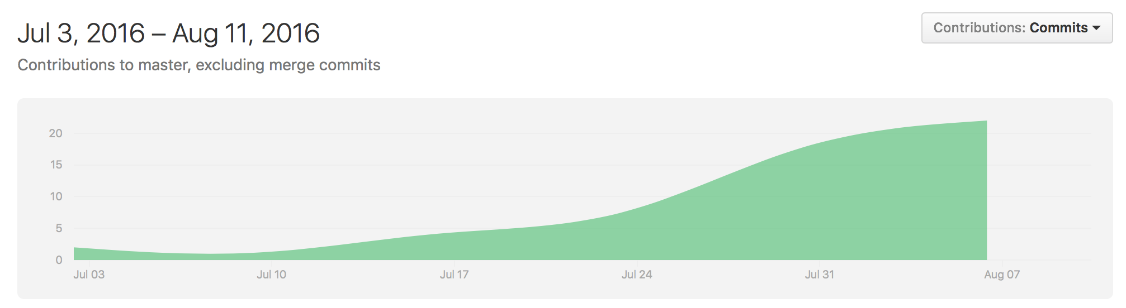

The commits curve from July 3 to Aug 11. It shows our work distributed evenly during the 30-day period. All our team members involved heavily in the development of LIVA.