**Face/Palm Measuring Tool**

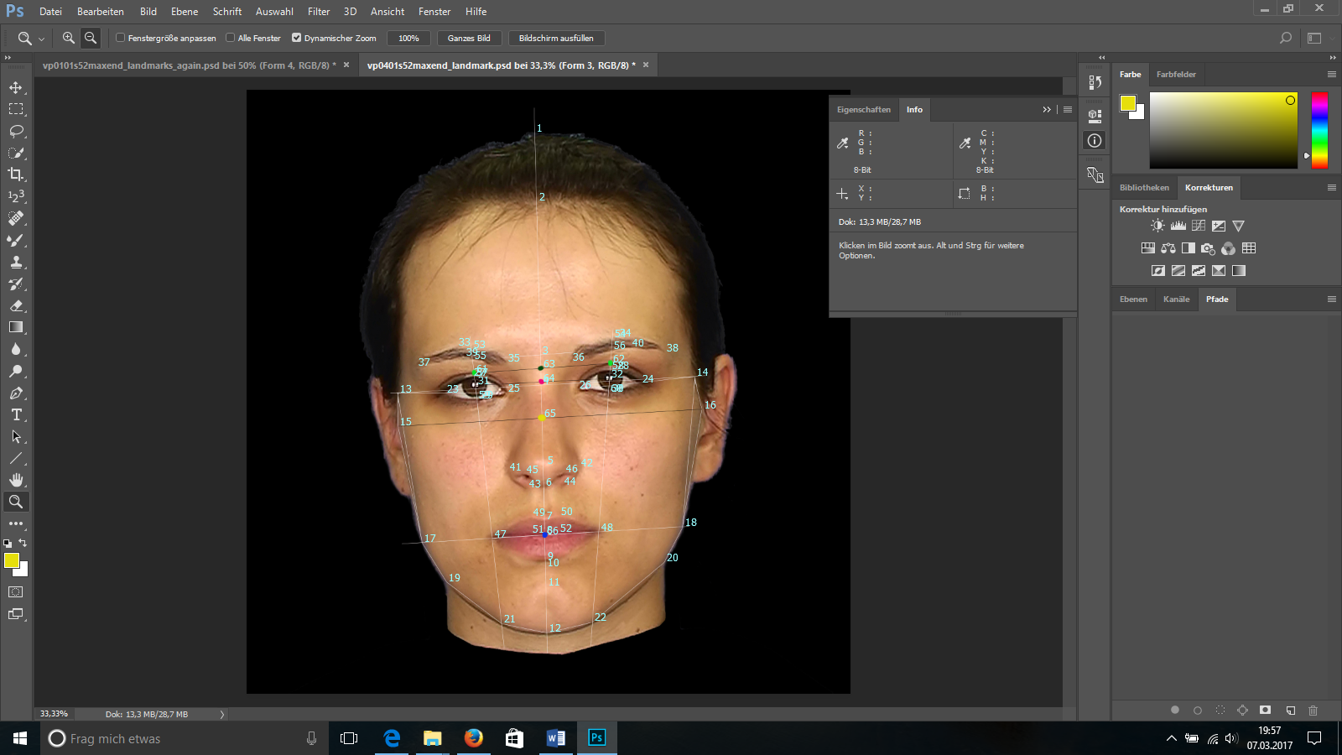

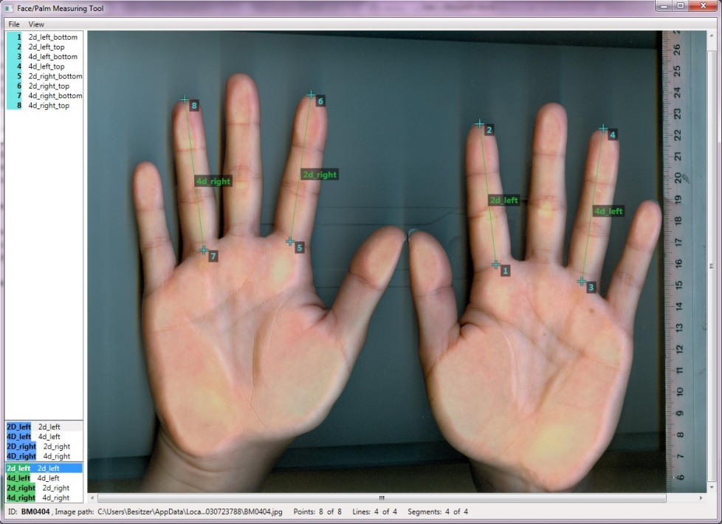

**Manual**

Please cite this software just as you would cite a regular paper:

Köllner, M. G., Schmiedl, H., Waßer, J., & Schmiedl, S. (2017). Face/Palm Measuring Tool: A stand-alone software for standardized hand and face morphometry [Software and manual]. Erlangen. Retrieved from <http://www.psych2.phil.uni-erlangen.de/~oschult/humanlab/resources/resources_Facepalm.htm>

**Table of contents**

XX

**Download**

* Development version: <https://github.com/swsch/FacePalm/>
* Stable version: <http://www.psych2.phil.uni-erlangen.de/~oschult/humanlab/resources/resources_Facepalm.htm>

**License**

Open source software (MIT license)

**System requirements/Installation**

The only system requirements are Win 7 or later with .NET 4.5. No installation or possession of administrative rights is required.

**Working with Face/Palm**

You can access the most recent version of this software and instructions on how to use (GUI elements, shortcuts) it via <https://github.com/swsch/FacePalm/>

* Instructions on how to prepare a definitions file: <https://github.com/swsch/FacePalm/wiki/HowTo_Definitions>
* Instructions on how to conduct your measurements: <https://github.com/swsch/FacePalm/wiki/HowTo_Measure>

**Morphometry of photos and scans**

We suppose that if you have downloaded this software, you already are familiar with the markers you are investigating and thus omit the theoretical background regarding morphometric research and organizational hormone effects here.

If you are interested in the various indirect ways of assessing 2D:4D, we recommend the overview by Kemper and Schwerdtfeger (2009). Also, some methods to assess facial width-to-height-ratio (fWHR) were used by Kramer, Jones, and Ward (2012). The genuine benefit of the Face/Palm Measuring Tool is its all-in-one solution, providing you with pre-programmed measurement points taken from facial-masculinity (Apicella et al., 2008; Penton-Voak et al., 2001; Pound, Penton-Voak, & Surridge, 2009), different fWHR approximations (see Janson et al., 2017, for a study reporting intercorrelations of brow, nasion, and lid approximations), or classical anthropometric approaches (Farkas…).

If you are involved or interested in getting involved in implicit motive research, the chapter by Köllner, Janson, and Bleck (submitted) is recommended as an overview regarding the intersection of motive and marker research.

**Other applications**

We developed the software to avoid relying on proprietary programs that are not specifically designed and fine-tuned for 2D-morphometry. Thus, we wanted to provide researchers with a free, easy-to-use solution that comes with the most important measurement points regarding hands and faces. However, as the basic structure of the program allows defining new measurement points and any photo or picture can be loaded in the GUI, any kind of 2D-measurement can be carried out with it. So feel free to use the software for other purposes and to experiment with new kinds of pictures.

**When taking photos…**

there are some avoidable obstacles to valid 2D-measurement of faces.

* Glasses: Ask your participants to remove their glasses, as they may cover important measurement points or add unwanted reflections to the pictures.
* Hair: Have some hairclips ready for your participants. If facial features or boundaries are covered by hair, your research assistants are later forced to speculate regarding relevant points or measurement may even be impossible.
* Sweat, make-up, piercings…: If feasible, ask your participants to refrain from using make-up prior to showing up at the lab and to remove piercings, earrings, and similar material for the photos. You could also offer your participants single-use towels to reduce reflections caused by sweating (just as you have germicide and a towel ready to clean the scanner after each measurement in the case of 2D:4D).
* Unstandardized photos: Build a standardized array before taking pictures, for example use a Tripod for your camera and mark its position with markings on the floor. The same goes for the chair you have your participants seated in. This way you ensure that the distance between camera and face does not vary extremely between different participants. Ideally, even use a chin rest (but ensure that participants do not press their chin too much on it, as this may blur lower facial boundaries).
* Background elements or fluctuating light: Ideally, use a blank blue screen as background and a room that does not depend too much on fluctuating available light. This may change illumination of the photos or even cause uneven illumination if one side of the face is turned towards the window.
* Issues with the camera: Use the same camera and the same resolution (HD, as high as possible) for all participants. Take actual photos and do not reuse material you have obtained from screenshots out of video recordings.

**Tips for documentation and data handling**

If you have taken scans or photos, please…

* always keep at least one backup of your material that is stored on at least two computers in different locations. This copy should never be used or modified by you or your research assistants.
* Save all measurements as sessions and additionally as actual pictures. This way, you make your measurements transparent and replicable.
* never treat the facial distances you obtain as absolute distances. What the program yields are distances in pixels, which in turn are dependent on the camera’s resolution and a given participant’s distance from the camera. Thus, they are not comparable to other studies with other parameters. To circumvent these drawbacks, you can for example use ratio scores (e.g., fWHR), as they do not depend on absolute distances.
* please do a *z*-standardization **within-studies** prior to if you comparing or aggregating different studies and always enter study as a separate variable you can control for later.
* always put a ruler on the scanner before starting to scan hands in the case of 2D:4D. This yields the necessary information to infer absolute distances at least for the “palm”-part of your measurements.

**Other resources**

* The free drawings accompanying the software were provided by Franziska Jägel, BSc
* Measurement guides from prior research is available from the first author upon request, including:
  + A guide for direct anthropometric measurements on living participants including fWHR, cheekbone prominence and other facial features
  + Measurement instructions for 2D:4D using ImageJ
  + Measurement instructions for measuring facial features using Photoshop – though we recommend using Face/Palm, as it is freely accessible to the research community and developed specifically for the needs of the morphometry researcher

**Contact information**

If you have

* ideas suggestions, or remarks, for us,
* written a new definitions file that may be of use to other researchers and want to share it via our website,
* spotted an error or the necessity for corrections,
* other requests of any kind,

please write an email to [martin.koellner@fau.de](mailto:martin.koellner@fau.de)

Dr. Martin G. Köllner

Chair for Experimental Psychology, Motivation, and Affective Neuroscience

Department of Psychology and Sport Sciences

Friedrich-Alexander University Erlangen-Nuremberg

Nägelsbachstraße 49b

91052 Erlangen

Germany

**References**

Apicella, C. L., Dreber, A., Campbell, B., Gray, P. B., Hoffman, M., & Little, A. C. (2008). Testosterone and financial risk preferences. *Evolution and Human Behavior, 29*, 384-390. doi:10.1016/j.evolhumbehav.2008.07.001

Janson, K. T., Bleck, K., Fenkl, J., Riegl, L. T., Jägel, F., & Köllner, M. G. (2017). Inhibited power motivation is associated with the facial width-to-height ratio in females. *Adaptive Human Behavior and Physiology*. doi:10.1007/s40750-017-0075-y

Kemper, C. J., & Schwerdtfeger, A. (2009). Comparing indirect methods of digit ratio (2D:4D) measurement. *American Journal of Human Biology, 21*(2), 188-191. doi:10.1002/ajhb.20843

Köllner, M. G., Janson, K. T., & Bleck, K. (submitted). The sociobiological development of implicit motives: Organizational hormone effects as a biological basis preceding socialization experiences. In O. C. Schultheiss & P. H. Mehta (Eds.), *International Handbook of Social Neuroendocrinology*: Routledge.

Kramer, R. S. S., Jones, A. L., & Ward, R. (2012). A lack of sexual dimorphism in width-to-height ratio in white European faces using 2D photographs, 3D scans, and anthropometry. *PLoS ONE, 7*(8), e42705. doi:10.1371/journal.pone.0042705

Penton-Voak, I. S., Jones, B. C., Little, A. C., Baker, S., Tiddeman, B., Burt, D. M., & Perrett, D. I. (2001). Symmetry, sexual dimorphism in facial proportions and male facial attractiveness. *Proceedings of the Royal Society B: Biological Sciences, 268*(1476), 1617-1623. doi:10.1098/rspb.2001.1703

Pound, N., Penton-Voak, I. S., & Surridge, A. K. (2009). Testosterone responses to competition in men are related to facial masculinity. *Proc Biol Sci, 276*(1654), 153-159. doi:10.1098/rspb.2008.0990

Last updated: XX.XX.2017

To-do:

* Fertig vermessenes Gesicht mit Publikationseinwilligung auf Titelblatt
* 2D4D-Bild mit aktuellem Definitions-File und bei Bild mit Publikationseinwilligung erstellen (Titelblatt)
* Datum rein
* Zitationen für diverse Statements ergänzen
* Inhaltsverzeichnis einbauen