This content explains the adds-on to the Tiger code (status: 2022/02) which are implemented in order to simulate the thermal process during the drilling of the RN-15/IDDP-2 well.

# Physical model aspects

## General description of the thermal model

The thermal model is two-dimensional and cylindrical. The wellbore completion (casings, cement, formation) are two dimensional. Depending on how the lateral heat transfer between the borehole fluid and contacting solid surface (e.g., drill pipe, casing, formation, etc.) is simulated within this tool, the borehole fluid region can be 1-D or 2-D (see section 2.

*Note: the fluid flow is considered incompressible, velocity is solely determined by Q/A, where Q is volumetric flow at well-head, A is the cross-sectional area of the borehole.*

Figure 1 is a sketch for a wellbore layout in a more general case (i.e., some regions are not necessarily exiting). The thermal transport equations are:

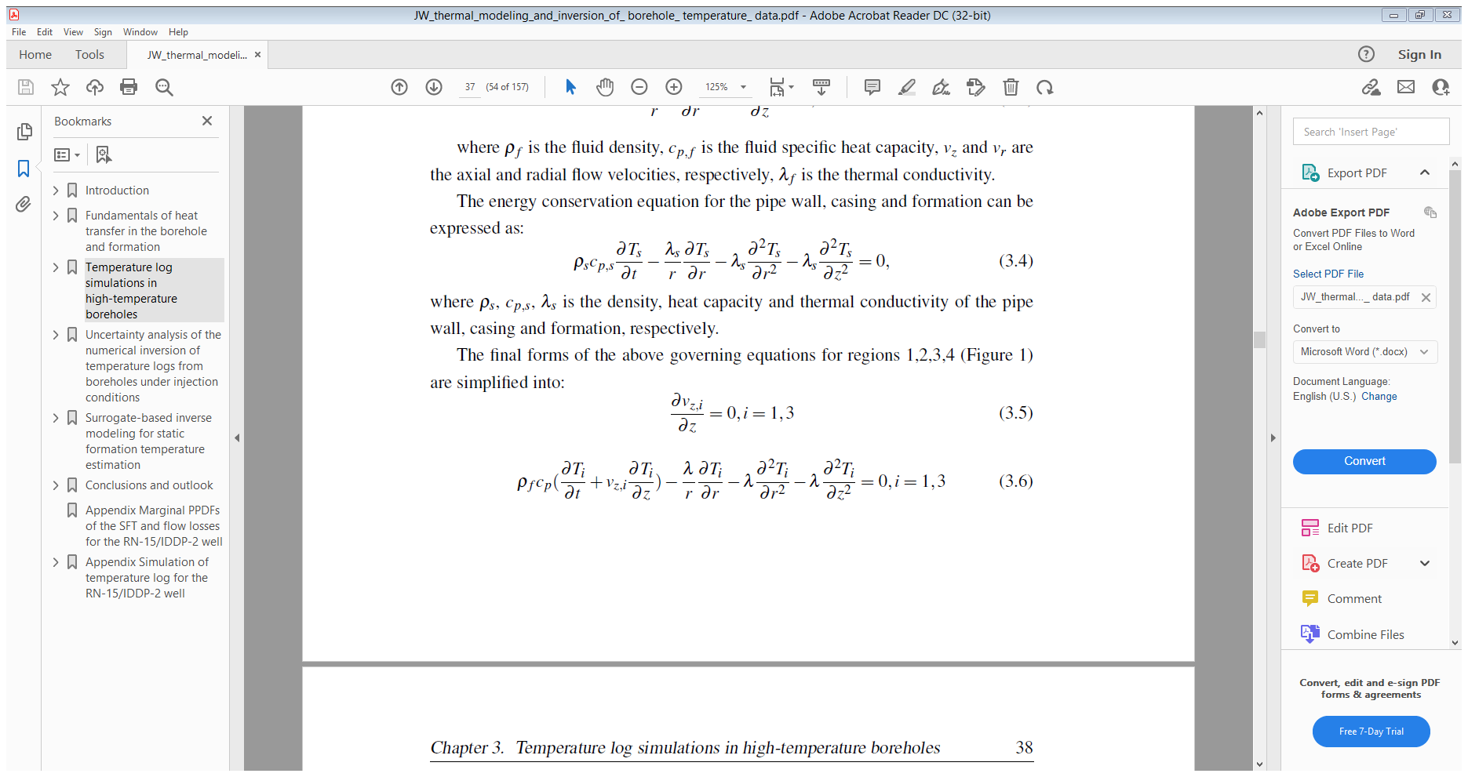 (1)

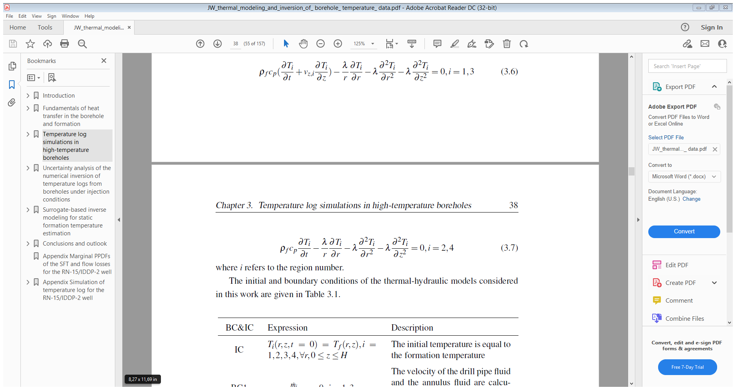 (2)



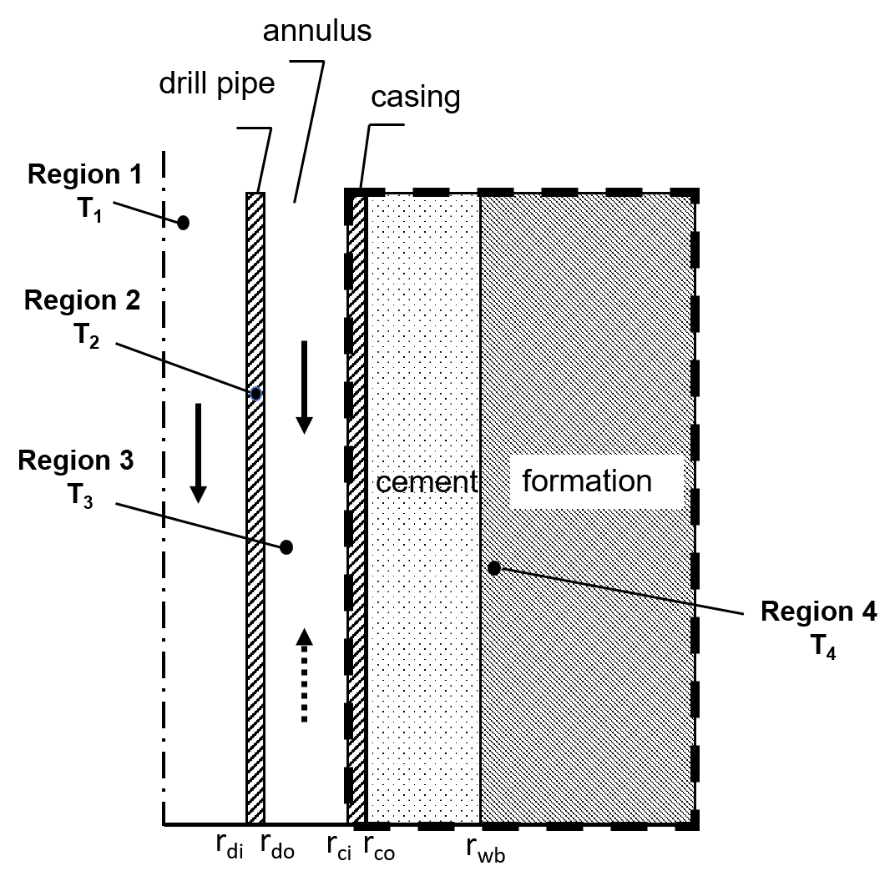

Figure 1. Schematic of the heat exchange model between the wellbore and the formation. Governing equations are solved in four regions: the fluid inside the drill pipe (Region 1), the drill pipe wall (Region 2), the annulus (Region 3), casing-cement-formation (Region 4). The solid arrow pointing downwards and the dashed arrow pointing upwards in the annulus refer to co-flow and counter-flow scenarios in the wellbore, respectively.

Boundary and initial conditions are

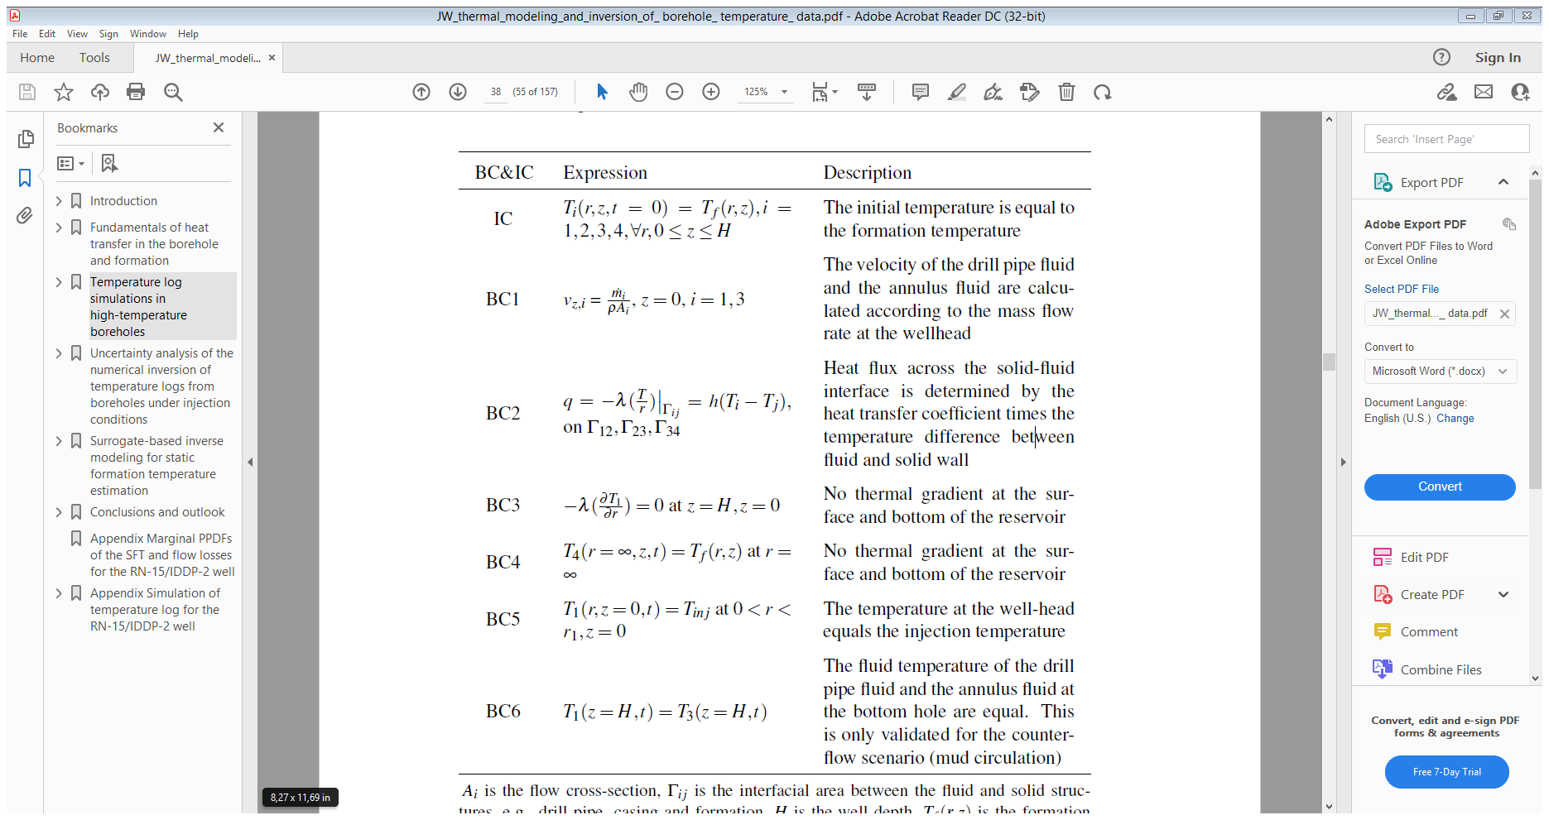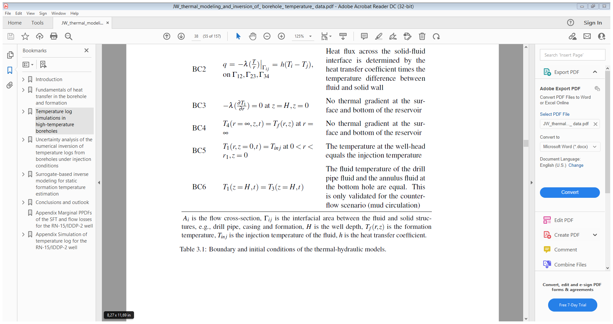

* 1. Explanation of the heat transfer coefficient

Hereafter, the BC2 in Table 1, which considers the lateral heat transfer between the fluid and its contacting wall, is explained. The lateral heat flux is calculated according to Newton’s law of cooling:

q=h·(Ts-Tf); W/m2 (3)

h: heat transfer coefficient (W/m2/K); Tf: temperature of the fluid; Ts: temperature of the contacting solid structure.

In Wang et.al 2019 (<https://doi.org/10.1186/s40517-019-0149-0>), h is calculated according to the flow condition in the well.

### Flowing condition (i.e. forced convection)

Under forced convection, the heat transfer coefficient is defined as:

(4)

where Nu is the Nusselt number, d is the hydraulic diameter of the drill pipe and annulus.

In laminar regime:

Nu=4.364, for Re<= 2300 (5)

For highly turbulent flow:

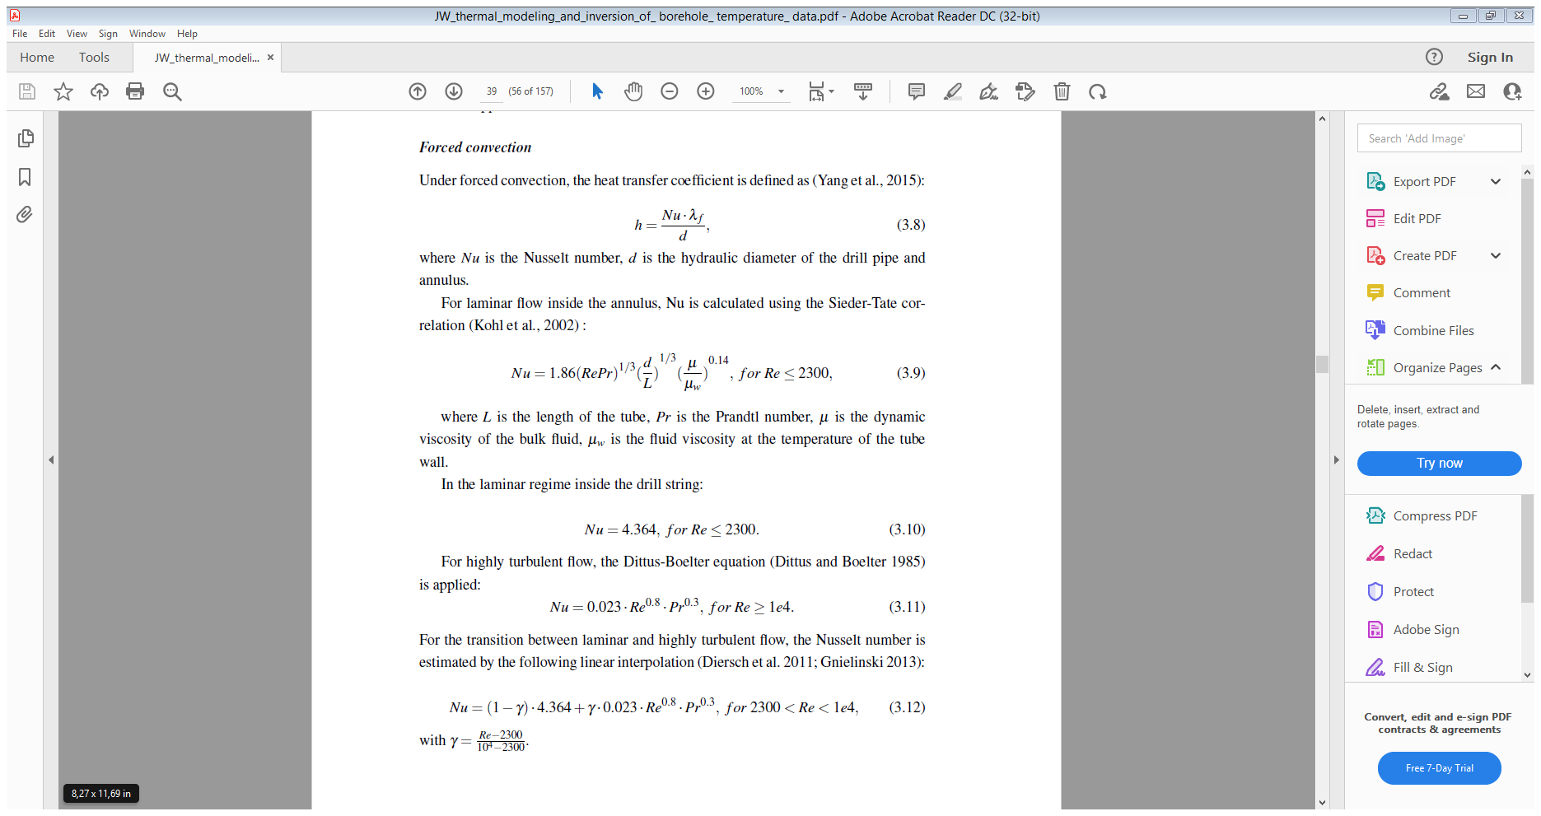

(6)

For the transition between laminar and highly turbulent flow, Nu is linearly interpolated:



(7)

*Note: the heat transfer coefficient h takes both the conduction and convection into account.*

### Shut-in condition

Under shut-in condition, flow injection into the well stops and the well is filled with static fluid column. In some cases, free convection can occur. The justification of free convection can be done using following equation (Diment and Urban [1983](https://geothermal-energy-journal.springeropen.com/articles/10.1186/s40517-019-0149-0#ref-CR16)):

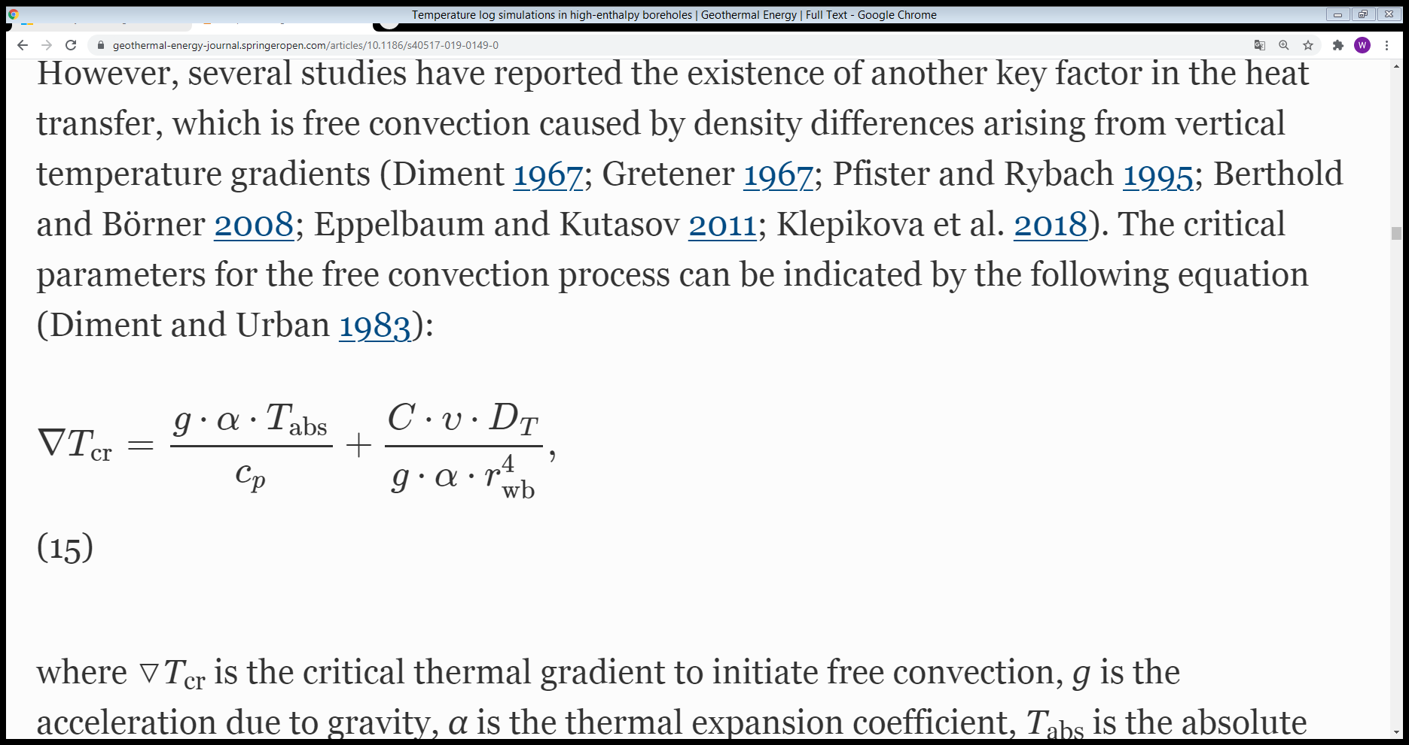 (8)

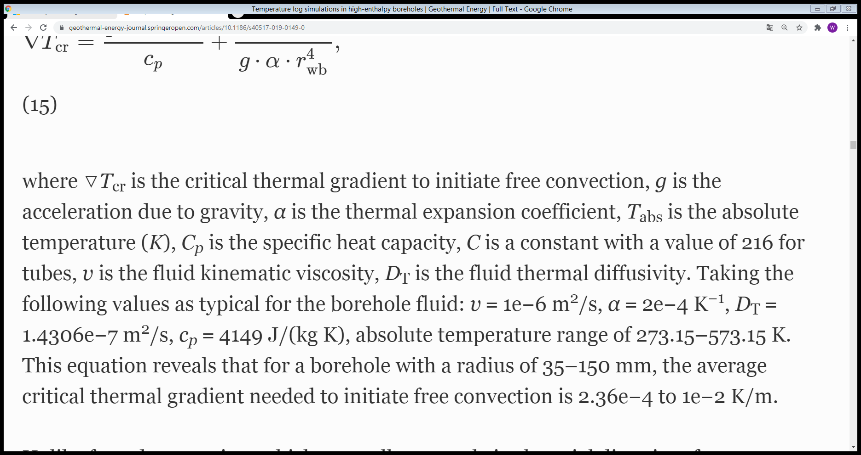

Therefore, the lateral heat transfer between the borehole fluid and contacting solid surface could depend on both free convection and conduction, which means that h= hc+hfree, where h is the overall heat transfer coefficient, hc is the heat transfer coefficient due to fluid conduction, hfree due to free convection.

The following equation is used to calculate hc :

(9)

where r_wb is the borehole radius.

The parameterization for hfree is missing in literature. In Wang et.al 2019, hfree is defined as a factor times hc to study the impact of free convection on the development of borehole temperature during shut-in.

# Implementation of lateral heat exchange in Tiger/Moose Code

Eq.(1) and (2) are already existing when I started working with Tiger. The adds-on from my side is mainly to implement the lateral heat transfer between the well and surrounding solid structures. More specifically, the heat exchange of borehole fluid with its contacting wall. Depending on how the dimension of the borehole (note: borehole refers to only the fluid-flowing part) is simulated (i.e., 1-D or 2-D), two different approaches to simulate lateral heat exchange can be applied and are introduced in the following.

## Multi-app approach

The multi-app concept in Moose can be found from <https://mooseframework.inl.gov/syntax/MultiApps/index.html> (status 2022/02/15). This method is suitable for scenarios that consider 1-D borehole fluid and 2-D or 3-D borehole-surrounding solid structures (e.g., wellbore completion, formation). A paper for referencing this approach is recommended: <https://doi.org/10.1016/j.nucengdes.2016.08.018>

One example is sketched in Figure 2. The borehole fluid (1-D line) is modeled as sub-app and 2-D formation as main-app. The general idea is to have the two apps exchange their solved temperatures and material properties to accomplish the loosely coupling between the borehole and the solid structure at their contacting surface. The technical details are sketched in Figure. For the 2-D structure, the lateral heat (q, W/m3) is simulated as a boundary flux condition where the q is computed according to Eq.(3). For the 1-D borehole fluid, the lateral heat is a volumetric source q’ (W/m2). The relationship between q’ and q is:

q’ = q* . Here, P_bh and A_bh denote borehole perimeter (see also wetted perimeter) and cross-sectional area, respectively. For a pipe with circular cross section, equals , where r_bh is the radius of the borehole.

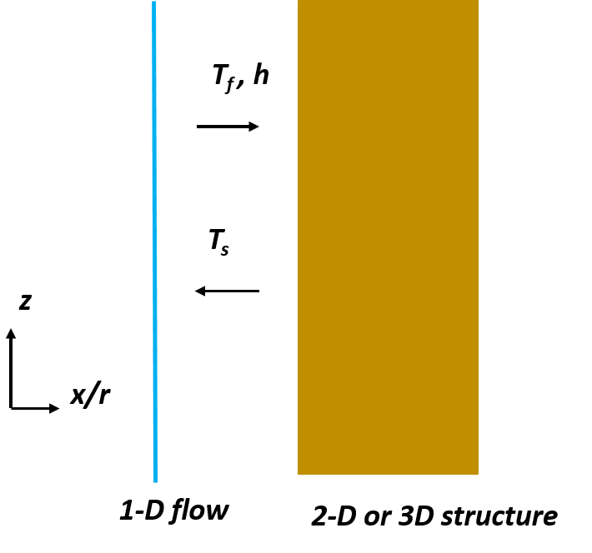

Figure 2: The schematic for the multi-app concept. The 1-D flow (sub-app) and 2-D or 3-D structure (main-app) exchange their state variable and material properties, e.g. temperatures (Tf, Ts) and heat transfer coefficient h. Note: the sub-app is set up in Cartesian coordinate system (x=0), the main-app in cylindrical coordinate system (r starts at r=r_bh).

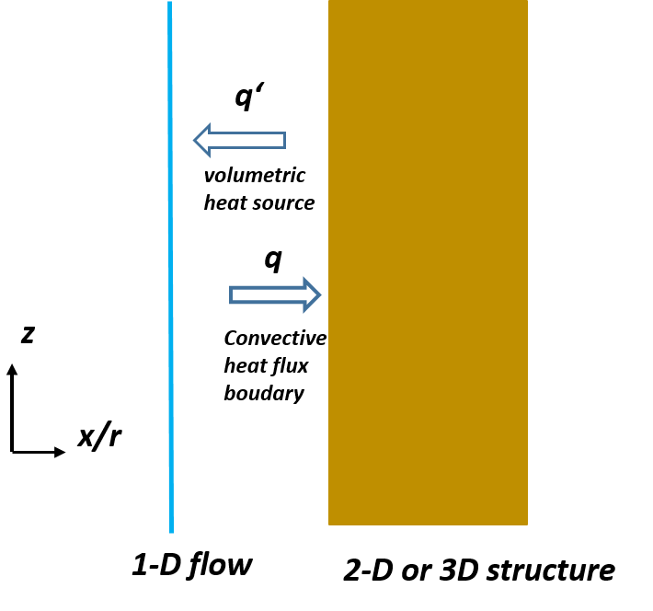

Figure 3: The schematic of the heat exchange model between 1-D borehole flow and 2-D/3-D surrounding solid.

The adds-on to the Tiger code due to the multi-app concept are in the following aspects:

1. Thermal material properties: for calculating the heat transfer coefficient, h
2. Kernel: volumetric heat source couples two variables: Tf and Ts and material property h)
3. BC: Coupled convective heat flux BC (couples two variables: Tf and Ts and material property h)

A paper that can be referenced

## Interface-kernel approach

The application of interface kernel in Moose requires the construction of a physical surface, therefore, this approach requires the borehole and the surrounding solid structures to have the same dimension. The adds-on to the Tiger related to the approach is an interface kernel that calculates the heat exchange according to Eq.(4). It couples the temperature of the borehole fluid and the temperature of the contacting wall at the interface of the fluid-solid. Unlike the former approach, the heat transfer model is solved within one moose app. Note that, in the example given in Figure 4, although the borehole is two-dimensional, but is modeled essentially as one-dimensional. This can be “tricked” by assigning very high thermal conductivity in the radial direction within the borehole.

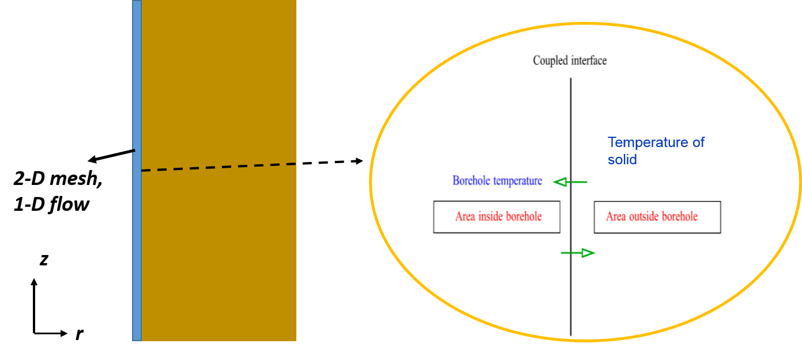

Figure 4. Sketch for the interface-kernel approach. The borehole and surrounding solid structure have the same dimension (cylindrical coordinate system). The borehole has a mesh in 2-D, however, the flow and the heat transport within the borehole fluid are simulated as 1-D.

Add-on to the Tiger code:

InterfaceKernel: heat flux at the interface of fluid and solid; couples both the variable and its neighboring variable

The following is an example for the [InterfaceKernels] block:

*[InterfaceKernels]*

*[./interface_1]*

*type = ConvectiveHeatFluxInterface*

*boundary = master1_interface ## the created inter-surface*

*variable = temperature_f*

*neighbor_var = temperature_s*

*[../]*

*[]*

## Pros and cons of two approaches

Multi-app approach

+ Easier mesh for the borehole

+ flexible due to the multi-app concept

* Coupling between the wellbore app and reservoir app
* Easy to manage when there are the multiple boreholes (e.g. heat pipes system)

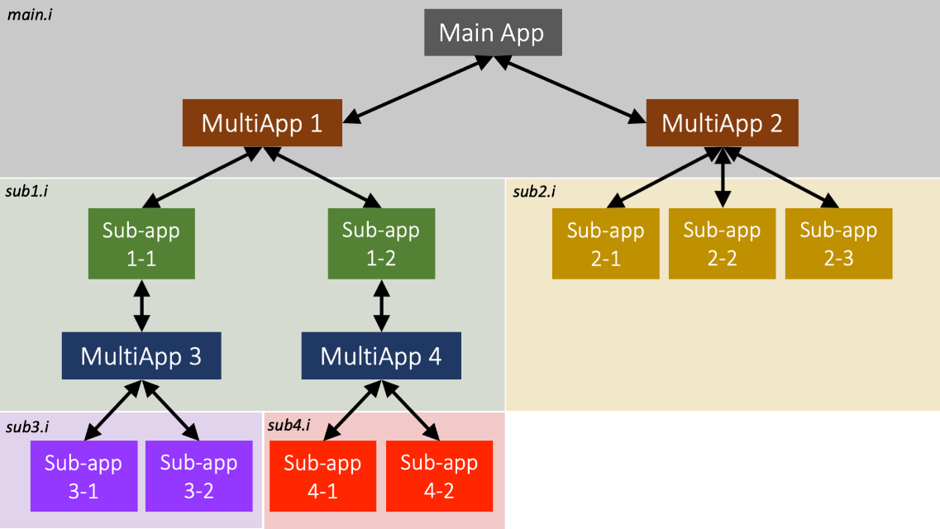

* Greater work with multiple input files:

Main_app.i sub_app1.i sub_app2.i … Each input requires the specification of the [Transfers] block (see the following as an example)

[Transfers]

[./to_sub_1]

type = MultiAppNearestNodeTransfer

direction = to_multiapp

multi_app = sub

source_variable = temperature_s

source_boundary = 'left'

variable = from_master

[../]

[./from_sub]

type = MultiAppNearestNodeTransfer

direction = from_multiapp

multi_app = sub

source_variable = temperature_f

variable = from_sub

target_boundary = 'left'

[../]

[./layered_transfer_from_sub_app]

type = MultiAppUserObjectTransfer

direction = from_multiapp

user_object = sub_app_uo

variable = from_sub_app_var

multi_app = sub

displaced_source_mesh = false

[../]

[]

* Slower computation speed

Loosely coupling requires the Picard iteration between main- and sub-apps which can drag down the speed.

Interface-kernel approach

+ faster computational speed

- more complex borehole geometry (diameter and change of diameter)

# Implementation of moving hydraulic point source

The moving hydraulic point source is used to account for the change of the well depth during drilling. In details, the point source is implemented as dirac mass source (> 0). The position of the source is the position of well bottom which is a function of time according to the drilling schedule. The magnitude of the mass source equals the injected flow at the well head (Figure 5). As such, the temperature of the un-drilled depth will remain undisturbed. The add-on to Tiger as a result of above is a new type of Dirac kernel.

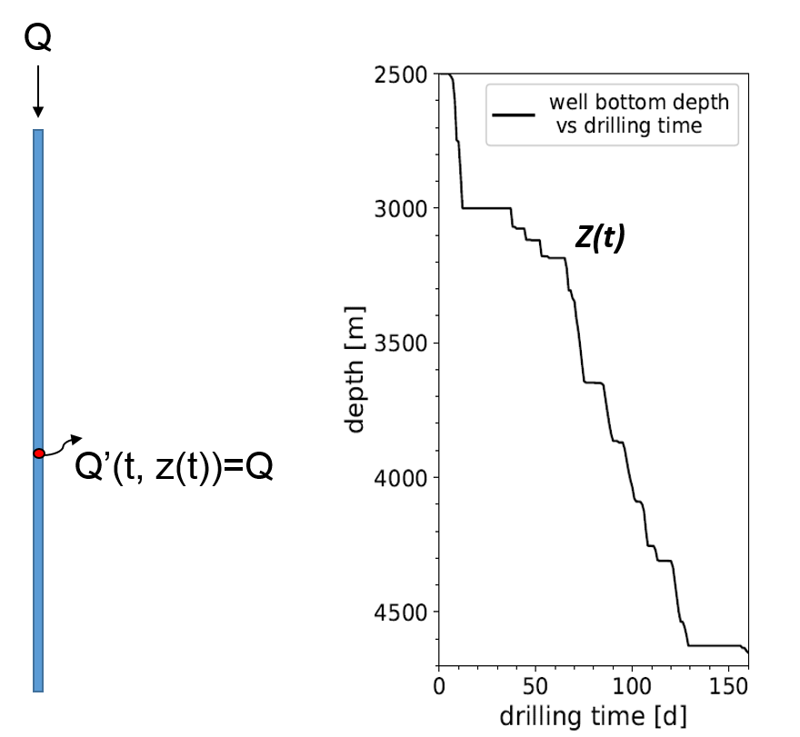

Figure 5. Sketch for the moving mass point source