TASK 3
Communication Delay and Complexity Analysis
Focused analysis of the Task 2 MPI message types
This revision keeps only the delay model, the message-by-message derivations, a compact summary, and the direct answers required by Task 3. It uses symbols rather than substituting a fixed number of charging nodes or base stations.

Notation
Symbol | Meaning
N | Number of charging nodes
S | Number of base stations
H | Number of heavy nodes in one round, where 0 <= H <= N
A | Number of active alerts in one round, where 0 <= A <= H
E | Undirected logical-mesh edges: E = R(C-1) + C(R-1)
L_x | Payload bytes for message type x
alpha | Fixed latency paid when starting one message
beta | Serialization time per byte: beta = 8/B

Whenever N/S, H/S or A/S is used, charging nodes and alerts are assumed to be distributed evenly across the base stations.

Delay equations
For a payload of L bytes, transmission time is represented by a fixed message-startup cost plus the time needed to place the payload on the link:
t(L) = alpha + beta L, beta = 8/B
For the required 1 Gbps link, B = 10^9 bit/s and beta = 8 x 10^-9 seconds per byte.

Separate messages
If the same endpoint must handle q separate messages, it may pay the startup cost q times and transmit q payloads:
T_individual(q,L) approx q(alpha + beta L) = Theta(q alpha + q beta L)

One batch containing q records
If q records are combined into one message, the startup cost is paid once while the payload term still contains q records:
T_batch(q,L) approx alpha + q beta L = Theta(alpha + q beta L)
Interpretation: MPI_Isend, MPI_Irecv and MPI_Waitall can overlap communication, so these are conservative endpoint models rather than exact measured times. In the analysis below, total complexity counts all records in the system, while phase complexity describes the busiest endpoint or the sequential critical path.

Message-by-message communication analysis

CONFIG_BCAST
Role. Base 0 distributes one configuration record to all P = N + S MPI ranks at startup.
Complexity. Total work is Theta(N+S); phase complexity is Theta(log(N+S)) for a tree broadcast.
How it is obtained. A broadcast tree sends approximately one copy for each receiving rank, giving Theta(N+S) total transmissions. The number of receivers can roughly double at each stage, so only log2(N+S) sequential stages are needed.
T_cfg approx ceil(log2(N+S)) [alpha + beta L_cfg]
Scaling result. Increasing either N or S increases delay logarithmically. More base stations do not reduce this delay.

STATUS_REPORT
Role. Every charging node sends one status report to its assigned base once per round.
Complexity. Total work is Theta(N); balanced phase complexity is Theta(N/S).
How it is obtained. There are N nodes and each sends once, so the system has N reports. With balanced ownership, the N reports are divided among S bases, leaving about N/S reports at the busiest base.
T_status approx (N/S) [alpha + beta L_status]
Scaling result. For fixed S, delay grows linearly with N. Increasing S reduces the regional fan-in approximately in proportion to 1/S.

QUERY
Role. Every charging node sends one query-intent record to each valid logical neighbour.
Complexity. Total work is Theta(N); per-node phase complexity is Theta(1).
How it is obtained. A 2-D non-periodic mesh has E = R(C-1) + C(R-1) = Theta(N) edges, and each edge carries two directed query records. However, one node has at most four neighbours, so its own work is bounded by a constant.
T_query,node <= 4 [alpha + beta L_query] = Theta(1)
Scaling result. Increasing N increases total query traffic linearly but does not increase ideal per-node delay. Increasing S gives no direct reduction and may create more cross-host boundary traffic.

NEIGHBOUR_REPLY
Role. A neighbour returns one reply for every active query received from a heavy node.
Complexity. Total work is Theta(H), with worst case Theta(N); per-heavy-node phase complexity is Theta(1).
How it is obtained. Each of the H heavy nodes can query at most four neighbours, so at most 4H replies are created. Because four is constant, 4H simplifies to Theta(H). When every node is heavy, H = N and the worst case is Theta(N).
T_reply,node <= 4 [alpha + beta L_reply] = Theta(1)
Scaling result. Increasing N raises worst-case total reply traffic linearly, but one requester still waits for at most four replies. Increasing S does not reduce neighbour reply delay.

ALERT_DECISION
Role. Every heavy node sends exactly one positive or negative alert decision to its assigned base.
Complexity. Total work is Theta(H); balanced phase complexity is Theta(H/S), with worst case Theta(N/S).
How it is obtained. There are H heavy nodes and each sends one decision. Balanced across S bases, each base receives about H/S decisions. Since H can be as large as N, the worst case becomes N/S.
T_decision approx (H/S) [alpha + beta L_decision]
Scaling result. Delay grows with the number of heavy nodes. Increasing S reduces the fan-in if heavy nodes are distributed evenly.

BASE_ALERT_COUNT
Role. Every base sends its alert count to every other base before the variable-size alert batches are exchanged.
Complexity. Total work is Theta(S^2); per-base phase complexity is Theta(S).
How it is obtained. Each of the S bases communicates with S-1 peers, creating S(S-1) messages. Dropping lower-order terms gives Theta(S^2) total work, while one base handles S-1 = Theta(S) peer messages.
T_count approx (S-1) [alpha + beta L_count]
Scaling result. Changing N has no direct effect when S is fixed. Increasing S increases this delay rather than reducing it.

ALERT_BATCH
Role. Each base sends its active-alert records to all other bases.
Complexity. Total record work is Theta(AS); balanced per-base phase complexity is Theta(A+S).
How it is obtained. Each of the A alerts is copied to S-1 other bases, producing A(S-1) = Theta(AS) transmitted records. With balanced ownership, each base sends or receives about A records in total and starts communication with S-1 peers, giving Theta(A+S).
T_alert approx (S-1)alpha + beta L_alert [A(S-1)/S] = Theta(S+A)
Scaling result. If A grows in proportion to N, delay grows linearly with N for fixed S. More bases do not reliably reduce delay because replication and peer-startup costs increase.

CANDIDATE_BATCH
Role. For each active alert, every non-owner base returns one regional candidate to the alert-owning base.
Complexity. Total record work is Theta(AS); balanced per-base phase complexity is Theta(A+S).
How it is obtained. One alert needs a candidate from each of the other S-1 bases, so A alerts create A(S-1) = Theta(AS) candidate records. Balanced batching again leaves about A records and S peer startups at each base.
T_candidate approx (S-1)alpha + beta L_candidate [A(S-1)/S] = Theta(S+A)
Scaling result. If A is proportional to N, delay grows linearly with N for fixed S. Increasing S adds candidate contributors, so it does not generally reduce delay.

REDIRECT
Role. The alert-owning base sends one redirect result to each node that produced an active alert.
Complexity. Total work is Theta(A); balanced phase complexity is Theta(A/S), with worst case Theta(N/S).
How it is obtained. There is at most one redirect for each of the A alerts, so the system sends A messages. If alerts are balanced among S bases, one base sends about A/S redirects. Since A can reach N, the worst case is N/S.
T_redirect approx (A/S) [alpha + beta L_redirect]
Scaling result. Delay grows with the active-alert count. Increasing S reduces base fan-out when alerts are balanced.

ROUND_SYNC
Role. All P = N + S ranks call one MPI_Barrier at the end of the round.
Complexity. Typical total control work is Theta(N+S); phase complexity is Theta(log(N+S)) for a tree barrier.
How it is obtained. A scalable barrier combines and releases ranks through a tree. Every rank contributes control work, but the tree has only about log2(N+S) sequential levels.
T_sync approx alpha_sync ceil(log2(N+S))
Scaling result. Increasing N or S slightly increases barrier delay. Adding bases does not reduce it.

Overall communication analysis
The communication phases occur in sequence, so their phase completion times are added. Within one phase, non-blocking operations may overlap; therefore, the phase term represents the busiest endpoint or the sequential critical path rather than the sum of every message in the system.
T_round = T_status + T_query + T_reply + T_decision + T_count + T_alert + T_candidate + T_redirect + T_sync
Substituting the per-type results above and removing constant or repeated terms gives:
T_round = Theta(N/S + H/S + A/S + A + S + log(N+S))
Term | Simple interpretation
N/S | Status reports handled by the busiest base
H/S | Alert decisions handled by the busiest base
A/S | Redirect messages sent by the busiest base
A | Alert and candidate records processed at each base
S | Base-to-base peer communication startup
log(N+S) | Tree-based round barrier depth

QUERY and NEIGHBOUR_REPLY are Theta(1) on the critical endpoint because each node has at most four neighbours; these constant terms therefore disappear.

Expressing alert frequency as a fraction of N
Let H = rho_H N and A = rho_A N denote the heavy-node and active-alert fractions. Then:
T_round = Theta((1 + rho_H + rho_A)N/S + rho_A N + S + log(N+S))
More bases reduce the N/S terms but increase S; the global rho_A N alert term remains.

Worst case
H = A = N => T_round = Theta(N/S + N + S + log(N+S))
The expanded form is preferred because it exposes the N/S balancing benefit and S coordination cost.

Total communication work
W_round = Theta(N + H + A + S^2 + AS)
Worst case H = A = N => W_round = Theta(NS + S^2 + N)
T_round is elapsed bottleneck delay, whereas W_round is system-wide work; they differ because endpoints can communicate concurrently.

Across K rounds
T_total = T_cfg + K T_round, T_cfg = Theta(log(N+S))
CONFIG_BCAST is paid once at startup, whereas the other message types and ROUND_SYNC repeat in every round.

Baseline evaluation of Questions (a) and (b)
Numerical assumptions: Task 2 provides B = 1 Gbps and the payload sizes. The plots additionally assume alpha = alpha_sync = 1 microsecond so that an illustrative end-to-end value can be calculated. They use the worst-case workload H = A = N, balanced ownership, no queueing or contention, S = 4 for the charging-node sweep, and N = 64 for the base-station sweep. The assumed alpha is not a value supplied by the assessment and should later be replaced by a measured value.
At 1 Gbps: beta = 0.008 microseconds/byte
The table gives the predicted bottleneck phase delay at the Task 2 baseline N = 64 and S = 4, followed by the direct answers to parts (a) and (b).
Baseline result. The illustrative steady-state path is 103.072 microseconds per round, excluding the one-time 10.584-microsecond CONFIG_BCAST. This is a model value, not a measured runtime.
Message type | Baseline delay (us) | a) As N increases | b) As S increases
CONFIG_BCAST | 10.584 | Grows slowly as Theta(log(N+S)). | No; tree depth may rise slightly.
STATUS_REPORT | 20.096 | Grows as Theta(N/S) at the busiest base. | Yes; balanced fan-in falls approximately as 1/S.
QUERY | 4.512 | Per node stays Theta(1); total records are Theta(N). | No; mesh degree is unchanged.
NEIGHBOUR_REPLY | 4.768 | Per heavy node stays Theta(1); worst total is Theta(N). | No direct reduction.
ALERT_DECISION | 20.096 | Worst case grows as Theta(N/S). | Yes; balanced fan-in falls approximately as 1/S.
BASE_ALERT_COUNT | 3.096 | Unchanged when S is fixed. | No; it grows as Theta(S) per base.
ALERT_BATCH | 15.288 | With A = rho_A N, grows as Theta(N) per base. | No; more peers add startup and replication work.
CANDIDATE_BATCH | 9.144 | With A = rho_A N, grows as Theta(N) per base. | No; more bases contribute candidates.
REDIRECT | 19.072 | Worst case grows as Theta(N/S). | Yes; balanced fan-out falls approximately as 1/S.
ROUND_SYNC | 7.000 | Grows slowly as Theta(log(N+S)). | No; more ranks slightly increase barrier depth.

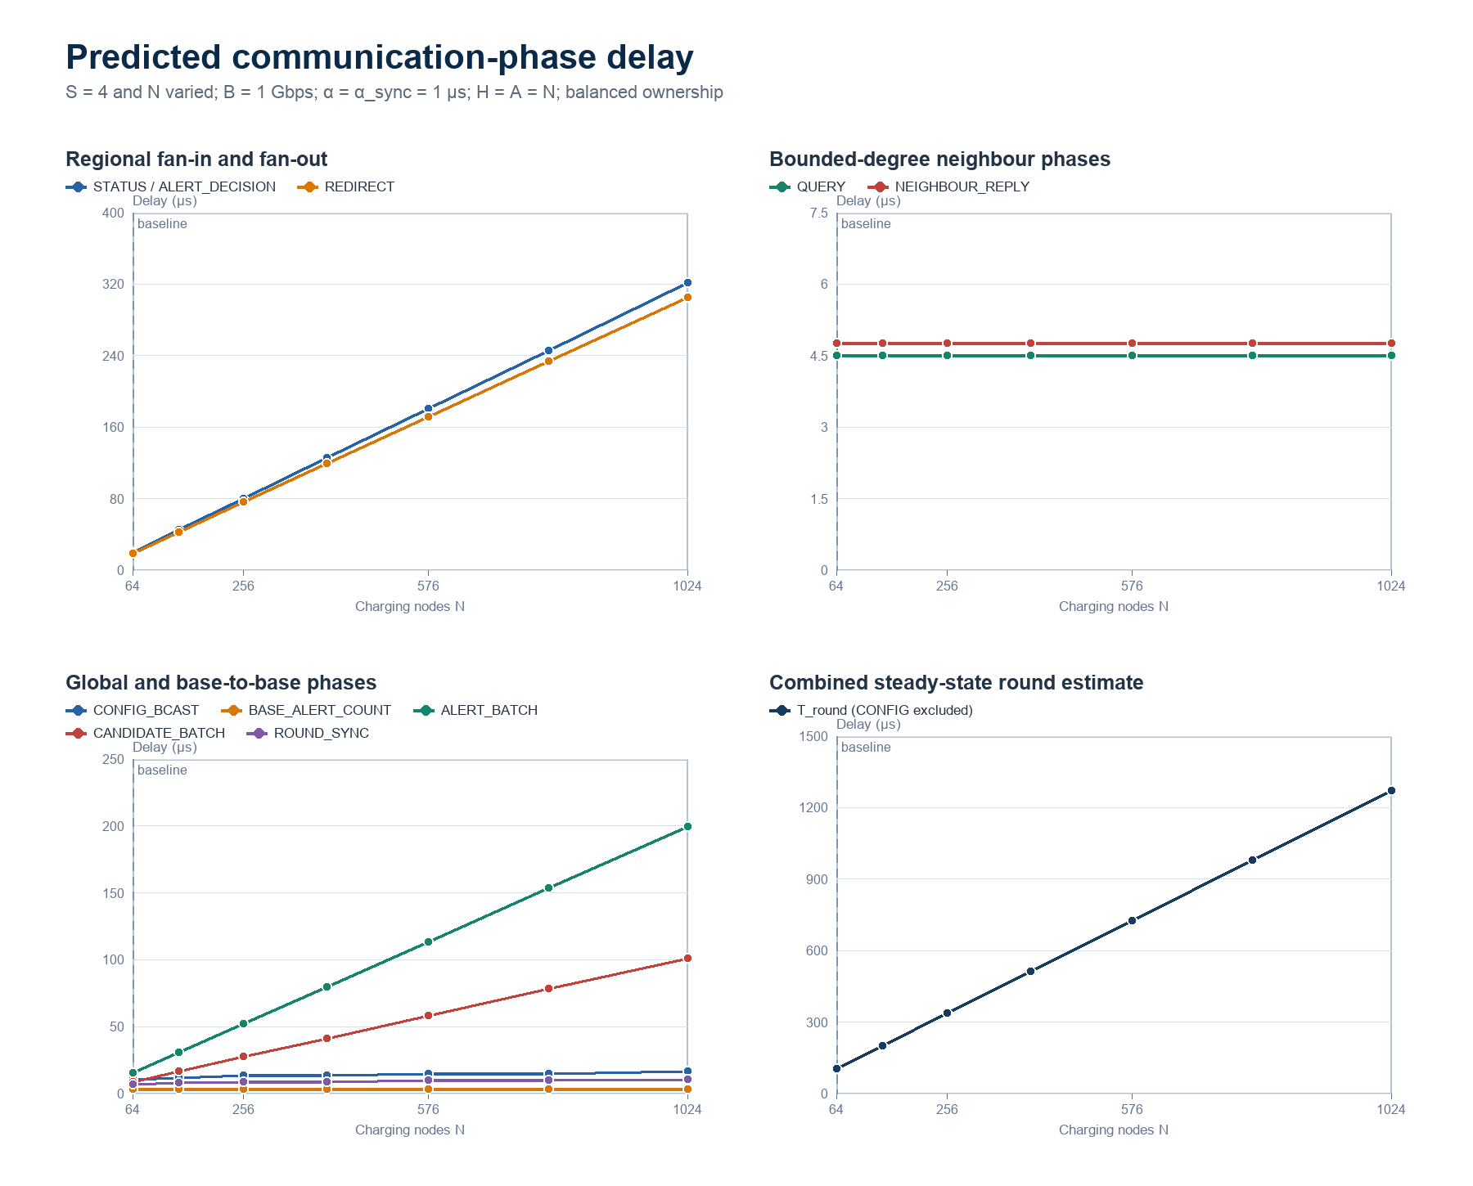
Figure 1. Predicted phase delay as the charging-node count increases with S = 4.
Interpretation of part (a): Increasing N does not change the serialisation delay of one fixed-size record. It increases how many records the busiest base or global batch must handle. Therefore STATUS_REPORT, ALERT_DECISION and REDIRECT grow as N/S, ALERT_BATCH and CANDIDATE_BATCH grow with A, and QUERY/NEIGHBOUR_REPLY remain constant per node while their total traffic grows linearly.
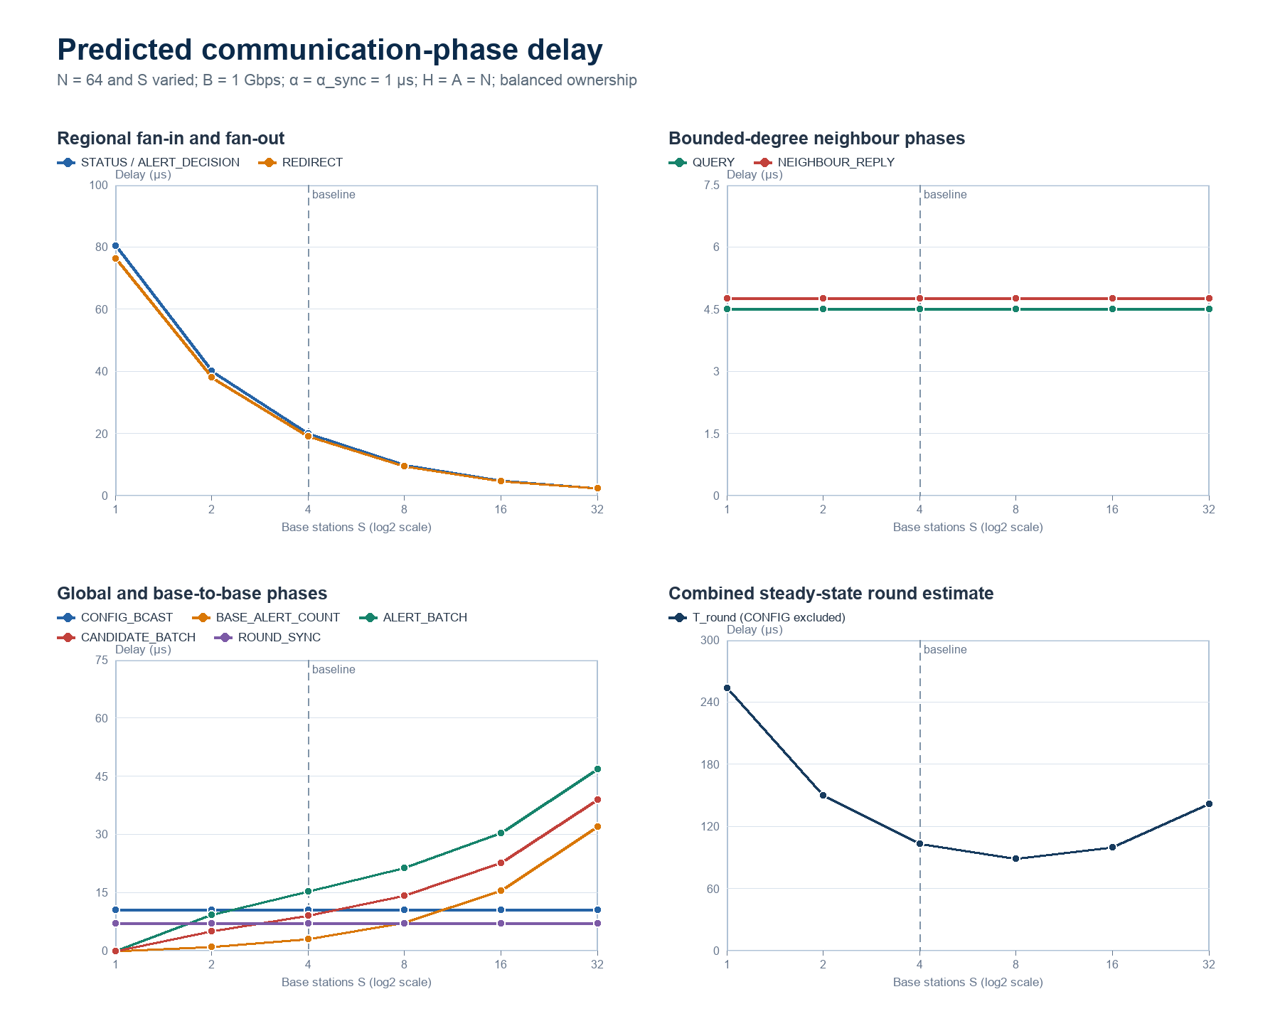
Figure 2. Predicted phase delay as the base-station count increases with N = 64.
Interpretation of part (b): More base stations reduce regional fan-in and fan-out, but do not reduce bounded-neighbour traffic and increase base-to-base coordination. Under these illustrative assumptions, the combined round estimate is lowest at S = 8 among the tested values, then rises as peer startup and replicated batches dominate. Therefore increasing S helps only up to a workload-dependent point; it is not a universal delay reduction.
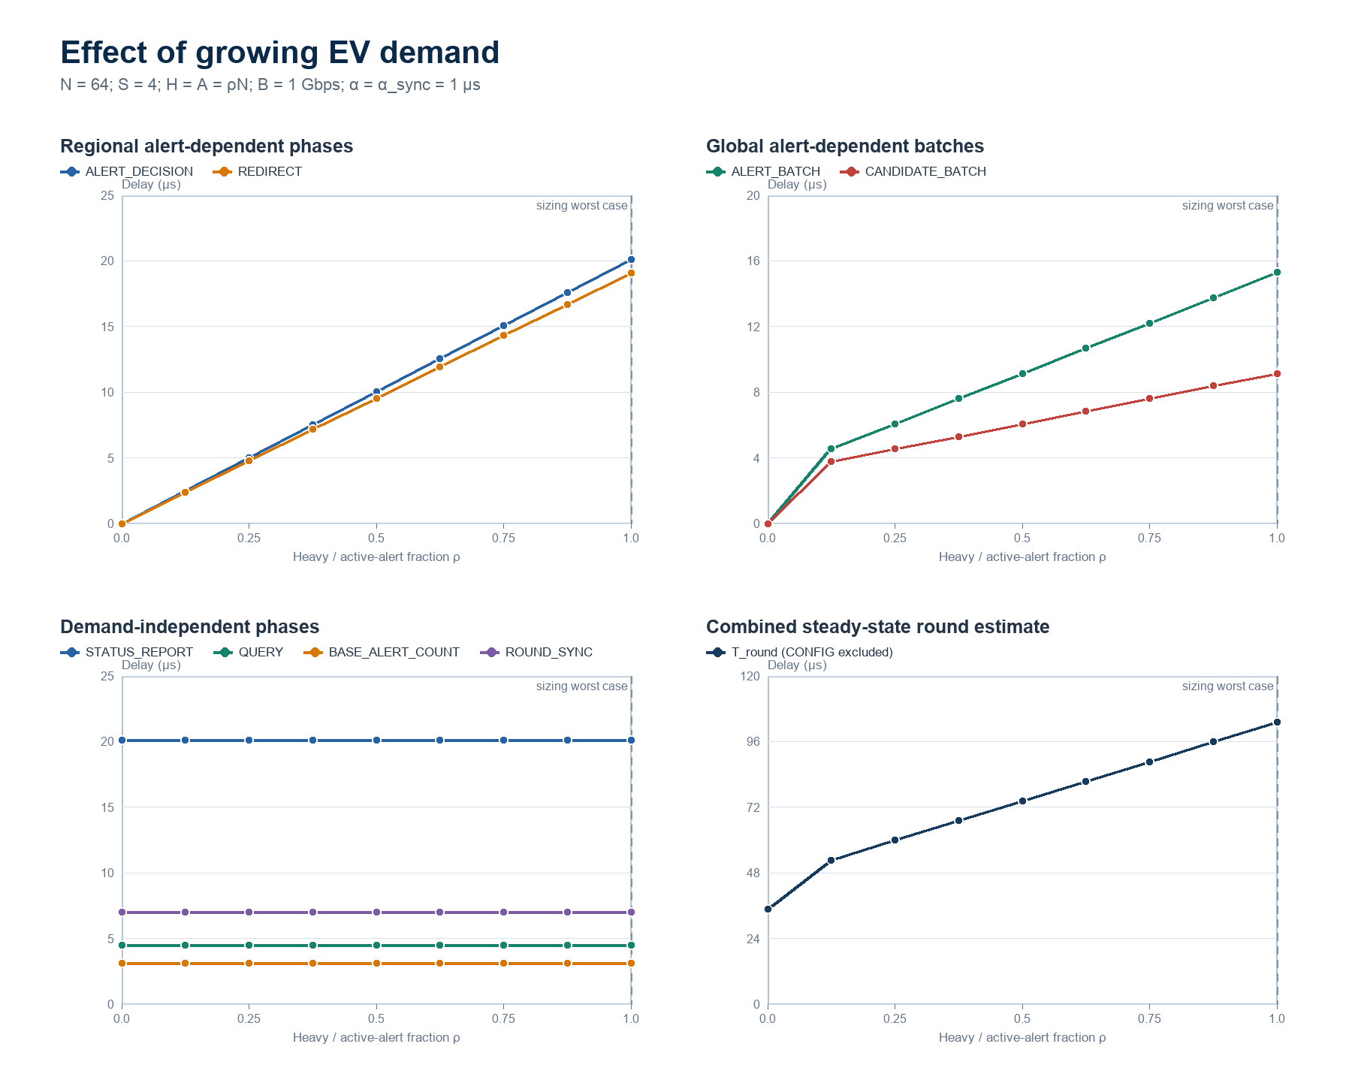
Figure 3. Predicted phase delay as EV demand increases with N = 64 and S = 4.
H = A = rho N, 0 <= rho <= 1
Other growing factor: EV demand: A growing EV population does not necessarily create additional MPI ranks; instead, it raises utilisation and therefore the heavy-node and active-alert fractions. With H = A = rho N, ALERT_DECISION and REDIRECT grow approximately as rho N/S, while ALERT_BATCH and CANDIDATE_BATCH grow approximately as rho N per base. STATUS_REPORT, fixed QUERY exchange, BASE_ALERT_COUNT and ROUND_SYNC are unchanged when N and S stay fixed. The combined delay therefore rises with demand even though the network topology is unchanged.

Complexity summary
Message type | Total work | Phase complexity | Reason
CONFIG_BCAST | Theta(N+S) | Theta(log(N+S)) | Tree depth
STATUS_REPORT | Theta(N) | Theta(N/S) | N reports divided across S bases
QUERY | Theta(N) | Theta(1) per node | At most four neighbours per node
NEIGHBOUR_REPLY | Theta(H), worst Theta(N) | Theta(1) per heavy node | At most four replies per requester
ALERT_DECISION | Theta(H) | Theta(H/S) | H decisions divided across S bases
BASE_ALERT_COUNT | Theta(S^2) | Theta(S) | Every base contacts S-1 peers
ALERT_BATCH | Theta(AS) | Theta(A+S) | A alerts replicated across bases
CANDIDATE_BATCH | Theta(AS) | Theta(A+S) | S-1 candidates per alert
REDIRECT | Theta(A) | Theta(A/S) | One redirect per alert
ROUND_SYNC | Theta(N+S) | Theta(log(N+S)) | Tree barrier depth

Direct answers: As N increases with S fixed, regional messages grow approximately as N/S, alert and candidate batches grow with A, and local neighbour delay remains constant per node although total mesh traffic is linear. Increasing S helps STATUS_REPORT, ALERT_DECISION and REDIRECT under balanced ownership, but worsens base-to-base coordination and does not reduce QUERY, NEIGHBOUR_REPLY, CONFIG_BCAST or ROUND_SYNC. Therefore, more base stations do not always reduce transmission delay.

