1.4

1) client port: 61317, server: 1238. Both used 127.0.0.1 as their IP address.
2)
The first two attempts from the client were rejected as the server was not ready. But the 3rd attempt starting from 273-275 was successful.
3)
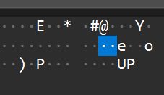
the command was “UP”
4)
a)Client tells server it wants to terminate
b)server says ok
c) server tells client it is terminating
d)client says ok

