## Dataset

**Iris Dataset**

Description: This dataset contains 150 instances of iris flowers classified into three classes (setosa, versicolor, and virginica), with four features per instance.

Characteristics: Numerical, multivariate data with known class labels.

**Wine Dataset**

Description: Contains 178 instances of wine, each belonging to one of three classes, with 13 continuous features.

Characteristics: Real-valued data with high dimensionality, useful for clustering evaluation.

## Modules

**Data Loading Module**:

* Loads datasets from scikit-learn and standardizes them for consistency. Uses StandardScaler to normalize the data.

if args.dataset == 'iris':

        data = load_iris()

    elif args.dataset == 'wine':

        data = load_wine()

**GMM Clustering Module**:

* Implements GMM using basic python operators.
* Uses the EM algorithm to estimate parameters and predict cluster labels.
* Design Insight: The number of components in GMM corresponds to the number of classes in the dataset, which is set as a parameter (n_components).

def expectation(X, means, covariances, weights):

    n_samples, n_components = X.shape[0], means.shape[0]

    responsibilities = np.zeros((n_samples, n_components))

    for k in range(n_components):

        responsibilities[:, k] = weights[k] * gaussian_pdf(X, means[k], covariances[k])

    responsibilities /= responsibilities.sum(axis=1, keepdims=True)

    return responsibilities

def maximization(X, responsibilities):

    n_samples, n_features = X.shape

    n_components = responsibilities.shape[1]

    weights = responsibilities.sum(axis=0) / n_samples

    means = np.dot(responsibilities.T, X) / responsibilities.sum(axis=0)[:, np.newaxis]

    covariances = np.zeros((n_components, n_features, n_features))

    for k in range(n_components):

        diff = X - means[k]

        covariances[k] = np.dot(responsibilities[:, k] * diff.T, diff) / responsibilities[:, k].sum()

    return means, covariances, weights

**Evaluation Module**:

* Evaluates clustering performance with Adjusted Rand Index (ARI) and Normalized Mutual Information (NMI) to assess how closely the clusters align with the actual class labels.

def calculate_accuracy_recall(y_true, y_pred, n_components):

    contingency_matrix = np.zeros((n_components, n_components), dtype=int)

    for i in range(len(y_true)):

        contingency_matrix[y_pred[i], y_true[i]] += 1

    row_ind, col_ind = linear_sum_assignment(-contingency_matrix)

    best_matching = [(row, col) for row, col in zip(row_ind, col_ind)]

    total_correct = sum(contingency_matrix[row, col] for row, col in best_matching)

    accuracy = total_correct / len(y_true)

    recall_values = []

    for row, col in best_matching:

        cluster_total = np.sum(contingency_matrix[:, col])

        recall = contingency_matrix[row, col] / cluster_total if cluster_total > 0 else 0

        recall_values.append(recall)

    recall = np.mean(recall_values)

    return accuracy, recall

## Results

**Iris Dataset Results**:

* Expected ARI and NMI scores indicate how well clusters align with actual flower classes.
* Interpretation: Due to class overlap, GMM might have moderate clustering performance on this dataset.

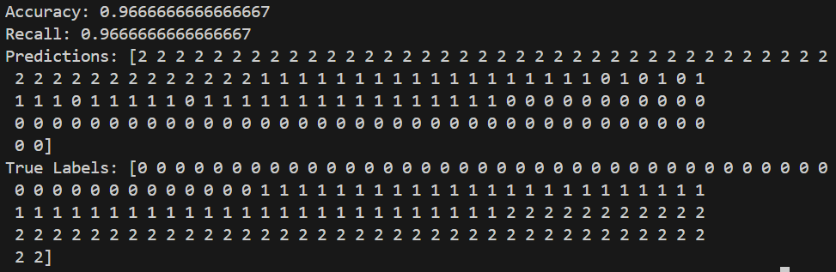

**Wine Dataset Results**:

* Expected results on wine data indicate whether GMM can effectively separate wine classes based on chemical properties.
* Interpretation: Higher dimensionality may lead to better separation, but covariance settings affect results.

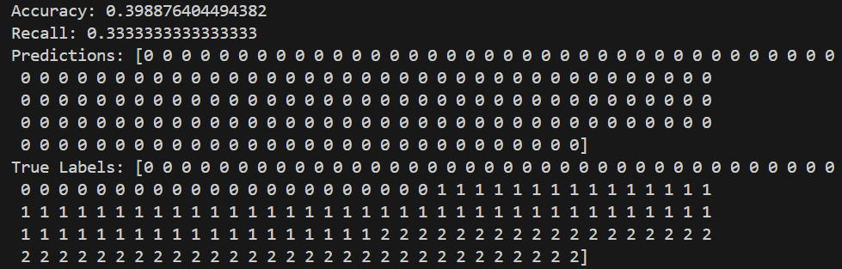

## Limitations & Possible Improvements

**Limitations**:

* Sensitivity to Initialization: GMM is sensitive to initial conditions and may converge to local optima.
* Component Assumptions: GMM assumes data in each cluster follows a Gaussian distribution, which might not always be valid.

**Possible Improvements**:

* Initialization: Using K-means or other initialization strategies to improve convergence.
* Covariance Matrix Types: Experimenting with different covariance types (e.g., tied, diag) could improve results based on dataset characteristics.
* Dimensionality Reduction: Using PCA or other techniques to reduce data dimensionality and potentially improve clustering results.