Guided Capstone Project Report

**Problem Identification Overview**

* **Background**

Big Mountain Resort, located in northwestern Montana, offers spectacular views of Glacier National Park and Flathead National Forest, and access to 105 named trails and vast bowl and tree skiing. Every year about 350,000 people ski or snowboard at Big Mountain. The resort has recently installed an additional chair lift which costs $1.54 million to attract more customers, the business wants to recoup the operational cost and maintain 9.2% margin profit in this year’s revenue.

* **Define the question specific to modeling activities**

We want to predict weekend lift ticket price to decide if it is possible to increase it by control other features of the resort.

* **Identify the data needed and or available**

Updated ski data from database manager

* **Describe the Modeling Response**

“AdultWeekend” as a continuous variable

* **Regression Model**

Linear regression

* **What Deliverables will be generated**

Word outlining modeling process from data exploration to best model results

**Data Preprocessing steps of note**

* Filling the following missing variables with mean: “AdultWeekday”, “daysOpenLastYear”, “projectedDaysOpen”, “averageSnowfall”, “LongestRun_mi”, “Runs”, “SkiableTerrain_ac”, “yearsOpen”
* Filling the following missing variables with zero: “NightSkiing_ac”, “TerrainParks”, “Snow Making_ac”
* Not take too much care about outliers since the data size is only 330x26, if we remove the lower and upper 25% of the outlier, the data size will be 176x26, not ideally for machine learning methods
* Remove “base_elev” since collinearity
* K-mean clustering patterns in the data
* Remove state since it is not something the managers at the Big Mountain Resort can do anything about

**Model Description**

* Input data size X: 330x23, Y: 330x1
* Response variable: AdultWeekend
* Model Algorithm: linear regression, 75/25 in train/test dataset

**Model Performance**

$R^{2}=0.9348$

* MAE (Mean Absolute Error) = 5.1261

**Model Findings**

* The predicted Adult Weekend price is: $86.59. The actual Adult Weekend price is: $81.00.
* Scatter plots for visualizing the Adult Weekend values compared to other characteristics:

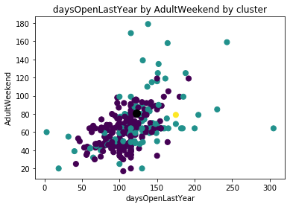

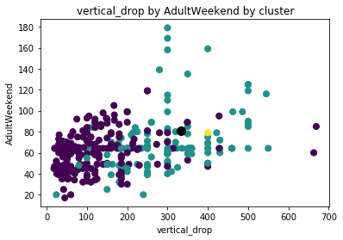

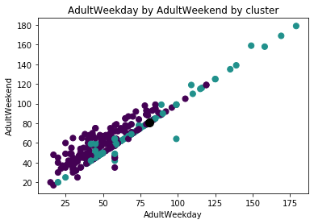

* The operational department by:
* Increase average cost of adult weekday chairlift per ticket by $1, then the expected cost of adult weekend chairlift per ticket will increase ~$20 dollars
* Increase days open for last year by 10 days, then the expected cost of adult weekend chairlift per ticket will increase ~$6 dollars
* Increase vertical change in elevation from the summit to the base by 10 foot, then the expected cost of adult weekend chairlift per ticket will increase ~$10 dollars