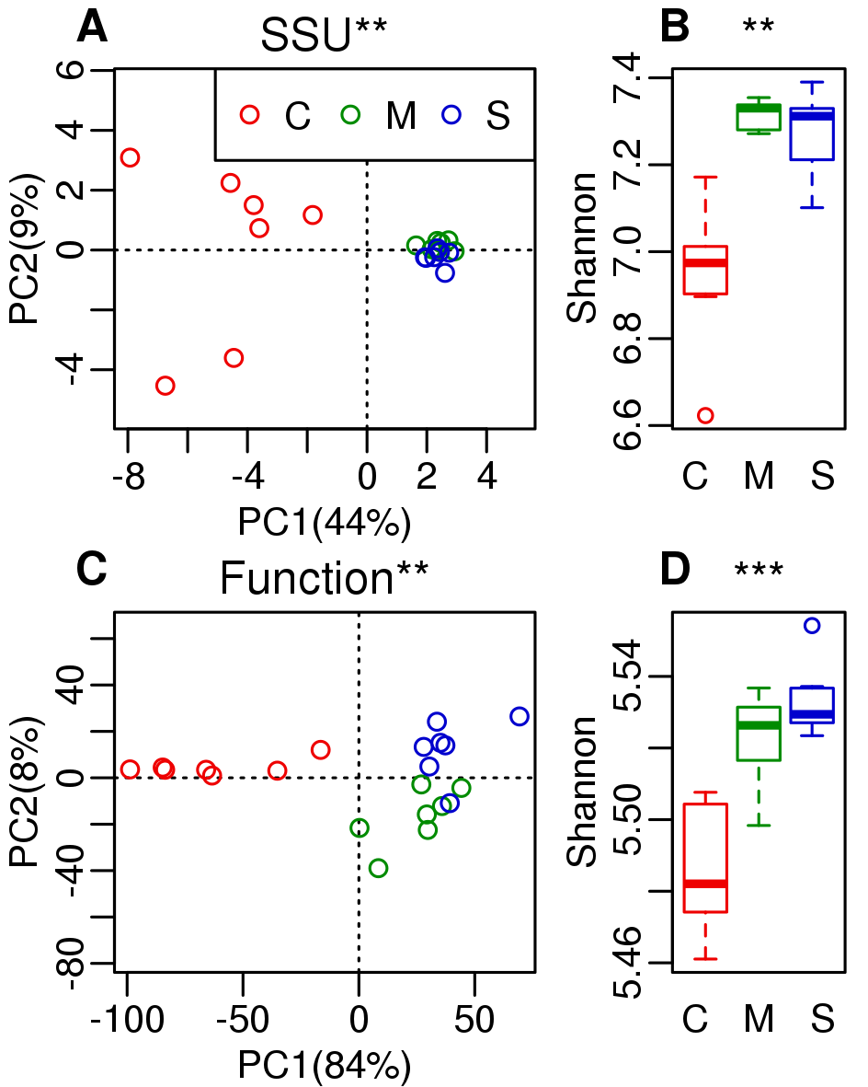

FIG 1 Species (OTU) and functional diversity comparsion among three crops: C (corn), M (*Miscanthus*), and S (switchgrass) [These abbreviations are used throughout the paper]. Corn has a different community composition from *Miscanthus* and switchgrass in both OTU (A) and function (level 3 subsystems) (subplot C), and corn has lower diversity in both OTU (B) and function (D). The symbol at top each graph indicates significance of difference (“***” indicates *p* < 0.001; “**” indicates *p* < 0.01; “*” indicates *p* < 0.05).

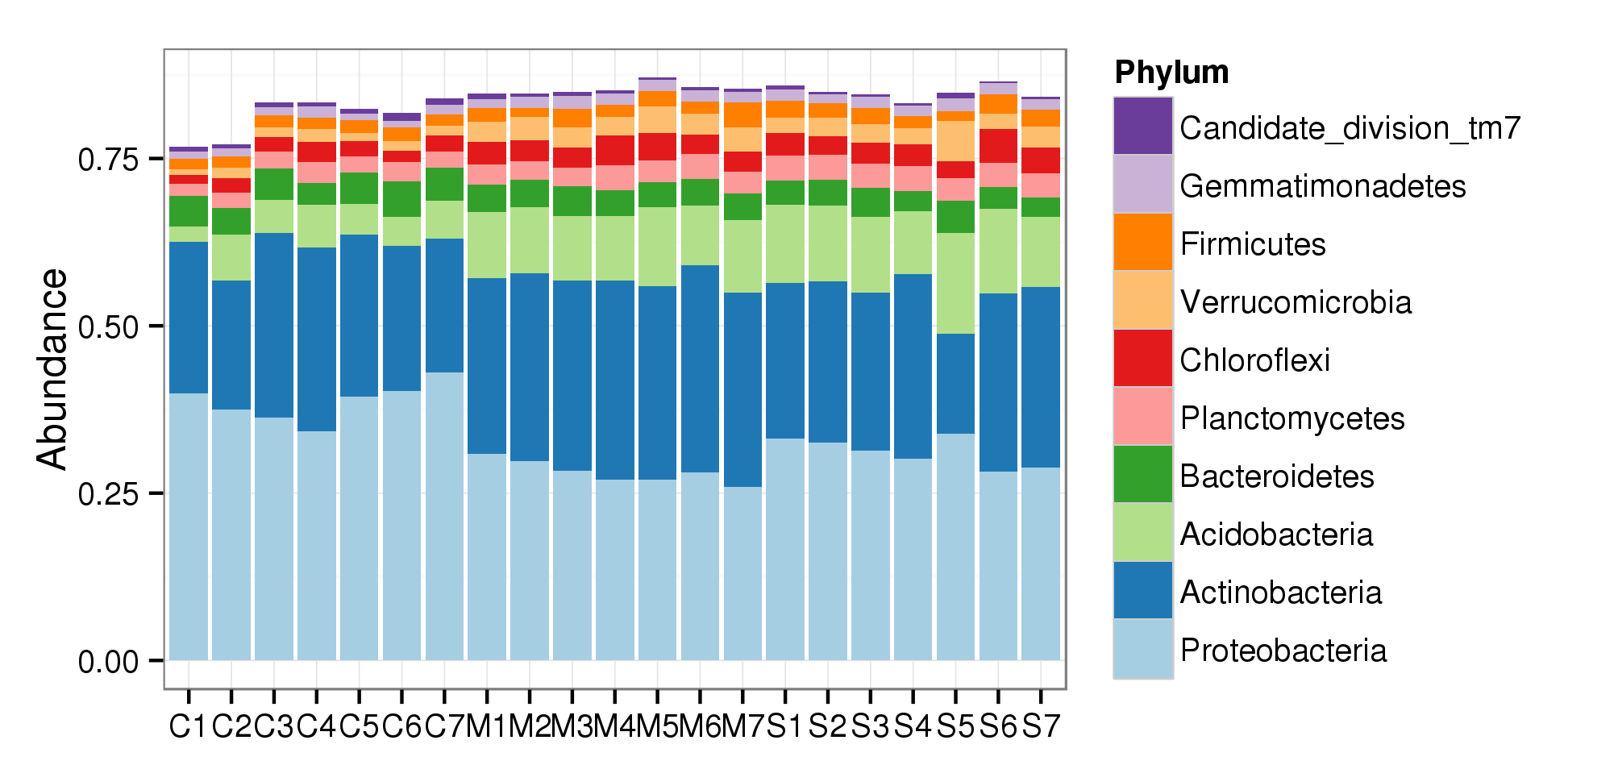

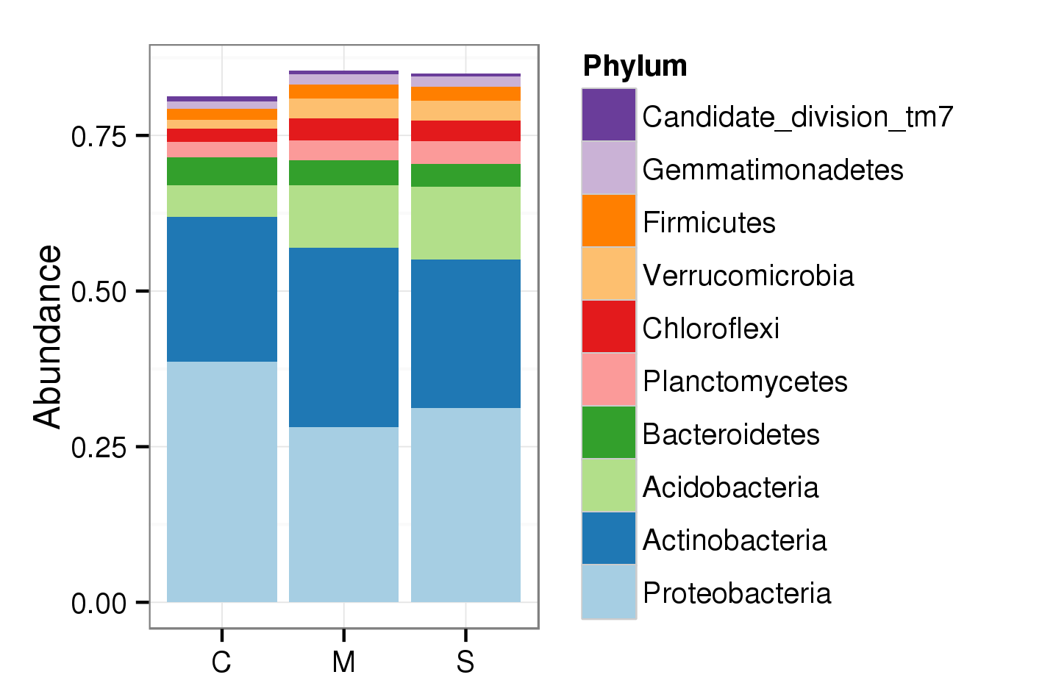

FIG 2 Relative abundance of top 10 most abundant bacterial phyla in three crops. Corn (C) is enriched in *Proteobacteria* (*p* < 0.01*, n* = 7), and *Miscanthus* (M) and switchgrass (S) are enriched in *Acidobacteria* (*p* < 0.001, *n* = 7). Average of *Proteobacteria* in corn, *Miscanthus*, and switchgrass are 0.387, 0.282, and 0.312 respectively. Average of *Actinobacteria* in corn, *Miscanthus*, and switchgrass are 0.050, 0.101, and 0.117 respectively. Average of *Acidobacteria* in corn, *Miscanthus*, and switchgrass are 0.050, 0.101, and 0.117 respectively.

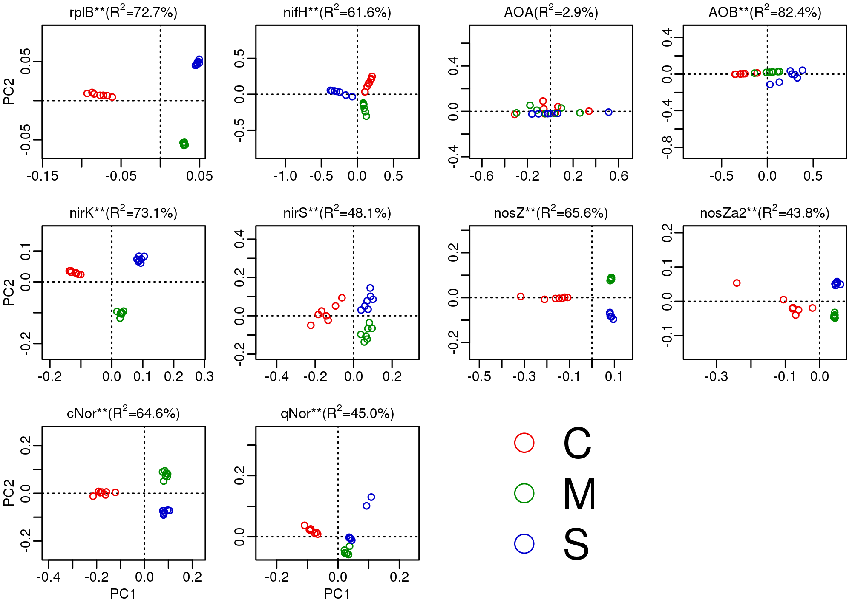

FIG 3 Ordination analysis of each N cycle gene and *rplB* using OTU. All genes except AOA show significant separation of samples by corn (C), Miscanthus (M) and switchgrass (S). OTUs of each gene are clustered at 5% distance cutoff using protein sequence.

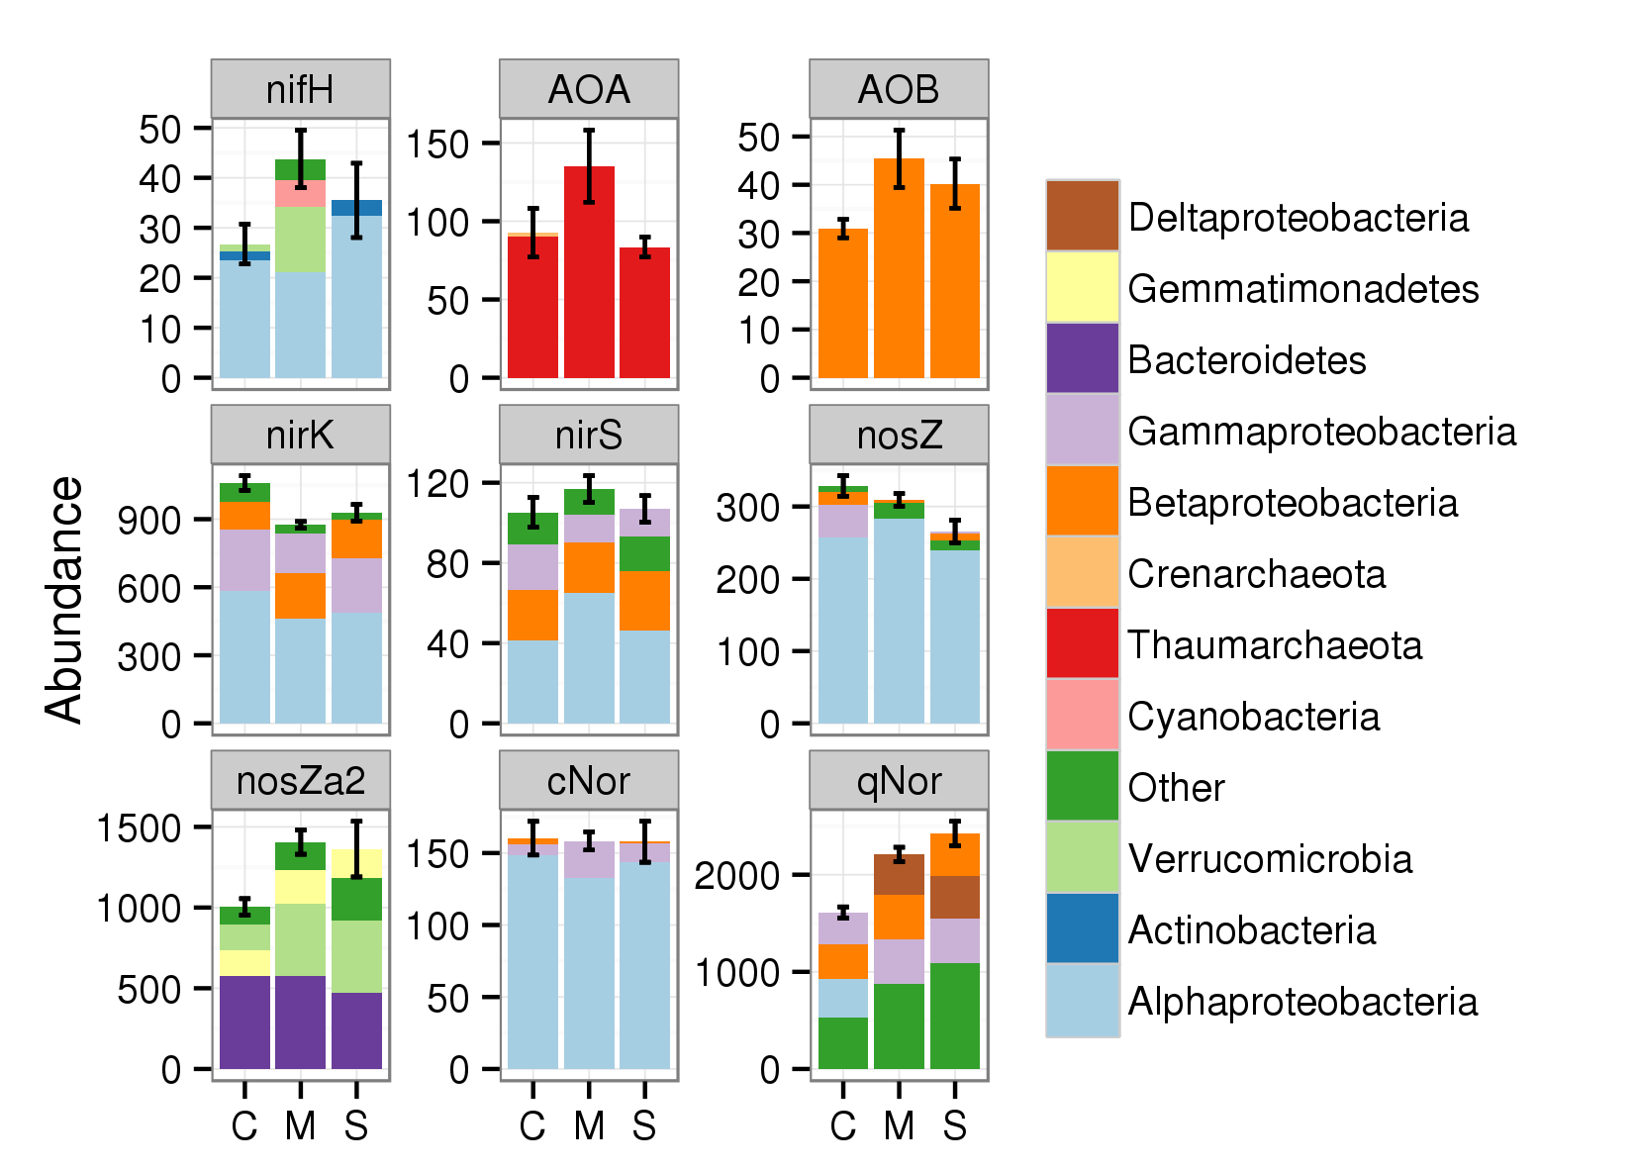

FIG 4 Abundance and phylum level association of the indicated N cycle genes in corn (C), *Miscanthus* (M) and switchgrass (S). Gene abundances are normalized relative to *rplB* copies. There are significant differences among three crops in *nirK*, *nosZ*, *nosZa2* and *qNor* (p < 0.05, n = 7). Additionally, pairwise *t* test shows *Miscanthus* is significantly higher than corn in *nifH* and AOB ( p < 0.05, n = 7).

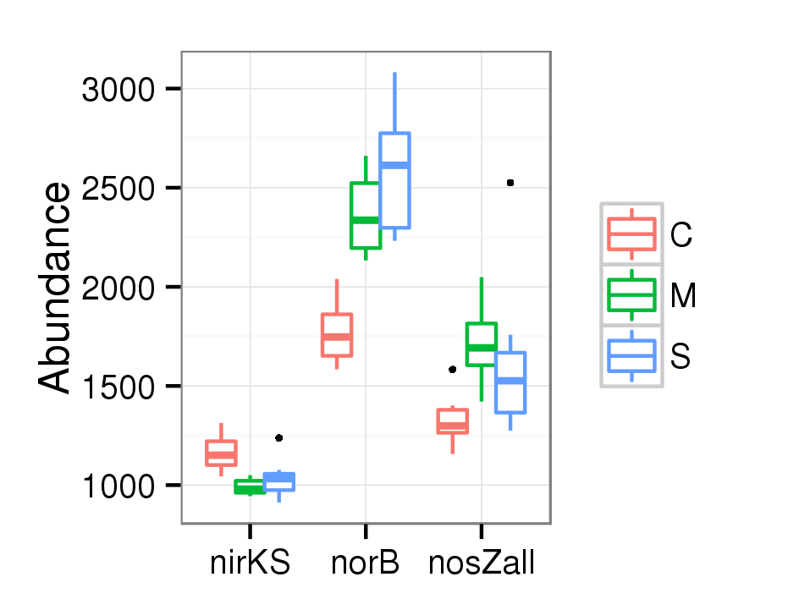

FIG 5 Denitrification gene abundances after combining the genes encoding enzymes with the same function. “NirKS” = *nirK* and *nirS*. “NorB” = *cNor* and *qNor*. “NosZall” = *nosZ* and *nosZa2*. Each gene’s abundance is normalized relative to *rplB* copies. Three crops are significantly different in abundances of “nirKS”, “norB”, and “nosZall” (*p* < 0.05, *n* = 7). Corn is higher than perennials in abundance of “nirKS” but lower in abundance of “norB” and “nosZall”.

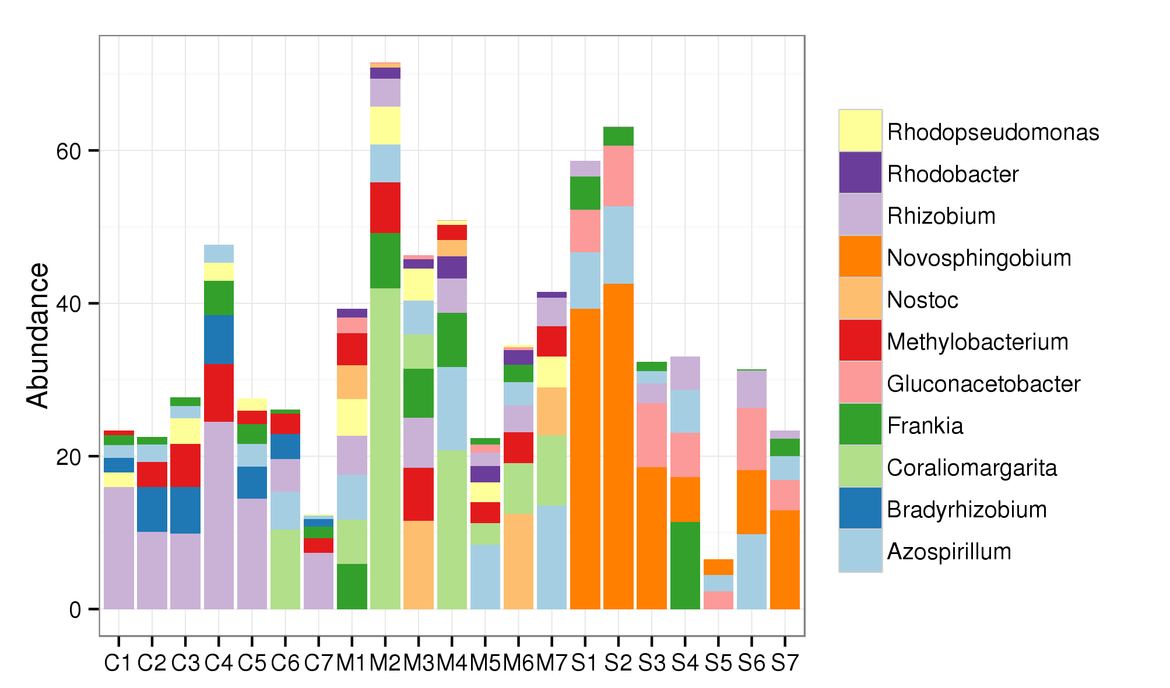

FIG 6 Abundance and genus level distribution of *nifH*. Y axis is gene abundance normalized relative to *rplB* copies. X axis is sample labels in which first letter stands for crop (C for corn, M for *Miscanthus*, and S for switchgrass). Three crops rhizospheres are quite different in genera with the closest sequence match. On average, *Rhizobium*, *Bradyrhizobium*, and *Methylobacterium*-like sequencesare the most abundant in corn, *Coraliomargarita*, *Azospirillum*, and *Nostoc* the most abundant in *Miscanthus*, and *Novosphigobium*, *Gluconacetobacter*, and *Azospirillum* the most abundant in switchgrass.

**Supplemental materials**

Table S1 Statistics of SSUsearch pipeline results for 21 samples.

|  |  |  |  |  |  |  |  |  |
| --- | --- | --- | --- | --- | --- | --- | --- | --- |
|  | TotalReads | TotalSSU | %SSU | V4 | OTUs | Chao1 | Shannon | V4 % |
| C1 | 232234095 | 117160 | 0.050% | 11615 | 1707 | 4013 | 6.6 | 9.9% |
| C2 | 220844998 | 95493 | 0.043% | 8137 | 2014 | 5037 | 7.0 | 8.5% |
| C3 | 282123335 | 119210 | 0.042% | 11579 | 2009 | 4759 | 7.0 | 9.7% |
| C4 | 260542662 | 107114 | 0.041% | 10295 | 2146 | 5131 | 7.2 | 9.6% |
| C5 | 285873232 | 143302 | 0.050% | 13520 | 1907 | 4365 | 6.9 | 9.4% |
| C6 | 250477617 | 124598 | 0.050% | 12487 | 2033 | 5228 | 6.9 | 10.0% |
| C7 | 262943930 | 114183 | 0.043% | 9449 | 2016 | 4818 | 7.0 | 8.3% |
| M1 | 274060925 | 102049 | 0.037% | 9693 | 2315 | 5456 | 7.4 | 9.5% |
| M2 | 278278868 | 100498 | 0.036% | 9767 | 2329 | 5818 | 7.3 | 9.7% |
| M3 | 244772969 | 92624 | 0.038% | 8963 | 2245 | 5358 | 7.3 | 9.7% |
| M4 | 206129129 | 69535 | 0.034% | 6474 | 2289 | 4984 | 7.3 | 9.3% |
| M5 | 225964704 | 74778 | 0.033% | 6892 | 2213 | 4860 | 7.3 | 9.2% |
| M6 | 215320045 | 73062 | 0.034% | 6800 | 2284 | 5258 | 7.3 | 9.3% |
| M7 | 160726636 | 71249 | 0.044% | 6580 | 2290 | 5506 | 7.3 | 9.2% |
| S1 | 192776425 | 68080 | 0.035% | 6481 | 2278 | 5205 | 7.3 | 9.5% |
| S2 | 143660127 | 57229 | 0.040% | 5469 | 2336 | 5426 | 7.3 | 9.6% |
| S3 | 218743879 | 76368 | 0.035% | 7210 | 2355 | 5208 | 7.4 | 9.4% |
| S4 | 249773480 | 78422 | 0.031% | 7215 | 2278 | 5364 | 7.3 | 9.2% |
| S5 | 140239637 | 49962 | 0.036% | 4598 | 2086 | 4639 | 7.1 | 9.2% |
| S6 | 254749228 | 82105 | 0.032% | 7282 | 2154 | 4888 | 7.2 | 8.9% |
| S7 | 194863138 | 68094 | 0.035% | 6504 | 2156 | 4711 | 7.2 | 9.6% |

Table S2 Shared OTUs, genera, and contig among rhizosphere microbial communities of corn (C), *Miscanthus* (M), and switchgrass (S). *Miscanthus* and switchgrass have more similarity to each other than to corn in OTU, genus, and contig.

|  |  |  |  |
| --- | --- | --- | --- |
|  | OTU | Genus | Contig |
| C∩M | 0.34 | 0.80 | 0.17 |
| C∩S | 0.33 | 0.80 | 0.17 |
| M∩S | 0.40 | 0.82 | 0.26 |

Table S3 Global assembly statistics. Mapping% is the percentage of reads mapped to contigs. C stands for corn, M stands for *Miscanthus*, and S stands for switchgrass.

|  |  |  |  |  |  |
| --- | --- | --- | --- | --- | --- |
|  | Contig no. (M) | Total (Gbp) | Max (Kbp) | Median (bp) | Mapping% |
| C | 12.9 | 6.4 | 21 | 400 | 20.7 |
| M | 12.9 | 6 | 15.7 | 391 | 19.1 |
| S | 11.4 | 5.3 | 16 | 391 | 20.3 |

Table S4. Average percentage of Bacteria, Archaea, Eukaryota, and fungi in rhizosphere communities of corn (C), *Miscanthus* (M) and switchgrass (S). “AMF/fungi” is percentage of AMF (arbuscular mycorrhizal fungi) of total fungi. Corn has more fungi in the whole community but has less percentage of AMF within fungi.

|  |  |  |  |  |  |
| --- | --- | --- | --- | --- | --- |
|  | Bac | Arc | Euk | Fungi | AMF/fungi |
| C | 91.9% | 0.7% | 7.2% | 4.9% | 0.1% |
| M | 94.1% | 1.2% | 4.5% | 2.2% | 0.3% |
| S | 95.0% | 0.9% | 4.0% | 2.0% | 0.4% |

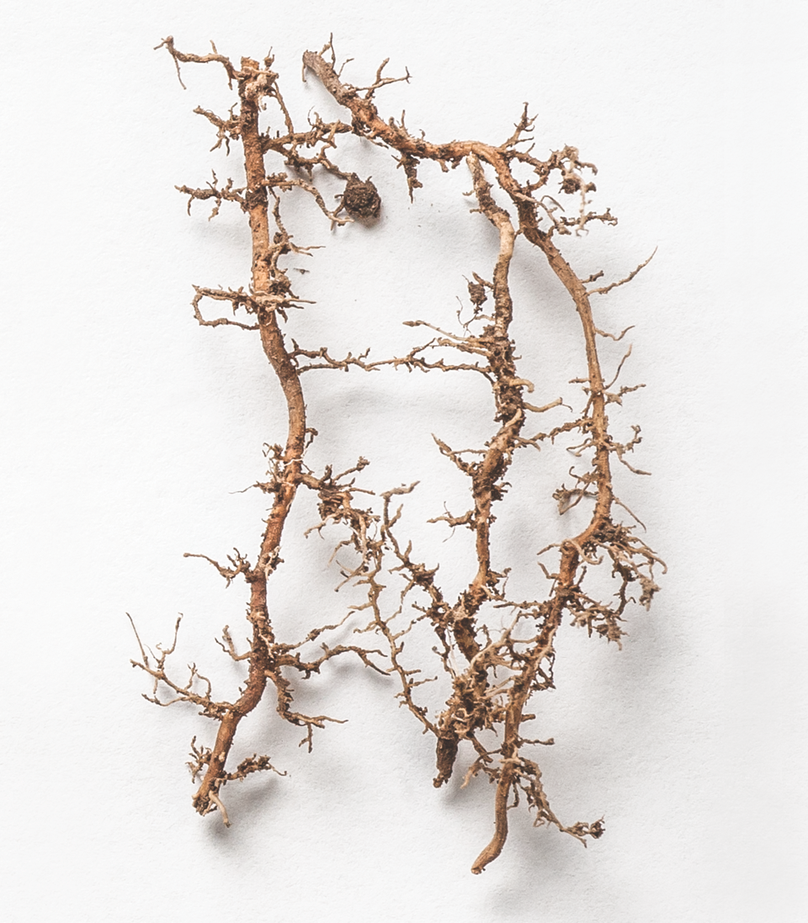

FIG S1 Roots (*Miscanthus*) and rhizosphere soil. Rhizosphere soil is collected by washing soil from the roots. The image shows that soil is very close (< 1 mm) to small roots.

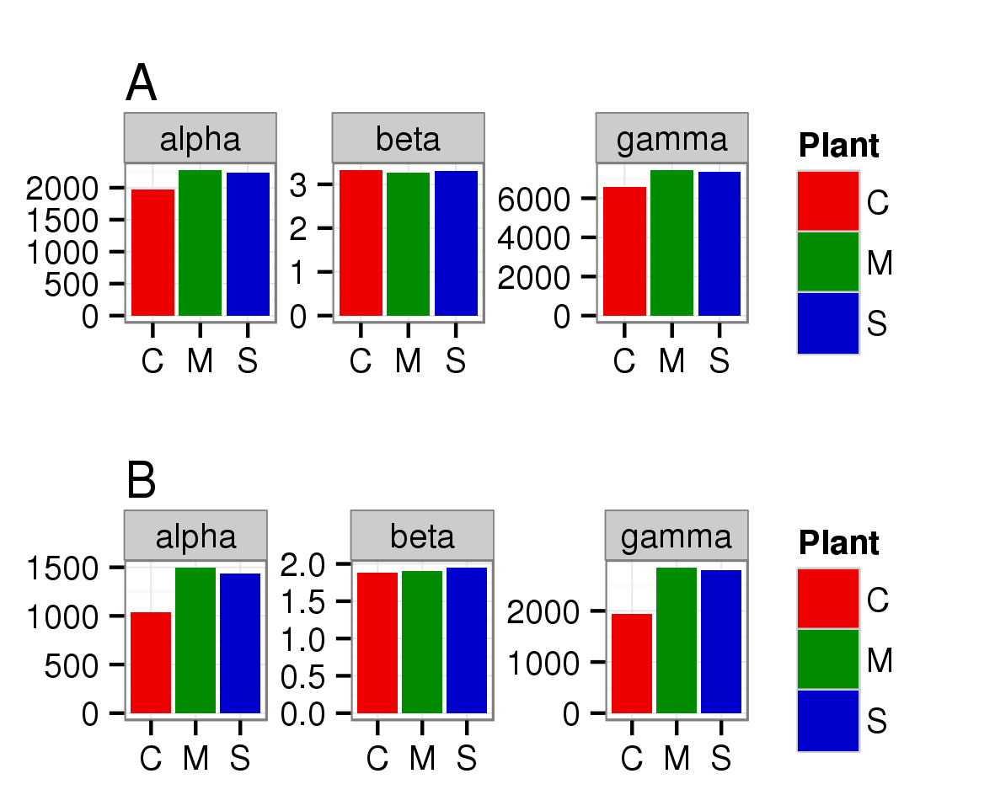

FIG S2 Species (OTU) diversity of three crops. *Miscanthus* and switchgrass are higher in both observed OTU number (q = 0 for “trudiv” function in simba package in R) (A) and another diversity index (B, q = 1 for “trudiv” function) (B). C stands for corn, M stands for *Miscanthus* and S stands for switchgrass. Alpha (diversity) refers to diversity of each replicate, gamma (diversity) refers to diversity when all replicates of each crop are combined, and beta (diversity) is ratio of gamma over alpha.

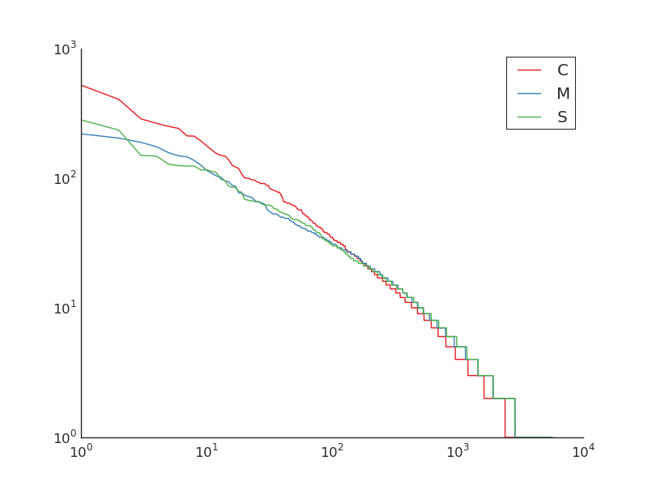

FIG S3 Rank abundance curve of microbial communities of corn (C), *Miscanthus* (M) and switchgrass (S) using OTU from SSU rRNA gene. Miscanthus and switchgrass have more even microbial community in rhizosphere than corn.

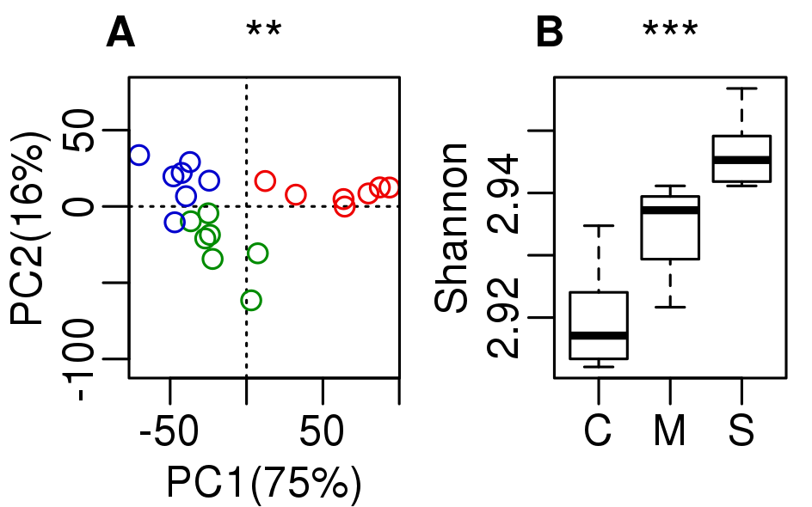

FIG S4 Functional diversity comparison among three crops. Corn has a different community functional composition from *Miscanthus* and switchgrass (level 1 subsystem) (A), and corn has lower diversity (B). C stands for corn, M stands for *Miscanthus*, and S stands for switchgrass. Symbols at top each subplot indicates significance of difference (“***” indicates *p* < 0.001; “**” indicates *p* < 0.01; “*” indicates *p* < 0.05).

Macintosh HD:Users:gjr:Dropbox:writing:2015-glbrc:figures:subsys-enrich-CvM.pdf

FIG S5 Function comparison between corn and *Miscanthus*. Corn had more pathways significantly enriched belonging to level 1 subsystems of “Stress Response”, “Carbohydrate”, and “Cell Wall/Capsule”, while Miscanthus had more pathways significantly enriched in “Amino Acids and Derivatives”, and “Respiration”. Signifcance of enrichment is done by Kruskal-Wallis test. Those level 3 pathways with FDR (False Discovery Rate) adjust *p* < 0.05, total count larger than 10 and ratio of corn over *Miscanthus* (in log2 space) larger than 1.5 or smaller than -1.5 are chosen as significant.

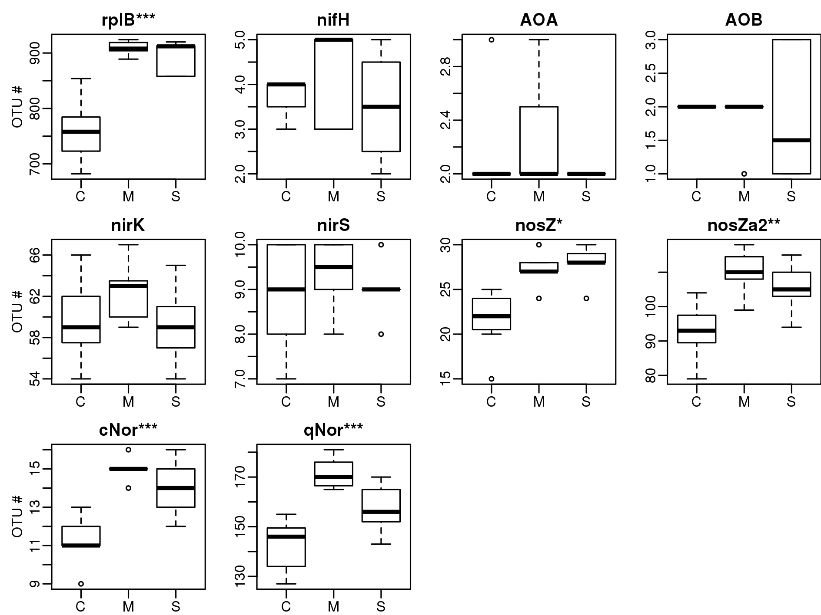

FIG S6 OTU number comparison among corn (C), Miscanthus (M) and switchgrass (S) using OTU tables of N cycle genes. Y axis of each plot shows OTU number. Symbols at top each subplot indicate significance of difference (“***” indicates *p* < 0.001; “**” indicates *p* < 0.01; “*” indicates *p* < 0.05, “.” indicates *p*<0.1).

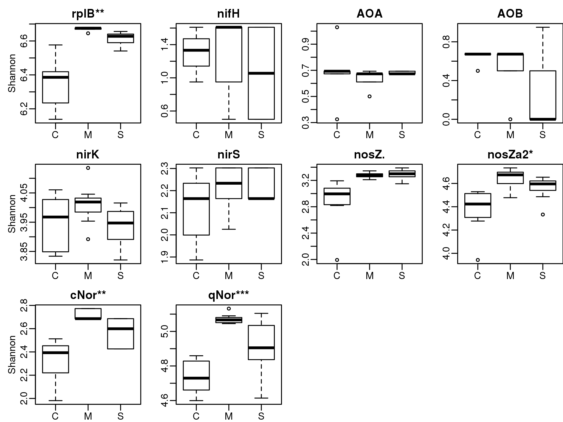

FIG S7 Diversity (Shannon) comparison among corn (C), *Miscanthus* (M) and switchgrass (S) using OTU tables of N cycle genes. Symbols at top each subplot indicate significance of difference (“***” indicates *p* < 0.001; “**” indicates *p* < 0.01; “*” indicates *p* < 0.05, “.” indicates *p*<0.1).

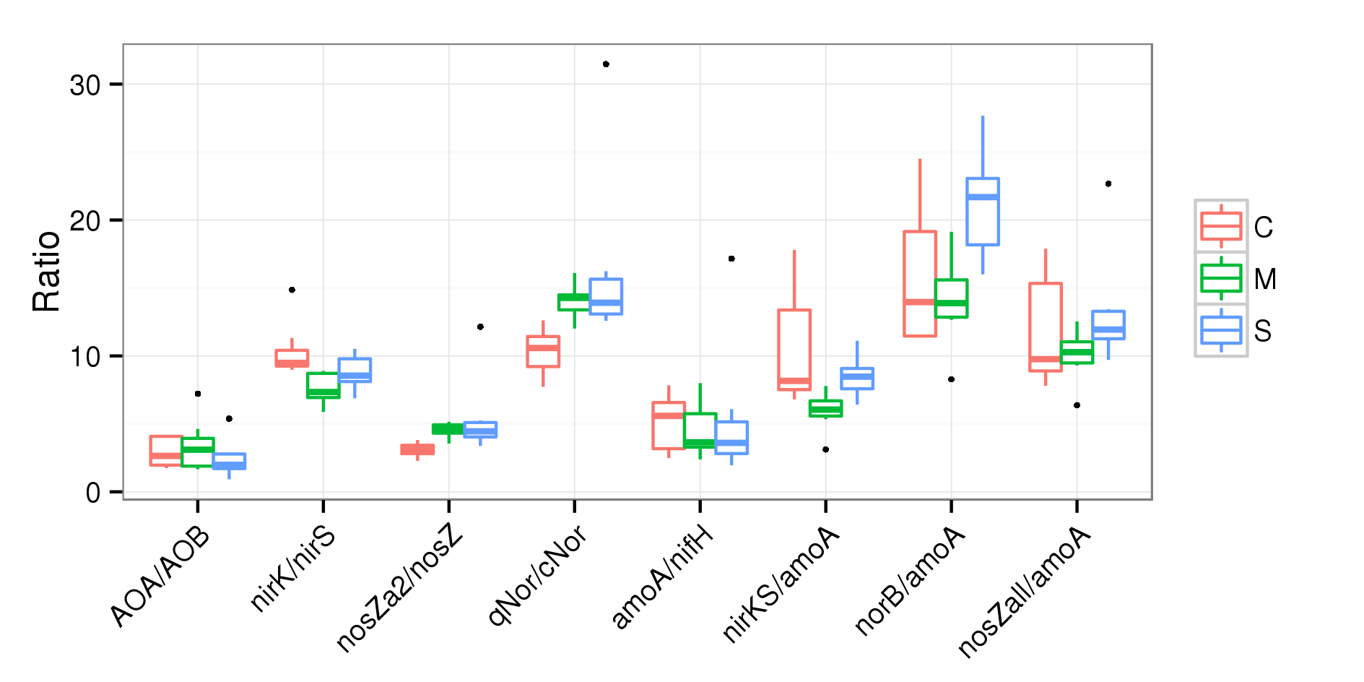

FIG S8 Ratios of interest related to N cycle genes in corn (C), *Miscanthus* (M) and switchgrass (S). “AmoA” is the sum of AOA and AOB; “nirKS” is the sum of *nirK* and *nirS*; “norB” is the sum of *cNor* and *qNor*; “nosZall” is the sum of *nosZ* and *nosZa2*. Each ratio is grouped by plant (7 replicates).

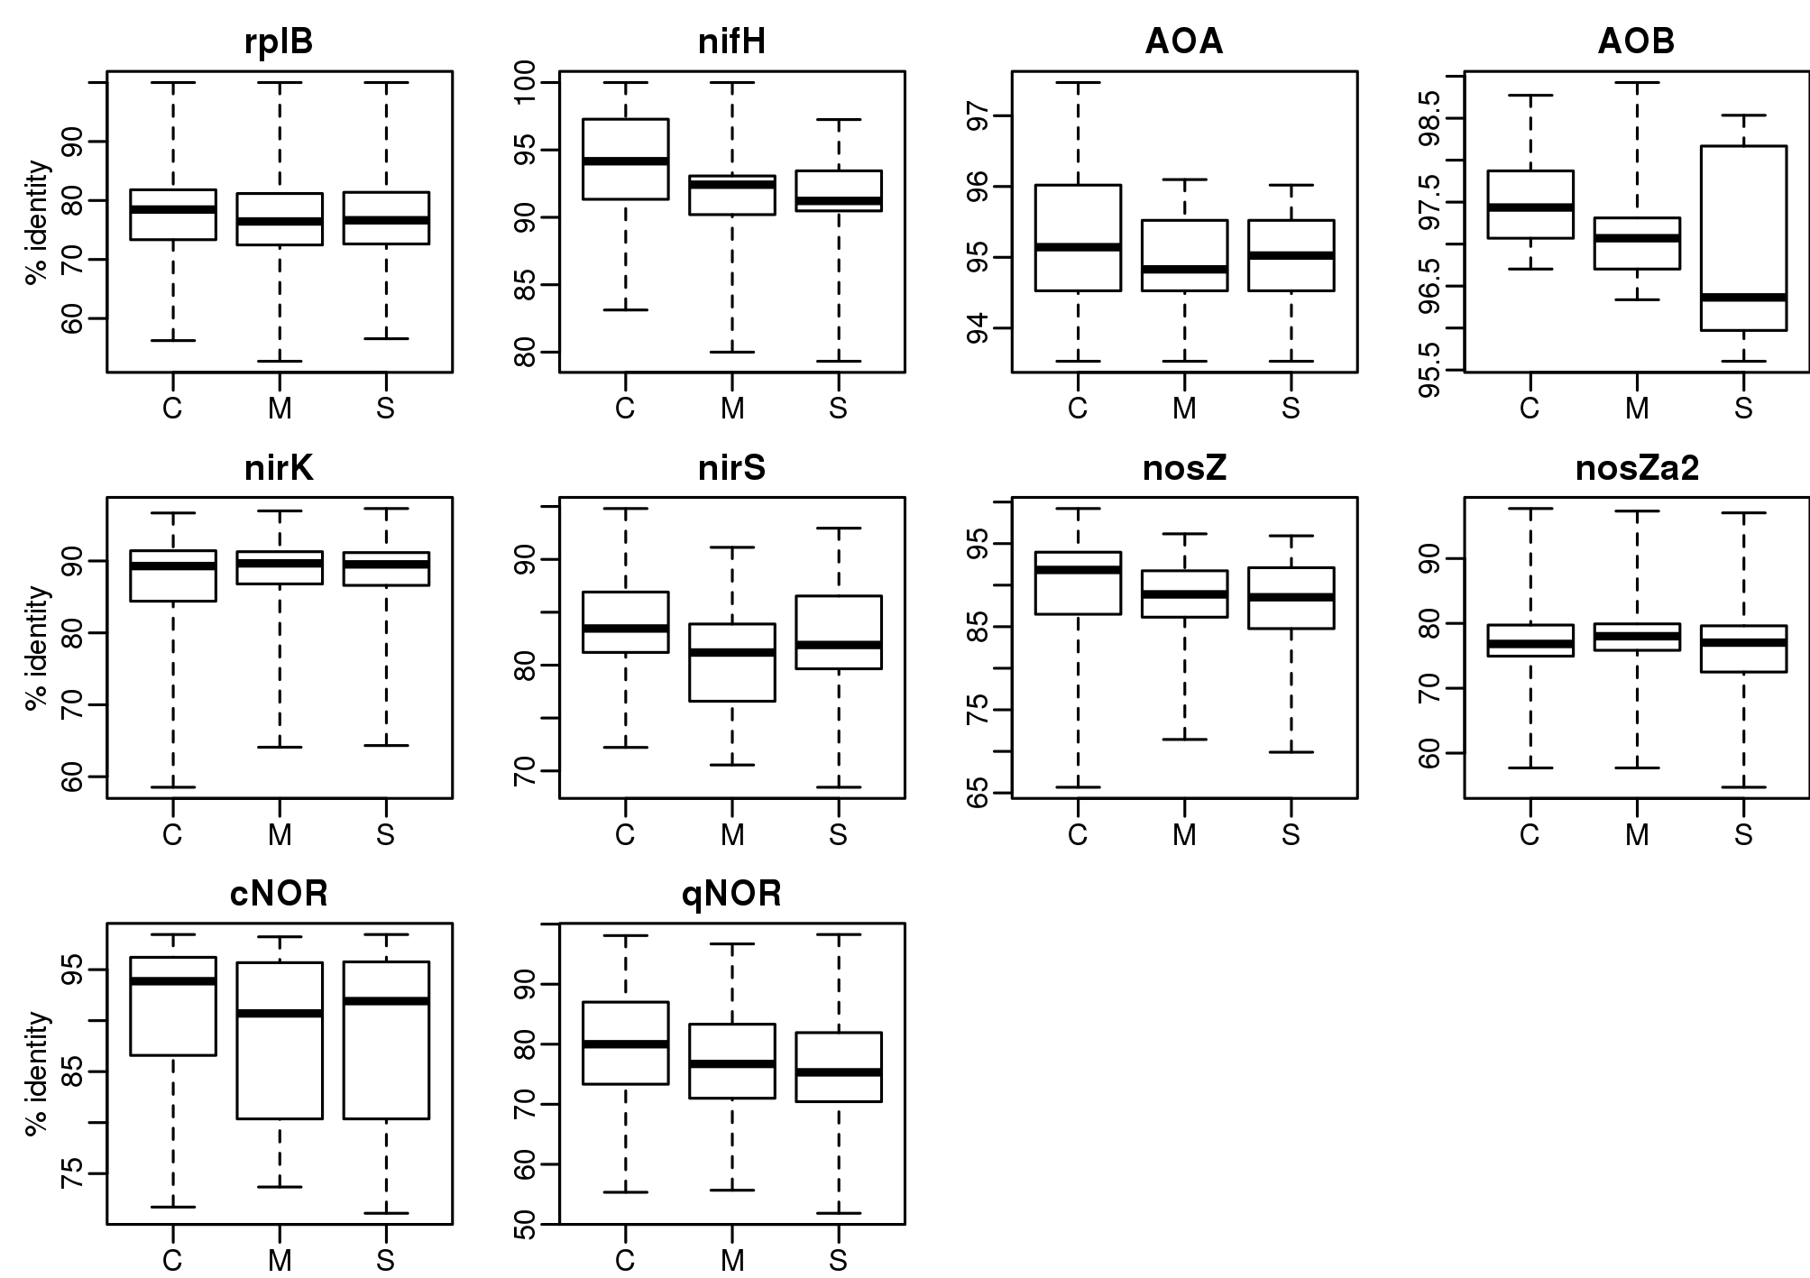

FIG S9 Sequnce identity of assembled N cycle genes to their best-hit references. Percentage identities (Y axis) are grouped by plant (C for corn, M for *Miscanthus*, and S for switchgrass). The lower identiy is, the more likely a assembled sequence is in correctly classified.

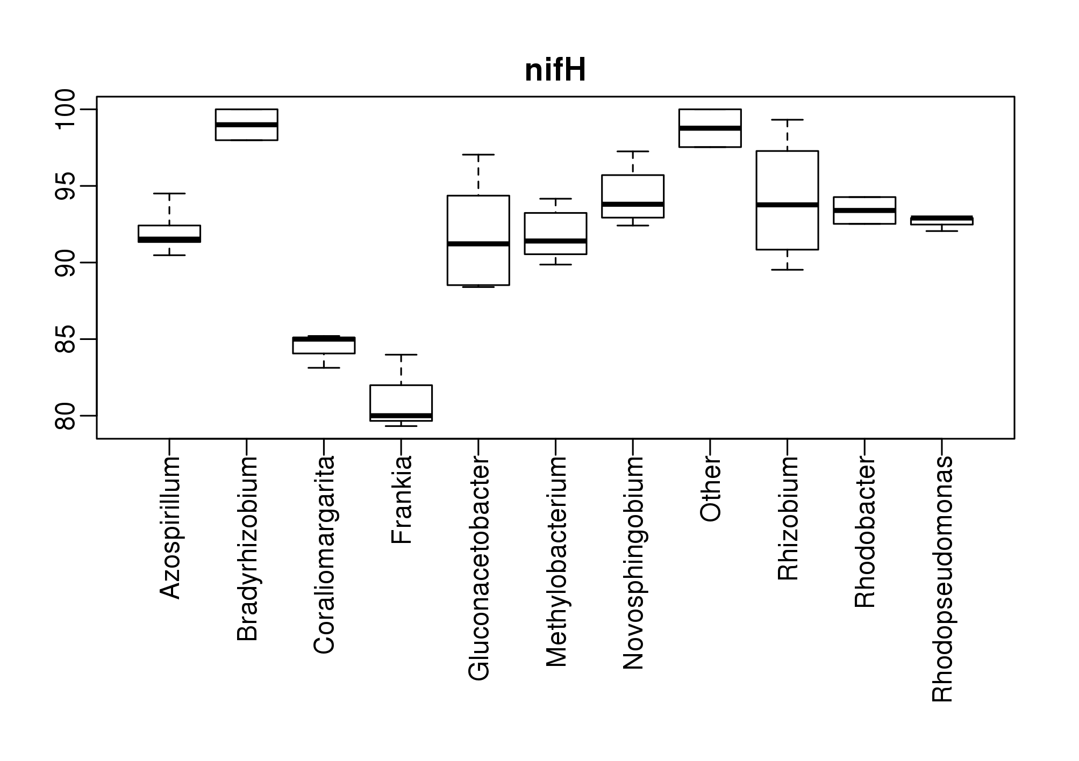

FIG S10 Distribution of identity of assembled *nifH* sequences to their best-hit references. Percent identities (Y axis) are grouped by genera. Assemblies with best-hit reference from *Coraliomargarita* and *Frankia* has percentage identity lower than other genera (< 85%), indicates these sequences are more likely to be incorrectly classified.

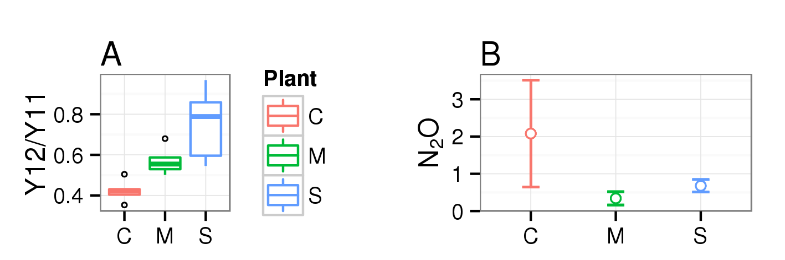

FIG S11 Ratio of 2012 yield over 2011 and N2O flux measured near sampling time. Ratio of 2012 yield over 2011 of corn is significantly lower than *Miscanthus* and switchgrass, suggesting corn yield is impacted more by 2012 drought (A). Average of N2O flux is higher in corn than *Miscanthus* and switchgrass, but not significant at *α* = 0.05 level due to high variation in corn (B).