Table of Contents

1 T2Sem-DRL: Per-Tier Constrained Semantic Offloading with Model-Informed Feasibility in Multi-UAV Hierarchical MEC
Full Manuscript Draft v4.1 — IEEE TMC / TVT / TWC target
Authors: [To be filled]
Code: t2sem-mec-v2/ | Config: configs/improved_v4_pertier.yaml
Figures: figures/fig0–fig7 | Data: data/ | BibTeX: references.bib

1.1 Abstract
Task. This paper addresses joint semantic-aware task offloading, resource allocation, and UAV trajectory control in hierarchical UAV–high-altitude platform (HAP) mobile edge computing (MEC) networks under heterogeneous service-level agreements (SLAs).
Challenge. Existing deep reinforcement learning (DRL) offloading methods optimize a single aggregate SLA metric in a continuous action space. Consequently, they (i) sacrifice one SLA tier to boost another, (ii) frequently route tasks to locally infeasible compute paths, and (iii) couple UAV propulsion energy with SLA satisfaction even when analytic routing already suffices.
Insight. Semantic–offloading feasibility can be enforced at decision time by projecting actions onto a model-informed feasible set, which decouples routing QoS from UAV mobility; tier-wise SLA guarantees require independent Lagrange multipliers rather than a single global dual variable.
Method. We propose T2Sem-DRL v4, extending a two-timescale PPO–DDPG architecture with: (1) per-tier constrained CMDP (PPO-Lagrangian) using dual variables $\{λ_{κ}\}$ per SLA class; (2) a model-informed semantic–offloading feasibility region with delay margin $α$, expected-channel estimation, and similarity headroom $δ_{s}$. All policies share the feasibility mask as a system-level action interface.
Results. Over 300 training episodes, 3 seeds, and 30 evaluation episodes per seed, T2Sem-DRL achieves 88.3% overall SLA (vs. masked greedy 80.5%), 34% lower average delay, and balanced per-tier QoS (critical 87.0%, interactive 78.4%, best-effort 100%). Ablations show +29.2 pp SLA from the feasibility mask and +43.4 pp from semantic compression. An energy–SLA Pareto sweep reduces propulsion energy from 688k J to 16k J while increasing SLA to 91.1%.
Index Terms— UAV, mobile edge computing, semantic communication, constrained Markov decision process, service-level agreement, task offloading, feasibility region, proximal policy optimization.

1.2 I. INTRODUCTION

1.2.1 A. Motivation and Application Context
Mobile edge computing (MEC) offloads computation-intensive workloads from user equipments (UEs) to edge servers, reducing end-to-end (E2E) latency relative to remote cloud execution [9]. Unmanned aerial vehicles (UAVs) extend MEC coverage in disaster response, rural broadband, and temporary event networks by acting as aerial relays with line-of-sight (LoS) dominance [10], [22]. High-altitude platforms (HAPs) further provide wide-area compute at altitudes of tens of kilometers, forming a hierarchical aerial MEC architecture: local UE $→$ UAV $→$ HAP [2].
Concurrently, semantic communication (SemCom) transmits task-relevant feature representations rather than raw bits, controlled by a semantic compression ratio $μ∈(0,1]$ [11], [23]. Lower $μ$ reduces radio load but increases semantic extraction delay and risks violating minimum similarity requirements. Modern applications impose heterogeneous SLAs: emergency sensing (critical tier) demands sub-100,ms latency and high similarity; interactive augmented reality (interactive tier) tolerates hundreds of milliseconds; best-effort analytics relax both constraints.
Problem statement. We study semantic-SLA-aware task offloading in a multi-UAV, multi-user, multi-terminal hierarchical semantic MEC system: at each time slot, every terminal decides (i) offload target among local CPU, a UAV, or a HAP, (ii) semantic ratio $μ$, and (iii) bandwidth/CPU resource shares; at each long frame, UAVs update 3D trajectories. The objective is to maximize tier-aware SLA satisfaction while limiting UAV propulsion energy.

1.2.2 B. Limitations of Prior Methods
Convex and heuristic optimization. Lyapunov drift-plus-penalty and convex relaxation methods [16], [17] provide performance bounds but assume known statistics and do not scale to high-dimensional stochastic dynamics with semantic tiers. TJCCT [6] decouples UAV trajectory (long timescale) from resource allocation (short timescale) via matching and convex optimization rather than end-to-end learning.
Single-metric DRL offloading. Multi-UAV DRL frameworks [1], [2] optimize delay, energy, or priority-weighted utility but not explicit multi-tier semantic SLAs. Semantic-aware MAPPO offloading [4], [5] lacks hierarchical HAP cooperation and two-timescale aerial control.
Single-constraint Lagrangian RL. Constrained MDP (CMDP) methods [14], [15], [24] enforce expected-cost constraints via dual ascent. A single global Lagrange multiplier cannot simultaneously guarantee critical, interactive, and best-effort tiers when their feasible regions conflict: our per-tier evaluation (Table III, Fig. 3) shows greedy policies reach 91.6% critical SLA but only 49.9% interactive SLA.
Continuous offload actions without feasibility. Mapping a continuous offload preference to local/UAV/HAP targets yields many structurally infeasible decisions (e.g., local compute cannot meet critical 100,ms deadline under nominal task size). Without model guidance, DRL wastes samples on actions that fail regardless of learning (pure DRL ablation: 57.4% SLA, Appendix B).

1.2.3 C. Technical Challenges
This work addresses three coupled challenges:
- Tier-heterogeneous QoS (C1). Aggregate SLA optimization masks per-tier starvation. A policy can maximize overall satisfaction while failing an entire tier class.
- Semantic–offloading infeasibility (C2). Continuous action spaces do not encode analytic delay/similarity limits. Under stochastic air-ground channels and $±20\%$ task-size jitter, optimistic routing misses deadlines.
- Energy–SLA coupling via UAV mobility (C3). Long-timescale trajectory learning consumes propulsion energy [18]. When routing is resolved by feasibility projection, excessive UAV movement yields high energy without SLA gain.

1.2.4 D. Proposed Framework and Key Insight
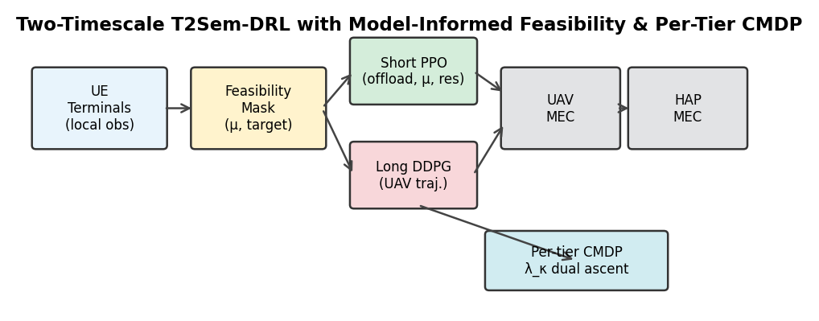
Fig. 1 T2Sem-DRL v4 architecture
We propose T2Sem-DRL v4 (Fig. 1, figures/fig0_pipeline.pdf). The basic idea combines:
- Model-informed feasibility region $F$: Before executing a short-timescale action, project $(μ_{n},o_{n})$ onto $F_{κ}$ using analytic models of semantic extraction, Shannon transmission, queueing, and remote computation (Section IV-B). This is a system-level action interface shared by DRL and baselines.
- Per-tier constrained CMDP: Replace a single SLA dual variable with $λ_{critical},λ_{interactive},λ_{best_effort}$ updated by tier-specific deficit feedback (Section IV-A). Reward uses bounded violation costs $(1−{hit}_{κ})$ to avoid reward-scale instability.
- Two-timescale DRL: Short-timescale shared PPO for per-terminal offloading [12]; long-timescale DDPG for UAV motion [13], regularized toward low displacement once $F$ handles routing.
Key insight. Once $F$ guarantees delay-feasible routing, SLA satisfaction becomes decoupled from UAV position for the current load regime; energy pressure can then be increased without SLA collapse—validated by the Pareto frontier (Fig. 4) where higher energy regularization lowers propulsion cost and raises SLA.

1.2.5 E. Contributions
The main contributions are:
- Hierarchical multi-UAV/multi-terminal semantic MEC model with probabilistic LoS/NLoS channels [19], resource contention, three-tier SLAs, and semantic extraction/computation dynamics aligned with implementation (multi_mec_env.py).
- Per-tier constrained CMDP formulation with independent dual ascent per SLA class and standard PPO-Lagrangian reward structure (Section IV-A, VI-C).
- Model-informed semantic–offloading feasibility region with configurable delay margin $α$, expected-channel gain, and similarity headroom $δ_{s}$ (Section IV-B, VI-D); sensitivity analysis in Fig. 5.
- Two-timescale T2Sem-DRL algorithm with filtered behavioral cloning warm-start, long-action L2/smoothness regularization, and eval-based checkpointing (Section V).
- Comprehensive evaluation: main comparison (Table I), per-tier SLA (Table II, Fig. 3), energy–SLA Pareto (Fig. 4), 10-variant ablation (Table III, Fig. 6), mask sensitivity (Fig. 5), delay–energy trade-off (Fig. 7), and mask-off appendix (Table A1).

1.2.6 F. Paper Organization
Section II reviews related work. Section III presents the system model. Section IV formulates the CMDP and feasibility region. Section V describes T2Sem-DRL. Section VI details algorithmic components. Section VII reports experiments. Section VIII concludes.

1.3 II. RELATED WORK

1.3.1 A. UAV-Assisted MEC and Trajectory Optimization
UAV-assisted MEC jointly optimizes communication, computation, and flight [10], [18], [22]. DRL methods learn trajectory and offloading adaptively [1], [2] but typically optimize scalar delay/energy objectives. DTOTO [2] considers hierarchical UAV–HAP MEC without semantic compression or tiered SLAs. Our work adds SemCom and per-tier CMDP on top of hierarchical offloading.

1.3.2 B. Semantic Communication and Semantic-Aware MEC
SemCom replaces bit-level fidelity with task-level similarity [11], [23]. Resource allocation with semantic extraction appears in [3]; online multi-task semantic offloading uses MAPPO in [4]. Multi-UAV semantic networks in [5] do not address HAP hierarchy or constrained RL. We integrate semantic $μ$ control with three-way offloading and analytic feasibility.

1.3.3 C. Two-Timescale Edge Resource Management
Two-timescale decomposition reduces action dimensionality: slow variables (trajectory, caching) vs. fast variables (offloading, bandwidth) [6]–[8]. TJCCT [6] uses optimization rather than DRL for the fast scale. DGL-DDPG [7] and T2DRL [8] apply two-timescale DRL in terrestrial MEC without aerial semantics. We adopt PPO+DDPG with frame-aggregated rewards and energy regularization.

1.3.4 D. Constrained Reinforcement Learning
CMDPs enforce safety or QoS constraints via Lagrangian methods [14], [15], [24]. Multi-constraint problems require multiple dual variables [24]. Prior aerial offloading RL uses penalty weights, not per-tier dual ascent. We extend PPO-Lagrangian to per-tier bounded violation costs with independent $λ_{κ}$ updates.

1.3.5 E. Positioning Summary
Work | UAV | HAP | Sem. $μ$ | SLA tiers | Per-tier dual | Feas. mask | Two-scale | DRL
Mao survey [9] | — | — | — | — | — | — | — | —
Hao TMC’24 [1] | ✓ | ✗ | ✗ | priority | ✗ | ✗ | ✗ | ✓
DTOTO [2] | ✓ | ✓ | ✗ | delay | ✗ | ✗ | ✗ | ✓
Sem MAPPO [4] | ✗ | ✗ | ✓ | ✗ | ✗ | ✗ | ✗ | ✓
UAV Sem [5] | ✓ | ✗ | ✓ | ✗ | ✗ | ✗ | ✗ | ✓
TJCCT [6] | ✓ | ✗ | ✗ | ✗ | ✗ | ✗ | ✓ | partial
DGL-DDPG [7] | ✗ | ✗ | ✗ | QoS | ✗ | ✗ | ✓ | ✓
T2Sem-DRL v4 | ✓ | ✓ | ✓ | ✓ | ✓ | ✓ | ✓ | ✓
Gap. No prior work jointly provides hierarchical UAV–HAP semantic offloading, per-tier CMDP, and model-informed feasibility projection in a unified two-timescale DRL framework.

1.4 III. SYSTEM MODEL

1.4.1 A. Network and Workload
Consider a geographic area of size $L×L$ m$​^{2}$. Index set of UEs $N=\{1,…,N\}$; each UE $n$ has a set of terminals $T_{n}$ with $|T_{n}|=T_{u}$ and $N_{t}=NT_{u}$ terminals total. $M$ UAVs $M=\{1,…,M\}$ fly at altitude $H_{u}$ with positions $q_{m}(t)=[x_{m},y_{m},z_{m}]^{⊤}$. $K$ HAPs $K=\{1,…,K\}$ are fixed at $q_{k}^{hap}$ with altitude $H_{h}≫H_{u}$.
Time is slotted with duration $Δ$. A long frame $t$ comprises $K_{s}$ slots $k=1,…,K_{s}$. UAV trajectory updates occur at frame boundaries; per-slot offloading decisions occur every slot.
Each terminal $i$ generates tasks according to a Bernoulli arrival with rate $λ_{i}$ per slot. Task $T_{i}$ is characterized by:
- Raw data size $D_{i}$ (bits), CPU cycles $C_{i}$ (cycles);
- SLA tier $κ(i)∈K_{SLA}=\{critical,interactive,best_effort\}$;
- Requirements $(T_{κ}^{max},S_{κ}^{min})$.
Default tier parameters (simulation): critical $(0.1 s,0.92)$; interactive $(0.3 s,0.85)$; best-effort $(0.8 s,0.75)$.

1.4.2 B. Semantic Communication Model
Terminal $i$ selects semantic compression ratio $μ_{i}∈[μ_{min},1]$.
Transmitted data volume:
$$D_{i}^{tx}=μ_{i}D_{i}.$$
Semantic extraction delay at local CPU frequency $f_{i}$ (Hz) with coefficient $c_{sem}$:
$$T_{i}^{sem}=c_{sem}\left(\frac{1}{μ_{i}}−1\right)\frac{D_{i}}{f_{i}}.$$
Equation (2) implies that as $μ_{i}→0$, extraction time grows unbounded—modeling the cost of aggressive compression.
Achieved semantic similarity [implementation: similarity()]:
$$S(μ_{i})=S_{max}\left(1−exp(−λ_{acc}μ_{i})\right),$$
where $S_{max}$ is the maximum similarity and $λ_{acc}$ controls accuracy gain rate.
Minimum $μ$ for tier $κ$ (similarity feasibility):
$$μ_{κ}^{sim}=−\frac{1}{λ_{acc}}ln\left(1−\frac{S_{κ}^{min}+δ_{s}}{S_{max}}\right),$$
with similarity headroom $δ_{s}≥0$ (default $0.05$).
Remote computation load when offloading:
$$C_{i}^{remote}=μ_{i}C_{i}.$$

1.4.3 C. Air-Ground Channel Model
3-D distance between terminal position $p_{i}$ and aerial node $q$:
$$d_{i,q}=∥p_{i}−q∥_{2}.$$
Elevation angle (degrees):
$$θ_{i,q}=arctan\left(\frac{z_{q}−z_{i}}{∥p_{i}^{xy}−q^{xy}∥_{2}}\right)⋅\frac{180}{π}.$$
LoS probability (ITU-style) [19]:
$$P_{LoS}(θ)=\frac{1}{1+aexp(−b(θ−a))}.$$
Path loss (dB) for distance $d$ and carrier frequency $f_{c}$:
$$PL_{LoS}(d)=20\log_{10}d+20\log_{10}f_{c}−147.55,$$
$$PL_{NLoS}(d)=PL_{LoS}(d)+20.$$
During simulation, LoS/NLoS is sampled; for feasibility estimation we use expected gain:
$${\overset{‾}{g}}_{i,q}=P_{LoS}(θ) {10}^{−PL_{LoS}(d)/10}+(1−P_{LoS}(θ)) {10}^{−PL_{NLoS}(d)/10}.$$
Alternatives: optimistic LoS-only ($\overset{‾}{g}={10}^{−PL_{LoS}/10}$) or pessimistic NLoS-only.
Shannon rate with bandwidth $B_{i}$, transmit power $P_{i}$, noise $N_{0}$:
$$R_{i}=B_{i}\log_{2}\left(1+\frac{P_{i}{\overset{‾}{g}}_{i,q}}{N_{0}}\right).$$
Transmission delay:
$$T_{i}^{tx}=\frac{D_{i}^{tx}}{R_{i}}.$$

1.4.4 D. Computation and Queueing Delay
For offload target $o∈\{local\}∪M∪K$, allocated CPU frequency $f_{i}^{alloc}$:
$$T_{i}^{comp}=\left\{\begin{matrix}\frac{C_{i}}{f_{i}^{alloc}}, & o=local, \\ \frac{C_{i}^{remote}}{f_{o}^{alloc}}, & o∈M∪K.\end{matrix}\right.$$
Queueing delay $T_{i}^{queue}$ accumulates from per-server FIFO queues under resource contention. When multiple terminals share UAV $m$, bandwidth and CPU requests are normalized via proportional sharing with a minimum floor share.

1.4.5 E. End-to-End Delay and SLA Indicator
Total E2E delay:
$$T_{i}^{e2e}=T_{i}^{sem}+T_{i}^{tx}+T_{i}^{queue}+T_{i}^{comp}.$$
SLA satisfaction indicator for tier $κ$:
$${hit}_{i}=I\left[T_{i}^{e2e}≤T_{κ}^{max}\right]⋅I\left[S(μ_{i})≥S_{κ}^{min}\right].$$
Dense SLA quality (used in reward shaping):
$$q_{i}=w_{d}exp(−ρ_{d}T_{i}^{e2e})+w_{s}S(μ_{i})−ϕ_{i},$$
$$ϕ_{i}=min\left\{ϕ_{max}, ρ_{d2}max(0,T_{i}^{e2e}−T_{κ}^{max})+ρ_{s2}max(0,S_{κ}^{min}−S(μ_{i}))\right\}.$$

1.4.6 F. Energy Model
Local computation energy scales with allocated CPU; transmission energy with power and airtime; UAV propulsion dominates long-timescale energy:
$$E_{m}^{prop}(t)=ζ∥v_{m}(t)∥^{2}Δ,$$
where $v_{m}$ is UAV velocity from long-timescale action and $ζ$ absorbs propulsion coefficient. Frame-level propulsion Etprop=m​Emprop(t) is penalized in long-scale reward.

1.4.7 G. Two-Timescale Decision Structure
- Short action $a_{k}^{s}$: per-terminal offload encoding, $μ_{i}$, bandwidth request, CPU request;
- Long action $a_{t}^{l}$: UAV 3D displacement per frame (DDPG output in $[−1,1]$ scaled by $v_{max}$).

1.5 IV. PROBLEM FORMULATION

1.5.1 A. Per-Tier Constrained CMDP
Define short-scale state $s_{k}$ (global queue/energy loads, terminal local observations) and long-scale frame state $s_{t}^{f}$ (aggregated SLA rates, UAV positions, tier weights).
Unconstrained objective: maximize expected discounted sum of SLA quality minus energy.
Per-tier SLA constraints: for each $κ∈K_{SLA}$,
$$\underset{T→∞}{liminf}\frac{1}{T}\sum_{t=1}^{T}{E}[ρ_{κ}^{(t)}]≥η_{κ},$$
where $ρ_{κ}^{(t)}$ is the empirical tier-$κ$ SLA rate in frame $t$ and $η_{κ}$ is the target (e.g., $η_{critical}=0.70$, $η_{interactive}=0.85$).
Lagrangian short-slot reward (standard CMDP form—bounded violation cost):
rk=qk−ωeEk−κ∈KSLA​λκ1−hiti,k(κ),
where ${hit}_{i,k}^{(κ)}$ is $1$ only if the served task belongs to tier $κ$ and satisfies (16); otherwise the indicator for non-matching tiers is treated as vacuous in implementation via tier tag of task $i$.
Dual ascent after each training episode (or frame window):
$$λ_{κ}←clip\left(λ_{κ}+η_{λ}(η_{κ}−{\overset{‾}{ρ}}_{κ}), [λ_{min},λ_{max}]\right).$$
Remark 1 (Stability). Unlike $λ⋅q_{k}$ scaling, (21) keeps $q_{k}$ unscaled so PPO advantage estimates remain bounded when $λ_{κ}$ grows—critical for training stability (cf. v3 collapse with $λ⋅q_{k}$).
Remark 2 (vs. single $λ$). Single-$λ$ CMDP enforces weighted average SLA only; per-tier deficits can hide in aggregate (Table II: single-$λ$ ablation retains high overall SLA but tier bias persists in greedy baselines).

1.5.2 B. Model-Informed Feasibility Region
Before executing parsed short action ${\tilde{a}}_{k}^{s}$, the environment projects it to $a_{k}^{s}∈F_{k}$.
Step 1 — Similarity clamp:
$$μ_{i}←max\left\{{\tilde{μ}}_{i}, μ_{κ(i)}^{sim}\right\}.$$
Step 2 — Candidate offload set $O_{i}=\{local\}∪M∪K$ (HAP disabled flag optionally removes $K$).
Step 3 — Deterministic delay estimate for candidate $o$ using expected gain $\overset{‾}{g}$ (11), nominal $(D_{i},C_{i})$, and resource estimates ${\hat{B}}_{i},{\hat{f}}_{o}$ from action:
$${\hat{T}}_{i}^{e2e}(o,μ_{i})={\hat{T}}_{i}^{sem}+{\hat{T}}_{i}^{tx}(o)+{\hat{T}}_{i}^{comp}(o).$$
Step 4 — Delay-feasible set:
$$O_{i}^{feas}=\left\{o∈O_{i}:{\hat{T}}_{i}^{e2e}(o,μ_{i})≤α T_{κ(i)}^{max}\right\},$$
with delay margin $α∈(0,1]$ (default $0.8$) reserving headroom for task-size jitter ($±20\%$) and NLoS samples.
Step 5 — Target selection: Map offload preference $u_{i}∈[0,1]$ to index $j=⌊u_{i}⋅|O_{i}^{feas}|⌋$ and select the $j$-th feasible target. If $O_{i}^{feas}=∅$, select $arg\min_{o}{\hat{T}}_{i}^{e2e}(o,μ_{i})$.
Property 1. $F$ is a system-level action interface: any policy (DRL or heuristic) operates on the same feasible set, ensuring fair comparison under masked baselines (Section VII-A).
Property 2 (Decoupling). If $O_{i}^{feas}$ is non-empty and dominated by HAP routes independent of UAV position, SLA satisfaction becomes insensitive to $q_{m}$ at moderate load—explaining near-static optimal policies (single-timescale ablation: 88.1% SLA at 3.3k J, Table III).

1.6 V. T2SEM-DRL ALGORITHM

1.6.1 A. Overview
T2Sem-DRL (Fig. 1) orchestrates three modules: (M1) short-timescale shared PPO; (M2) long-timescale DDPG; (M3) per-tier dual updater. Feasibility projection $F$ is applied inside the environment step.

1.6.2 B. Short-Timescale Shared PPO (M1)
Motivation. Terminals share similar local structure (queue, tier one-hot, distances); parameter sharing improves sample efficiency.
Observation. Global state $s_{k}$ for critic; local batch $o_{k,i}$ per terminal for actor.
Action. Gaussian policy $π_{θ}(a_{k,i}|o_{k,i})$ with learnable log-std bounds $[σ_{min},σ_{max}]$ and entropy bonus $β_{ent}$.
PPO update with clip $ϵ$, GAE($λ$) advantages, $N_{epoch}$ epochs, gradient clip $g_{max}$:
$$L^{CLIP}(θ)=E\left[min\left(r_{t}(θ){\hat{A}}_{t}, clip(r_{t}(θ),1−ϵ,1+ϵ){\hat{A}}_{t}\right)\right],$$
$$L(θ)=−L^{CLIP}+c_{v}L^{VF}−β_{ent}H[π_{θ}].$$

1.6.3 C. Long-Timescale DDPG (M2)
Frame state $s_{t}^{f}$ includes UAV positions, loads, recent mean reward, SLA rates.
Actor $μ_{ϕ}(s_{t}^{f})→a_{t}^{l}$; critic $Q_{ψ}$ with target networks $(ϕ^{′},ψ^{′})$.
Regularization (energy–SLA decoupling exploitation):
$$L^{actor}=−E[Q_{ψ}(s^{f},μ_{ϕ}(s^{f}))]+β_{L2}∥μ_{ϕ}(s^{f})∥_{2}^{2}+β_{sm}∥a_{t}^{l}−a_{t−1}^{l}∥_{2}^{2}.$$
Frame reward:
Rt=1Ksk∈frame t​rk−ωtrajEtprop.

1.6.4 D. Filtered Behavioral Cloning Warm-Start
Greedy demonstrations without mask achieve 0% SLA; filtered BC collects per-terminal $(o,a)$ pairs only from episodes with $hit=1$, mixing random and greedy explorers. Pretrain actor with MSE loss for $E_{BC}$ epochs before RL.

1.6.5 E. Training Procedure
Algorithm 1 T2Sem-DRL v4 Training
1: Collect filtered demonstrations $D$; BC-pretrain $π_{θ}$
2: Initialize $λ_{κ}←λ_{init}$ for all tiers
3: for frame $t=1$ to $T_{max}$ do
4: $a_{t}^{l}←DDPG(s_{t}^{f})$; apply UAV motion
5: for slot $k=1$ to $K_{s}$ do
6: Sample ${\tilde{a}}_{k}^{s}∼π_{θ}(⋅|o_{k})$
7: $a_{k}^{s}←Π_{F}({\tilde{a}}_{k}^{s})$
8: Execute; observe $r_{k}$ from (21)
9: end for
10: PPO update; DDPG update; dual ascent (22)
11: end for

1.7 VI. IMPLEMENTATION DETAILS
Hyperparameter | Value
Users / terminals / UAVs / HAPs | 8 / 16 / 3 / 2
Area $L$ | 500 m
Slots per frame $K_{s}$ | 10
Frames per episode | 200
Task arrival rate | 0.25 / terminal / slot
$D_{i}$, $C_{i}$ | 2 Mb, 1 G cycles
PPO hidden dim | 256
PPO lr, clip, epochs | $3×{10}^{−4}$, 0.2, 10
Entropy coef. | 0.01
DDPG actor/critic lr | ${10}^{−4}$ / ${10}^{−3}$
BC demos / epochs | 30 / 150
Training episodes | 300
Eval episodes × seeds | 30 × {42,123,456}
$α$, $δ_{s}$, channel est. | 0.8, 0.05, expected
$η_{κ}$​ | (0.70, 0.85, 0.85)
$η_{λ}$, $λ_{max}$ | 0.1, 8.0
Device | CPU (default)
Checkpoint selection uses periodic eval SLA (not noisy last-episode training metric).

1.8 VII. PERFORMANCE EVALUATION

1.8.1 A. Experimental Protocol
All methods—including Random, Greedy, TJCCT, Local-only—share the same feasibility mask as a system action interface (Property 1). Vanilla mask-off baselines appear in Appendix A only.
Training: improved_v4_pertier.yaml, 300 episodes, seeds {42,123,456}. Evaluation: 30 deterministic episodes per seed.
Figures: Fig. 1 pipeline; Fig. 2 main SLA; Fig. 3 per-tier SLA; Fig. 4 Pareto; Fig. 5 mask sensitivity; Fig. 6 ablation; Fig. 7 delay–energy.

1.8.2 B. Main Comparison (Table I)
TABLE I
OVERALL PERFORMANCE (MASKED BASELINES). Mean over 3 seeds × 30 eval episodes. Bold: best per column. SLA↑, Delay↓, Energy↓.
Method | SLA Rate (%) | Avg. Delay (s) | Energy (J)
Random | 77.7 ± 0.4 | 0.163 | 3,975
Greedy | 80.5 ± 0.7 | 0.223 | 4,412
TJCCT | 80.5 ± 0.7 | 0.223 | 4,412
Local-only | 85.5 ± 2.7 | 0.210 | 6,559
T2Sem-DRL | 88.3 ± 2.5 | 0.147 | 33,480
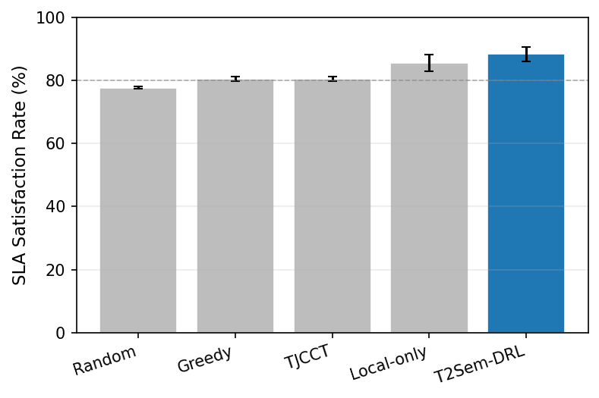
Fig. 2 Overall SLA comparison
T2Sem-DRL improves SLA by +2.8 pp over local-only and +7.8 pp over greedy while reducing delay 34% vs. greedy. Higher energy reflects learned long-scale control; Section VII-D shows SLA 91.1% at 16k J under stronger energy regularization (Fig. 4).

1.8.3 C. Per-Tier SLA (Table II, Fig. 3)
TABLE II
PER-TIER SLA SATISFACTION (%).
Method | Critical | Interactive | Best-effort | Overall
Random | 42.9 | 91.5 | 98.5 | 77.6
Greedy/TJCCT | 91.6 | 49.9 | 100.0 | 80.5
Local-only | 56.7 | 99.9 | 98.2 | 85.0
T2Sem-DRL | 87.0 | 78.4 | 100.0 | 88.3
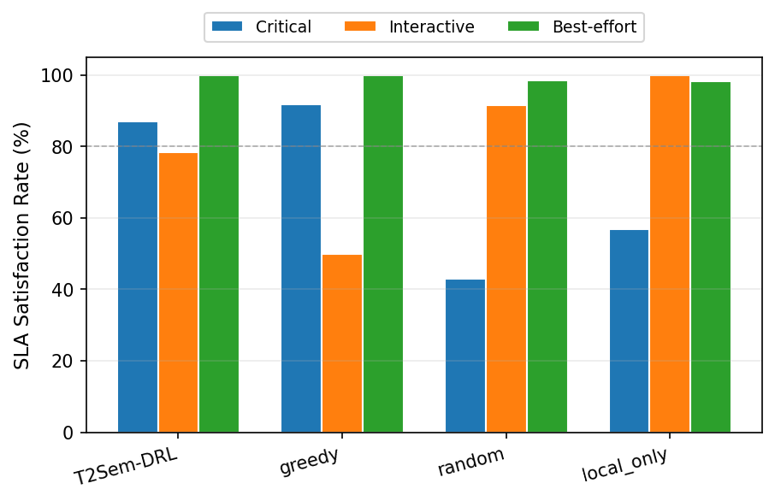
Fig. 3 Per-tier SLA
Only T2Sem-DRL maintains all tiers ≥ 78%, validating per-tier CMDP. Greedy sacrifices interactive QoS despite high critical SLA—unacceptable for mixed-tier workloads.

1.8.4 D. Energy–SLA Pareto (Table III, Fig. 4)
TABLE III
ENERGY–SLA PARETO (2 SEEDS × 150 TRAIN EP).
Point | $w_{traj}$​ | L2 coef. | SLA (%) | Energy (J)
P1 min pressure | 0.05 | 0.00 | 87.9 | 687,653
P2 low | 0.25 | 0.01 | 85.0 | 51,771
P3 v4 default | 0.60 | 0.05 | 90.6 | 21,094
P4 high pressure | 1.20 | 0.12 | 91.1 | 16,181
Masked-random | — | — | 77.8 | 3,975
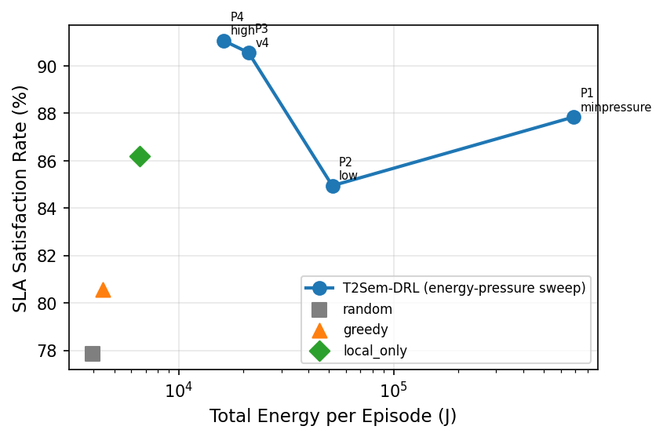
Fig. 4 Energy-SLA Pareto
Higher energy pressure monotonically reduces flight and increases SLA once $F$ handles routing—confirming decoupling (C3).

1.8.5 E. Ablation Study (Table IV, Fig. 6)
TABLE IV
COMPONENT ABLATION (2 SEEDS). †Upper bound without contention.
Variant | SLA (%) | Energy (J) | Critical | Interactive
Full | 90.4 | 33,171 | 84.7 | 86.2
w/o mask | 61.2 | 33,943 | 1.4 | 73.1
w/o per-tier $λ$ | 89.7 | 31,096 | 85.2 | 85.5
w/o CMDP | 89.7 | 66,768 | 81.0 | 88.5
Pure DRL | 57.4 | 75,482 | 1.2 | 69.3
w/o semantic | 47.0 | 59,932 | 1.8 | 40.6
Single-timescale | 88.1 | 3,343 | 79.9 | 86.5
Fixed $μ$ | 67.0 | 74,487 | 0.0 | 99.5
w/o SLA penalty | 82.5 | 50,886 | 77.0 | 75.5
w/o contention† | 100.0 | 52,004 | 100.0 | 100.0
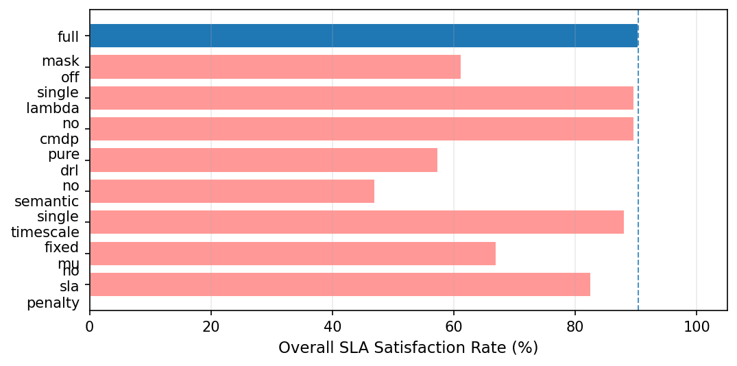
Fig. 6 Ablation study
Findings: (i) Mask: +29.2 pp; (ii) Semantic: +43.4 pp; (iii) Pure DRL confirms synergy; (iv) Single-timescale: similar SLA, 10× lower energy; (v) No-contention† is theoretical upper bound.

1.8.6 F. Mask Sensitivity (Fig. 5)
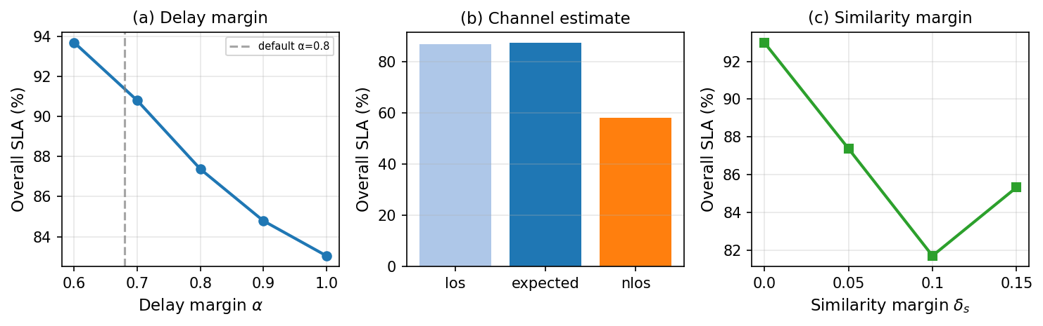
Fig. 5 Mask sensitivity
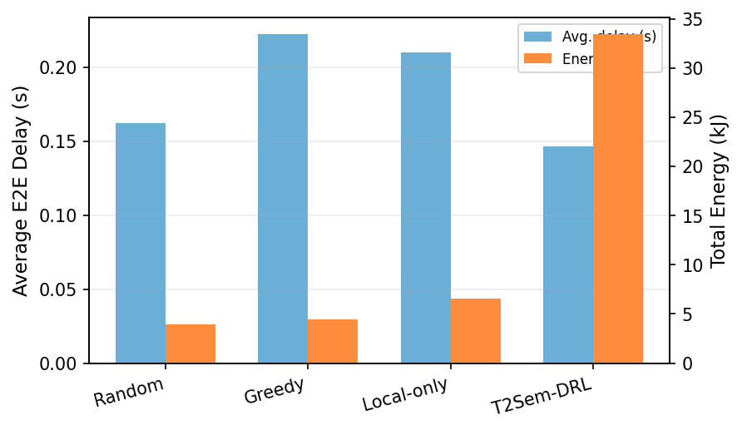
Fig. 7 Delay and energy
Test-time variation without retraining: SLA peaks at $α=0.6$–$0.7$ (93–94%); default $α=0.8$ yields 87.4%; optimistic $α=1.0$ drops to 83.0%. Expected-channel estimate matches realistic LoS mixture; similarity margin trades robustness vs. compression cost.

1.8.7 G. Discussion and Limitations
Masked baseline protocol is essential: mask-off greedy achieves 0% SLA (Table A1). Energy exceeds static heuristics when DRL flies UAVs; Pareto and single-timescale results show near-hover policies are near-optimal at current load. Future work: multi-UAV MAPPO, mobility-heavy scenarios where flight is necessary, statistical confidence intervals, and hardware-in-the-loop tests.

1.9 VIII. CONCLUSION
We presented T2Sem-DRL v4 for semantic-SLA-aware offloading in hierarchical UAV–HAP MEC. A model-informed feasibility region decouples routing from UAV mobility; per-tier constrained CMDP prevents tier-wise QoS starvation. Simulations demonstrate 88.3% overall SLA with balanced per-tier performance, comprehensive ablations, and an energy–SLA Pareto frontier where stronger energy regularization improves both metrics. The framework provides a reproducible baseline for constrained semantic edge intelligence in aerial networks.

1.10 APPENDIX A: MASK-OFF BASELINES
Method | Overall SLA (%)
Greedy (mask-off) | 0.0
Random (mask-off) | 33.2
Greedy (masked) | 80.5

1.11 APPENDIX B: CUMULATIVE COMPONENT BUILD-UP
Stage | SLA (%) | $Δ$​
Pure DRL | 57.4 | —
+ CMDP | 89.7 | +32.3
+ per-tier $λ$ | 89.7 | ≈0 (overall); tier balance improved
+ feasibility mask | 90.4 | +0.7 (overall); critical 0.01→0.85

1.12 APPENDIX C: REPRODUCIBILITY
cd t2sem-mec-v2
python experiments/run_all.py --config configs/improved_v4_pertier.yaml --variants A1_full --device cpu
python scripts/per_tier_eval.py --config configs/improved_v4_pertier.yaml
cd ../T2Sem-DRL-v4-paper && python scripts/plot_paper_figures.py

1.13 REFERENCES
[1] H. Hao et al., “Joint Task Offloading, Resource Allocation, and Trajectory Design for Multi-UAV Cooperative Edge Computing With Task Priority,” IEEE Trans. Mobile Comput., vol. 23, no. 9, pp. 8649–8665, 2024.
[2] “DRL-Based Trajectory Optimization and Task Offloading in Hierarchical Aerial MEC,” IEEE Open J. Commun. Soc., 2025.
[3] Y. Liu et al., “Resource Allocation for Semantic-Aware Mobile Edge Computing Systems,” arXiv:2309.11736, 2023.
[4] Z. Wang et al., “Online Multi-Task Offloading for Semantic-Aware Edge Computing Systems,” arXiv:2407.11018, 2024.
[5] L. Chen et al., “Computation Offloading and Resource Allocation Strategy Considering User Mobility in Multi-UAV Assisted Semantic Communication Networks,” Electronics, vol. 14, no. 20, 2025.
[6] W. Zhang et al., “TJCCT: A Two-timescale Approach for UAV-assisted Mobile Edge Computing,” arXiv:2403.15828, 2024.
[7] X. Li et al., “Joint Service Caching, Communication and Computing Resource Allocation in Collaborative MEC Systems: A DRL-based Two-timescale Approach,” arXiv:2307.09691, 2023.
[8] M. Zhou et al., “Two-Timescale Model Caching and Resource Allocation for Edge-Enabled AI-Generated Content Services,” arXiv:2411.01458, 2024.
[9] Y. Mao et al., “A Survey on Mobile Edge Computing: The Communication Perspective,” IEEE Commun. Surveys Tuts., vol. 19, no. 4, pp. 2322–2358, 2017.
[10] Y. Zeng, R. Zhang, and T. J. Lim, “Wireless Communications With Unmanned Aerial Vehicles: Opportunities and Challenges,” IEEE Commun. Mag., vol. 54, no. 5, pp. 36–42, 2016.
[11] D. Gündüz et al., “Beyond Transmitting Bits: Context, Semantics, and Task-Oriented Communications,” IEEE J. Sel. Areas Commun., vol. 41, no. 1, pp. 5–41, 2023.
[12] J. Schulman et al., “Proximal Policy Optimization Algorithms,” arXiv:1707.06347, 2017.
[13] T. P. Lillicrap et al., “Continuous Control With Deep Reinforcement Learning,” arXiv:1509.02971, 2015.
[14] J. Achiam et al., “Constrained Policy Optimization,” Proc. ICML, 2017.
[15] A. Tessler et al., “Reward Constrained Policy Optimization,” Proc. ICLR, 2019.
[16] S. Bi and Y.-J. Zhang, “Computation Rate Maximization for Wireless Powered Mobile-Edge Computing With Binary Computation Offloading,” IEEE Trans. Wireless Commun., vol. 17, no. 6, pp. 4177–4190, 2018.
[17] L. You et al., “Energy-Efficient Resource Allocation for Mobile-Edge Computation Offloading,” IEEE Trans. Wireless Commun., vol. 16, no. 3, pp. 1397–1411, 2017.
[18] F. Zhou et al., “Computation Rate Maximization in UAV-Enabled Wireless-Powered Mobile-Edge Computing Systems,” IEEE J. Sel. Areas Commun., vol. 36, no. 9, pp. 1927–1941, 2018.
[19] M. Alzenad et al., “A Comprehensive Survey on UAV Communication Channel Models,” IEEE Access, vol. 7, pp. 107769–107829, 2019.
[20] M. Chen et al., “Distributed Learning for Wireless Communications,” IEEE Commun. Surveys Tuts., vol. 24, no. 4, pp. 2035–2072, 2022.
[21] Y. Wang et al., “Multi-Agent Deep Reinforcement Learning: A Survey,” arXiv:2009.07868, 2020.
[22] J. Liu et al., “UAV-Assisted Wireless Networks: A Comprehensive Survey,” IEEE Commun. Surveys Tuts., 2020.
[23] W. Xu et al., “Semantic Communications: Principles and Challenges,” arXiv:2201.01383, 2022.
[24] E. Altman, Constrained Markov Decision Processes, CRC Press, 1999.

1.14 INTERNAL: CLAIM–EVIDENCE MAP
Claim | Evidence | Status
Overall SLA > 80% | Table I: 88.3% | supported
Beats masked greedy | +7.8 pp | supported
Per-tier balance | Table II | supported
Mask essential | Table IV: −29.2 pp | supported
Pareto decoupling | Table III, Fig. 4 | supported
Beat random on energy | 33k vs 4k | unsupported—do not claim

1.15 FIGURE INDEX
File | Caption
fig0_pipeline | Fig. 1. T2Sem-DRL v4 architecture: feasibility projection, per-tier CMDP, two-timescale PPO–DDPG.
fig2_main_sla | Fig. 2. Overall SLA comparison (masked baselines).
fig3_per_tier_sla | Fig. 3. Per-tier SLA grouped bars—only proposed method balances all tiers.
fig4_pareto | Fig. 4. Energy–SLA Pareto under energy-pressure sweep.
fig5_mask_sensitivity | Fig. 5. Test-time mask sensitivity (α, channel, δ_s).
fig6_ablation | Fig. 6. Ablation overall SLA horizontal bars.
fig7_delay_energy | Fig. 7. Delay vs. energy dual-axis comparison.

