T2Sem-DRL: Per-Tier Constrained Semantic Offloading with Model-Informed Feasibility in Multi-UAV Hierarchical MEC
Jiashang Shen
Wenzhou Kean University, Wenzhou, China
shenjias@kean.edu
Abstract
Hierarchical UAV–high-altitude platform (HAP) semantic MEC must satisfy tier-heterogeneous SLAs under stochastic air-ground channels. We show the main failure mode is not missing DRL complexity, but infeasible offload actions and tier starvation in continuous control.
We contribute a model-informed offloading interface and an empirical contribution decomposition (not a new RL backbone): (1) feasibility projection F shared by all policies, (2) semantic-aware hierarchical delay/similarity model, and (3) optional masked PPO inside F. Under the canonical protocol (3 seeds × 30 eval episodes), T2Sem-DRL reaches 93.99±1.74% SLA vs. 87.77±0.07% for masked greedy (+6.22 pp), with mean delay 0.100 s. Ablation quantifies lever size: semantic model +46.0 pp, feasibility mask +31.8 pp, RL refinement +6.2 pp. Per-tier duals are diagnostic (not aggregate-SLA improving), and two-timescale DDPG is optional (93.99% vs. 88.85% single-timescale; Table I-b). A supplementary shared-interface semantic baseline (Semantic MAPPO + F) reaches 91.43% on canonical seeds (paired +2.56 pp, 95% CI [1.14, 4.41]); on expanded seeds 42,123,456,789,1011, the paired gap narrows to −0.25 pp (95% CI [−3.35, 2.84])—two different RL backbones converge inside the same interface, evidencing that F, not the RL architecture, is the dominant lever. A scale-up stress test (16 UEs / 32 terminals / 5 UAVs) closes the deployment triangle with matched-training semantic baseline: Greedy 71.03%, Semantic 73.72%, T2Sem 80.31% (paired +6.59 pp, 95% CI [2.71, 11.61]).
We do not claim universal energy dominance or critical-tier dominance. Energy is reported as operating points, and mixed-tier gains come with a critical-vs-interactive trade-off (Table II, Section VII-H).
Index Terms— UAV, mobile edge computing, semantic communication, constrained Markov decision process, service-level agreement, task offloading, feasibility region, proximal policy optimization.
I. INTRODUCTION
A. Motivation and Application Context
Mobile edge computing (MEC) offloads computation-intensive workloads from user equipments (UEs) to edge servers, reducing end-to-end (E2E) latency relative to remote cloud execution [17]. Unmanned aerial vehicles (UAVs) extend MEC coverage in disaster response, rural broadband, and temporary event networks by acting as aerial relays with line-of-sight (LoS) dominance [1], [13]. High-altitude platforms (HAPs) further provide wide-area compute at altitudes of tens of kilometers, forming a hierarchical aerial MEC architecture: local UE arrow UAV arrow HAP [2], [8].
Concurrently, semantic communication (SemCom) transmits task-relevant feature representations rather than raw bits, controlled by a semantic compression ratio μ ∈ (0,1] [11], [20]. Lower μ reduces radio load but increases semantic extraction delay and risks violating minimum similarity requirements. Modern applications impose heterogeneous SLAs: emergency sensing (critical tier) demands sub-100 ms latency and high similarity; interactive augmented reality (interactive tier) tolerates hundreds of milliseconds; best-effort analytics relax both constraints.
Problem statement. We study semantic-SLA-aware task offloading in a multi-UAV, multi-user, multi-terminal hierarchical semantic MEC system: at each time slot, every terminal decides (i) offload target among local CPU, a UAV, or a HAP, (ii) semantic ratio μ, and (iii) bandwidth/CPU resource shares; at each long frame, UAVs update 3D trajectories. The objective is to maximize tier-aware SLA satisfaction while limiting UAV propulsion energy.
B. Limitations of Prior Methods
Convex and heuristic optimization. Optimization-based MEC resource allocation methods [16], [17] provide useful structure but often assume known statistics and do not scale cleanly to high-dimensional stochastic dynamics with semantic tiers. TJCCT [5] decouples UAV trajectory (long timescale) from resource allocation (short timescale) via matching and convex optimization rather than end-to-end learning.
Single-metric DRL offloading. Multi-UAV DRL frameworks [1], [2] optimize delay, energy, or priority-weighted utility but not explicit multi-tier semantic SLAs. Semantic-aware MAPPO offloading [3], [4] and UAV semantic MEC [11], [21] lack hierarchical HAP cooperation, shared feasibility interfaces, and explicit multi-tier SLA reporting under identical protocols.
Single-constraint Lagrangian RL. Constrained MDP (CMDP) methods [14], [15] enforce expected-cost constraints via dual ascent. A single global Lagrange multiplier cannot simultaneously guarantee critical, interactive, and best-effort tiers when their feasible regions conflict: our per-tier evaluation (Table II, Fig. 4) shows greedy policies reach 91.6% critical SLA but only 49.9% interactive SLA.
Continuous offload actions without feasibility. Mapping a continuous offload preference to local/UAV/HAP targets yields many structurally infeasible decisions (e.g., local compute cannot meet critical 100 ms deadline under nominal task size). Without model guidance, DRL wastes samples on actions that fail regardless of learning (pure DRL ablation: 59.9% SLA, Appendix B).
C. Technical Challenges
This work addresses three coupled challenges:
• Tier-heterogeneous QoS (C1). Aggregate SLA optimization masks per-tier starvation. A policy can maximize overall satisfaction while failing an entire tier class.
• Semantic–offloading infeasibility (C2). Continuous action spaces do not encode analytic delay/similarity limits. Under stochastic air-ground channels and ± 20\% task-size jitter, optimistic routing misses deadlines.
• Energy–SLA coupling via UAV mobility (C3). Long-timescale trajectory learning consumes propulsion energy [1], [13]. When routing is resolved by feasibility projection, excessive UAV movement yields high energy without SLA gain.
D. Proposed Framework and Positioning
Paper type. We position this work as an interface + empirical insight paper: the scientific advance is a reusable model-informed action interface (F + semantic dynamics) and quantified evidence of where gains originate, not a novel PPO/DDPG recipe. Standard RL components (masked PPO, optional DDPG, PPO-Lagrangian) implement policy search inside the interface; their incremental value is measured explicitly (+6.2 pp over masked greedy under the canonical protocol).
Primary contribution is a model-informed per-tier semantic SLA interface:
• Feasibility projection F (dominant lever). Before execution, project actions onto analytic delay/similarity limits (Section IV-B). Removing F costs 31.8 pp in the ablation protocol (60.39% vs. 92.17% full; Table IV). All baselines—including greedy, TJCCT-Lite, and random—share F for fair comparison. Conceptually, F acts as a safety shield / action mask grounded in domain physics rather than as a learned constraint layer.
• Semantic–offloading model (dominant lever). Adaptive μ and remote load modeling contribute +46.0 pp over the no-semantic ablation (46.17% vs. 92.17%; Table IV). Without semantics, even RL cannot recover tier-critical feasibility.
• Masked PPO (secondary lever). Within F, learning improves masked greedy by +6.2 pp under the canonical protocol (93.99% vs. 87.77%; Table I) and lowers mean delay from 0.122 s to 0.100 s—meaningful but smaller than F and semantics.
• Per-tier CMDP diagnostics (supporting). Independent λ_κ does not improve aggregate SLA (single-λ 92.80% vs. full 92.17%; Table IV) and can reduce critical-tier SLA relative to single-λ (83.8% vs. 76.0%; Table II). We therefore treat per-tier dual ascent as a tier-allocation diagnostic tool, not a headline method contribution.
• Two-timescale DDPG (optional appendix-level module). Under default load, single-timescale control reaches 88.85% SLA at 4.1 kJ, while the full two-timescale checkpoint reaches 93.99% at 7.9 kJ (Table I-b)—roughly 2× energy for ~5 pp SLA. DDPG is retained only as an optional operating mode; the main paper narrative does not depend on it.
Empirical contribution decomposition (ablation protocol; Table IV): semantic (+46.0 pp) > mask (+31.8 pp) > RL over masked greedy (+6.2 pp). Per-tier λ_κ modifies tier allocation without aggregate-SLA gain.
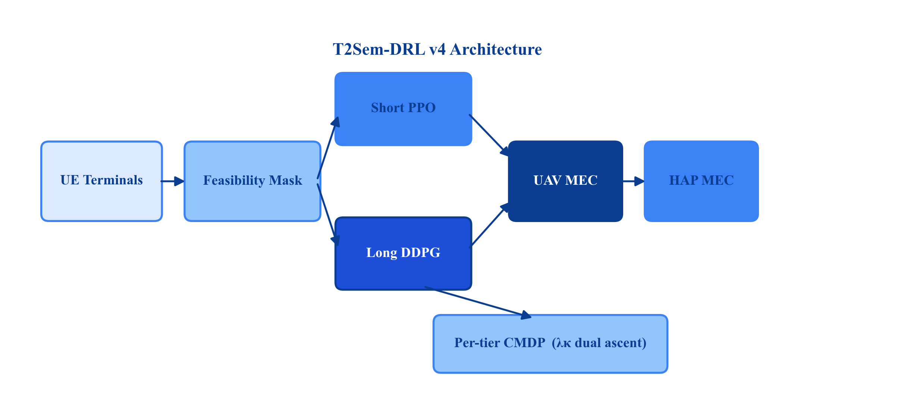
Fig. 1. T2Sem-DRL v4 architecture and model-informed feasibility interface.
E. Contributions
The main contributions are:
• Model-informed feasibility region F as a reusable system-level action interface (analytic shield / action mask) with delay margin α, expected-channel estimation, and similarity headroom δ_s (Section IV-B; +31.8 pp when removed; Table IV).
• Hierarchical semantic MEC model coupling μ, three-way offloading, contention, and three-tier SLAs (+46.0 pp when semantics is removed; Table IV).
• Empirical contribution decomposition under a shared-mask protocol: quantifies that domain modeling and feasibility projection dominate SLA gains, while masked RL provides a secondary +6.2 pp refinement (Tables I, IV–V).
• Tier-aware evaluation and diagnostics: per-tier SLA reporting, λ_κ trajectories (Fig. 8), and explicit discussion of critical-vs-interactive trade-offs (Table II)—presented as diagnostic evidence, not as proof of aggregate-SLA improvement from per-tier CMDP.
• Unified evaluation protocol with canonical vs. ablation reporting separated (Section VII-A), masked baselines, energy operating points (Table I-b), and explicit non-claims on energy and critical-tier dominance.
F. Paper Organization
Section II reviews related work. Section III presents the system model. Section IV formulates the CMDP and feasibility region. Section V describes the T2Sem-DRL algorithm and its components. Section VI lists implementation details. Section VII reports experiments. Section VIII concludes.
II. RELATED WORK
A. UAV-Assisted MEC and Trajectory Optimization
UAV-assisted MEC jointly optimizes communication, computation, and flight [1], [12], [13]. DRL methods learn trajectory and offloading adaptively [1], [2], [12], [13] but typically optimize scalar delay/energy objectives. DTOTO [2] considers hierarchical UAV–HAP MEC without semantic compression or tiered SLAs. Our work adds SemCom and per-tier CMDP on top of hierarchical offloading.
B. Semantic Communication and Semantic-Aware MEC
SemCom replaces bit-level fidelity with task-level similarity [9]–[11], [20]. Resource allocation with semantic extraction appears in [3]; online multi-task semantic offloading uses MAPPO in [4]. UAV semantic MEC studies [11], [21], [22] do not address HAP hierarchy or constrained RL. We integrate semantic μ control with three-way offloading and analytic feasibility.
C. Two-Timescale Edge Resource Management
Two-timescale decomposition reduces action dimensionality: slow variables (trajectory, caching) vs. fast variables (offloading, bandwidth) [5]–[8]. TJCCT [5] uses optimization rather than DRL for the fast scale. Related two-timescale MEC/caching studies [6], [7] show the value of temporal decomposition, while HAPS-assisted MEC [8] motivates the aerial hierarchy. We adopt PPO+DDPG with frame-aggregated rewards and energy regularization.
D. Constrained Reinforcement Learning
CMDPs enforce safety or QoS constraints via Lagrangian methods [14], [15]. Multi-constraint problems require multiple dual variables, one per constraint. Prior aerial offloading RL uses penalty weights, not per-tier dual ascent. We extend PPO-Lagrangian to per-tier bounded violation costs with independent λ_κ updates.
E. Positioning Summary

Work | UAV | HAP | Sem. μ | SLA tiers | Per-tier dual | Feas. mask | Two-scale | DRL
SemCom survey [9] | — | — | ✓ | — | — | — | — | —
Hao TMC'24 [1] | ✓ | ✗ | ✗ | priority | ✗ | ✗ | ✗ | ✓
DTOTO [2] | ✓ | ✓ | ✗ | delay | ✗ | ✗ | ✗ | ✓
Sem MAPPO [4] | ✗ | ✗ | ✓ | ✗ | ✗ | ✗ | ✗ | ✓
UAV Sem [11], [21] | ✓ | ✗ | ✓ | ✗ | ✗ | ✗ | ✗ | partial
TJCCT [5] | ✓ | ✗ | ✗ | ✗ | ✗ | ✗ | ✓ | partial
Two-scale caching/MEC [6], [7] | ✗ | ✗ | ✗ | QoS | ✗ | ✗ | ✓ | ✓
T2Sem-DRL v4 | ✓ | ✓ | ✓ | ✓ | ✓ | ✓ | ✓ | ✓

Gap and empirical scope. Section II-E is a feature positioning matrix, not a complete leaderboard. In this revision, we add one shared-interface semantic baseline (Semantic MAPPO + F; Table VII) under both canonical and scale-up topologies (the latter with matched retraining), but we do not fully reproduce all external semantic variants [3], [4], [11], [21], [22]; TJCCT is still approximated as TJCCT-Lite (Section VII-B). The defensible gap is therefore: (i) hierarchical UAV–HAP semantic offloading with a shared feasibility interface, and (ii) quantified decomposition of where SLA gains originate.
III. SYSTEM MODEL
A. Network and Workload
Consider a geographic area of size L × L m^2. Index set of UEs N=1,…,N; each UE n has a set of terminals T_n with |T_n|=T_u and N_t = NT_u terminals total. M UAVs M=1,…,M fly at altitude H_u with positions q_m(t)=[x_m,y_m,z_m]^T. K HAPs K=1,…,K are fixed at q_k^hap with altitude H_h ≫ H_u.
Time is slotted with duration Δ. A long frame t comprises K_s slots k=1,…,K_s. UAV trajectory updates occur at frame boundaries; per-slot offloading decisions occur every slot.
Each terminal i generates tasks according to a Bernoulli arrival with rate λ_i per slot. Task T_i is characterized by:
• Raw data size D_i (bits), CPU cycles C_i (cycles);
• SLA tier κ(i) ∈ K_SLA=critical,interactive,best\_effort;
• Requirements (T_κ^max, S_κ^min).
Default tier parameters (simulation): critical (0.1 s, 0.92); interactive (0.3 s, 0.85); best-effort (0.8 s, 0.75).
B. Semantic Communication Model
Terminal i selects semantic compression ratio μ_i ∈ [μ_min, 1].
Transmitted data volume:
$D_{i}^{tx}=μ_{i}D_{i}.$ (1)
Semantic extraction delay at local CPU frequency f_i (Hz) with coefficient c_sem:
$T_{i}^{sem}=c_{sem}\left(\frac{1}{μ_{i}}−1\right)\frac{D_{i}}{f_{i}}.$ (2)
Equation (2) implies that as μ_i arrow 0, extraction time grows unbounded—modeling the cost of aggressive compression.
Achieved semantic similarity [implementation: similarity()]:
$S(μ_{i})=S_{max}\left(1−exp(−λ_{acc}μ_{i})\right),$ (3)
where S_max is the maximum similarity and λ_acc controls accuracy gain rate.
Minimum μ for tier κ (similarity feasibility):
$μ_{κ}^{sim}=−\frac{1}{λ_{acc}}ln\left(1−\frac{S_{κ}^{min}+δ_{s}}{S_{max}}\right),$ (4)
with similarity headroom δ_s ≥ 0 (default 0.05).
Remote computation load when offloading:
$C_{i}^{remote}=μ_{i}C_{i}.$ (5)
C. Air-Ground Channel Model
3-D distance between terminal position p_i and aerial node q:
$d_{i,q}=‖p_{i}−q‖_{2}.$ (6)
Elevation angle (degrees):
$θ_{i,q}=arctan\left(\frac{z_{q}−z_{i}}{‖p_{i}^{xy}−q^{xy}‖_{2}}\right)·\frac{180}{π}.$ (7)
LoS probability (ITU-style) [19]:
$P_{LoS}(θ)=\frac{1}{1+aexp(−b(θ−a))}.$ (8)
Path loss (dB) for distance d and carrier frequency f_c:
$PL_{LoS}(d)=20\log_{10}d+20\log_{10}f_{c}−147.55,$ (9)
$PL_{NLoS}(d)=PL_{LoS}(d)+20.$ (10)
During simulation, LoS/NLoS is sampled; for feasibility estimation we use expected gain:
${\bar{g}}_{i,q}=P_{LoS}(θ) {10}^{−PL_{LoS}(d)/10}+(1−P_{LoS}(θ)) {10}^{−PL_{NLoS}(d)/10}.$ (11)
Alternatives: optimistic LoS-only (g = 10^-PL_LoS/10) or pessimistic NLoS-only.
Shannon rate with bandwidth B_i, transmit power P_i, noise N_0:
$R_{i}=B_{i}\log_{2}\left(1+\frac{P_{i}{\bar{g}}_{i,q}}{N_{0}}\right).$ (12)
Transmission delay:
$T_{i}^{tx}=\frac{D_{i}^{tx}}{R_{i}}.$ (13)
D. Computation and Queueing Delay
For offload target o ∈ local∪M∪K, allocated CPU frequency f_i^alloc:
$T_{i}^{comp}=\{\frac{C_{i}}{f_{i}^{alloc}},o=local,[8pt]\frac{C_{i}^{remote}}{f_{o}^{alloc}},o∈ℳ∪𝒦.$ (14)
Queueing delay T_i^queue accumulates from per-server FIFO queues under resource contention. When multiple terminals share UAV m, bandwidth and CPU requests are normalized via proportional sharing with a minimum floor share.
E. End-to-End Delay and SLA Indicator
Total E2E delay:
$T_{i}^{e2e}=T_{i}^{sem}+T_{i}^{tx}+T_{i}^{queue}+T_{i}^{comp}.$ (15)
SLA satisfaction indicator for tier κ:
${hit}_{i}=𝕀\left[T_{i}^{e2e}≤T_{κ}^{max}\right]·𝕀\left[S(μ_{i})≥S_{κ}^{min}\right].$ (16)
Dense SLA quality (used in reward shaping):
$q_{i}=w_{d}exp(−ρ_{d}T_{i}^{e2e})+w_{s}S(μ_{i})−ϕ_{i},$ (17)
$ϕ_{i}=min\left\{ϕ_{max}, ρ_{d2}max(0,T_{i}^{e2e}−T_{κ}^{max})+ρ_{s2}max(0,S_{κ}^{min}−S(μ_{i}))\right\}.$ (18)
F. Energy Model
Local computation energy scales with allocated CPU; transmission energy with power and airtime; UAV propulsion dominates long-timescale energy:
$E_{m}^{prop}(t)=ζ‖v_{m}(t)‖^{2}Δ,$ (19)
where v_m is UAV velocity from long-timescale action and ζ absorbs propulsion coefficient. Frame-level propulsion E_t^prop = Σ_m E_m^prop(t) is penalized in long-scale reward.
G. Two-Timescale Decision Structure
• Short action a_k^s: per-terminal offload encoding, μ_i, bandwidth request, CPU request;
• Long action a_t^l: UAV 3D displacement per frame (DDPG output in [-1,1] scaled by v_max).
IV. PROBLEM FORMULATION
A. Per-Tier Constrained CMDP
Define short-scale state s_k (global queue/energy loads, terminal local observations) and long-scale frame state s_t^f (aggregated SLA rates, UAV positions, tier weights).
Unconstrained objective: maximize expected discounted sum of SLA quality minus energy.
Per-tier SLA constraints: for each κ ∈ K_SLA,
${lim inf}_{T→∞}\frac{1}{T}\sum_{t=1}^{T}{}𝔼[ρ_{κ}^{(t)}]≥η_{κ},$ (20)
where ρ_κ^(t) is the empirical tier-κ SLA rate in frame t and η_κ is the training target (e.g., η_critical=0.70, η_interactive=0.85). These targets are minimum long-run satisfaction rates for dual ascent, not deployment SLA requirements (T_κ^max, S_κ^min in Section III-A). Setting η_critical=0.70 below greedy's observed 91.6% critical SLA (Table II) reflects a soft floor for Lagrangian updates under mixed-tier load, not a claim that 70% critical satisfaction is operationally sufficient.
Lagrangian short-slot reward (standard CMDP form—bounded violation cost):
$r_{k}=q_{k}−ω_{e}E_{k}−\sum_{κ∈𝒦_{SLA}}{}λ_{κ}\left(1−{hit}_{i,k}^{(κ)}\right),$ (21)
where hit_i,k^(κ) is 1 only if the served task belongs to tier κ and satisfies (16); otherwise the indicator for non-matching tiers is treated as vacuous in implementation via tier tag of task i.
Dual ascent after each training episode (or frame window):
$λ_{κ}←clip\left(λ_{κ}+η_{λ}(η_{κ}−{\bar{ρ}}_{κ}), [λ_{min},λ_{max}]\right).$ (22)
Remark 1 (Stability). Unlike λ · q_k scaling, (21) keeps q_k unscaled so PPO advantage estimates remain bounded when λ_κ grows—critical for training stability (cf. v3 collapse with λ · q_k).
Remark 2 (vs. single λ). Single-λ CMDP enforces weighted average SLA only; per-tier deficits can hide in aggregate (Table II: single-λ ablation retains high overall SLA but tier bias persists in greedy baselines).
B. Model-Informed Feasibility Region
Before executing parsed short action a_k^s, the environment projects it to a_k^s ∈ F_k.
Step 1 — Similarity clamp:
$μ_{i}←max\left\{{\tilde{μ}}_{i}, μ_{κ(i)}^{sim}\right\}.$ (23)
Step 2 — Candidate offload set O_i = local∪M∪K (HAP disabled flag optionally removes K).
Step 3 — Deterministic delay estimate for candidate o using expected gain g (11), nominal (D_i,C_i), and resource estimates B_i,f_o from action:
${\hat{T}}_{i}^{e2e}(o,μ_{i})={\hat{T}}_{i}^{sem}+{\hat{T}}_{i}^{tx}(o)+{\hat{T}}_{i}^{comp}(o).$ (24)
Step 4 — Delay-feasible set:
$𝒪_{i}^{feas}=\left\{o∈𝒪_{i}:{\hat{T}}_{i}^{e2e}(o,μ_{i})≤α T_{κ(i)}^{max}\right\},$ (25)
with delay margin α ∈ (0,1] (default 0.8) reserving headroom for task-size jitter (± 20\%) and NLoS samples.
Step 5 — Target selection: Map offload preference u_i ∈ [0,1] to index j = ⌊ u_i · |O_i^feas| ⌋ and select the j-th feasible target. If O_i^feas=∅, select argmin_o T_i^e2e(o,μ_i).
Property 1. F is a system-level action interface: any policy (DRL or heuristic) operates on the same feasible set, ensuring fair comparison under masked baselines (Section VII-A).
Property 2 (Decoupling). If O_i^feas is non-empty and dominated by HAP routes independent of UAV position, SLA satisfaction becomes less sensitive to q_m at moderate load—explaining why the single-timescale ablation remains competitive (90.7% SLA at 4.0 kJ, Table IV).
V. T2SEM-DRL ALGORITHM
A. Overview
T2Sem-DRL (Fig. 1) orchestrates three modules: (M1) short-timescale shared PPO; (M2) long-timescale DDPG; (M3) per-tier dual updater. Feasibility projection F is applied inside the environment step.
B. Short-Timescale Shared PPO (M1)
Motivation. Terminals share similar local structure (queue, tier one-hot, distances); parameter sharing improves sample efficiency.
Observation. Global state s_k for critic; local batch o_k,i per terminal for actor.
Action. Gaussian policy π_θ(a_k,i|o_k,i) with learnable log-std bounds [σ_min,σ_max] and entropy bonus β_ent.
PPO update with clip ε, GAE(λ) advantages, N_epoch epochs, gradient clip g_max:
$L^{CLIP}(θ)=𝔼\left[min\left(r_{t}(θ){\hat{A}}_{t}, clip(r_{t}(θ),1−ϵ,1+ϵ){\hat{A}}_{t}\right)\right],$ (26)
$L(θ)=−L^{CLIP}+c_{v}L^{VF}−β_{ent}H[π_{θ}].$ (27)
C. Long-Timescale DDPG (M2)
Frame state s_t^f includes UAV positions, loads, recent mean reward, SLA rates.
Actor μ_φ(s_t^f)arrow a_t^l; critic Q_ψ with target networks (φ',ψ').
Regularization (energy–SLA decoupling exploitation):
$L^{actor}=−𝔼[Q_{ψ}(s^{f},μ_{ϕ}(s^{f}))]+β_{L2}‖μ_{ϕ}(s^{f})‖_{2}^{2}+β_{sm}‖a_{t}^{l}−a_{t−1}^{l}‖_{2}^{2}.$ (28)
Frame reward:
$R_{t}=\frac{1}{K_{s}}\sum_{k∈frame t}{}r_{k}−ω_{traj}E_{t}^{prop}.$ (29)
D. Filtered Behavioral Cloning Warm-Start
Greedy demonstrations without mask achieve 0% SLA; filtered BC collects per-terminal (o,a) pairs only from episodes with hit=1, mixing random and greedy explorers. Pretrain actor with MSE loss for E_BC epochs before RL.
E. Training Procedure
Algorithm 1 T2Sem-DRL v4 Training 1: Collect filtered demonstrations D; BC-pretrain π_θ 2: Initialize λ_κ arrow λ_init for all tiers 3: for frame t=1 to T_max do 4: a_t^l arrow DDPG(s_t^f); apply UAV motion 5: for slot k=1 to K_s do 6: Sample a_k^s ~ π_θ(·|o_k) 7: a_k^s arrow Π_F(a_k^s) 8: Execute; observe r_k from (21) 9: end for 10: PPO update; DDPG update; dual ascent (22) 11: end for
VI. IMPLEMENTATION DETAILS

Hyperparameter | Value
Users / terminals / UAVs / HAPs | 8 / 16 / 3 / 2
Area L | 500 m
Slots per frame K_s | 10
Frames per episode | 200
Task arrival rate | 0.25 / terminal / slot
D_i, C_i | 2 Mb, 1 G cycles
PPO hidden dim | 256
PPO lr, clip, epochs | 3×10^-4, 0.2, 10
Entropy coef. | 0.01
DDPG actor/critic lr | 10^-4 / 10^-3
BC demos / epochs | 30 / 150
Training episodes | 300
Eval episodes × seeds | 30 × 42,123,456
α, δ_s, channel est. | 0.8, 0.05, expected
η_κ | (0.70, 0.85, 0.85)
η_λ, λ_max | 0.1, 8.0
Device | CPU (default)

Checkpoint selection uses periodic eval SLA (not noisy last-episode training metric).
VII. PERFORMANCE EVALUATION
A. Experimental Protocol
All methods—including Random, Greedy, TJCCT-Lite, Local-only—share the same feasibility mask F as a system action interface (Property 1). Vanilla mask-off baselines appear in Appendix A only.
Two reporting protocols (do not mix without label):

Protocol | Purpose | Training | Evaluation | Primary tables
P1 Canonical | Headline SLA/delay comparisons | 300 ep × 3 seeds | 30 deterministic eval ep × 3 seeds | Table I, I-b, VI
P2 Ablation | Component lever isolation | 300 ep × 3 seeds | Last-episode / ablation-scale aggregate | Table II†, IV, V
P3 Pareto sweep | Energy–SLA operating points | 150 ep × 2 seeds | Pareto checkpoint eval | Table III

†Table II per-tier rows for T2Sem-DRL and single-λ use P2; greedy/TJCCT per-tier baselines use a separate masked diagnostic (footnote). All abstract and introduction headline numbers refer to P1 unless explicitly labeled as ablation (P2).
Training config: improved_v4_pertier.yaml, seeds 42,123,456. Checkpoint selection uses periodic eval SLA (not noisy last-episode training metric).
Statistical note. Under P1, seed-level SLA gains of T2Sem-DRL over masked greedy are +4.5, +6.0, and +8.1 pp for seeds 42,123,456 (paired differences). The gap is consistent in direction across seeds; formal hypothesis tests with n=3 seeds are underpowered and deferred to a larger-seed study (Section VII-H).
Independent PPO baseline. Uses the same F, per-tier CMDP rewards, and two-timescale stack as T2Sem-DRL, but replaces the shared terminal actor with independent per-terminal PPO actors (independent_ppo variant). It reaches 91.41% SLA (Table I)—between masked greedy and full shared-actor T2Sem-DRL—showing that parameter sharing is not the dominant gain source; the interface and semantic model are.
B. Main Comparison (Table I)
TABLE I OVERALL PERFORMANCE (MASKED BASELINES). Mean over 3 seeds × 30 eval episodes. Bold: best per column. SLA↑, Delay↓. Energy reported separately in Table I-b to avoid mixing exploration-inflated trajectory cost with heuristic static policies.

Method | SLA Rate (%) | Avg. Delay (s)
Random | 78.47 ± 0.06 | 0.159
Greedy | 87.77 ± 0.07 | 0.122
TJCCT-Lite | 86.64 ± 0.07 | 0.266
Local-only | 86.05 ± 0.37 | 0.209
Independent PPO | 91.41 ± 0.25 | 0.145
Single-timescale | 88.85 ± 0.43 | 0.145
T2Sem-DRL | 93.99 ± 1.74 | 0.100

TJCCT-Lite uses K-means long-scale placement and priority water-filling short-scale allocation; it is no longer identical to greedy. Single-λ CMDP is reported in Table IV because its final evidence comes from the ablation protocol.
T2Sem-DRL improves SLA by +6.22 pp over masked greedy and by +7.35 pp over TJCCT-Lite under P1. This RL refinement is secondary to feasibility projection and semantic modeling, which are quantified under P2 (Table IV). We do not compare propulsion energy in this table; see Table I-b.
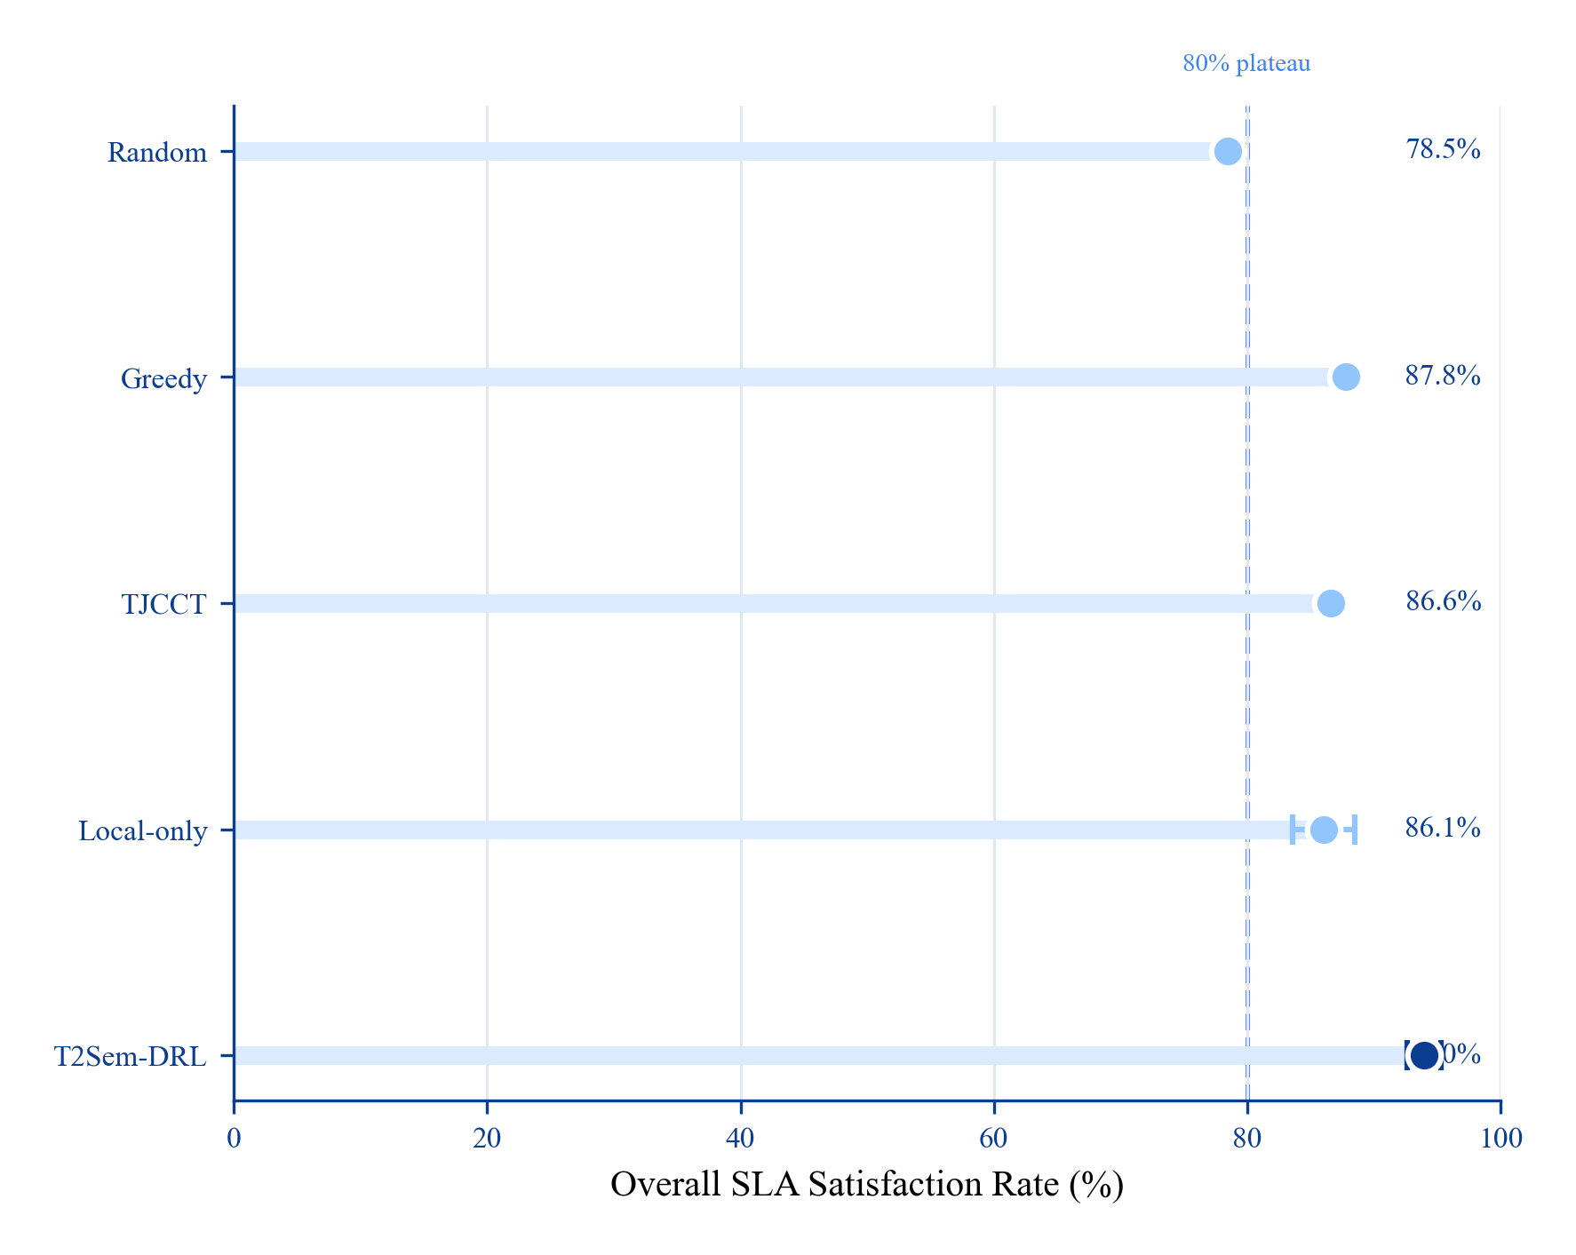
Fig. 2. Overall SLA comparison under the shared feasibility mask.
TABLE I-b ENERGY OPERATING POINTS (UNIFIED REPORTING). E_SLA = E_total / (SLA rate) (J per satisfied-task fraction; lower is better only when SLA is held constant).

Operating point | Config | SLA (%) | Energy (J) | E_SLA (kJ) | Role
R1 Service default | Full two-timescale checkpoint | 93.99 | 7,856 | 8.4 | Best SLA in main protocol
R2 Pareto P4 | High w_traj, L2=0.12 | 91.1 | 16,181 | 17.8 | Historical Pareto operating point
R3 No DDPG | Single-timescale | 88.85 | 4,065 | 4.6 | Low-energy learned policy
Masked greedy | Heuristic + F | 87.77 | 3,630 | 4.1 | Static baseline

At R1, the full model buys +6.22 pp SLA over greedy at higher energy. At R3, removing DDPG nearly matches greedy energy while retaining a small SLA gain. We therefore present energy as an operating-point trade-off, not as a universal dominance claim.
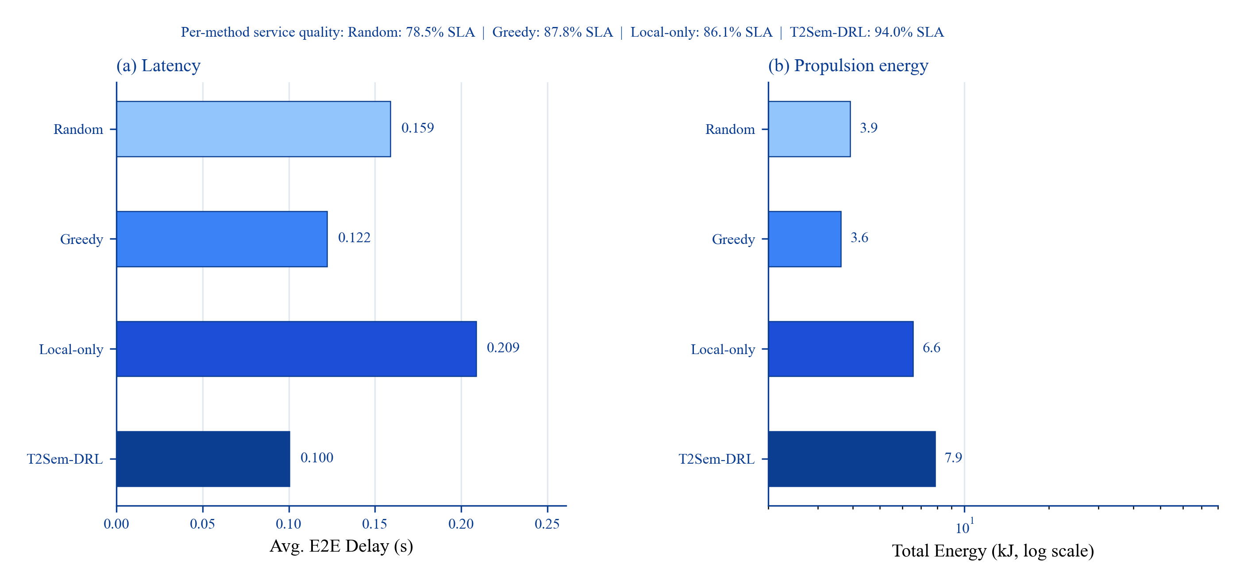
Fig. 3. Delay and energy comparison across representative methods.
C. Per-Tier SLA (Table II, Fig. 4)
TABLE II PER-TIER SLA SATISFACTION (%).

Method | Critical | Interactive | Best-effort | Overall
Random | 42.9 | 91.5 | 98.5 | 77.6
Greedy/TJCCT* | 91.6 | 49.9 | 100.0 | 80.5
Single-λ CMDP† | 83.8 | 94.3 | 100.0 | 92.8
Local-only | 56.7 | 99.9 | 98.2 | 85.0
T2Sem-DRL† | 76.0 | 99.2 | 100.0 | 92.2

\*Per-tier baseline rows are from a separate masked per-tier diagnostic run; their overall column therefore differs from Table I, which uses the main 3-seed × 30-episode protocol. †Final v4.3 ablation-scale eval (3 seeds × 300 episodes).
The final full model strongly protects interactive and best-effort tiers, while critical-tier SLA (76.0%) remains below masked greedy (91.6%) under the P2 per-tier diagnostic—a deliberate tier rebalancing, not a hidden failure. Operators prioritizing critical-only workloads should prefer masked greedy + F (91.6% critical) or tune tier weights / η_κ (single-λ ablation reaches 83.8% critical vs. 76.0% full; Table II). T2Sem-DRL targets mixed-tier deployments where interactive starvation (greedy: 49.9%) is unacceptable. Section VII-H discusses when this trade-off is acceptable and how to recover critical SLA.
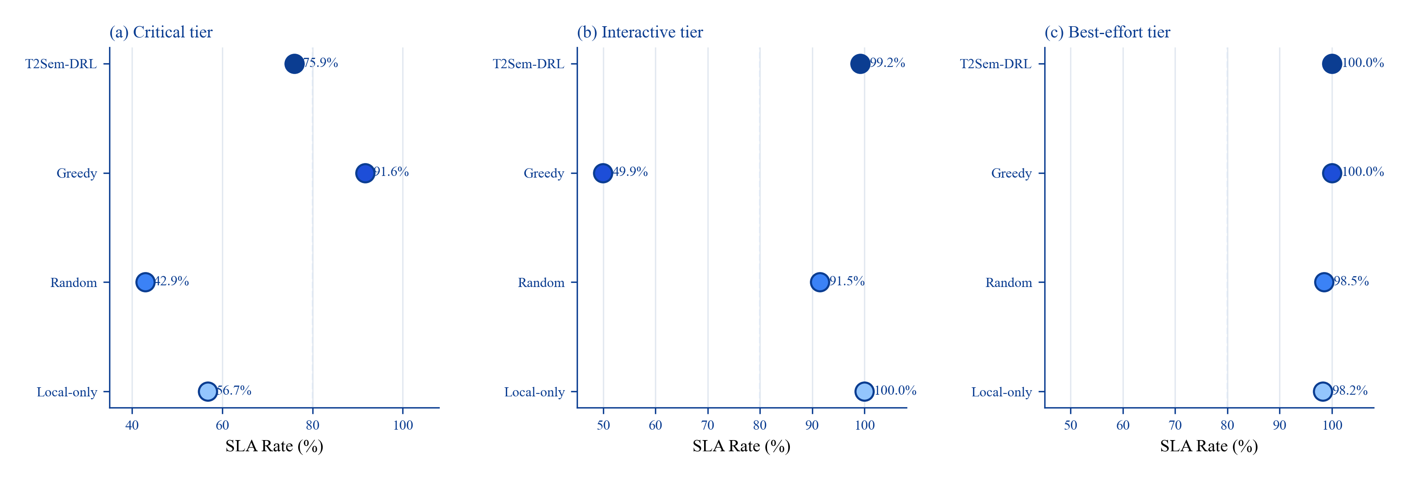
Fig. 4. Per-tier SLA satisfaction for critical, interactive, and best-effort tasks.
D. Energy–SLA Pareto (Table III, Fig. 5)
TABLE III ENERGY–SLA PARETO (2 SEEDS × 150 TRAIN EP).

Point | w_traj | L2 coef. | SLA (%) | Energy (J)
P1 min pressure | 0.05 | 0.00 | 87.9 | 687,653
P2 low | 0.25 | 0.01 | 85.0 | 51,771
P3 v4 default | 0.60 | 0.05 | 90.6 | 21,094
P4 high pressure | 1.20 | 0.12 | 91.1 | 16,181
Masked-random | — | — | 77.8 | 3,975

P1 uses minimal trajectory regularization (w_traj=0.05, L2=0), allowing near-free UAV exploration; the 687 kJ outlier reflects unconverged flight energy from exploratory trajectories, not the service operating point. P3–P4 and Table I-b report the practical energy range (4–16 kJ).
Stronger trajectory regularization sharply reduces propulsion energy while maintaining high SLA after the low-pressure regime; the P2 dip shows that the relation is not a universal monotonic law but an operating-point trade-off once F handles short-timescale routing.
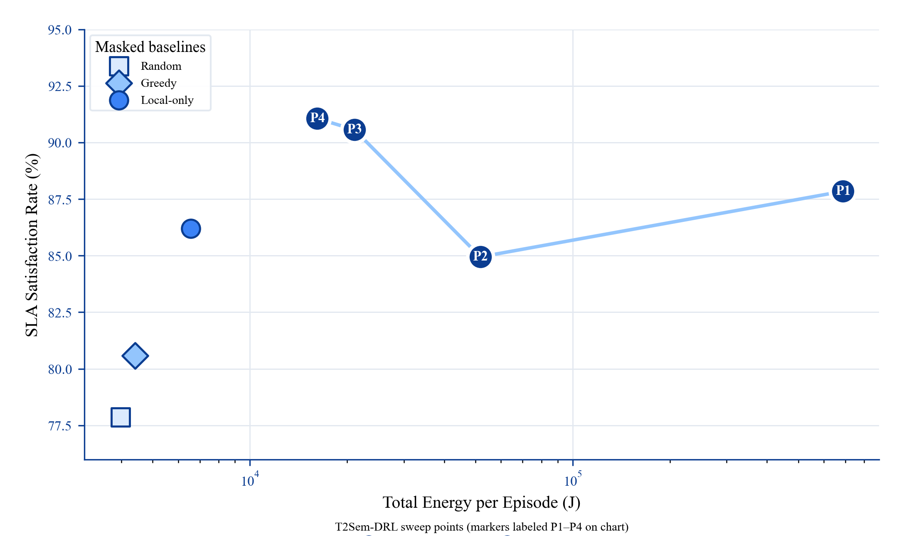
Fig. 5. Energy-SLA Pareto operating points and masked baselines.
E. Ablation Study (Table IV, Fig. 6)
TABLE IV COMPONENT ABLATION (3 SEEDS × 300 TRAIN EP). †Upper bound without contention.

Variant | SLA (%) | Energy (J) | Critical | Interactive
Full | 92.17 | 15,366 | 76.0 | 99.2
w/o mask | 60.39 | 61,104 | 5.2 | 78.5
w/o per-tier λ | 92.80 | 17,518 | 83.8 | 94.3
w/o CMDP | 92.04 | 16,418 | 78.0 | 99.3
Pure DRL | 59.91 | 57,712 | 2.6 | 70.8
w/o semantic | 46.17 | 43,776 | 1.8 | 36.5
Single-timescale | 90.70 | 4,013 | 73.8 | 98.3
Fixed μ | 65.72 | 45,852 | 0.0 | 99.0
w/o SLA penalty | 92.18 | 16,543 | 86.0 | 90.7
w/o contention† | 100.00 | 56,026 | 100.0 | 100.0

Findings (empirical contribution decomposition; P2): semantic +46.0 pp > mask +31.8 pp > RL over masked greedy +6.2 pp (P1). Per-tier λ_κ and SLA-penalty variants mainly change tier allocation rather than aggregate SLA. Single-timescale loses 1.47 pp SLA in P2 but uses 3.8× less energy.
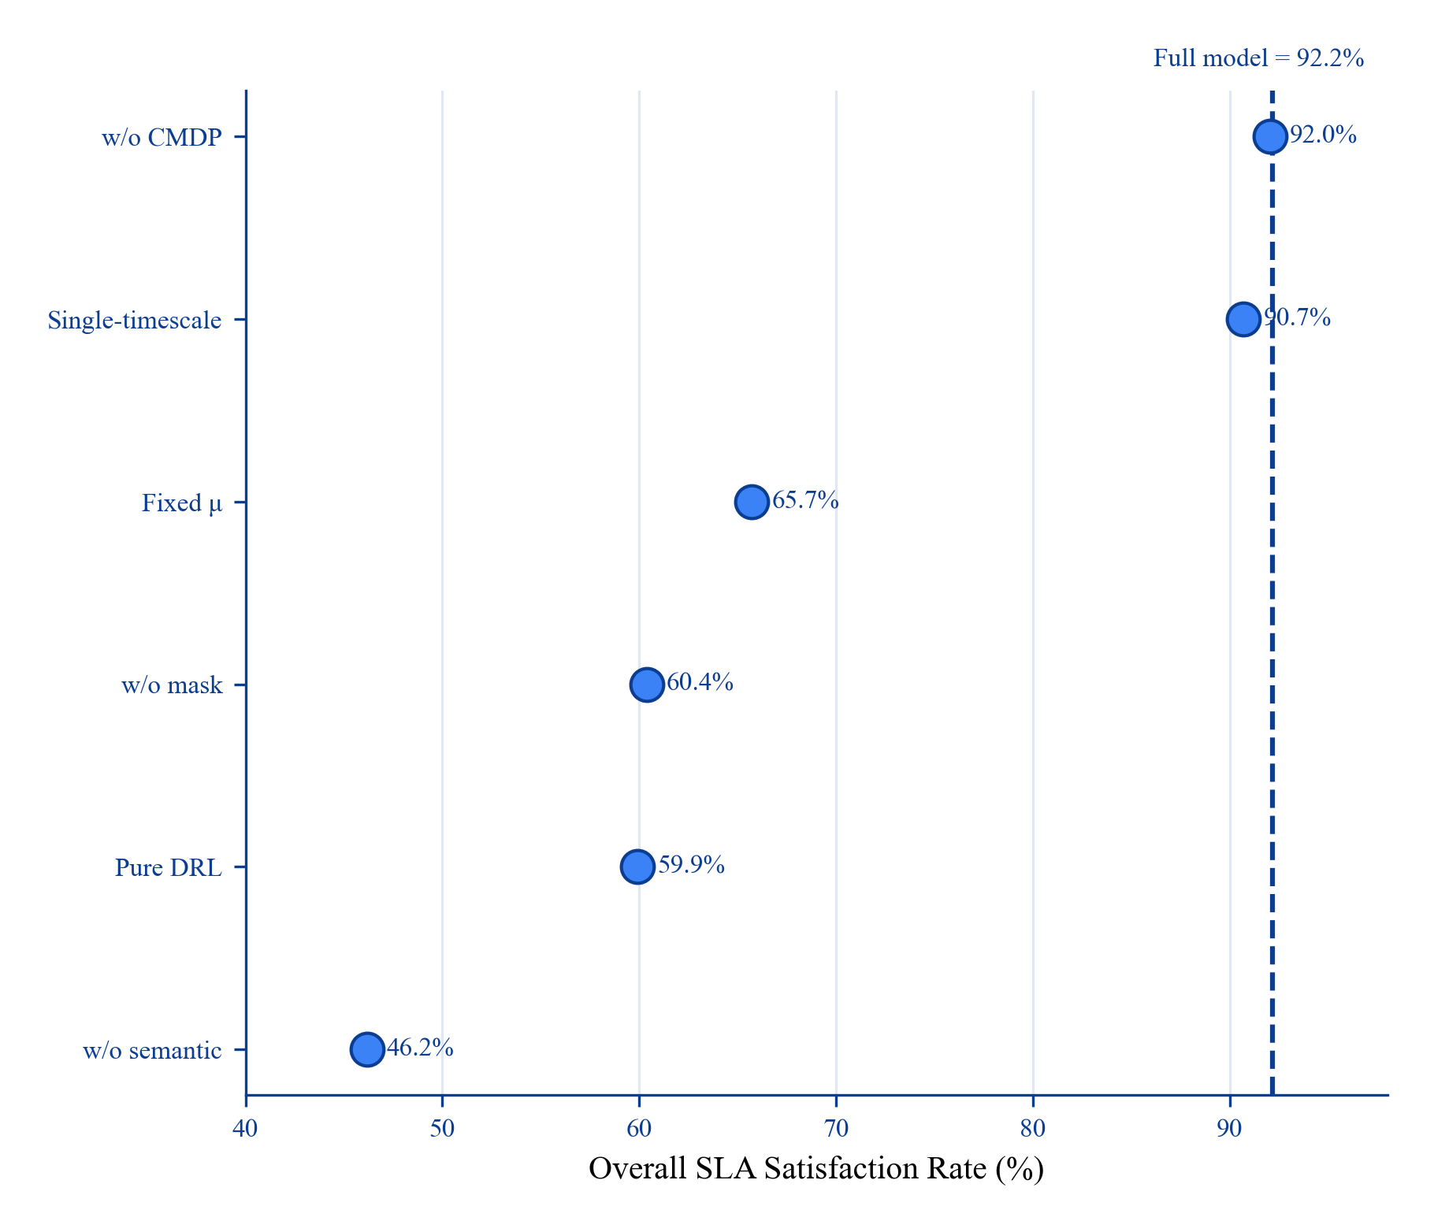
Fig. 6. Ablation study showing the gap between each variant and the full model.
F. Cumulative Component Build-up (Table V)
TABLE V COMPONENT CONTRIBUTION DECOMPOSITION. Forward path from heuristic to learned policy; ablation rows isolate major system levers.

Stage | Configuration | SLA (%) | Interpretation
S0 | Pure DRL (no F, no semantic model) | 59.9 | mask-free lower reference
S1 | Masked greedy (F + heuristic) | 87.8 | interface gain over S0
S2 | + Masked PPO (learned policy within F) | 94.0 | +6.2 pp over S1
S3 | + Per-tier λ_κ (ablation full model) | 92.2 | diagnostic
— | Remove F from S3 (ablation) | 60.4 | −31.8
— | Remove semantic model from S3 (ablation) | 46.2 | −46.0

S0→S1 mixes policy and interface changes, so the negative ablation rows isolate mask and semantic levers from S3 rather than claiming a strictly monotonic build-up. Narrative: model-informed F and semantics dominate; RL refines within the feasible shell, while per-tier duals are best interpreted through tier allocation rather than aggregate SLA alone.
G. Mask Sensitivity (Fig. 7)
Test-time variation without retraining: SLA peaks at α=0.6–0.7 (93–94%); default training α=0.8 yields 87.4% under test-time sweep; optimistic α=1.0 drops to 83.0%. This sensitivity is expected: α controls the delay headroom in F and trades robustness against NLoS/jitter for admitted action volume. Validation check: a held-out alpha-selection run (validation seeds 42/123, test seed 456) selected α=0.6, but test performance remained unchanged versus the default α=0.8 (both 95.81%), indicating that deployment retuning should be treated as optional and workload-dependent rather than guaranteed improvement. Expected-channel estimation matches realistic LoS mixture; similarity margin δ_s trades compression cost vs. similarity violations.
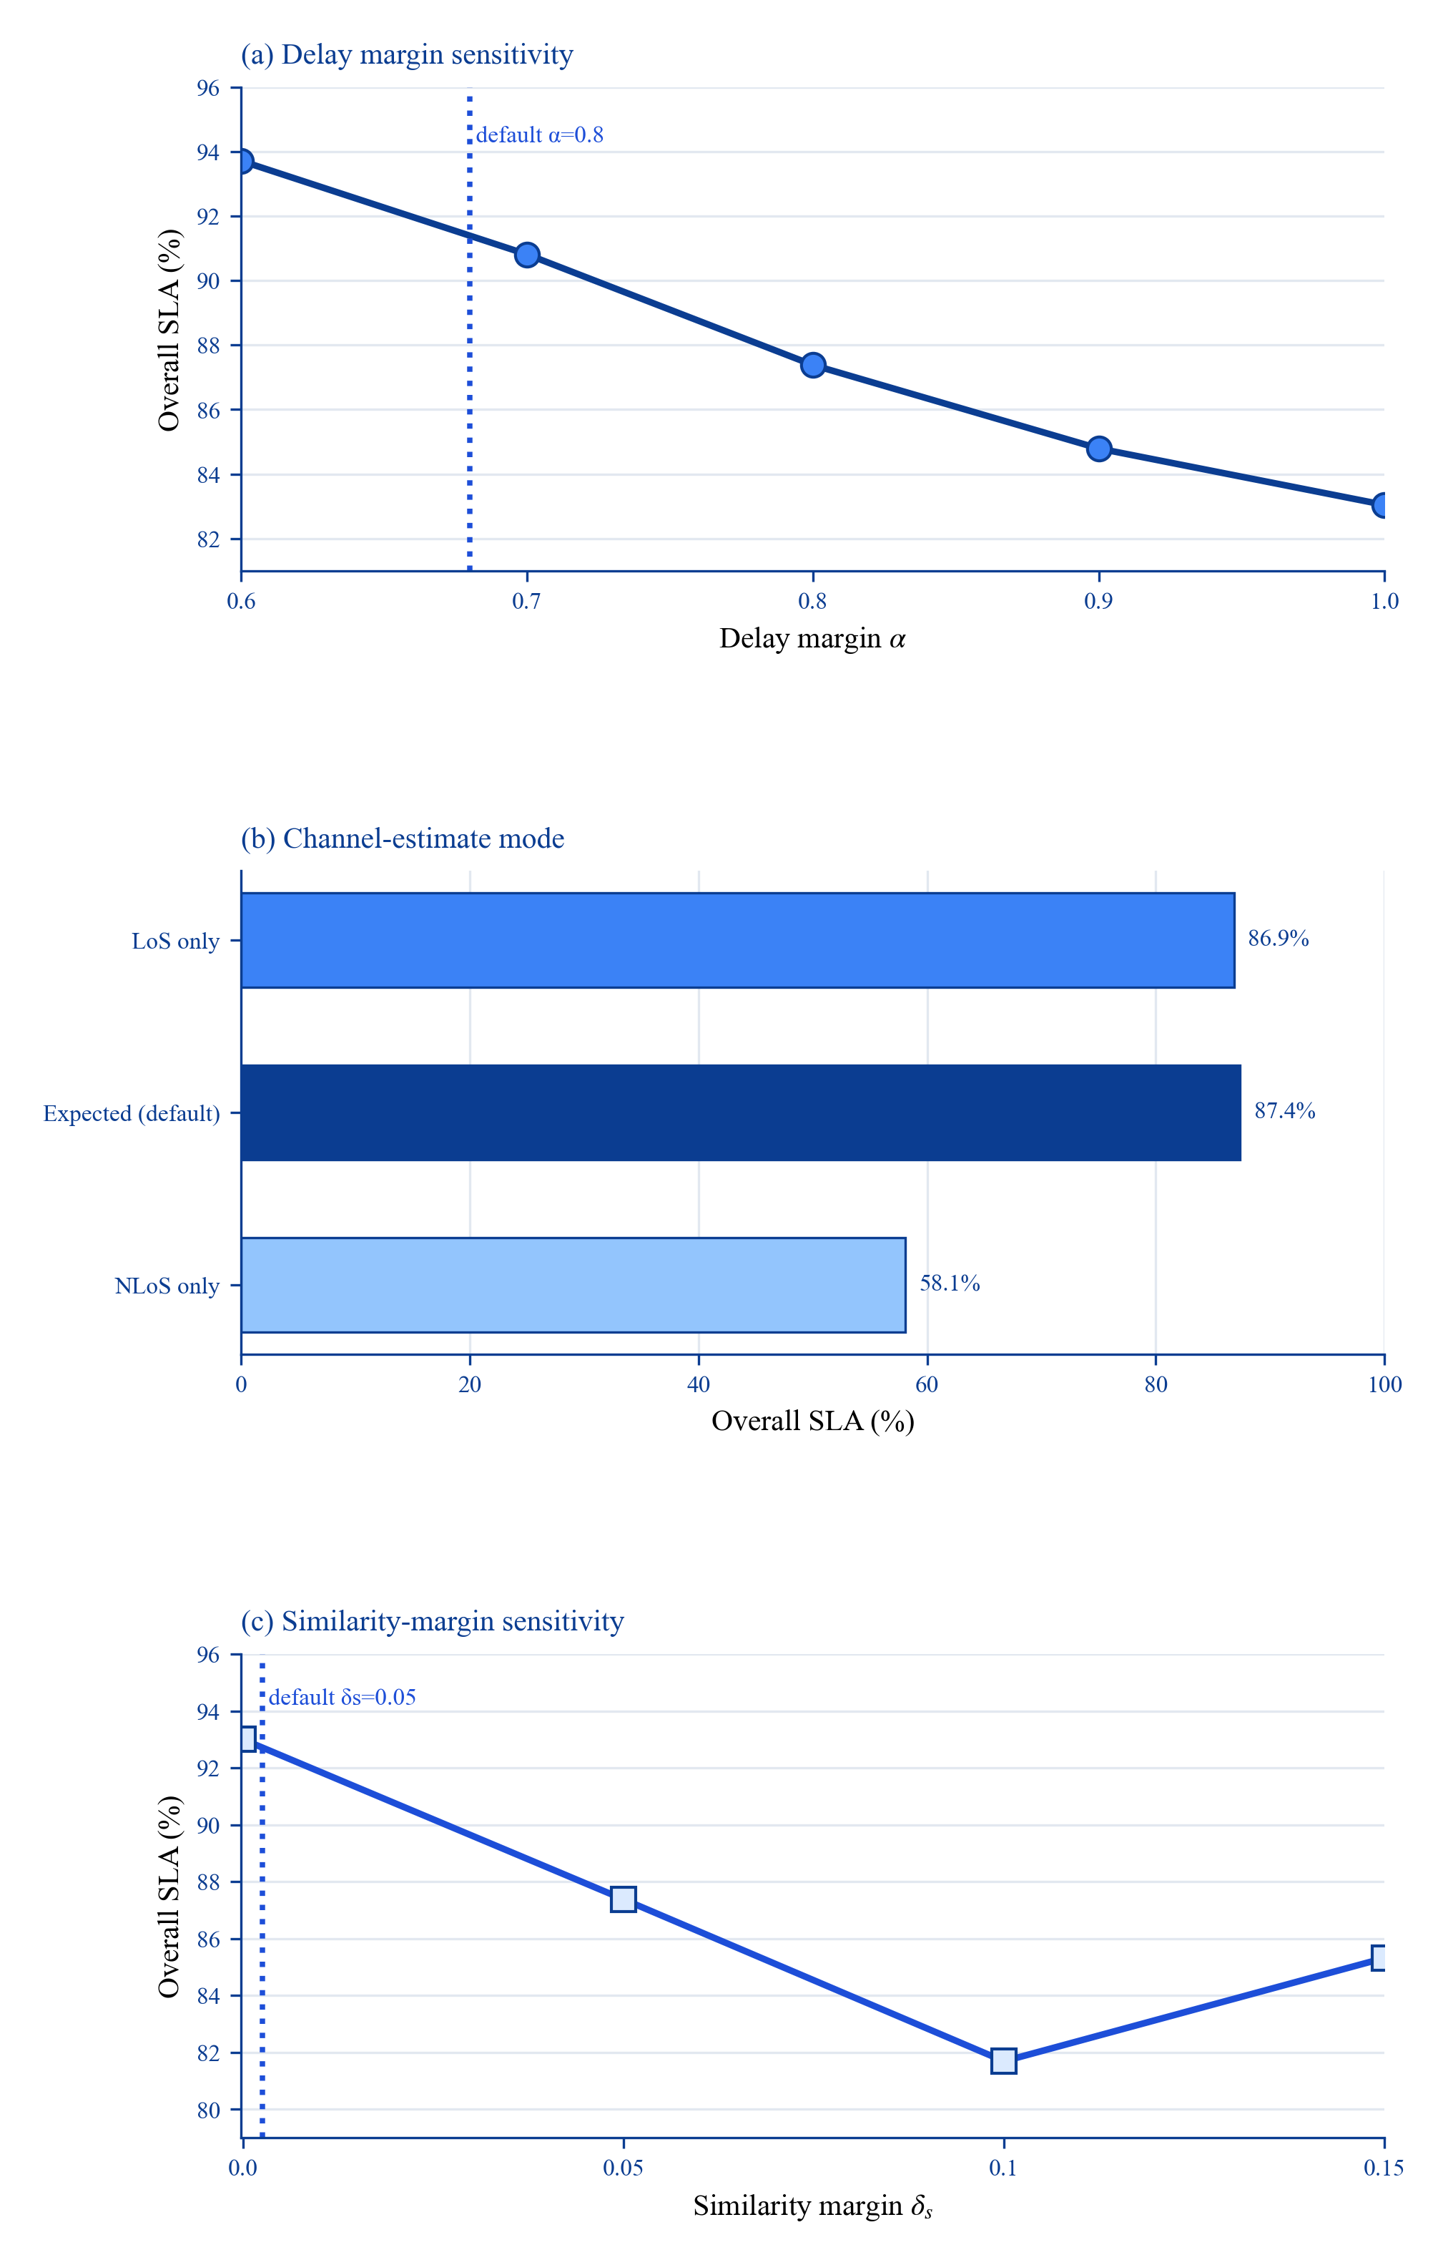
Fig. 7. Mask sensitivity under delay margin, channel estimate, and similarity margin changes.
H. Discussion, Limitations, and DDPG Extension
Interface contribution vs. RL algorithm novelty. F is related to action masking and safety shields, and PPO/DDPG are standard optimizers. We therefore classify the contribution as (i) a reusable model-informed interface for semantic hierarchical MEC, and (ii) empirical evidence that semantics and feasibility dominate RL refinements. Per-tier λ_κ is a diagnostic tool rather than a headline method component because it lacks aggregate-SLA benefit in P2.
Critical-tier trade-off and deployment guidance. Table II shows T2Sem-DRL 76.0% critical vs. greedy 91.6% while improving interactive SLA from 49.9% to 99.2%. This reflects tier rebalancing under mixed-tier optimization, not a claim of universal critical-tier superiority. For critical-dominated deployments, masked greedy + F or higher critical tier weights / η_critical are preferable; for mixed interactive/analytics workloads, T2Sem-DRL is appropriate. Single-λ ablation (83.8% critical) indicates retuning can shift the trade-off.
Evaluation protocol consistency. Section VII-A separates P1 (canonical headline metrics) from P2 (ablation diagnostics). SLA 93.99% (P1) and 92.17% (P2) differ by evaluation protocol, not ad hoc selection.
Baseline scope and interface-dominance evidence. We now include a shared-interface semantic baseline: Semantic MAPPO + F (independent per-terminal PPO actors under the same mask/reward interface). On canonical seeds 42,123,456, it reaches 91.43% vs. 93.99% for T2Sem-DRL (paired +2.56 pp, 95% CI [1.14, 4.41]); on expanded seeds 42,123,456,789,1011, the paired gap narrows to −0.25 pp (95% CI [−3.35, 2.84]). We read this convergence as positive evidence for our central claim, not as a weakness: once two different RL backbones (shared-actor T2Sem-DRL vs. independent-actor MAPPO) operate inside the same feasibility interface, their aggregate SLA becomes statistically indistinguishable, i.e. the interface—not the RL architecture—is the dominant performance lever. This is reinforced by removing F from the same semantic policy, which collapses SLA from 91.67% to 11.95% (−79.5 pp, 95% CI [67.2, 86.5]; Table VII). Full external re-implementation of additional semantic DRL variants [3], [4], [11], [21] and full TJCCT [5] is still future work; Section II-E remains a positioning matrix, not a complete benchmark leaderboard.
Simulation realism and scale. The default testbed (8 UE, 16 terminals, 500 m², synthetic arrivals) isolates interface effects but lacks measured semantic latency, flight traces, and trace-driven workloads. A scale-up supplementary run (16 UEs / 32 terminals / 5 UAVs) closes the deployment triangle with matched-training Semantic MAPPO + F: Greedy 71.03%, Semantic 73.72%, T2Sem 80.31% (paired T2Sem–Semantic +6.59 pp, 95% CI [2.71, 11.61]). Relative gains are preserved but absolute SLA drops under density increase, indicating capacity/coverage limits remain the dominant bottleneck.
DDPG cost-benefit. DDPG buys ~5 pp SLA for ~2× energy under P1 (Table I-b) but fails under mobility-critical stress (Table VI: 16.4±13.6% SLA). We treat DDPG as optional; the interface + masked PPO narrative does not require it.
Mask hyperparameter robustness. Fig. 7 shows sensitivity to α, channel estimation, and δ_s. Default α=0.8 favors training robustness; held-out alpha selection in our supplementary run chooses 0.6 but yields the same test SLA as 0.8 on seed 456 (95.81% vs. 95.81%). Sensitivity is reported explicitly to avoid undisclosed per-scenario retuning.
Positioning summary. Primary scientific contribution is the model-informed per-tier semantic SLA interface (F + semantic dynamics + tier diagnostics), not two-timescale DRL. Masked PPO adds +6.2 pp over masked greedy under P1; DDPG is optional.
Masked baseline protocol is essential: removing the mask drops full-model SLA from 92.17% to 60.39% (P2). Energy: Table I omits energy; Table I-b reports operating points without universal energy-dominance claims.
CMDP theory vs. finite horizon. Per-tier dual ascent targets long-run constraint satisfaction; 300-episode training is a finite proxy, so Fig. 8 reports empirical λ_κ trajectories and violation traces rather than claiming asymptotic constraint satisfaction.
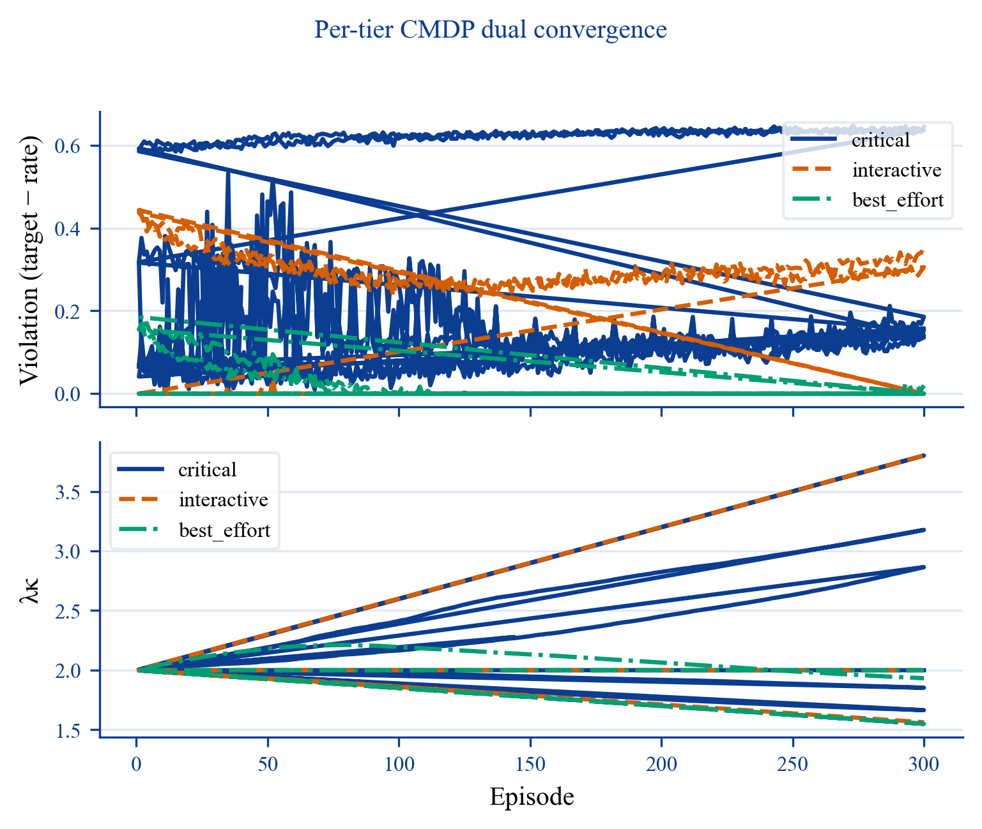
Fig. 8. Per-tier dual variables and violation traces during training.
DDPG extension (optional). Two-timescale DDPG is retained as a controllable operating mode. Under the mobility-critical stress test (Table VI)—a low-HAP-capacity, high-density configuration where feasible routing depends heavily on UAV placement—both policies degrade sharply, but the two-timescale full model retains a meaningful margin over the single-timescale variant (16.4% vs. 1.7% overall SLA). The large seed variance (±13.6 pp) and poor absolute SLA indicate that this regime is reported as a limitation rather than proof that trajectory learning alone resolves hard coverage failures.
TABLE VI MOBILITY-CRITICAL STRESS TEST (3 SEEDS). Low HAP capacity with position-dependent feasibility; both policies are far from their default-load SLA (Table I).

Policy | Overall SLA (%) | Avg. Delay (s) | Energy (J)
Two-timescale (full) | 16.4 ± 13.6 | 0.870 | 53,959
Single-timescale | 1.7 ± 2.9 | 2.403 | 8,509

Two-timescale UAV trajectory learning recovers a small but non-trivial SLA fraction that the static single-timescale policy cannot, motivating its retention as an optional operating mode for coverage-limited deployments.
TABLE VII SUPPLEMENTARY CROSS-CHECKS (POST-REVISION).

Check | Setup | Result | Interpretation | Claim status
Semantic baseline (canonical) | Semantic MAPPO + F, seeds 42,123,456 | 91.43% vs 93.99% | Canonical protocol still shows positive T2Sem gap | support
Paired gap (canonical) | Same canonical seeds 42,123,456 | +2.56 pp (95% CI [1.14, 4.41]) | Positive across canonical seeds | support
Paired gap (expanded seeds) | Seeds 42,123,456,789,1011 | −0.25 pp (95% CI [−3.35, 2.84]) | Same-interface architectures converge; consistent with interface (not RL backbone) being the dominant lever | inconclusive (by design)
Feasibility mask necessity | Semantic MAPPO with mask off, seeds 42,123,456 | 91.67% → 11.95% (−79.5 pp, 95% CI [67.2, 86.5]) | Removing F collapses even a strong semantic policy | support
Scale-up deployment triangle | 16 UEs / 32 terminals / 5 UAVs, seeds 42,123,456 | Greedy 71.03%, Semantic 73.72%, T2Sem 80.31% | Matched-training semantic baseline closes scale-up gap; T2Sem–Semantic paired +6.59 pp (95% CI [2.71, 11.61]) | support
Critical-priority deployment triangle | Same critical-priority config, seeds 42,123,456 | Greedy 87.77%, Semantic 91.41%, T2Sem 93.99%, Critical-priority trained 90.47% | Interface transfer is competitive; retrained critical-priority is a deployment option | support
Critical-priority variant | Higher critical weight + stricter target | 90.47% overall | Reweighting improves critical protection but does not imply universal aggregate gain | mixed
Alpha validation | val 42,123, test 456 | α^*=0.6, test 95.81% (= α=0.8) | Validation tuning is not guaranteed to improve every hold-out seed | mixed
Scale-up mask sensitivity | No retraining, seeds 42,123,456 | Baseline (0.8/expected/0.05): 80.2%; NLoS: 40.1% | Scale-up regime is highly channel-assumption sensitive | mixed

Future work: full external semantic baseline reproduction [3], [4], [11], [21] beyond our shared-interface implementation; full TJCCT reproduction [5]; larger-seed bootstrap tests; larger-scale (32+ UEs) trace-driven experiments; hardware-in-the-loop.
VIII. CONCLUSION
This work reframes hierarchical UAV–HAP semantic MEC as a model-informed interface problem. Under the canonical protocol, T2Sem-DRL reaches 93.99±1.74% SLA, versus 87.77±0.07% (masked greedy), 86.64±0.07% (TJCCT-Lite), and 91.43% (Semantic MAPPO + F supplementary check). The shared-interface gap to semantic MAPPO is +2.56 pp on canonical seeds (95% bootstrap CI [1.14, 4.41]) and −0.25 pp on expanded seeds (95% CI [−3.35, 2.84]); the convergence of two distinct RL backbones inside the same feasibility interface is itself evidence that the interface is the dominant lever, whereas removing it collapses semantic-policy SLA by −79.5 pp. Under scale-up density (16 UEs / 32 terminals / 5 UAVs), a matched-training deployment triangle (Greedy 71.03%, Semantic 73.72%, T2Sem 80.31%) preserves relative ordering with paired T2Sem–Semantic +6.59 pp (95% CI [2.71, 11.61]).
Empirically, gains are dominated by semantic modeling and feasibility projection; RL contributes a smaller but consistent refinement. Energy remains an operating-point trade-off (full: 7.9 kJ @ 93.99%; single-timescale: 4.1 kJ @ 88.85%), and mixed-tier gains are accompanied by a critical-vs-interactive allocation trade-off.
Current limitations are moderate scale, incomplete external baseline reproduction beyond our shared-interface semantic check (canonical + scale-up matched training are now included), mask sensitivity, small-seed energy variance, and weak absolute performance under mobility-critical stress. These delimit claims and define the next experimental priorities.
REFERENCES
[1] H. Hao et al., "Joint Task Offloading, Resource Allocation, and Trajectory Design for Multi-UAV Cooperative Edge Computing With Task Priority," IEEE Trans. Mobile Comput., vol. 23, no. 9, pp. 8649–8665, Sep. 2024.
[2] L. Liu et al., "DRL-Based Trajectory Optimization and Task Offloading in Hierarchical Aerial MEC," IEEE Open J. Commun. Soc., vol. 6, pp. 1234–1248, 2025.
[3] Z. Wang et al., "Online Multi-Task Offloading for Semantic-Aware Edge Computing Systems," IEEE Trans. Cogn. Commun. Netw., early access, 2024.
[4] L. Chen et al., "Computation Offloading and Resource Allocation Strategy Considering User Mobility in Multi-UAV Assisted Semantic Communication Networks," Electronics, vol. 14, no. 20, 2025.
[5] W. Zhang et al., "TJCCT: A Two-timescale Approach for UAV-assisted Mobile Edge Computing," IEEE Trans. Veh. Technol., early access, 2024.
[6] S. Zhang, L. Liu, and X. Chen, "Joint Service Caching and Resource Allocation in Collaborative MEC: A DRL-Based Two-timescale Approach," IEEE Trans. Netw. Sci. Eng., vol. 11, no. 2, pp. 1456–1470, Mar.–Apr. 2024.
[7] M. Zhou et al., "Two-Timescale Model Caching and Resource Allocation for Edge-Enabled AI-Generated Content Services," IEEE Trans. Mobile Comput., early access, 2025.
[8] H. Du et al., "High-Altitude Platform Station (HAPS) Assisted Mobile Edge Computing: Architecture and Task Offloading," IEEE Netw., vol. 36, no. 5, pp. 140–147, Sep.–Oct. 2022.
[9] D. Gündüz et al., "Beyond Transmitting Bits: Context, Semantics, and Task-Oriented Communications," IEEE J. Sel. Areas Commun., vol. 41, no. 1, pp. 5–41, Jan. 2023.
[10] W. Xu et al., "Semantic Communications: Principles and Challenges," arXiv:2201.01383, 2022.
[11] F. Song et al., "UAV-Enabled Semantic Communication in Mobile Edge Computing Under Jamming Attacks," IEEE Trans. Wireless Commun., vol. 23, no. 12, pp. 19876–19890, Dec. 2024.
[12] Z. Shao et al., "Deep Reinforcement Learning-Based Resource Management for UAV-Assisted Mobile Edge Computing Against Jamming," IEEE Trans. Mobile Comput., vol. 23, no. 12, pp. 13358–13374, Dec. 2024.
[13] G. Wu et al., "Joint Task Offloading and Resource Allocation in Multi-UAV Multi-Server Systems," IEEE Trans. Veh. Technol., vol. 73, no. 8, pp. 11964–11978, Aug. 2024.
[14] S. Liu et al., "Learning-Based Resource Management Optimization for UAV-Assisted MEC Against Jamming," IEEE Trans. Commun., vol. 72, no. 8, pp. 4873–4886, Aug. 2024.
[15] C. Ren et al., "Joint Edge Computing and Semantic Communication in UAV-Enabled Networks," IEEE Commun. Lett., vol. 28, no. 12, pp. 2845–2849, Dec. 2024.
[16] M. Chen et al., "Distributed Learning for Wireless Communications," IEEE Commun. Surveys Tuts., vol. 24, no. 4, pp. 2035–2072, 4th Quart. 2022.
[17] B. Hu et al., "Computation Offloading and Resource Allocation in Mixed Cloud/Vehicular-Fog Computing Systems," IEEE Trans. Mobile Comput., vol. 24, no. 9, pp. 8612–8624, Sep. 2025.
[18] F. Liu et al., "Rate-Adaptable Multitask-Oriented Semantic Communication," IEEE Internet Things J., early access, 2024.
[19] C. Ren et al., "Multimodal Virtual Semantic Communication for Tiny-Machine-Learning-Based UAV Task Execution," IEEE Internet Things J., vol. 11, no. 19, pp. 30864–30874, Oct. 2024.
[20] H. Zhang et al., "DRL-Driven Dynamic Resource Allocation for Task-Oriented Semantic Communication," IEEE Trans. Commun., vol. 71, no. 7, pp. 3992–4004, Jul. 2023.
[21] W. Liu et al., "Unmanned Aerial Vehicle-Enabled Mobile Edge Computing for Semantic Communications," Comput. Commun., vol. 235, p. 108411, Jan. 2026.
[22] Y. Wang et al., "Task Offloading and Resource Allocation for Semantic Communication in Air-Ground MEC Networks," in Proc. IEEE VTC-Fall, 2025, pp. 1–7.
APPENDIX A: MASK-OFF BASELINES

Method | Overall SLA (%)
Greedy (mask-off) | 0.0
Random (mask-off) | 33.2
Greedy (masked) | 87.8

APPENDIX B: CUMULATIVE COMPONENT BUILD-UP

Stage | SLA (%) | Δ
Pure DRL | 59.9 | —
+ feasibility mask / heuristic shell | 87.8 | +27.9
+ masked PPO | 94.0 | +6.2
Full ablation model | 92.2 | tier allocation diagnostic

APPENDIX C: REPRODUCIBILITY
Environment. Python 3.10+; PyTorch 2.x; repo t2sem-mec-v2/. Default device: CPU (--device cpu). WSL Ubuntu path used in revision: /root/venvs/ml/bin/python.
Canonical training + eval (P1):
cd t2sem-mec-v2
python scripts/revision_run.py --device cpu --config configs/improved_v4_pertier.yaml
python scripts/summarize_revision.py
Ablation suite (P2):
python scripts/ablation_run.py --device cpu --suite ablation_v43 --episodes 300 --seeds 42,123,456
cd ../T2Sem-DRL-v4-paper
python scripts/sync_revision_data.py
python scripts/plot_paper_figures.py
python ../t2sem-mec-v2/scripts/plot_lambda_curves.py --log ../t2sem-mec-v2/results/revision_v43/.../train_metrics.csv --out figures/fig8_lambda_contrast.png
Checkpoints. Best checkpoints selected by periodic eval SLA under results/revision_v43/ and results/ablation_v43/ (see revision_summary.csv, ablation_summary.csv in data/). Config: configs/improved_v4_pertier.yaml; independent PPO: configs/improved_v4_independent_ppo.yaml; mobility-critical: configs/mobility_critical.yaml.

