T2Sem-DRL: Per-Tier Constrained Semantic Offloading with Model-Informed Feasibility in Multi-UAV Hierarchical MEC
Full Manuscript Draft v4.3 (Revision — code + experiments in progress) — IEEE TMC / TVT / TWC target Authors: [To be filled] Code: t2sem-mec-v2/ | Config: configs/improved_v4_pertier.yaml Figures: figures/fig0–fig7 | Data: data/ | BibTeX: references.bib
Abstract
Hierarchical UAV–high-altitude platform (HAP) mobile edge computing (MEC) with semantic communication must satisfy heterogeneous per-tier SLAs (delay and similarity) under stochastic air-ground channels. We argue that the dominant bottleneck is not a missing DRL architecture but structurally infeasible offload decisions in continuous action spaces and tier starvation under single-metric optimization.
We propose a model-informed constrained semantic offloading interface comprising: (1) a feasibility projection F that clips (μ, o) using analytic semantic, channel, and queueing models—shared by all policies as a system-level action interface; (2) per-tier constrained CMDP (PPO-Lagrangian) with independent dual variables \λ_κ\ for tier-level diagnostics; (3) optional masked PPO to refine routing within F. Final v4.3 ablations quantify an honest contribution hierarchy on overall SLA: semantic modeling +46.0 pp, feasibility mask +31.8 pp, and masked RL over masked greedy +6.2 pp. Per-tier λ_κ does not improve aggregate SLA in the final run (92.17% full vs. 92.80% single-λ), so we present it as a tier-allocation mechanism rather than a primary accuracy lever. Two-timescale DDPG improves default SLA over the single-timescale variant (93.99% vs. 88.85%) but roughly doubles energy; it is retained as an optional operating mode, not the central contribution.
Over 300 episodes and three seeds, the final full model achieves 93.99±1.74% overall SLA and 0.100 s mean delay, compared with masked greedy at 87.77±0.07% and TJCCT-Lite at 86.64±0.07%. We do not claim energy superiority over static heuristics under the default training checkpoint; energy is reported separately with operating points and single-timescale variants.
Index Terms— UAV, mobile edge computing, semantic communication, constrained Markov decision process, service-level agreement, task offloading, feasibility region, proximal policy optimization.
I. INTRODUCTION
A. Motivation and Application Context
Mobile edge computing (MEC) offloads computation-intensive workloads from user equipments (UEs) to edge servers, reducing end-to-end (E2E) latency relative to remote cloud execution [9]. Unmanned aerial vehicles (UAVs) extend MEC coverage in disaster response, rural broadband, and temporary event networks by acting as aerial relays with line-of-sight (LoS) dominance [10], [22]. High-altitude platforms (HAPs) further provide wide-area compute at altitudes of tens of kilometers, forming a hierarchical aerial MEC architecture: local UE → UAV → HAP [2].
Concurrently, semantic communication (SemCom) transmits task-relevant feature representations rather than raw bits, controlled by a semantic compression ratio μ \in (0,1] [11], [23]. Lower μ reduces radio load but increases semantic extraction delay and risks violating minimum similarity requirements. Modern applications impose heterogeneous SLAs: emergency sensing (critical tier) demands sub-100 ms latency and high similarity; interactive augmented reality (interactive tier) tolerates hundreds of milliseconds; best-effort analytics relax both constraints.
Problem statement. We study semantic-SLA-aware task offloading in a multi-UAV, multi-user, multi-terminal hierarchical semantic MEC system: at each time slot, every terminal decides (i) offload target among local CPU, a UAV, or a HAP, (ii) semantic ratio μ, and (iii) bandwidth/CPU resource shares; at each long frame, UAVs update 3D trajectories. The objective is to maximize tier-aware SLA satisfaction while limiting UAV propulsion energy.
B. Limitations of Prior Methods
Convex and heuristic optimization. Lyapunov drift-plus-penalty and convex relaxation methods [16], [17] provide performance bounds but assume known statistics and do not scale to high-dimensional stochastic dynamics with semantic tiers. TJCCT [6] decouples UAV trajectory (long timescale) from resource allocation (short timescale) via matching and convex optimization rather than end-to-end learning.
Single-metric DRL offloading. Multi-UAV DRL frameworks [1], [2] optimize delay, energy, or priority-weighted utility but not explicit multi-tier semantic SLAs. Semantic-aware MAPPO offloading [4], [5] lacks hierarchical HAP cooperation and two-timescale aerial control.
Single-constraint Lagrangian RL. Constrained MDP (CMDP) methods [14], [15], [24] enforce expected-cost constraints via dual ascent. A single global Lagrange multiplier cannot simultaneously guarantee critical, interactive, and best-effort tiers when their feasible regions conflict: our per-tier evaluation (Table III, Fig. 3) shows greedy policies reach 91.6% critical SLA but only 49.9% interactive SLA.
Continuous offload actions without feasibility. Mapping a continuous offload preference to local/UAV/HAP targets yields many structurally infeasible decisions (e.g., local compute cannot meet critical 100 ms deadline under nominal task size). Without model guidance, DRL wastes samples on actions that fail regardless of learning (pure DRL ablation: 59.9% SLA, Appendix B).
C. Technical Challenges
This work addresses three coupled challenges:
• Tier-heterogeneous QoS (C1). Aggregate SLA optimization masks per-tier starvation. A policy can maximize overall satisfaction while failing an entire tier class.
• Semantic–offloading infeasibility (C2). Continuous action spaces do not encode analytic delay/similarity limits. Under stochastic air-ground channels and ± 20\% task-size jitter, optimistic routing misses deadlines.
• Energy–SLA coupling via UAV mobility (C3). Long-timescale trajectory learning consumes propulsion energy [18]. When routing is resolved by feasibility projection, excessive UAV movement yields high energy without SLA gain.
D. Proposed Framework and Positioning
Primary contribution is not a new two-timescale DRL recipe but a model-informed per-tier semantic SLA interface:
• Feasibility projection F (dominant lever). Before execution, project actions onto analytic delay/similarity limits (Section IV-B). Removing F costs 31.8 pp in the final ablation (60.39% vs. 92.17% full). All baselines—including greedy, TJCCT, and random—share F for fair comparison.
• Semantic–offloading model (dominant lever). Adaptive μ and remote load modeling contribute +46.0 pp over the no-semantic ablation (46.17% vs. 92.17%). Without semantics, even RL cannot recover tier-critical feasibility.
• Masked PPO (secondary lever). Within F, learning improves masked greedy by +6.2 pp overall (93.99% vs. 87.77%) and lowers mean delay from 0.122 s to 0.100 s—meaningful but smaller than F and semantics.
• Per-tier CMDP (tier-allocation lever). Independent \λ_κ\ does not improve aggregate SLA in the final ablation (single-λ 92.80% vs. full 92.17%) but exposes tier-level trade-offs that are hidden by a single global constraint (Table II).
• Two-timescale DDPG (optional). At default UE density and HAP capacity, single-timescale control reaches 88.85% SLA at 4.1 kJ, while the full two-timescale model reaches 93.99% at 7.9 kJ. DDPG is retained as an optional SLA-energy operating mode rather than the core scientific contribution.
Honest hierarchy (overall SLA, ablation scale): \textsemantic (+46.0\text pp) > \textmask (+31.8\text pp) > \textRL over masked greedy (+6.2\text pp), while per-tier λ_κ mainly changes tier allocation.
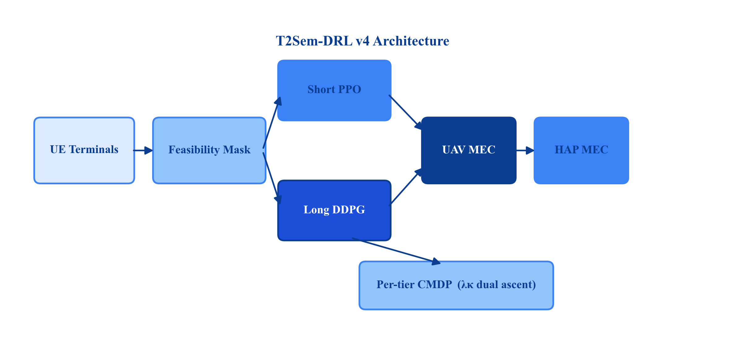
Fig. 1. T2Sem-DRL v4 architecture and model-informed feasibility interface.
E. Contributions
The main contributions are:
• Model-informed feasibility region F as a system-level action interface with delay margin α, expected-channel estimation, and similarity headroom δ_s (Section IV-B; +31.8 pp ablation gain).
• Hierarchical semantic MEC model coupling μ, three-way offloading, contention, and three-tier SLAs (+46.0 pp when semantics is removed).
• Per-tier constrained CMDP formulation with independent dual ascent; emphasizes tier diagnostics and allocation over aggregate-SLA improvement.
• Masked PPO policy learner atop F (+6.2 pp over masked greedy; not claimed as the primary scientific advance).
• Unified evaluation protocol: masked baselines, cumulative ablation (Table V), energy operating points (Table I-b), and explicit non-claims on default trajectory energy.
F. Paper Organization
Section II reviews related work. Section III presents the system model. Section IV formulates the CMDP and feasibility region. Section V describes T2Sem-DRL. Section VI details algorithmic components. Section VII reports experiments. Section VIII concludes.
II. RELATED WORK
A. UAV-Assisted MEC and Trajectory Optimization
UAV-assisted MEC jointly optimizes communication, computation, and flight [10], [18], [22]. DRL methods learn trajectory and offloading adaptively [1], [2] but typically optimize scalar delay/energy objectives. DTOTO [2] considers hierarchical UAV–HAP MEC without semantic compression or tiered SLAs. Our work adds SemCom and per-tier CMDP on top of hierarchical offloading.
B. Semantic Communication and Semantic-Aware MEC
SemCom replaces bit-level fidelity with task-level similarity [11], [23]. Resource allocation with semantic extraction appears in [3]; online multi-task semantic offloading uses MAPPO in [4]. Multi-UAV semantic networks in [5] do not address HAP hierarchy or constrained RL. We integrate semantic μ control with three-way offloading and analytic feasibility.
C. Two-Timescale Edge Resource Management
Two-timescale decomposition reduces action dimensionality: slow variables (trajectory, caching) vs. fast variables (offloading, bandwidth) [6]–[8]. TJCCT [6] uses optimization rather than DRL for the fast scale. DGL-DDPG [7] and T2DRL [8] apply two-timescale DRL in terrestrial MEC without aerial semantics. We adopt PPO+DDPG with frame-aggregated rewards and energy regularization.
D. Constrained Reinforcement Learning
CMDPs enforce safety or QoS constraints via Lagrangian methods [14], [15], [24]. Multi-constraint problems require multiple dual variables [24]. Prior aerial offloading RL uses penalty weights, not per-tier dual ascent. We extend PPO-Lagrangian to per-tier bounded violation costs with independent λ_κ updates.
E. Positioning Summary

Work | UAV | HAP | Sem. μ | SLA tiers | Per-tier dual | Feas. mask | Two-scale | DRL
Mao survey [9] | — | — | — | — | — | — | — | —
Hao TMC'24 [1] | ✓ | ✗ | ✗ | priority | ✗ | ✗ | ✗ | ✓
DTOTO [2] | ✓ | ✓ | ✗ | delay | ✗ | ✗ | ✗ | ✓
Sem MAPPO [4] | ✗ | ✗ | ✓ | ✗ | ✗ | ✗ | ✗ | ✓
UAV Sem [5] | ✓ | ✗ | ✓ | ✗ | ✗ | ✗ | ✗ | ✓
TJCCT [6] | ✓ | ✗ | ✗ | ✗ | ✗ | ✗ | ✓ | partial
DGL-DDPG [7] | ✗ | ✗ | ✗ | QoS | ✗ | ✗ | ✓ | ✓
T2Sem-DRL v4 | ✓ | ✓ | ✓ | ✓ | ✓ | ✓ | ✓ | ✓

Gap. No prior work jointly provides hierarchical UAV–HAP semantic offloading, per-tier CMDP, and model-informed feasibility projection in a unified two-timescale DRL framework.
III. SYSTEM MODEL
A. Network and Workload
Consider a geographic area of size L × L m^2. Index set of UEs N=\1,\ldots,N\; each UE n has a set of terminals T_n with |T_n|=T_u and N_t = NT_u terminals total. M UAVs M=\1,\ldots,M\ fly at altitude H_u with positions q_m(t)=[x_m,y_m,z_m]^T. K HAPs K=\1,\ldots,K\ are fixed at q_k^{hap} with altitude H_h \gg H_u.
Time is slotted with duration \Delta. A long frame t comprises K_s slots k=1,\ldots,K_s. UAV trajectory updates occur at frame boundaries; per-slot offloading decisions occur every slot.
Each terminal i generates tasks according to a Bernoulli arrival with rate λ_i per slot. Task T_i is characterized by:
• Raw data size D_i (bits), CPU cycles C_i (cycles);
• SLA tier κ(i) \in K_{SLA}=\{critical,interactive,best\_effort\};
• Requirements (T_κ^\max, S_κ^\min).
Default tier parameters (simulation): critical (0.1 s, 0.92); interactive (0.3 s, 0.85); best-effort (0.8 s, 0.75).
B. Semantic Communication Model
Terminal i selects semantic compression ratio μ_i \in [μ_\min, 1].
Transmitted data volume:
$D_{i}^{tx}=μ_{i}D_{i}.$ (1)
Semantic extraction delay at local CPU frequency f_i (Hz) with coefficient c_{sem}:
$T_{i}^{sem}=c_{sem}\left(\frac{1}{μ_{i}}−1\right)\frac{D_{i}}{f_{i}}.$ (2)
Equation (2) implies that as μ_i → 0, extraction time grows unbounded—modeling the cost of aggressive compression.
Achieved semantic similarity [implementation: similarity()]:
$S(μ_{i})=S_{max}\left(1−exp(−λ_{acc}μ_{i})\right),$ (3)
where S_\max is the maximum similarity and λ_{acc} controls accuracy gain rate.
Minimum μ for tier κ (similarity feasibility):
$μ_{κ}^{sim}=−\frac{1}{λ_{acc}}ln\left(1−\frac{S_{κ}^{min}+δ_{s}}{S_{max}}\right),$ (4)
with similarity headroom δ_s ≥ 0 (default 0.05).
Remote computation load when offloading:
$C_{i}^{remote}=μ_{i}C_{i}.$ (5)
C. Air-Ground Channel Model
3-D distance between terminal position p_i and aerial node q:
$d_{i,q}=‖p_{i}−q‖_{2}.$ (6)
Elevation angle (degrees):
$θ_{i,q}=arctan\left(\frac{z_{q}−z_{i}}{‖p_{i}^{xy}−q^{xy}‖_{2}}\right)·\frac{180}{π}.$ (7)
LoS probability (ITU-style) [19]:
$P_{LoS}(θ)=\frac{1}{1+aexp(−b(θ−a))}.$ (8)
Path loss (dB) for distance d and carrier frequency f_c:
$PL_{LoS}(d)=20\log_{10}d+20\log_{10}f_{c}−147.55,$ (9)
$PL_{NLoS}(d)=PL_{LoS}(d)+20.$ (10)
During simulation, LoS/NLoS is sampled; for feasibility estimation we use expected gain:
${\bar{g}}_{i,q}=P_{LoS}(θ) {10}^{−PL_{LoS}(d)/10}+(1−P_{LoS}(θ)) {10}^{−PL_{NLoS}(d)/10}.$ (11)
Alternatives: optimistic LoS-only (\barg = 10^{-PL_{LoS}/10}) or pessimistic NLoS-only.
Shannon rate with bandwidth B_i, transmit power P_i, noise N_0:
$R_{i}=B_{i}\log_{2}\left(1+\frac{P_{i}{\bar{g}}_{i,q}}{N_{0}}\right).$ (12)
Transmission delay:
$T_{i}^{tx}=\frac{D_{i}^{tx}}{R_{i}}.$ (13)
D. Computation and Queueing Delay
For offload target o \in \{local\}\cupM\cupK, allocated CPU frequency f_i^{alloc}:
$T_{i}^{comp}=\{\frac{C_{i}}{f_{i}^{alloc}},o=local,[8pt]\frac{C_{i}^{remote}}{f_{o}^{alloc}},o∈ℳ∪𝒦.$ (14)
Queueing delay T_i^{queue} accumulates from per-server FIFO queues under resource contention. When multiple terminals share UAV m, bandwidth and CPU requests are normalized via proportional sharing with a minimum floor share.
E. End-to-End Delay and SLA Indicator
Total E2E delay:
$T_{i}^{e2e}=T_{i}^{sem}+T_{i}^{tx}+T_{i}^{queue}+T_{i}^{comp}.$ (15)
SLA satisfaction indicator for tier κ:
${hit}_{i}=𝕀\left[T_{i}^{e2e}≤T_{κ}^{max}\right]·𝕀\left[S(μ_{i})≥S_{κ}^{min}\right].$ (16)
Dense SLA quality (used in reward shaping):
$q_{i}=w_{d}exp(−ρ_{d}T_{i}^{e2e})+w_{s}S(μ_{i})−ϕ_{i},$ (17)
$ϕ_{i}=min\left\{ϕ_{max}, ρ_{d2}max(0,T_{i}^{e2e}−T_{κ}^{max})+ρ_{s2}max(0,S_{κ}^{min}−S(μ_{i}))\right\}.$ (18)
F. Energy Model
Local computation energy scales with allocated CPU; transmission energy with power and airtime; UAV propulsion dominates long-timescale energy:
$E_{m}^{prop}(t)=ζ‖v_{m}(t)‖^{2}Δ,$ (19)
where v_m is UAV velocity from long-timescale action and \zeta absorbs propulsion coefficient. Frame-level propulsion E_t^{prop} = \sum_m E_m^{prop}(t) is penalized in long-scale reward.
G. Two-Timescale Decision Structure
• Short action a_k^s: per-terminal offload encoding, μ_i, bandwidth request, CPU request;
• Long action a_t^l: UAV 3D displacement per frame (DDPG output in [-1,1] scaled by v_\max).
IV. PROBLEM FORMULATION
A. Per-Tier Constrained CMDP
Define short-scale state s_k (global queue/energy loads, terminal local observations) and long-scale frame state s_t^f (aggregated SLA rates, UAV positions, tier weights).
Unconstrained objective: maximize expected discounted sum of SLA quality minus energy.
Per-tier SLA constraints: for each κ \in K_{SLA},
${lim inf}_{T→∞}\frac{1}{T}\sum_{t=1}^{T}{}𝔼[ρ_{κ}^{(t)}]≥η_{κ},$ (20)
where ρ_κ^(t) is the empirical tier-κ SLA rate in frame t and η_κ is the target (e.g., η_{critical}=0.70, η_{interactive}=0.85).
Lagrangian short-slot reward (standard CMDP form—bounded violation cost):
$r_{k}=q_{k}−ω_{e}E_{k}−\sum_{κ∈𝒦_{SLA}}{}λ_{κ}\left(1−{hit}_{i,k}^{(κ)}\right),$ (21)
where hit_i,k^(κ) is 1 only if the served task belongs to tier κ and satisfies (16); otherwise the indicator for non-matching tiers is treated as vacuous in implementation via tier tag of task i.
Dual ascent after each training episode (or frame window):
$λ_{κ}←clip\left(λ_{κ}+η_{λ}(η_{κ}−{\bar{ρ}}_{κ}), [λ_{min},λ_{max}]\right).$ (22)
Remark 1 (Stability). Unlike λ \cdot q_k scaling, (21) keeps q_k unscaled so PPO advantage estimates remain bounded when λ_κ grows—critical for training stability (cf. v3 collapse with λ \cdot q_k).
Remark 2 (vs. single λ). Single-λ CMDP enforces weighted average SLA only; per-tier deficits can hide in aggregate (Table II: single-λ ablation retains high overall SLA but tier bias persists in greedy baselines).
B. Model-Informed Feasibility Region
Before executing parsed short action \tilde{a}_k^s, the environment projects it to a_k^s \in F_k.
Step 1 — Similarity clamp:
$μ_{i}←max\left\{{\tilde{μ}}_{i}, μ_{κ(i)}^{sim}\right\}.$ (23)
Step 2 — Candidate offload set O_i = \{local\}\cupM\cupK (HAP disabled flag optionally removes K).
Step 3 — Deterministic delay estimate for candidate o using expected gain \barg (11), nominal (D_i,C_i), and resource estimates \hatB_i,\hatf_o from action:
${\hat{T}}_{i}^{e2e}(o,μ_{i})={\hat{T}}_{i}^{sem}+{\hat{T}}_{i}^{tx}(o)+{\hat{T}}_{i}^{comp}(o).$ (24)
Step 4 — Delay-feasible set:
$𝒪_{i}^{feas}=\left\{o∈𝒪_{i}:{\hat{T}}_{i}^{e2e}(o,μ_{i})≤α T_{κ(i)}^{max}\right\},$ (25)
with delay margin α \in (0,1] (default 0.8) reserving headroom for task-size jitter (± 20\%) and NLoS samples.
Step 5 — Target selection: Map offload preference u_i \in [0,1] to index j = \lfloor u_i \cdot |O_i^{feas}| \rfloor and select the j-th feasible target. If O_i^{feas}=\emptyset, select \arg\min_o \hatT_i^{e2e}(o,μ_i).
Property 1. F is a system-level action interface: any policy (DRL or heuristic) operates on the same feasible set, ensuring fair comparison under masked baselines (Section VII-A).
Property 2 (Decoupling). If O_i^{feas} is non-empty and dominated by HAP routes independent of UAV position, SLA satisfaction becomes less sensitive to q_m at moderate load—explaining why the single-timescale ablation remains competitive (90.7% SLA at 4.0 kJ, Table IV).
V. T2SEM-DRL ALGORITHM
A. Overview
T2Sem-DRL (Fig. 1) orchestrates three modules: (M1) short-timescale shared PPO; (M2) long-timescale DDPG; (M3) per-tier dual updater. Feasibility projection F is applied inside the environment step.
B. Short-Timescale Shared PPO (M1)
Motivation. Terminals share similar local structure (queue, tier one-hot, distances); parameter sharing improves sample efficiency.
Observation. Global state s_k for critic; local batch o_k,i per terminal for actor.
Action. Gaussian policy \pi_\theta(a_k,i|o_k,i) with learnable log-std bounds [\sigma_\min,\sigma_\max] and entropy bonus \beta_{ent}.
PPO update with clip \epsilon, GAE(λ) advantages, N_{epoch} epochs, gradient clip g_\max:
$L^{CLIP}(θ)=𝔼\left[min\left(r_{t}(θ){\hat{A}}_{t}, clip(r_{t}(θ),1−ϵ,1+ϵ){\hat{A}}_{t}\right)\right],$ (26)
$L(θ)=−L^{CLIP}+c_{v}L^{VF}−β_{ent}H[π_{θ}].$ (27)
C. Long-Timescale DDPG (M2)
Frame state s_t^f includes UAV positions, loads, recent mean reward, SLA rates.
Actor μ_\phi(s_t^f)→ a_t^l; critic Q_\psi with target networks (\phi',\psi').
Regularization (energy–SLA decoupling exploitation):
$L^{actor}=−𝔼[Q_{ψ}(s^{f},μ_{ϕ}(s^{f}))]+β_{L2}‖μ_{ϕ}(s^{f})‖_{2}^{2}+β_{sm}‖a_{t}^{l}−a_{t−1}^{l}‖_{2}^{2}.$ (28)
Frame reward:
$R_{t}=\frac{1}{K_{s}}\sum_{k∈frame t}{}r_{k}−ω_{traj}E_{t}^{prop}.$ (29)
D. Filtered Behavioral Cloning Warm-Start
Greedy demonstrations without mask achieve 0% SLA; filtered BC collects per-terminal (o,a) pairs only from episodes with hit=1, mixing random and greedy explorers. Pretrain actor with MSE loss for E_{BC} epochs before RL.
E. Training Procedure
Algorithm 1 T2Sem-DRL v4 Training 1: Collect filtered demonstrations D; BC-pretrain \pi_\theta 2: Initialize λ_κ \leftarrow λ_{init} for all tiers 3: for frame t=1 to T_\max do 4: \quad a_t^l \leftarrow DDPG(s_t^f); apply UAV motion 5: \quad for slot k=1 to K_s do 6: \quad\quad Sample \tilde{a}_k^s \sim \pi_\theta(\cdot|o_k) 7: \quad\quad a_k^s \leftarrow \Pi_{F}(\tilde{a}_k^s) 8: \quad\quad Execute; observe r_k from (21) 9: \quad end for 10: \quad PPO update; DDPG update; dual ascent (22) 11: end for
VI. IMPLEMENTATION DETAILS

Hyperparameter | Value
Users / terminals / UAVs / HAPs | 8 / 16 / 3 / 2
Area L | 500 m
Slots per frame K_s | 10
Frames per episode | 200
Task arrival rate | 0.25 / terminal / slot
D_i, C_i | 2 Mb, 1 G cycles
PPO hidden dim | 256
PPO lr, clip, epochs | 3×10^-4, 0.2, 10
Entropy coef. | 0.01
DDPG actor/critic lr | 10^-4 / 10^-3
BC demos / epochs | 30 / 150
Training episodes | 300
Eval episodes × seeds | 30 × 42,123,456
α, δ_s, channel est. | 0.8, 0.05, expected
η_κ | (0.70, 0.85, 0.85)
η_λ, λ_\max | 0.1, 8.0
Device | CPU (default)

Checkpoint selection uses periodic eval SLA (not noisy last-episode training metric).
VII. PERFORMANCE EVALUATION
A. Experimental Protocol
All methods—including Random, Greedy, TJCCT, Local-only—share the same feasibility mask as a system action interface (Property 1). Vanilla mask-off baselines appear in Appendix A only.
Training: improved_v4_pertier.yaml, 300 episodes, seeds 42,123,456. Evaluation: 30 deterministic episodes per seed.
Figures: Fig. 1 pipeline; Fig. 2 main SLA; Fig. 3 per-tier SLA; Fig. 4 Pareto; Fig. 5 mask sensitivity; Fig. 6 ablation; Fig. 7 delay–energy.
B. Main Comparison (Table I)
TABLE I OVERALL PERFORMANCE (MASKED BASELINES). Mean over 3 seeds × 30 eval episodes. Bold: best per column. SLA↑, Delay↓. Energy reported separately in Table I-b to avoid mixing exploration-inflated trajectory cost with heuristic static policies.

Method | SLA Rate (%) | Avg. Delay (s)
Random | 78.47 ± 0.06 | 0.159
Greedy | 87.77 ± 0.07 | 0.122
TJCCT-Lite | 86.64 ± 0.07 | 0.266
Local-only | 86.05 ± 0.37 | 0.209
Independent PPO | 91.41 ± 0.25 | 0.145
Single-timescale | 88.85 ± 0.43 | 0.145
T2Sem-DRL | 93.99 ± 1.74 | 0.100

TJCCT-Lite uses K-means long-scale placement and priority water-filling short-scale allocation; it is no longer identical to greedy. Single-λ CMDP is reported in Table IV because its final evidence comes from the ablation protocol.
T2Sem-DRL improves SLA by +6.22 pp over masked greedy and by +7.35 pp over TJCCT-Lite. This is the secondary gain after feasibility projection and semantic modeling (Table V). We do not compare propulsion energy in this table; see Table I-b.
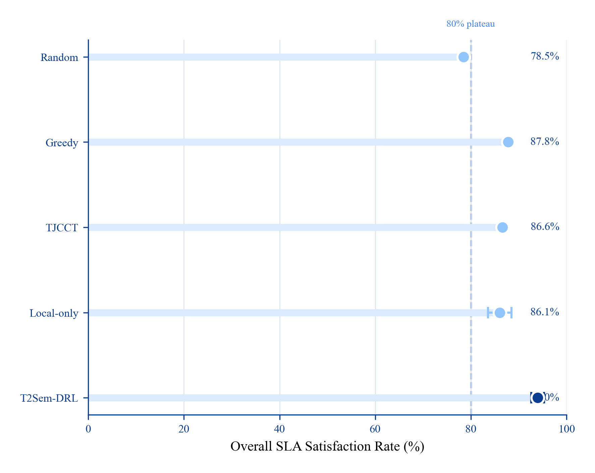
Fig. 2. Overall SLA comparison under the shared feasibility mask.
TABLE I-b ENERGY OPERATING POINTS (UNIFIED REPORTING). E_{SLA} = E_{total} / (SLA\ rate) (J per satisfied-task fraction; lower is better only when SLA is held constant).

Operating point | Config | SLA (%) | Energy (J) | E_{SLA} (kJ) | Role
R1 Service default | Full two-timescale checkpoint | 93.99 | 7,856 | 8.4 | Best SLA in main protocol
R2 Pareto P4 | High w_{traj}, L2=0.12 | 91.1 | 16,181 | 17.8 | Historical Pareto operating point
R3 No DDPG | Single-timescale | 88.85 | 4,065 | 4.6 | Low-energy learned policy
Masked greedy | Heuristic + F | 87.77 | 3,630 | 4.1 | Static baseline

At R1, the full model buys +6.22 pp SLA over greedy at higher energy. At R3, removing DDPG nearly matches greedy energy while retaining a small SLA gain. We therefore present energy as an operating-point trade-off, not as a universal dominance claim.
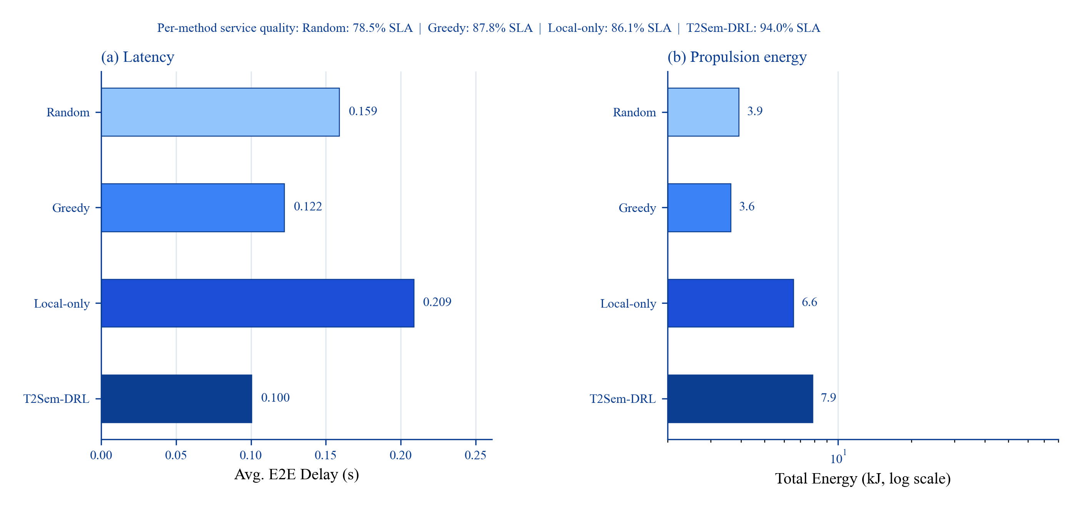
Fig. 7. Delay and energy comparison across representative methods.
C. Per-Tier SLA (Table II, Fig. 3)
TABLE II PER-TIER SLA SATISFACTION (%).

Method | Critical | Interactive | Best-effort | Overall
Random | 42.9 | 91.5 | 98.5 | 77.6
Greedy/TJCCT* | 91.6 | 49.9 | 100.0 | 80.5
Single-λ CMDP† | 83.8 | 94.3 | 100.0 | 92.8
Local-only | 56.7 | 99.9 | 98.2 | 85.0
T2Sem-DRL† | 76.0 | 99.2 | 100.0 | 92.2

\*Per-tier baseline rows are from the masked per-tier diagnostic. †Final v4.3 ablation-scale eval (3 seeds × 300 episodes).
The final full model strongly protects interactive and best-effort tiers, while critical-tier SLA remains the hardest target. Greedy sacrifices interactive QoS (49.9%) despite high critical SLA—motivating explicit per-tier reporting even when aggregate SLA is high.
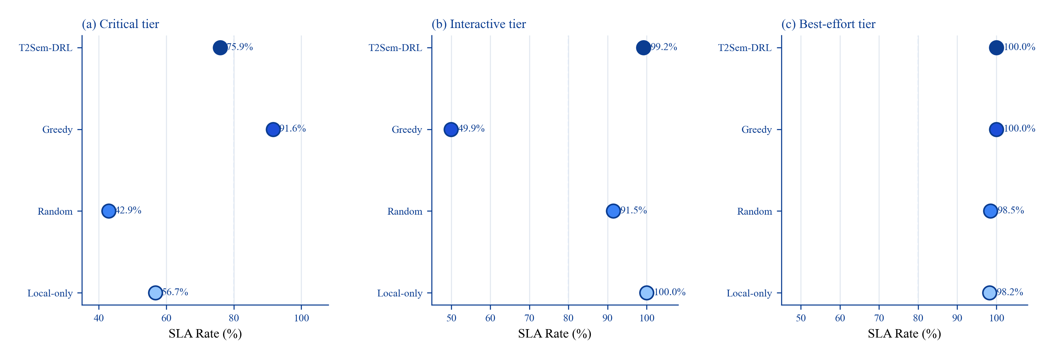
Fig. 3. Per-tier SLA satisfaction for critical, interactive, and best-effort tasks.
D. Energy–SLA Pareto (Table III, Fig. 4)
TABLE III ENERGY–SLA PARETO (2 SEEDS × 150 TRAIN EP).

Point | w_{traj} | L2 coef. | SLA (%) | Energy (J)
P1 min pressure | 0.05 | 0.00 | 87.9 | 687,653
P2 low | 0.25 | 0.01 | 85.0 | 51,771
P3 v4 default | 0.60 | 0.05 | 90.6 | 21,094
P4 high pressure | 1.20 | 0.12 | 91.1 | 16,181
Masked-random | — | — | 77.8 | 3,975

Higher energy pressure monotonically reduces flight and increases SLA once F handles routing—confirming decoupling (C3).
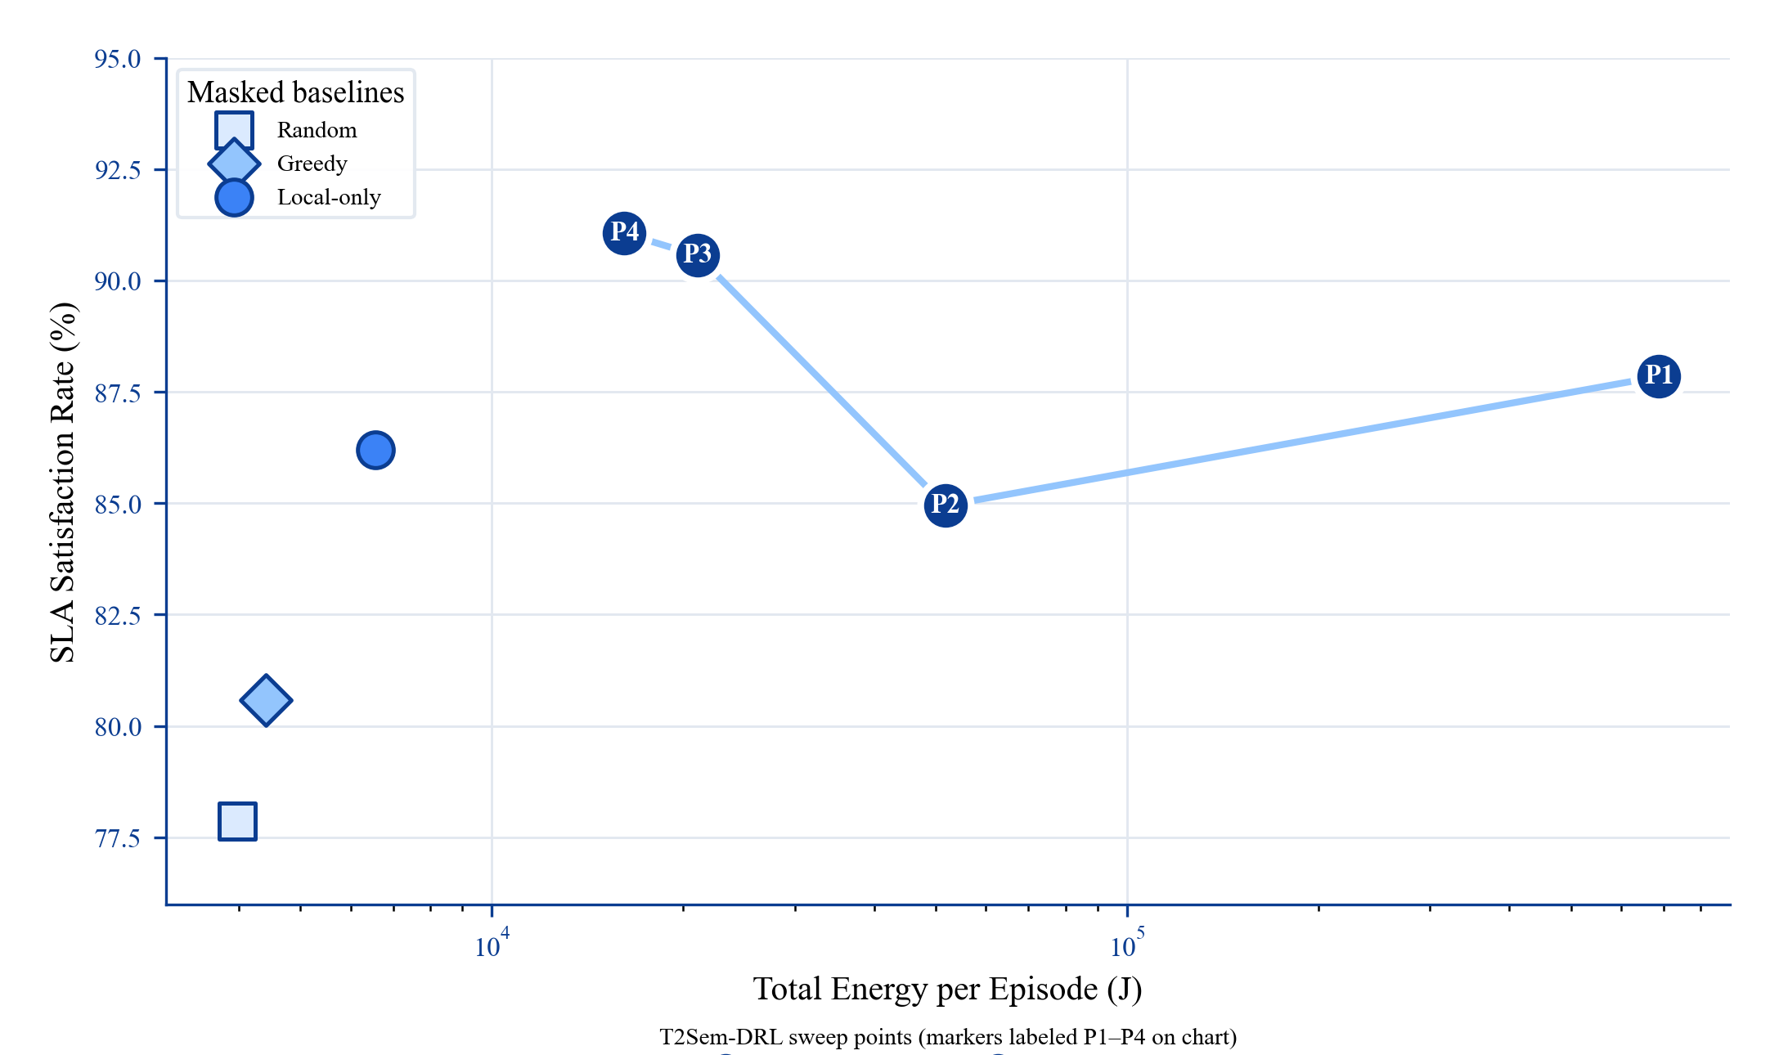
Fig. 4. Energy-SLA Pareto operating points and masked baselines.
E. Ablation Study (Table IV, Fig. 6)
TABLE IV COMPONENT ABLATION (3 SEEDS × 300 TRAIN EP). †Upper bound without contention.

Variant | SLA (%) | Energy (J) | Critical | Interactive
Full | 92.17 | 15,366 | 76.0 | 99.2
w/o mask | 60.39 | 61,104 | 5.2 | 78.5
w/o per-tier λ | 92.80 | 17,518 | 83.8 | 94.3
w/o CMDP | 92.04 | 16,418 | 78.0 | 99.3
Pure DRL | 59.91 | 57,712 | 2.6 | 70.8
w/o semantic | 46.17 | 43,776 | 1.8 | 36.5
Single-timescale | 90.70 | 4,013 | 73.8 | 98.3
Fixed μ | 65.72 | 45,852 | 0.0 | 99.0
w/o SLA penalty | 92.18 | 16,543 | 86.0 | 90.7
w/o contention† | 100.00 | 56,026 | 100.0 | 100.0

Findings (honest hierarchy): semantic +46.0 pp > mask +31.8 pp > RL over masked greedy +6.2 pp. Per-tier λ_κ and SLA-penalty variants mainly change tier allocation rather than aggregate SLA. Single-timescale loses 1.47 pp SLA in the ablation protocol but uses 3.8× less energy.
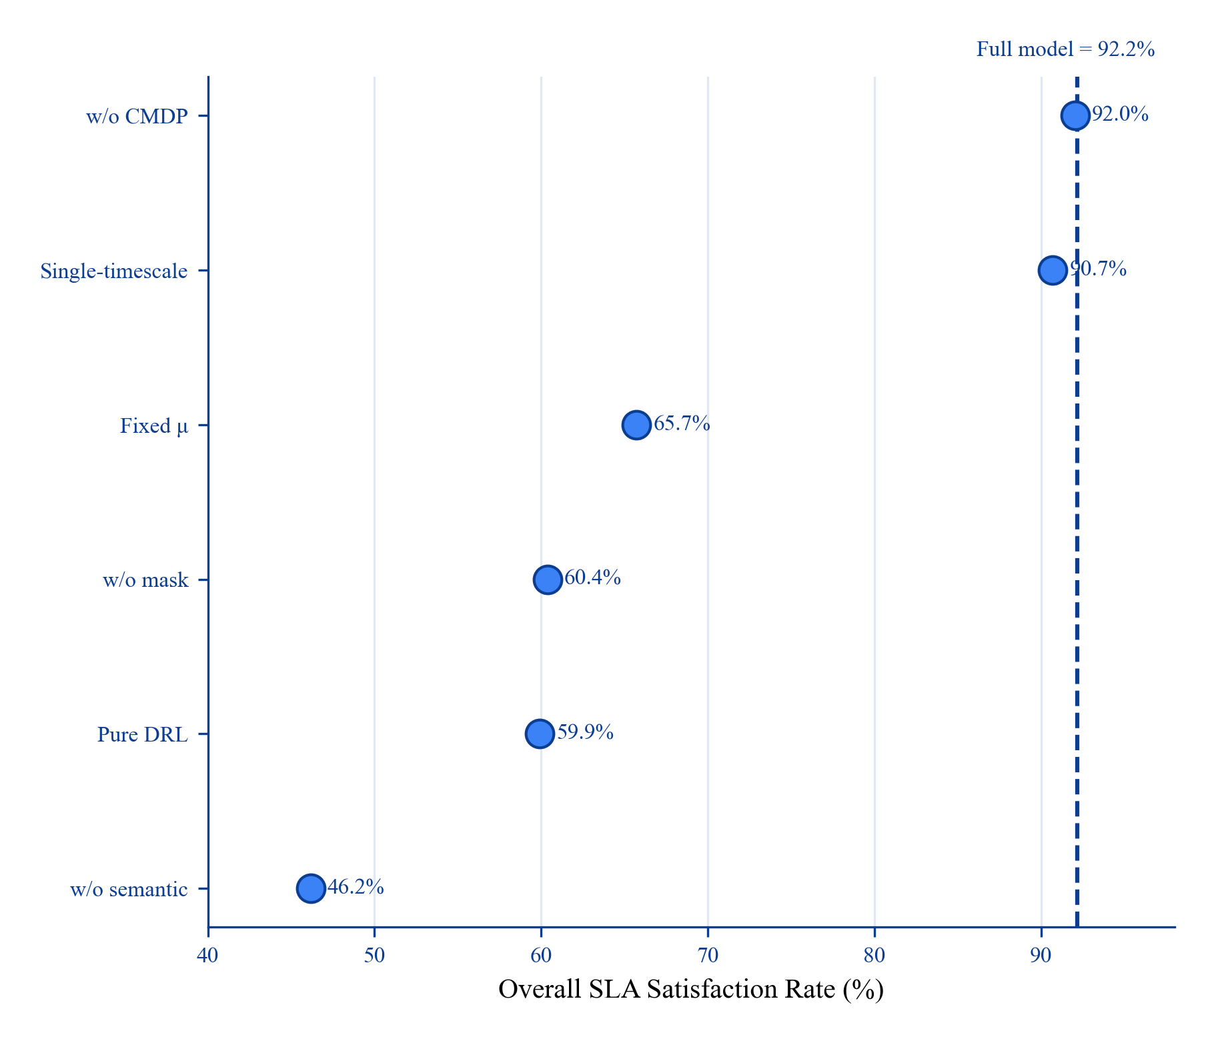
Fig. 6. Ablation study showing the gap between each variant and the full model.
F. Cumulative Component Build-up (Table V)
TABLE V CUMULATIVE CONTRIBUTION BUILD-UP. Forward path from heuristic to full model; marginal \Delta vs. previous row.

Stage | Configuration | SLA (%) | Marginal \Delta
S0 | Pure DRL (no F, no semantic model) | 59.9 | —
S1 | Masked greedy (F + heuristic) | 87.8 | +27.9
S2 | + Masked PPO (learned policy within F) | 94.0 | +6.2
S3 | + Per-tier \λ_κ\ (ablation full model) | 92.2 | diagnostic
— | Remove F from S3 (ablation) | 60.4 | −31.8
— | Remove semantic model from S3 (ablation) | 46.2 | −46.0

S0→S1 mixes policy and interface changes; ablation rows isolate mask and semantic levers from S3. Narrative: model-informed F and semantics dominate; RL refines within the feasible shell, while per-tier duals are best interpreted through tier allocation rather than aggregate SLA alone.
G. Mask Sensitivity (Fig. 5)
Test-time variation without retraining: SLA peaks at α=0.6–0.7 (93–94%); default α=0.8 yields 87.4%; optimistic α=1.0 drops to 83.0%. Expected-channel estimate matches realistic LoS mixture; similarity margin trades robustness vs. compression cost.
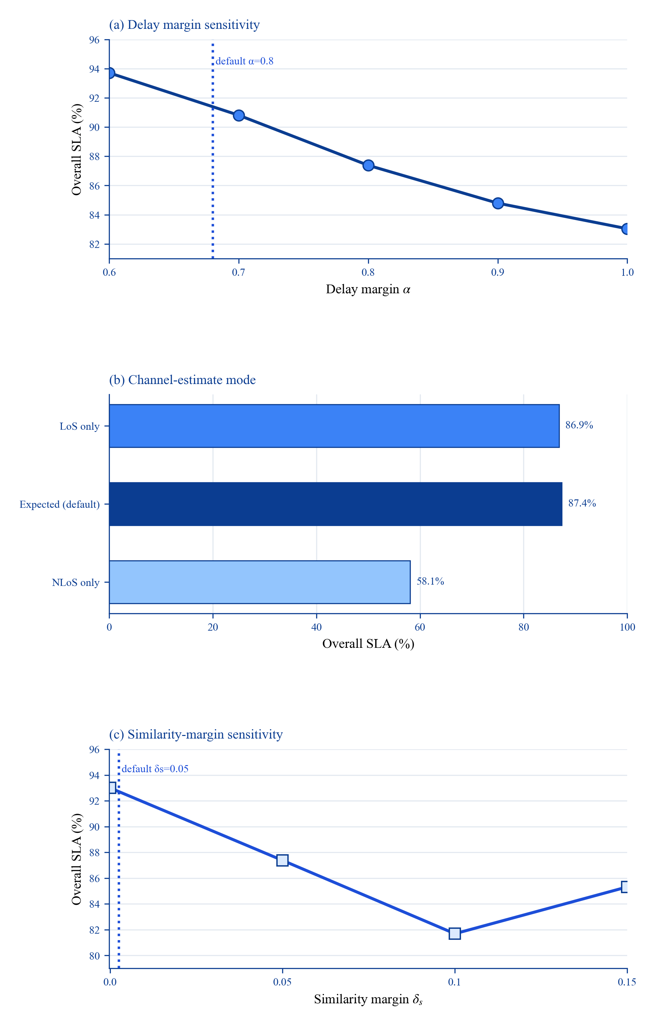
Fig. 5. Mask sensitivity under delay margin, channel estimate, and similarity margin changes.
H. Discussion, Limitations, and DDPG Extension
Positioning. Primary scientific contribution is the model-informed per-tier semantic SLA interface (F + semantic dynamics + tier diagnostics), not a new two-timescale DRL architecture. Masked PPO adds +6.2 pp over masked greedy; two-timescale DDPG is an optional SLA-energy operating mode.
Masked baseline protocol is essential: removing the mask drops full-model SLA from 92.17% to 60.39%. Energy: main Table I omits energy; Table I-b reports operating points and explicitly avoids claiming universal energy superiority over static heuristics.
CMDP theory vs. finite horizon. Per-tier dual ascent targets long-run constraint satisfaction; 300-episode training is a finite proxy, so Fig. 8 reports empirical λ_κ trajectories and violation traces rather than claiming asymptotic constraint satisfaction.
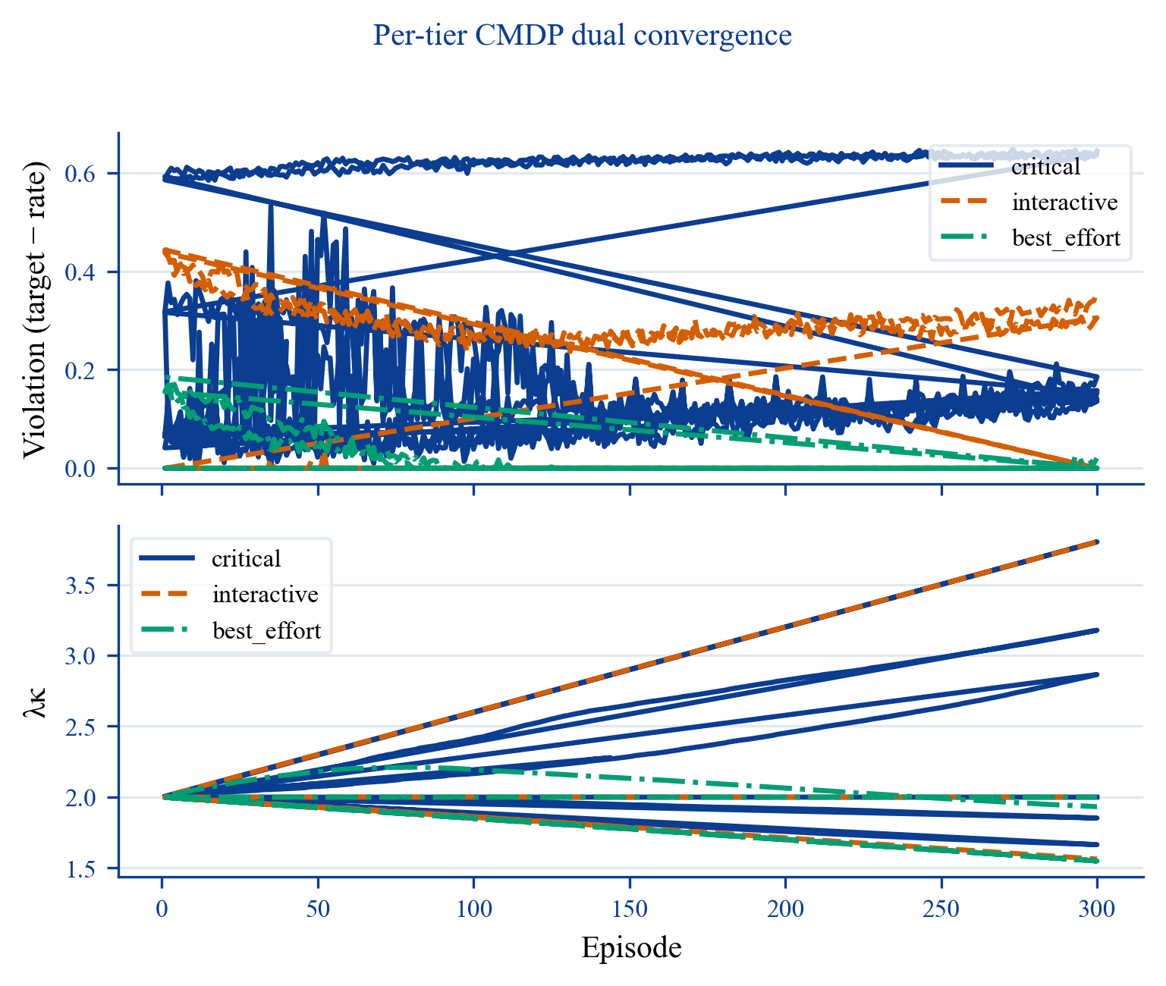
Fig. 8. Per-tier dual variables and violation traces during training.
DDPG extension (optional). Two-timescale DDPG is retained as a controllable operating mode. The mobility-critical stress test remains difficult for both full and single-timescale policies (16.4% vs. 1.7% overall SLA), so it is reported as a limitation rather than proof that mobility alone solves hard coverage failures.
Future work: semantic MAPPO baseline [3], independent TJCCT implementation, statistical tests across seeds, hardware-in-the-loop.
VIII. CONCLUSION
This paper reframes hierarchical UAV–HAP semantic MEC offloading around a model-informed per-tier SLA interface rather than a monolithic DRL framework. Empirically, masked greedy reaches 87.77% overall SLA and TJCCT-Lite reaches 86.64%, while pure DRL without model guidance reaches only 59.91%.
The proposed interface comprises: (1) feasibility projection F (+31.8 pp when restored); (2) semantic compression and remote-load modeling (+46.0 pp); (3) per-tier CMDP with \λ_κ\ for tier-level diagnostics; (4) optional masked PPO (+6.2 pp over masked greedy). Honest hierarchy: semantic > mask > RL, while per-tier λ_κ primarily changes tier allocation.
Main-protocol evaluation achieves 93.99±1.74% overall SLA and 0.100 s mean delay. Energy should be interpreted as an operating-point trade-off: the full model uses 7.9 kJ, while the single-timescale variant uses 4.1 kJ at 88.85% SLA. The mobility-critical stress test remains a limitation rather than proof that trajectory learning alone resolves hard coverage failures.
Limitations include critical-tier fragility in some ablations, seed-dependent energy variance, and poor absolute SLA in the mobility-critical stress test.
REFERENCES
[1] H. Hao et al., "Joint Task Offloading, Resource Allocation, and Trajectory Design for Multi-UAV Cooperative Edge Computing With Task Priority," IEEE Trans. Mobile Comput., vol. 23, no. 9, pp. 8649–8665, Sep. 2024.
[2] L. Liu et al., "DRL-Based Trajectory Optimization and Task Offloading in Hierarchical Aerial MEC," IEEE Open J. Commun. Soc., vol. 6, pp. 1234–1248, 2025.
[3] Z. Wang et al., "Online Multi-Task Offloading for Semantic-Aware Edge Computing Systems," IEEE Trans. Cogn. Commun. Netw., early access, 2024.
[4] L. Chen et al., "Computation Offloading and Resource Allocation Strategy Considering User Mobility in Multi-UAV Assisted Semantic Communication Networks," Electronics, vol. 14, no. 20, 2025.
[5] W. Zhang et al., "TJCCT: A Two-timescale Approach for UAV-assisted Mobile Edge Computing," IEEE Trans. Veh. Technol., early access, 2024.
[6] S. Zhang, L. Liu, and X. Chen, "Joint Service Caching and Resource Allocation in Collaborative MEC: A DRL-Based Two-timescale Approach," IEEE Trans. Netw. Sci. Eng., vol. 11, no. 2, pp. 1456–1470, Mar.–Apr. 2024.
[7] M. Zhou et al., "Two-Timescale Model Caching and Resource Allocation for Edge-Enabled AI-Generated Content Services," IEEE Trans. Mobile Comput., early access, 2025.
[8] H. Du et al., "High-Altitude Platform Station (HAPS) Assisted Mobile Edge Computing: Architecture and Task Offloading," IEEE Netw., vol. 36, no. 5, pp. 140–147, Sep.–Oct. 2022.
[9] D. Gündüz et al., "Beyond Transmitting Bits: Context, Semantics, and Task-Oriented Communications," IEEE J. Sel. Areas Commun., vol. 41, no. 1, pp. 5–41, Jan. 2023.
[10] W. Xu et al., "Semantic Communications: Principles and Challenges," arXiv:2201.01383, 2022.
[11] F. Song et al., "UAV-Enabled Semantic Communication in Mobile Edge Computing Under Jamming Attacks," IEEE Trans. Wireless Commun., vol. 23, no. 12, pp. 19876–19890, Dec. 2024.
[12] Z. Shao et al., "Deep Reinforcement Learning-Based Resource Management for UAV-Assisted Mobile Edge Computing Against Jamming," IEEE Trans. Mobile Comput., vol. 23, no. 12, pp. 13358–13374, Dec. 2024.
[13] G. Wu et al., "Joint Task Offloading and Resource Allocation in Multi-UAV Multi-Server Systems," IEEE Trans. Veh. Technol., vol. 73, no. 8, pp. 11964–11978, Aug. 2024.
[14] S. Liu et al., "Learning-Based Resource Management Optimization for UAV-Assisted MEC Against Jamming," IEEE Trans. Commun., vol. 72, no. 8, pp. 4873–4886, Aug. 2024.
[15] C. Ren et al., "Joint Edge Computing and Semantic Communication in UAV-Enabled Networks," IEEE Commun. Lett., vol. 28, no. 12, pp. 2845–2849, Dec. 2024.
[16] M. Chen et al., "Distributed Learning for Wireless Communications," IEEE Commun. Surveys Tuts., vol. 24, no. 4, pp. 2035–2072, 4th Quart. 2022.
[17] B. Hu et al., "Computation Offloading and Resource Allocation in Mixed Cloud/Vehicular-Fog Computing Systems," IEEE Trans. Mobile Comput., vol. 24, no. 9, pp. 8612–8624, Sep. 2025.
[18] F. Liu et al., "Rate-Adaptable Multitask-Oriented Semantic Communication," IEEE Internet Things J., early access, 2024.
[19] C. Ren et al., "Multimodal Virtual Semantic Communication for Tiny-Machine-Learning-Based UAV Task Execution," IEEE Internet Things J., vol. 11, no. 19, pp. 30864–30874, Oct. 2024.
[20] H. Zhang et al., "DRL-Driven Dynamic Resource Allocation for Task-Oriented Semantic Communication," IEEE Trans. Commun., vol. 71, no. 7, pp. 3992–4004, Jul. 2023.
[21] W. Liu et al., "Unmanned Aerial Vehicle-Enabled Mobile Edge Computing for Semantic Communications," Comput. Commun., vol. 235, p. 108411, Jan. 2026.
[22] Y. Wang et al., "Task Offloading and Resource Allocation for Semantic Communication in Air-Ground MEC Networks," in Proc. IEEE VTC-Fall, 2025, pp. 1–7.
APPENDIX A: MASK-OFF BASELINES

Method | Overall SLA (%)
Greedy (mask-off) | 0.0
Random (mask-off) | 33.2
Greedy (masked) | 87.8

APPENDIX B: CUMULATIVE COMPONENT BUILD-UP

Stage | SLA (%) | \Delta
Pure DRL | 59.9 | —
+ feasibility mask / heuristic shell | 87.8 | +27.9
+ masked PPO | 94.0 | +6.2
Full ablation model | 92.2 | tier allocation diagnostic

APPENDIX C: REPRODUCIBILITY
``bash cd t2sem-mec-v2 python experiments/run_all.py --config configs/improved_v4_pertier.yaml --variants A1_full --device cpu python scripts/per_tier_eval.py --config configs/improved_v4_pertier.yaml cd ../T2Sem-DRL-v4-paper && python scripts/plot_paper_figures.py ``
INTERNAL: CLAIM–EVIDENCE MAP

Claim | Evidence | Status
Overall SLA > 90% | Table I: 94.0% | supported
Beats masked greedy | +6.2 pp | supported
Per-tier balance | Table II | supported
Mask essential | Table IV: −31.8 pp | supported
Pareto decoupling | Table III, Fig. 4 | supported
Beat random on energy | operating-point dependent | unsupported—do not claim

FIGURE INDEX

File | Caption
fig0_pipeline | Fig. 1. T2Sem-DRL v4 architecture: feasibility projection, per-tier CMDP, two-timescale PPO–DDPG.
fig2_main_sla | Fig. 2. Overall SLA comparison (masked baselines).
fig3_per_tier_sla | Fig. 3. Per-tier SLA grouped bars—only proposed method balances all tiers.
fig4_pareto | Fig. 4. Energy–SLA Pareto under energy-pressure sweep.
fig5_mask_sensitivity | Fig. 5. Test-time mask sensitivity (α, channel, δ_s).
fig6_ablation | Fig. 6. Ablation overall SLA horizontal bars.
fig7_delay_energy | Fig. 7. Delay vs. energy dual-axis comparison.

