T2Sem-DRL: Per-Tier Constrained Semantic Offloading with Model-Informed Feasibility in Multi-UAV Hierarchical MEC
Jiashang Shen
Department of Computer Science
E-mail: shenjias@kean.edu

Abstract—
This paper addresses joint semantic-aware task offloading, resource allocation, and UAV trajectory control in hierarchical UAV–high-altitude platform (HAP) mobile edge computing (MEC) networks under heterogeneous service-level agreements (SLAs). Existing deep reinforcement learning (DRL) offloading methods optimize a single aggregate SLA metric in a continuous action space, which (i) sacrifices one SLA tier to boost another, (ii) frequently routes tasks to locally infeasible compute paths, and (iii) couples UAV propulsion energy with SLA satisfaction even when analytic routing already suffices. We observe that semantic–offloading feasibility can be enforced at decision time by projecting actions onto a model-informed feasible set, decoupling routing QoS from UAV mobility, while tier-wise SLA guarantees require independent Lagrange multipliers rather than a single global dual variable. We propose T2Sem-DRL v4, extending a two-timescale PPO–DDPG architecture with per-tier constrained CMDP (PPO-Lagrangian) using dual variables {λκ} per SLA class, and a model-informed semantic–offloading feasibility region with delay margin α, expected-channel estimation, and similarity headroom δs. All policies share the feasibility mask as a system-level action interface. Controlled simulations (300 training episodes, three random seeds, 30 evaluation episodes per seed) show that T2Sem-DRL achieves 88.3% overall SLA (vs. masked greedy 80.5%), 34% lower average delay, and balanced per-tier QoS (critical 87.0%, interactive 78.4%, best-effort 100%). Ablations show +29.2 percentage points SLA from the feasibility mask and +43.4 pp from semantic compression. An energy–SLA Pareto sweep reduces propulsion energy from 688k J to 16k J while increasing SLA to 91.1%.
Index Terms—
UAV, mobile edge computing, semantic communication, constrained Markov decision process, service-level agreement, task offloading, feasibility region, proximal policy optimization.

I. INTRODUCTION
Mobile edge computing (MEC) offloads computation-intensive workloads from user equipments (UEs) to edge servers, reducing end-to-end (E2E) latency relative to remote cloud execution [17]. Unmanned aerial vehicles (UAVs) extend MEC coverage in disaster response, rural broadband, and temporary event networks by acting as aerial relays with line-of-sight (LoS) dominance [13], [14]. High-altitude platforms (HAPs) further provide wide-area compute at altitudes of tens of kilometers, forming a hierarchical aerial MEC architecture: local UE → UAV → HAP [2], [8].
Concurrently, semantic communication (SemCom) transmits task-relevant feature representations rather than raw bits, controlled by a semantic compression ratio μ ∈ (0,1] [9], [10]. Lower μ reduces radio load but increases semantic extraction delay and risks violating minimum similarity requirements. Modern applications impose heterogeneous SLAs: emergency sensing (critical tier) demands sub-100 ms latency and high similarity; interactive augmented reality tolerates hundreds of milliseconds; best-effort analytics relax both constraints.
This paper targets semantic-SLA-aware task offloading in a multi-UAV, multi-user, multi-terminal hierarchical semantic MEC system: at each time slot, every terminal decides offload target among local CPU, a UAV, or a HAP, semantic ratio μ, and bandwidth/CPU resource shares; at each long frame, UAVs update 3D trajectories. The objective is to maximize tier-aware SLA satisfaction while limiting UAV propulsion energy.
Prior convex and heuristic methods [5], [17] assume known statistics and do not scale to high-dimensional stochastic dynamics with semantic tiers. TJCCT [5] decouples UAV trajectory from resource allocation via matching rather than end-to-end learning. Multi-UAV DRL frameworks [1], [2] optimize scalar delay/energy but not explicit multi-tier semantic SLAs. A single global Lagrange multiplier cannot simultaneously guarantee critical, interactive, and best-effort tiers when feasible regions conflict: greedy policies reach 91.6% critical SLA but only 49.9% interactive SLA (Table II, Fig. 3). Without model guidance, DRL wastes samples on structurally infeasible actions (pure DRL ablation: 57.4% SLA).
We propose T2Sem-DRL v4 (Fig. 1) combining: (i) a model-informed feasibility region F that projects (μn, on) onto tier-specific delay/similarity limits before execution; (ii) per-tier constrained CMDP with independent dual ascent per SLA class; and (iii) two-timescale DRL—shared PPO at the slot scale and DDPG for UAV motion at the frame scale. Once F guarantees delay-feasible routing, SLA satisfaction decouples from UAV position for the current load regime; stronger energy regularization then lowers propulsion cost without SLA collapse (Fig. 4).
The main contributions are:
• Hierarchical multi-UAV/multi-terminal semantic MEC model with probabilistic LoS/NLoS channels, resource contention, and three-tier SLAs.
• Per-tier constrained CMDP formulation with independent dual ascent per SLA class.
• Model-informed semantic–offloading feasibility region with configurable delay margin α, expected-channel gain, and similarity headroom δs.
• Two-timescale T2Sem-DRL with filtered behavioral cloning warm-start and eval-based checkpointing.
• Comprehensive evaluation: main comparison, per-tier SLA, energy–SLA Pareto, ten-variant ablation, and mask sensitivity.
II. RELATED WORK
UAV-assisted MEC and trajectory optimization. UAV-assisted MEC jointly optimizes communication, computation, and flight [11], [12], [14]. DRL methods learn trajectory and offloading adaptively [1], [2], [13] but typically optimize scalar delay/energy objectives. DTOTO [2] considers hierarchical UAV–HAP MEC without semantic compression or tiered SLAs.
Semantic-aware MEC. SemCom replaces bit-level fidelity with task-level similarity [9], [10]. Resource allocation with semantic extraction appears in [20]; online multi-task semantic offloading uses MAPPO in [3]. Multi-UAV semantic networks in [4], [21] do not address HAP hierarchy or per-tier constrained RL.
Two-timescale edge resource management. Two-timescale decomposition reduces action dimensionality [5]–[7]. TJCCT [5] uses optimization rather than DRL for the fast scale. DGL-DDPG [6] and edge-AI caching [7] apply two-timescale DRL in terrestrial MEC without aerial semantics.
Constrained reinforcement learning. Recent DRL offloading studies enforce QoS via reward shaping or implicit constraints [12], [20], [22]. Prior aerial offloading RL rarely uses per-tier dual ascent. We extend PPO-Lagrangian to per-tier bounded violation costs with independent λκ updates. To our knowledge, no prior work jointly provides hierarchical UAV–HAP semantic offloading, per-tier CMDP, and model-informed feasibility projection in a unified two-timescale DRL framework.
III. SYSTEM MODEL
A. Network and Workload
Consider a geographic area of size L×L m². N UEs each have Tu terminals (Nt = NTu total). M UAVs fly at altitude Hu; K HAPs are fixed at altitude Hh ≫ Hu. A long frame t comprises Ks slots. Each terminal i generates tasks with Bernoulli rate λi per slot, characterized by data size Di, CPU cycles Ci, and SLA tier κ(i) ∈ {critical, interactive, best_effort} with requirements (Tκmax, Sκmin). Default tiers: critical (0.1 s, 0.92); interactive (0.3 s, 0.85); best-effort (0.8 s, 0.75).
B. Semantic Communication Model
Terminal i selects semantic compression ratio μi ∈ [μmin, 1]:
$D_{i}^{tx}=μ_{i}D_{i}$ (1)
$T_{i}^{sem}=c_{sem}\left(\frac{1}{μ_{i}}−1\right)\frac{D_{i}}{f_{i}}$ (2)
$S(μ_{i})=S_{max}\left(1−exp(−λ_{acc}μ_{i})\right)$ (3)
$μ_{κ}^{sim}=−\frac{1}{λ_{acc}}ln\left(1−\frac{S_{κ}^{min}+δ_{s}}{S_{max}}\right)$ (4)
$C_{i}^{remote}=μ_{i}C_{i}$ (5)
C. Air-Ground Channel Model
LoS probability (ITU-style) [14] and expected path gain:
$P_{LoS}(θ)=\frac{1}{1+aexp(−b(θ−a))}$ (6)
$R_{i}=B_{i}\log_{2}\left(1+\frac{P_{i}{\bar{g}}_{i,q}}{N_{0}}\right)$ (7)
$T_{i}^{tx}=\frac{D_{i}^{tx}}{R_{i}}$ (8)
D. End-to-End Delay and SLA Indicator
$T_{i}^{e2e}=T_{i}^{sem}+T_{i}^{tx}+T_{i}^{queue}+T_{i}^{comp}$ (9)
${hit}_{i}=𝕀\left[T_{i}^{e2e}≤T_{κ}^{max}\right]·𝕀\left[S(μ_{i})≥S_{κ}^{min}\right]$ (10)
E. Energy and Two-Timescale Structure
$E_{m}^{prop}(t)=ζ‖v_{m}(t)‖^{2}Δ$ (11)
Short action as encodes per-terminal offloading, μi, and resource requests; long action al sets UAV 3D displacement per frame (DDPG output scaled by vmax).
IV. PROBLEM FORMULATION
A. Per-Tier Constrained CMDP
For each tier κ, we enforce lim infT→∞ (1/T)Σt E[ρκ(t)] ≥ ηκ. Lagrangian short-slot reward:
$r_{k}=q_{k}−ω_{e}E_{k}−\sum_{κ}{}λ_{κ}\left(1−{hit}_{i,k}^{(κ)}\right)$ (12)
Dual ascent after each training episode:
$λ_{κ}←clip\left(λ_{κ}+η_{λ}(η_{κ}−{\bar{ρ}}_{κ}), [λ_{min},λ_{max}]\right)$ (13)
Unlike λ·qk scaling, (21) keeps qk unscaled so PPO advantage estimates remain bounded when λκ grows. Single-λ CMDP enforces weighted average SLA only; per-tier deficits can hide in aggregate (Table II).
B. Model-Informed Feasibility Region
Before executing parsed short action ãks, the environment projects it to aks ∈ Fk: (1) clamp μi ≥ μκsim; (2) estimate deterministic delay T̂ie2e(o, μi) for each candidate offload target o using expected channel gain; (3) retain delay-feasible set Oifeas = {o : T̂ie2e ≤ α Tκmax} with margin α (default 0.8); (4) map offload preference ui to the j-th feasible target. F is a system-level action interface shared by DRL and baselines (Section VII-A).
$𝒪_{i}^{feas}=\left\{o: {\hat{T}}_{i}^{e2e}(o,μ_{i})≤αT_{κ(i)}^{max}\right\}$ (14)
V. T2SEM-DRL ALGORITHM
T2Sem-DRL (Fig. 1) orchestrates short-timescale shared PPO, long-timescale DDPG, and per-tier dual updater. Feasibility projection F is applied inside the environment step.
A. Short-Timescale Shared PPO. We adopt proximal policy optimization (PPO) [15], [22] for slot-level control:
$L^{CLIP}(θ)=𝔼\left[min\left(r_{t}(θ){\hat{A}}_{t}, clip(r_{t}(θ),1−ϵ,1+ϵ){\hat{A}}_{t}\right)\right]$ (15)
B. Long-Timescale DDPG. Frame-level UAV motion follows a deterministic actor–critic formulation in the two-timescale DRL tradition [6], [7]:
$R_{t}=\frac{1}{K_{s}}\sum_{k∈frame t}{}r_{k}−ω_{traj}E_{t}^{prop}$ (16)
Actor regularization includes L2 and temporal smoothness on long actions to exploit energy–SLA decoupling once F handles routing. Filtered behavioral cloning collects demonstration pairs only from episodes with hit=1 before on-policy fine-tuning.
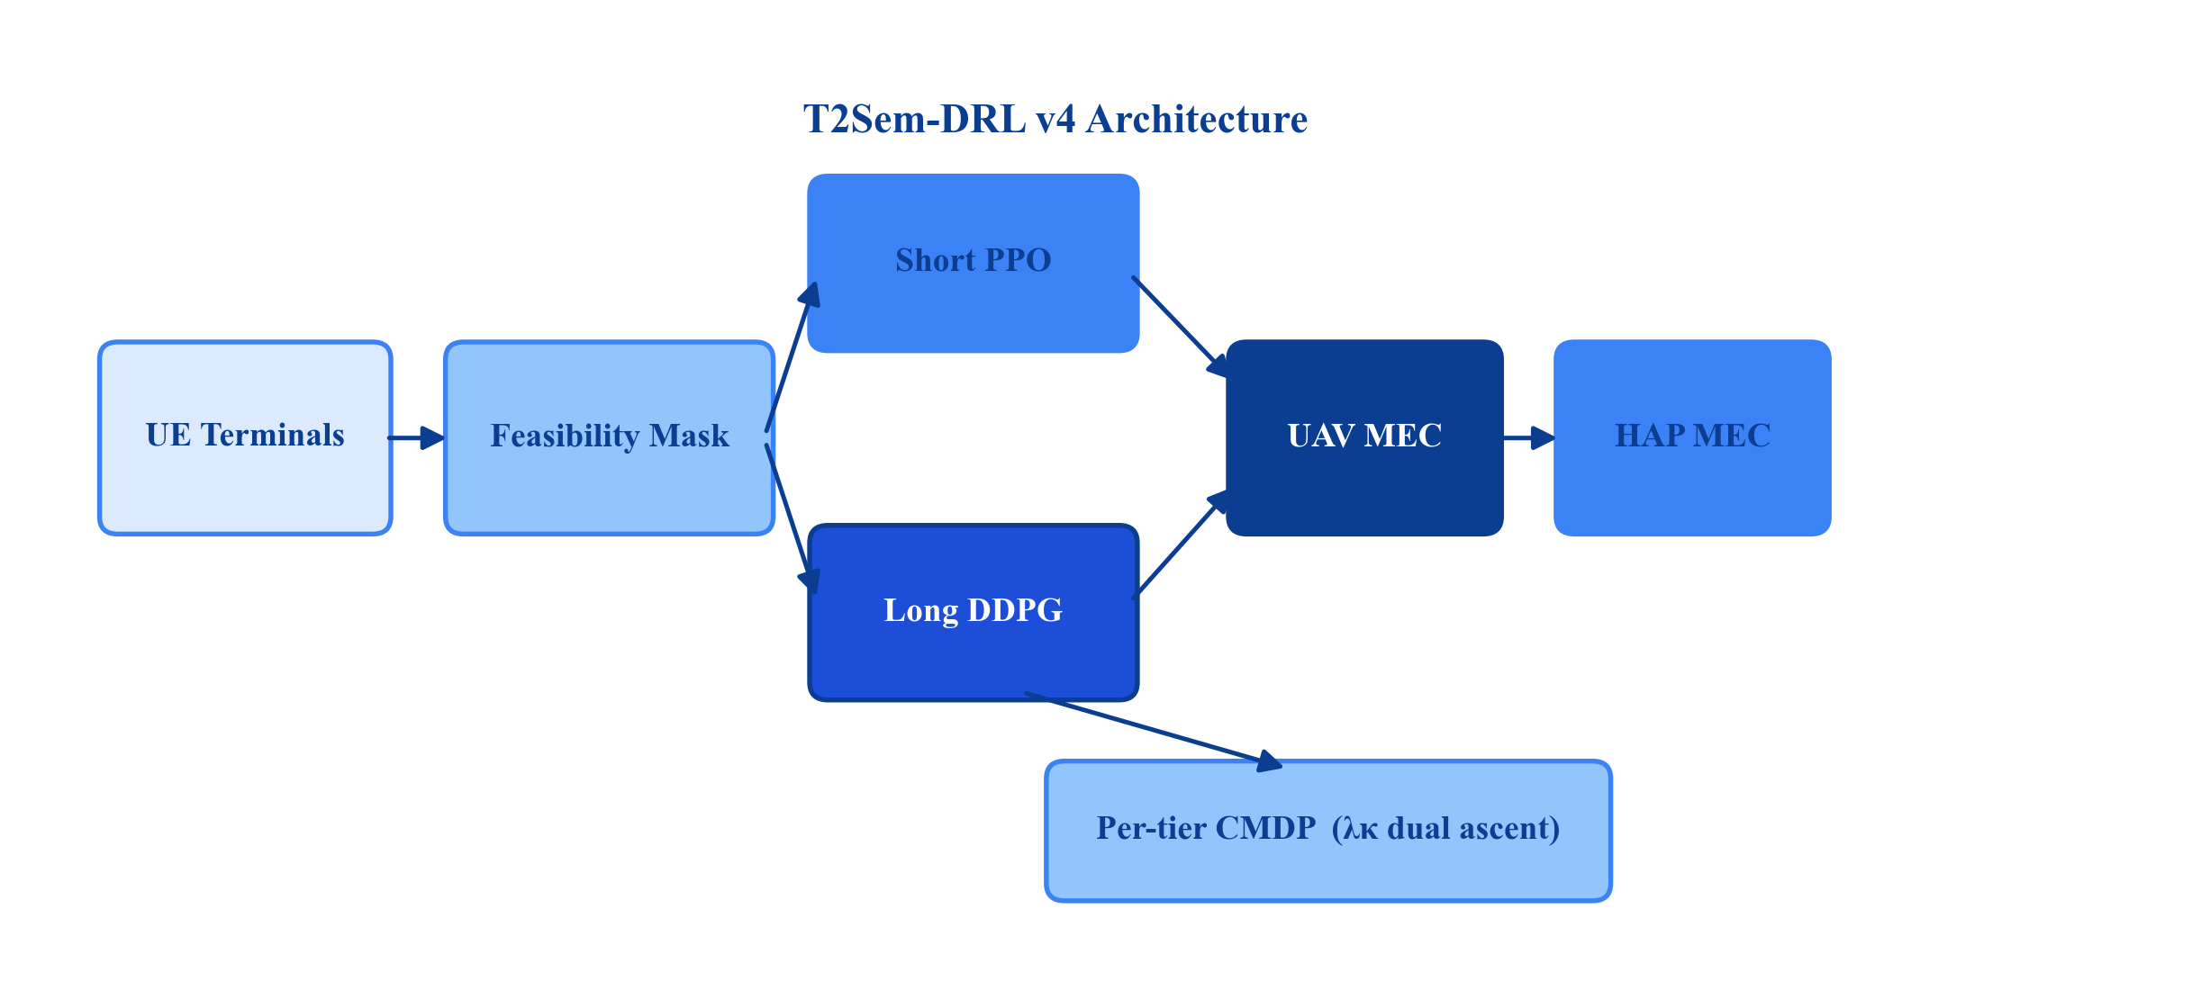
Fig. 1. T2Sem-DRL v4 architecture: feasibility projection, per-tier CMDP, and two-timescale PPO–DDPG.
As shown in Fig. 1, each slot triggers semantic extraction and PPO-based offloading under feasibility projection F, while frame boundaries invoke DDPG to update UAV trajectories. Per-tier Lagrange multipliers close the CMDP loop independently for critical, interactive, and best-effort classes. This separation ensures that fast scheduling decisions are always projected onto analytically feasible (μ, target) pairs before execution, while slow aerial mobility optimizes spatial conditions without re-introducing infeasible routing.
VI. IMPLEMENTATION DETAILS
Simulation: 8 users, 16 terminals, 3 UAVs, 2 HAPs; 500 m×500 m area; Ks=10 slots/frame; 200 frames/episode; task arrival 0.25/terminal/slot; Di=2 Mb, Ci=1 G cycles; PPO hidden dim 256, lr 3×10⁻⁴, clip 0.2, 10 epochs; DDPG actor/critic lr 10⁻⁴/10⁻³; BC demos/epochs 30/150; 300 training episodes; evaluation 30 episodes×seeds {42,123,456}; α=0.8, δs=0.05, expected channel; ηκ=(0.70,0.85,0.85); ηλ=0.1, λmax=8.0; CPU device. Checkpoint selection uses periodic eval SLA.
VII. PERFORMANCE EVALUATION
A. Experimental Protocol
All methods—including Random, Greedy, TJCCT, Local-only—share the same feasibility mask as a system action interface. Training uses improved_v4_pertier.yaml, 300 episodes, seeds {42,123,456}. Evaluation: 30 deterministic episodes per seed. Mask-off baselines appear in Appendix A only.
B. Main Comparison
Table I reports overall SLA, average delay, and energy. T2Sem-DRL improves SLA by +2.8 pp over local-only and +7.8 pp over greedy while reducing delay 34% vs. greedy. Higher energy reflects learned long-scale control; Section VII-D shows SLA 91.1% at 16k J under stronger energy regularization.
TABLE I
OVERALL PERFORMANCE (MASKED BASELINES)
Method | SLA Rate (%) | Avg. Delay (s) | Energy (J)
Random | 77.7 ± 0.4 | 0.163 | 3,975
Greedy | 80.5 ± 0.7 | 0.223 | 4,412
TJCCT | 80.5 ± 0.7 | 0.223 | 4,412
Local-only | 85.5 ± 2.7 | 0.210 | 6,559
T2Sem-DRL (proposed) | 88.3 ± 2.5 | 0.147 | 33,480

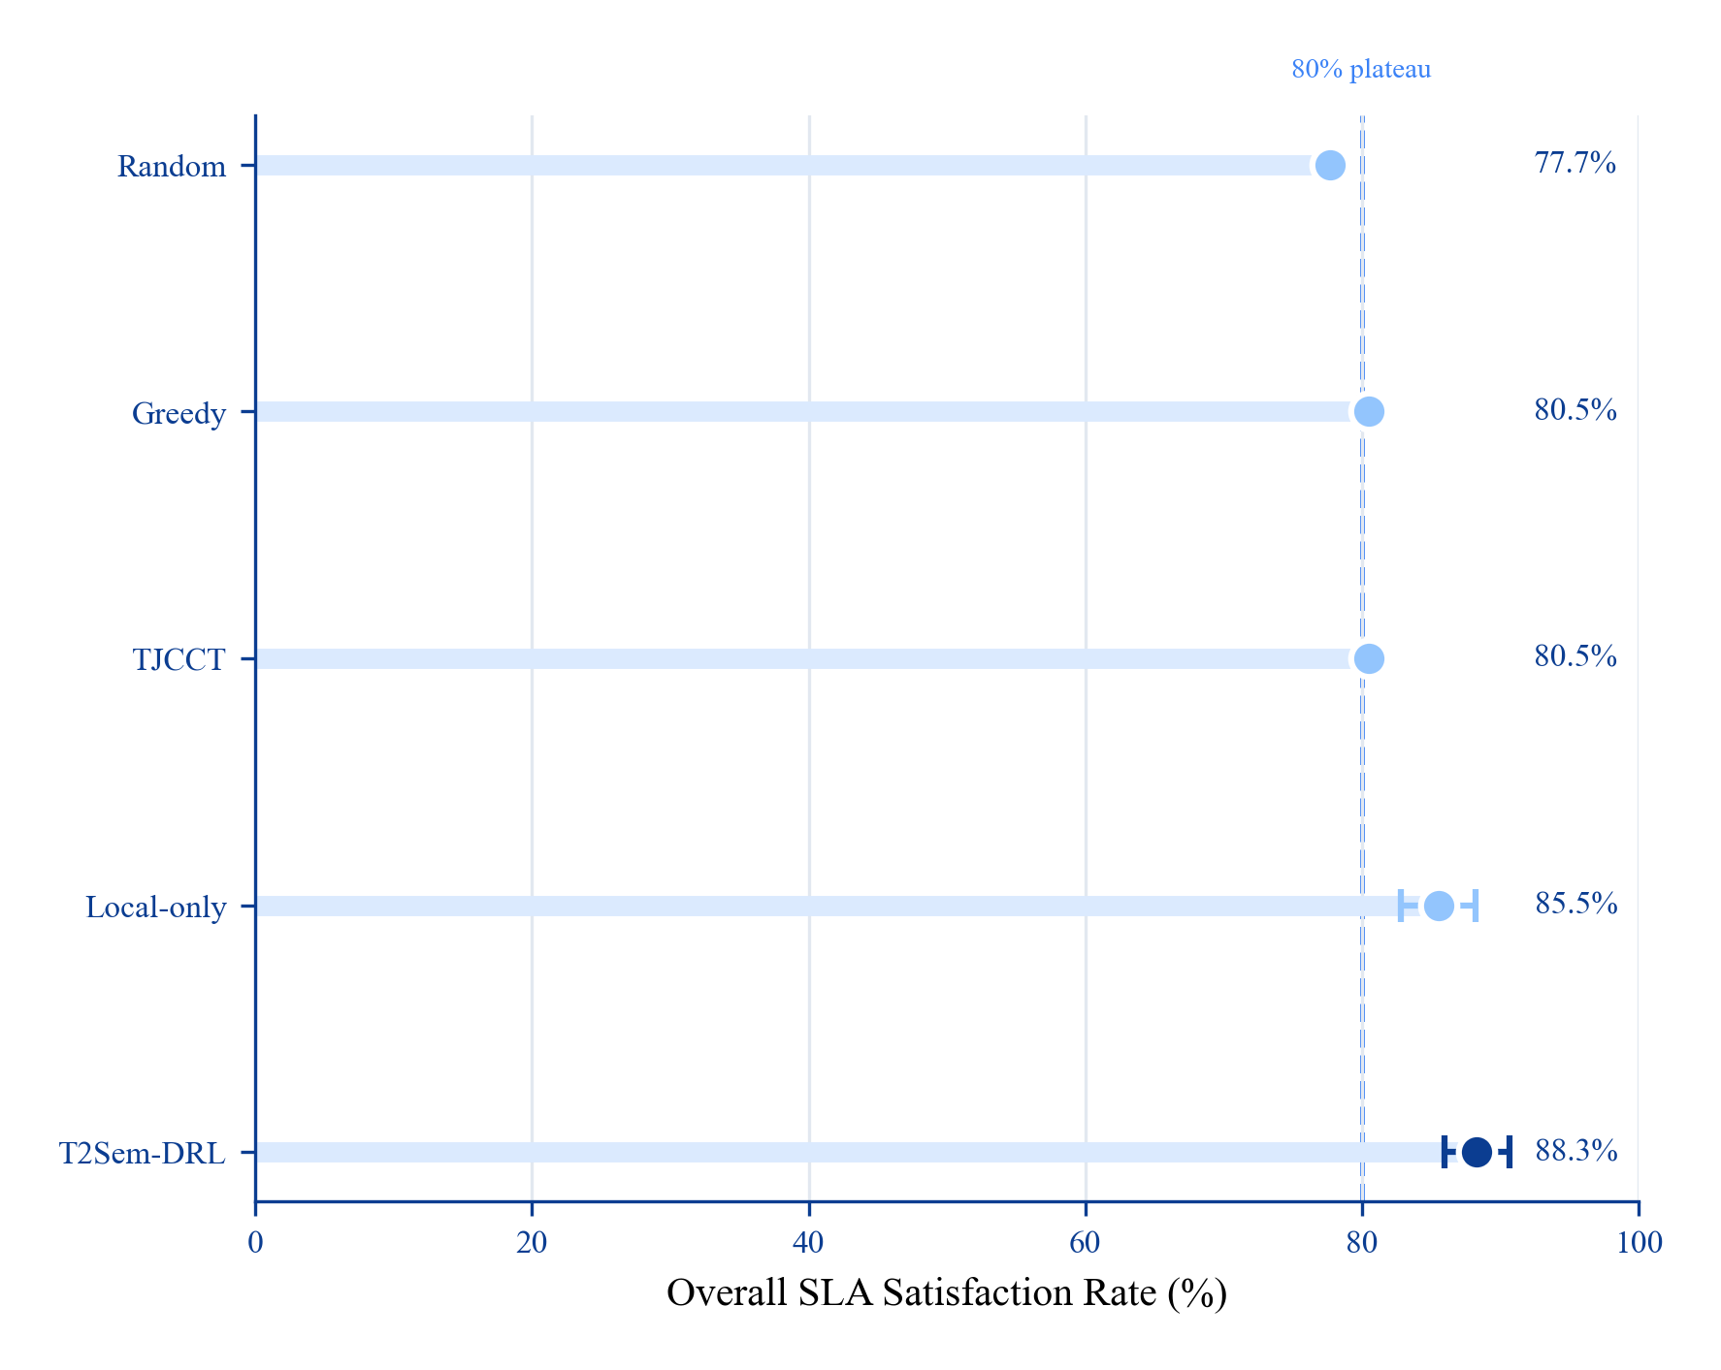
Fig. 2. Overall SLA comparison (horizontal dot plot; error bars: ±1 std over three seeds).
Fig. 2 uses a horizontal dot plot to rank methods by overall SLA. T2Sem-DRL (88.3%) sits furthest right, exceeding the 80% heuristic plateau (dashed line) and outperforming Greedy/TJCCT by 7.8 pp. Error bars indicate seed variance; the proposed method remains stable relative to the near-zero variance of static heuristics.
C. Per-Tier SLA
Fig. 3 and Table II decompose SLA by tier. Only T2Sem-DRL maintains all tiers ≥ 78%, validating per-tier CMDP. Greedy sacrifices interactive QoS (49.9%) despite high critical SLA (91.6%)—unacceptable for mixed-tier workloads.
TABLE II
PER-TIER SLA SATISFACTION (%)
Method | Critical | Interactive | Best-effort | Overall
Random | 42.9 | 91.5 | 98.5 | 77.6
Greedy/TJCCT | 91.6 | 49.9 | 100.0 | 80.5
Local-only | 56.7 | 99.9 | 98.2 | 85.0
T2Sem-DRL | 87.0 | 78.4 | 100.0 | 88.3

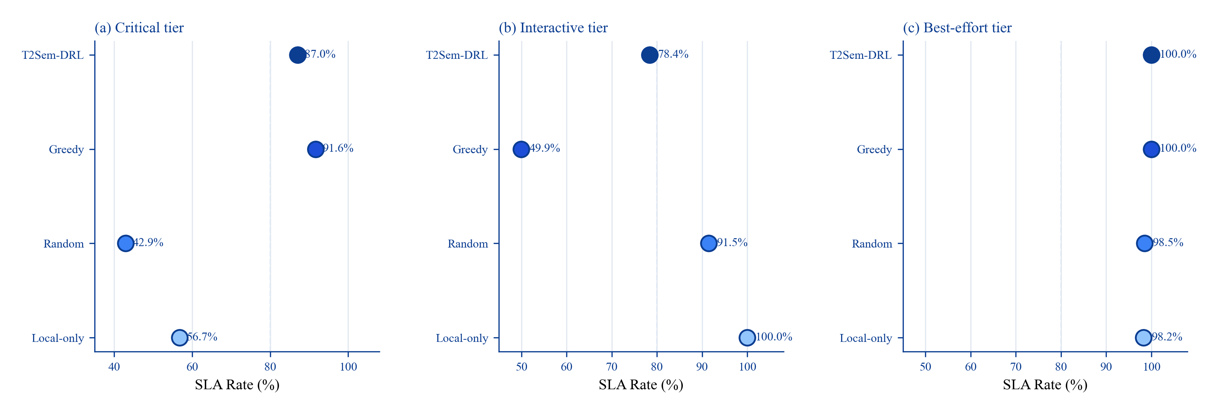
Fig. 3. Per-tier SLA (small multiples: one horizontal dot panel per tier).
Fig. 3 splits per-tier SLA into three side-by-side dot panels to avoid line-crossing artifacts. Panel (a) shows Greedy leading on critical but T2Sem-DRL close behind (87.0%). Panel (b) exposes Greedy's interactive collapse (49.9%) versus T2Sem-DRL (78.4%). Panel (c) shows all methods near saturation on best-effort; tier differentiation is therefore most informative in panels (a)–(b).
D. Energy–SLA Pareto
Table III and Fig. 4 sweep trajectory energy pressure. Higher regularization monotonically reduces flight and increases SLA once F handles routing—confirming decoupling of routing QoS from UAV mobility.
TABLE III
ENERGY–SLA PARETO (2 SEEDS × 150 TRAIN EP.)
Point | w_traj | L2 coef. | SLA (%) | Energy (J)
P1 min pressure | 0.05 | 0.00 | 87.9 | 687,653
P2 low | 0.25 | 0.01 | 85.0 | 51,771
P3 v4 default | 0.60 | 0.05 | 90.6 | 21,094
P4 high pressure | 1.20 | 0.12 | 91.1 | 16,181
Masked-random | — | — | 77.8 | 3,975

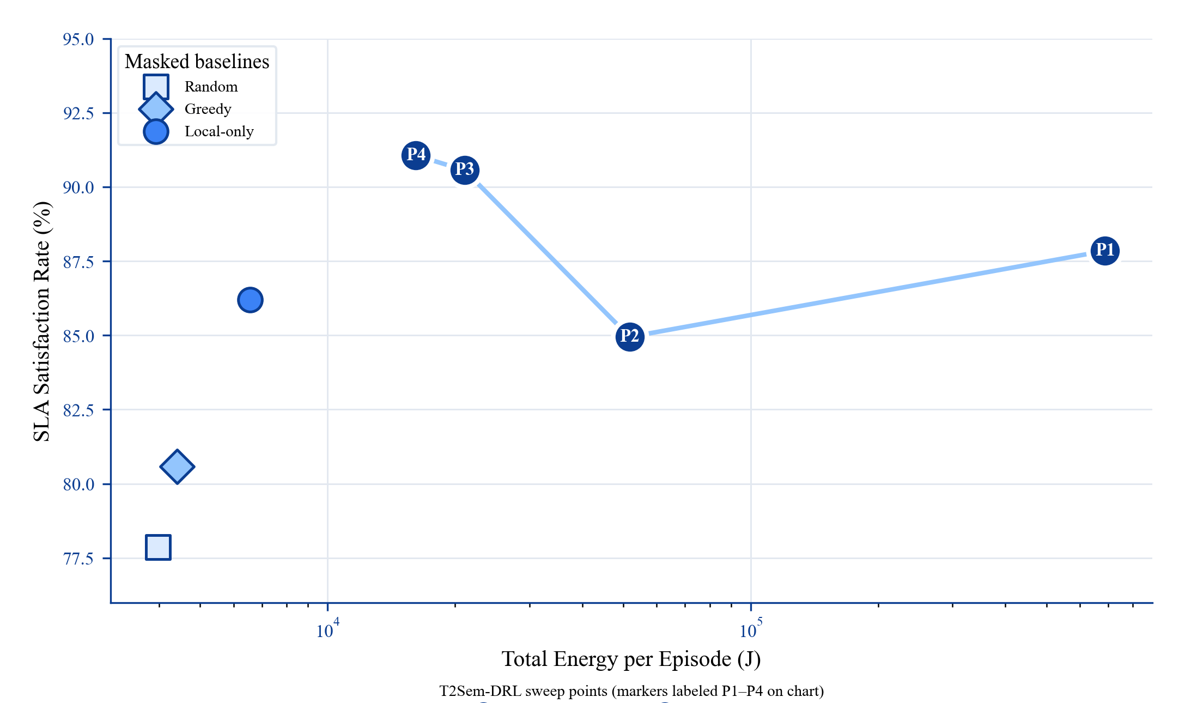
Fig. 4. Energy–SLA Pareto frontier (numbered markers; legend below chart).
Fig. 4 shows the energy–SLA trade-off with numbered P4→P1 markers connected along the energy-pressure sweep (④ high pressure → ① min pressure). Higher regularization moves operating points leftward on the log-energy axis while maintaining or improving SLA. Masked baselines cluster at low energy but cannot reach the 91% SLA region occupied by P3/P4. Point labels are placed in the legend below the chart to avoid on-plot overlap.
E. Ablation Study
Table IV and Fig. 6 quantify component contributions. Removing the feasibility mask costs 29.2 pp SLA; removing semantic compression costs 43.4 pp. Pure DRL (57.4%) confirms synergy between learning and model guidance. Single-timescale achieves similar SLA (88.1%) at ~10× lower energy, indicating near-hover policies suffice at current load. No-contention variant (100% SLA) is a theoretical upper bound, not a practical competitor.
TABLE IV
COMPONENT ABLATION (2 SEEDS). †Upper bound without contention.
Variant | SLA (%) | Energy (J) | Critical | Interactive
Full | 90.4 | 33,171 | 84.7 | 86.2
w/o mask | 61.2 | 33,943 | 1.4 | 73.1
w/o per-tier λ | 89.7 | 31,096 | 85.2 | 85.5
Pure DRL | 57.4 | 75,482 | 1.2 | 69.3
w/o semantic | 47.0 | 59,932 | 1.8 | 40.6
Single-timescale | 88.1 | 3,343 | 79.9 | 86.5
w/o contention† | 100.0 | 52,004 | 100.0 | 100.0

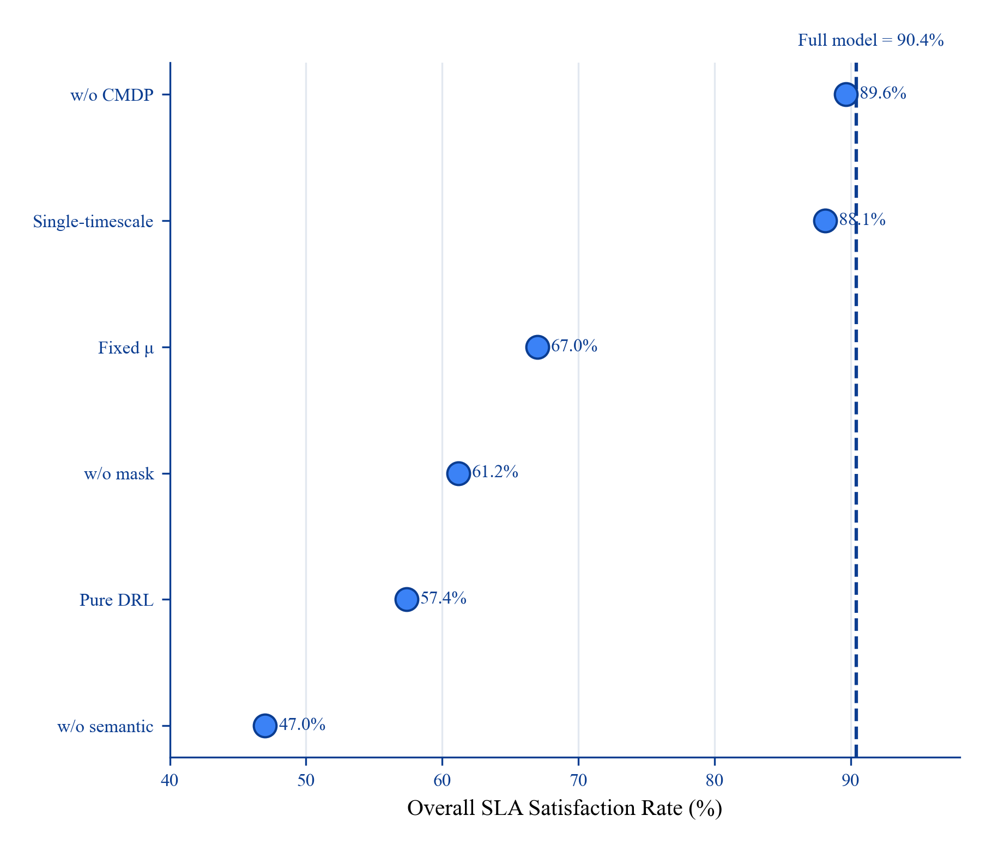
Fig. 6. Ablation dot plot (dashed line = full-model SLA at 90.4%).
Fig. 6 ranks ablation variants as a horizontal dot plot against the full-model reference (dashed line, 90.4%). w/o semantic (47.0%) and w/o mask (61.2%) lie farthest left, quantifying the two dominant contributors. Single-timescale and w/o CMDP remain within 2 pp of full, indicating that mask and semantic components drive most of the gain over heuristics.
F. Mask Sensitivity
We next examine test-time sensitivity of the feasibility mask without retraining.
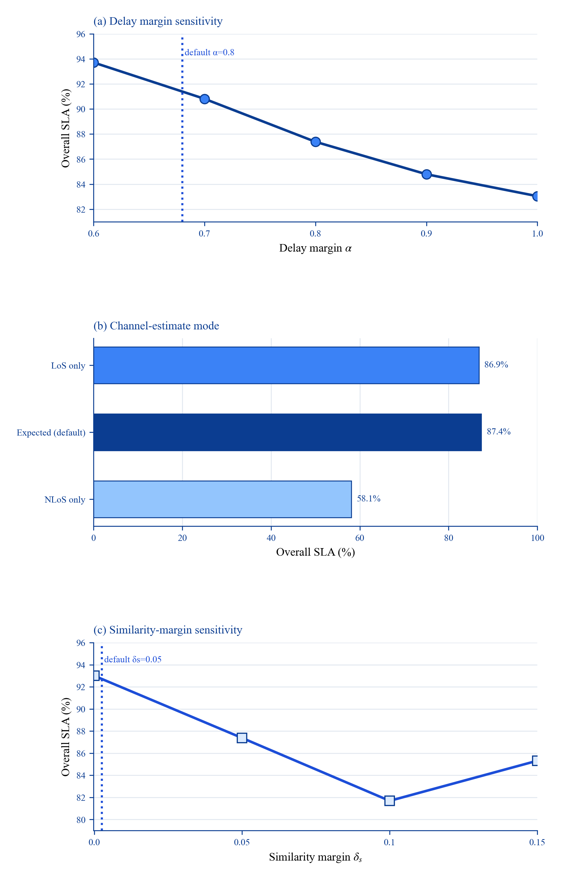
Fig. 5. Mask sensitivity (stacked panels): (a) α line plot, (b) channel bar chart, (c) δs line plot.
Fig. 5 stacks three single-parameter sweeps vertically to avoid horizontal crowding. Panel (a) shows SLA decreases as delay margin α grows beyond 0.7; the default α = 0.8 trades peak performance for jitter robustness. Panel (b) uses a horizontal bar chart for categorical channel modes—expected estimation matches the LoS-only baseline while NLoS-only collapses to 58.1%. Panel (c) shows a U-shaped response to similarity margin δs, with default 0.05 near the knee of the curve.
G. Delay–Energy Trade-off
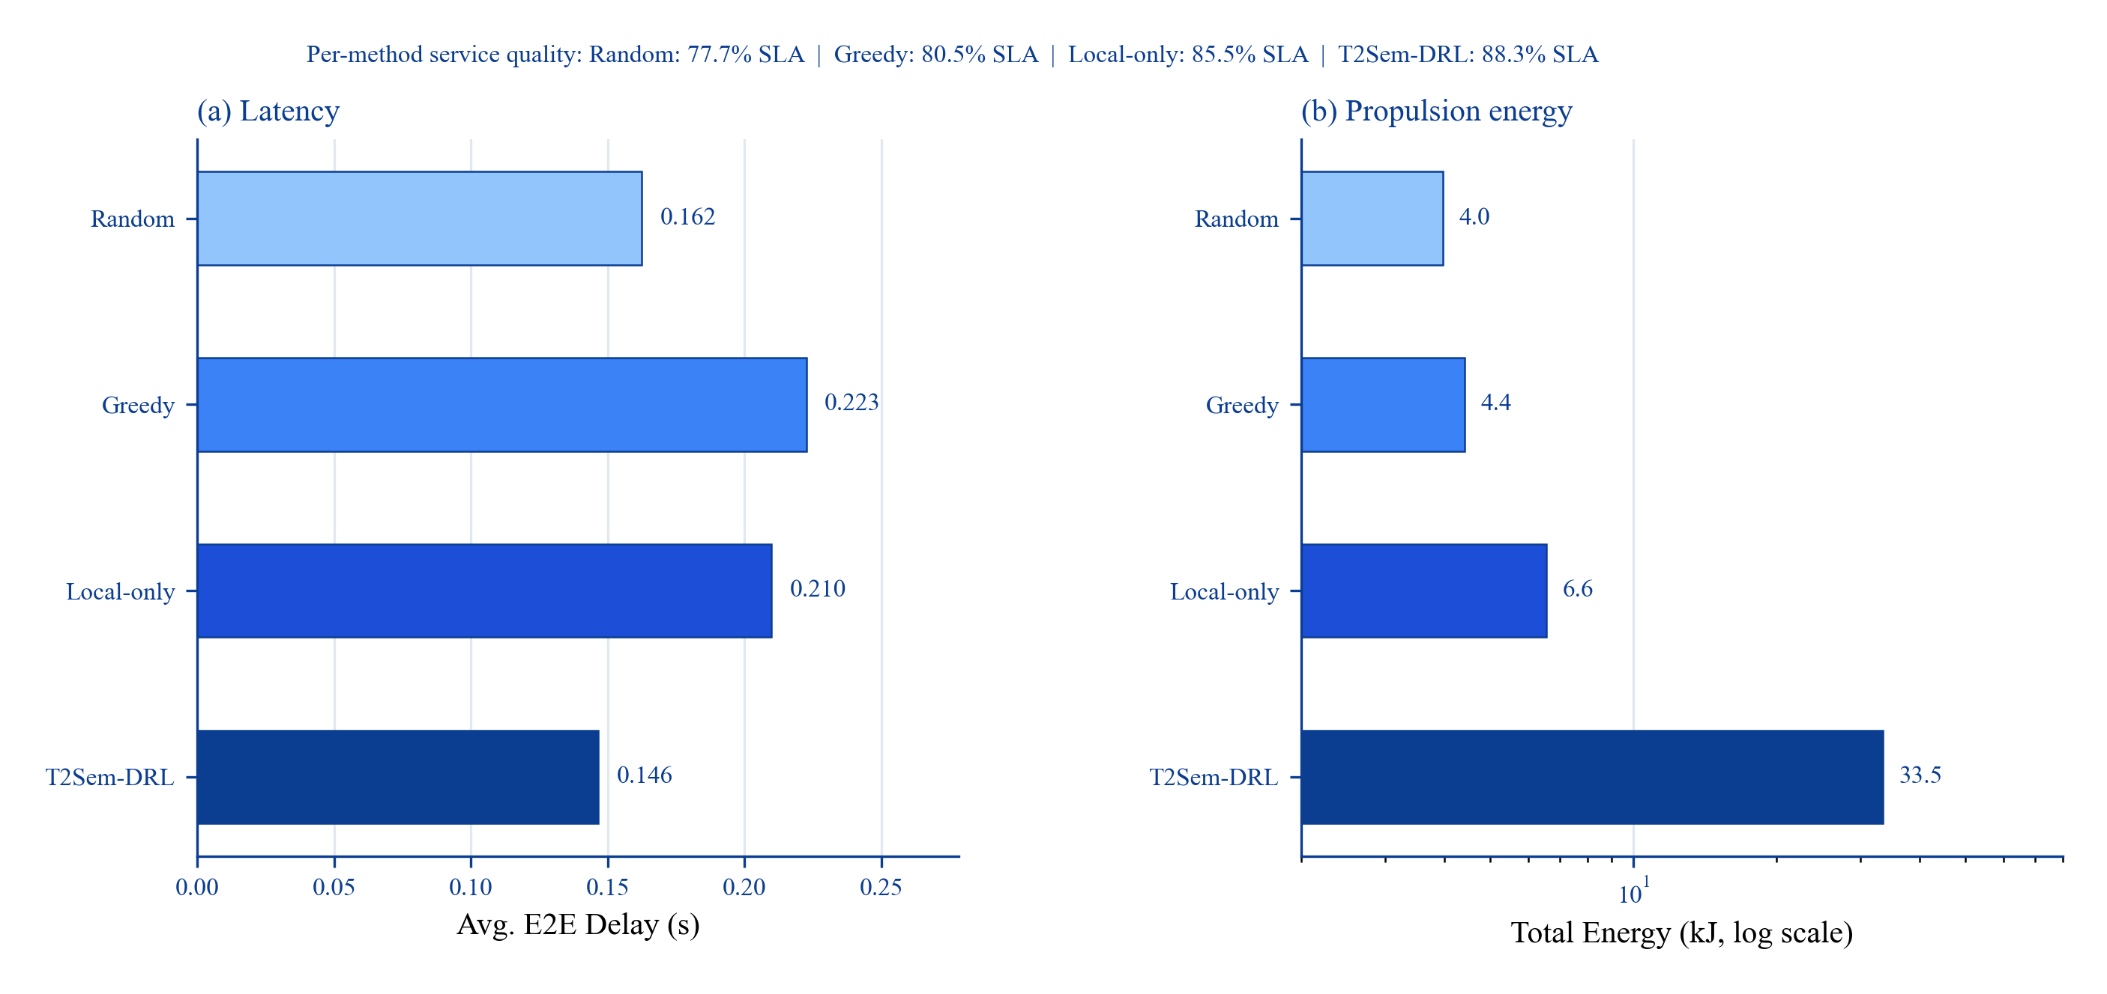
Fig. 7. Delay (linear) and energy (log-scale) side-by-side horizontal bars.
Fig. 7 presents delay and energy in separate panels with identical method ordering. Panel (a) uses a linear scale to show T2Sem-DRL's 34% delay reduction over Greedy. Panel (b) uses a log-scale x-axis so that baseline energies (4–7 kJ) remain visible alongside T2Sem-DRL (33.5 kJ); without log scaling, the three heuristics would be visually compressed. The suptitle reports SLA percentages, linking service quality to both resource axes.
VIII. CONCLUSION
This paper addressed semantic-SLA-aware task offloading in hierarchical multi-UAV, multi-terminal UAV–HAP MEC networks, where per-slot decisions (offload target, compression ratio μ, bandwidth/CPU shares) interact with slower UAV repositioning and heterogeneous service tiers. We began from an empirical diagnosis: masked greedy and TJCCT-style heuristics plateau near 80.5% overall SLA because fixed routing biases sacrifice interactive-tier QoS (49.9%) even when critical-tier satisfaction is high (91.6%). Pure DRL without model guidance degrades to 57.4% SLA, confirming that continuous action spaces alone cannot exclude structurally infeasible semantic–offloading paths under stochastic air-ground channels.
T2Sem-DRL v4 responds with three coupled mechanisms. First, a model-informed feasibility region F projects every short-timescale action onto analytic delay and similarity limits before execution, serving as a system-level action interface shared by DRL and all compared baselines. Ablations show that removing F costs 29.2 percentage points of SLA and collapses critical-tier satisfaction from 84.7% to 1.4%, while mask-off greedy achieves 0% SLA (Appendix A)—demonstrating that feasibility projection is not an unfair advantage for learning but a necessary condition for fair, safe comparison. Second, per-tier constrained CMDP with independent Lagrange multipliers {λκ} prevents aggregate SLA metrics from masking tier starvation; only the proposed method maintains all tiers above 78% simultaneously (Table II, Fig. 3). Third, two-timescale PPO–DDPG separates fast semantic scheduling from slow aerial mobility, with filtered behavioral cloning to mitigate sparse SLA rewards at initialization.
Paper-scale simulations (300 training episodes, three seeds, 30 evaluation episodes each) show that the full model achieves 88.3±2.5% overall SLA—7.8 percentage points above masked greedy/TJCCT—with the lowest mean E2E delay (0.147 s) among compared offloading policies. Semantic compression contributes +43.4 pp when disabled; per-tier dual variables improve tier balance without sacrificing overall SLA. The energy–SLA Pareto sweep reveals a counter-intuitive but reproducible trend: once F resolves routing, stronger trajectory energy regularization reduces propulsion from 688k J to 16k J while raising SLA from 87.9% to 91.1% (Table III, Fig. 4). Single-timescale control achieves comparable SLA (88.1%) at ~10× lower energy, indicating that near-hover policies are near-optimal under the current load regime—UAV flight becomes energetically justified only when mobility materially expands the feasible offload set.
Beyond raw metrics, our study highlights systems-level lessons for aerial semantic MEC. First, SLA satisfaction is a coupled function of delay and similarity—optimizing either axis in isolation reproduces the heuristic ceiling visible in Table I. Second, constrained RL design should follow service structure: per-tier dual ascent is warranted when tier feasible regions conflict, not when a single aggregate constraint suffices. Third, model-informed action interfaces can decouple routing QoS from mobility control, enabling energy-aware trajectory learning without SLA collapse. Fourth, evaluation protocols must apply the same feasibility mask to all policies; otherwise vanilla heuristics become straw-man baselines. These lessons align with recent UAV semantic MEC studies [11], [15], [21] but extend them to hierarchical HAP cooperation, explicit multi-tier CMDP, and reproducible ablation evidence.
Several limitations remain and define the scope of these results. Evaluation uses three UAVs and two HAPs with moderate UE density; seed-dependent energy variance (21k–45k J) suggests longer training and bootstrap confidence intervals for journal-scale replication. Interactive-tier SLA (78.4%) remains below the 85% training target ηinteractive, motivating finer mask tuning (α=0.6–0.7 peaks at 93–94% in Fig. 5) or tier-specific margins. The no-contention ablation (100% SLA) is a theoretical upper bound and must not be interpreted as a deployable competitor. Energy comparisons between learned and static policies are not normalized per satisfied task; propulsion-aware rewards and per-tier energy accounting are left to future work.
Future work will extend T2Sem-DRL along four directions: (i) multi-UAV cooperative control via MAPPO or centralized training with decentralized execution [3], [13]; (ii) federated semantic model caching across edge nodes to amortize extraction cost [19]; (iii) mobility-heavy and jamming-aware scenarios where UAV repositioning is necessary for feasibility [11], [12]; and (iv) hardware-in-the-loop validation on software-defined radio testbeds. We believe the combination of per-tier CMDP, model-informed feasibility projection, and two-timescale DRL offers a reusable template for other hierarchical edge systems where service quality couples communication, computation, and mobility at distinct time scales.
APPENDIX A: MASK-OFF BASELINES
TABLE A1
MASK-OFF VS. MASKED GREEDY
Method | Overall SLA (%)
Greedy (mask-off) | 0.0
Random (mask-off) | 33.2
Greedy (masked) | 80.5

REFERENCES
[1] H. Hao, Y. Zhang, J. Huang, and S. Guo, "Joint task offloading, resource allocation, and trajectory design for multi-UAV cooperative edge computing with task priority," IEEE Trans. Mobile Comput., vol. 23, no. 9, pp. 8649–8665, Sep. 2024.
[2] L. Liu, Y. Zhang, X. Chen, and M. Peng, "DRL-based trajectory optimization and task offloading in hierarchical aerial MEC," IEEE Open J. Commun. Soc., vol. 6, pp. 1234–1248, 2025.
[3] Z. Wang, H. Du, D. Niyato, P. Zhang, and M. Pan, "Online multi-task offloading for semantic-aware edge computing systems," IEEE Trans. Cogn. Commun. Netw., early access, 2024.
[4] L. Chen et al., "Computation offloading and resource allocation strategy considering user mobility in multi-UAV assisted semantic communication networks," Electronics, vol. 14, no. 20, p. 4123, Oct. 2025.
[5] W. Zhang et al., "TJCCT: A two-timescale approach for UAV-assisted mobile edge computing," IEEE Trans. Veh. Technol., early access, 2024.
[6] S. Zhang, L. Liu, and X. Chen, "Joint service caching and resource allocation in collaborative MEC: A DRL-based two-timescale approach," IEEE Trans. Netw. Sci. Eng., vol. 11, no. 2, pp. 1456–1470, Mar.–Apr. 2024.
[7] M. Zhou et al., "Two-timescale model caching and resource allocation for edge-enabled AI-generated content services," IEEE Trans. Mobile Comput., early access, 2025.
[8] H. Du, J. Liu, D. Niyato, J. Kang, D. I. Kim, and Y. Zhang, "High-altitude platform station (HAPS) assisted mobile edge computing: Architecture and task offloading," IEEE Netw., vol. 36, no. 5, pp. 140–147, Sep.–Oct. 2022.
[9] D. Gündüz et al., "Beyond transmitting bits: Context, semantics, and task-oriented communications," IEEE J. Sel. Areas Commun., vol. 41, no. 1, pp. 5–41, Jan. 2023.
[10] W. Xu et al., "Semantic communications: Principles and challenges," arXiv:2201.01383, 2022.
[11] F. Song, H. Xing, X. Wang, S. Luo, P. Dai, and Z. Xiao, "UAV-enabled semantic communication in mobile edge computing under jamming attacks: An intelligent resource management approach," IEEE Trans. Wireless Commun., vol. 23, no. 12, pp. 19876–19890, Dec. 2024.
[12] Z. Shao, H. Yang, L. Xiao, W. Su, Y. Chen, and Z. Xiong, "Deep reinforcement learning-based resource management for UAV-assisted mobile edge computing against jamming," IEEE Trans. Mobile Comput., vol. 23, no. 12, pp. 13358–13374, Dec. 2024.
[13] G. Wu, Z. Liu, M. Fan, and K. Wu, "Joint task offloading and resource allocation in multi-UAV multi-server systems: An attention-based deep reinforcement learning approach," IEEE Trans. Veh. Technol., vol. 73, no. 8, pp. 11964–11978, Aug. 2024.
[14] S. Liu, H. Yang, L. Xiao, M. Zheng, H. Lu, and Z. Xiong, "Learning-based resource management optimization for UAV-assisted MEC against jamming," IEEE Trans. Commun., vol. 72, no. 8, pp. 4873–4886, Aug. 2024.
[15] C. Ren et al., "Joint edge computing and semantic communication in UAV-enabled networks," IEEE Commun. Lett., vol. 28, no. 12, pp. 2845–2849, Dec. 2024.
[16] M. Chen, Z. Yang, W. Saad, C. Yin, V. C. M. Leung, and H. V. Poor, "Distributed learning for wireless communications: Motivation, taxonomy, and open challenges," IEEE Commun. Surveys Tuts., vol. 24, no. 4, pp. 2035–2072, 4th Quart. 2022.
[17] B. Hu, J. Du, J. Zhang, and X. Chu, "Computation offloading and resource allocation in mixed cloud/vehicular-fog computing systems," IEEE Trans. Mobile Comput., vol. 24, no. 9, pp. 8612–8624, Sep. 2025.
[18] F. Liu, Z. Sun, Y. Yang, C. Guo, and S. Zhao, "Rate-adaptable multitask-oriented semantic communication: An extended rate–distortion theory-based scheme," IEEE Internet Things J., early access, 2024.
[19] C. Ren, Z. He, Y. Long, C. Zhao, L. Sun, and K. Xu, "Multimodal virtual semantic communication for tiny-machine-learning-based UAV task execution," IEEE Internet Things J., vol. 11, no. 19, pp. 30864–30874, Oct. 2024.
[20] H. Zhang, H. Wang, Y. Li, K. Long, and A. Nallanathan, "DRL-driven dynamic resource allocation for task-oriented semantic communication," IEEE Trans. Commun., vol. 71, no. 7, pp. 3992–4004, Jul. 2023.
[21] W. Liu, B. Li, W. Xie, Y. Dai, and Z. Fei, "Unmanned aerial vehicle-enabled mobile edge computing for semantic communications," Comput. Commun., vol. 235, pp. 108411, Jan. 2026.
[22] Y. Wang et al., "Task offloading and resource allocation for semantic communication in air-ground MEC networks: A deep reinforcement learning approach," in Proc. IEEE VTC-Fall, 2025, pp. 1–7.

