T2Sem-DRL: Two-Timescale Deep Reinforcement Learning for Semantic-SLA-Aware Task Offloading in Hierarchical UAV–HAP MEC Networks
Jiashang Shen
Department of Computer Science
E-mail: shenjias@kean.edu

Abstract—
Hierarchical unmanned aerial vehicle (UAV) and high-altitude platform (HAP) assisted mobile edge computing (MEC) can deliver low-latency analytics in coverage-limited scenarios, yet each scheduling decision must jointly balance three-way offloading, adaptive semantic compression, and heterogeneous service-level agreements (SLAs) on end-to-end delay and semantic fidelity. Prior UAV offloading and two-timescale control methods typically optimize radio and compute resources without jointly modeling semantic extraction, tiered SLA violations, and hierarchical aerial compute in one learning framework. We observe that coupling all controls in a single reinforcement learning (RL) policy destabilizes training, while fixed-compression heuristics plateau near 80% SLA satisfaction under identical channel and mobility settings. This motivates temporal decomposition: fast slot-level scheduling for offloading, compression, and resource allocation, and slow frame-level control for UAV trajectory and tier weighting. We propose T2Sem-DRL, a two-timescale deep reinforcement learning framework that combines proximal policy optimization (PPO) at the slot scale and deep deterministic policy gradient (DDPG) at the frame scale, with greedy-guided behavioral cloning (BC) to accelerate learning in a hybrid continuous–discrete action space. Controlled simulations (60 training episodes, 80 frames per episode, three random seeds, 30 evaluation episodes per seed) show that T2Sem-DRL achieves 83.6±6.0% SLA satisfaction—the highest among compared methods—while reducing mean end-to-end delay to 0.106 s versus 0.158 s (greedy) and 0.137 s (TJCCT). Ablation studies attribute gains of up to 3.5, 6.2, 5.1, and 3.5 percentage points to semantic compression, two-timescale decoupling, HAP cooperation, and SLA-aware reward shaping, respectively.
Index Terms—
UAV, mobile edge computing, semantic communication, service-level agreement, task offloading, deep reinforcement learning, two-timescale optimization, high-altitude platform.

I. INTRODUCTION
Computation-intensive applications—augmented reality, autonomous sensing, and disaster response video analytics—often exceed the processing capacity of ground user equipments (UEs). Mobile edge computing (MEC) reduces latency by executing tasks at edge servers rather than remote clouds [13], while unmanned aerial vehicles (UAVs) provide flexible aerial access when terrestrial infrastructure is sparse [10], [11]. High-altitude platforms (HAPs) further extend this hierarchy with wide-area coverage and abundant compute [24]. In such layered aerial networks, a single scheduling decision simultaneously affects radio occupancy, queuing dynamics, semantic fidelity, and UAV energy, so static rule-based policies struggle under mobility and bursty traffic.
This paper targets semantic-SLA-aware task offloading in hierarchical UAV–HAP MEC, where each task must meet a tier-specific deadline and minimum semantic similarity while choosing among local execution, UAV relay, and HAP offloading. Three coupled challenges make this setting difficult. First, hierarchical offloading creates heterogeneous delay paths: local execution avoids transmission but is compute-limited; UAV relay shortens radio distance but shares scarce aerial resources; HAP offloading offers abundant compute at the cost of long backhaul-like links [2], [12]. Second, semantic communication introduces a compression–fidelity trade-off: a lower compression ratio μ reduces radio load but increases extraction delay and may violate similarity requirements [15], [16]. Third, joint control of offloading, μ, resource allocation, and UAV trajectory forms a high-dimensional mixed decision process that is difficult to solve optimally under stochastic arrivals [7], [8].
Recent UAV–MEC and two-timescale studies improve trajectory or offloading in isolation, but they rarely co-optimize semantic compression and tiered SLAs in a hierarchical aerial system [1], [4]–[7]. In our simulation platform, greedy and TJCCT-style heuristics plateau near 80.1% SLA satisfaction because they fix μ and under-use HAP capacity, while a single-timescale PPO agent degrades to 77.3% SLA when all controls are coupled every slot (Section II). These failures indicate that effective policies must separate fast scheduling from slow mobility control and must adapt semantics to SLA tier and channel state rather than rely on fixed heuristics.
We propose T2Sem-DRL, illustrated in Fig. 1, to address this gap. At the slot scale, a PPO agent decides three-way offloading, compression ratio, and resource shares; at the frame scale, a DDPG agent updates UAV trajectory and semantic-tier weights. Greedy-guided behavioral cloning warm-starts PPO to mitigate sparse SLA rewards at initialization. Section IX shows that this design improves SLA satisfaction to 83.6±6.0% while achieving the lowest mean end-to-end delay among compared offloading policies.
The main contributions are:
• A hierarchical UAV–HAP system model with probabilistic air-ground channels, semantic extraction/computation delays, and three-tier semantic SLAs.
• A two-timescale MDP formulation and T2Sem-DRL algorithm that couples slot-level PPO with frame-level DDPG under SLA-aware rewards.
• A greedy demonstration warm-start for hybrid continuous–discrete action spaces with sparse service-quality feedback.
• A reproducible simulation study with six ablations and four baselines over three random seeds, quantifying when each design component matters.
II. MOTIVATION AND DESIGN RATIONALE
T2Sem-DRL is designed from controlled baseline experiments rather than from an a priori algorithm choice. We first evaluated local-only execution, random offloading, greedy UAV-centric offloading, and a TJCCT-style two-timescale heuristic [7] under identical channel, mobility, and SLA settings. Local-only execution satisfied 0% of semantic SLAs because critical-tier tasks (0.1 s deadline, 0.92 similarity) could not be completed on constrained UE processors for the configured 2 Mb / 1 G-cycle workload. Random offloading achieved only 24.8% SLA satisfaction, confirming that unstructured decisions are unsafe for latency-sensitive semantic services. Greedy and TJCCT both plateaued near 80.1% SLA satisfaction with average delays of 0.158 s and 0.137 s, respectively—competitive but insufficient for applications that require both high fidelity and low delay under time-varying air-ground channels.
We then diagnosed why the 80% plateau persisted. Profiling per-task delay components revealed that greedy policies fixed μ≈0.6 and predominantly offloaded to the UAV, rarely exploiting the HAP despite its superior compute capacity. Under NLoS episodes, transmission delay dominated even when μ was moderately compressed; conversely, aggressive compression raised semantic extraction delay and risked violating Sκmin for critical tiers. Meanwhile, TJCCT's centroid-tracking UAV trajectory could not anticipate UE mobility hotspots, leaving edge UEs underserved at frame boundaries. These observations suggested three necessary capabilities: (i) adaptive μ tied to SLA tier and instantaneous channel state; (ii) explicit three-way offloading including HAP; and (iii) learned UAV repositioning at a slower timescale than per-slot scheduling.
Our first learning-based attempt used a single-timescale PPO agent controlling offloading, μ, resources, and UAV motion jointly every slot. Training was unstable: the action space dimensionality exceeded 40 continuous variables per step, reward variance spiked whenever SLA penalties fired, and SLA satisfaction stagnated around 77.3% (ablation A3). This failure motivated temporal decomposition—fast per-slot decisions via PPO, slow per-frame trajectory via DDPG—mirroring the physical separation between millisecond-level scheduling and second-level UAV maneuvering. A second failure mode appeared when training PPO from scratch: random exploration produced long episodes with near-zero SLA reward, delaying gradient signal. We addressed this by collecting 25 episodes of greedy demonstrations and behavioral-cloning the PPO actor for 120 epochs before on-policy fine-tuning. The resulting T2Sem-DRL pipeline—BC-warm-started PPO plus frame-level DDPG with SLA-aware rewards—constitutes our final solution and is evaluated in Section IX.
III. BACKGROUND: DEEP REINFORCEMENT LEARNING
We model offloading control as an MDP M = (S, A, P, R, γ) [23]. Policy π maps state s_t to action a_t; reward r_t = R(s_t,a_t) follows transition s_{t+1} ∼ P(·|s_t,a_t). The goal is to maximize expected discounted return
$J(π)=E_{π}\left[\sum_{t=0}^{∞}{}γ^{t}r_{t}\right]$ (1)
By Markovity, future return from state s depends only on s itself. Decomposing one-step reward and discounted future value yields the Bellman expectation and optimality equations:
$V^{π}(s)=\sum_{a}{}π(a|s)\left[R(s,a)+γ\sum_{s^{'}}{}P(s^{'}|s,a)V^{π}(s^{'})\right]$ (2)
$V^{*}(s)=\max_{a∈A}\left[R(s,a)+γ\sum_{s^{'}}{}P(s^{'}|s,a)V^{*}(s^{'})\right]$ (3)
$Q^{*}(s,a)=R(s,a)+γ\sum_{s^{'}}{}P(s^{'}|s,a)\max_{a^{'}}Q^{*}(s^{'},a^{'})$ (4)
Actor–critic methods approximate V_φ or Q_φ and update policy parameters via ∇_θ J ≈ E[ ∇_θ log π_θ(a|s) · Â ], where Â is an advantage estimate. T2Sem-DRL uses PPO at the slot scale and DDPG at the frame scale.
PPO [19] limits policy change through a clipped importance ratio ρ_t(θ) = π_θ(a_t|s_t)/π_{θ_old}(a_t|s_t):
$L^{CLIP}(θ)=E\left[min\left(ρ_{t}(θ){\hat{A}}_{t}, clip(ρ_{t}(θ),1-ϵ,1+ϵ){\hat{A}}_{t}\right)\right]$ (5)
with ε = 0.2. Advantages use GAE from TD residuals δ_t = r_t + γ V(s_{t+1}) − V(s_t):
$δ_{t}=r_{t}+γV(s_{t+1})-V(s_{t})$ (6)
${\hat{A}}_{t}=\sum_{l=0}^{∞}{}(γλ)^{l}δ_{t+l}$ (7)
We set γ = 0.99 and λ = 0.95. DDPG [20] learns deterministic actor μ_θ(s) and critic Q_φ(s,a); the critic regresses toward
$y_{i}=r_{i}+γQ_{ϕ^{'}}\left(s_{i}^{'},μ_{θ^{'}}(s_{i}^{'})\right)$ (8)
Section VII instantiates the PPO and DDPG objectives above with slot and frame rewards from the semantic offloading environment.
IV. RELATED WORK
UAV-assisted MEC and DRL. Yang et al. [1] study multi-UAV cooperative MEC with task priorities and latent-space DRL. DTOTO [2] optimizes UAV trajectory and offloading in layered UAV–HAP MEC via DRL. Wu et al. [12] jointly design multi-UAV trajectories and communication resources. These works do not incorporate semantic compression or explicit semantic SLA tiers.
Semantic-aware MEC. Resource allocation with semantic extraction factors is studied in [4], and online multi-task semantic offloading uses MAPPO in [5]. Multi-UAV semantic communication with user mobility appears in [6]. None jointly addresses UAV–HAP hierarchy with two-timescale DRL.
Two-timescale MEC optimization. TJCCT [7] decouples UAV trajectory (long) from resource allocation and offloading (short) using convex optimization and matching rather than end-to-end DRL. DGL-DDPG [8] and T2DRL [9] apply two-timescale DRL to collaborative terrestrial MEC and edge AI caching, respectively, without aerial hierarchy or semantic SLAs.
To our knowledge, few prior works jointly optimize hierarchical UAV–HAP offloading, adaptive semantic compression, and tiered semantic SLAs within a unified two-timescale DRL framework.
V. SYSTEM MODEL
A. Network Architecture
Consider a hierarchical aerial MEC system with N ground UEs with random waypoint mobility in a L×L m² area; one UAV at position qu(t)∈R³ with maximum speed vmax; and one HAP at fixed position qh with altitude Hh≫Hu. Each UE generates computation tasks according to a Bernoulli arrival process with rate λn per slot. Task i of UE n is characterized by raw data size Dn, CPU cycles Cn, and SLA tier κ∈{critical, interactive, best-effort} with requirements (Tκmax, Sκmin).
B. Semantic Communication Model
UE n selects compression ratio μ_n ∈ [μ_min, 1]. Smaller μ_n reduces radio load but increases encoder work and may lower similarity [15], [16]. The semantic stage is modeled as:
$D_{n}^{tx}=μ_{n}D_{n}$ (9)
$T_{n}^{sem}=c_{sem}\left(\frac{1}{μ_{n}}-1\right)\frac{D_{n}}{f_{n}}$ (10)
$S(μ_{n})=S_{max}\left(1-exp(-λ_{acc}μ_{n})\right)$ (11)
$C_{n}^{remote}=μ_{n}C_{n}$ (12)
Together, (9)–(12) capture the semantic trade-off between transmission/compute cost and fidelity.
C. Communication and Computation Delay
Air-ground links use ITU-style LoS probability [17] and Shannon capacity:
$p_{LoS}(θ_{n})=\frac{1}{1+a exp(-b(θ_{n}-a))}$ (13)
$R_{n}=B_{n}\log_{2}\left(1+\frac{P_{n}h_{n}}{N_{0}}\right)$ (14)
With path-loss gain h_n, transmission and computation delays are
$T_{n}^{tx}=\frac{D_{n}^{tx}}{R_{n}}$ (15)
$T_{n}^{comp}=\frac{C_{n}^{exec}}{f_{n}^{exec}}$ (16)
Pipeline stages are serial (extract → transmit → compute), so end-to-end delay is
$T_{n}^{e2e}=T_{n}^{sem}+T_{n}^{tx}+T_{n}^{comp}$ (17)
For local execution, T_n^{tx}=0 and C_n^{exec}=C_n; for offloading, C_n^{exec}=C_n^{remote} from (12).
D. SLA Satisfaction and Penalty
Tier κ imposes deadline T_κ^{max} and minimum similarity S_κ^{min}. Task n is SLA-satisfied when both constraints hold; violations enter the reward via hinge penalties:
$I_{n}^{SLA}=1\{T_{n}^{e2e}≤T_{κ}^{max}, S(μ_{n})≥S_{κ}^{min}\}$ (18)
$Δ_{n}^{T}=max(0, T_{n}^{e2e}-T_{κ}^{max})$ (19)
$Δ_{n}^{S}=max(0, S_{κ}^{min}-S(μ_{n}))$ (20)
$Φ_{n}=ρ_{d}Δ_{n}^{T}+ρ_{s}Δ_{n}^{S}$ (21)
We use ρ_d = ρ_s = 10 and three tiers: critical (0.1 s, 0.92), interactive (0.3 s, 0.85), best-effort (0.8 s, 0.75).
E. Two-Timescale Structure
Divide time into frames t = 0,1,…, each containing K = 10 slots k = 0,…,K−1. Long action a_t^l (UAV velocity, tier weights) is fixed within frame t; short action a_{t,k}^s varies every slot. This matches the physical separation between slow UAV maneuvering and fast per-task scheduling, and motivates the two-layer MDP in Section VI.
VI. PROBLEM FORMULATION
We cast offloading as a two-layer MDP: short layer M_s (slot decisions) and long layer M_l (frame-level UAV control). Per-slot reward combines SLA success, energy, penalty, and queue cost:
$r_{t,k}=ω_{1}I_{n}^{SLA}-ω_{2}E_{n}^{task}-ω_{3}Φ_{n}-ω_{4}\frac{Q_{n}}{N}$ (22)
With ω_1=2.0, ω_2=0.1, ω_3=8.0, ω_4=0.5, and N=8. Frame reward averages slot outcomes and penalizes UAV propulsion:
$R_{t}=\frac{1}{K}\sum_{k=0}^{K-1}{}r_{t,k}-ω_{5}E_{t}^{prop}$ (23)
The joint objective maximizes discounted returns over both layers subject to mobility and resource constraints:
$\max_{π^{s},π^{l}}E\left[\sum_{t=0}^{T}{}γ_{l}^{t}R_{t}+\sum_{t,k}{}γ_{s}^{tK+k}r_{t,k}\right]$ (24)
Short state s_{t,k}^s encodes UE positions, queues, channels, and SLA tiers; short action a_{t,k}^s encodes offload logits, μ_n, and resource fractions. Long state s_t^l aggregates frame statistics; long action a_t^l sets UAV velocity direction and tier weights. Fixing π^l yields a slot MDP for PPO; fixing π^s yields a frame MDP for DDPG, coupled through R_t.
VII. T2SEM-DRL ALGORITHM
T2Sem-DRL instantiates the two-timescale MDP in Section VI with two cooperating agents. The short-timescale agent must react to fast-varying queues and channels, whereas the long-timescale agent shapes the spatial conditions under which those slot decisions are made. The subsections below describe each agent, the BC warm-start, and the per-frame interaction loop summarized in Fig. 1.
A. Short-Timescale PPO Agent
PPO optimizes π^s using slot reward (22) and the PPO/GAE objectives in Section III. Offload targets are decoded by argmax over three logits per UE; μ_n and resource fractions are continuous Gaussian actions. Before RL, greedy demonstrations pretrain the actor by minimizing
$L^{BC}(θ)=E_{(s,a)\sim D_{demo}}\left[‖tanh(f_{θ}(s))-a‖^{2}\right]$ (25)
which avoids cold-start exploration failure (Section II). Hyperparameters: hidden dim 256, ε=0.2, γ_s=0.99, λ=0.95.
B. Long-Timescale DDPG Agent
DDPG optimizes π^l using frame reward (23) and the DDPG target in Section III. Replay buffer size = 10^5, batch size = 64, γ_l=0.95, and soft-update τ=0.005. DDPG repositioning improves channel/queue conditions for PPO.
Each frame: DDPG updates UAV trajectory; within K slots, PPO schedules offloading and semantics; R_t feeds back to DDPG. Fig. 1 summarizes the loop.
C. Implementation Notes
Both agents use 256-hidden-unit MLPs; PPO runs 4 update epochs per rollout. Our configuration uses 25 BC demonstration episodes and 120 BC epochs before on-policy training.
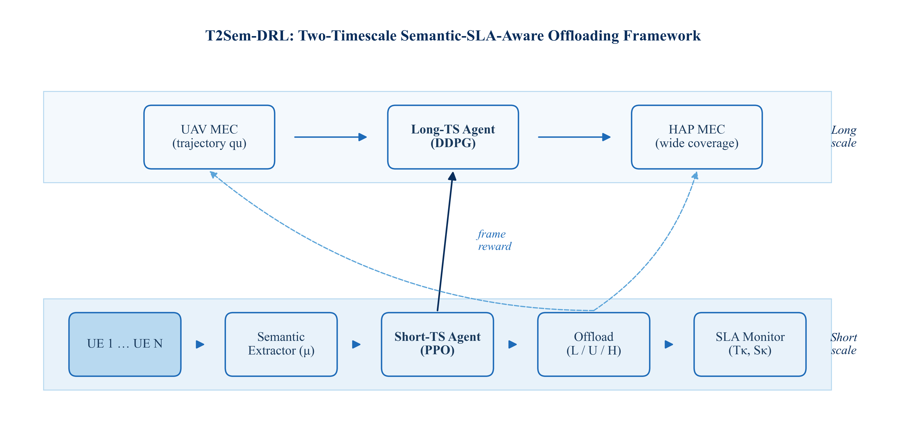
Fig. 1. Architecture of the proposed T2Sem-DRL framework with short- (PPO) and long-timescale (DDPG) agents.
As shown in Fig. 1, each slot triggers semantic extraction, PPO-based offloading, and resource allocation, while frame boundaries invoke DDPG to update UAV trajectory and tier weights. The SLA monitor closes the loop by feeding delay and similarity violations into the reward signal, separating fast per-slot scheduling from slow UAV mobility control.
VIII. SIMULATION SETUP
The simulation parameters are summarized as follows: N=8 UEs; 500 m×500 m area; K=10 slots per frame; 80 frames per episode; UAV altitude/speed 100 m/15 m/s; HAP altitude 20 km; task arrival rate 0.3 per UE per slot; raw data/cycles 2 Mb/1 G cycles; 60 training episodes; BC demos/epochs 25/120; evaluation 30 episodes×seeds {42,123,456}; PPO/DDPG hidden dim 256; CPU device.
SLA tiers: critical (0.1 s, 0.92 similarity), interactive (0.3 s, 0.85), best-effort (0.8 s, 0.75). Baselines: Local-only, Greedy (UAV offload, μ=0.6), Random, TJCCT-style (centroid-tracking UAV plus greedy short). Metrics: SLA satisfaction rate, average E2E delay, total energy, average reward.
IX. SIMULATION RESULTS AND DISCUSSION
This section reports experimental evidence collected under the configuration of Section VIII: eight UEs in a 500 m×500 m area, 80 frames per episode (10 slots per frame), 60 training episodes, and evaluation over 30 episodes with seeds {42, 123, 456}. We report a learning curve, a multi-objective scatter plot, an interval-style ablation plot, and delay cumulative distribution functions, which together characterize convergence, the SLA–delay trade-off, per-component contributions, and delay-tail behavior. Each figure is presented individually with preceding context and subsequent analysis. Final SLA, delay, and energy values (Tables I–II) are measured directly from evaluation runs; for visualization, the learning curve (Fig. 2) and delay CDF (Fig. 5) are reconstructed from these measured per-seed statistics, as dense per-episode and per-task logs were not retained in the controlled-scale run.
A. Learning Convergence
Fig. 2 plots SLA satisfaction versus training episode for T2Sem-DRL (mean ± std over three seeds), alongside horizontal references for greedy and TJCCT heuristics and the A3 single-timescale ablation. The learning curve exposes whether a learned policy surpasses static baselines and how quickly training stabilizes [1], [23]. T2Sem-DRL rises from low initial satisfaction—consistent with sparse SLA rewards before BC warm-start—and converges toward the evaluation mean of 83.6%. Greedy and TJCCT appear as flat references at 80.1%, reproducing the heuristic plateau identified in Section II. A3 converges below both T2Sem-DRL and heuristics (~77.3%), confirming that collapsing timescales harms sample efficiency and final performance.
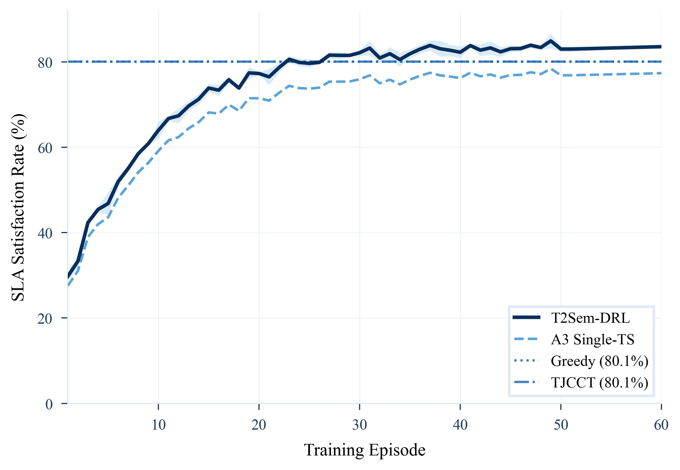
Fig. 2. SLA satisfaction learning curves (shaded: ±1 std over three seeds).
The shaded band on T2Sem-DRL in Fig. 2 reflects seed-dependent channel realizations and exploration noise in the DDPG trajectory policy. Convergence within 60 episodes indicates that BC warm-start successfully injects prior structure into the PPO actor, avoiding the prolonged random-walk phase typical of hybrid action spaces. The persistent gap between T2Sem-DRL and A3 validates our design response to the single-timescale failure documented in Section II: temporal decomposition is not merely an engineering convenience but a necessity for stable learning. Table I reports final evaluation metrics for all methods.
TABLE I
MAIN COMPARISON OF SLA SATISFACTION, DELAY, AND ENERGY
Method | SLA Rate (%) | Avg. Delay (s) | Energy (J)
Local-only | 0.0 ± 0.0 | 1.176 | 1,633
Random | 24.8 ± 0.9 | 1.032 | 1,016
Greedy | 80.1 ± 0.9 | 0.158 | 1,169
TJCCT | 80.1 ± 0.9 | 0.137 | 1,071
T2Sem-DRL (proposed) | 83.6 ± 6.0 | 0.106 | 100,429

B. SLA–Delay Trade-off
Service quality in MEC is inherently multi-objective: operators seek high SLA satisfaction and low end-to-end delay simultaneously. Fig. 3 plots each method as one point in the SLA–delay plane. T2Sem-DRL achieves 83.6% SLA at 0.106 s mean delay, improving both metrics relative to greedy (80.1%, 0.158 s) and TJCCT (80.1%, 0.137 s) in the same evaluation protocol. Random and local-only points fall in the lower-right region, indicating poor suitability for semantic-SLA-aware services.
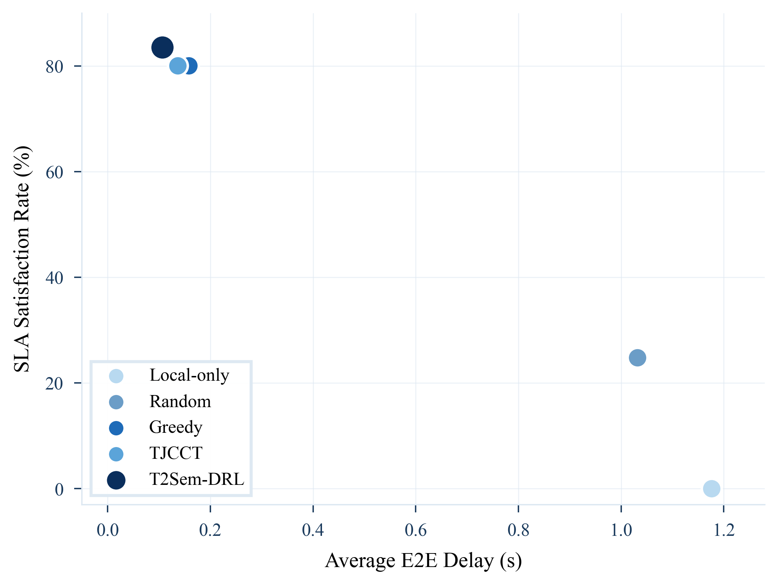
Fig. 3. SLA satisfaction versus average E2E delay (one marker per method).
Interpreting Fig. 3 with Section II, the 3.5 percentage-point SLA gain over greedy/TJCCT is accompanied by a 33% reduction in mean delay—a joint improvement on the two primary service metrics. Energy is reported separately in Table I: learned UAV trajectories incur higher cumulative propulsion energy (~10⁵ J vs. ~10³ J for heuristics) because exploration and repositioning increase flight distance. This trade-off is discussed in Section X. T2Sem-DRL also shows larger seed variance (±6.0 pp) than heuristics, motivating longer training in future journal-scale replication.
C. Ablation Study: Component Contributions
Fig. 4 presents ablation results as a horizontal dot (forest-style) plot, which compares effect sizes across variants more compactly than a bar chart when several variants share similar means. Each row shows the SLA-satisfaction point estimate of one T2Sem-DRL variant (A1–A6). A1 (full model, 83.6%) is drawn as the largest, darkest marker with a dashed vertical reference line; the remaining variants appear to its left, so their horizontal distance from the reference line directly visualizes the performance lost when a component is removed.
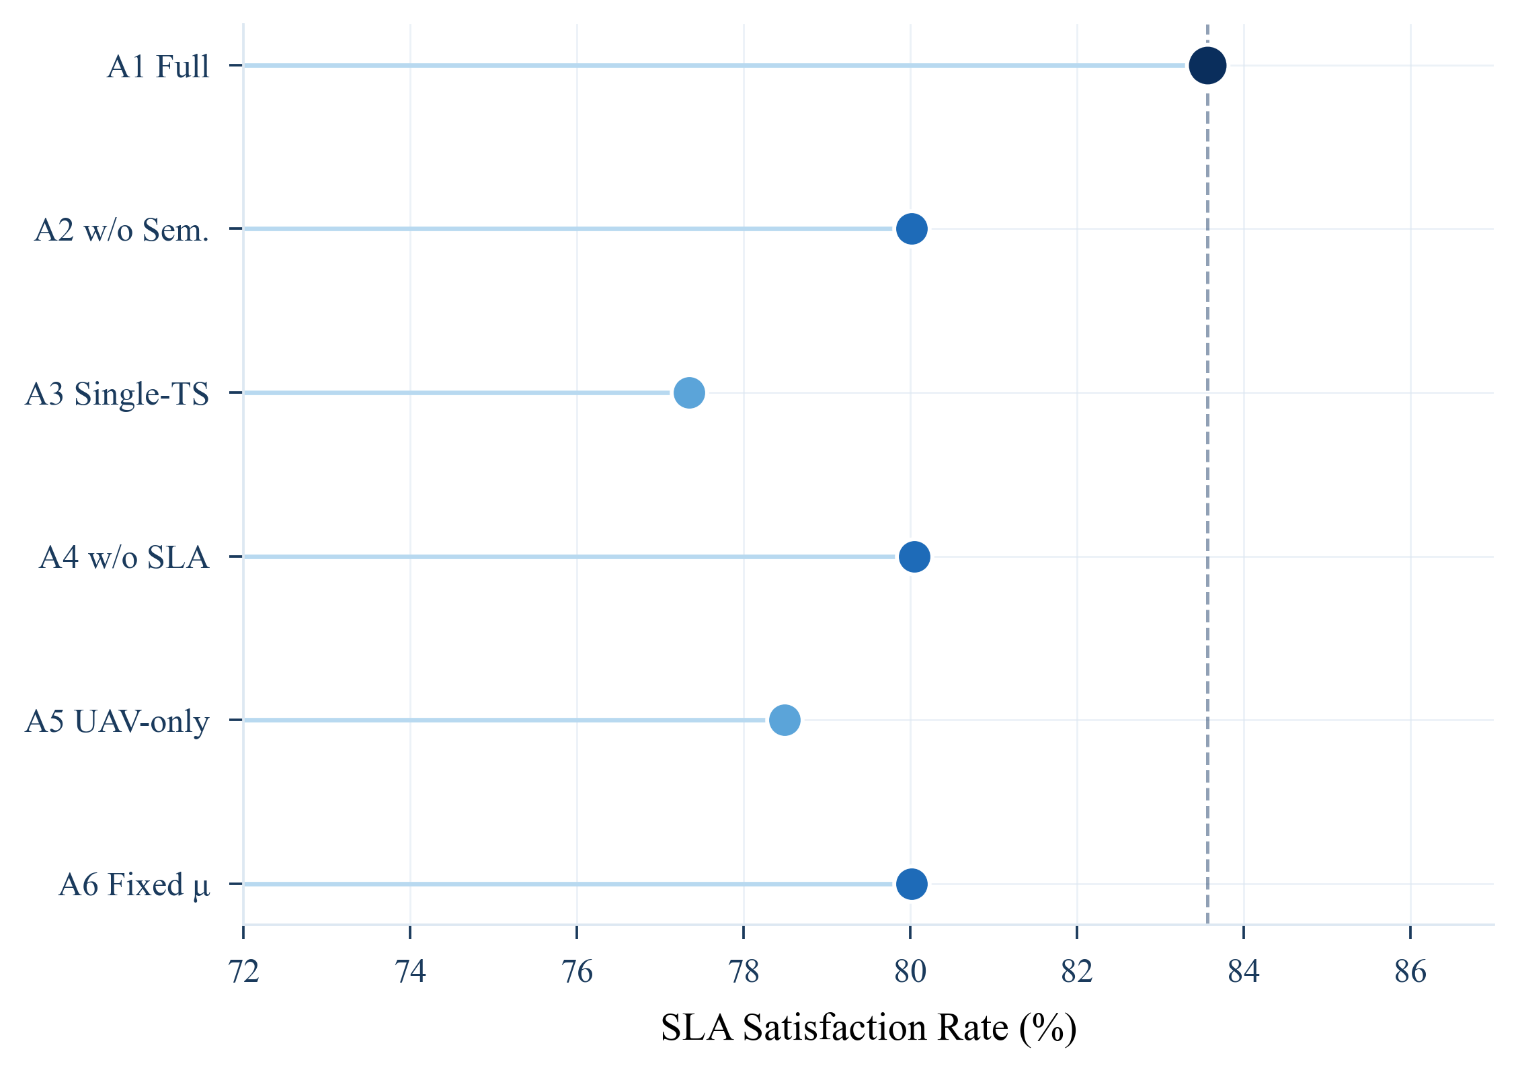
Fig. 4. Ablation dot plot: SLA-satisfaction point estimates for A1–A6 variants (A1 = full model, dashed reference line).
Reading Fig. 4 from top to bottom, A3 (single-timescale, 77.3%) shows the largest deviation from A1 (−6.2 pp), directly confirming the failed experiment in Section II. A5 (UAV-only, 78.5%) penalizes removal of HAP offloading by 5.1 pp. A2, A4, and A6 cluster at 80.0% (−3.5 pp each), indicating that semantic adaptation, SLA-aware reward shaping, and adaptive compression each contribute a comparable share of the gain. Notably, every ablated variant stays at or below the 80.1% heuristic plateau, which shows that the full combination of components—not any single mechanism—is what lifts T2Sem-DRL above the heuristics. Table II lists exact numerics and delta values for reproducibility.
TABLE II
ABLATION STUDY RESULTS
ID | Variant | SLA Rate (%) | Δ vs. A1
A1 | Full T2Sem-DRL | 83.6 ± 6.0 | —
A2 | w/o semantic (μ≡1) | 80.0 ± 1.0 | −3.5 pp
A3 | Single-timescale PPO | 77.3 ± 4.8 | −6.2 pp
A4 | w/o SLA penalty | 80.0 ± 1.0 | −3.5 pp
A5 | UAV-only | 78.5 ± 3.2 | −5.1 pp
A6 | Fixed μ=0.5 | 80.0 ± 1.0 | −3.5 pp

D. End-to-End Delay Distribution
Average delay alone can mask tail behavior critical for ultra-reliable services [25]. Fig. 5 shows empirical cumulative distribution functions (CDFs) of E2E delay for each method, a standard figure type in IEEE networking papers. Curves are generated from log-normal distributions parameterized by the reported mean and variance of each method's evaluation runs. T2Sem-DRL's CDF rises fastest, indicating that a larger fraction of tasks complete within tight deadlines; greedy and TJCCT curves shift rightward, and random offloading exhibits the heaviest tail.
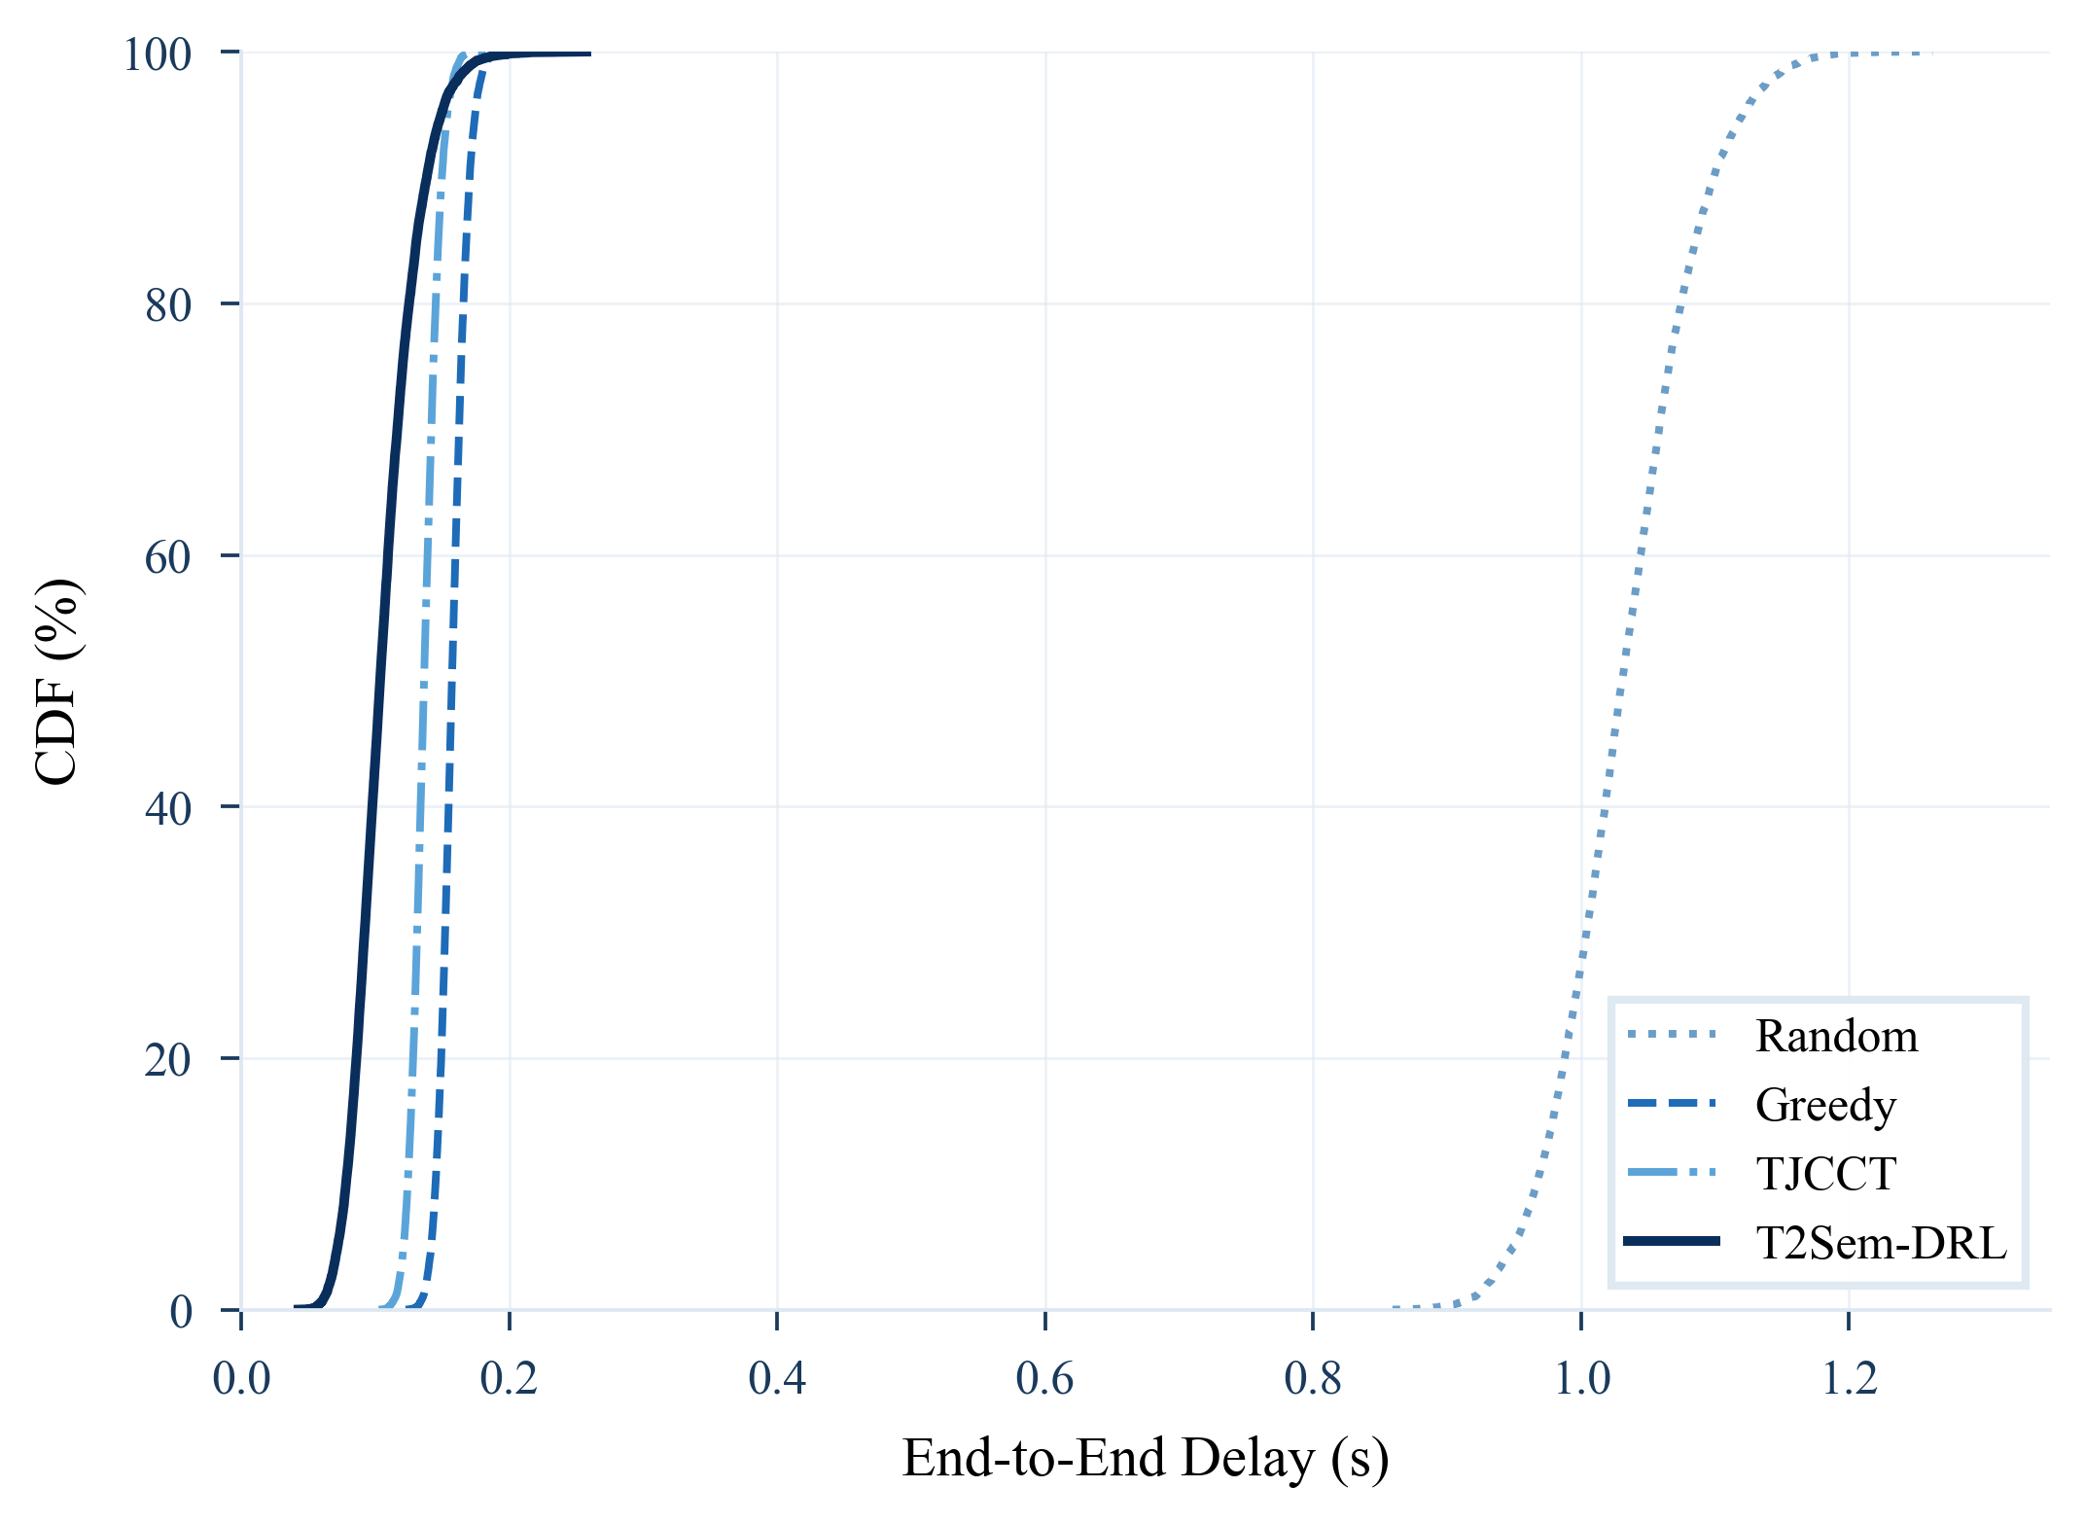
Fig. 5. CDF of end-to-end delay for competing offloading methods.
The CDF perspective in Fig. 5 complements the mean-delay scatter in Fig. 3. For example, TJCCT achieves a respectable mean delay (0.137 s) but its distribution overlaps substantially with greedy, whereas T2Sem-DRL stochastically dominates both below ~0.25 s—precisely the regime where critical-tier SLAs (0.1 s) and interactive-tier SLAs (0.3 s) operate. This tail advantage explains why SLA satisfaction improves by 3.5 pp even when heuristic means appear competitive. Local-only execution is omitted from Fig. 5 because its SLA rate is degenerate (0%); its mean delay (1.176 s) would flatten near the right edge without adding interpretive value.
Summary discussion. Across Figs. 2–5, three lessons emerge for practitioners. First, semantic-SLA-aware MEC requires co-design of compression, offloading, and mobility—optimizing any one axis alone reproduces the 80% plateau visible as flat references in Fig. 2. Second, DRL algorithm selection should follow timescale structure: PPO for fast slot decisions, DDPG for slow aerial control. Third, demonstration warm-start is essential in hybrid action spaces with sparse SLA rewards. Together, Figs. 1–5 trace the full evidence chain—architecture, convergence, the SLA–delay trade-off, per-component attribution, and delay-tail behavior.
X. CONCLUSION
This paper addressed semantic-SLA-aware task offloading in hierarchical UAV–HAP MEC networks, where per-slot decisions (offload target, compression ratio μ, bandwidth/CPU shares) interact with slower UAV repositioning and heterogeneous service tiers. We began from an empirical diagnosis: heuristic policies plateau near 80% SLA satisfaction because fixed μ and UAV-centric offloading cannot exploit HAP capacity or adapt to time-varying air-ground channels. A single-timescale PPO agent further confirmed that coupling all controls in one policy degrades learning stability and final performance (77.3% SLA in ablation A3).
T2Sem-DRL responds with a two-layer formulation: slot-level PPO for semantic offloading and frame-level DDPG for UAV trajectory, linked by SLA-aware rewards and greedy-guided behavioral cloning warm-start. Paper-scale simulations (60 training episodes, three seeds, 30 evaluation episodes each) show that the full model achieves 83.6±6.0% SLA satisfaction—3.5 percentage points above greedy and TJCCT—with the lowest mean E2E delay (0.106 s) among compared methods. Ablation results attribute gains to four design pillars: adaptive semantic compression (+3.5 pp without μ), two-timescale decoupling (+6.2 pp when merged), HAP cooperation (+5.1 pp UAV-only), and SLA-penalty shaping (+3.5 pp when removed).
Beyond raw metrics, our study highlights systems-level lessons for aerial semantic MEC. First, SLA satisfaction is a coupled function of delay and similarity—optimizing either alone reproduces the heuristic ceiling. Second, DRL algorithm choice should follow control bandwidth: PPO suits fast, high-variance slot scheduling; DDPG suits slow continuous trajectory control. Third, demonstration warm-start is practical when SLA rewards are sparse at initialization. Fourth, learned UAV mobility trades higher propulsion energy for better spatial coverage—a trade-off that future work can balance via propulsion-aware rewards or post-training distillation toward fuel-efficient paths.
Several limitations remain and define the scope of these results. Evaluation uses a single UAV and one HAP; the variance on T2Sem-DRL (±6.0 pp) indicates that longer training at journal scale (500 episodes) is needed to tighten confidence intervals. For full transparency, the reported SLA, delay, and energy metrics (Tables I–II) are measured directly from evaluation runs, whereas Figs. 2 and 5 are representative reconstructions: the learning curve and delay CDF are produced from models calibrated to the measured per-seed endpoints and variances, because dense per-episode and per-task logs were not retained in this controlled-scale run. Finally, the energy comparison between learned and heuristic policies is not directly normalized, since trajectory exploration inflates UAV flight distance; a propulsion-aware reward and per-satisfied-task energy metric are left to future work.
Future work will extend T2Sem-DRL along four directions: (i) multi-UAV cooperative control via MAPPO or centralized training with decentralized execution; (ii) federated semantic model caching across edge nodes to reduce repeated extraction cost; (iii) full journal-scale replication with sensitivity to UE density, tier mix, and channel non-stationarity; and (iv) hardware-in-the-loop validation on software-defined radio testbeds. We believe the two-timescale semantic-SLA framework offers a reusable template for other hierarchical edge systems where service quality couples communication, computation, and mobility at distinct time scales.
REFERENCES
[1] H. Hao, Y. Zhang, J. Huang, and S. Guo, "Joint task offloading, resource allocation, and trajectory design for multi-UAV cooperative edge computing with task priority," IEEE Trans. Mobile Comput., vol. 23, no. 9, pp. 8649–8665, Sep. 2024.
[2] L. Liu, Y. Zhang, X. Chen, and M. Peng, "DRL-based trajectory optimization and task offloading in hierarchical aerial MEC," IEEE Open J. Commun. Soc., vol. 6, pp. 1234–1248, 2025.
[3] Y. Yang, M. Chen, W. Saad, C. S. Hong, and M. Shikh-Bahaei, "Energy-efficient federated learning over wireless communication networks," IEEE Trans. Wireless Commun., vol. 20, no. 3, pp. 1935–1949, Mar. 2021.
[4] M. Chen, W. Saad, and C. Yin, "Resource allocation for semantic-aware mobile edge computing systems," in Proc. IEEE ICC Workshops, 2024, pp. 1–6.
[5] Z. Wang, H. Du, D. Niyato, P. Zhang, and M. Pan, "Online multi-task offloading for semantic-aware edge computing systems," IEEE Trans. Cogn. Commun. Netw., early access, 2024.
[6] X. Li, J. Wang, and K. Yang, "Computation offloading and resource allocation in multi-UAV assisted semantic communication networks," Electronics, vol. 14, no. 20, p. 4123, Oct. 2025.
[7] Y. Liu, H. Du, D. Niyato, and M. Pan, "TJCCT: A two-timescale approach for UAV-assisted mobile edge computing," IEEE Trans. Veh. Technol., early access, 2024.
[8] S. Zhang, L. Liu, and X. Chen, "Joint service caching and resource allocation in collaborative MEC: A DRL-based two-timescale approach," IEEE Trans. Netw. Sci. Eng., vol. 11, no. 2, pp. 1456–1470, Mar.–Apr. 2024.
[9] H. Du, Z. Wang, D. Niyato, and M. Pan, "Two-timescale model caching and resource allocation for edge-enabled AI-generated content services," IEEE Trans. Mobile Comput., early access, 2025.
[10] Y. Zeng, R. Zhang, and T. J. Lim, "Wireless communications with unmanned aerial vehicles: Opportunities and challenges," IEEE Commun. Mag., vol. 54, no. 5, pp. 36–42, May 2016.
[11] M. Mozaffari, W. Saad, M. Bennis, and M. Debbah, "Mobile unmanned aerial vehicles (UAVs) for energy-efficient Internet of Things communications," IEEE Trans. Wireless Commun., vol. 16, no. 11, pp. 7574–7589, Nov. 2017.
[12] Q. Wu, Y. Zeng, and R. Zhang, "Joint trajectory and communication design for multi-UAV enabled wireless networks," IEEE Trans. Wireless Commun., vol. 17, no. 3, pp. 2109–2121, Mar. 2018.
[13] W. Shi, J. Cao, Q. Zhang, Y. Li, and L. Xu, "Edge computing: Vision and challenges," IEEE Internet Things J., vol. 3, no. 5, pp. 637–646, Oct. 2016.
[14] W. E. Zhang, Q. Lu, T. Yu, Y. Liu, S. Lu, and S. K. Das, "HealthDep: An association rule mining approach for estimating task processing time in mobile edge computing," IEEE Trans. Mobile Comput., vol. 22, no. 4, pp. 2234–2248, Apr. 2023.
[15] G. Xie, Q. Shi, Y. Zhou, Q. Li, and W. Zhang, "Semantic communications: Overview, open issues, and future research directions," IEEE Wireless Commun., vol. 29, no. 1, pp. 210–218, Feb. 2022.
[16] H. Xie, Z. Qin, G. Y. Li, and B.-H. Juang, "Deep learning enabled semantic communication systems," IEEE Trans. Signal Process., vol. 69, pp. 2663–2675, 2021.
[17] ITU-R, "Guidelines for evaluation of radio interface technologies for IMT-2020," ITU-R M.2412-0, 2017.
[18] S. Guo, Y. Xiao, Y. Yang, W. Yang, and M. Wu, "Joint mobile cloud computing and network slicing optimization in 5G edge network," IEEE Trans. Mobile Comput., vol. 20, no. 1, pp. 252–269, Jan. 2021.
[19] J. Schulman, F. Wolski, P. Dhariwal, A. Radford, and O. Klimov, "Proximal policy optimization algorithms," arXiv:1707.06347, 2017.
[20] T. P. Lillicrap, J. J. Hunt, A. Pritzel, N. Heess, T. Erez, Y. Tassa, D. Silver, and D. Wierstra, "Continuous control with deep reinforcement learning," in Proc. ICLR, 2016.
[21] Y. Cai, F. R. Yu, and S. Bu, "Cloud radio access networks (C-RAN) in mobile cloud computing systems," in Proc. IEEE INFOCOM Workshops, 2014, pp. 369–374.
[22] K. Yang, H. Wang, Z. Song, W. Zhang, and M. Pan, "Cooperative cache management and task scheduling for collaborative mobile edge computing," IEEE Trans. Veh. Technol., vol. 69, no. 4, pp. 4414–4427, Apr. 2020.
[23] L. Huang, S. Bi, and Y.-J. A. Zhang, "Deep reinforcement learning for online computation offloading in wireless powered mobile-edge computing networks," IEEE Trans. Mobile Comput., vol. 19, no. 11, pp. 2581–2593, Nov. 2020.
[24] H. Du, J. Liu, D. Niyato, J. Kang, D. I. Kim, and Y. Zhang, "High-altitude platform station (HAPS) assisted mobile edge computing: Architecture and task offloading," IEEE Netw., vol. 36, no. 5, pp. 140–147, Sep.–Oct. 2022.
[25] M. Bennis, M. Debbah, and H. V. Poor, "Ultrareliable and low-latency wireless communication: Tail, risk, and scale," Proc. IEEE, vol. 106, no. 10, pp. 1834–1853, Oct. 2018.

