Table of Contents

1.0 Introduction 2

2.0 Elicitation Execution 3

3.0 Proof of Execution (Google Form Survey Responses using Kano-style) 5

3.1 General Question 5

3.2 Campus Carpooling and Parking System (Include and Exclude) 9

3.3 Admin Features (Include and Exclude) 17

4.0 Kano Model 21

4.1 Kano Model Chart (Campus Carpooling and Parking System) 21

4.2 Kano Model Chart (Admin Rights) 22

# Introduction

The documenation presents the outcomes of the requirements elicitation plan for our project title, which is Campus Ride-Sharing Platform with Parking System Integration. The main goal of the document and its objective is to analyze and classify user requirements and their opinions with the system using Kano Model.

As mentioned previously, we had chosen survery-based way as our elicitation plan and technique. The reason behind this was because it was much efficiency and flexiblity in collecting responses from wide range of university people, including with students, staff and lecturers as they were the main target users for ride-sharing platform project. The survey was conducted with Kano-style questions to penetrate with user feedback about the present and abesent within the system.

With the analysis of the response gathered from the survey, we were able to distinguish potential system feature based on user feedback and expectations. The perceptiveness of user feedback are crucial as it priotizing the development of the features that meets basic requirements and enhance user engagement.

# Elicitation Execution

In regards of our elicitation plan, we proceeded to execute the system requirements gathering process using survey-based style. The main goal of the execution is to collect feedback from users, which is student, staff and lecturers to express their expectiations and preferences for the system features.

The survery was implemented to align with the Kano Model Methodology, which involves in user feedback about their response on the presence or absence of the system features, and each features will have two(2) question to be answered by respondents. The two(2) questions was made in the following:

i) How do you feel if this system feature “Included” in the system?

and

ii) How do you feel if this system feature “Not Included” in the system?

Then, each question will be given with five(5) options as in standardlized set based on Kano method. The five(5) options for each question will be set as radio button, and only able to choose one(1) option out of five(5). Belown shown the answer options based on Kano method:

1. I like it (Strongly Agree)
2. I expect it (Agree)
3. I am neutral (Moderate)
4. I can tolerate it (Disagree)
5. I dislike it (Strongly Disagree)

The survey was distributed using Google Forms, which deliver smooth user experience deisgn and effective data colleciton tools. The forms was shared throughout multiple platforms such as Whatsapp group chat, emails, student’s social media and university communication channel, which is Telegram to each faculty. In the last fourteen (14) days of data collection, we have received thirty (30) valid responses within the university community.

The key various system features are manipulated in the survey included:

For all User

1. Role at University (Students, Staff, Lecturers or Other)
2. Type of Vehicle used to travel to university (Car, Motorbike, Bicycle, Bus or Other)
3. Travel to University in what Transportation (Drive, Public Transport, Walk, Cycling or Other)
4. Difficulty of finding free parking space at university
5. Difference in number of parking spaces in faculty area and student area.
6. Campus Carpool service usage

Campus Carpooling and Parking System (Include and Not Include Options)

1. System display Real-Time Available Parking Spots
2. System Login using ID and Password
3. System Login Input Requirement using ID and Password
4. Parking Distribution for Student, Staff and Lecturer
5. System display Reserved Parking Information (Car Plate Number and Parking Status)
6. System Parking Space Reservation
7. System Individual Reservation Parking Space
8. System Parking Space Reservation per Account

Admin Features (Include and Not Include Options)

1. System Offer Parking Space to Student, Staff and Lecturer
2. System Permission to Cancel Reserved Parking from reported parking violation
3. System Permitted to track user’s information (contact, faculty etc.)
4. System Enabled to send remainder notification through inbox message if user park vehicle illegally

# Proof of Execution (Google Form Survey Responses using Kano-style)

* 1. General Question

1. Role at University

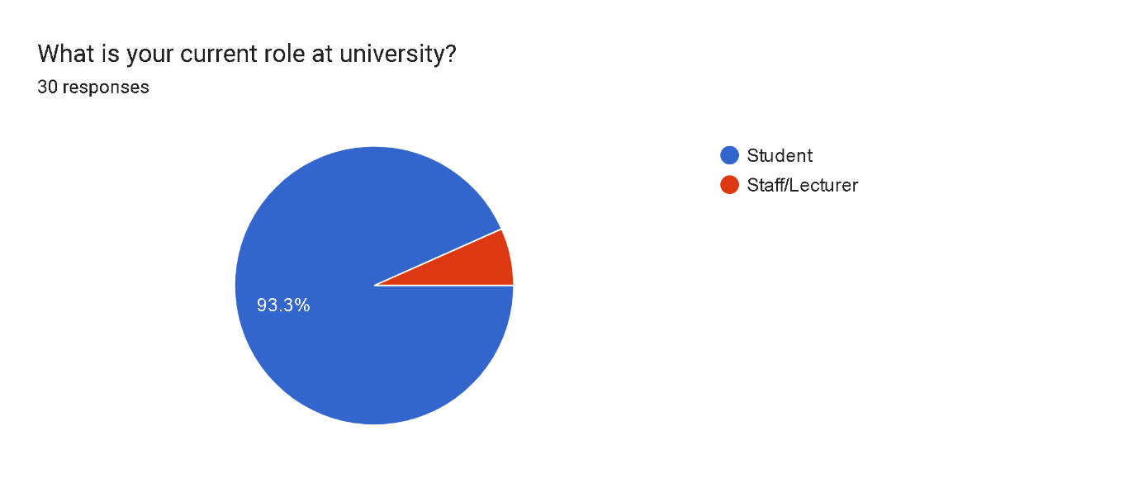

Figure 3.1 Piechart of Role at University

1. Type of Vehicle used to travel to university

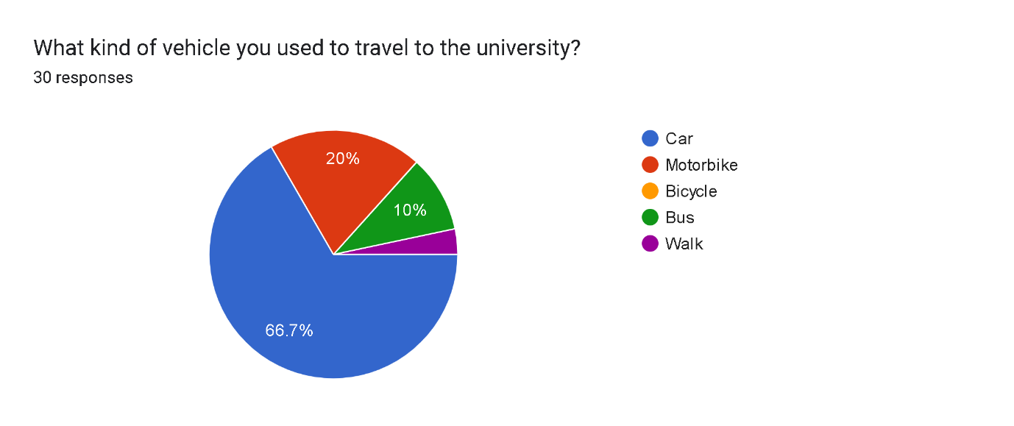

Figure 3.1.1 Piechart of Type of Vehicle used to travel to university

1. Travel to University in what Transportation

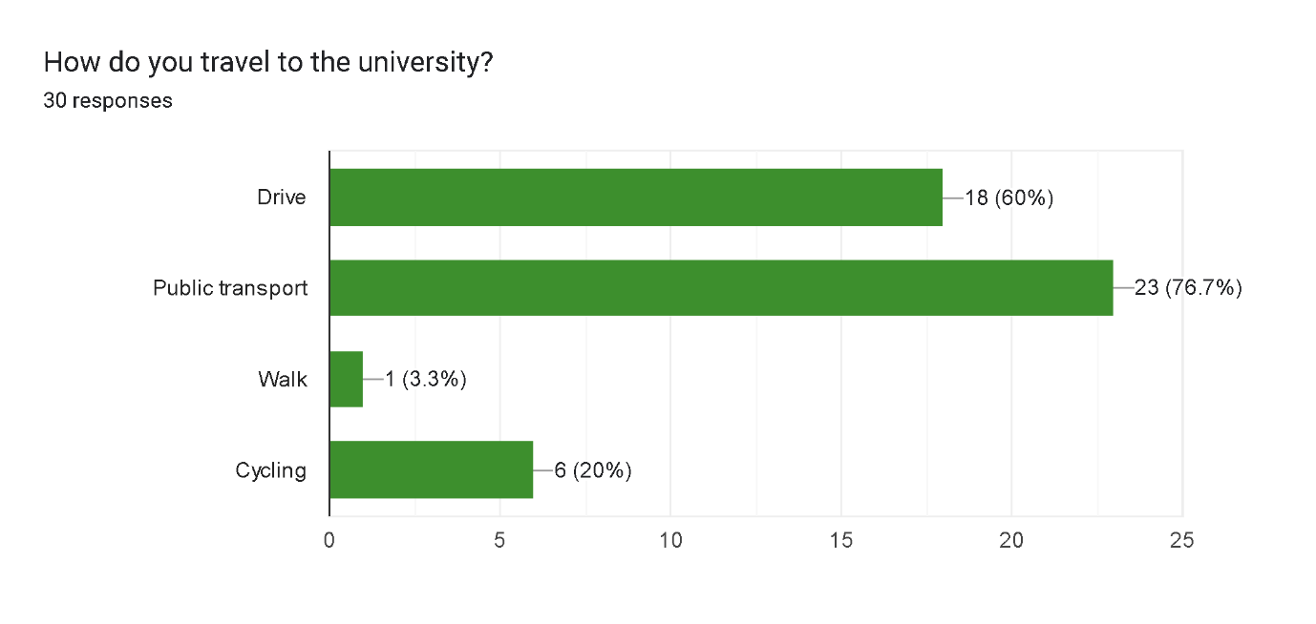

Figure 3.1.2 Barchart of Travel to University in what Transportation

1. Difficulty of finding free parking space in university

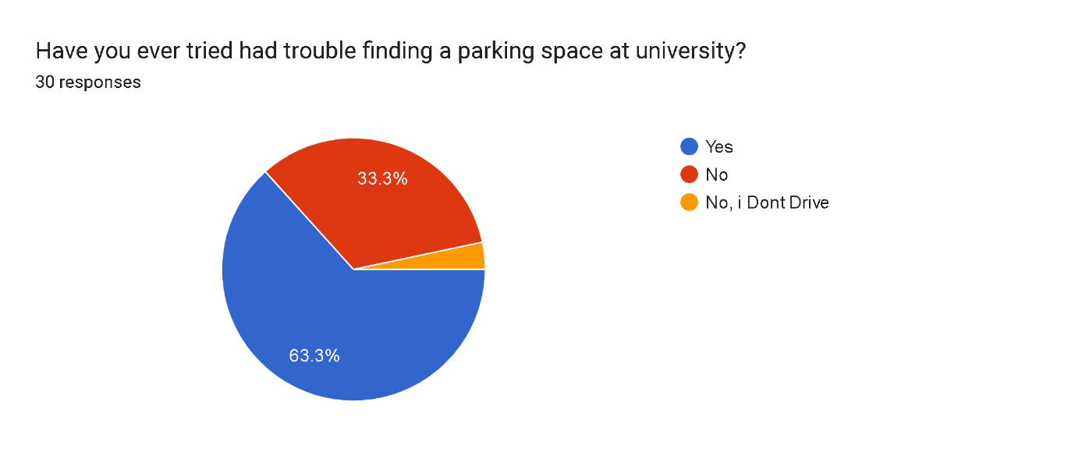

Figure 3.1.3 Piechart of Difficulty of finding free parking space in university

1. Difference in number of parking spaces in faculty area and student area.

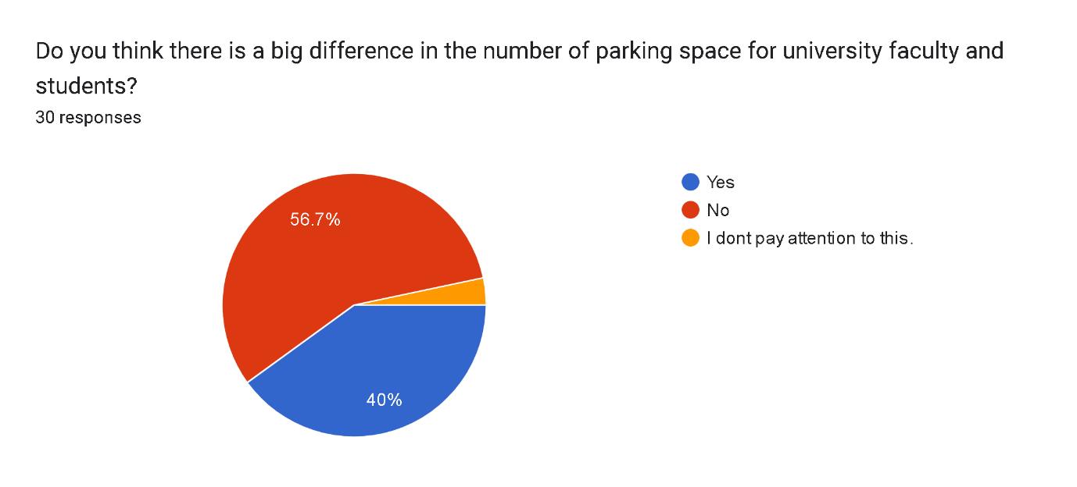

Figure 3.1.4 Piechart of Difference in number of parking spaces in faculty area and student area

1. Campus carpool service usage

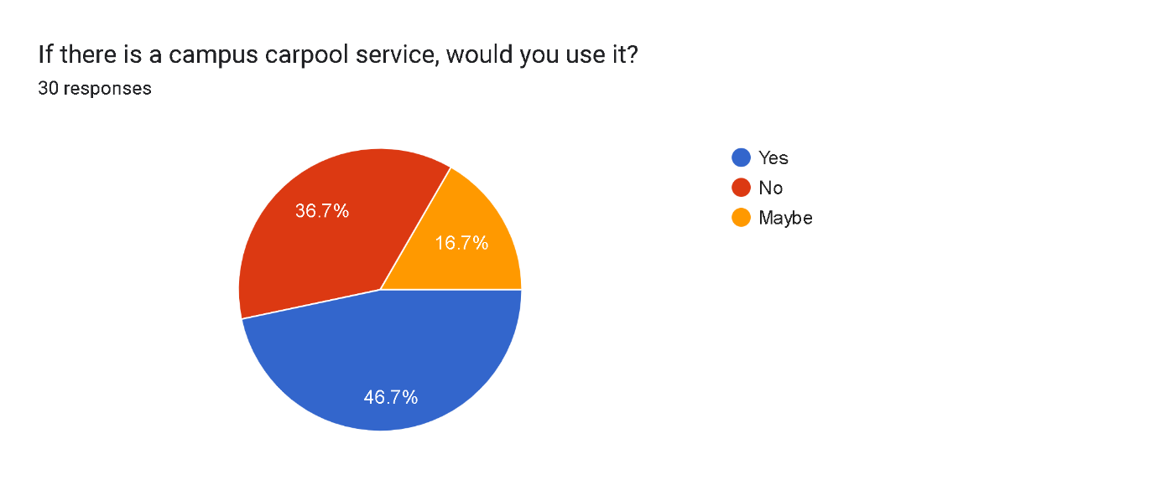

Figure 3.1.5 Piechart of Campus carpool service usage

* 1. Campus Carpooling and Parking System (Include and Exclude)

1. System Real-time Available Parking Spots (Include)

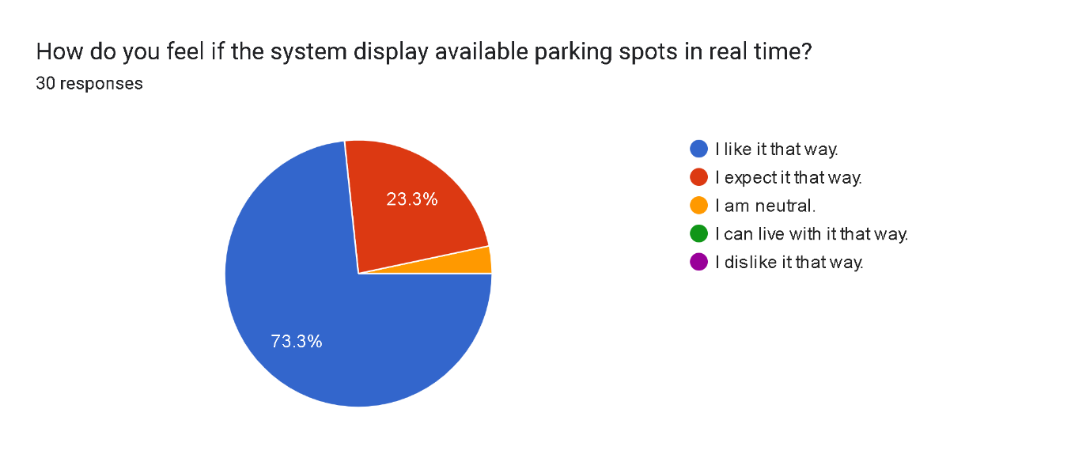

Figure 3.2 Piechart of System Real-time Available Parking Spots (Include)

System Real-time Available Parking Spots (Exclude)

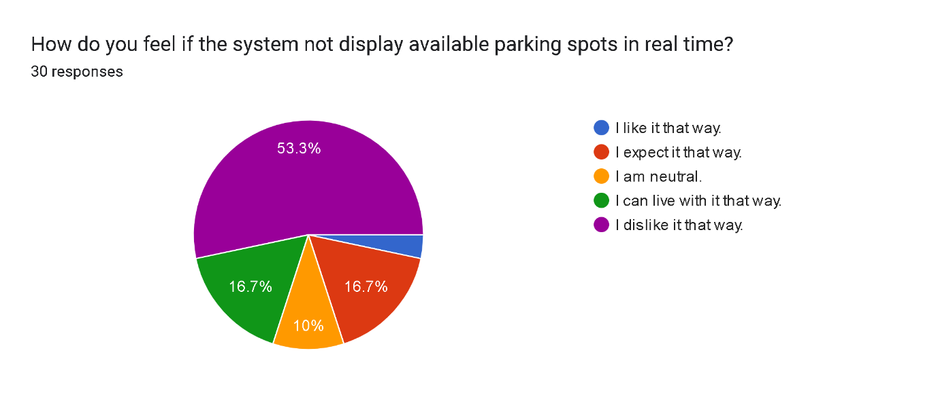

Figure 3.2.1 Piechart of System Real-time Available Parking Spots (Exclude)

1. System Login using ID and Password (Include)

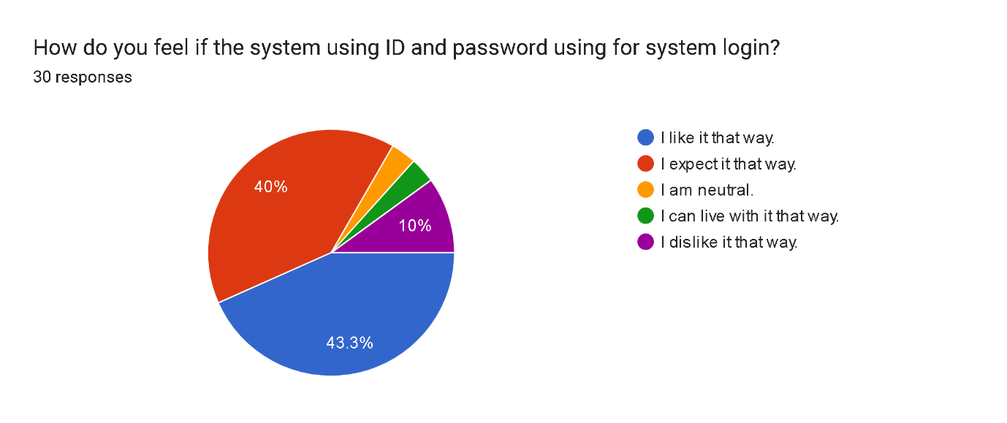

Figure 3.2.2 Piechart of System Login using ID and Password (Include)

System Login using ID and Password (Exclude)

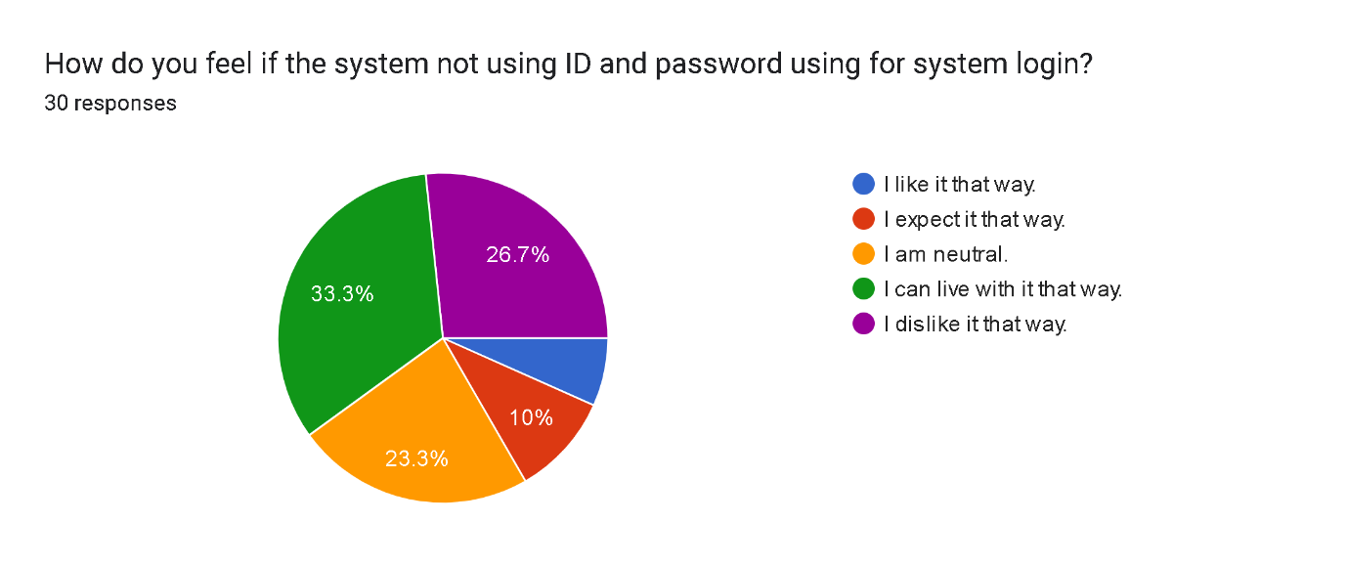

Figure 3.2.3 Piechart of System Login using ID and Password (Exclude)

1. System Login Input Requirement using ID and Password (Include)

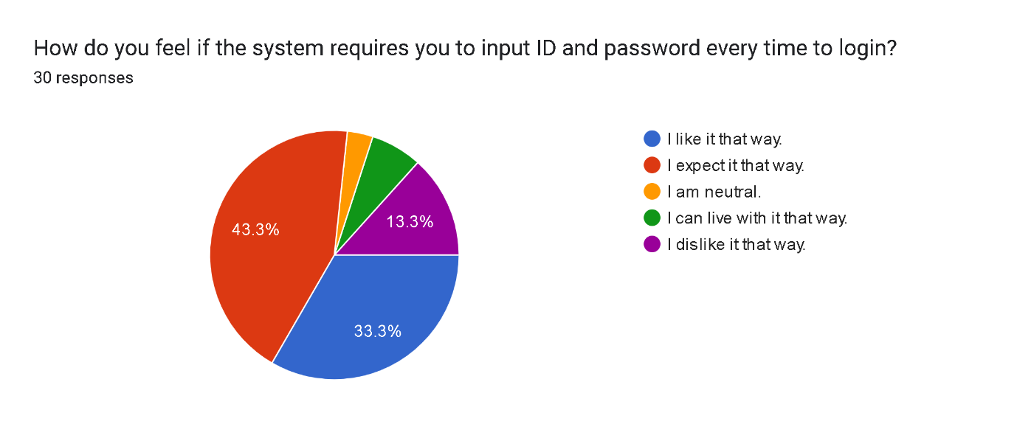

Figure 3.2.4 Piechart of System Login Input Requirement using ID and Password (Include)

System Login Input Requirement using ID and Password (Exclude)

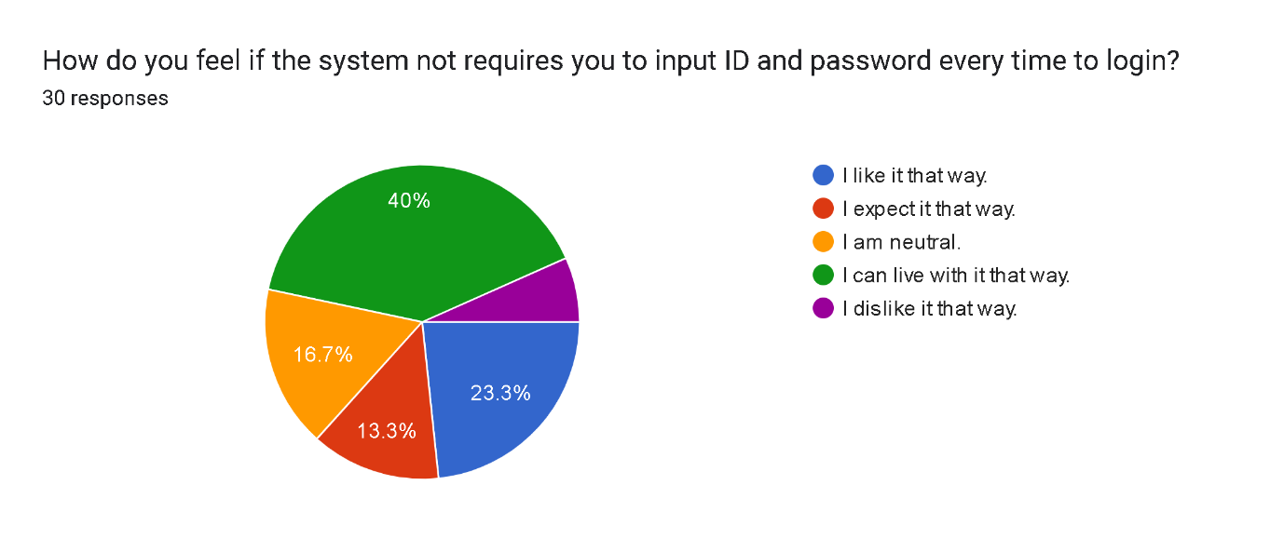

Figure 3.2.5 Piechart of System Login Input Requirement using ID and Password (Exclude)

1. Parking Distribution for Student, Staff and Lecturer (Include)

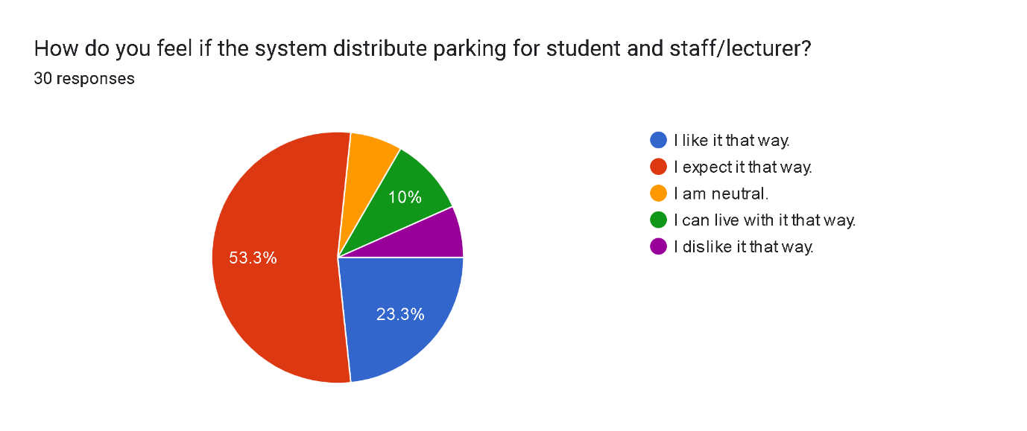

Figure 3.2.6 Piechart of Parking Distribution for Student, Staff and Lecturer (Include)

Parking Distribution for Student, Staff and Lecturer (Exclude)

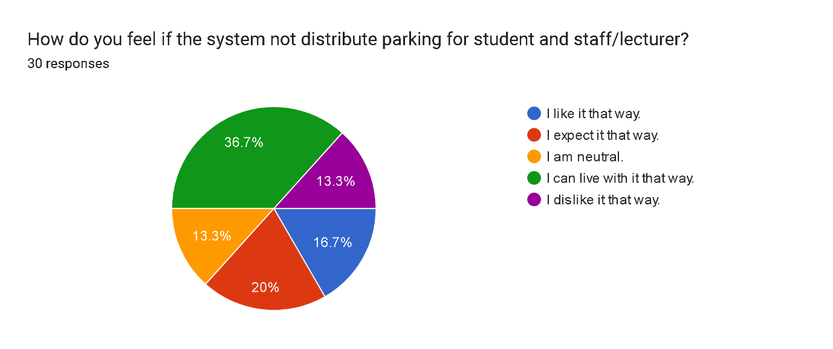

Figure 3.2.7 Piechart of Parking Distribution for Student, Staff and Lecturer (Exclude)

1. System display Reserved Parking Information (Include)

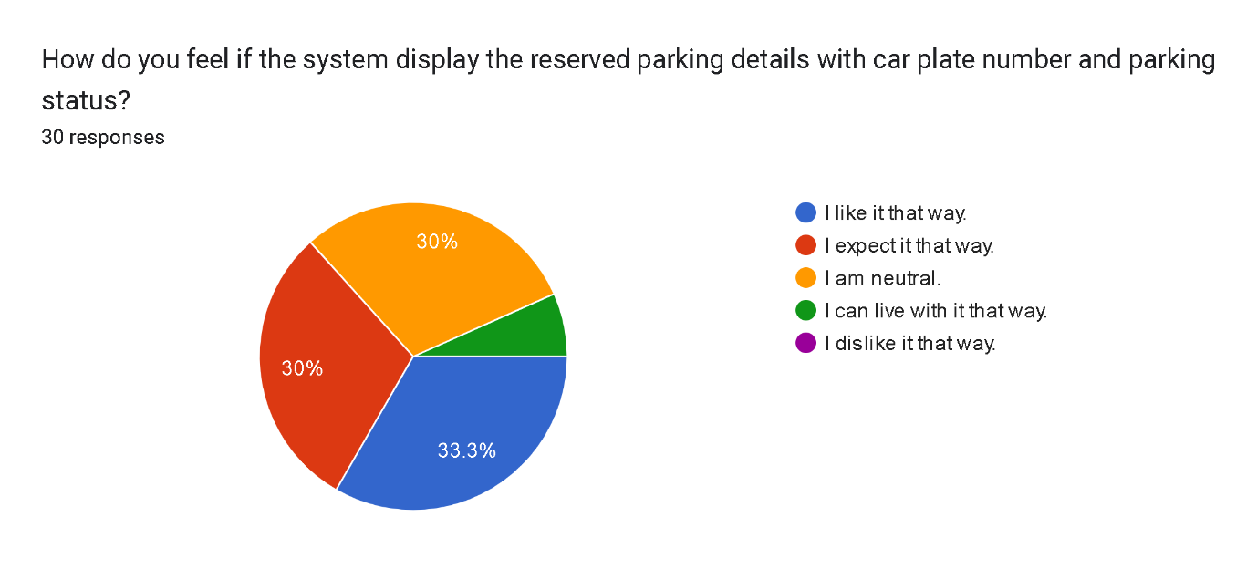

Figure 3.2.8 Piechart of System display Reserved Parking Information (Include)

System display Reserved Parking Information (Exclude)

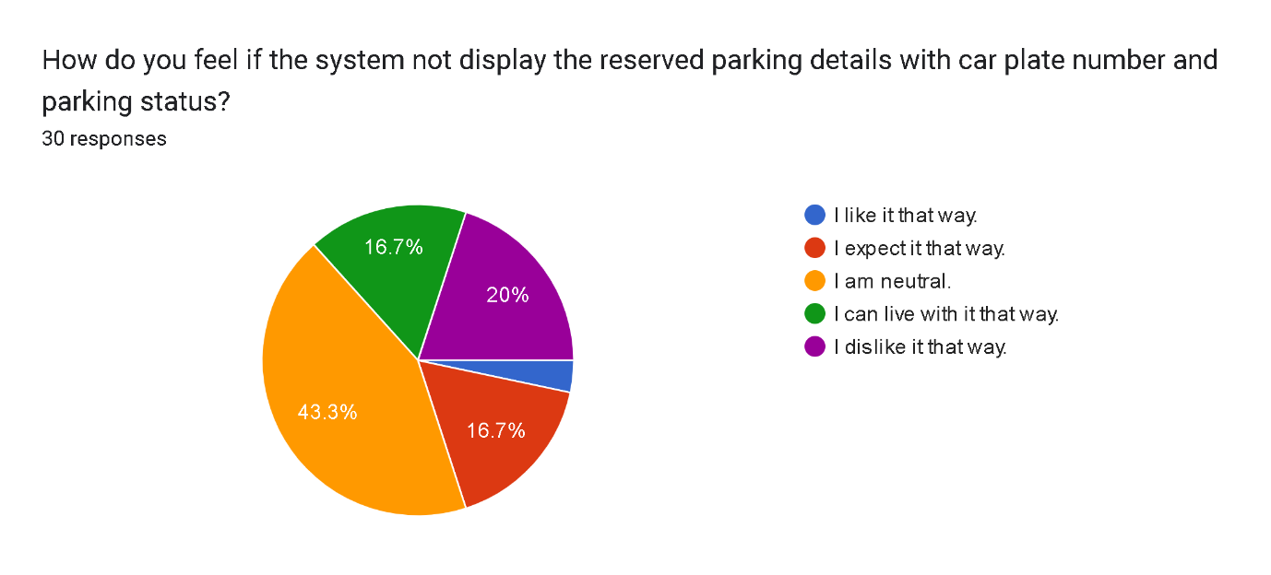

Figure 3.2.9 Piechart of System display Reserved Parking Information (Exclude)

1. System Parking Space Reservation (Include)

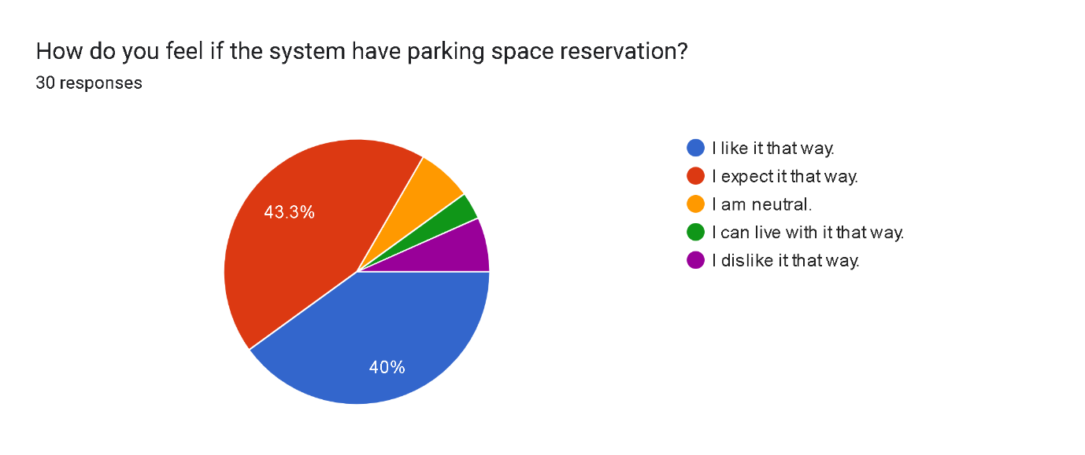

Figure 3.2.10 Piechart of System Parking Space Reservation (Include)

System Parking Space Reservation (Exclude)

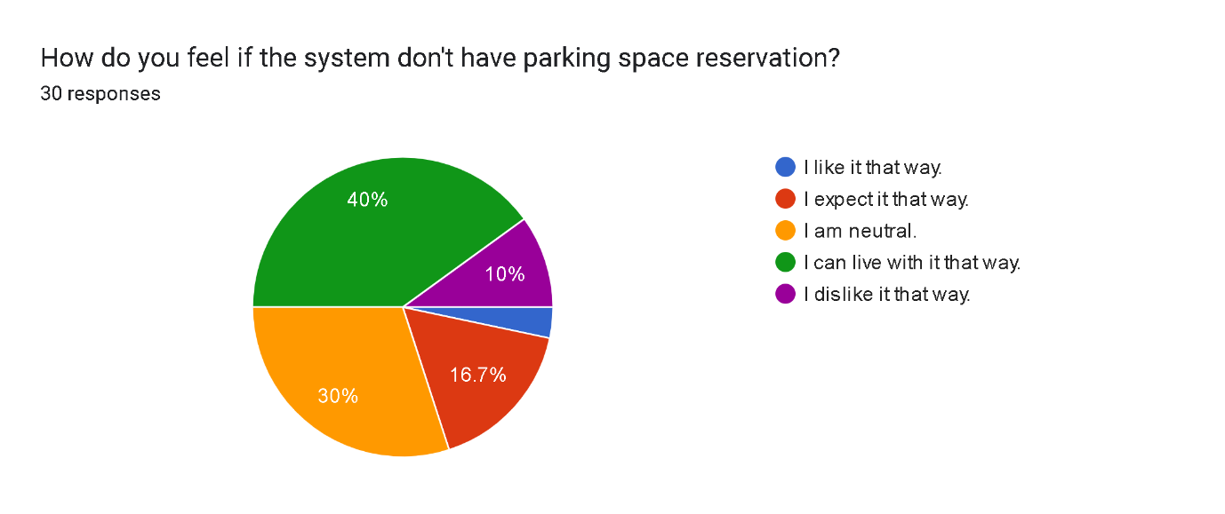

Figure 3.2.11 Piechart of System Parking Space Reservation (Exclude)

1. System Individual Reservation Parking Space (Include)

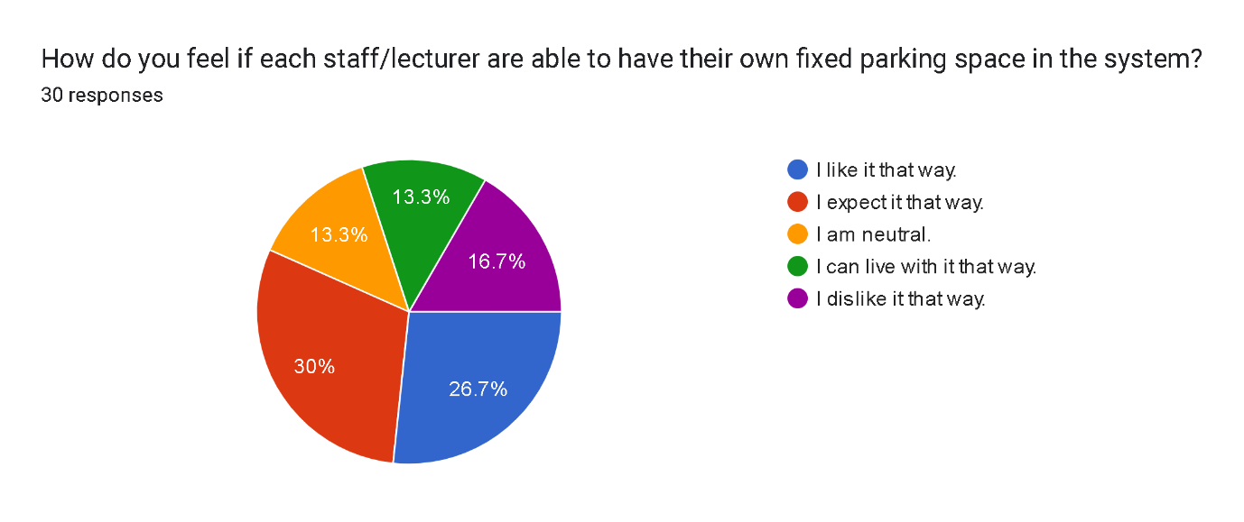

Figure 3.2.12 Piechart of System Individual Reservation Parking Space (Include)

System Individual Reservation Parking Space (Exclude)

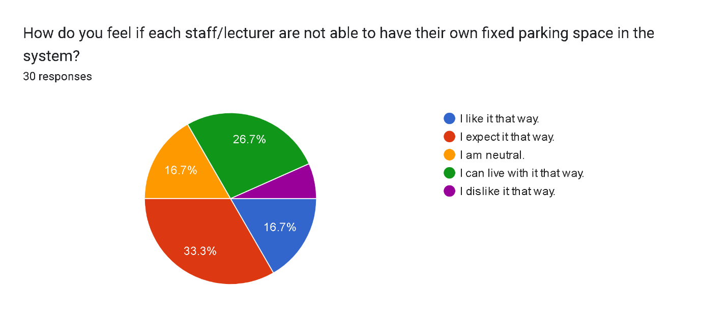

Figure 3.2.13 Piechart of System Individual Reservation Parking Space (Exclude)

1. System Parking Space Reservation per Account (Include)

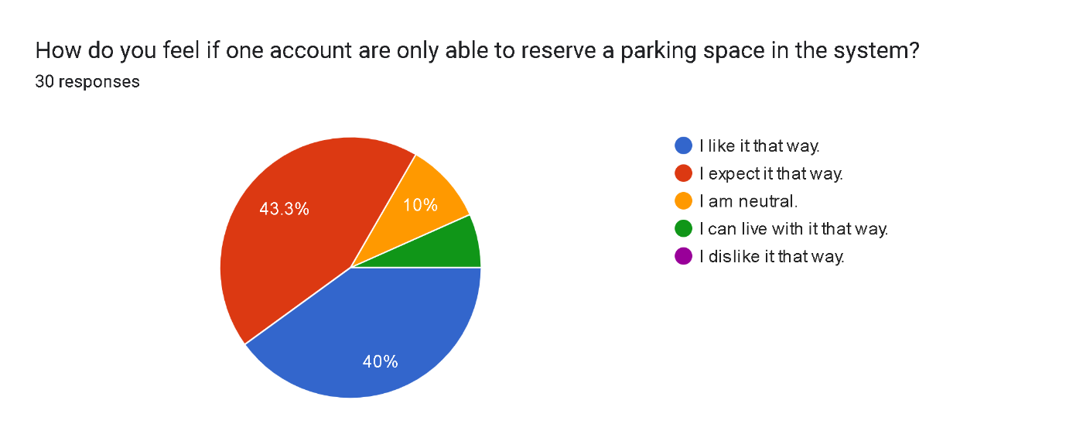

Figure 3.2.14 System Parking Space Reservation per Account (Include)

System Parking Space Reservation per Account (Exclude)

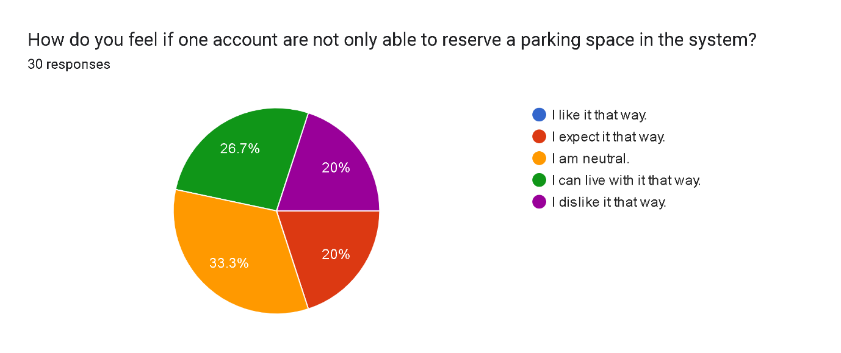

Figure 3.2.15 System Parking Space Reservation per Account (Exclude)

* 1. Admin Features (Include and Exclude)

1. System offer Parking Space to Student, Staff and Lecturer (Include)

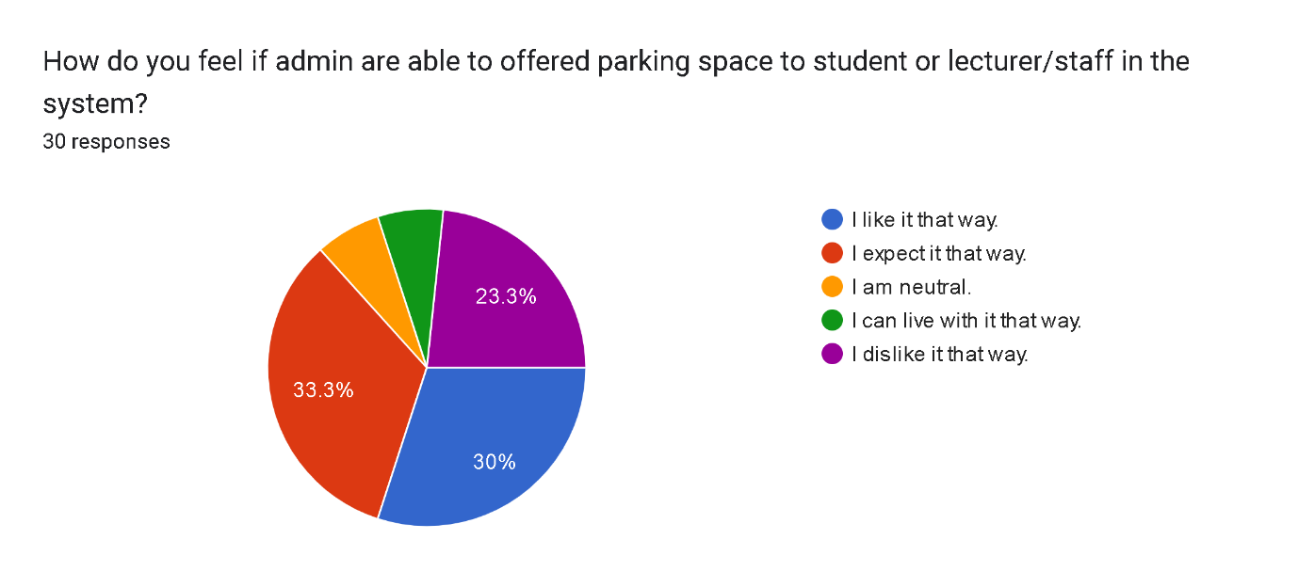

Figure 3.3 Piechart of System offer Parking Space to Student, Staff and Lecturer (Include)

System offer Parking Space to Student, Staff and Lecturer (Exclude)

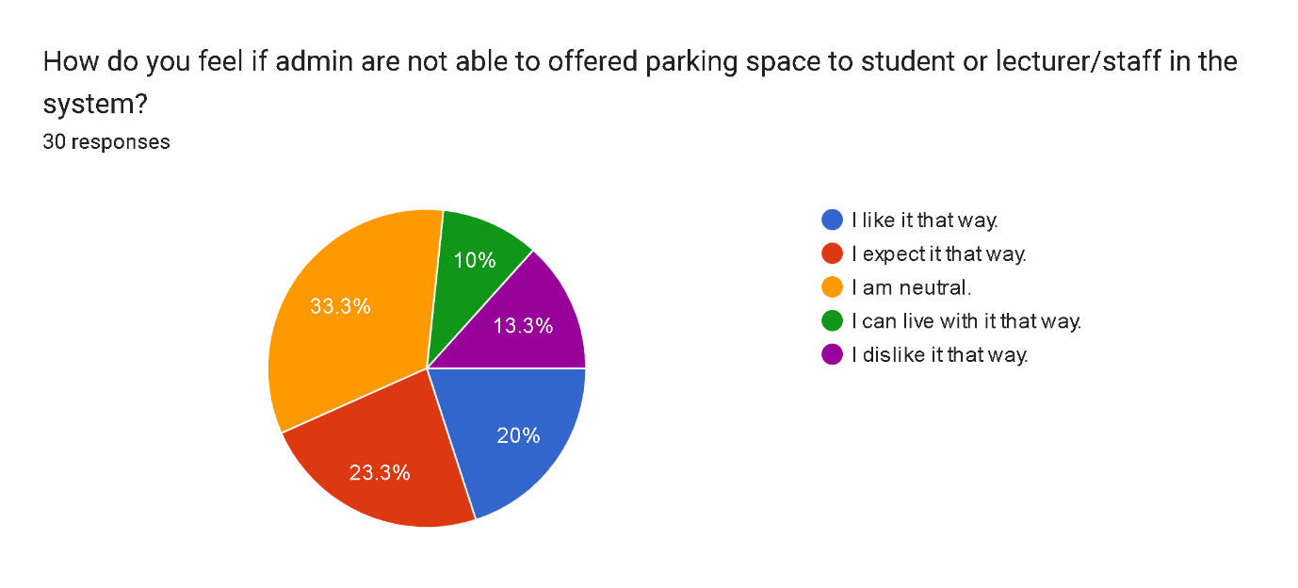

Figure 3.3.1 Piechart of System offer Parking Space to Student, Staff and Lecturer (Exclude)

1. System Permission to cancel reserved parking from reported parking violation (Include)

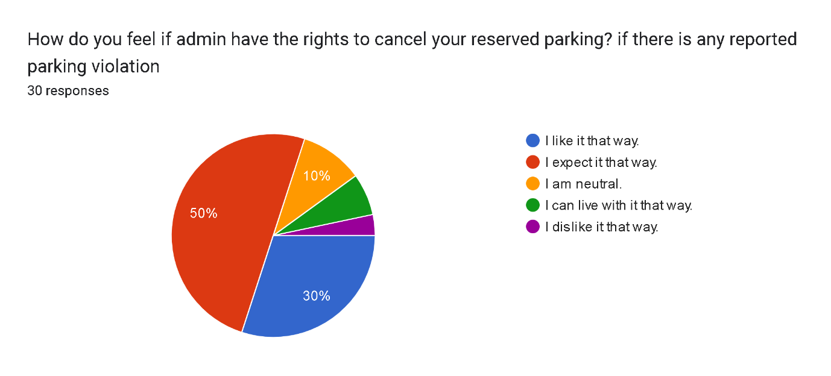

Figure 3.3.2 Piechart of System Permission to cancel reserved parking from reported parking violation (Include)

System Permission to cancel reserved parking from reported parking violation (Exclude)

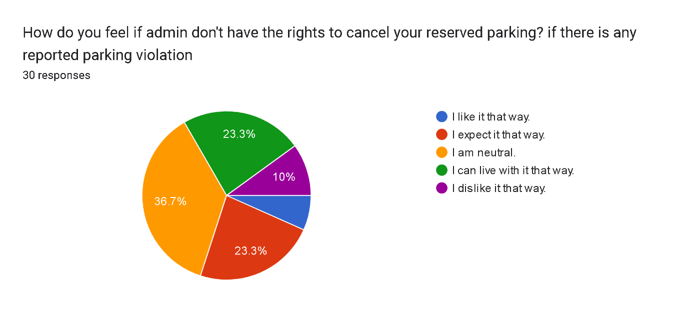

Figure 3.3.3 Piechart of System Permission to cancel reserved parking from reported parking violation (Exclude)

1. System Permitted to track user’s information (Include)

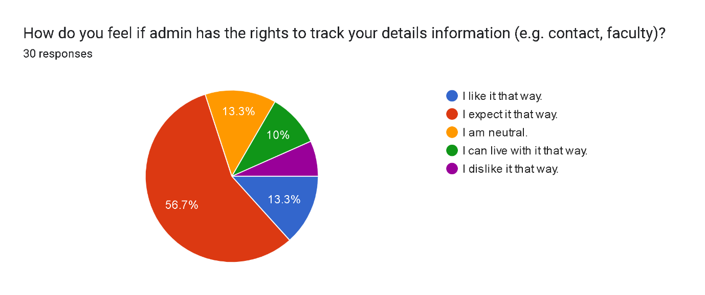

Figure 3.3.4 Piechart of System Permitted to track user’s information (Include)

System Permitted to to track user's information (Exclude)

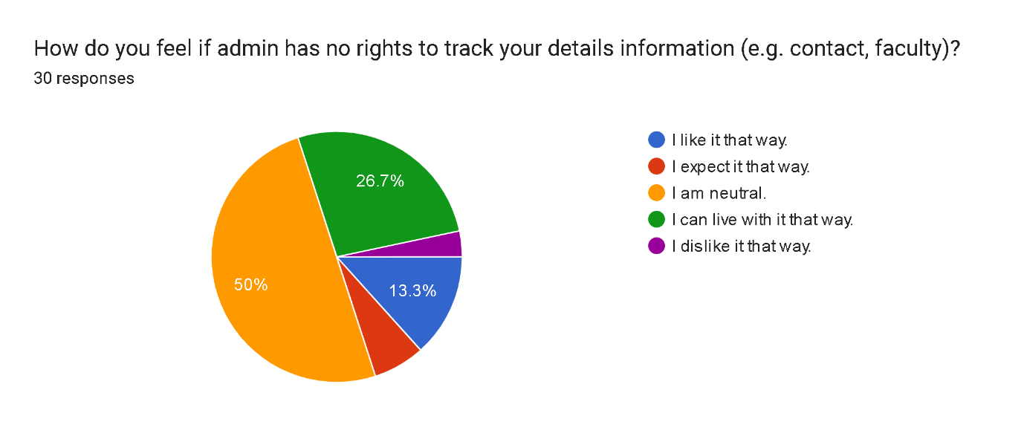

Figure 3.3.5 Piechart of System Permitted to track user’s information (Exclude)

1. System enabled to send notification about vehicle parking illegally (Include)

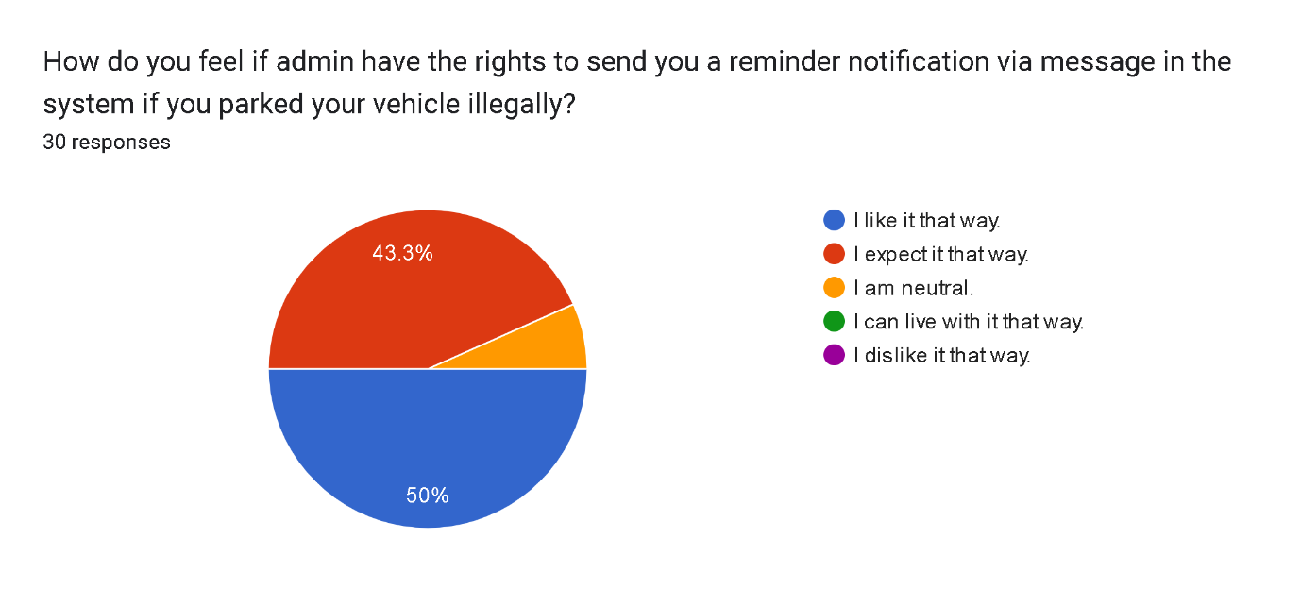

Figure 3.3.6 Piechart of System enable to send notification about vehicle parking illegally (Include)

System enabled to send notification about vehicle parking illegally (Exclude)

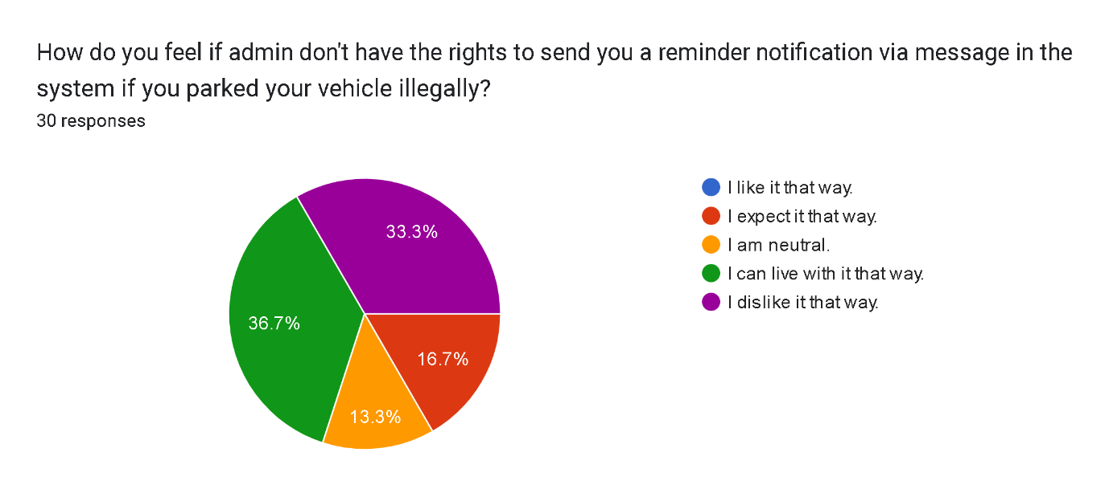

Figure 3.3.7 Piechart of System enable to send notification about vehicle parking illegally (Exclude)

# 4.0 Kano Model

## 4.1 Kano Model Chart (Campus Carpooling and Parking System)

Figure 4.1 Kano Model Chart for Campus Carpooling and Parking System

## 4.2 Kano Model Chart (Admin Rights)

Figure 4.2 Kano Model Chart for Admin Rights

5.0 Reflection and Conclusion

In the process of conducting Kano Model Analysis for our Campus Ride-Sharing Application System, we gained valueable outcomes into user’s expectations, preferences and requirements. By applying elicitation plan using survey-based method, we were able to collect responses across university area from students, staff and lecturers in which they delivered their opinions of the system feature whether it should be needed, neutral or unnecessary.

Based on the survey results from respondents, we observed that these system features such as system login with ID and password, real-time parking space track, and reserved parking details were considered as must-have or performance needs according to Kano Model chart to ensure functional and usability system when it comes to development. On the other hand, these system features considered as excitement, also known as “delighters” such as administrator’s system feature parts reflects in different way where it does not necessarily should be implemented in the system, but users will not have any issues without those features.

Overall, the implementation of Kano Model allowed us to understand deeply about user’s requirement concerns and the important of priotizing features based on user’s feedback. It also helped us to clarify how responses from respondents would turn them into actual observation. With that, the research impact on how we design and implement the application system to ensure delivering the best experience for the users.