Client Summary

Problem Statement
In this experiment, each test subject responded to five questionnaires: three tinnitus questionnaires (THI/TPFQ/THI), and two emotional questionnaires (BAI/BDI). We used their responses to answer two questions:
- Identify the best tinnitus questionnaire for clinical practice
- Identify how tinnitus influences emotion
We found the following results.

Data Description
Below we describe the data and call out any interesting patterns.

Demographics
We found little influence of age, gender, and hearing loss onto tinnitus or emotion. Tinnitus and emotion are measured based on the total score of the survey responses.

 | Tinnitus | Emotion
Age | Little Influence | Little Influence
Gender | Little Influence | Little Influence
Hearing Loss | Little Influence | NEGATIVE Influence

BAI/ BDI
We create frequency plots for the total score of BAI and BDA, which are both emotional measurements. We add two vertical lines to represent clinical thresholds.
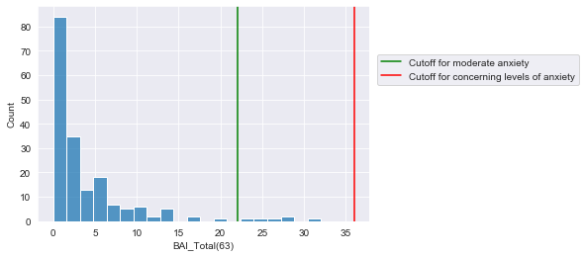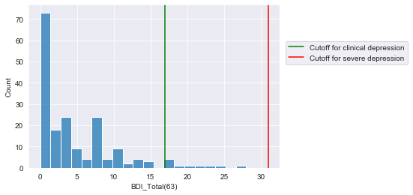
For BAI (anxiety), we only have very few patients (6) that are considered as moderate anxiety and none of them have concerning levels of anxiety.
For BDA (depression), we only have very few patients (10) that are considered as clinical depression and none of them have severe depression.
As we will see later, having few patients at clinical levels of depression impacts our ability to predict emotion using tinnitus.

Milestone 1 – Validity
In this section we identify which tinnitus survey provides the most ‘valid’ measure of tinnitus. We use factor analysis to assess how well each tinnitus questionnaire performs on three measures:
- Reproduction: Can we reproduce the existing tinnitus subscales with EFA?
- Internal Consistency: How fully do the subscales explain responses to their own survey?
- Comprehensiveness: Which survey best explains the others and therefore is the most comprehensive?

EFA Consistency
Can we reproduce questionnaire subscales using EFA?
The following tables compare the existing subscales vs the reproduced subscales. The numbers represent the number of questions belonging to each subscale. The goal is to identify whether the reproduced EFA subscales and the existing subscales group questions in the same way.
THI:
The reproduced subscales group questions completely differently from the existing questionnaire.
Existing \ Reproduced EFA | Factor1: Severity | Factor2: Social | Factor3: Depression
Catastrophic | 3 | 1 | 1
Emotional | 4 | 2 | 2
Functional | 8 | 4 | 0
EFA gives us one subscale measuring the overall severity of the tinnitus and one subscale measuring the social impact of tinnitus. For more information on how individual questions are categorized see the appendix EFA Excel.
TPFQ:
Here EFA largely reproduces the existing subscales:
Existing \ Reproduced EFA | F1: Sleep | F2: Hearing | F3: Concentration | F4: Emotion
S_Sleep | 5 | 0 | 0 | 0
H_Hearing | 0 | 5 | 0 | 0
C_Concentration | 0 | 1 | 4 | 0
E_Emotion | 0 | 0 | 2 | 3
Questions belong to the wrong subscale:
ID | Question | Sleep | Hearing | Concentration | Emotion | Existing subscales
3 | I just wish my tinnitus would go away. It is so frustrating. | 0.15 | 0.11 | 0.23 | 0.13 | Emotion
5 | When there are lots of things happening at once, my tinnitus interferes with my ability to attend to the most important thing. | 0.16 | 0.34 | 0.24 | 0.13 | Concentration
8 | My tinnitus is annoying. | 0.07 | 0.25 | 0.25 | 0.06 | Emotion
The reproduced TPFQ is similar to the existing one. Questions 3, 5, 8 might be modified or removed from the questionnaire.
TFI:
Exploratory factor analysis puts almost all questions into the correct existing subscales. There are two exceptions:
ID | AUDITORY | COGNITIVE | SLEEP | RELAXATION | EMOTIONAL | QUALITY OF LIFE | INTRUSIVE | SENSE OF CONTROL
Q4 | 0.07 | 0.16 | -0.16 | 0.3 | 0.06 | -0.19 | -0.06 | 0.29
Q22 | -0.04 | 0.34 | 0.08 | 0.11 | 0.06 | 0.31 | -0.03 | 0
In addition to questions Q4 and Q22, other questions belong to the same subscales as the existing TFI.
Key takeaways from EFA:
- THI was not reproduced by EFA
- TPFQ was mostly reproduced by EFA
- TFI was reproduced by EFA successfully
- TPFQ and TFI have a few questions which may be miscategorized. These questions might be removed to improve consistency.

Internal Validity
How well do the subscales describe the responses to that survey? Ideally if we knew the subscales of a survey, we would have a good idea of how that subject responded to individual questions in the survey.
First we examine how well the survey responses are explained given different choices of subscales:
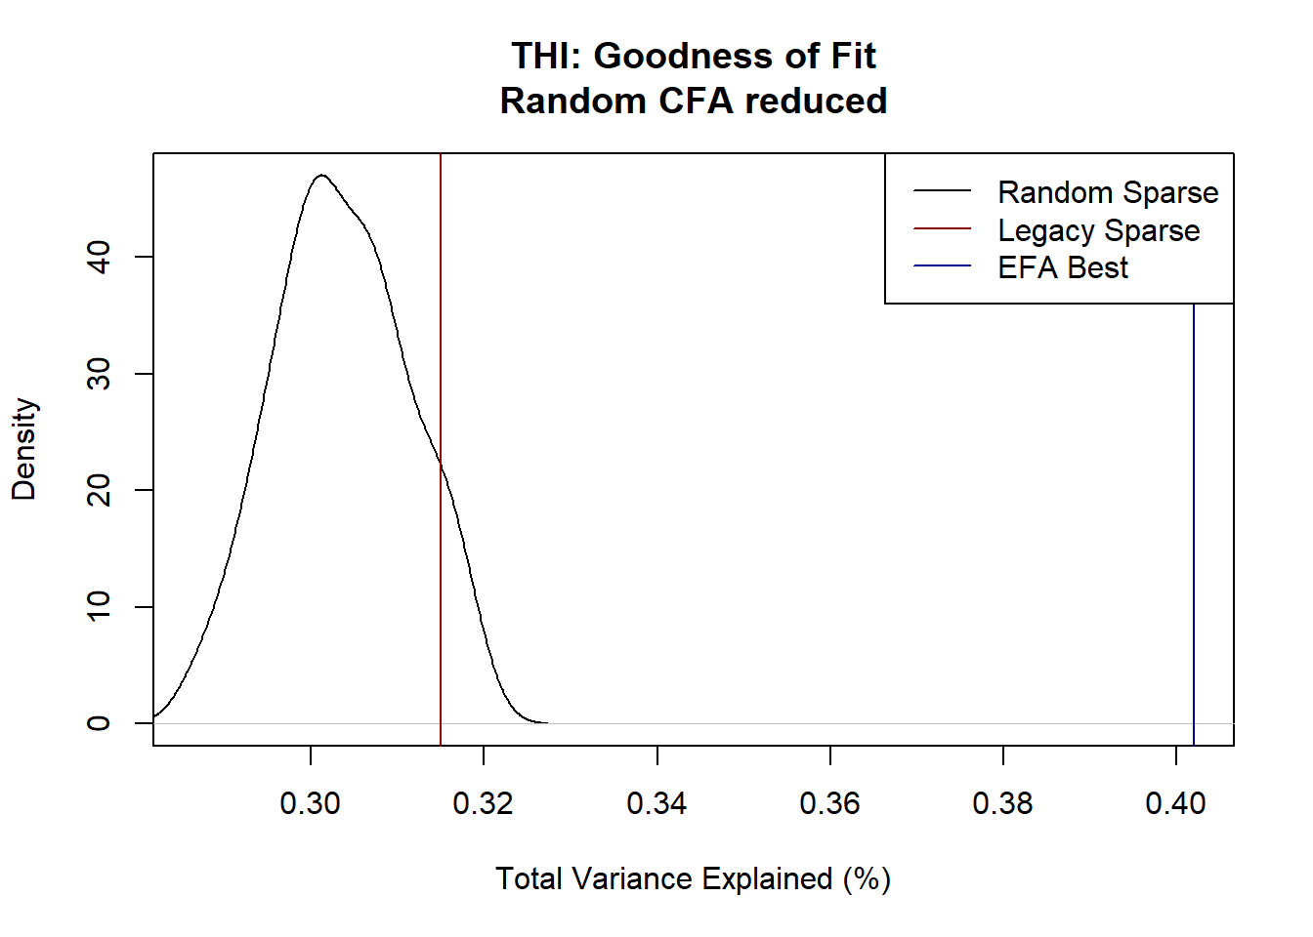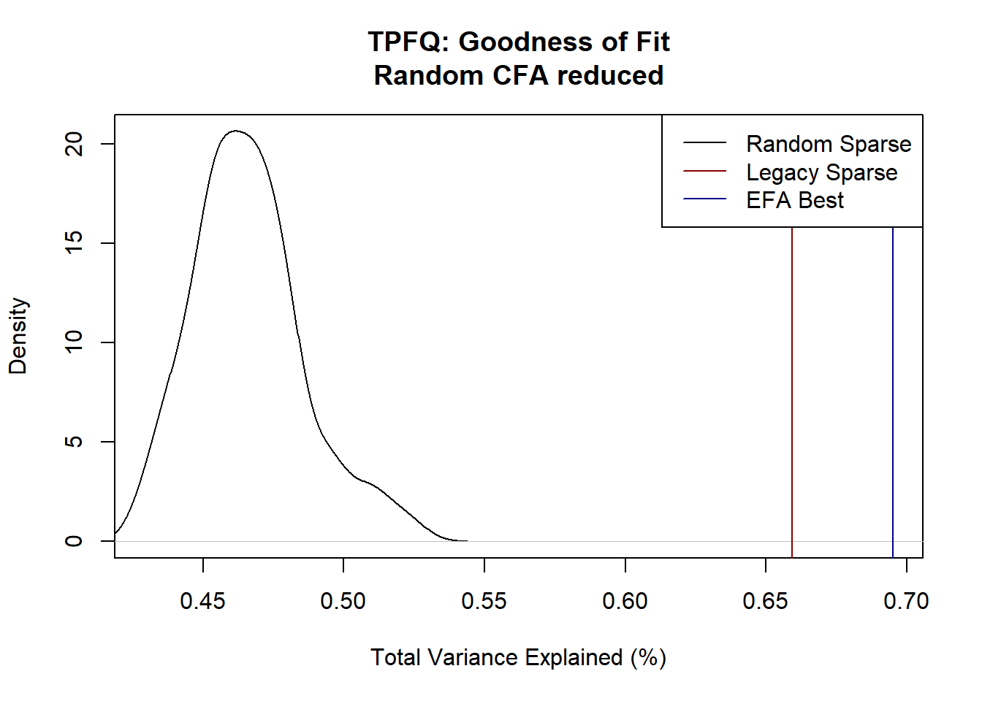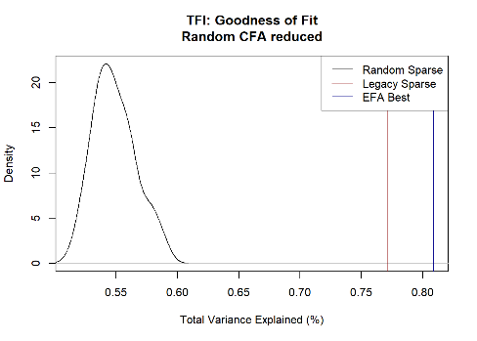
Note: Above we examine how well different subscales explain the variation in survey responses across all questions. We compare the goodness of fit of the existing subscales (red), EFA custom subscales (blue), and randomly permuted subscales (black).

Now we examine how well each existing subscale explains the questions related to that subscale.
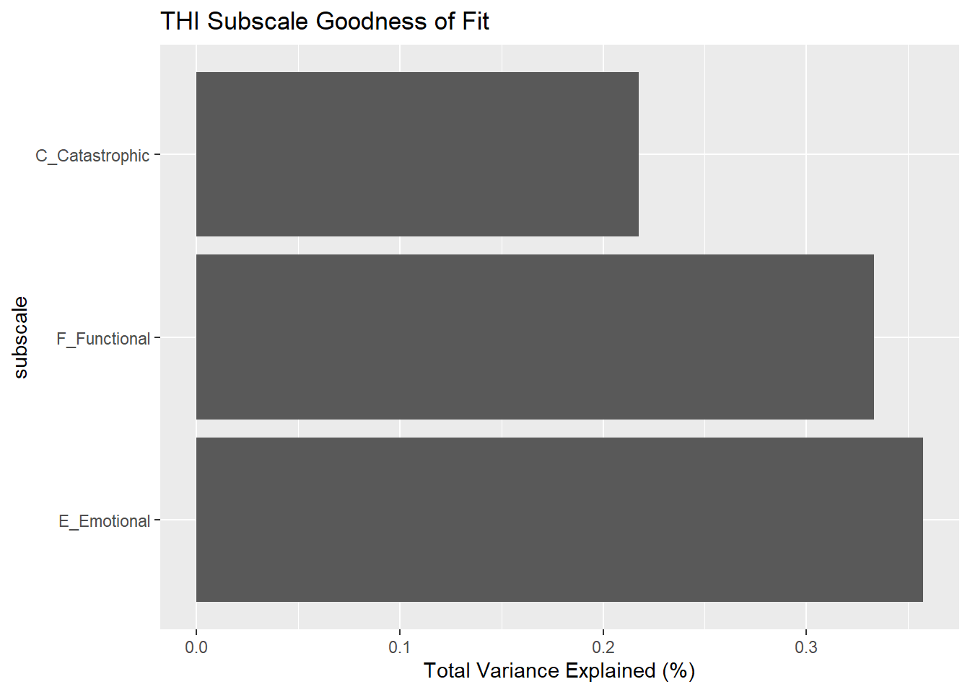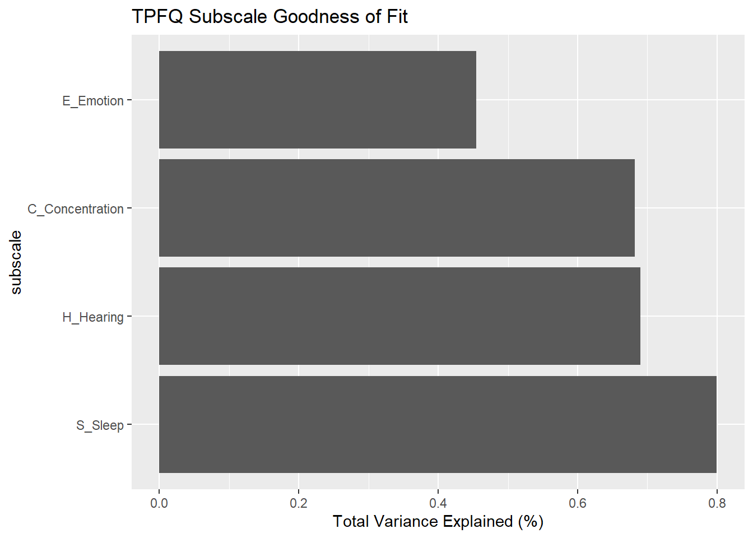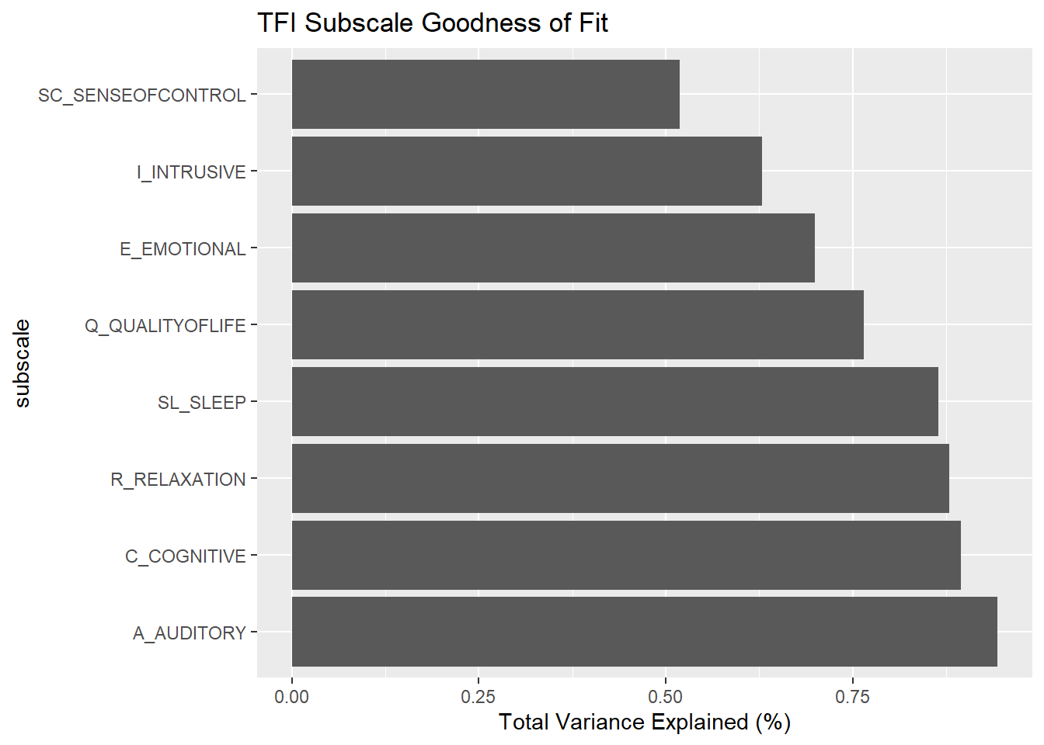
Note: Above we examine how well individual subscales explain their corresponding questions. For example how well does the emotional subscale explain variation in the emotion questions?

Key takeaways from internal validity:
- THI does little better than random subscales and much worse than ideal EFA.
- TPFQ and TFI do much better than random subscales and perform similarly to ideal EFA.
- TFI has slightly better internal validity, but this may be because it has more subscales allowing for a more customized fit.

Comprehensiveness
How well does one survey predict another survey? If one survey predicts another perfectly, then the first survey is comprehensive enough that there is no need to ask the second survey.
Overall  Variation Explained (%) |  | Predicted Survey |  |  | 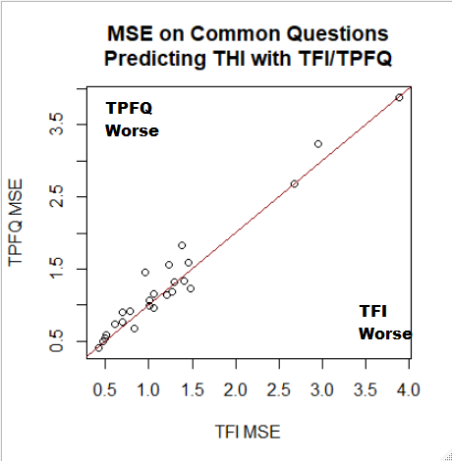
 |  | THI | TPFQ | TFI
Input | THI |  | 50% | 47%
Input | TPFQ | 61% |  | 63%
Input | TFI | 65% | 72%

Left: How well do the subscales of the input survey predict the subscales of the predicted survey, on average? e.g. The TFI subscales explain 65% of the variation in the THI subcales in a GLM.
Right: Each dot represents an individual THI question. That question is predicted with the TFI subscales (bottom) and the TPFQ subscales (right).
Predicting THI | Explained Variance (%) |  |  | TPFQ predicting TFI |  |  | TFI Predicting TPFQ
Predicted Subscale | from TPFQ | from TFI |  | Predicted Subscale | Explained  Variance (%) |  | Predicted Subscale | Explained  Variance (%)
THI-F_Functional | 69% | 70% |  | TFI-SL_SLEEP | 78% |  | TPFQ-S_Sleep | 78%
THI-E_Emotional | 51% | 61% |  | TFI-C_COGNITIVE | 71% |  | TPFQ-C_Concentration | 74%
THI-C_Catastrophic | 36% | 36% |  | TFI-R_RELAXATION | 66% |  | TPFQ-H_Hearing | 68%
 |  |  |  | TFI-Q_QUALITYOFLIFE | 62% |  | TPFQ-E_Emotion | 67%
 |  |  |  | TFI-A_AUDITORY | 61%
 |  |  |  | TFI-E_EMOTIONAL | 56%
 |  |  |  | TFI-I_INTRUSIVE | 51%
 |  |  |  | TFI-SC_SENSEOFCONTROL | 48%
Note: How well do the subscales of one survey predict each individual subscale of another survey? Are there any subscales in survey B which are not well captured by survey A?
Key takeaways
- THI has a poor fit
- TPFQ and TFI produce similar quality fits when fitted to THI
- Neither TFI/TPFQ explain THI_Catastrophic well.
- Since TFI has more subscales, there are some subscales of TFI not explained well by TPFQ.

Removing Questions
Based on our EFA analysis we identified certain questions with poor fit to their subscales:
- TPFQ: Q3, Q5, Q8
- TFI: Q4, Q22
Below we examine the goodness of fit after removing those questions.
There is some data snooping here. We use the same sample both to identify the questions to remove and to measure the goodness of fit.
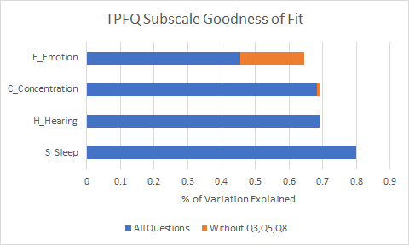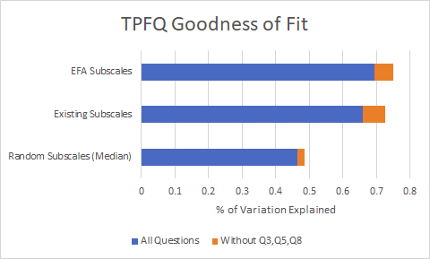
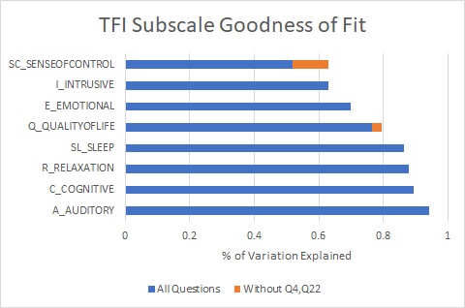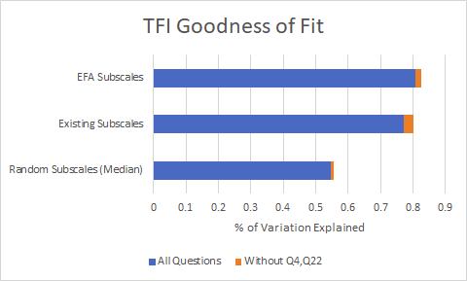
Left: We examine how well individual subscales explain the questions on that subscale. For example how well does the emotional subscale explain variation in the emotion questions?
Right: We examine how well different subscales explain the overall variation in survey responses.
Key takeaways:
- Removing questions improves goodness of fit particularly for the worst explained subscales.
  - Removing TPFQ Q3/Q8 seems to improve the Emotional subscale
  - Removing TFI Q4 seems to improve the Sense of Control Subscale
- The overall goodness of fit improves most for TPFQ

Milestone 1 – Conclusions
In this section we attempted to identify which tinnitus questionnaire gives the most ‘valid’ measure of tinnitus. In the EFA section, we identified whether we were able to reproduce the existing subscales with our data. In the internal validity section, we measured how completely the subscales explained responses to individual questions on that survey. In the comprehensiveness section, we measured how well one survey predicted another survey; the idea that if one survey predicted another well there is no need to ask the second survey.
The results were:
 | EFA | Internal Validity | Comprehensiveness
THI | Not Reproduced | Poor Fit | Poor Fit
TPFQ | Reproduced, mostly | Good Fit | Good Fit
TFI | Reproduced, mostly | Good Fit | Good Fit

All three approaches agreed that the surveys from worst to best are THI < TPFQ < TFI. However the difference between TPFQ and TFI was consistently small, attributable at least in part to the fact that TFI has more subscales (overfitting). Removing certain questions from each survey seems to improve goodness of fit; especially for TPFQ.
The numbers give a slight advantage to TFI, but not enough to be conclusive. The choice comes down to this. Do you want a slightly more complicated measure (TFI) with more subscales or a slightly simpler/parsimonious measure (TPFQ) with fewer subscales? Both perform similarly.

Milestone 2 - Emotion
The goal for milestone 2 is to figure out whether it is possible to model the emotional disturbance from tinnitus based on the scores from BDI, BAI and the emotional subscales from the tinnitus questionnaires.
Part 1 Regression
While BAI and BDI certainly do not give us a comprehensive view of the true emotional state, they are likely to be the best response variables in our dataset. The predictors are emotional subscales from TFI, THI, and TPFQ. These subscales are calculated in percentages, therefore this is a regression problem. The results of building the model with the whole dataset is as follows (measured in mean absolute error):
Model | BAI | BDI
Linear Regression | 3.29 | 3.61
Log Transform | 3.10 | 3.45
Decision Tree | 3.00 | 3.10
Random Forest | 1.94 | 2.10
Gradient Boosting | 1.69 | 1.58

Train-test split results:
Random Forests | BAI | BDI
Training MAE | 1.99 | 1.64
Testing MAE | 3.47 | 5.20

Gradient Boosting | BAI | BDI
Training MAE | 1.74 | 1.69
Testing MAE | 2.50 | 4.13

It is possible to model the emotional disturbance from tinnitus based on BDI, BAI and emotion subscales using techniques like Random Forests and Gradient Boosting, but the fit is poor. These models can be highly overfitting and are not useful to predict new observations. In addition, neither BAI score nor BDI score is good enough to be a response variable for this regression task, possibly due to the subjective nature of the self-report questionnaire.
Part 2 Classification
The regression on BAI and BDI did not give us a very good result. In this section we are going to try out the classification methods on BAI and BDI. To build up our classification methods, we started off from a very simple logistic regression model based on emotional subscales. Then we refined its responses and predictors to improve the classification accuracy. Finally, we applied up-sampling methods on BAI and BDI and corrected the skewness in the BAI and BDI dataset.
The best classification result is from this model:
BAI & BDI ~ 4 emotional subscales + other subscales in TFI
The “BAI & BDI'' identifies whether someone is emotionally disturbed by either BAI or BDI (or both) based on clinical cutoffs. We then applied up-sampling methods on this combined response to correct for the right skewness. Besides the 4 emotional subscales as we included in the regression part, we added any other subscales in TFI to make a higher classification accuracy.
The best classification accuracy after up-sampling is shown below:

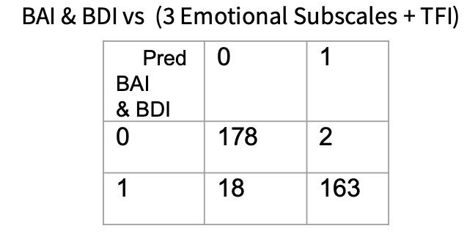
The classification accuracy is 0.89 and the No-Information-rate is 0.5 (after up-sampling), which is a good result. But there are several things that need to be considered before making a conclusion. Firstly, we applied up-sampling techniques, many of the observations in the data are not real. This good result might not be real. Moreover, we did model fitting and testing on the same data set, which might overestimate the prediction accuracy. Cross-validation is a way to fix this problem, but we do not have all real data at this moment, cross-validation on fabricated data still will not help much.
In conclusion, classification is a promising method to model the emotional disturbance. However, before we make a solid conclusion that classification is for sure to work, we need to collect more data, especially a considerably larger group of patients who would be classified as emotionally dsturbed.

Conclusions
Based on our analysis we conclude the following.
Milestone 1 - Choosing the Best Survey
- We recommend TFI as the primary tool to measure Tinnitus. To further improve validity you could remove questions Q4 and Q22.
- TPFQ is also a good candidate. It’s validity is slightly worse, but this is due largely to having fewer subscales. TPFQ validity is improved significantly by removing questions Q3, Q5, and Q8.
- THI has poor fit relative to the other surveys.

Milestone 2 - Influence of Tinnitus onto Emotion
- Neither BAI nor BDI is good enough to be a response variable for regression, possibly due to the subjective nature of the self-report questionnaire.
- Ensemble methods for regression overfit and offer poor predictions.
- Using median as a cutoff, classification on BAI and BDI performs poorly with a simple logistic model.
- After up-sampling, classification fits well. This allows us to use the scientific cutoffs of each questionnaire even though our data is unbalanced.

