Main Body

BackgrouFnd
Problem Statement
In this experiment, each test subject responded to five questionnaires: three tinnitus questionnaires (THI/TPFQ/THI), and two emotional questionnaires (BAI/BDI). We used their responses to answer two questions:
- Identify the best tinnitus questionnaire for clinical practice
- Identify how tinnitus influences emotion
We found the following results.
Definition of Tinnitus
Tinnitus is when you experience ringing or other noises in one or both of your ears. The noise you hear when you have tinnitus isn't caused by an external sound, and other people usually can't hear it. Tinnitus is a common problem and analyzing the potential factors that are associated with tinnitus is important for clinical practices.
Questionnaires Data
- Tinnitus Handicap Index (THI)
- Tinnitus Functional Index (TFI)
- Tinnitus Primary Function Questionnaire (TPFQ)
- Beck Anxiety Inventory(BAI)
- Beck Depression Inventory (BDI)
The datasets are collected by the clients and they are in the questionnaire format. The five questionnaire datasets we will use are THI, TFI, TPFQ, BAI and BDI. The first three questionnaires assess tinnitus severity and they measure different subscales. Subscale means different measurements that contribute to tinnitus. The last two questionnaires are all self-reported emotional reactions, which measure patients’ emotional problem and they do not have any subscales.The questionnaire together with its subscales are shown below.

Tinnitus Handicap Index (THI) -- Functional, Emotional, Catastrophic.
Tinnitus Functional Index (TFI) -- Intrusive, Sense of Control, Cognitive, Sleep, Auditory, Relaxation, Quality of life, Emotional.
Tinnitus Primary Function Questionnaire (TPFQ) -- Sleep, Emotion, Concentration, Hearing.

For more detailed information about which questions measure different types of subscales, please refer to the appendix.

Combined Dataset
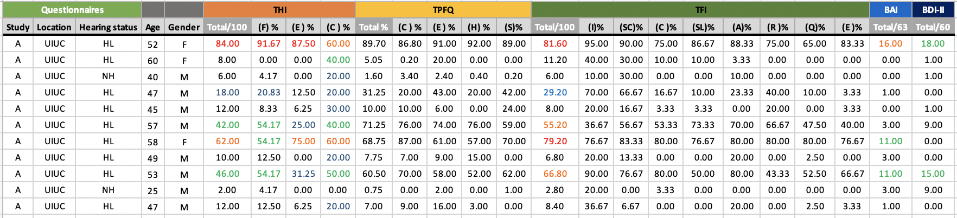

The combined dataset has 190 observations with 3 observations that contain missing values. The combined dataset contains three main parts. The first part is questionnaire information, including study type, location and hearing status. The second part is demographic features, including age and gender. The rest columns are all scores calculated based on the responses from all the patients using different formulas. For the three total scores that measure tinnitus severity, the total scores are in a scale of 0-100 and all the scores of the subscales are in percentage format. The other two scores that measure emotional problems are in a range of 0-63.

Data
We merged responses across questionnaires and dropped any observations with missing responses.

Demographics
For the three studies, the protocol for recruiting subjects to adults who had tinnitus and did not have severe emotional problems. Therefore the demographic makeup is quite a bit different from the average US population. We have a higher frequency of older individuals, men, and people with hearing loss.
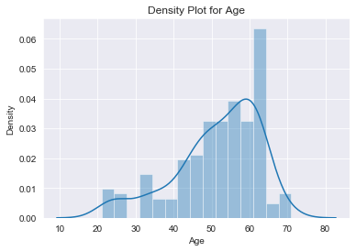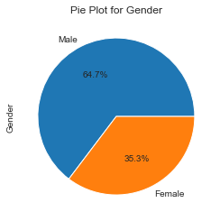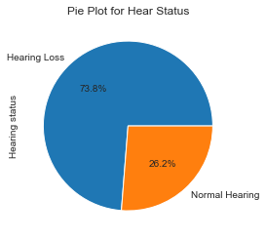
Our analysis did not show any strong relationship between these demographics and the tinnitus responses (below). You can see below that generally people without hearing loss tend to have higher emotional scores indicating that when there is no clear cause for the tinnitus there may be some emotional component. Furthermore, females have slightly higher tinnitus and emotional total scores. There is no strong age relationship.
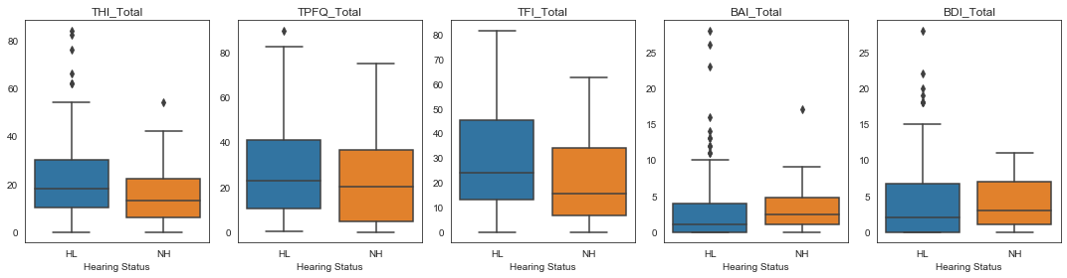
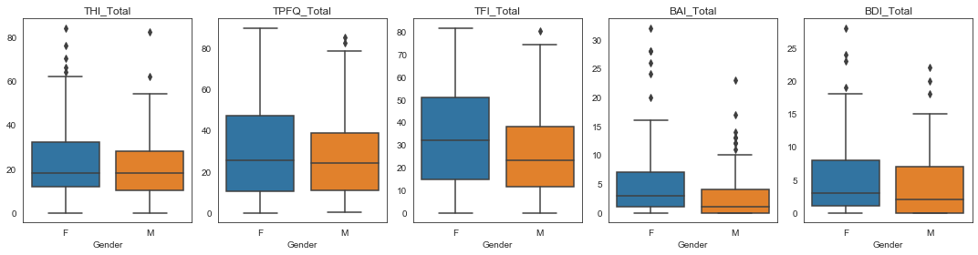

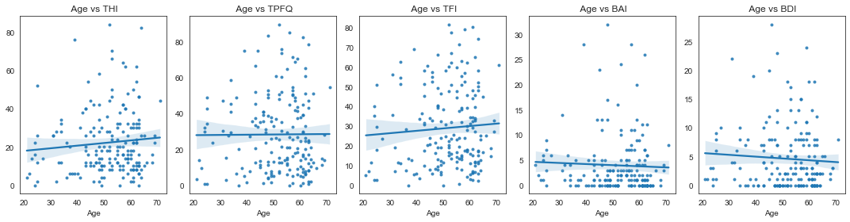
In general our analysis did not find any strong relationships between demographics and tinnitus. Therefore we do not include demographic interactions in our analysis for milestone 1.

THI/ TPFQ/ TFI
We create frequency plots for the total score of THI, TFI and TPFQ, which are all tinnitus severity measurements and contain different subscales. The distributions of the three total scores are right skewed and very few observations that lie beyond the severity cutoff.
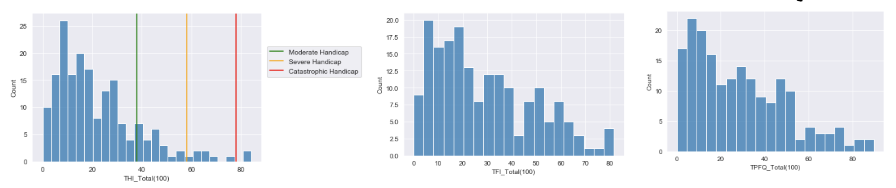

BAI/ BDI
We create frequency plots for the total score of BAI and BDI, which are all emotional measurements. We add two vertical lines to represent the thresholds.
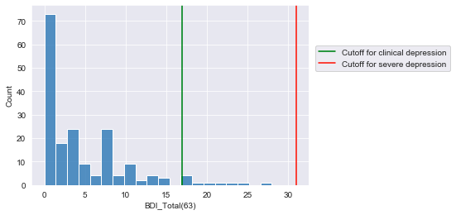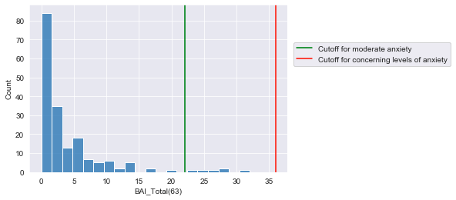
For BAI (anxiety), we only have very few patients (6) that are considered as moderate anxiety and none of them have concerning levels of anxiety.
For BDA (depression), we only have very few patients (10) that are considered as clinical depression and none of them have severe depression.

 | Tinnitus | Emotion
Age | Little Influence | Little Influence
Gender | Little Influence | Little Influence
Hearing Loss | Little Influence | NEGATIVE Influence

Conclusions of Exploratory Data Analysis
If we look at relationships, age, gender and hearing loss have little influence on patients’ annoyance generated by tinnitus. While hearing loss tends to have negative impacts on people’s emotions.
If we look at distributions, Only a small portion of the patients actually suffer from tinnitus or emotional problems.

Factor Analysis - Background
A survey might have a large number of questions, but only ask about a few key ideas. For example a 20 question math exam might measure someone’s ability to add and multiply; with several questions on either topic. A big five personality test might have 60 questions, but only measures five personality traits: openness, conscientiousness, extraversion, agreeableness, and neuroticism. In either case it’s not efficient to look at each question individually. Instead we want to group similar questions into subscales, look across questions, and evaluate these larger ideas.
Factor analysis is a statistical tool for building and evaluating groups/subscales. Exploratory factor analysis (EFA) is a way to ‘explore’ the data and identify new groups/subscales. Confirmatory factor analysis (CFA) is a way to ‘confirm’ the quality of existing subscales. We assume these subscales are measuring some real (but unobserved) phenomena (e.g. addition problems measure skill with addition). We call these phenomena latent factors.
Traditional factor analysis assumes continuous normal responses to each question. Our tinnitus surveys are not continuous. Instead the subject is given a small set of choices (e.g. 0/2/4) ordered from smallest to largest (i.e. likert/ordinal responses). There are three main approaches for adapting factor analysis to ordinal data.
Structural Equation Modeling (SEM): We assume that the ordinal responses are the result of rounding. Underlying each response is an actual continuous number which is rounded to the closest value (e.g. 0/2/4). The latent factors influence these continuous responses which in turn determine our rounded responses.
Item Response Theory: We treat our responses entirely as discrete. But we allow for latent factors to influence the probability of choosing a given response. Some examples are the Graded Response Model (Samejima 1997), and the MIRT (Chalmers 2012).
Correlation Based Methods: We pretend the data is continuous. We build a correlation matrix describing the relationship between questions. Then we pretend those associations were generated from a normal random variable instead of our ordinal responses. The correlation matrix could be built using usual (pearson) correlations, polychoric correlations, or spearman rank correlations. Polychoric and spearman correlations recognize the responses are ordinal, and make adjustments to get a more accurate correlation. For example see LISREL (Joreskog 1994), and Lavaan (Igolkina 2020 appendix C).
IRT/SEM are robust and interpretable from a statistical perspective. In comparison the correlation method impersonates continuity and lacks the same rigor. However the more formal IRT/SEM methods require many more parameters compared to the correlation method. Additionally there is less software support for IRT/SEM (particularly for CFA). Due to our small sample size and software needs, we opted for a correlation based method using Spearman Correlation. The tradeoff is we cannot reverse the continuity assumption. We cannot take this continuous random variable, convert it back into the discrete response, and compare our estimates against the actual responses. In particular we cannot calculate proper probabilities or likelihoods.
In general our factor model is:
Response = Loadings * Factors + Noise
$X=ΛF+E$
Where factors (F) are the hidden underlying phenomenon we are studying, and the loadings (Λ) describe how strongly a factor relates to a given individual question.

Milestone 1 - Methods
In milestone 1, we restricted our analysis to subjects which completely filled out all of the tinnitus surveys. This made sure our results were consistent across all of our comparisons. Our analysis proceeded as follows:
1. Internal Validity: We examined each questionnaire individually and measured its validity.
1A. Reliability: We measure to what extent the questions in a survey support the building of one or more subscales. We looked at several metrics for this: Cronbach’s Alpha, EFA, and Bartlett Sphere test, and KMO. We considered a variety of quality measures for EFA since the Spearman Correlation does not permit a proper calculation of likelihood, AIC, or BIC due to non-normality. Instead, we used cumulative variance as the metric. The cumulative variance represents the proportion of the total variance caused by all common factors.
Also, we used KMO score and Bartlett’s Sphericity test to check the suitability of the dataset for factor analysis . The KMO value represents the simple correlation coefficient and partial correlation coefficient between the comparison variables. The value range of KMO is 0-1. If the sum of squares of simple correlation coefficients is much larger than the sum of squares of partial correlation coefficients, and the KMO value is close to 1. The stronger the correlation between variables, the more suitable for factor analysis. The Bartlett sphere test is a coefficient to test whether the variables are correlated. If the p-value is less than 0.05, it means that the variables are correlated and suitable for factor analysis.
Cronbach’s Alpha is a measure of internal consistency and the reliability of the scale. When we use multiple items to measure a latent variable, we call this set of items a scale. For example, we want to know whether Tinnitus makes people feel stressed. If we ask this question directly, we will not get reliable results because it is up to the patients to define what is feeling. Alternatively, we can construct a scale such as “Yes”, “Sometimes” and “No”, or a scale of “Always”, “Sometimes”, “Rarely”, and “Never”, or a scale of 1-5. To test whether these measures are useful and consistent, we use Cronbach’s Alpha. Generally, a Cronbach’s Alpha of .7 or more is considered acceptable.
1B. CFA: We used confirmatory factor analysis (CFA) to take our existing subscales, fit an analogous model, and evaluate the goodness of fit. We focused on ‘sparse’ CFA which equally weights all questions in a subscale (only 0/1’s as loadings). We opted for a limited information method using Spearman rank correlation. Spearman rank correlation uses the same formal as traditional (pearson) correlation, but does correlation on inferred rankings rather than raw values. In a limited information method our data is used to generate an artificial correlation method, and that artificial correlation method is fit under CFA. Because our CFA is fit to an artificial construct rather than directly on our data, we cannot calculate likelihoods or measures derived from likelihoods such as AIC/BIC. Instead we evaluate goodness of fit based on the percent of Spearman correlation explained. Remember that Spearman correlation is an artificial construct, and we are using it as a proxy to estimate goodness of fit.
1C. EFA: We use EFA to build custom subscales fitted directly on our data (no sparse 0/1 loadings assumed). We then interpret the results and see if they are consistent with the legacy subscales. We calculated spearman correlation due to the ordinal data (Likert scale) and used maximum likelihood method to find the parameters. To prevent overfitting and have a better one to one comparison with the existing subscales, we use the legacy amount of factors.
2. External Validity: We examine how well one questionnaire explains another questionnaire. The most comprehensive questionnaire should explain the others best.
2A. Survey to Survey: We examine how well do the subscales from one survey explain all of the surveys from another survey. We fit multiple linear regression predicting each individual subscale, and then look at the average reduction in variation.
2B. Survey to Subscale: We examine how well do the subscales from one survey explain an individual subscale from another survey.
2C. Survey to Question: We examine how well do the subscales from one survey explain individual questions from another survey. Since the questions are ordinal we use a proportional odds model. Since different surveys have different scales (0,2,4 vs 0-100) we grouped the responses of each survey into three (0, 1-50, 51-100). We evaluated the accuracy of our models with mean squared error (MSE).

Milestone 1 – EFA Consistency
We attempted to reproduce the legacy subscales organically. We would build new subscales on our data using EFA and then compare our fitted models against the legacy subscales. If we are able to reproduce the existing subscales this validates the choice of subscales. Three kinds of rotation methods were used on factor loadings to get more interpretable and reliable results, including varimax, oblimin, and target rotation. Varimax is an orthogonal rotation method that assumes the common factors are uncorrelated. In contrast, oblimin is an oblique rotation method that assumes that the factors are correlated. Target rotation is an intermediate process between CFA and EFA. This method tests a specific hypothesis for the common factors.
Considering the subscales are correlated with each other, we analyze the factor loadings after oblimin rotation. The details of factor loadings are in the excel file. We only show the factor loadings that are greater than 0.2. Factor loadings less than 0.2 are hidden, but you can see them by changing the text color.
For THI our fitted models were inconsistent with the existing subscales. For TPFQ we had a similar result. For TFI we were able to closely match the existing subscales using EFA.

THI
Existing \ Reproduced EFA | Factor1: Severity | Factor2: Social | Factor3: Depression
Catastrophic | 3 | 1 | 1
Emotional | 4 | 2 | 2
Functional | 8 | 4 | 0

The reproduced THI has 3 common factors which only explain 40% of the total variance together (cumulative variance). Factor1 represents the overall severity. Factor2 separates out the social impacts. Factor3 separates out depression from other emotions. The contingency table shows whether the questions in reproduced THI are mislabelled as the wrong subscale or not. We can see that we got a completely different result from the existing THI questionnaire.

TPFQ
ID | Question | Sleep | Hearing | Concentration | Emotion | Existing subscales
3 | 3 I just wish my tinnitus would go away. It is so frustrating. | 0.15 | 0.11 | 0.23 | 0.13 | Emotion
5 | 5 When there are lots of things happening at once, my tinnitus interferes with my ability to attend to the most important thing. | 0.16 | 0.34 | 0.24 | 0.13 | Concentration
8 | 8 My tinnitus is annoying. | 0.07 | 0.25 | 0.25 | 0.06 | Emotion

Existing \ Reproduced EFA | F1: Sleep | F2: Hearing | F3: Concentration | F4: Emotion
S_Sleep | 5 | 0 | 0 | 0
H_Hearing | 0 | 5 | 0 | 0
C_Concentration | 0 | 1 | 4 | 0
E_Emotion | 0 | 0 | 2 | 3
TPFQ has 20 items assessing 4 primary subscales: Emotion, Hearing, Sleep and Concentration. The cumulative variance of TPFQ is 0.70, which is acceptable. The factor loadings of Question 3, 5, 8 are smaller than 0.4, which makes it hard to find the common factors that they belong to. The contingency table shows that these 3 questions are not assigned to the right subscales in existing TPFQ. Therefore, these questions need to be modified or removed from the questionnaire. To improve the structure of the TPFQ questionnaire, we deleted these 3 questions and rebuilt the EFA. After deleting questions, the cumulative variance changes to 0.75. Therefore, we can delete Question 3, 5, 8 to make the structure more concise.
TFI
ID | AUDITORY | COGNITIVE | SLEEP | RELAXATION | EMOTIONAL | QUALITYOFLIFE | INTRUSIVE | SENSEOFCONTROL
Q4 | 0.07 | 0.16 | -0.16 | 0.3 | 0.06 | -0.19 | -0.06 | 0.29
Q22 | -0.04 | 0.34 | 0.08 | 0.11 | 0.06 | 0.31 | -0.03 | 0

The reproduced TFI has almost the same structure as the existing questionnaire. Only Question 4 and 22 belong to the wrong subscale. We deleted these 2 questions and rebuilt the EFA model. After deleting questions, the cumulative variance changed from 0.81 to 0.84. It makes sense to delete Question 4 and 22.

Conclusions
THI was not reproduced by EFA so it’s not a good choice for statistical analysis. We did not rebuild the EFA and CFA models for THI due to the huge difference between the reproduced results and the existing results. TPFQ was mostly reproduced by EFA and the result was acceptable. However, some emotion questions were assigned to the concentration subscale. TFI was reproduced by EFA successfully. After deleting these mislabelled questions, the cumulative variance of TPFQ and TFI both increased.
In general, TFI is the best one based on exploratory factor analysis, but it may have overfitting problems. TPFQ is acceptable. It’s best not to use THI for research.

Milestone 1 – Internal Validity
In this section we examined each questionnaire individually and measured its validity.
We will show that TFI and TPFQ perform similarly with TFI having a modest advantage.

Question Strength
In this section we measure to what extent the questions in a survey support the building of one or more subscales.
Reliability: Are the questions in a survey interrelated? Ideally we want a survey to focus on a few main topics with questions on each topic closely related. Cronbach’s alpha is one way to measure the degree of relationship on a scale from zero to one. One of the strengths of Cronbach’s alpha is we can measure without needing to specify specific topics, number of topics, or which questions should be grouped together.
 | THI | TPFQ | TFI
Cronbach’s alpha | 0.92 | 0.95 | 0.97
Above we can see that all questionnaires have strong relationships (>0.8) with TFI the strongest by a small margin.
Dimensionality: If we used the same number of factors which questionnaire would perform best? Below we use EFA to build new subscales of different sizes. For each questionnaire we start to build between 1 and 8 total subscales, and measure the goodness of fit.
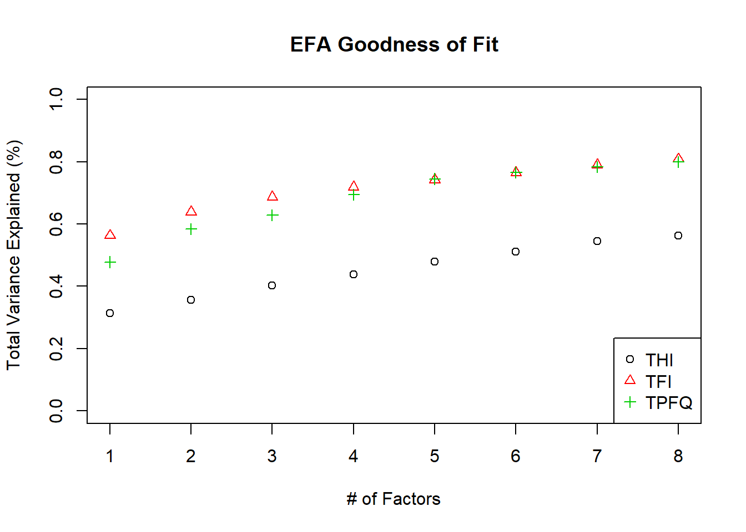
Above we can see that for any fixed number of factors that TFI and TPFQ perform similarly (TFI slightly better), and THI performs the worst.
Other Measures: We also used the Bartlette’s Sphericity test and KMO score to evaluate the appropriateness of subscales (and factor analysis). Consistent with the above we find evidence for subscales with TFI performing best. See definitions above (#XMeasures).
 | Good If | THI | TPFQ | TFI
Bartlett Sphere P-Value | <5% | <1% | <1% | <1%
KMO | >0.8 | 0.88 | 0.91 | 0.94

Subscale Accuracy with CFA:
How well do the subscales describe the responses to that survey? Ideally if we knew the subscales of a survey, we would have a good idea of how that subject responded to individual questions in the survey.
Individual Subscales: How well does each subscale explain its corresponding questions? Some subscales perform better than others. Below we measure how much of the spearman correlation of each question group is explained by its corresponding subscale.
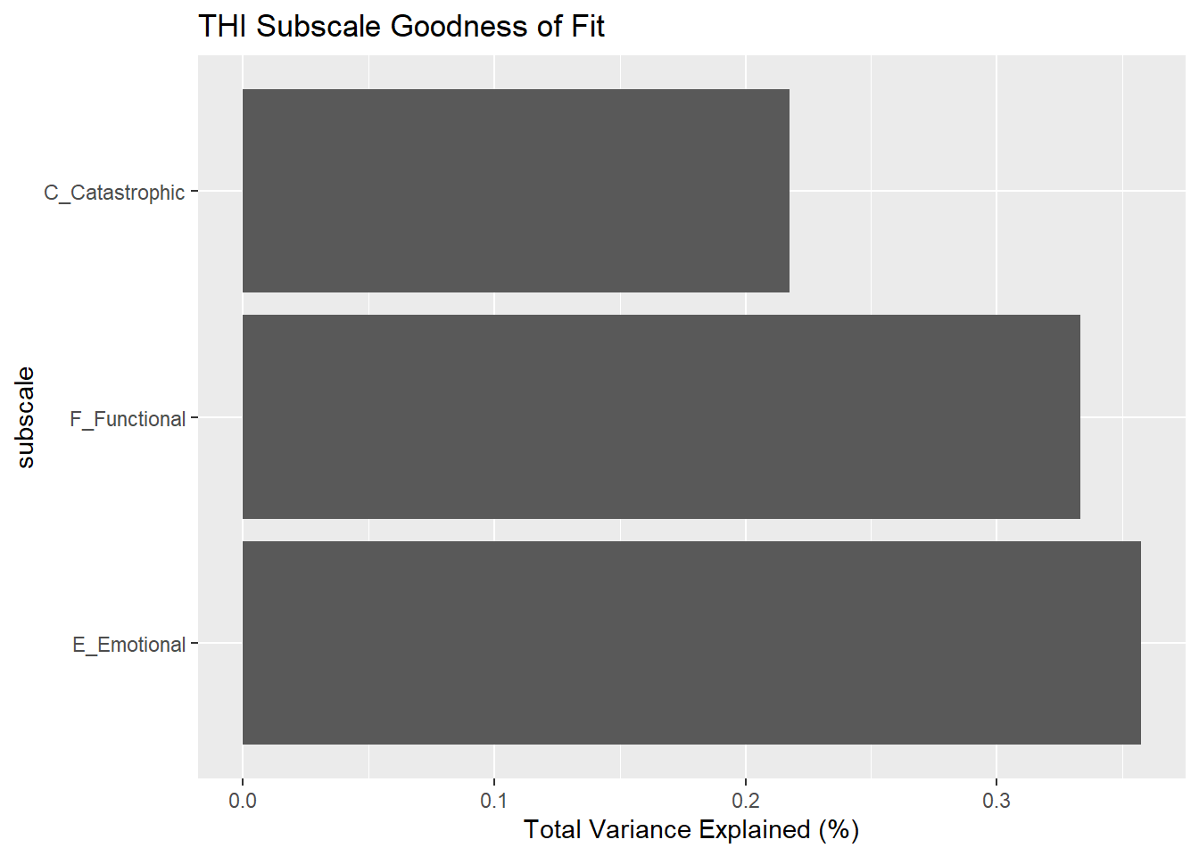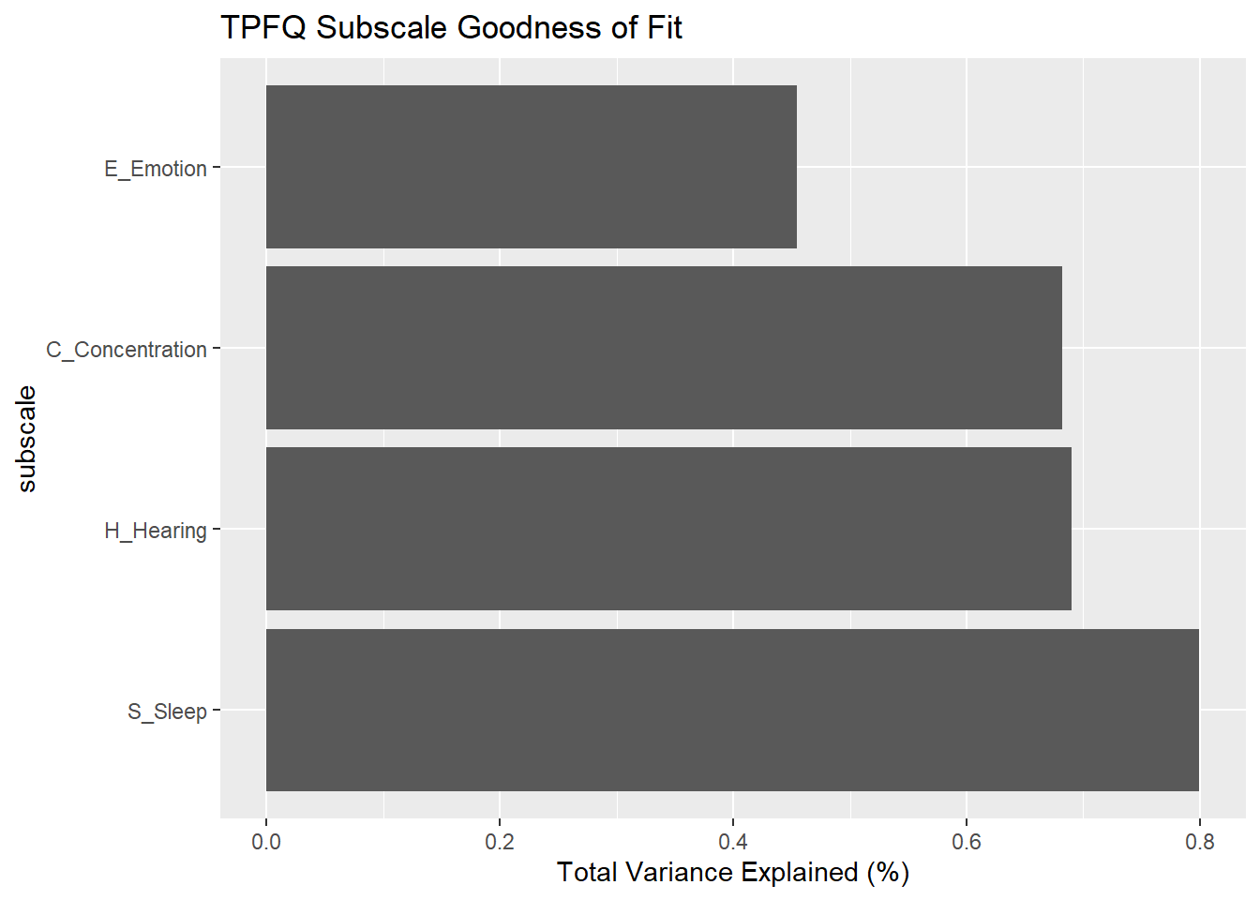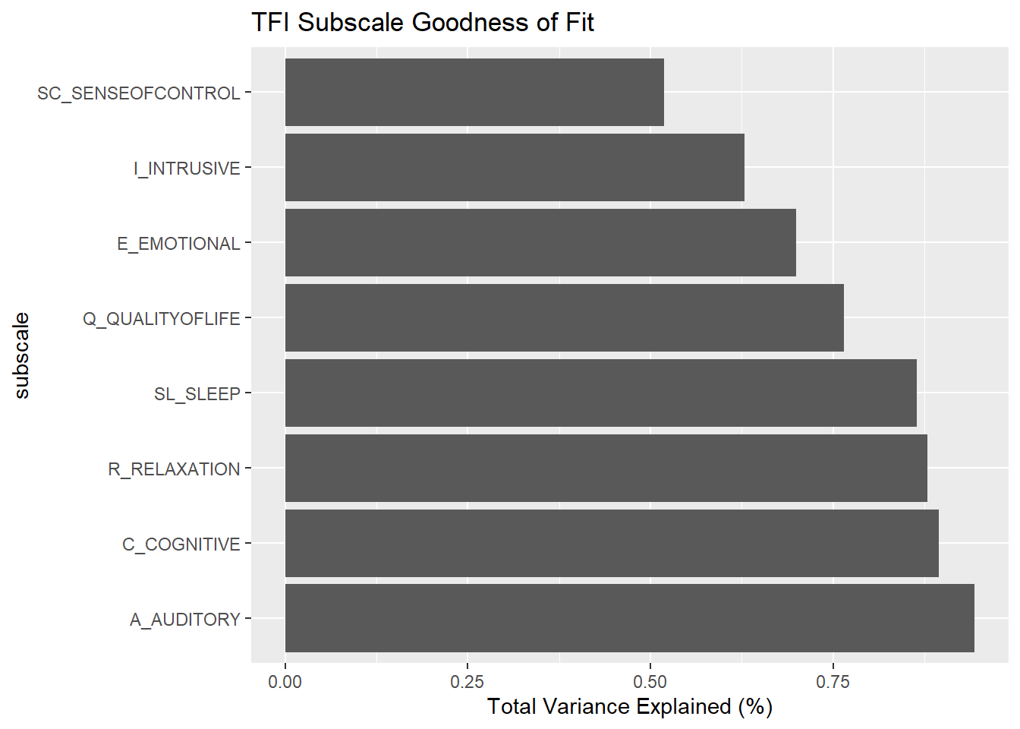
Above we see that the THI subscales provide the worst explanations. TPFQ and TFI have roughly similar goodness of fit. Note that THI_Catastrophic and TPFQ_Emotion have the worst reliability.
Overall Quality: How well do the subscales combined explain the responses? We use confirmatory factor analysis to fit the legacy subscales to the observed spearman correlation. We then offer two comparison points. As a ‘worst case’ comparison, we generate 100 random subscales. As a ‘best case’ comparison, we fit an EFA model which builds a subscale specifically customized to our data. We expect the legacy subscales to sit somewhere between either extreme.
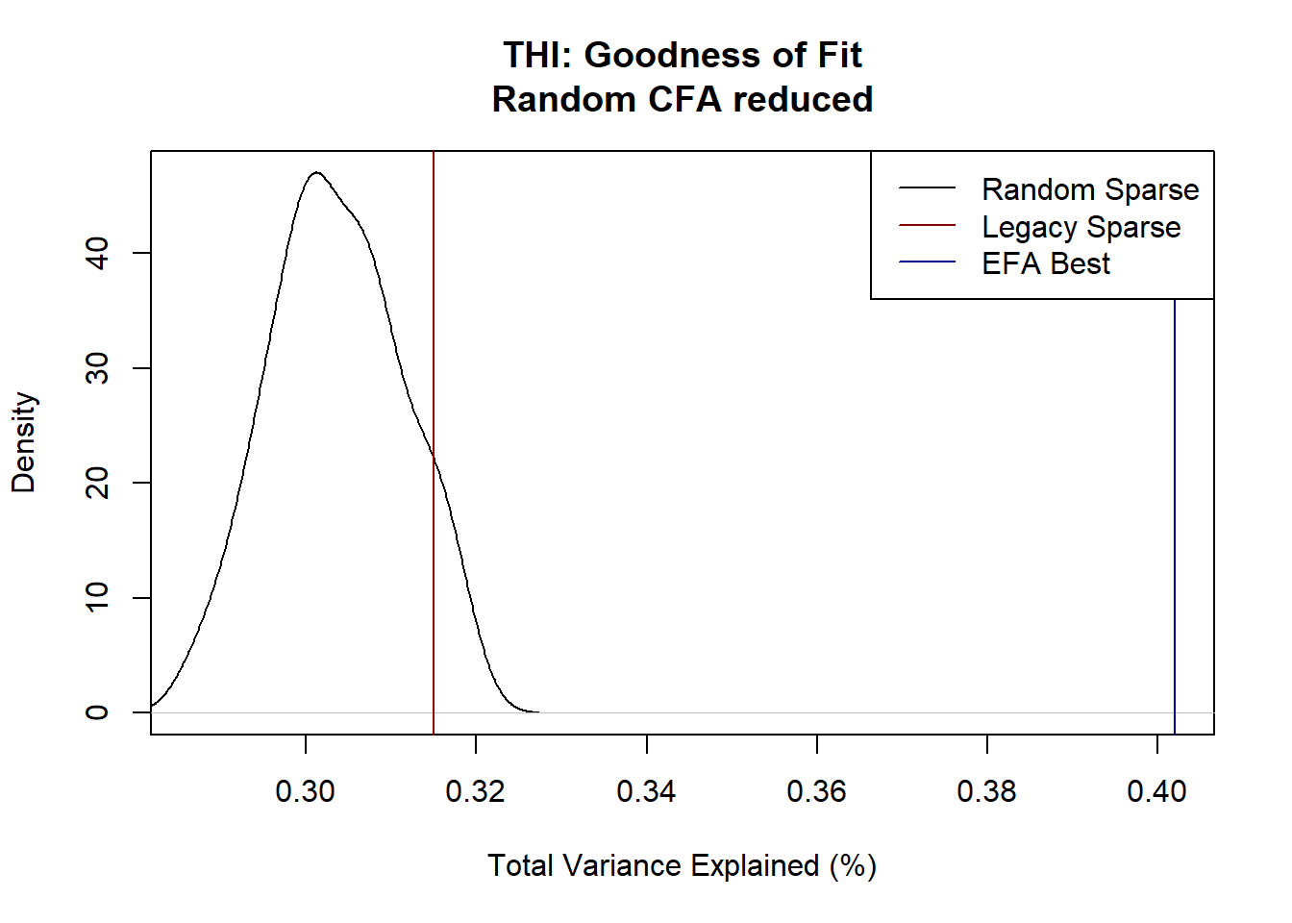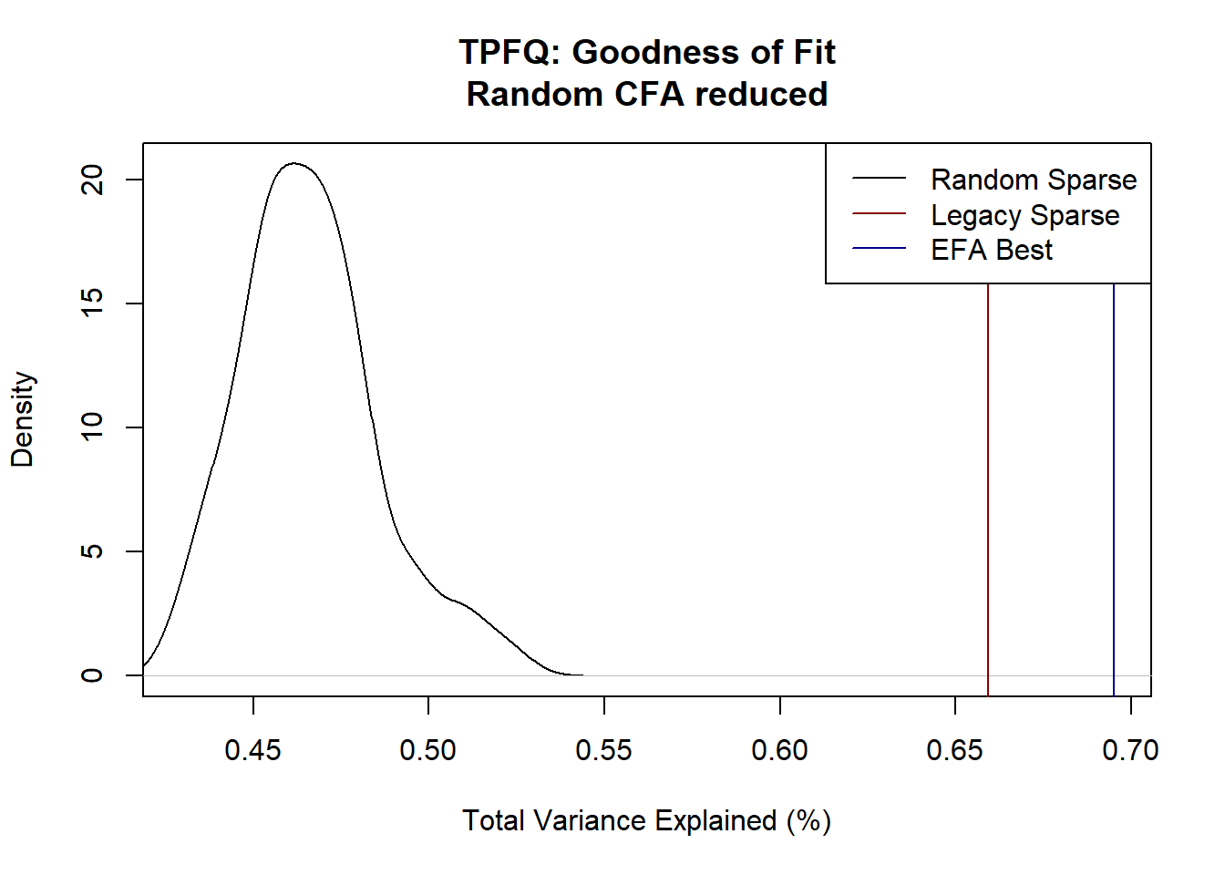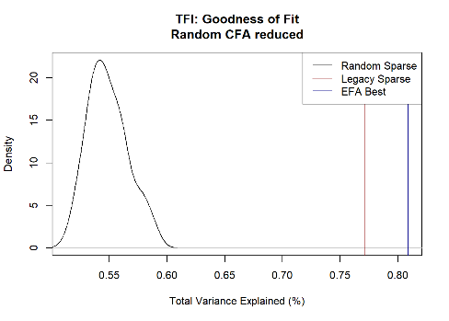
Total Variance Explained (%) | THI | TPFQ | TFI
Lower Bound: Random Subscale (95%) | [0.289, 0.317] | [0.433, 0.511] | [0.521, 0.585]
Legacy Subscale | 0.315 | 0.659 | 0.772
Upper Bound: EFA Subscale | 0.402 | 0.695 | 0.809
Subscales (#) | 3 | 4 | 8
Above we see that THI by far performs the worst; little better than random subscales. TPFQ and TFI both perform well with TFI as the best. Note that the TFI legacy subscales perform better than a five factor EFA model. Additionally TFI surpasses random subscales by a wider margin compared to TPFQ.
Other Measures: Below are some additional measures of the goodness of fit of the provided subscales. These results are consistent with our analysis above. TFI subscales perform the best and THI subscales often perform the worst.
 | Cut-off for good fit | THI | TPFQ | TFI
RMSEA | RMSEA < 0.08 | 0.092 | 0.130 | 0.074
SRMR | SRMR <0.08 | 0.102 | 0.092 | 0.094
CFI | CFI ≥0.90 | 0.736 | 0.840 | 0.950
TLI | TLI≥ 0.95 | 0.730 | 0.831 | 0.944
For more information about these measures see the appendix (#XMeasures).

Removing Questions
Based on our EFA analysis we identified certain questions with poor fit to their subscales:
- TPFQ: Q3, Q5, Q8
- TFI: Q4, Q22
Below we examine the goodness of fit after removing those questions.
There is some data snooping here. We both identify the questions to remove and measure the goodness of fit on the same sample.
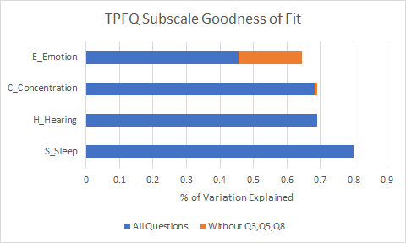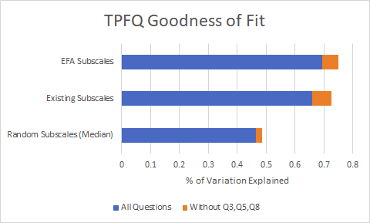
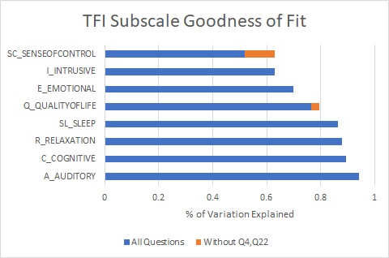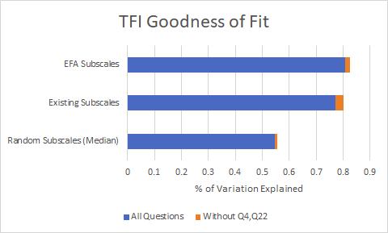
Left: We examine how well individual subscales explain their corresponding questions. For example how well does the emotional subscale explain variation in the emotion questions?
Right: We examine how well different subscales explain the variation in survey responses.
Key takeaways:
- Removing questions improves goodness of fit particularly for the worst explained subscales.
  - Removing TPFQ Q3/Q8 seems to improve the Emotional subscale
  - Removing TFI Q4 seems to improve the Sense of Control Subscale
- The overall goodness of fit improves most for TPFQ

Conclusions:
The above metrics suggest the surveys from worst to best are: THI < TPFQ < TFI.
Overfitting: The difference between TPFQ and TFI is not always large. Furthermore TFI has several more subscales than TPFQ (8 vs 4). This gives a risk of overstating TFI performance. With additional subscales, TFI has more flexibility to adapt to the data regardless of the true underlying validity. Ideally we would use a measure of goodness of fit which is unaffected by differences in model complexity. Unfortunately classic solutions to this problem (e.g. BIC, cross validation) are inappropriate for our data. Therefore the choice between TPFQ and TFI cannot be made on one metric (e.g. BIC) alone.
BIC is not appropriate because our models use Spearman Correlation and Spearman Correlation does not provide a proper likelihood. Cross validation is only appropriate when we are fitting two models to the same data. In our case each questionnaire is distinct with its own data and therefore cannot be compared.
Removing Questions: Removing select questions seems to improve the goodness of fit of each survey; especially as it relates to the worst performing subscales.
We will later suggest that despite the difficulty that TFI has the best internal validity.

Milestone 1 – Comprehensiveness
In this section we measure how well one questionnaire explains another questionnaire. The most comprehensive questionnaire should explain the others best. In the best case scenario if one questionnaire explains the others perfectly, there is no need to ask the other questionnaires.

Survey to Survey
How well do the subscales from one survey explain all of the subscales from another survey? We fit multiple linear regression and looked at the decrease in variance.
Variation Explained (%) |  | Predicted Survey |  |  |  | AIC |  | Predicted Survey
 |  | THI | TPFQ | TFI |  |  |  | THI | TPFQ | TFI
Input | THI |  | 50% | 47% |  | Input | THI |  | 2. TPFQ Worse | 2. TFI Worse
Input | TPFQ | 61% |  | 63% |  | Input | TPFQ | 2. THI Worse |  | 1. TFI Better
Input | TFI | 65% | 72% |  |  | Input | TFI | 1. THI Better | 1. TPFQ Better

Above we see that THI performs worst and TFI/TPFQ perform similarly. TFI is best by a small margin.

Survey to Subscale
Which subscales does a survey predict best? Worst? Although a survey might be the most comprehensive overall, it might not capture specific subscales. This is again done using linear regression, and we looked at the explained variance (%).
Predicting THI | Explained Variance (%) |  |  | TPFQ predicting TFI |  |  | TFI Predicting TPFQ
Predicted Subscale | from TPFQ | from TFI |  | Predicted Subscale | Explained  Variance (%) |  | Predicted Subscale | Explained  Variance (%)
THI-F_Functional | 69% | 70% |  | TFI-SL_SLEEP | 78% |  | TPFQ-S_Sleep | 78%
THI-E_Emotional | 51% | 61% |  | TFI-C_COGNITIVE | 71% |  | TPFQ-C_Concentration | 74%
THI-C_Catastrophic | 36% | 36% |  | TFI-R_RELAXATION | 66% |  | TPFQ-H_Hearing | 68%
 |  |  |  | TFI-Q_QUALITYOFLIFE | 62% |  | TPFQ-E_Emotion | 67%
 |  |  |  | TFI-A_AUDITORY | 61%
 |  |  |  | TFI-E_EMOTIONAL | 56%
 |  |  |  | TFI-I_INTRUSIVE | 51%
 |  |  |  | TFI-SC_SENSEOFCONTROL | 48%

Both TPFQ and TFI provide similar predictions for THI, and both perform poorly on the THI Catastrophic subscale. Since TFI has more subscales than TPFQ, there are some subscales in TFI which TPFQ does not predict well. THI performs poorly with 37%-58% explained variance.

Survey to Question
Which questions does a survey predict best? Worst? Although a survey might be the most comprehensive overall, it might not capture specific questions.
We code all response questions on a 0/2/4 scale with 1-50 coded 2 and 51-100 coded 4. Then for each pair of questionnaires we take all of the subscales from survey A to predict each question from survey B using an ordinal proportional odds model.
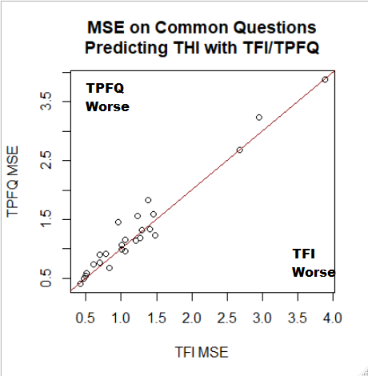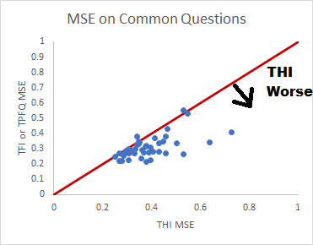
Above we see that TFI and TPFQ subscale perform almost identically on THI questions. TFI has a very slight advantage with better MSE in 60% of questions, and better AIC in 52% of questions.
Below we show the questions that TFI and TPFQ predict worst. TFI and TPFQ struggle with the same three questions the most:
ID | Subscale | Questions worst predicted by TFI/TPFQ
THI_Q8 | Catastrophic | 8. Do you feel as though you cannot escape your tinnitus?
THI_Q19 | Catastrophic | 19. Do you feel that you have no control over your tinnitus?
THI_Q24 | Functional | 24. Does your tinnitus get worse when you are under stress?
For additional questions see the appendix (#external)

Conclusion
The above metrics suggest the surveys from worst to best are: THI < TPFQ < TFI. However again the difference between TFI and TPFQ is not large, and can be explained by TFI having more subscales. After controlling for model complexity (e.g. with AIC), the difference between TFI and TPFQ is negligible. One element which neither TFI or TPFQ capture well is the THI Catastrophic subscale.

Milestone 1 – Conclusions
We propose that TFI offers the best internal validity. This is based on the following evidence:
- Question Strength: In the question strength section, we identified TFI as the best performer using Cronbach’s alpha and EFA. These measures are unaffected by the number of subscales and avoid the ‘overfitting’ problem above.
- Subscale Accuracy: Although the subscale accuracy section is liable to overfit, TFI performs quite strongly. The eight TFI subscales explain 77% of the variance. To match this with the TPFQ not only would we need seven subscales, but those subscales would have to be specially crafted to our observed data and allow for questions to be weighted unequally.
- Heuristics: The TFI was the only questionnaire where our custom subscales (EFA) were consistent with the legacy subscales.
In internal validity we assessed how well a questionnaire is described by its subscales. In external validity we measured how well a questionnaire is described by the subscales of another survey. Both approaches suggested the order of the surveys from best to worst is THI < TPFQ < TFI. However the difference between TPFQ and TFI is small and attributable at least in part to the fact that TFI has more subscales (overfitting). It’s also possible that if we repeated the experiment that we might instead find a slight advantage for TPFQ by random chance.
The numbers give a slight advantage to TFI, but not enough to be conclusive. The choice comes down to this. Do you want a slightly more complicated measure (TFI) with more subscales or a slightly simpler/parsimonious measure (TPFQ) with fewer subscales? Both perform similarly.

Milestone 2 - Emotion

Part 1 Regression
The goal for milestone 2 is to figure out whether it is possible to model the emotional disturbance from tinnitus based on the scores from BDI, BAI and the emotional subscales from the tinnitus annoyance questionnaires. In order to tackle this problem, we have to be clear about our predictors, responses, and problem type. We used BAI and BDI as our response variables. Because all of our data are from questionnaires, they are intrinsically subjective. The most ambiguous part is to find a reasonable and comparably solid value to quantify the emotional disturbance level. Based on our understanding towards the design of each questionnaire, we chose BDI and BAI to be our measure of emotional disturbance. This is because BDI and BAI measure the depression level of each patient due to tunnius. We believe it is reasonable that the depression level somehow describes how this patient’s emotion is disturbed by tunnius. While BAI and BDI certainly do not give us a comprehensive view of the true emotional state, they are likely to be the best measures we have in our dataset. The predictors are emotional subscales from TFI, THI, and TPFQ. These subscales are calculated in percentages, therefore this is a regression problem.
First of all, we extracted the emotional subscales from all three questionnaires, and ran a linear regression on those subscales to predict the total value of BAI and BDI respectively. The predicted values versus the true values are plotted below, and we can see that a simple linear regression does not yield a good result. Specifically, the mean absolute error for predicting BAI is 3.29, while the mean absolute error for predicting BDI is 3.61, which are both pretty large.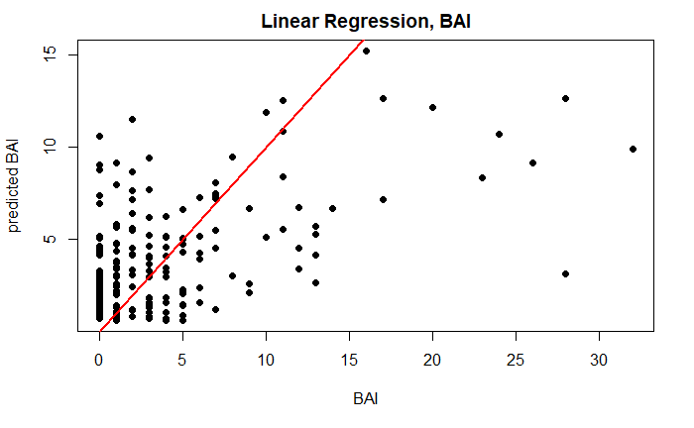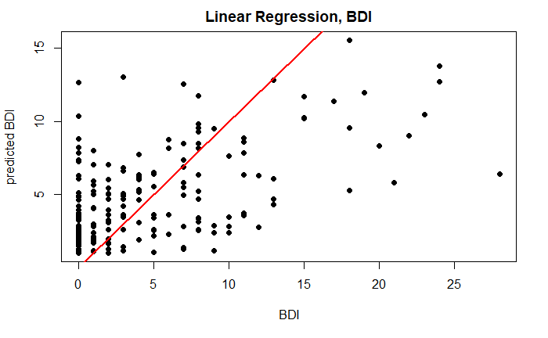The linear regression models are underfitted due to the fact that the model is not complex enough for our dataset. Since our response variables are highly right-skewed, we tried to transform the BAI and BDI scores into logarithmic scales, in order to neutralize the skewness. The resulting plots still showed underfitting. The mean absolute error for predicting BAI is 3.10, whereas the mean absolute error for predicting BDI is 3.45. Compared to the linear models, we saw a slight improvement, but the errors are still too large to offer us any useful insights.
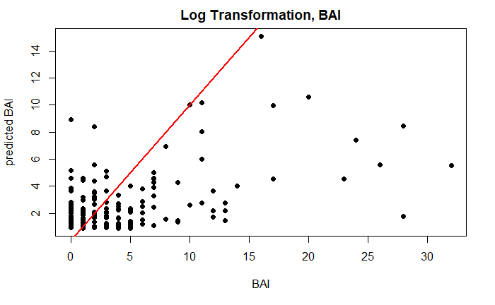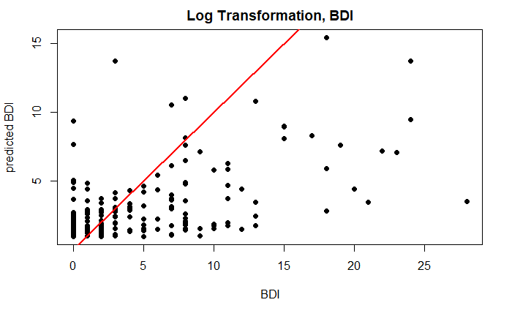
Next, we started to try some non-parametric regression models. The first method we used is the decision tree, which is simply a series of questions. When we get a set of features and values, we use each attribute to answer a question. The answer to each question decides the next question, forming a tree-shaped diagram in the end. In other words, decision trees learn from data to approximate a sine curve with a set of it-then-else decision rules. The deeper the tree, the more complex the decision rules and the fitter the model. The results were still not ideal. The mean absolute error for predicting BAI is 3.00, while the mean absolute error for predicting BDI is 3.10. From the plots below we can see that the decision tree tends to assign discrete values and builds the model in a classification way rather than a regression one.
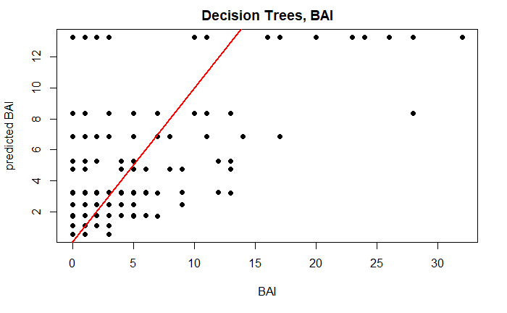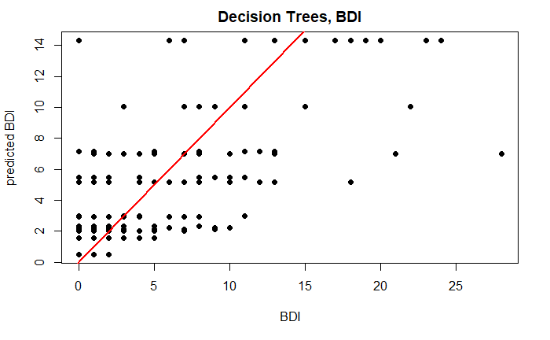
Then we tried some ensemble methods, which involve using many learners to enhance the performance of any single one of them individually. These methods can be described as techniques that use a group of weak learners together, in order to create a strong, aggregated one. Random Forests are an ensemble of many individual Decision Trees. The mean absolute error for predicting BAI is 1.94, whereas the mean absolute error for predicting BDI is 2.10. We also tried another ensemble method, the stochastic gradient boosting, and it performed even better. The mean absolute error for predicting BAI is 1.69, and the mean absolute error for predicting BDI is 1.58. The plots are shown below.
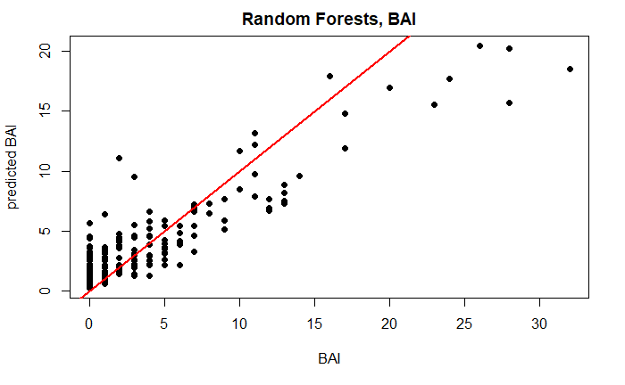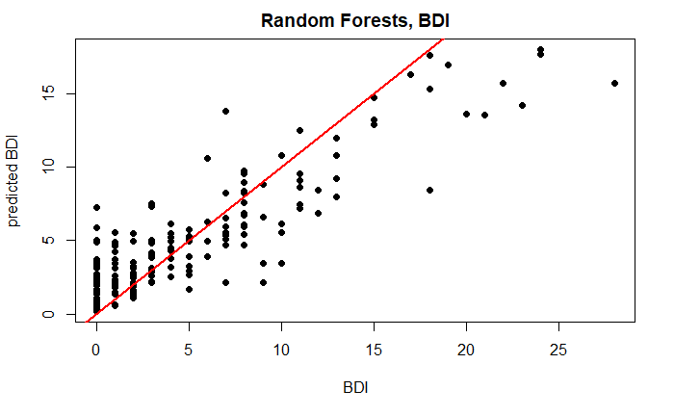
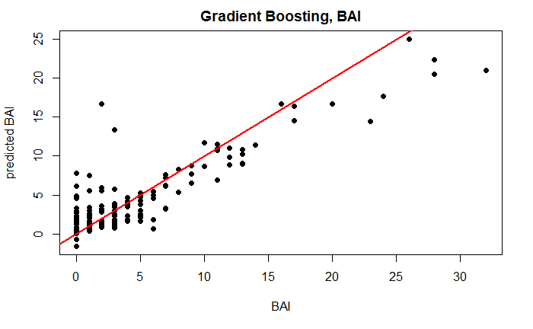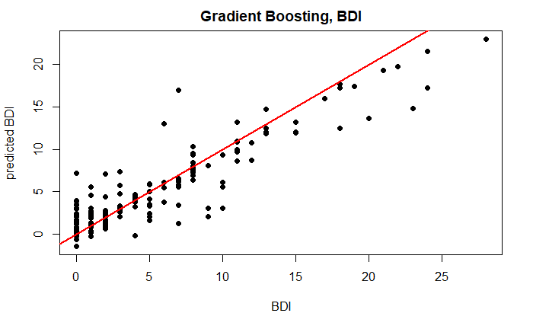
One of the main drawbacks of ensemble methods such as Random Forests and Stochastic Gradient Boosting is that they are very prone to overfitting: they do well on training data, but are not so flexible for making predictions on unseen samples. Although we have seen improvements in the Random Forests and Stochastic Gradient Boosting methods, they are just training errors. In order for us to conclude that the models can be used, we need to split the data into training set and testing set, then check whether the prediction on the new data can be as good as the training data. From the tables below we can see that the testing mean absolute errors are much higher than the training mean absolute errors. This indicates that Random Forests and Stochastic Gradient Boosting methods are trying too hard to fit on the training data and do not generalize well on new data points, which makes future predictions very hard.
Random Forests | BAI | BDI
Training MAE | 1.99 | 1.64
Testing MAE | 3.47 | 5.20

Gradient Boosting | BAI | BDI
Training MAE | 1.74 | 1.69
Testing MAE | 2.50 | 4.13
To sum it up, it is possible to model the emotional disturbance from tinnitus based on BDI, BAI and emotion subscales using techniques like Random Forests and Gradient Boosting, but these models can be highly overfitting and are not useful to predict new observations. In addition, neither BAI score nor BDI score is good enough to be a response variable for this regression task, possibly due to the subjective nature of the self-report questionnaire.
Part 2 Classification
Our goal in this section is to model the emotional disturbance based on the emotional subscales from each questionnaire. The poor fit from our previous regression analysis inspired us to try out classification methods. This is because we only need to identify if the patients are emotionally distrubed or not, and we do not need to consider any other trends or properties embedded in our dataset.
In the classification methods, we started off from a very simple model. To build this model, we used the median in BAI and BDI to be the benchmark to classify patients. Anyone who has a total score more than the benchmark will be classified as 0 (being emotionally distrubed), otherwise, 1 (not being emotionally distrubed). This is because BAI and BDI are extremely skewed to the right. In order to generate a balanced response variable, median is the easiest. We then fitted logistic regressions on classified BAI and BDI separately based on the three emotional subscales. However, this did not give us a good result. To make a more robust response, we combined BAI and BDI together, which means anyone who is being classified as emotionally distruebed in either BAI or BDI will be identified as emotionally disturbed. The combination of BAI and BDI sort of improved our classification sensitivity, but the overall accuracy is still low, which is only a bit above the no information rate (NIR). The results from the simplest model are shown below.
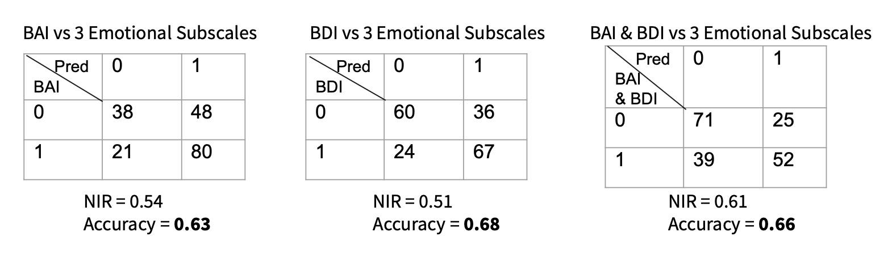
In order to improve our model, what we did next was to upgrade our predictors. Based on our results from milestone 1, TFI was basically the best questionnaire, which was not complex and performed the best. Using only three emotional subscales to fit a classification model might not be sufficient in power to explain the classification result from BAI and BDI. So we added any other subscales in TFI into our model and refitted the three models again. The results are printed out below.
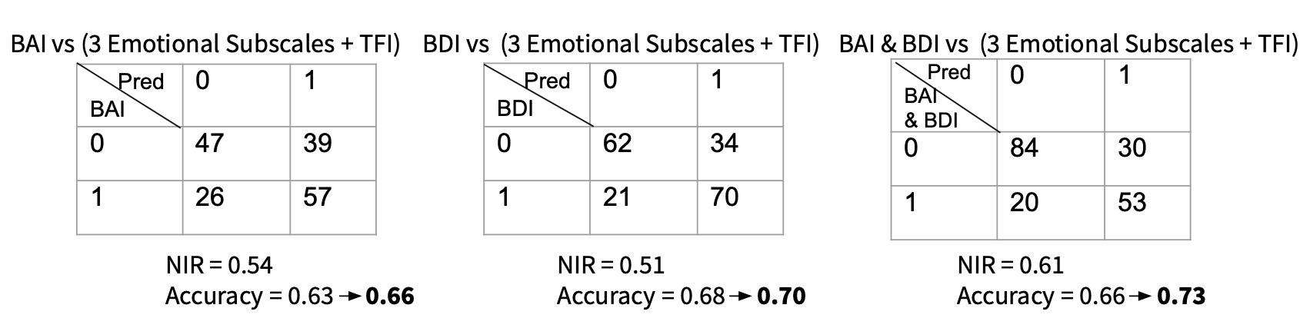
However, adding extra predictors from TFI did not give good results either. We can see that even if we have a little increase in the prediction accuracy, this increase was too small to offset the expense of adding extra predictors. However, To exhaust every possibility that can improve our prediction accuracy, we would still keep a model with those extra predictors in our future analysis.
Considering we used median as the cut-off and ignored the true nature of BAI and BDI in our previous classification models. We then took a look back at these two questionnaires to see how scientists decided the benchmark. However, the scientific benchmark is way higher than the median, which means there are very few people being classified as “emotionally disturbed”, even after we combined the results from BAI and BDI. We call this data unbalanced. In order to fix this problem, we firstly combined the newly classified BAI and BDI together, and then implemented up-sampling methods, SMOTE. Up-sampling methods are helpful in fixing skewed data by generating new data based on existing observations. SOMTE is similar to K-means clustering. It will cluster observations first, then it will randomly generate new observations based on those clusters. After up-sampling by SMOTE, we then fitted a logistic regression model on our balanced predictors. This yielded a good result, which is shown below.
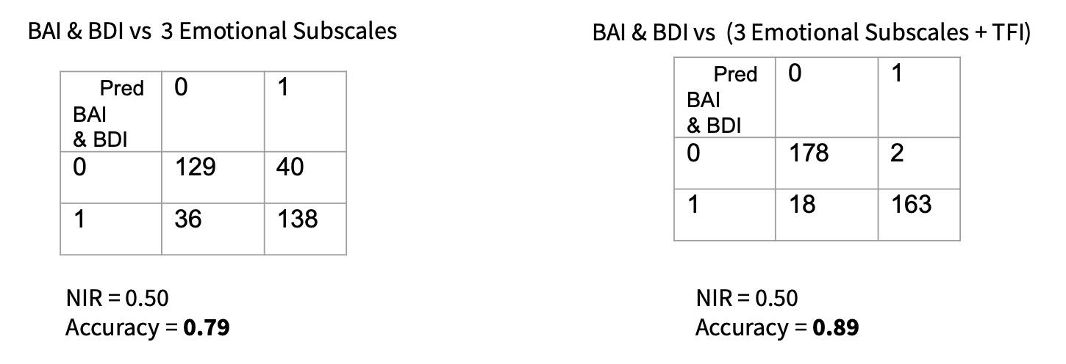

We can see that after up-sampling, the dataset is balanced and the NIR is 0.5. The accuracy is high, which is around 0.8 for both models. However, we cannot jump into any conclusions now. This is because for our previous analysis in this part, we did fitting and testing on the same dataset, which is potentially to cause an overestimation on the classification accuracy. A cross validation is capable of fixing this problem. However, we cannot do it here. It is because many of the observations are fabricated by SMOTE, there is no meaning if we test the model on the data that is not real. The only way that we can fix this problem is to collect more data, which is potentially to include more observations that are emotionally disturbed into our dataset. Even if there is a problem, classification still has a promising future on modeling the emotional disturbance.

Conclusions
We present the following results from our analysis.
Milestone 1 - Choosing the Best Survey
- We recommend TFI as the primary tool to measure Tinnitus. To further improve validity you could remove questions Q4 and Q22.
- TPFQ is also a good candidate. It’s validity is slightly worse, but this is due largely to having fewer subscales. TPFQ validity is improved significantly by removing questions Q3, Q5, and Q8.
- THI has poor fit relative to the other surveys.

Milestone 2 - Influence of Tinnitus onto Emotion
- Neither BAI nor BDI is good enough to be a response variable for regression, possibly due to the subjective nature of the self-report questionnaire.
- Ensemble methods for regression overfit and offer poor predictions.
- Using median as a cutoff, classification on BAI and BDI performs poorly with a simple logistic model.
- After up-sampling, classification fits well. This allows us to use the scientific cutoffs of each questionnaire even though our data is unbalanced.

