Citations
- (Samejima 1997) https://link.springer.com/chapter/10.1007/978-1-4757-2691-6_5
- (Chalmers 2012) https://www.researchgate.net/publication/228534363_Mirt_A_Multidimensional_Item_Response_Theory_Package_for_the_R_Environment
- Joreskog (1994). KARL G. JORESKOG STRUCTURAL EQUATION MODELINGWITH ORDINAL VARIABLES IMS Lecture Notes - Monograph Series (1994) Volume 24
- Igolkina (2020) Anna A. Igolkina & Georgy Meshcheryakov (2020) semopy: A Python Package for Structural Equation Modeling, Structural Equation Modeling: A Multidisciplinary Journal, 27:6,952-963, DOI: 10.1080/10705511.2019.1704289

Appendix

THI Questions
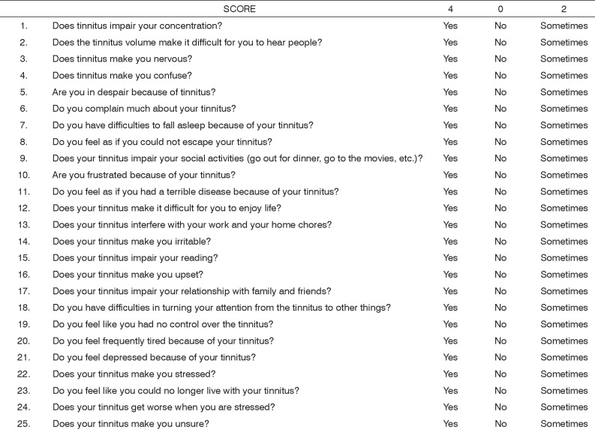

TFI Questions
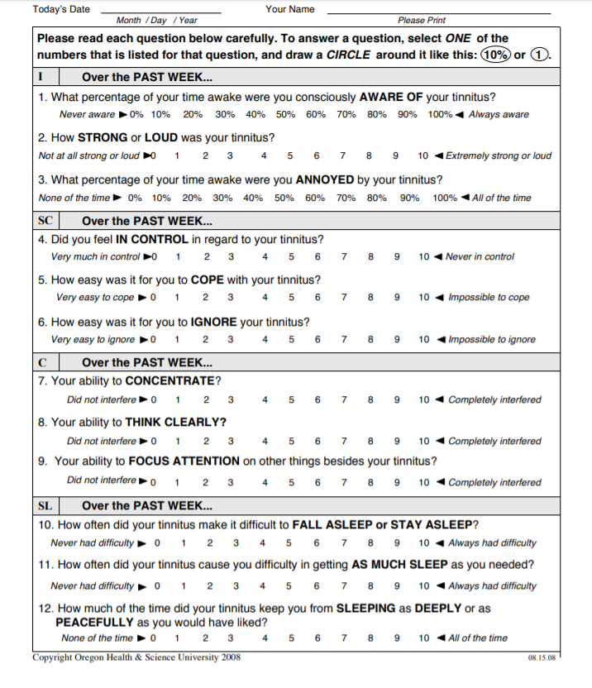
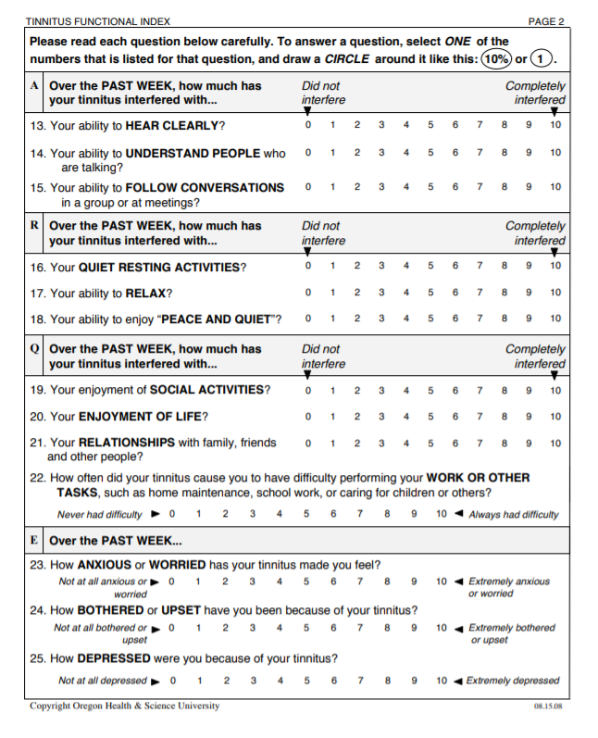

TPFQ Questions
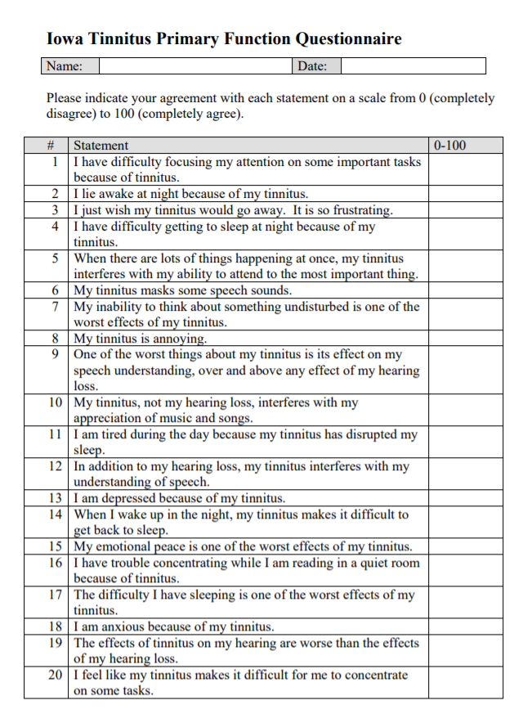

Questions with subscales:
TFI
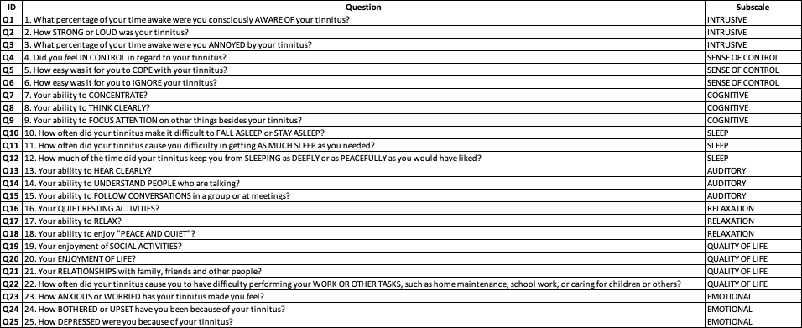

THI:
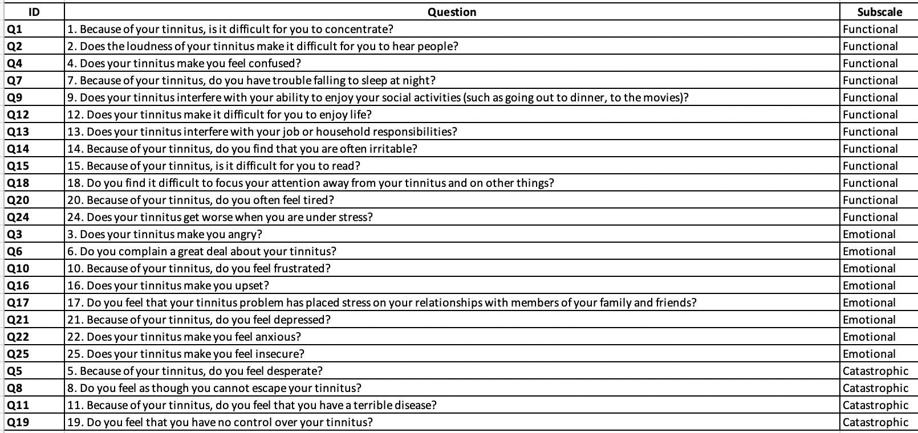

TPFQ
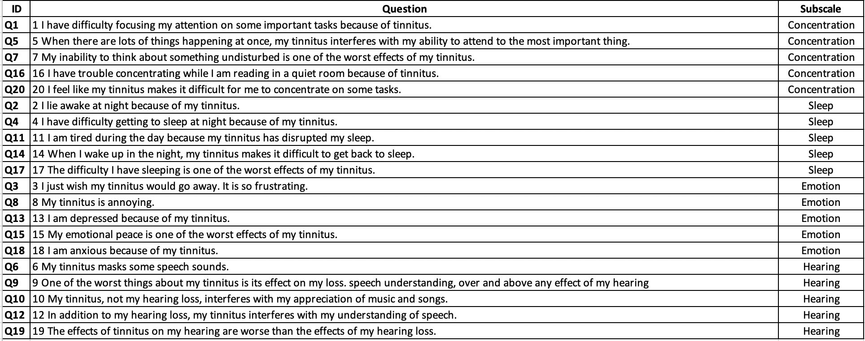

EDA
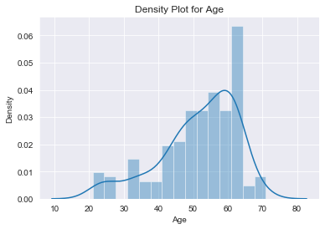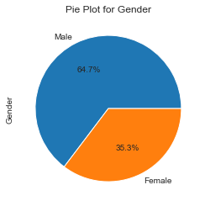
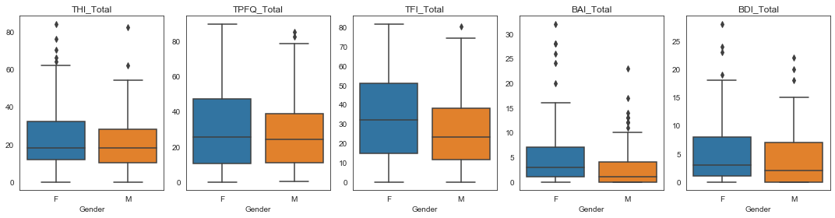
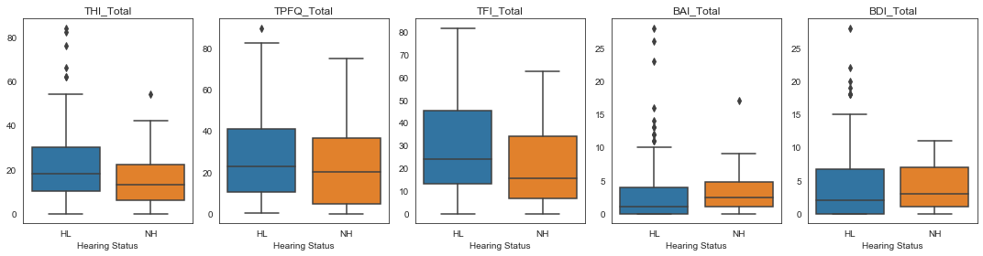
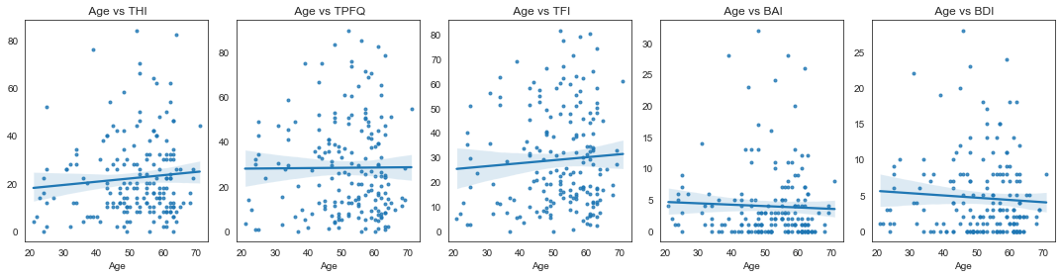

THI 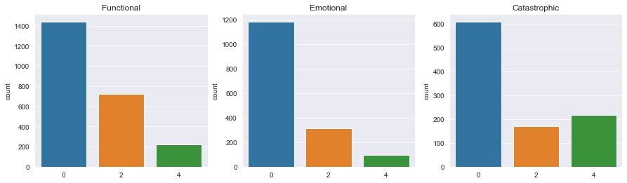
TFI
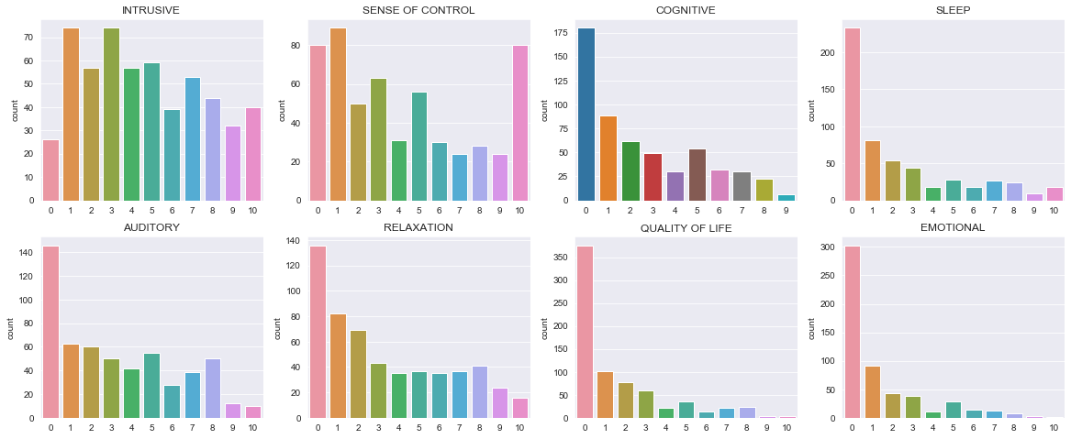
TPFQ
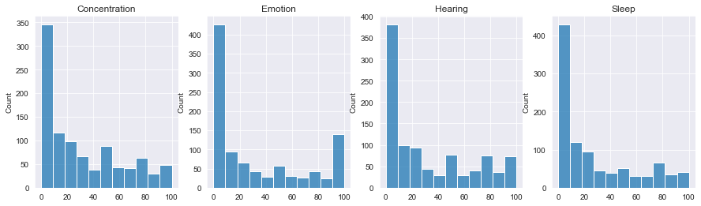

Within Questionnaire Subscale Correlations
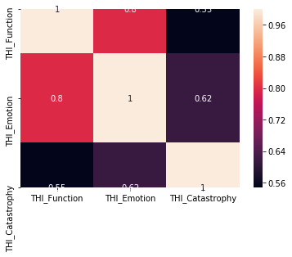
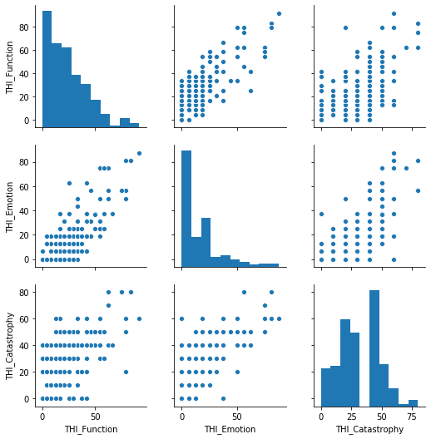

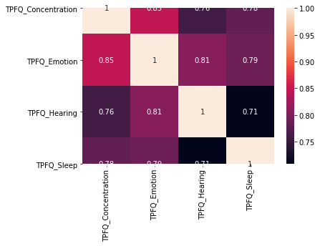
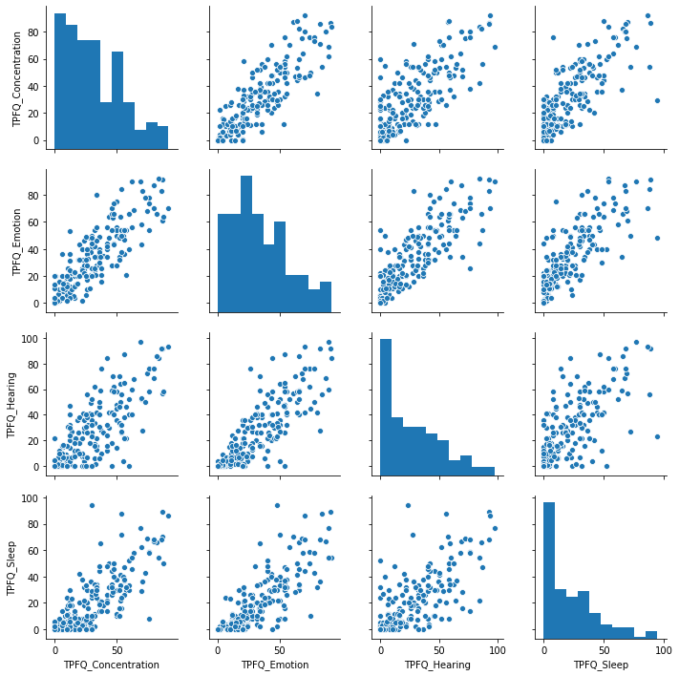

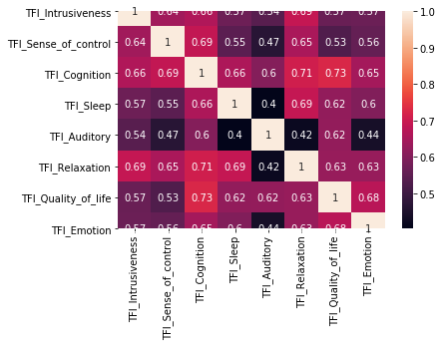
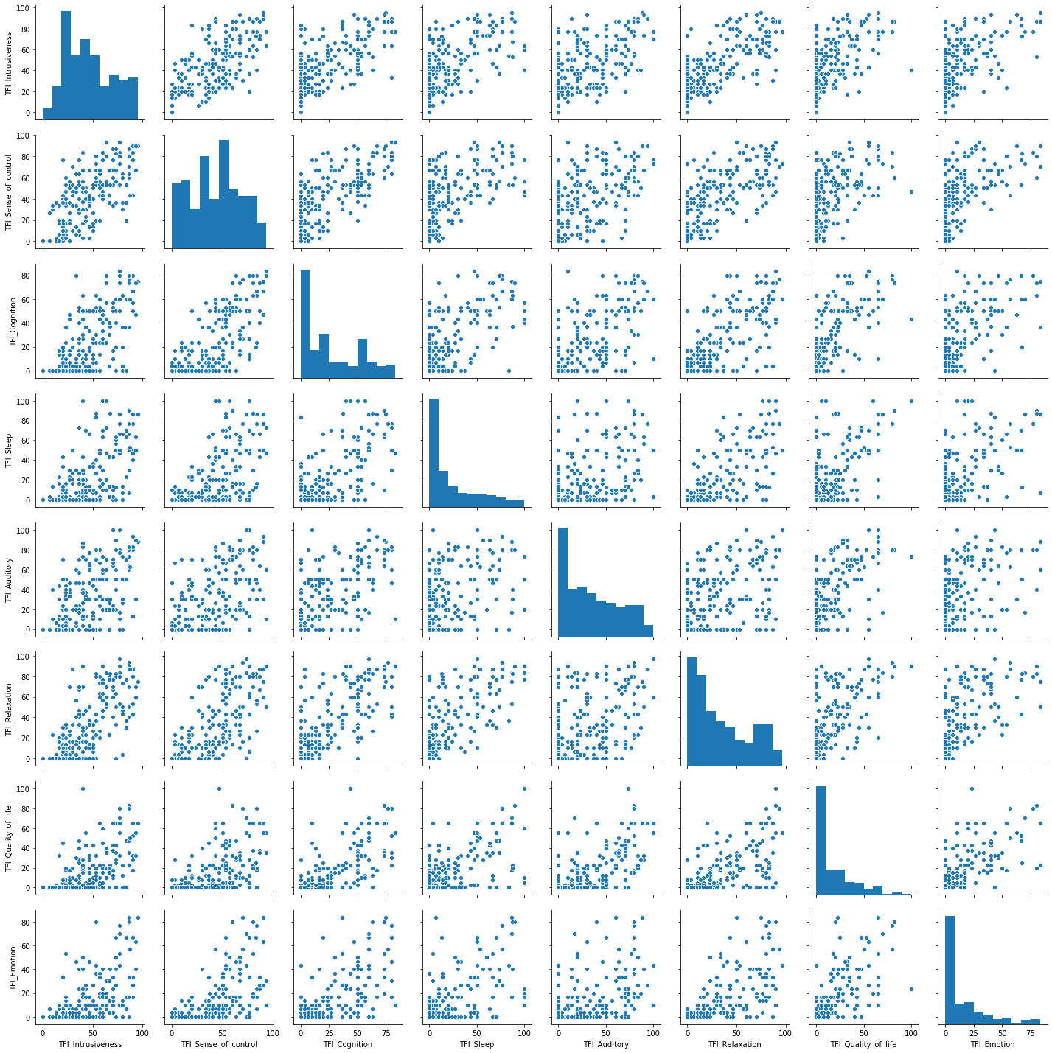

Quality Measures (#XMeasures)
TK fill in for Milestone 1 Internal validity

External Validity (#external)
Below we fit individual questions of one survey with the subscales of another survey using a proportional odds model. In each case the responses are broken out into three categories corresponding to: 0, 1-50, 51-100.
Input  Subscales | Output | Output  Questions | MSE | Baseline MSE  Intercept Only | AIC
TFI | THI | THI_Q1 | 1.30 | 1.90 | 258.1
TPFQ | THI | THI_Q1 | 1.32 | 1.90 | 266.1
TFI | THI | THI_Q2 | 1.45 | 2.39 | 278.5
TPFQ | THI | THI_Q2 | 1.59 | 2.39 | 288.3
TFI | THI | THI_Q3 | 1.39 | 1.67 | 233.1
TPFQ | THI | THI_Q3 | 1.83 | 1.67 | 239.3
TFI | THI | THI_Q4 | 0.69 | 0.85 | 150.3
TPFQ | THI | THI_Q4 | 0.76 | 0.85 | 146.9
TFI | THI | THI_Q5 | 0.42 | 0.42 | 120.1
TPFQ | THI | THI_Q5 | 0.40 | 0.42 | 98.3
TFI | THI | THI_Q6 | 1.23 | 1.54 | 231.0
TPFQ | THI | THI_Q6 | 1.56 | 1.54 | 245.0
TFI | THI | THI_Q7 | 1.27 | 2.12 | 262.1
TPFQ | THI | THI_Q7 | 1.18 | 2.12 | 237.2
TFI | THI | THI_Q8 | 2.68 | 2.77 | 346.5
TPFQ | THI | THI_Q8 | 2.68 | 2.77 | 341.6
TFI | THI | THI_Q9 | 1.41 | 1.80 | 239.2
TPFQ | THI | THI_Q9 | 1.34 | 1.80 | 252.2
TFI | THI | THI_Q10 | 1.47 | 1.98 | 276.9
TPFQ | THI | THI_Q10 | 1.23 | 1.98 | 258.1
TFI | THI | THI_Q11 | 0.47 | 0.51 | 102.3
TPFQ | THI | THI_Q11 | 0.49 | 0.51 | 96.2
TFI | THI | THI_Q12 | 0.83 | 1.27 | 165.7
TPFQ | THI | THI_Q12 | 0.67 | 1.27 | 173.1
TFI | THI | THI_Q13 | 0.69 | 1.31 | 165.1
TPFQ | THI | THI_Q13 | 0.89 | 1.31 | 184.2
TFI | THI | THI_Q14 | 1.01 | 1.36 | 204.2
TPFQ | THI | THI_Q14 | 1.07 | 1.36 | 203.8
TFI | THI | THI_Q15 | 1.21 | 1.49 | 252.6
TPFQ | THI | THI_Q15 | 1.14 | 1.49 | 236.2
TFI | THI | THI_Q16 | 0.96 | 1.45 | 192.9
TPFQ | THI | THI_Q16 | 1.45 | 1.45 | 214.5
TFI | THI | THI_Q17 | 1.05 | 1.49 | 186.9
TPFQ | THI | THI_Q17 | 1.16 | 1.49 | 196.6
TFI | THI | THI_Q18 | 1.01 | 1.27 | 219.6
TPFQ | THI | THI_Q18 | 0.98 | 1.27 | 201.2
TFI | THI | THI_Q19 | 2.95 | 2.39 | 326.4
TPFQ | THI | THI_Q19 | 3.24 | 2.39 | 332.7
TFI | THI | THI_Q20 | 1.05 | 1.54 | 210.5
TPFQ | THI | THI_Q20 | 0.96 | 1.54 | 194.6
TFI | THI | THI_Q21 | 0.60 | 0.83 | 109.8
TPFQ | THI | THI_Q21 | 0.74 | 0.83 | 114.4
TFI | THI | THI_Q22 | 0.78 | 1.32 | 179.3
TPFQ | THI | THI_Q22 | 0.92 | 1.32 | 173.8
TFI | THI | THI_Q23 | 0.49 | 0.60 | 113.7
TPFQ | THI | THI_Q23 | 0.54 | 0.60 | 115.5
TFI | THI | THI_Q24 | 3.89 | 2.47 | 352.6
TPFQ | THI | THI_Q24 | 3.89 | 2.47 | 344.2
TFI | THI | THI_Q25 | 0.51 | 0.60 | 107.0
TPFQ | THI | THI_Q25 | 0.58 | 0.60 | 118.4
THI | TFI | TFI_Q1.... | 0.35 | 0.50 | 264.5
TPFQ | TFI | TFI_Q1.... | 0.34 | 0.50 | 256.1
THI | TFI | TFI_Q2
TPFQ | TFI | TFI_Q2
THI | TFI | TFI_Q3.... | 0.25 | 0.32 | 220.4062
TPFQ | TFI | TFI_Q3.... | 0.25 | 0.32 | 206.4081
THI | TFI | TFI_Q4 | 0.53 | 0.67 | 314.7928
TPFQ | TFI | TFI_Q4 | 0.55 | 0.67 | 331.1093
THI | TFI | TFI_Q5 | 0.31 | 0.35 | 255.7714
TPFQ | TFI | TFI_Q5 | 0.27 | 0.35 | 248.377
THI | TFI | TFI_Q6 | 0.34 | 0.41 | 278.5003
TPFQ | TFI | TFI_Q6 | 0.30 | 0.41 | 255.21
THI | TFI | TFI_Q7 | 0.31 | 0.46 | 257.6416
TPFQ | TFI | TFI_Q7 | 0.27 | 0.46 | 234.3514
THI | TFI | TFI_Q8 | 0.32 | 0.55 | 253.8266
TPFQ | TFI | TFI_Q8 | 0.29 | 0.55 | 239.1421
THI | TFI | TFI_Q9 | 0.33 | 0.47 | 263.564
TPFQ | TFI | TFI_Q9 | 0.27 | 0.47 | 229.067
THI | TFI | TFI_Q10 | 0.46 | 0.58 | 328.9656
TPFQ | TFI | TFI_Q10 | 0.27 | 0.58 | 222.3961
THI | TFI | TFI_Q11 | 0.38 | 0.59 | 278.5193
TPFQ | TFI | TFI_Q11 | 0.21 | 0.59 | 191.8528
THI | TFI | TFI_Q12 | 0.41 | 0.60 | 293.809
TPFQ | TFI | TFI_Q12 | 0.28 | 0.60 | 231.8441
THI | TFI | TFI_Q13 | 0.40 | 0.48 | 307.0644
TPFQ | TFI | TFI_Q13 | 0.31 | 0.48 | 257.9188
THI | TFI | TFI_Q14 | 0.45 | 0.53 | 312.0856
TPFQ | TFI | TFI_Q14 | 0.35 | 0.53 | 273.4687
THI | TFI | TFI_Q15 | 0.43 | 0.54 | 317.2032
TPFQ | TFI | TFI_Q15 | 0.34 | 0.54 | 273.1275
THI | TFI | TFI_Q16 | 0.38 | 0.53 | 302.0177
TPFQ | TFI | TFI_Q16 | 0.32 | 0.53 | 261.7775
THI | TFI | TFI_Q17 | 0.37 | 0.54 | 284.5789
TPFQ | TFI | TFI_Q17 | 0.31 | 0.54 | 255.5069
THI | TFI | TFI_Q18 | 0.34 | 0.50 | 292.4317
TPFQ | TFI | TFI_Q18 | 0.32 | 0.50 | 259.8541
THI | TFI | TFI_Q19 | 0.36 | 0.62 | 262.5271
TPFQ | TFI | TFI_Q19 | 0.29 | 0.62 | 245.3333
THI | TFI | TFI_Q20 | 0.31 | 0.59 | 240.9554
TPFQ | TFI | TFI_Q20 | 0.30 | 0.59 | 230.3639
THI | TFI | TFI_Q21 | 0.35 | 0.61 | 265.7393
TPFQ | TFI | TFI_Q21 | 0.33 | 0.61 | 253.1778
THI | TFI | TFI_Q22 | 0.30 | 0.59 | 228.2657
TPFQ | TFI | TFI_Q22 | 0.28 | 0.59 | 238.2014
THI | TFI | TFI_Q23 | 0.27 | 0.61 | 220.7706
TPFQ | TFI | TFI_Q23 | 0.27 | 0.61 | 224.8454
THI | TFI | TFI_Q24 | 0.35 | 0.47 | 257.1141
TPFQ | TFI | TFI_Q24 | 0.35 | 0.47 | 262.9568
THI | TFI | TFI_Q25 | 0.28 | 0.44 | 202.3497
TPFQ | TFI | TFI_Q25 | 0.25 | 0.44 | 190.6957
THI | TPFQ | TPFQ_Q1 | 0.28 | 0.47 | 259.5626
TFI | TPFQ | TPFQ_Q1 | 0.22 | 0.47 | 209.8074
THI | TPFQ | TPFQ_Q2 | 0.40 | 0.51 | 309.5499
TFI | TPFQ | TPFQ_Q2 | 0.22 | 0.51 | 226.4124
THI | TPFQ | TPFQ_Q3 | 0.30 | 0.55 | 262.2938
TFI | TPFQ | TPFQ_Q3
THI | TPFQ | TPFQ_Q4 | 0.39 | 0.54 | 318.4813
TFI | TPFQ | TPFQ_Q4 | 0.27 | 0.54 | 241.5564
THI | TPFQ | TPFQ_Q5 | 0.37 | 0.56 | 274.062
TFI | TPFQ | TPFQ_Q5 | 0.27 | 0.56 | 239.2041
THI | TPFQ | TPFQ_Q6 | 0.73 | 0.68 | 337.5809
TFI | TPFQ | TPFQ_Q6 | 0.41 | 0.68 | 280.1652
THI | TPFQ | TPFQ_Q7 | 0.46 | 0.57 | 315.7199
TFI | TPFQ | TPFQ_Q7 | 0.43 | 0.57 | 310.6259
THI | TPFQ | TPFQ_Q8
TFI | TPFQ | TPFQ_Q8
THI | TPFQ | TPFQ_Q9 | 0.50 | 0.63 | 317.6509
TFI | TPFQ | TPFQ_Q9 | 0.34 | 0.63 | 256.437
THI | TPFQ | TPFQ_Q10 | 0.46 | 0.62 | 311.825
TFI | TPFQ | TPFQ_Q10 | 0.38 | 0.62 | 282.5465
THI | TPFQ | TPFQ_Q11 | 0.36 | 0.62 | 269.0303
TFI | TPFQ | TPFQ_Q11 | 0.23 | 0.62 | 219.9973
THI | TPFQ | TPFQ_Q12 | 0.53 | 0.61 | 325.3018
TFI | TPFQ | TPFQ_Q12 | 0.26 | 0.61 | 245.1357
THI | TPFQ | TPFQ_Q13 | 0.27 | 0.34 | 198.8964
TFI | TPFQ | TPFQ_Q13 | 0.22 | 0.34 | 195.9135
THI | TPFQ | TPFQ_Q14 | 0.43 | 0.59 | 300.8011
TFI | TPFQ | TPFQ_Q14 | 0.28 | 0.59 | 261.9814
THI | TPFQ | TPFQ_Q15 | 0.34 | 0.71 | 258.6999
TFI | TPFQ | TPFQ_Q15 | 0.38 | 0.71 | 275.0589
THI | TPFQ | TPFQ_Q16 | 0.41 | 0.55 | 310.6283
TFI | TPFQ | TPFQ_Q16 | 0.37 | 0.55 | 287.3266
THI | TPFQ | TPFQ_Q17 | 0.64 | 0.67 | 322.5982
TFI | TPFQ | TPFQ_Q17 | 0.34 | 0.67 | 260.9343
THI | TPFQ | TPFQ_Q18 | 0.31 | 0.50 | 204.4669
TFI | TPFQ | TPFQ_Q18 | 0.22 | 0.50 | 208.6798
THI | TPFQ | TPFQ_Q19 | 0.55 | 0.66 | 320.5109
TFI | TPFQ | TPFQ_Q19 | 0.53 | 0.66 | 314.2372
THI | TPFQ | TPFQ_Q20 | 0.29 | 0.48 | 261.0669
TFI | TPFQ | TPFQ_Q20 | 0.27 | 0.48 | 238.3988

Emotion Scores Across Questionnaires

# BAI Q19 Faint / lightheaded
Estimate Std. Error z value Pr(>|z|)
(Intercept) -8.97215 3.76632 -2.382 0.0172 *
xdf[nafilter, ]THI_E_Emotional 0.52070 0.24412 2.133 0.0329 *
xdf[nafilter, ]THI_C_Catastrophic -0.63202 0.42736 -1.479 0.1392
xdf[nafilter, ]TFI_E_EMOTIONAL -0.11114 0.18073 -0.615 0.5386
xdf[nafilter, ]TPFQ_E_Emotion 0.01309 0.01363 0.960 0.3369
---
Estimate Std. Error z value Pr(>|z|)
(Intercept) -7.54151 2.09383 -3.602 0.000316 ***
THI_E_Emotional 0.27138 0.09608 2.825 0.004734 **

# BAI Q18: Appetite
Estimate Std. Error z value Pr(>|z|)
(Intercept) -2.303166 0.499689 -4.609 4.04e-06 ***
xdf[nafilter, ]THI_E_Emotional 0.043089 0.047045 0.916 0.360
xdf[nafilter, ]THI_C_Catastrophic 0.096332 0.079481 1.212 0.226
xdf[nafilter, ]TFI_E_EMOTIONAL 0.077719 0.050793 1.530 0.126
xdf[nafilter, ]TPFQ_E_Emotion -0.001882 0.003271 -0.575 0.565
---
Estimate Std. Error z value Pr(>|z|)
(Intercept) -1.90434 0.26186 -7.272 3.53e-13 ***
TFI_E_EMOTIONAL 0.10980 0.03024 3.631 0.000282 ***

TFI

# BAI Q19 Faint / lightheaded
Estimate Std. Error z value Pr(>|z|)
(Intercept) -250.338 78048.379 -0.003 0.997
xdf[nafilter, ]TFI_I_INTRUSIVE -8.852 7199.448 -0.001 0.999
xdf[nafilter, ]TFI_SC_SENSEOFCONTROL 2.110 9640.982 0.000 1.000
xdf[nafilter, ]TFI_C_COGNITIVE 2.947 12093.300 0.000 1.000
xdf[nafilter, ]TFI_SL_SLEEP -3.042 5948.178 -0.001 1.000
xdf[nafilter, ]TFI_A_AUDITORY 6.602 5396.141 0.001 0.999
xdf[nafilter, ]TFI_R_RELAXATION 3.938 3297.256 0.001 0.999
xdf[nafilter, ]TFI_Q_QUALITYOFLIFE 3.230 2988.402 0.001 0.999
xdf[nafilter, ]TFI_E_EMOTIONAL 2.782 9761.085 0.000 1.000
---
Estimate Std. Error z value Pr(>|z|)
(Intercept) -9.5469 3.2983 -2.894 0.0038 **
TFI_Q_QUALITYOFLIFE 0.2775 0.1143 2.428 0.0152 *

# BAI Q11 Feeling of choking
Estimate Std. Error z value Pr(>|z|)
(Intercept) -57.816 6964.487 -0.008 0.993
xdf[nafilter, ]TFI_I_INTRUSIVE -1.757 564.399 -0.003 0.998
xdf[nafilter, ]TFI_SC_SENSEOFCONTROL -82.061 6062.447 -0.014 0.989
xdf[nafilter, ]TFI_C_COGNITIVE 6.232 1582.589 0.004 0.997
xdf[nafilter, ]TFI_SL_SLEEP 16.933 1304.401 0.013 0.990
xdf[nafilter, ]TFI_A_AUDITORY -1.405 1299.535 -0.001 0.999
xdf[nafilter, ]TFI_R_RELAXATION 17.313 1357.075 0.013 0.990
xdf[nafilter, ]TFI_Q_QUALITYOFLIFE 1.986 795.316 0.002 0.998
xdf[nafilter, ]TFI_E_EMOTIONAL 20.281 1577.301 0.013 0.990
---

Authors

 | Primary Author | Editor
Background | Zhehui | Shuyu
EDA | Zhehui | Shuyu
Methods | Mix | Yumeng
Milestone 1
EFA | Yumeng | Jesse
CFA | Jesse | Yumeng
Milestone 2
Regression | Shuyu | Shiwei
Classification | Shiwei | Zhehui
Final Conclusion | Mix | Mix

