CASE STUDIES – MEGADOCK, a bioinformatics application

**High-performance protein-protein docking on Azure Cloud**

*Powerful calculation of huge amount of protein-protein interactions by using MEGADOCK 4.0 on Azure HPC.*

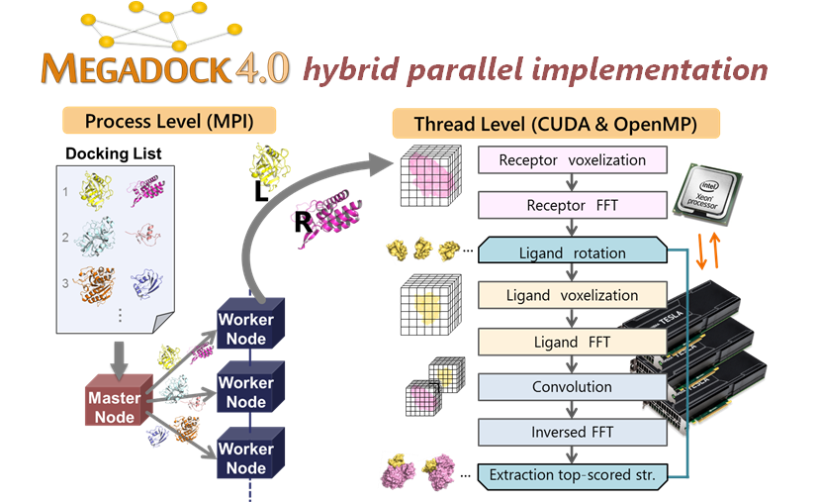

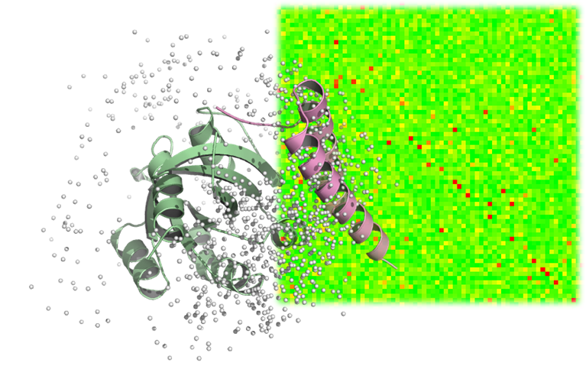

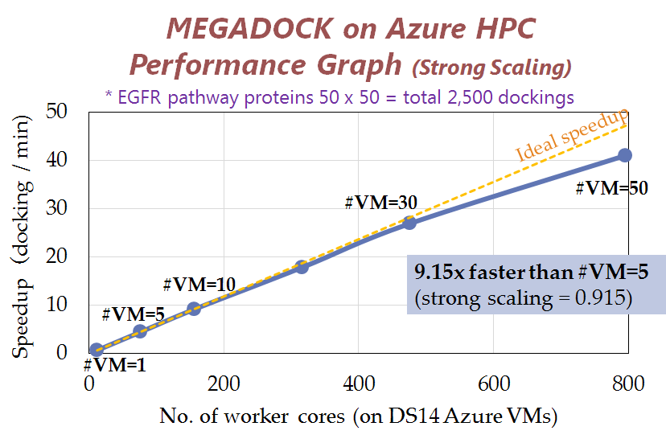

The elucidation of protein-protein interaction (PPI) networks is important for understanding cellular function and accelerating structure-based drug design. However, computational approach for exhaustive PPI screening has long been a grand challenge.

Akiyama laboratory, Tokyo Institute of Technology, Japan developed exhaustive structure-based protein-protein interaction prediction software named MEGADOCK 4.0 which conducts tertiary structural docking based on shape complementarity and physicochemical properties in a massively parallel fashion. MEGADOCK shows powerful, scalable performance up to 600,000 CPU cores on the world-leading supercomputers.

The Tokyo Tech group showed that MEGADOCK 4.0 performed on 50 computing node (DS14 instances) on Microsoft Azure, totaling 600 cores and 5.5 TByte RAMs, with >90% excellent strong scaling. Azure HPC provides stable and secure computing environment for biologists and pharmaceutical scientists working on PPIs.

CASE STUDIES – GHOST-MP, a bioinformatics application

**GHOST-MP on Azure Cloud accelerates whole genome shotgun metagenomic analysis**

*Microbial flora on metagenomic samples can be analyzed by using GHOST-MP on Azure HPC.*

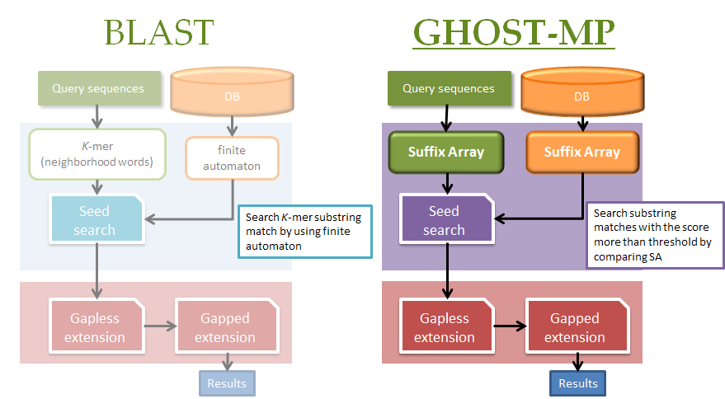

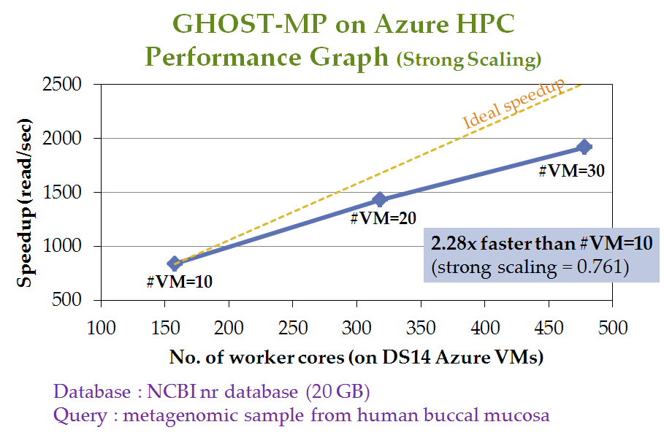

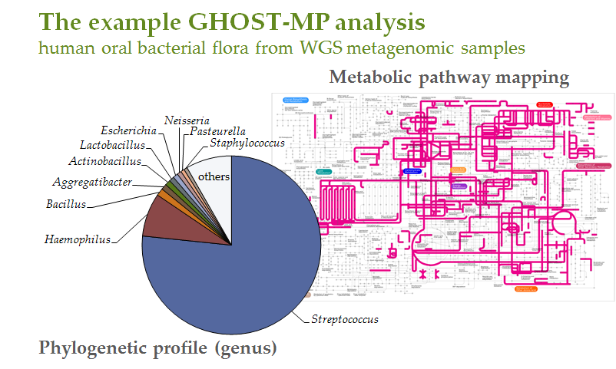

Metagenomics is the study of the genomes of uncultured microbes obtained directly from microbial flora in their natural habitats. Such analyses have recently become more popular and important as the throughput of DNA sequencers has increased. Especially, whole-genome shotgun sequencing, carried out using next-generation sequencing technologies, produces huge amounts of metagenomic data which enables us to uncover an abundance of orthologous groups, i.e., the distribution of gene/protein functions, in environmental samples.

GHOST-MP is a massively parallel sequence homology search tool developed by Akiyama laboratory, Tokyo Institute of Technology, Japan, for functional annotation of metagenome sequences. Although BLAST is the golden standard homology search tool, GHOST-MP is more than 160 times faster than BLAST with single CPU core and has sufficient search sensitivity for metagenome analysis. The Tokyo Tech group runs GHOST-MP on 30 computing node (DS14 instances) in Microsoft Azure, totaling 480 cores and 3.3 TByte RAMs. Azure HPC enables efficient metagenome analysis of microbial metagenomic samples and unravels the unknown functions of microbial flora.