@Configuration
public class SecurityConfig extends WebSecurityConfigurerAdapter {

@Override
protected void configure(AuthenticationManagerBuilder auth) throws Exception {
auth.inMemoryAuthentication().withUser("user").password("password").roles("USER").and().withUser("admin")
.password("admin").roles("USER", "ADMIN");
}

@Override
protected void configure(HttpSecurity http) throws Exception {
http.authorizeRequests().anyRequest().authenticated()
// .anonymous()
.and().formLogin();
}
}

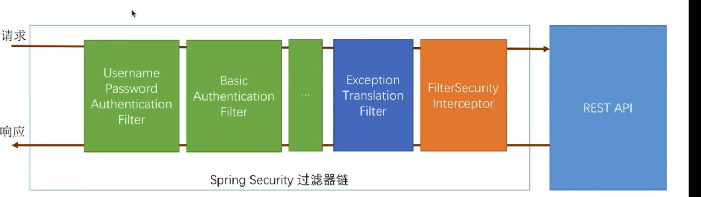

实现UserDetailsServices接口

返回UserDetails
@Bean
PasswordEncoder

自定义登录页面及返回数据 html还是json
@Configuration
public class SecurityConfig extends WebSecurityConfigurerAdapter {
@Bean
public PasswordEncoder passwordEncoder() {
return new BCryptPasswordEncoder();
}

// @Override
// protected void configure(AuthenticationManagerBuilder auth) throws Exception {
// auth.inMemoryAuthentication().withUser("user").password("password").roles("USER").and().withUser("admin")
// .password("admin").roles("USER", "ADMIN");
// }

@Override
protected void configure(HttpSecurity http) throws Exception {
http.formLogin().loginPage("/toLogin").loginProcessingUrl("/loginProcessingUrl").and().authorizeRequests()
.antMatchers("/toLogin", "/signIn.html").permitAll().anyRequest().authenticated()
// .anonymous()
.and().csrf().disable();
}
@RestController
public class LoginController {
private RequestCache requestCache = new HttpSessionRequestCache();
private RedirectStrategy redirectStrategy = new DefaultRedirectStrategy();
private Logger logger = LoggerFactory.getLogger(LoginController.class);

@RequestMapping("/toLogin")
public String toLogin(HttpServletRequest request, HttpServletResponse response) throws IOException {
SavedRequest savedRequest = requestCache.getRequest(request, response);

if (savedRequest != null) {
String redirectUrl = savedRequest.getRedirectUrl();
logger.info("引发跳转的请求url:" + redirectUrl);
if (StringUtils.endsWithIgnoreCase(redirectUrl, ".html")) {
redirectStrategy.sendRedirect(request, response, "/signIn.html");
}
}
return "not authenticated";
}

}
@Component
public class MyUserDetailsService implements UserDetailsService {
@Autowired
private PasswordEncoder passwordEncoder;

@Override
public UserDetails loadUserByUsername(String username) throws UsernameNotFoundException {
String encode = passwordEncoder.encode("123456");
UserDetails userDetails = new User(username, encode, true, true, true, true,
AuthorityUtils.commaSeparatedStringToAuthorityList("admin,teacher"));
return userDetails;
<form action="/loginProcessingUrl" method="post">
<table>
<tr>
<td>用户名:</td>
<td><input type="text" name="username"></td>
</tr>
<tr>
<td>密码:</td>
<td><input type="password" name="password"></td>
</tr>
<!-- <tr>
<td>图形验证码:</td>
<td>
<input type="text" name="imageCode">
<img src="/code/image?width=200">
</td>
</tr>
<tr>
<td colspan='2'><input name="remember-me" type="checkbox" value="true" />记住我</td>
</tr> -->
<tr>
<td colspan="2"><button type="submit">登录</button></td>
</tr>
</table>
</form>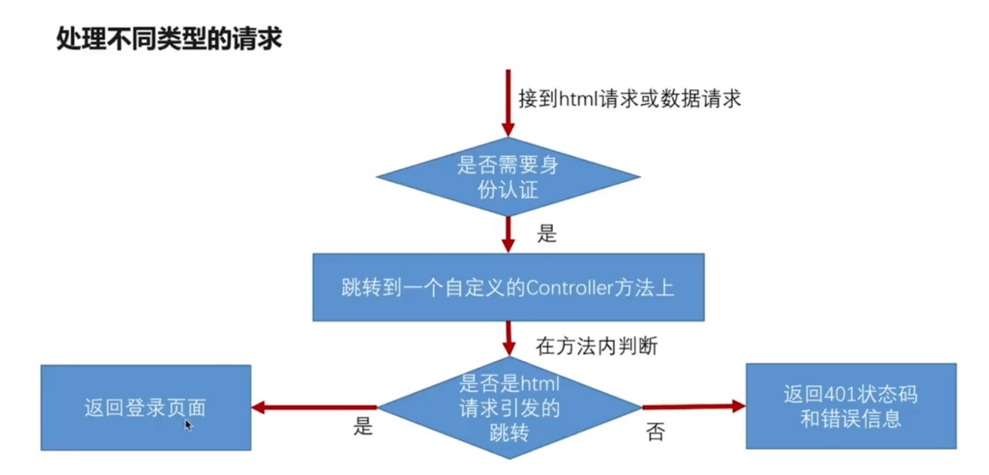

自定义登录成功后的处理逻辑

自定义登录失败后的处理逻辑

@Component
public class MyAuthenticationSuccessHanlder extends SavedRequestAwareAuthenticationSuccessHandler{//implements AuthenticationSuccessHandler {
@Autowired
private ObjectMapper objectMapper;

@Override
public void onAuthenticationSuccess(HttpServletRequest request, HttpServletResponse response,
Authentication authentication) throws IOException, ServletException {

response.setCharacterEncoding("UTF-8");
response.setHeader("Content-Type", "application/json;charset=UTF-8");
PrintWriter out = response.getWriter();
// objectMapper.setSerializerProvider(new CustomSerializerProvider());
out.println(objectMapper.writeValueAsString(authentication));
out.flush();
out.close();
//父类默认行为
//super.onAuthenticationSuccess(request, response, authentication);

}

}

@Component
public class MyAuthenticationFailureHanlder extends SimpleUrlAuthenticationFailureHandler{//implements AuthenticationFailureHandler {
@Autowired
private ObjectMapper objectMapper;

@Override
public void onAuthenticationFailure(HttpServletRequest request, HttpServletResponse response,
AuthenticationException exception) throws IOException, ServletException {
response.setStatus(HttpStatus.INTERNAL_SERVER_ERROR.value());
response.setCharacterEncoding("UTF-8");
response.setHeader("Content-Type", "application/json;charset=UTF-8");
PrintWriter out = response.getWriter();
// objectMapper.setSerializerProvider(new CustomSerializerProvider());
out.println(objectMapper.writeValueAsString(exception));
out.flush();
out.close();
//父类默认行为
//super.onAuthenticationFailure(request, response, exception);
}

}

@Autowired
private MyAuthenticationSuccessHanlder myAuthenticationSuccessHanlder;
@Autowired
private MyAuthenticationFailureHanlder myAuthenticationFailureHanlder;
// @Override
// protected void configure(AuthenticationManagerBuilder auth) throws Exception {
// auth.inMemoryAuthentication().withUser("user").password("password").roles("USER").and().withUser("admin")
// .password("admin").roles("USER", "ADMIN");
// }

@Override
protected void configure(HttpSecurity http) throws Exception {
http.formLogin().loginPage("/toLogin").loginProcessingUrl("/loginProcessingUrl")
.successHandler(myAuthenticationSuccessHanlder).failureHandler(myAuthenticationFailureHanlder).and()
.authorizeRequests().antMatchers("/toLogin", "/signIn.html").permitAll().anyRequest().authenticated()
// .anonymous()
.and().csrf().disable();
}

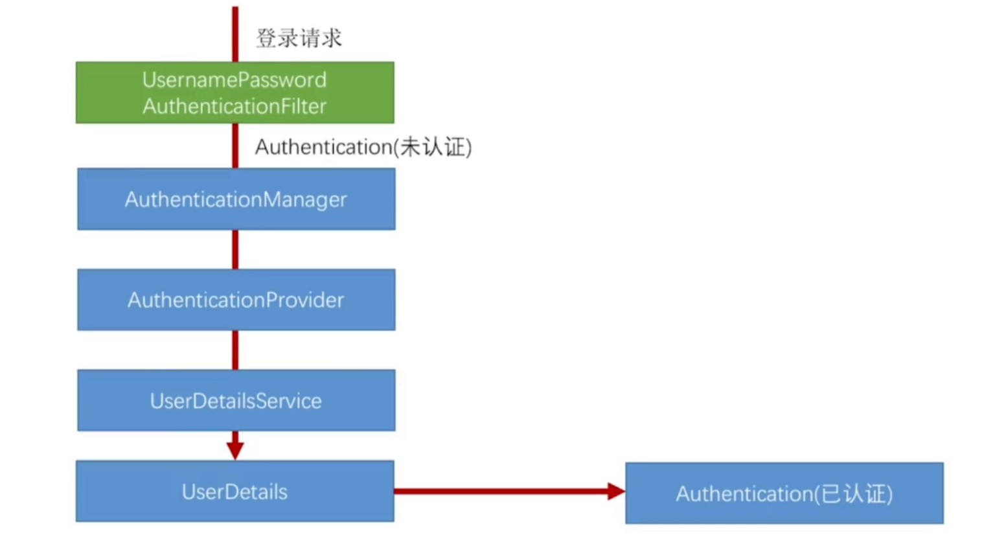

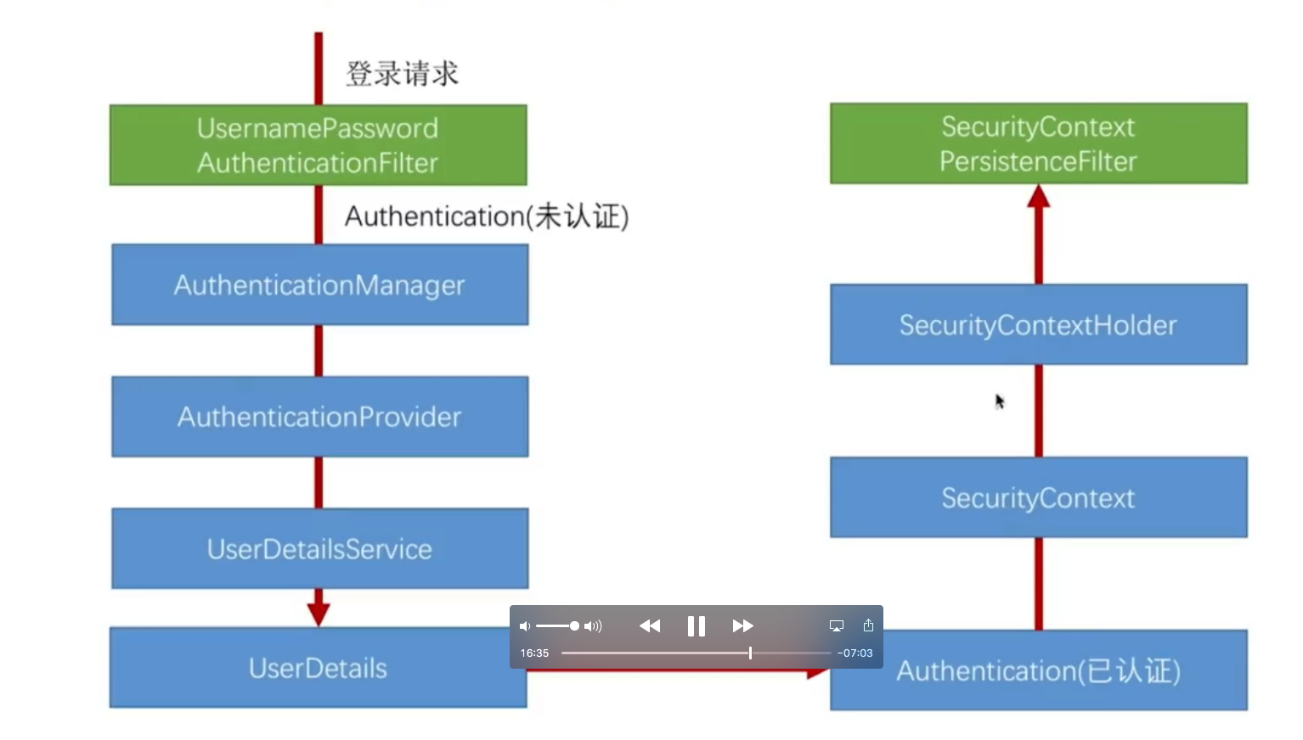

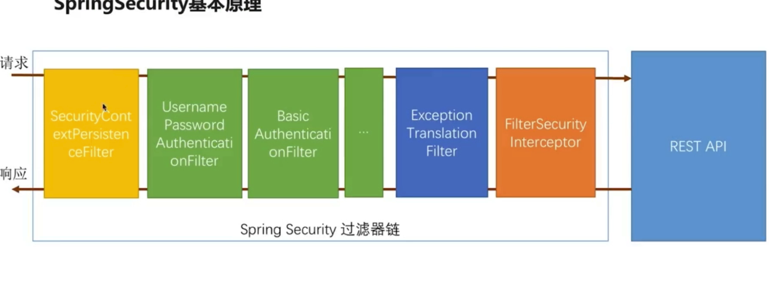

获取当前登录用户信息
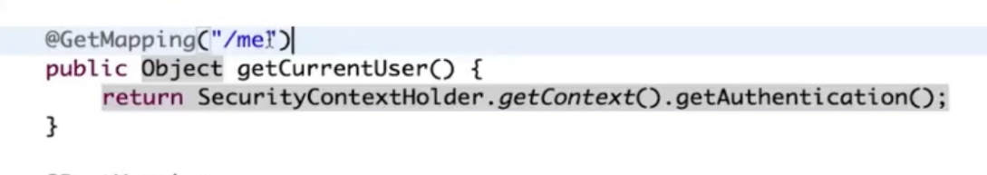
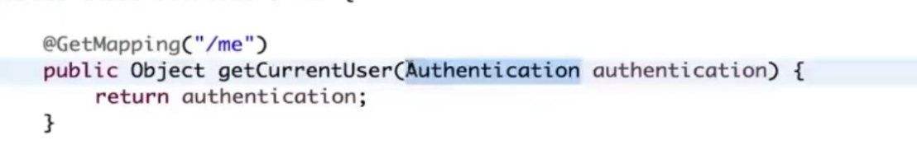
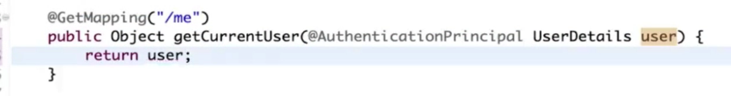

登录添加验证码


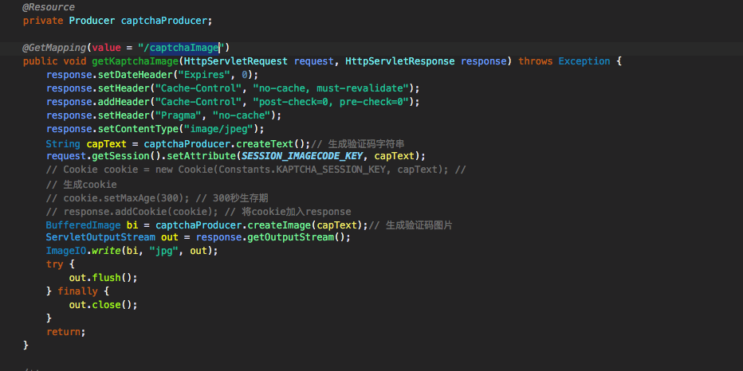
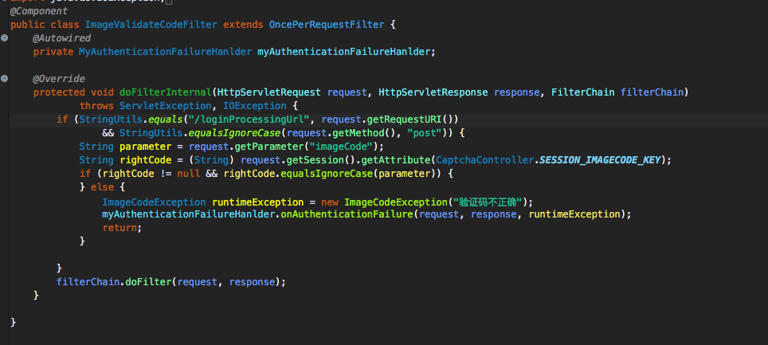

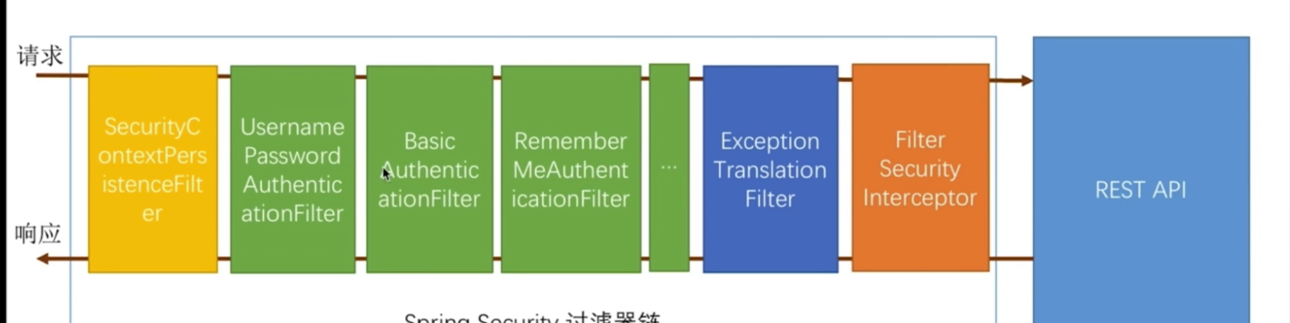

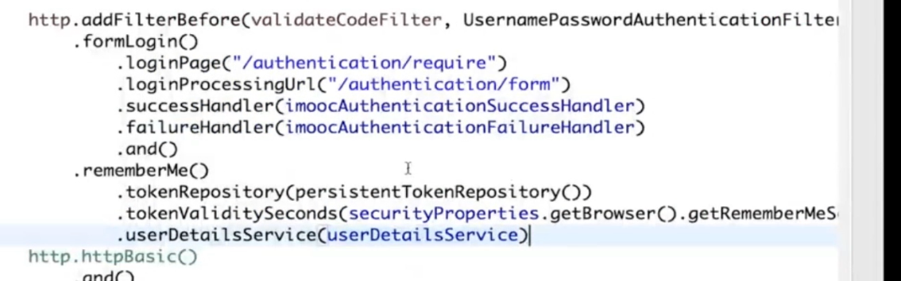

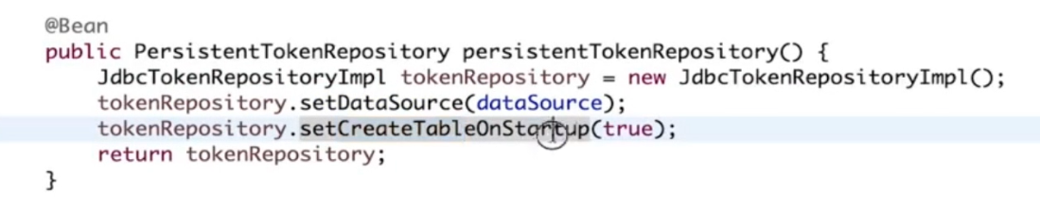

1. Introduction
In this article, we’ll have a look at Spring Boot’s opinionated approach to security.
Simply put, we’re going to focus on the default security configuration and how we can disable or customize it if we need to.

2. Default Security Setup
In order to add security to our Spring Boot application, we need to add the security starter dependency:
1  2  3  4 | <dependency>  <groupId>org.springframework.boot</groupId>  <artifactId>spring-boot-starter-security</artifactId>  </dependency>
This will include the SecurityAutoConfiguration class – containing the initial/default security configuration.
Notice how we didn’t specify the version here, with the assumption that the project is already using Boot as the parent.
Simply put, by default, the Authentication gets enabled for the Application. Also, content negotiation is used to determine if basic or formLogin should be used.
There are some predefined properties, such as:
1  2 | spring.security.user.name  spring.security.user.password
If we don’t configure the password using the predefined property spring.security.user.password and start the application, we’ll notice that a default password is randomly generated and printed in the console log:
1 | Using default security password: c8be15de-4488-4490-9dc6-fab3f91435c6
For more defaults, see the security properties section of the Spring Boot Common Application Properties reference page.

3. Disabling the Auto-Configuration
To discard the security auto-configuration and add our own configuration, we need to exclude the SecurityAutoConfiguration class.
This can be done via a simple exclusion:
1  2  3  4  5  6  7 | @SpringBootApplication(exclude = { SecurityAutoConfiguration.class })  public class SpringBootSecurityApplication {  public static void main(String[] args) {  SpringApplication.run(SpringBootSecurityApplication.class, args);  }  }
Or by adding some configuration into the application.properties file:
1 | spring.autoconfigure.exclude=org.springframework.boot.autoconfigure.security.SecurityAutoConfiguration
There are also some particular cases in which this setup isn’t quite enough.
For example, almost each Spring Boot application is started with Actuator in the classpath. This causes problems because another auto-configuration class needs the one we’ve just excluded, so the application will fail to start.
In order to fix this issue, we need to exclude that class; and, specific to the Actuator situation, we need to exclude ManagementWebSecurityAutoConfiguration.

3.1. Disabling vs. Surpassing Security Auto-Configuration
There’s a significant difference between disabling autoconfiguration and surpassing it.
By disabling it, it’s just like adding the Spring Security dependency and the whole setup from scratch. This can be useful in several cases:
- Integrating application security with a custom security provider
- Migrating a legacy Spring application with already existing security setup – to Spring Boot
But, most of the time we won’t need to fully disable the security auto-configuration.
The way Spring Boot is configured permits surpassing the autoconfigured security by adding in our new/custom configuration classes. This is typically easier, as we’re just customizing an existing security setup to fulfill our needs.

4. Configuring Spring Boot Security
If we’ve chosen the path of disabling security auto-configuration, we naturally need to provide our own configuration.
As we’ve discussed before, this is the default security configuration; we can customize it by modifying the property file.
We can, for example, override the default password by adding our own:
1 | security.user.password=password
If we want a more flexible configuration, with multiple users and roles for example – you now need to make use of a full @Configuration class:
1  2  3  4  5  6  7  8  9  10  11  12  13  14  15  16  17  18  19  20  21  22  23  24  25  26  27  28 | @Configuration  @EnableWebSecurity  public class BasicConfiguration extends WebSecurityConfigurerAdapter {  @Override  protected void configure(AuthenticationManagerBuilder auth)  throws Exception {  auth  .inMemoryAuthentication()  .withUser("user")  .password("password")  .roles("USER")  .and()  .withUser("admin")  .password("admin")  .roles("USER", "ADMIN");  }  @Override  protected void configure(HttpSecurity http) throws Exception {  http  .authorizeRequests()  .anyRequest()  .authenticated()  .and()  .httpBasic();  }  }
The @EnableWebSecurity annotation is crucial if we disable the default security configuration.
If missing, the application will fail to start. The annotation is only optional if we’re just overriding the default behavior using a WebSecurityConfigurerAdapter.
Now, we should verify that our security configuration applies correctly by with a couple of quick live tests:
1  2  3  4  5  6  7  8  9  10  11  12  13  14  15  16  17  18  19  20  21  22  23  24  25  26  27  28  29  30  31  32  33  34  35  36  37  38  39  40 | @RunWith(SpringRunner.class)  @SpringBootTest(webEnvironment = RANDOM_PORT)  public class BasicConfigurationIntegrationTest {  TestRestTemplate restTemplate;  URL base;  @LocalServerPort int port;  @Before  public void setUp() throws MalformedURLException {  restTemplate = new TestRestTemplate("user", "password");  base = new URL("http://localhost:" + port);  }  @Test  public void whenLoggedUserRequestsHomePage_ThenSuccess()  throws IllegalStateException, IOException {  ResponseEntity<String> response  = restTemplate.getForEntity(base.toString(), String.class);  assertEquals(HttpStatus.OK, response.getStatusCode());  assertTrue(response  .getBody()  .contains("Baeldung"));  }  @Test  public void whenUserWithWrongCredentials_thenUnauthorizedPage()  throws Exception {  restTemplate = new TestRestTemplate("user", "wrongpassword");  ResponseEntity<String> response  = restTemplate.getForEntity(base.toString(), String.class);  assertEquals(HttpStatus.UNAUTHORIZED, response.getStatusCode());  assertTrue(response  .getBody()  .contains("Unauthorized"));  }  }
The idea is that behind Spring Boot Security is, in fact, Spring Security, so any security configuration that can be done with this one, or any integration this one supports can be also implemented into Spring Boot.

5. Spring Boot OAuth2 Auto-Configuration
Spring Boot has a dedicated auto-configuration support for OAuth2.
Before we get to that, let’s add the Maven dependency to start setting up our application:
1  2  3  4 | <dependency>  <groupId>org.springframework.security.oauth</groupId>  <artifactId>spring-security-oauth2</artifactId>  </dependency>
This dependency includes a set of classes that are capable of triggering the auto-configuration mechanism defined in OAuth2AutoConfiguration class.
Now, we have multiple choices to continue, depending on the scope of our application.

5.1. OAuth2 Authorization Server Auto-Configuration
If we want our application to be an OAuth2 provider, we can use @EnableAuthorizationServer.
On startup, we’ll notice in the logs that the auto-configuration classes will generate a client id and a client-secret for our authorization server and of course a random password for basic authentication.
1  2  3 | Using default security password: a81cb256-f243-40c0-a585-81ce1b952a98  security.oauth2.client.client-id = 39d2835b-1f87-4a77-9798-e2975f36972e  security.oauth2.client.client-secret = f1463f8b-0791-46fe-9269-521b86c55b71
These credentials can be used to obtain an access token:
1  2  3 | curl -X POST -u 39d2835b-1f87-4a77-9798-e2975f36972e:f1463f8b-0791-46fe-9269-521b86c55b71 \  -d grant_type=client_credentials -d username=user -d password=a81cb256-f243-40c0-a585-81ce1b952a98 \  -d scope=write http://localhost:8080/oauth/token

5.2. Other Spring Boot OAuth2 Auto-Configuration Settings
There are some other use cases covered by Spring Boot OAuth2 like:
- Resource Server – @EnableResourceServer
- Client Application – @EnableOAuth2Sso or @EnableOAuth2Client
If we need our application to be one of the types above we just have to add some configuration to application properties.
All OAuth2 specific properties can be found at Spring Boot Common Application Properties.

6. Spring Boot 2 Security vs Spring Boot 1 Security
Compared to Spring Boot 1, Spring Boot 2 has greatly simplified the auto-configuration.
In Spring Boot 2, if we want our own security configuration, we can simply add a custom WebSecurityConfigurerAdapter. This will disable the default auto-configuration and enable our custom security configuration.
Spring Boot 2 uses most of Spring Security’s defaults. Because of this, some of the endpoints that were unsecured by default in Spring Boot 1 are now secured by default.
These endpoints include static resources such as /css/**, /js/**, /images/**, /webjars/**, /**/favicon.ico, and the error endpoint. If we need to allow unauthenticated access to these endpoints, we can explicitly configure that.
To simplify the security-related configuration, Spring Boot 2 has removed the following Spring Boot 1 properties:
1  2  3  4  5  6  7  8  9  10  11  12  13  14  15 | security.basic.authorize-mode  security.basic.enabled  security.basic.path  security.basic.realm  security.enable-csrf  security.headers.cache  security.headers.content-security-policy  security.headers.content-security-policy-mode  security.headers.content-type  security.headers.frame  security.headers.hsts  security.headers.xss  security.ignored  security.require-ssl  security.sessions

7. Conclusion
In this article, we focused on the default security configuration provided by Spring Boot. We saw how the security auto-configuration mechanism can be disabled or overridden and how a new security configuration can be applied.
The source code can be found over on Github.

I just announced the new Learn Spring course, focused on the fundamentals of Spring 5 and Spring Boot 2:
>> CHECK OUT THE COURSE

