BMW Sales Report (2020-2024)
Generated: 2025-11-24T08:23:06.260184

Executive Summary
The BMW sales data from 2020 to 2024 reveals a dynamic market performance. Sales showed an upward trend from 2020 to 2022, peaking at over 17.9 million units, followed by a dip in 2023 to 16.2 million units, and a strong recovery in 2024 reaching approximately 17.5 million units. Regional sales generally mirrored this trend, with Asia and Europe consistently leading in volume. The '7 Series', 'X6', and 'M5' were the top-performing models, while the 'X5', 'i3', 'M3', '5 Series', and 'X1' were identified as underperformers. Europe emerged as the highest-performing region, with the Middle East and North America also showing robust sales, while South America registered the lowest sales volume. OLS regression analysis indicated that the chosen features were not strong predictors of sales volume, though 'Grey' colored cars showed a statistically significant negative association with sales. Additional insights highlight that electric, diesel, and hybrid fuel types, as well as manual transmission vehicles, show slightly higher average sales volumes compared to petrol and automatic transmission respectively.
--------------------

Analysis: Sales Performance Trend Over Time (by Region)
The analysis of BMW sales data from 2020 to 2024 reveals a dynamic trend in sales volume. Overall, BMW experienced a general upward trend in sales from 2020 to 2022, reaching a peak in 2022 with over 17.9 million units sold. Following this peak, there was a noticeable dip in sales during 2023, with the total sales volume dropping to approximately 16.2 million units. However, the data for 2024 shows a strong recovery, with sales volume climbing back to around 17.5 million units, indicating a resilient market performance after a temporary setback.
When breaking down the sales by region, several interesting patterns emerge. All regions generally followed the overall sales trend, with most experiencing a peak in 2022 and a subsequent decline in 2023, followed by a recovery in 2024. Asia and Europe consistently show strong sales performance throughout the period, often leading in sales volume. North America also maintains a significant contribution to the total sales. The Middle East and Africa regions demonstrate steady sales, while South America, though generally lower in volume compared to other regions, also reflects similar annual fluctuations.
It is important to note that while the overall trend suggests a recovery in 2024, the regional breakdowns highlight the diverse contributions and market dynamics across different parts of the world. The consistent performance of established markets like Europe and Asia, coupled with the overall rebound in 2024, indicates a strong underlying demand for BMW vehicles globally, even with annual fluctuations influenced by various market factors.
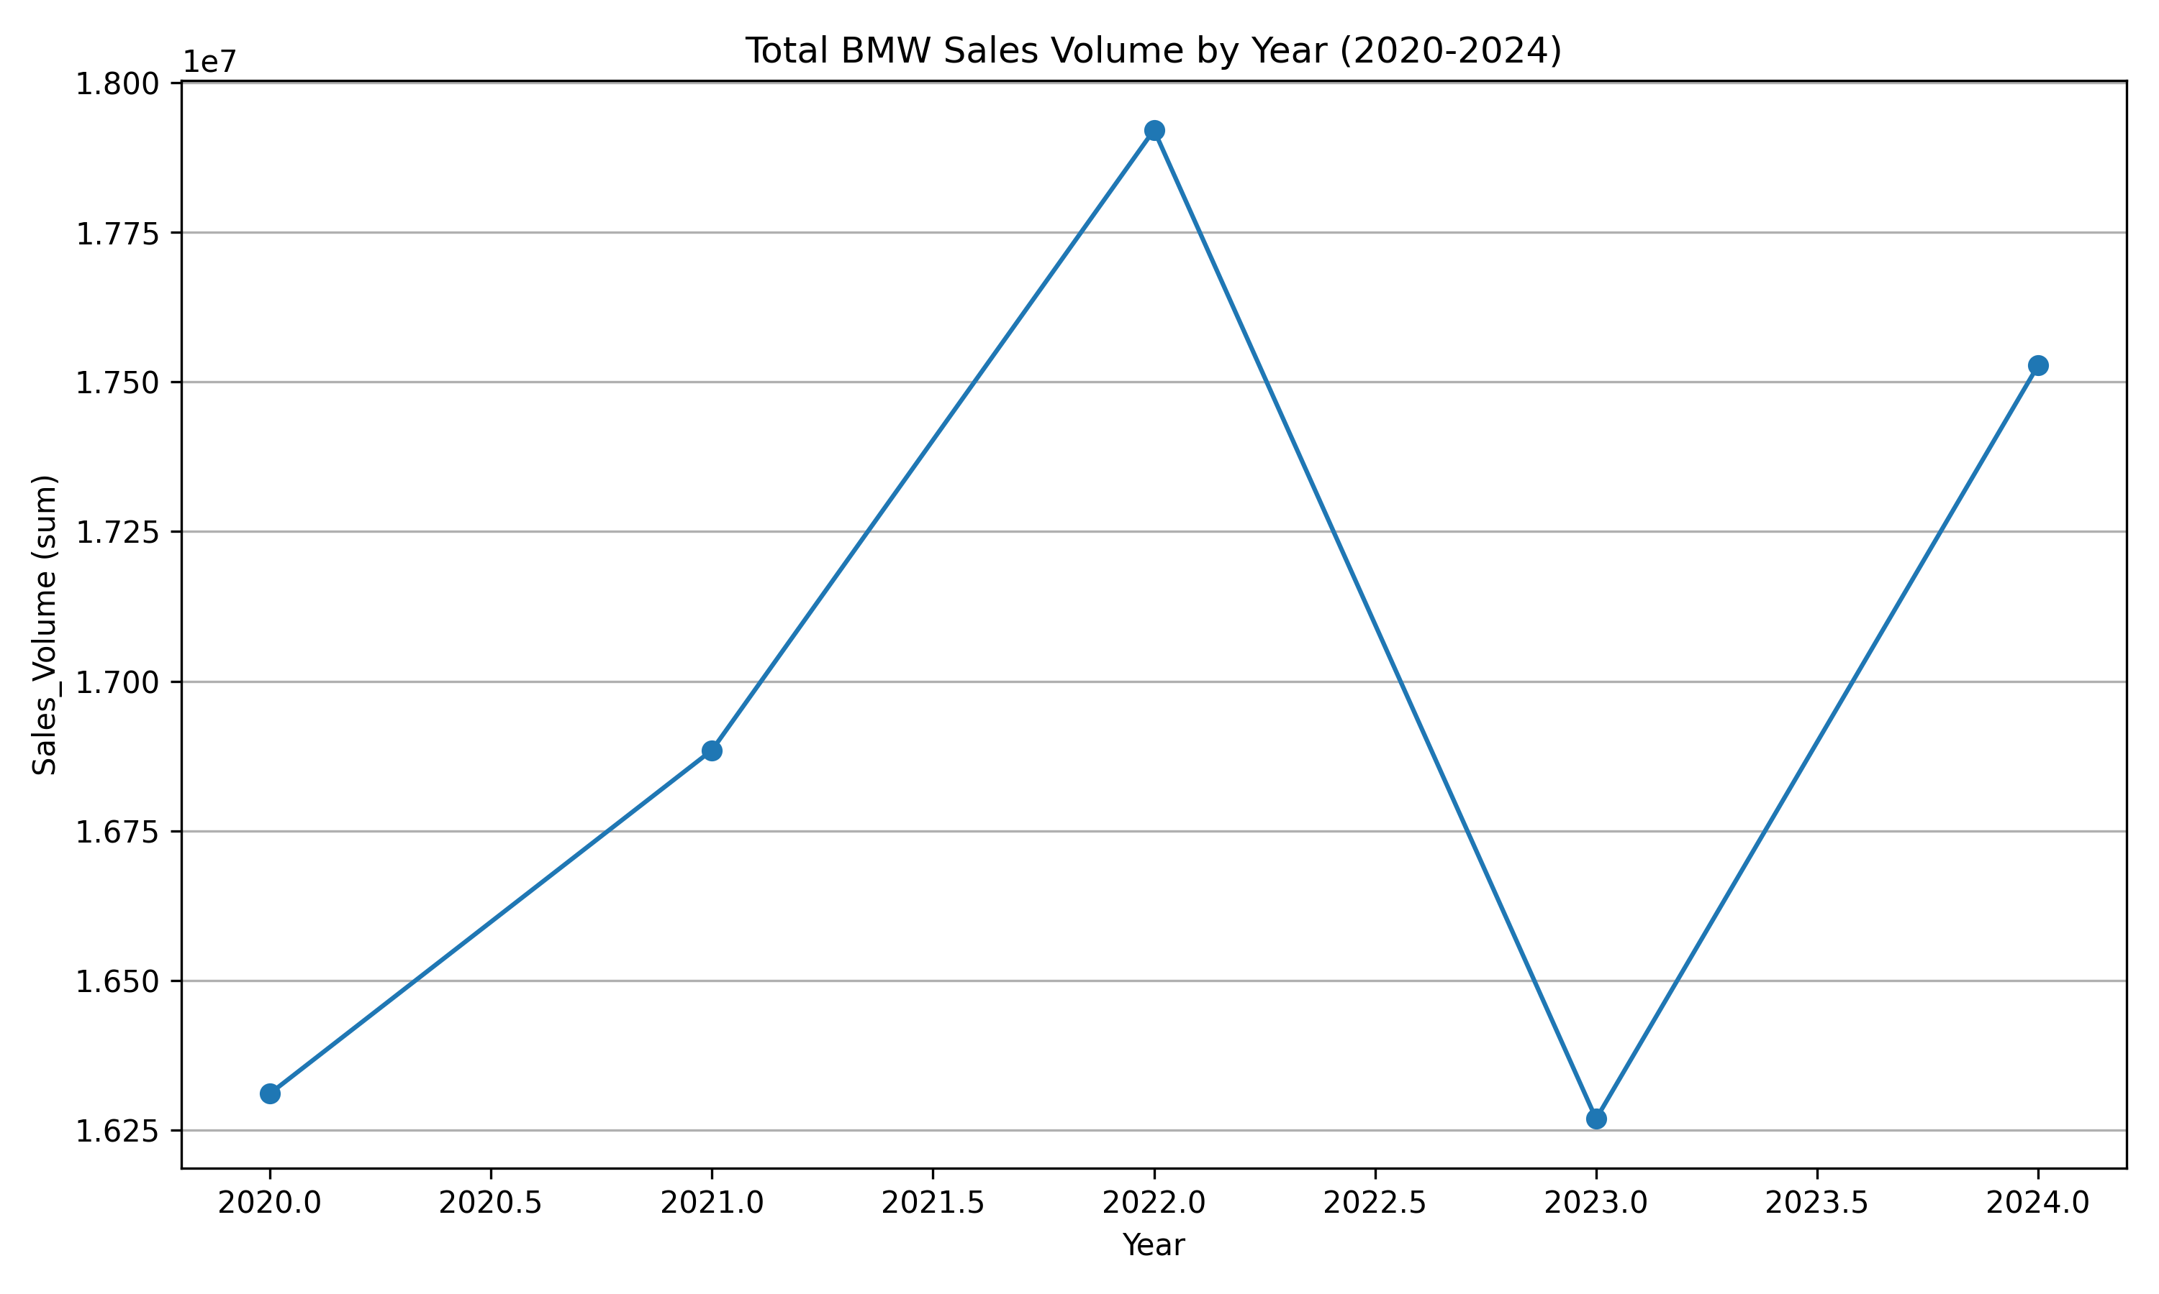
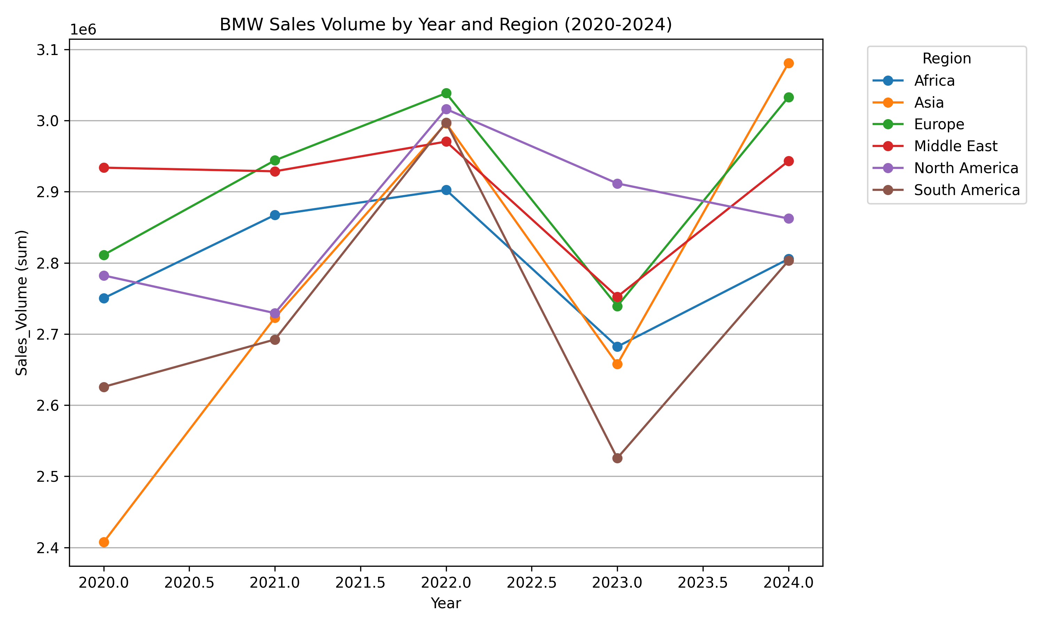
--------------------

Analysis: Top-Performing and Underperforming Models
The '7 Series' emerged as the leading model with the highest sales volume, closely followed by the 'X6' and 'M5'. These models demonstrate strong market demand and contribute significantly to overall sales. Conversely, the 'X5' model registered the lowest sales volume, making it the worst performer. Other underperforming models include the 'i3', 'M3', '5 Series', and 'X1', which may warrant further investigation into their market strategies, pricing, or consumer appeal.
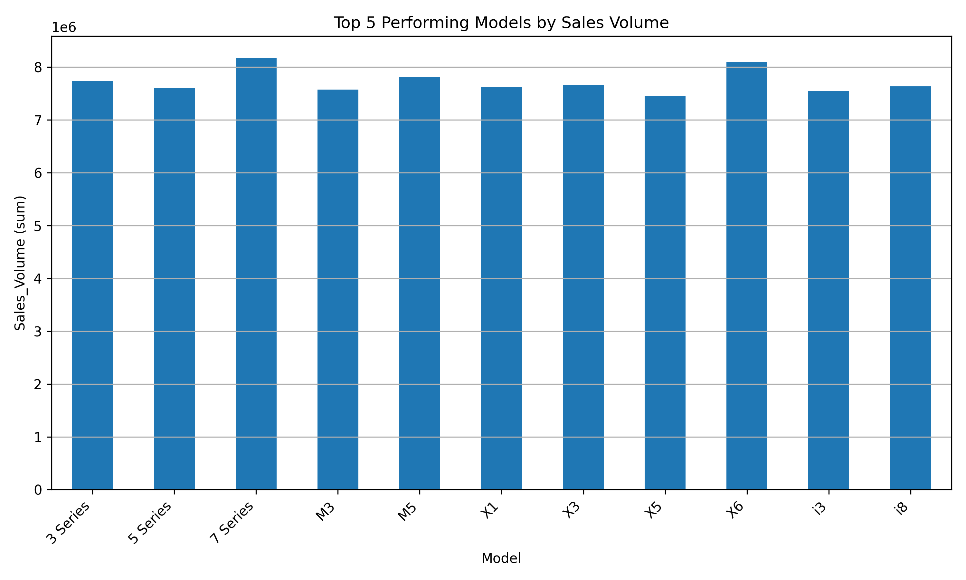
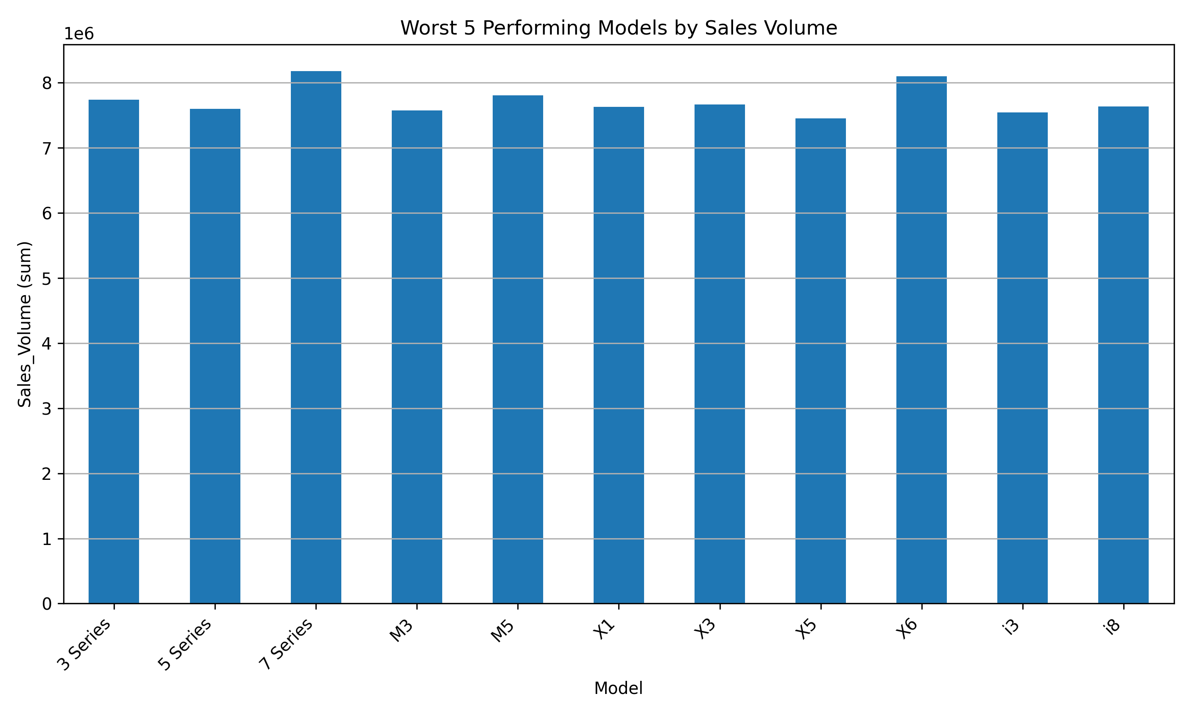
--------------------

Analysis: Top-Performing and Underperforming Markets
From a regional perspective, Europe stands out as the highest-performing region, generating the largest sales volume. The Middle East and North America also show robust sales, securing their positions among the top-performing regions. South America, on the other hand, is the clear underperformer with the lowest sales volume. Interestingly, regions such as Asia, Africa, North America, and the Middle East appear in both the top and underperforming lists, indicating a more nuanced performance that might depend on specific models or timeframes within these regions. This overlap suggests that while these regions contribute significantly to overall sales, there might be segments within them that are not performing optimally.
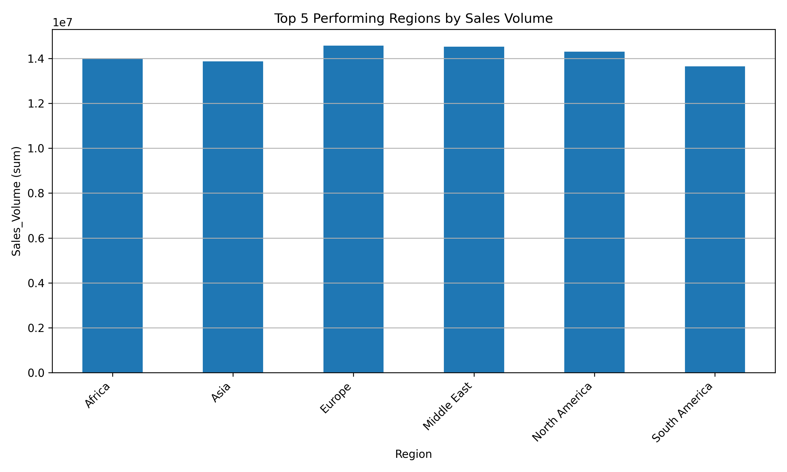
--------------------

Analysis: Key Drivers of Sales (OLS Regression)
The Ordinary Least Squares (OLS) regression analysis aimed to identify key drivers of 'Sales_Volume' using various car attributes. The model's R-squared value of 0.0013 indicates that it explains less than 1% of the variance in sales volume, suggesting that the selected features (Model, Year, Region, Color, Fuel_Type, Transmission, Engine Size, Mileage, and Price) are not strong predictors of sales volume in this dataset.
Upon examining the p-values, only 'Color[T.Grey]' showed statistical significance (p-value < 0.05). The negative coefficient of -166.89 for 'Color[T.Grey]' suggests that, when compared to the baseline color (likely the first alphabetically or most frequent), grey colored cars are associated with a decrease in sales volume, holding all other factors constant. However, the overall weak performance of the model implies that this individual significance should be interpreted with caution, as other confounding factors might be at play. Most other features, including 'Year', 'Engine_Size_L', 'Mileage_KM', and 'Price_USD', as well as other categorical variations, were not found to be statistically significant drivers of sales volume in this analysis. This indicates a need for exploring additional potential drivers or different modeling approaches to better understand the factors influencing BMW sales volume.
--------------------

Analysis: Additional Insights
Here are some additional insights from the data:
1. **Average Sales Volume by Fuel Type**: Electric cars show the highest average sales volume (approximately 5098 units), closely followed by Diesel (approximately 5093 units) and Hybrid (approximately 5091 units). Petrol vehicles have the lowest average sales volume (approximately 5055 units). The difference in average sales volume across different fuel types is not very significant.
2. **Average Sales Volume by Transmission Type**: Vehicles with manual transmission have a slightly higher average sales volume (approximately 5089 units) compared to automatic transmission vehicles (approximately 5079 units). The difference between the two transmission types is minor.
3. **Total Sales Volume by Region**: Europe leads in total sales volume with approximately 14.57 million units, followed closely by the Middle East (approximately 14.53 million units) and North America (approximately 14.30 million units). South America has the lowest total sales volume, approximately 13.64 million units.
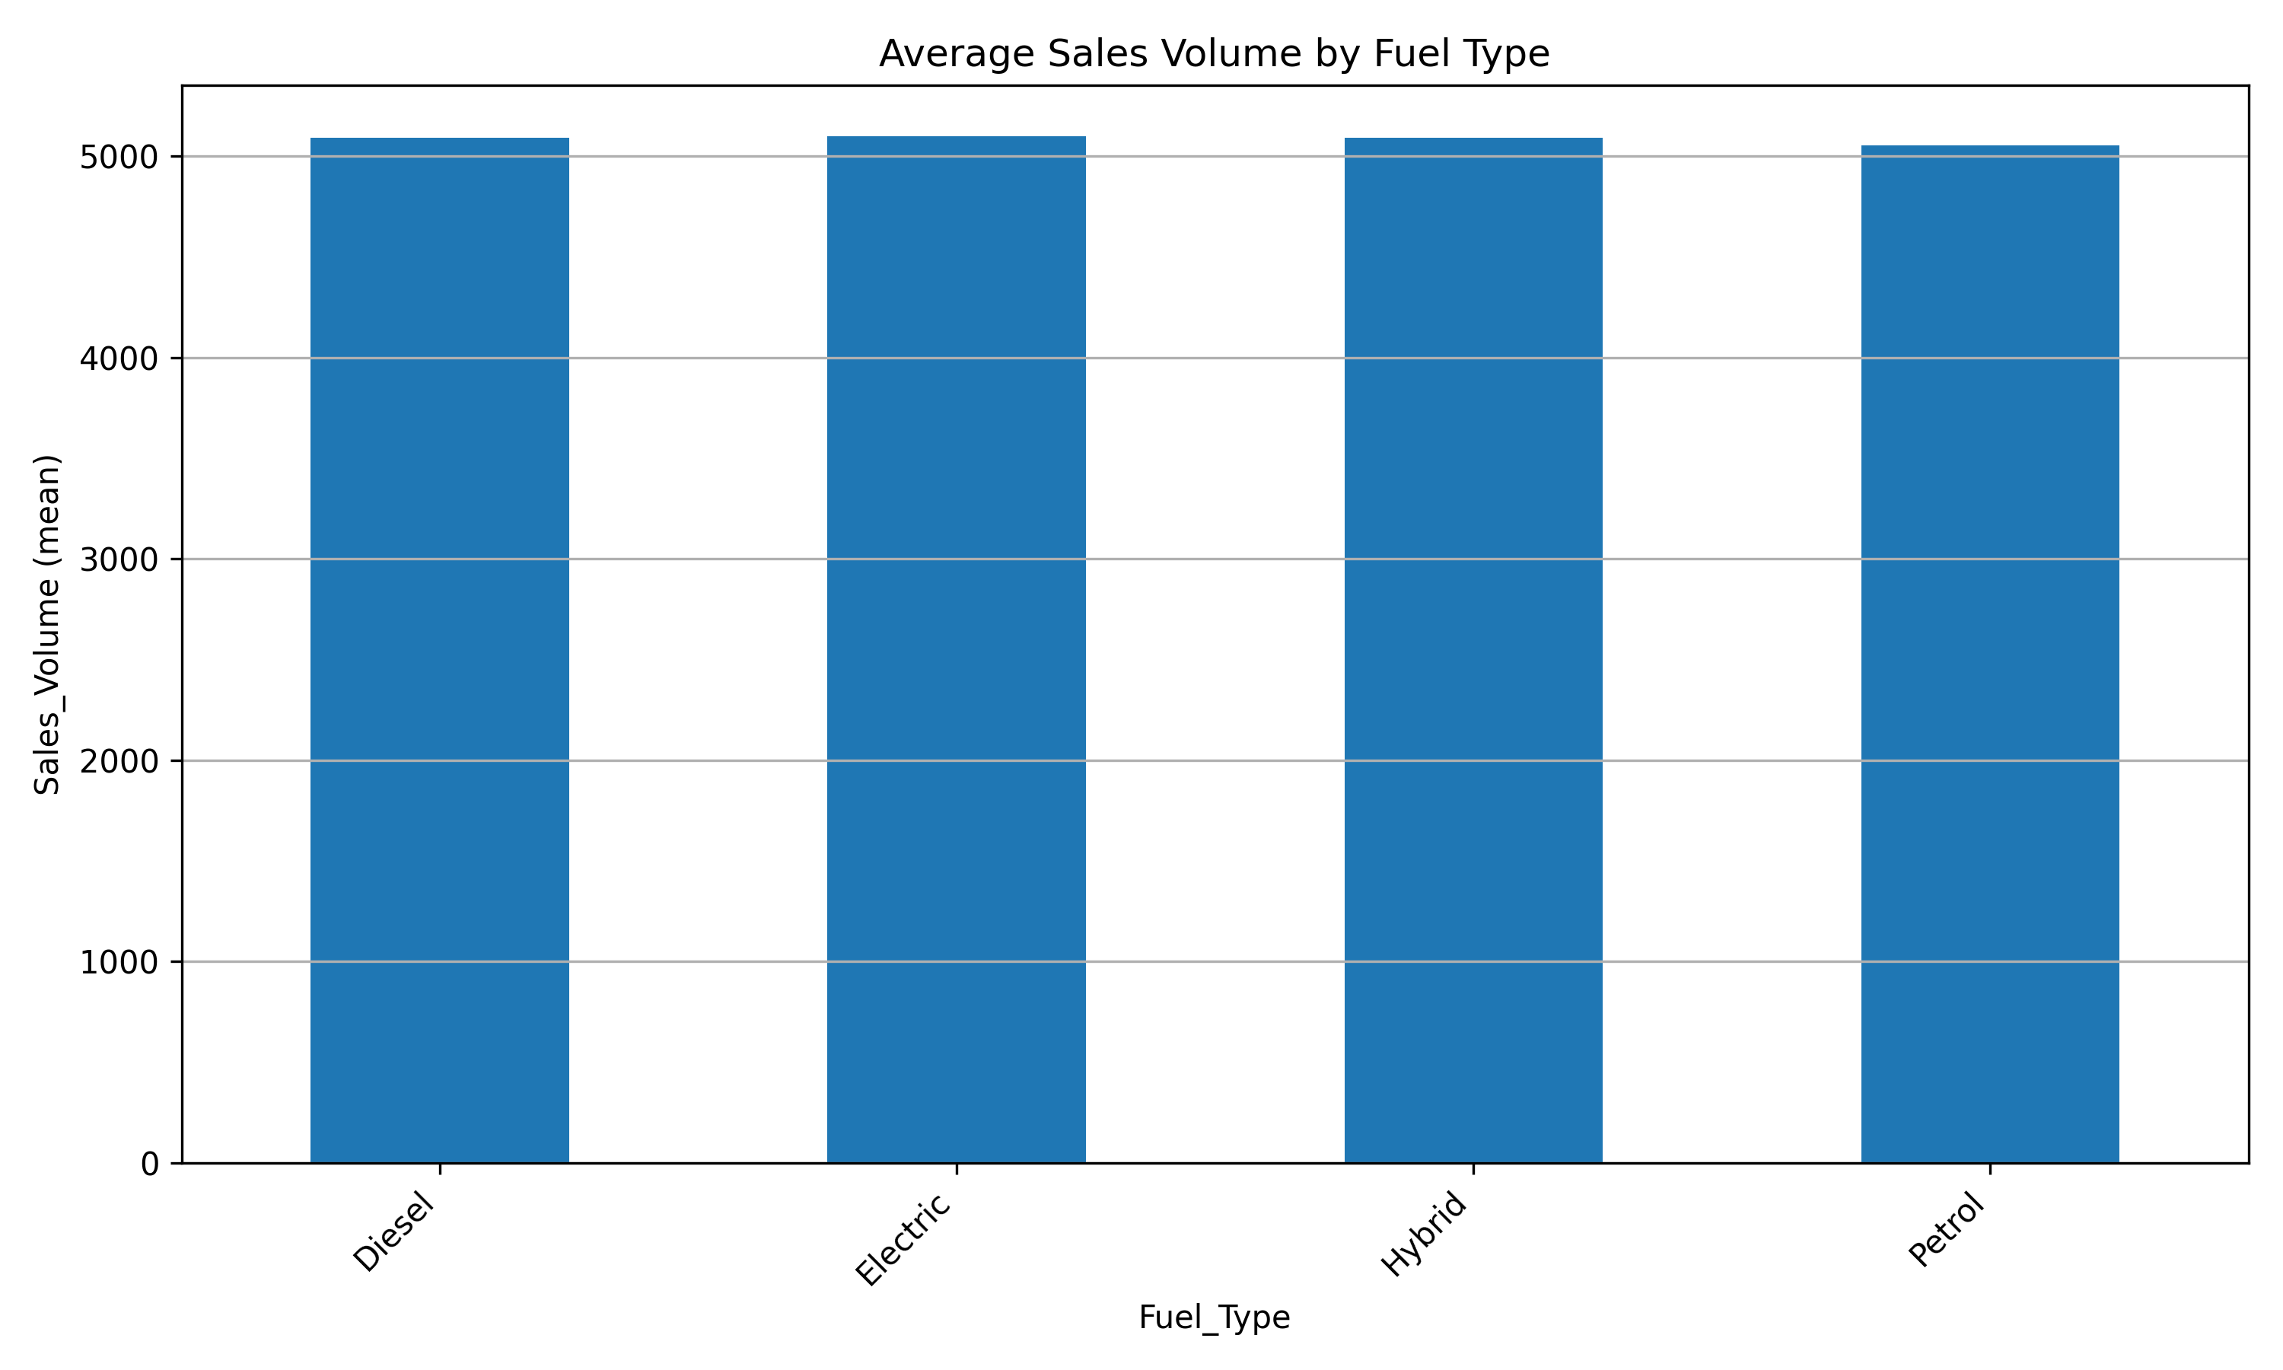
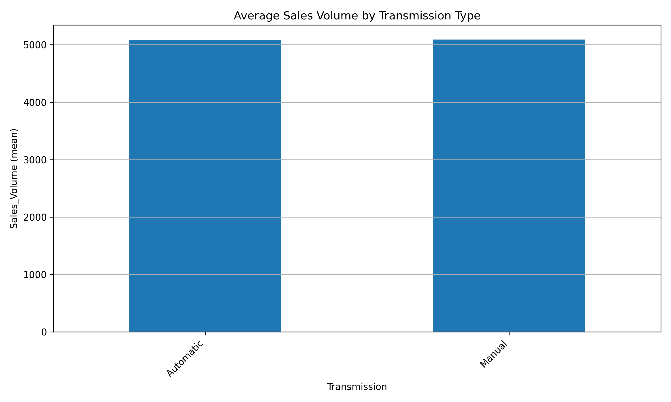
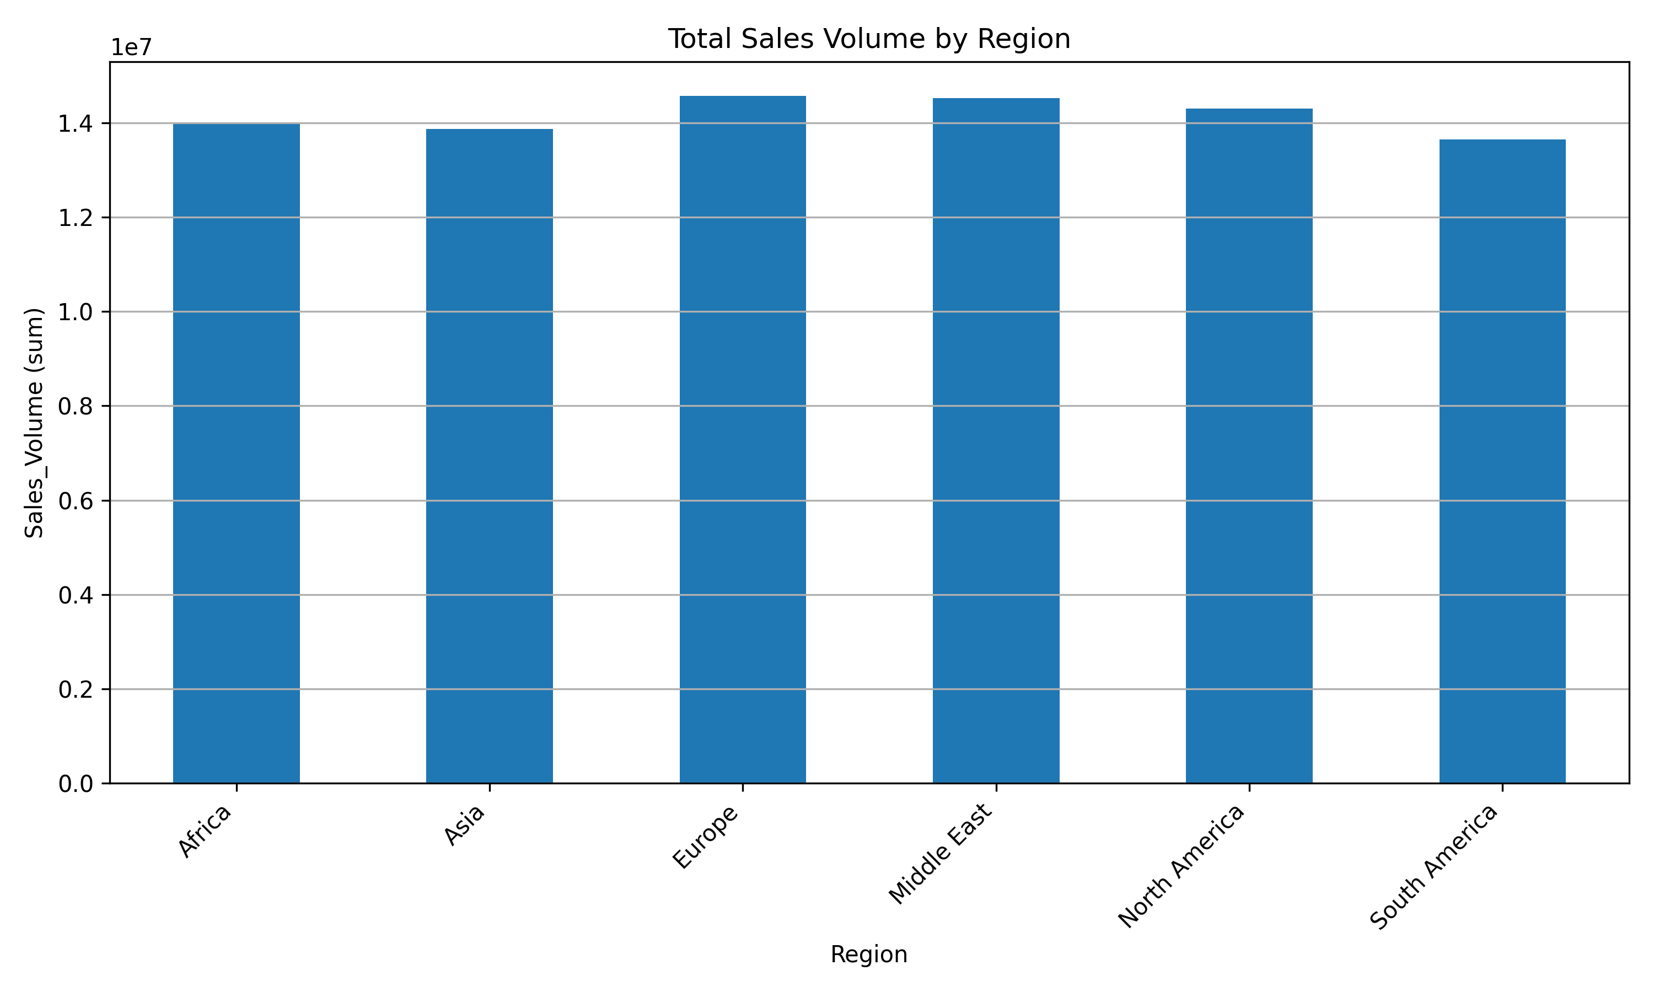
--------------------

Recommendations
Based on the analysis, the following recommendations are provided to enhance BMW's sales performance:
1. **Leverage Top-Performing Models:** Analyze the success factors of the '7 Series', 'X6', and 'M5' models (e.g., marketing strategies, pricing, target demographics, features) and explore opportunities to replicate these strategies across other models, where applicable.
2. **Investigate Underperforming Models:** Conduct a detailed review of underperforming models such as the 'X5', 'i3', 'M3', '5 Series', and 'X1'. This should include a deep dive into their market positioning, competitive landscape, pricing strategy, and customer feedback to identify root causes of low sales and formulate corrective actions.
3. **Targeted Market Interventions for South America:** Develop specific market penetration and sales strategies for South America, which consistently ranks as the lowest-performing region. This could involve localized marketing campaigns, adjusting product mix, or exploring different distribution channels.
4. **Nuanced Regional Strategy:** For regions like Asia and Africa, which show fluctuating performance, a more granular analysis is needed to identify specific models or market segments that are underperforming. This will allow for targeted interventions to capitalize on their full potential.
5. **Re-evaluate Key Drivers Analysis:** Given the low R-squared of the OLS regression model, further investigation into additional potential sales drivers is recommended. This could involve incorporating economic indicators, competitor activities, marketing spend, or consumer sentiment data. While 'Grey' color showed a negative association, its practical significance is limited without a more robust model. Further qualitative research into color preferences in different markets might also be beneficial.
6. **Capitalize on Fuel Type Trends:** Given the slightly higher average sales volume for Electric, Diesel, and Hybrid vehicles compared to Petrol, BMW should continue to invest in and promote its electrified and diesel offerings, aligning with evolving consumer preferences and environmental regulations.
7. **Consider Transmission Preferences:** The marginal preference for manual transmission vehicles in terms of average sales volume, though small, might indicate a niche market segment that could be further explored or catered to in specific regions.
--------------------

