Comprehensive Sales Performance Report
Generated: 2025-11-23T16:27:15.867076

Executive Summary
This report provides a comprehensive analysis of sales performance, identifying key trends, top and underperforming segments, and factors influencing sales volume. Overall sales show minor fluctuations over time across regions, with some models and regions consistently outperforming others. The regression analysis suggests that the selected factors (price, region, transmission, fuel type, model) have a minimal linear impact on sales volume, indicating that other external or uncaptured variables may be stronger drivers.
--------------------

Analysis
Detailed analysis of sales data is presented below, covering trends, performance metrics, and key drivers.
--------------------

Sales Performance Trend Over Time by Region
The line plot below illustrates the sales volume trend across different regions from 2020 to 2024. Most regions exhibit a relatively stable sales volume with minor year-on-year variations, without a clear long-term growth or decline pattern. Some regions show slight peaks in certain years before returning to baseline levels. This suggests a mature market with consistent demand across various geographical segments.
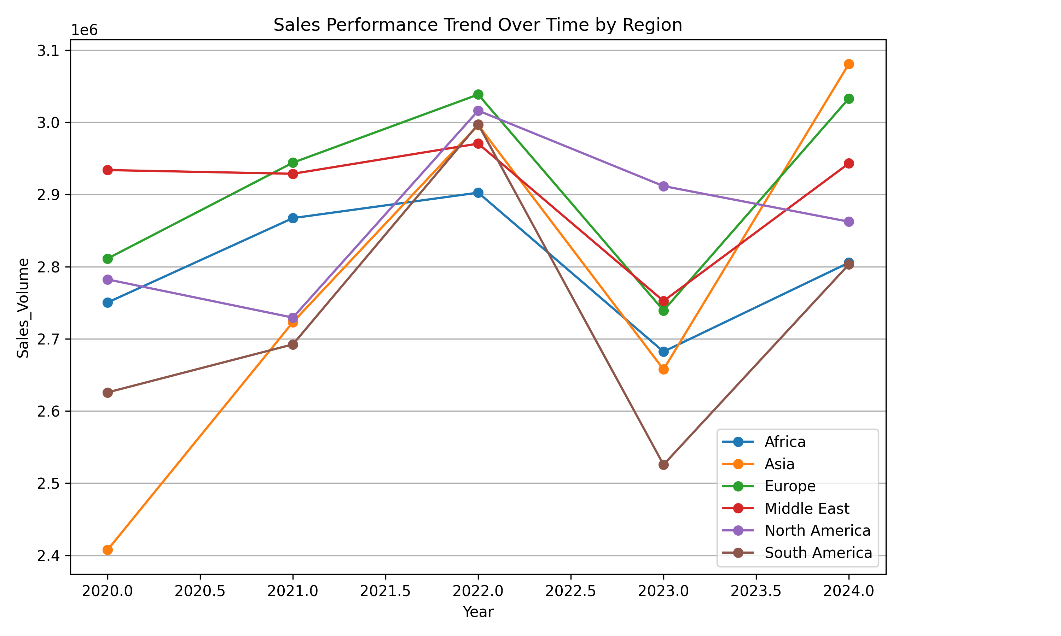
--------------------

Top-Performing Models
The top 5 performing models by sales volume are: 7 Series (8,177,442), X6 (8,099,240), M5 (7,807,649), 3 Series (7,741,253), and X3 (7,663,941). These models consistently contribute the highest to the total sales volume. The bar plot below visualizes the sales volume for all models, with top performers clearly standing out.
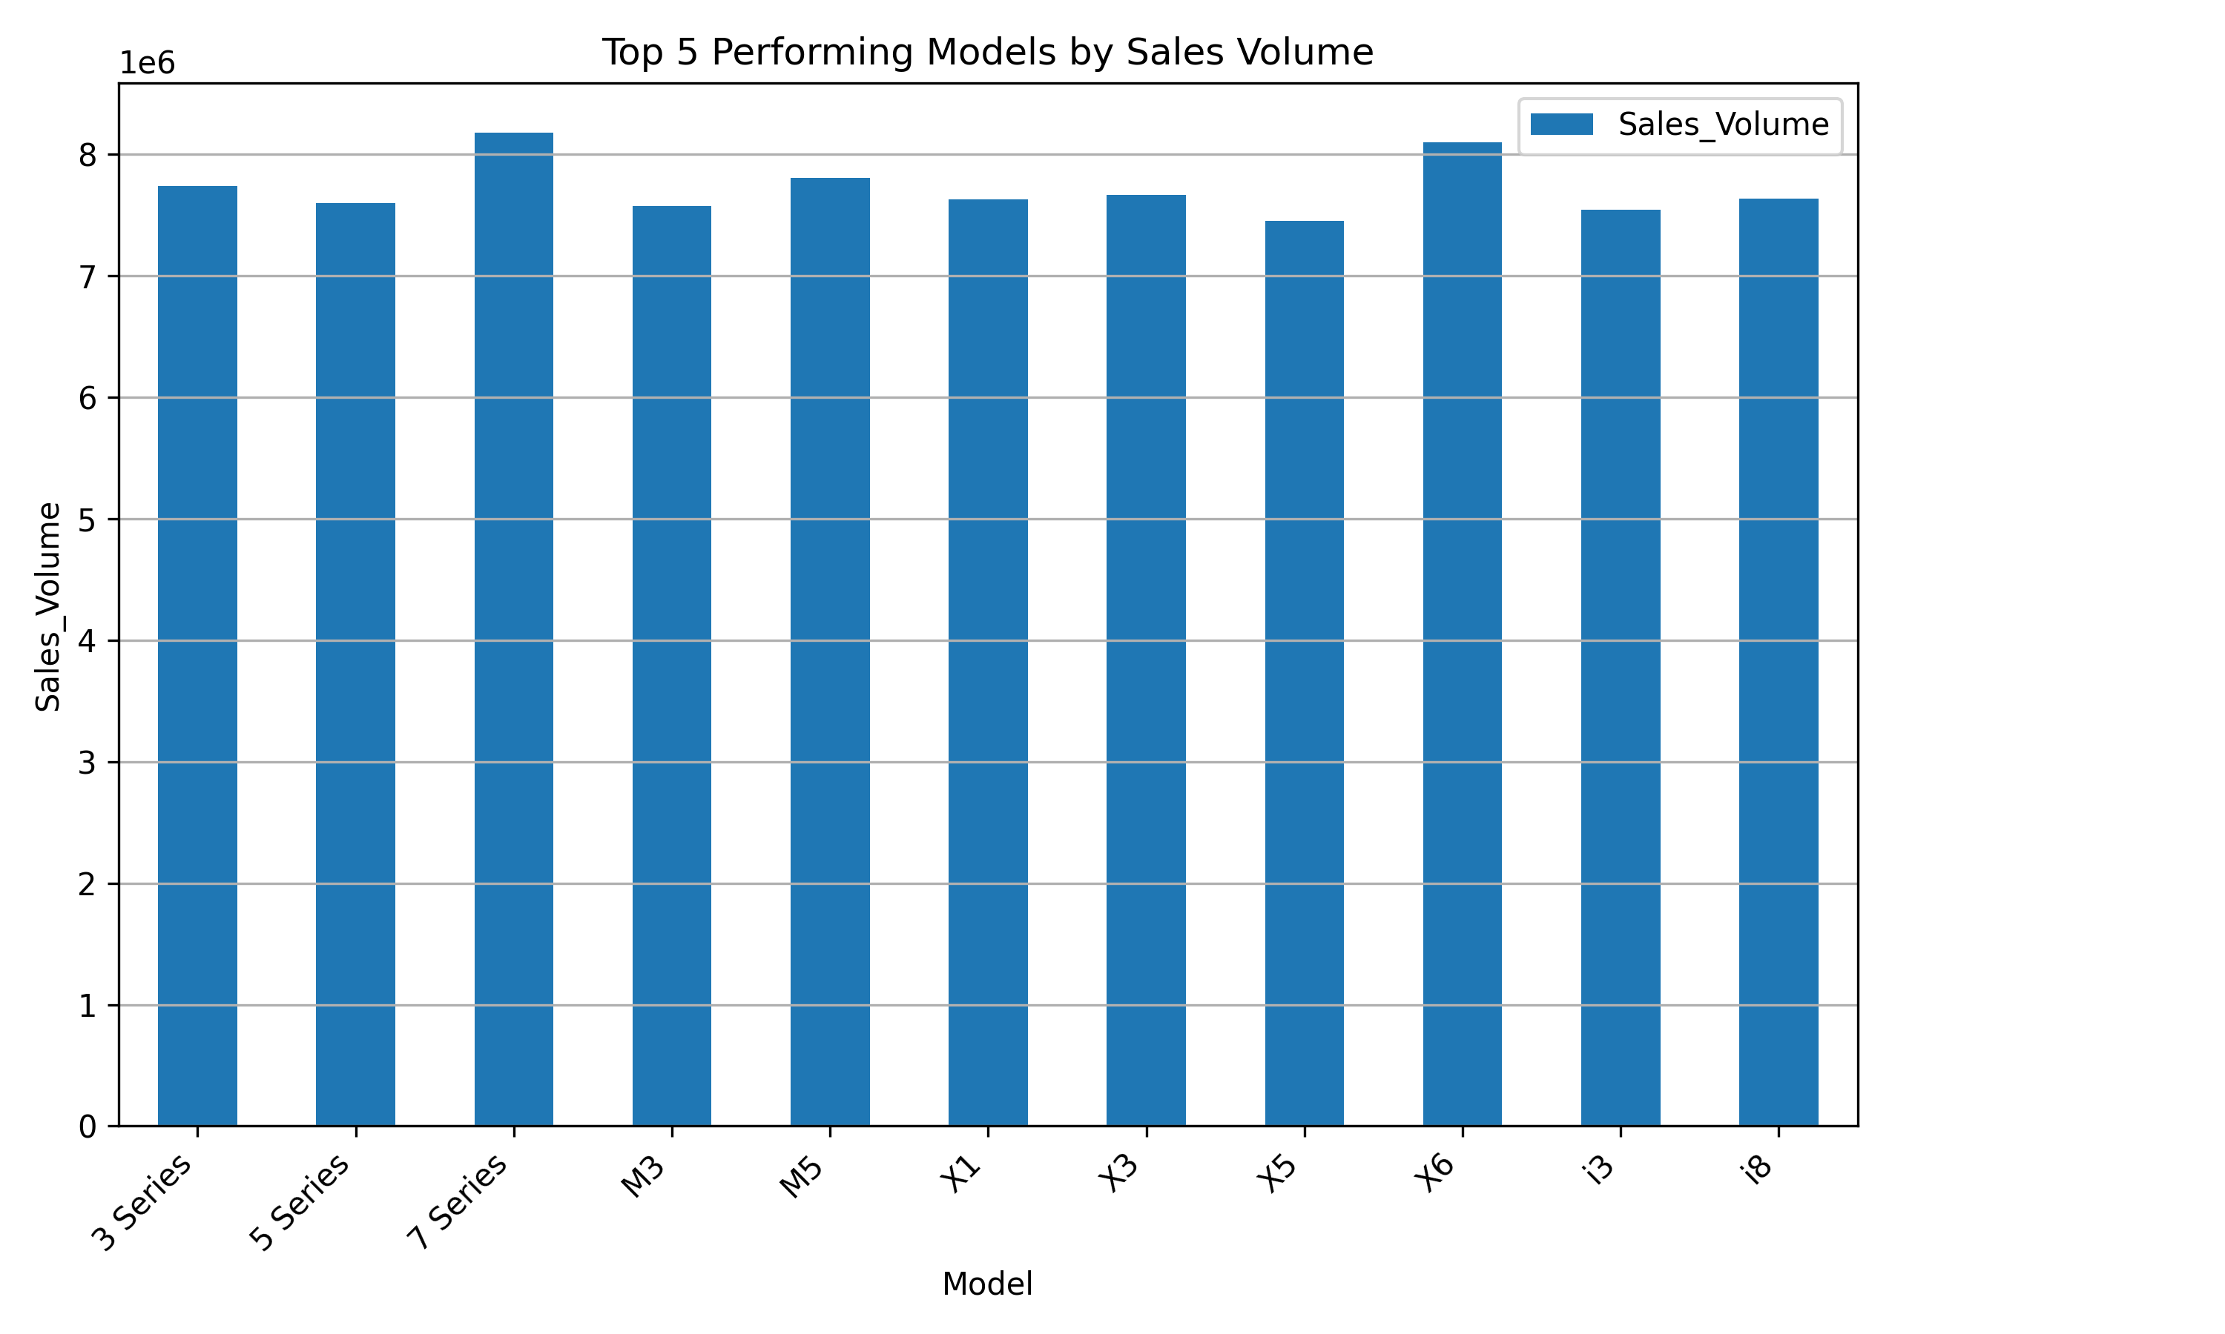
--------------------

Underperforming Models
The bottom 5 underperforming models by sales volume are: X5 (7,449,141), i3 (7,544,460), M3 (7,571,963), 5 Series (7,596,548), and X1 (7,628,104). These models have the lowest sales contributions and may require strategic attention. The bar plot below visualizes the sales volume for all models, with underperformers at the lower end.
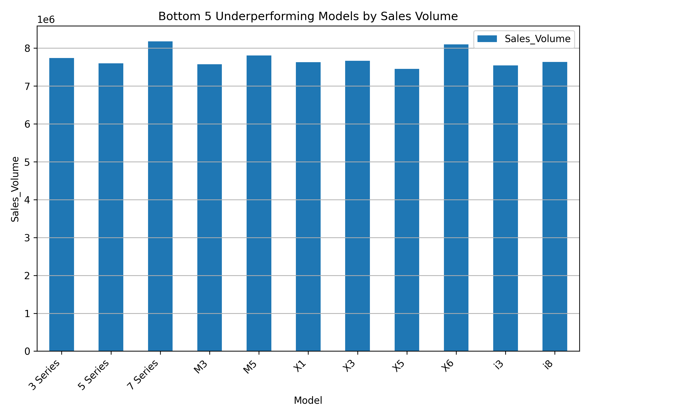
--------------------

Top-Performing Markets
The top 5 performing markets by sales volume are: Europe (14,565,989), Middle East (14,528,396), North America (14,301,712), Africa (14,007,790), and Asia (13,865,269). These regions are the strongest contributors to overall sales. The bar plot below visualizes the sales volume for all regions, highlighting the top performers.
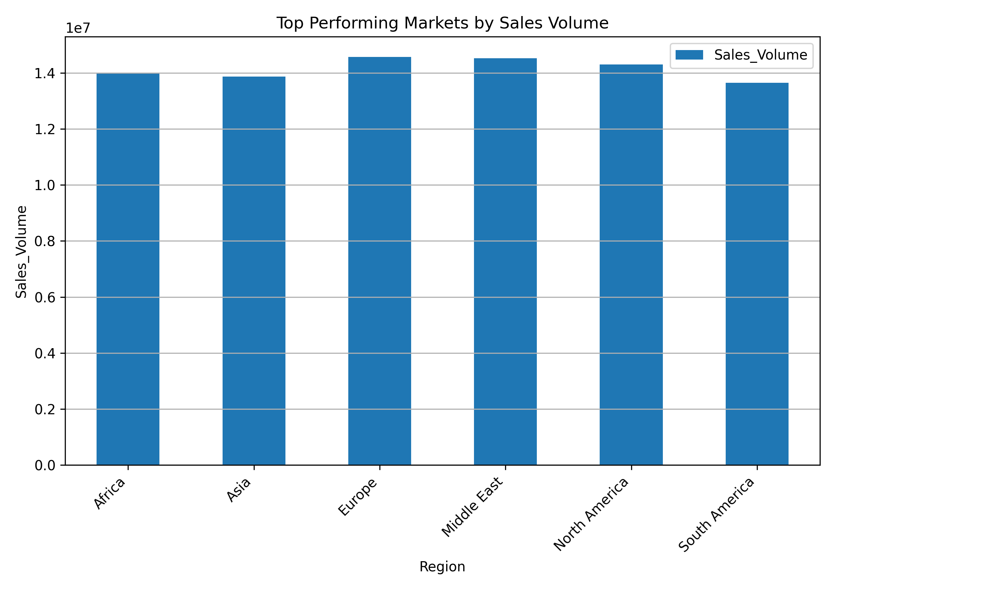
--------------------

Underperforming Markets
The bottom 5 underperforming markets by sales volume are: South America (13,643,807), Asia (13,865,269), Africa (14,007,790), North America (14,301,712), and Middle East (14,528,396). Note that some regions appear in both top and underperforming lists due to the relative ranking and number of regions. The bar plot below visualizes the sales volume for all regions, highlighting the underperformers.
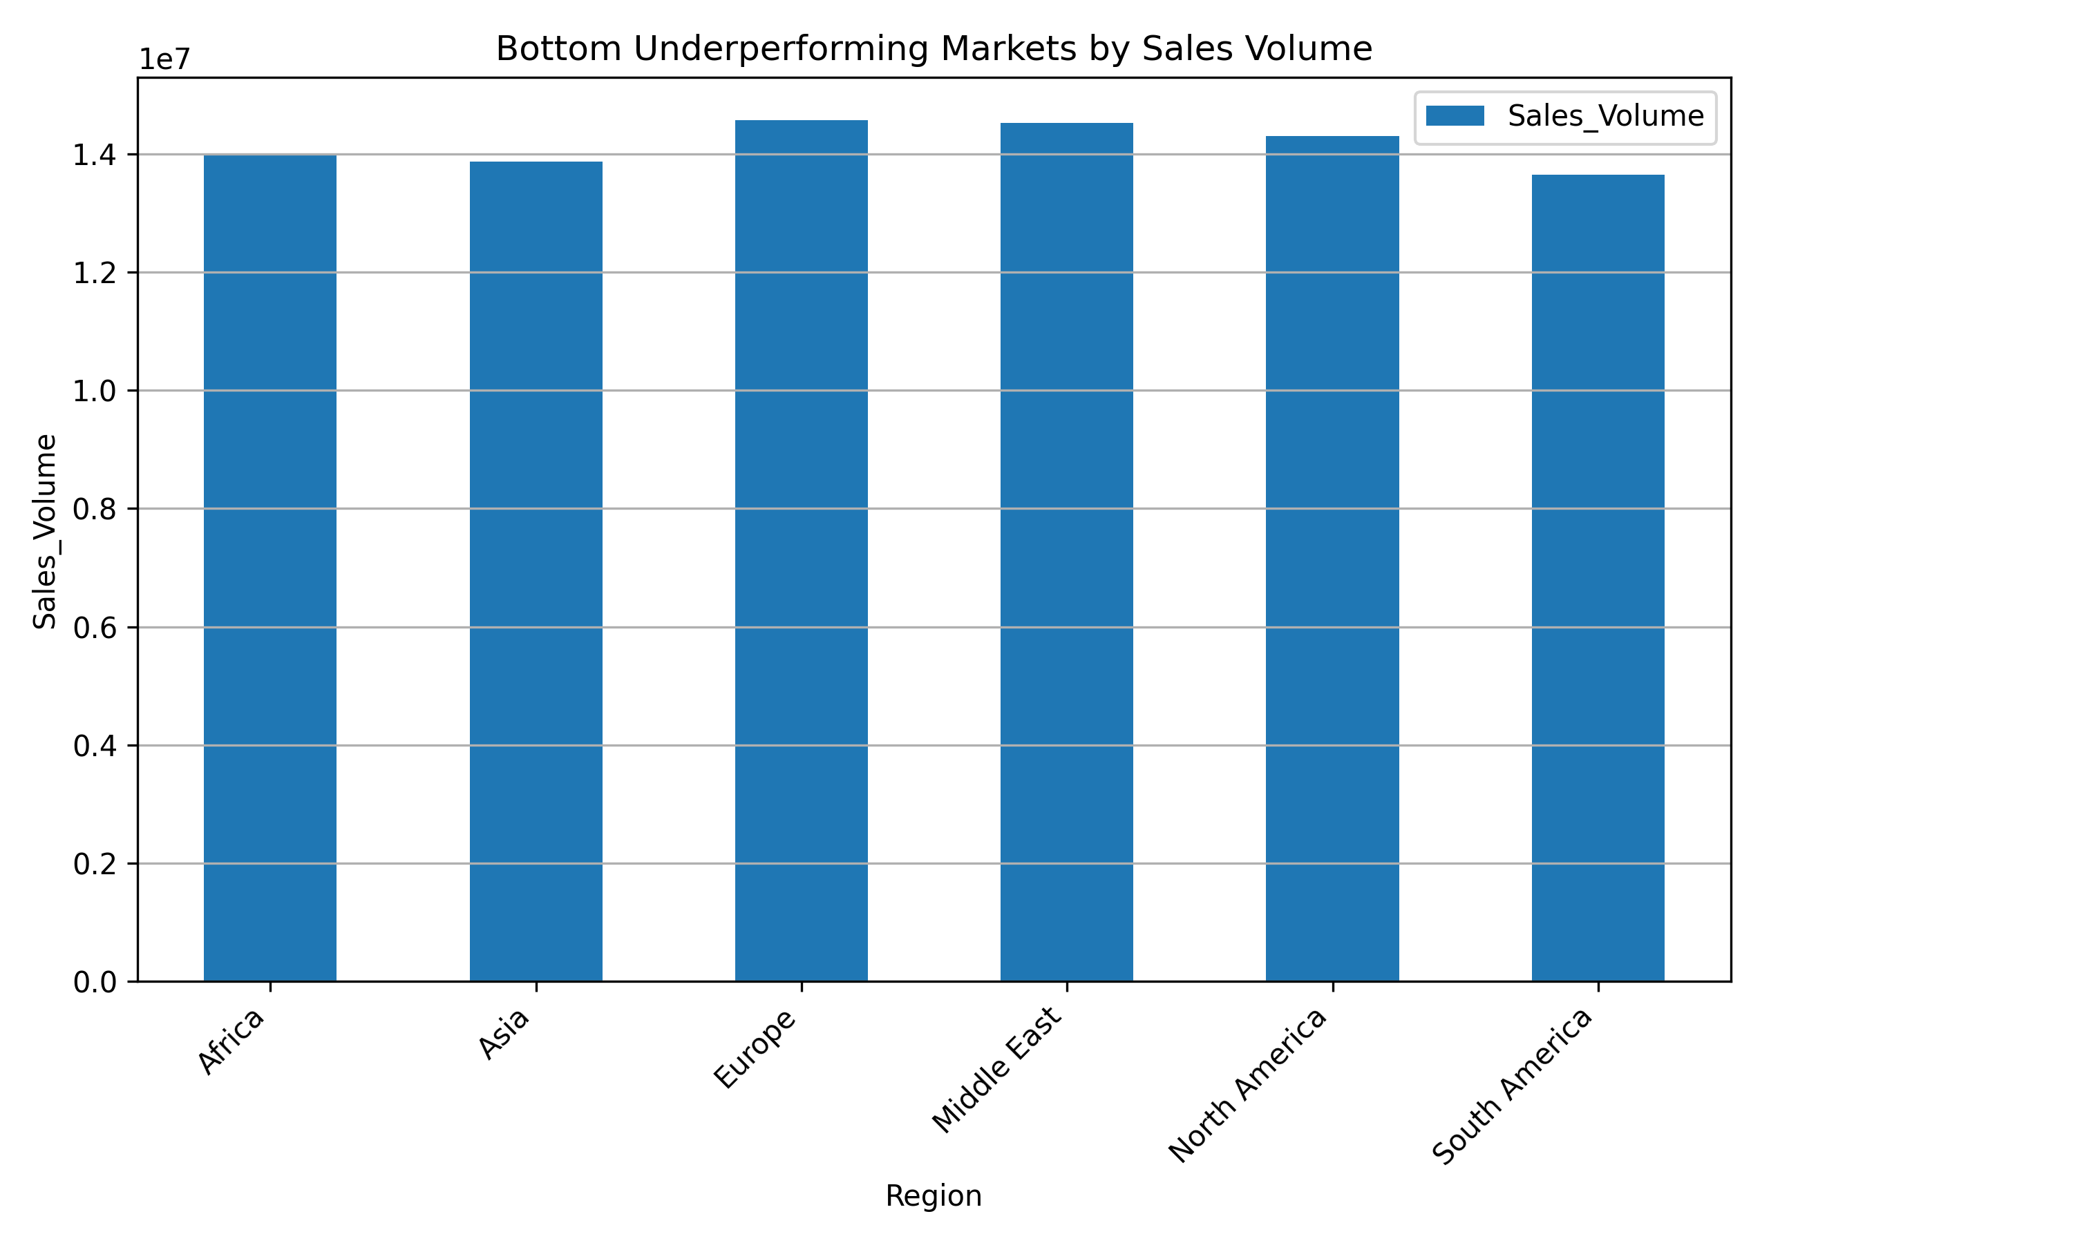
--------------------

Key Drivers of Sales (OLS Regression)
An Ordinary Least Squares (OLS) regression analysis was conducted to identify key drivers of sales volume. The target variable was 'Sales_Volume', and feature variables included 'Price_USD', 'Region', 'Transmission', 'Fuel_Type', and 'Model'.
**Key Findings:**
- **R-squared:** The R-squared value for the model is extremely low (0.00089), indicating that only a very small proportion (less than 0.1%) of the variance in sales volume can be explained by the selected independent variables. This suggests that the model is not a good fit for predicting sales volume based on these features alone.
- **Coefficients and P-values:** Most feature variables, including 'Price_USD' and the different categories within 'Region', 'Transmission', 'Fuel_Type', and 'Model', show high p-values (mostly greater than 0.05). This implies that, at conventional significance levels, these variables are not statistically significant predictors of sales volume in this dataset. For instance, 'Price_USD' has a very small coefficient (0.0001) and a high p-value (0.9067), suggesting no significant linear relationship with sales volume.
- **Relative Impact:** While not statistically significant, 'Model[T.X6]' (coefficient 129.23) and 'Model[T.i3]' (coefficient -112.96) show the largest absolute coefficients among the models, hinting at a potential (though not statistically robust) relative positive impact for X6 and negative for i3 on sales volume compared to the baseline model. Similarly, 'Region[T.South America]' has a negative coefficient (-118.59), but its p-value (0.1255) is above the typical significance threshold.
**Conclusion:** The OLS regression results suggest that the chosen factors are not strong linear predictors of sales volume. It is highly likely that other variables, not included in this analysis (e.g., marketing spend, economic indicators, competitor activity, seasonality, customer demographics, specific product features), play a more significant role in driving sales. The current model lacks explanatory power.
--------------------

Additional Insights and Hypotheses
1. **Market Stability vs. Growth Opportunities:** The consistent sales trends across regions without significant growth or decline could indicate a saturated market. This might mean that growth strategies should focus on market share capture rather than overall market expansion, or on identifying niche growth segments. Further investigation into market specific growth inhibitors and drivers is needed.
2. **Beyond Price and Basic Features:** The OLS analysis strongly suggests that factors like `Price_USD`, `Region`, `Transmission`, `Fuel_Type`, and `Model` are not primary drivers of sales volume. This leads to the hypothesis that intangible factors (brand loyalty, customer experience, after-sales service) or external macroeconomic conditions and competitive landscape are more influential. Future analysis should incorporate these types of variables to build a more robust predictive model. The low R-squared also implies that the relationship between these features and sales volume is likely not linear, or there are significant interaction effects not captured by the current model.
--------------------

Recommendations
Based on the analysis, the following recommendations are put forth:
1. **Strategic Focus on Top Performers:** Continue to invest in and promote top-performing models (7 Series, X6, M5) and regions (Europe, Middle East, North America) to maintain their strong sales momentum. Explore what makes these segments successful and replicate best practices.
2. **Revitalize Underperforming Segments:** Conduct in-depth market research for underperforming models (X5, i3, M3, 5 Series, X1) and regions (South America, Asia, Africa to some extent) to understand root causes. This could involve product enhancements, targeted marketing campaigns, price adjustments, or improved distribution strategies.
3. **Expand Data Collection for Deeper Insights:** Given the limited explanatory power of the current regression model, it is crucial to expand data collection to include more influential factors. This may include marketing spend per region/model, economic indicators (GDP growth, disposable income), competitor pricing and product launches, customer satisfaction scores, and detailed product feature data. This will enable the development of more accurate predictive models.
4. **Consider Non-Linear Relationships:** Future analytical efforts should explore non-linear relationships and interaction effects between variables, as the current OLS model's poor performance suggests that linear assumptions may not hold true for sales drivers.
5. **Competitive Analysis:** Implement regular competitive benchmarking to understand how competitors are performing in different segments and what strategies they are employing effectively. This can provide valuable insights for refining our own sales and marketing approaches.
--------------------

