**DevStack(Stein版)安装说明2020-10-20**

**1、修改apt源**

# cp /etc/apt/sources.list /etc/apt/sources.list.backup

# vim /etc/apt/sources.list

|  |
| --- |
| deb http://mirrors.aliyun.com/ubuntu/ bionic main restricted universe multiverse  deb http://mirrors.aliyun.com/ubuntu/ bionic-security main restricted universe multiverse  deb http://mirrors.aliyun.com/ubuntu/ bionic-updates main restricted universe multiverse  deb http://mirrors.aliyun.com/ubuntu/ bionic-proposed main restricted universe multiverse  deb http://mirrors.aliyun.com/ubuntu/ bionic-backports main restricted universe multiverse  deb-src http://mirrors.aliyun.com/ubuntu/ bionic main restricted universe multiverse  deb-src http://mirrors.aliyun.com/ubuntu/ bionic-security main restricted universe multiverse  deb-src http://mirrors.aliyun.com/ubuntu/ bionic-updates main restricted universe multiverse  deb-src http://mirrors.aliyun.com/ubuntu/ bionic-proposed main restricted universe multiverse  deb-src http://mirrors.aliyun.com/ubuntu/ bionic-backports main restricted universe multiverse |

# apt-get update

# apt-get upgrade

**2、配置pip源与Python**

**（1）配置pip国内源**

# mkdir ~/.pip

# vim ~/.pip/pip.conf

|  |
| --- |
| [global]  index-url = https://mirrors.aliyun.com/pypi/simple/  extra-index-url = https://mirrors.163.com/pypi/simple/  timeout = 60 |

**（2）配置pip默认为pip3，Python默认为Python3**

# ln -s /usr/bin/pip2 /usr/bin/pip2.7

# ln -s /usr/bin/pip3 /usr/bin/pip3.6

# rm -f /usr/bin/pip

# ln -s /usr/bin/pip3 /usr/bin/pip

# rm -f /usr/bin/python

# ln -s /usr/bin/python3 /usr/bin/python

**3、准备devstack安装**

**（1）clone devstack代码（Stein版）**

# git clone http://git.trystack.cn/openstack-dev/devstack -b stable/stein

**（2）创建stack账户**

# devstack/tools/create-stack-user.sh

**（3）移动代码（同后续安装目标目录放在一起）**

# mv devstack /opt/stack

# chown -R stack:stack /opt/stack/devstack

**（4）切换到 stack 用户**

# su - stack

# cd devstack

**（5）对于stack账户的pip，再次执行步骤2**

# mkdir ~/.pip

# vim ~/.pip/pip.conf

|  |
| --- |
| [global]  index-url = https://mirrors.aliyun.com/pypi/simple/  extra-index-url = https://mirrors.163.com/pypi/simple/  timeout = 60 |

**4-1、安装控制节点，编辑local.conf**

# stack@controller:~/devstack$ vim local.conf

控制节点（ip与网卡名根据实际设置）

复制粘贴到local.conf后需要检查一下，开头第一行必须是[[local|localrc]]，否则不会生效。

|  |
| --- |
| [[local|localrc]]  #---------------common section even some node role may not use this setting  # use TryStack git mirror  GIT_BASE=http://git.trystack.cn  NOVNC_REPO=http://git.trystack.cn/kanaka/noVNC.git  SPICE_REPO=http://git.trystack.cn/git/spice/spice-html5.git  #LIBVIRT_TYPE=kvm  DEST=/opt/stack  LOGFILE=$DEST/logs/stack.sh.log  VERBOSE=True  LOGDAYS=1  LOG_COLOR=True  RECLONE=false  PIP_UPGRADE=Flase  DOWNLOAD_DEFAULT_IMAGES=False  IMAGE_URLS="http://download.cirros-cloud.net/0.4.0/cirros-0.4.0-x86_64-disk.img"  IP_VERSION=4  SERVICE_IP_VERSION=4  ENABLE_IDENTITY_V2=False  DATABASE_TYPE=mysql  SERVICE_HOST=172.16.62.228  MYSQL_HOST=$SERVICE_HOST  RABBIT_HOST=$SERVICE_HOST  GLANCE_HOSTPORT=$SERVICE_HOST:9292  ADMIN_PASSWORD=admin  MYSQL_PASSWORD=admin  RABBIT_PASSWORD=admin  SERVICE_PASSWORD=admin  # Neutron options  NEUTRON_CREATE_INITIAL_NETWORKS=False  MULTI_HOST=1  USE_PYTHON3=True  enable_service placement-api  enable_service placement-client  disable_service etcd3  #---------------node special section  HOST_IP=172.16.62.228  FLAT_INTERFACE=eno1  #RECLONE=True  #enable_plugin octavia https://opendev.org/openstack/octavia stable/stein  #enable_plugin octavia http://git.trystack.cn/openstack/octavia stable/stein  #disable_service n-cpu q-agt n-api-meta c-vol n-net  disable_service n-cpu c-vol  enable_service q-fwaas,q-vpn  enable_service q-lbaasv2,octavia,o-cw,o-hk,o-hm,o-api |

**4-2、控制节点上，修改脚本**

**（1）修改tools/install_pip.sh**

# vim /opt/stack/devstack/tools/install_pip.sh

注释掉135-140行

**（2）修改lib/apache**

# vim /opt/stack/devstack/lib/apache

第98行改为 uwsgi=$(ls uWSGI*)

第99行改为 mkdir uwsgi & tar xvf $uwsgi -C uwsgi

**（3）修改lib/tempest**

# vim /opt/stack/devstack/lib/tempest

第110行改为python3的写法：

echo $size | python -c "import math; print(int(math.ceil(float(int(input()) / 1024.0 ** 3))))"

**（4）如果已经安装了指定版本的OVS，则需要修改lib/neutron_plugins/ovs_base**

# vim /opt/stack/devstack/lib/neutron_plugins/ovs_base

注释掉64、67行

**4-3、控制节点上，执行denstack安装脚本**

# FORCE=yes ./stack.sh

**4-4、控制节点上，报错后的一些操作**

每次报错后都要先执行 ./unstack.sh

再执行步骤4-3

**（1）Could not install packages due to an EnvironmentError: [Errno 13] Permission denied: '/opt/stack/.cache/pip/wheels/f5/f7/61/86e07ded98f46b16a452dfd6e5eef061833f03b9a6bab5e9dd' Consider using the `--user` option or check the permissions.**

# sudo chmod -R 777 /opt/stack/.cache

**（2）env: ‘/opt/stack/requirements/.venv/bin/pip’: No such file or directory**

# virtualenv -p python3 ../requirements/.venv/

**（3）如果os-testr===1.0.0安装卡住，则可以人工安装os-testr===2.0.0**

# pip install os-testr==2.0.0

若无法解决，就直接改upper-constraints.txt文件

# vim /opt/stack/requirements/upper-constraints.txt

第438行改为 os-testr===2.0.0

**（4）如果cirros-0.4.0-x86_64-disk.img下载卡住，可以浏览器下载，再放入对应目录**

下载链接复制到浏览器 <http://download.cirros-cloud.net/0.4.0/cirros-0.4.0-x86_64-disk.img>

把下载好的镜像文件传到服务器，再放入对应目录

# mv cirros-0.4.0-x86_64-disk.img /opt/stack/devstack/files/

**（5）若git某个模块卡住，则可以手工git clone**

# git clone http://git.trystack.cn/openstack/neutron /opt/stack/neutron -b stable/stein

**4-5、控制节点安装结束后的输出**

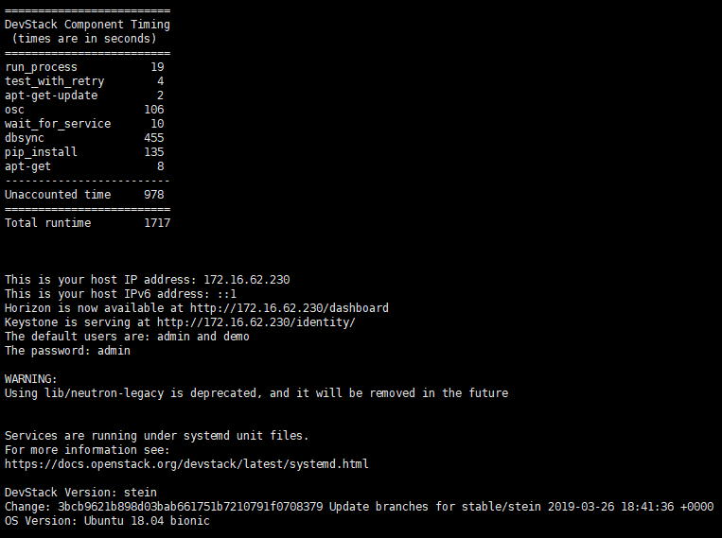

**（1）**执行 # cp /opt/stack/noVNC/vnc_lite.html /opt/stack/noVNC/vnc_auto.html

使得web界面的控制台可以正常显示

**（2）**执行 # ./run_tests.sh 进行各项服务的测试

**（3）**执行 # openstack user list ，若出现 Missing value auth-url required for auth plugin password

则执行 # source openrc admin admin

**4-6、控制节点安装结束后登录OpenStack web界面，账号密码均为 admin**

[http://172.16.62.229/dashboard/auth/login/](http://172.16.62.230/dashboard/auth/login/)

**5-1、安装计算节点，编辑local.conf**

# stack@computer1:~/devstack$ vim local.conf

计算节点（ip与网卡名根据实际设置）

复制粘贴到local.conf后需要检查一下，开头第一行必须是[[local|localrc]]，否则不会生效。

|  |
| --- |
| [[local|localrc]]  #---------------common section even some node role may not use this setting  # use TryStack git mirror  GIT_BASE=http://git.trystack.cn  NOVNC_REPO=http://git.trystack.cn/kanaka/noVNC.git  SPICE_REPO=http://git.trystack.cn/git/spice/spice-html5.git  #LIBVIRT_TYPE=kvm  DEST=/opt/stack  LOGFILE=$DEST/logs/stack.sh.log  VERBOSE=True  LOGDAYS=1  LOG_COLOR=True  RECLONE=false  PIP_UPGRADE=Flase  DOWNLOAD_DEFAULT_IMAGES=False  IMAGE_URLS="http://download.cirros-cloud.net/0.4.0/cirros-0.4.0-x86_64-disk.img"  IP_VERSION=4  SERVICE_IP_VERSION=4  ENABLE_IDENTITY_V2=False  DATABASE_TYPE=mysql  SERVICE_HOST=172.16.62.228  MYSQL_HOST=$SERVICE_HOST  RABBIT_HOST=$SERVICE_HOST  GLANCE_HOSTPORT=$SERVICE_HOST:9292  ADMIN_PASSWORD=admin  MYSQL_PASSWORD=admin  RABBIT_PASSWORD=admin  SERVICE_PASSWORD=admin  # Neutron options  NEUTRON_CREATE_INITIAL_NETWORKS=False  MULTI_HOST=1  USE_PYTHON3=True  #---------------compute node common section  ENABLED_SERVICES=n-cpu,q-agt,n-api-meta,placement-client,n-novnc  NOVA_VNC_ENABLED=True  NOVNCPROXY_URL="http://$SERVICE_HOST:6080/vnc_auto.html"  #---------------compute node special section  HOST_IP=172.16.62.231  FLAT_INTERFACE=enp5s0  VNCSERVER_PROXYCLIENT_ADDRESS=$HOST_IP  VNCSERVER_LISTEN=$HOST_IP  #ENABLED_SERVICES+=,c-vol |

**5-2、计算节点上，修改脚本，同4-2**

**5-3、计算节点上，执行denstack安装脚本**

# FORCE=yes ./stack.sh

**5-4、计算节点上，报错后的一些操作**

每次报错后都要先执行 ./unstack.sh

再执行步骤5-3

**具体操作同4-4，一般只会遇到4-4- (1)(2)(5)的报错，git clone和安装时的网络环境有关**

**5-5、计算节点安装结束后的输出**

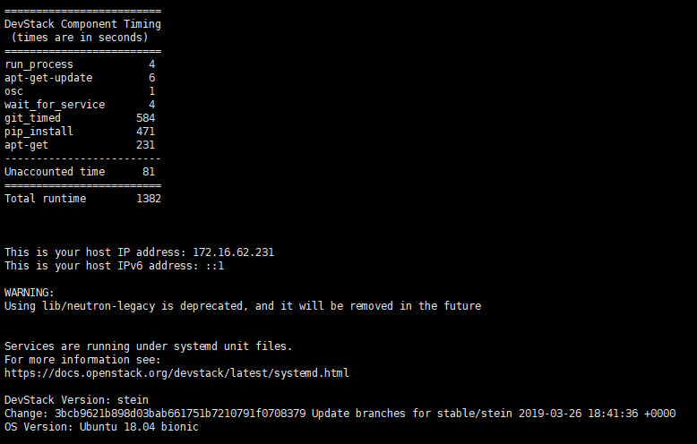

执行 # ./run_tests.sh 进行各项服务的测试

执行 # openstack user list ，若出现 Missing value auth-url required for auth plugin password

则执行 # source openrc admin admin

**5-6、让计算节点注册，在控制节点上运行**

# stack@controller:~/devstack$ /opt/stack/devstack/tools/discover_hosts.sh

**5-7、计算节点安装结束后登录OpenStack web界面，账号密码均为 admin**

[http://172.16.62.229/dashboard/auth/login/](http://172.16.62.230/dashboard/auth/login/)

侧边栏：管理员/计算/虚拟机管理器，可以看到新增的计算节点

[http://172.16.62.229/dashboard/admin/hypervisors/](http://172.16.62.230/dashboard/admin/hypervisors/)

