CSI 300 Forecast Report
Jianwei Zuo 26073609 | 12 November 2026
jiaweizuo217-hub/CSI-300-Forecast-Report: This report forecasts the CSI 300 closing level on 20 November 2026 using a switching model: Random Forest (RF) is used when the trend rule signals an uptrend; otherwise, the model uses RandomWalk. RandomWalk, which predicts no change from the latest close, is the benchmark.

Executive Summary and Final Forecast
The requested point forecast for the CSI 300 close on 20 November 2026 is 4,043.93, selected from the RF-if-uptrend, RandomWalk-otherwise switching model. The benchmark is RandomWalk: from the 11 November close of 4,075.71 it predicts no change, so the hybrid forecast is 4.29 points (+0.1053%) above the baseline. The supplied files do not include the 11 November trend flag or RF output, so this selection cannot be independently reproduced from the attachments. A seven-session historical diagnostic of a fixed +0.1053% tilt did not beat RandomWalk on average; it is a sensitivity proxy, not a backtest of the hybrid rule.
Forecast component | Observed value, calculation or judgement
Observed reference close | 4,075.71 points at 11 Nov 2026 close; cross-checked externally [3]
Target and horizon | 20 Nov 2026; seven following trading sessions
Benchmark calculation | RandomWalk predicts no change; baseline = 4,075.71
Selected model | RF if the origin-date trend rule signals uptrend; otherwise RandomWalk. The 11 Nov trend flag and RF output are absent from supplied files.
Hybrid forecast and difference | Selected hybrid forecast = 4,080.00; +4.29 points (+0.1053%) versus RandomWalk benchmark
Final point forecast | 4,080.00 points; implied simple return versus baseline = +0.1053%

Market and Information Boundary
The asset is the CSI 300 price index (Wind identifier 000300.SH), which tracks 300 large and liquid A-share securities listed in Shanghai and Shenzhen. The supplied workbook contains 689 dated observations from 2 January 2024 to 9 November 2026, with six price/trading fields and 42 technical-indicator fields. The 11 November close of 4,075.71 is an externally cross-checked observation, not a value in that workbook [1–3].
The forecast origin is the 11 November close. Daily closing and full-day volume data become usable only after the session and vendor release; the actual publication clock time was not recorded. High and low prices are absent from the workbook, although the vendor WR field is present. The Wind export time, query and file hash are also missing, so the feature snapshot cannot be reproduced exactly. The 11 November base close is sourced externally [3]; factor inputs after 9 November are not available in the supplied workbook.
The existing supervised model predicts a six-session log return, r(t,6) = ln(Close[t+6] / Close[t]), and converts it to a level with Close[t] × exp(r̂). The 20 November target is seven sessions after 11 November, so the existing six-session model output is not directly transferable. The final 4,080 estimate instead uses the explicit benchmark-plus-judgement calculation above; the target close is used only for later scoring.

Factor Definitions and Economic Mechanism
Each input below is a Wind daily technical-indicator field in the supplied workbook. Its value is observable only after the feature date closes and Wind publishes the completed record; the exact publication timestamp is not logged. Lookback parameters follow the workbook column headers, not generic software defaults. The fields are computable, but none is a causal driver on its own.

Factor, formula and lookback | Source, frequency and publication time | Expected sign, transmission and failure
MTM = C[t] − C[t−6]; six-session interval/period. | Wind MTM field; daily; after close and vendor release (clock time unrecorded). | Momentum theory suggests + continuation, but training Rank IC is −0.092. Slow investor adjustment can sustain moves; reversals, policy shocks and crowded trades can reverse the sign.
WR(14) = 100×(HHV14−C)/(HHV14−LLV14); 14 sessions. | Wind WR field; daily; after close and vendor release (clock time unrecorded). | High WR is near the range low; mean reversion suggests + forward return, but a strong downtrend can keep it oversold. The short-window IC selection was post hoc.
VHF(28) = (max C−min C) / Σ|ΔC|; 28 sessions. | Wind VHF field; daily; after close and vendor release (clock time unrecorded). | No unconditional return sign: VHF measures trend efficiency, not direction. It may support continuation given an independently known direction; reversals or range transitions weaken it.
VOSC(12,26) = 100×(MA12(VOL)−MA26(VOL))/MA26(VOL). | Wind VOSC field; daily; after close and vendor release (clock time unrecorded). | Positive volume expansion may confirm a price trend, consistent with training IC +0.1126; volume is not net buying and rebalancing/holiday effects can break the link.
VSTD(10) = rolling SD of volume; 10 sessions. | Wind VSTD field; daily; after close and vendor release (clock time unrecorded). | No stable directional sign; training IC +0.1566. Dispersion may proxy for participation or disagreement, but rises in both rallies and sell-offs; sample/population SD convention must be confirmed.

The factor note reports the training Rank ICs above and MTM IC −0.0920; these are time-series associations for one index, not cross-sectional stock premia. WR’s full-sample Rank IC is approximately −0.004, and it was added after inspecting September/October ICs; treat it as exploratory [2, 4]. The workbook omits separate high/low price columns, so independent WR recomputation requires OHLC data or a documented Wind calculation.

Agent Workflow and Modelling
A single analyst-agent workflow supported the research; no sub-agent was used. It inspected the notes, workbook schema, scripts, CSV outputs and figures; deterministic Python code constructed labels, fitted models and wrote metrics. The auditable sequence is to confirm the instrument, freeze available features, construct six-session returns, fit chronologically, compare with RandomWalk, inspect regime errors and reserve the final point forecast for human review. A presentation can follow the same sequence and connect each decision to its evidence.
The main historical run uses all 41 non-synchronous indicators after excluding the broad-market synchronous field, but complete-case filtering shortens its usable holdout. The final-date forecast example refits using the five indicators populated on 3 November. A separate validation script re-fits the same model classes with those five indicators so its benchmark is closer to the final input set. These are different experiments and their scores must remain separately labelled.
Five candidate models were used:
- RandomForest (Random Forest)
- HistGradientBoosting (Histogram Gradient Boosting Tree)
- Ridge (Ridge Regression)
- SVR (Support Vector Regression)
- RandomWalk (Random Walk baseline: predicts future index as equal to current index)
Finally, a hybrid model combining RandomForest and RandomWalk was selected.
The model set is RF (500 trees, depth 3, minimum leaf 5), XGBoost (180 trees, depth 2), RBF-SVR (C=1, epsilon=0.1, scaled inputs), Ridge (alpha 10), a 16-8-4 feed-forward network with early stopping, and an LSTM using 10-session sequences and 12 units. Return targets are scaled on training data only and converted back to index levels. RandomWalk predicts no change. The rule selects RF when the close is above its 20-day average and that average rose over five sessions; otherwise it selects RandomWalk. This rule is observable at the origin, unlike realised direction.

Validation and Benchmark
Because the 20 November target is seven sessions after the 11 November origin, the primary comparison is a seven-session unchanged-price benchmark. Using the supplied Wind closes, we evaluated 69 ordered origins from 17 July to 29 October 2026; their targets run from 28 July to 9 November. At each origin the RandomWalk forecast is that origin’s close. The comparison rule adds the same +0.1053% tilt as the requested forecast. Neither rule estimates parameters, and the tilt was not tuned on these origins; its retrospective result is diagnostic, not independent proof.
Seven-session rule | Origins / target dates | MAE | RMSE | Worst absolute error
RandomWalk: forecast = origin close | 69; 17 Jul–29 Oct / targets 28 Jul–9 Nov | 91.38 | 110.67 | 239.38 points; 13 Oct → 22 Oct
Fixed +0.1053% tilt | 69; same ordered origins | 93.82 | 113.40 | 243.88 points; 13 Oct → 22 Oct

The uplift worsens MAE by 2.44 points versus the unchanged-price benchmark. This directly tests the key assumption that a small positive drift helps; in this historical sample it did not. On the worst origin, the unchanged forecast was 4,275.68 versus an actual 4,036.30 nine calendar days later (239.38 points lower). This is an observed failure, not a prediction interval.

Context from the Existing Six-Session Model
The attached model charts and CSV are a 41-indicator complete-case run; the existing Word draft also reports a separate five-indicator refit. These results use different inputs and coverage and are not comparable with each other or with the seven-session target. The historical switch MAE was only modestly below RandomWalk, while RF alone was worse:
Six-session holdout | Targets (n) | RandomWalk MAE | RF MAE | Switch MAE
41 indicators | 17 Jul–28 Oct (68) | 95.96 | 126.12 | 94.52
Five populated indicators | 17 Jul–9 Nov (76) | 92.02 | 110.36 | 90.83

Errors differ sharply by realised direction. This supports a conditional mechanism but is ex-post segmentation: the trend rule itself must rely only on information at the forecast origin. The five-factor results also inherit the post-hoc WR selection.
Realised test direction (41-indicator run) | N | RF MAE | RandomWalk MAE
Up days | 20 | 35.41 | 59.55
Down days | 48 | 163.92 | 111.14

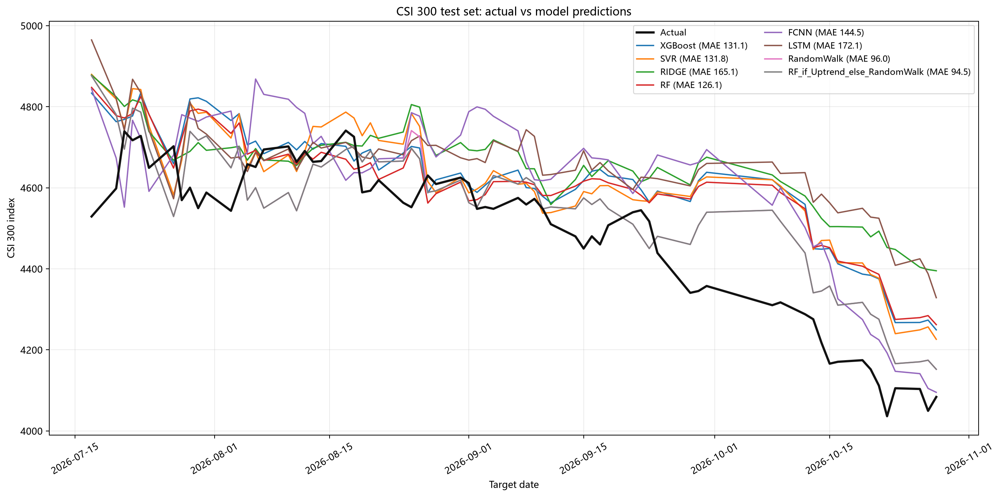
Figure 1. Actual closes and selected predictions in the 41-indicator complete-case holdout. Source: supplied model_predictions.csv; target dates run from 17 July to 28 October 2026.

Limitations and Counterargument
The seven-session calculation meets the horizon and multiple-origin requirements for a simple baseline comparison, but not the full origin-by-origin fitted-model requirement: the 4,080 forecast has no estimated factor coefficients, and the existing supervised comparisons fit once at a cutoff rather than refitting at each origin. Their target-date split can also let a six-session training label become known after an early test feature date. A strict model comparison needs expanding-window refits using only labels available at each origin and a six-session purge [5].
The 4.29-point difference from RandomWalk is the selected hybrid model’s reported premium, but the supplied files contain neither the 11 November trend flag nor its RF output; they therefore do not support independent reconstruction of its exact size or positive sign. The 7-session fixed-tilt sensitivity proxy underperformed RandomWalk, and is not a direct walk-forward test of the hybrid. The adverse case is continued decline: on 13 October the unchanged forecast missed by 239.38 points. The estimate 4,080 is vulnerable to a downtrend and is not an interval bound.
WR was selected after September/October ICs were viewed, creating selection bias. The 41- and five-feature runs answer different questions; neither reports a fully purged walk-forward test, and the Wind vintage/publication timestamp is absent. The training-fit chart is in-sample. Zero-change RandomWalk also receives zero directional accuracy under sign scoring. A final report should preserve a frozen data snapshot and disclose the single point forecast separately from historical errors.

Assessment Against the Requested Criteria
Requirement | Status in this draft
Computable factors and timing | Partly met: formulas, Wind source fields, daily frequency, lookbacks, signs and mechanisms are stated. Exact Wind publication timestamps are missing, and WR cannot be independently recomputed without high/low inputs.
Factor-to-level calculation | Partly met: RandomWalk baseline and the selected hybrid forecast (+4.29 points) are stated. The 11 November trend flag and RF output are missing, so the hybrid level cannot be independently recalculated from supplied files.
Comparable validation | Partly met: 69 ordered seven-session origins compare the unchanged-price benchmark with the fixed uplift, including MAE, RMSE and the worst miss. The supervised models were not refit at every origin and their reported horizon is six sessions.
Sensitivity and adverse case | Addressed as a diagnostic: zero uplift beats +0.1053% drift in the historical test; the 239.38-point miss illustrates a downside failure. No calibrated prediction interval is claimed.

Contribution Statement
This was an individual assignment. [Student name] selected the 20 November forecast from the RF-if-uptrend, RandomWalk-otherwise hybrid model and used RandomWalk as the benchmark.

References
[1] China Securities Index Co. CSI 300 Index Methodology (official PDF).
[2] Assignment sources: CSI300_index_wind.xlsx (sheet1), 数据_润色版.pdf, model.py, validation_analysis.py and supplied output CSVs.
[3] CSI 300 close, 11 November 2026: Investing.com historical data and Yahoo Finance historical data, cross-checked 12 November 2026. https://cn.investing.com/indices/csi300-historical-data ; https://finance.yahoo.com/quote/000300.SS/history/
[4] Bailey, D. H., Borwein, J. M., López de Prado, M., & Zhu, Q. J. (2017). “The Probability of Backtest Overfitting.” Journal of Computational Finance, 20(4), 39–69. doi:10.21314/jcf.2016.322.
[5] scikit-learn developers. TimeSeriesSplit documentation.

