ABSTRACT

Advancement in technology is ceaselessly developing. Society as we presumably am mindful it depends on upon this. Application generator system basically deals with generating a application soft copy which we require in day to day activity in several governmental and non-governmental offices. This system eases the task of writing application in the offices which are on pre-specified format and tends to simplify and reduce the most tedious job efficiently and also generates the Curriculum Vitae as per requirement of the user. As a whole this system reduce the user confusion on official application writing format and dependency on other people outsides of offices.

TABLE OF CONTENTS

ABSTRACT i

TABLE OF CONTENTS ii

LIST OF FIGURE iii

ACRONYMS iv

1. INTRODUCTION 1

1.1 BACKGROUND 1

1.2 OVERVIEW 2

1.3 PROBLEM STATEMENT 2

1.4 OBJECTIVE 2

1.5 SCOPES/APPLICATIONS 3

2. LITERATURE REVIEW 4

3. PROJECT METHODOLOGY 5

3.1 DEVELOPMENT MODEL 5

3.2 PROJECT WORKFLOW 7

4. SYSTEM DESIGN 9

4.1 BLOCK DIAGRAM 10

4.2 ER DIAGRAM 11

4.3 USE CASE DIAGRAM 12

5. FUNCTIONAL AND NON-FUNCTIONAL REQUIREMENTS 13

5.1 FUNCTIONAL REQUIREMENT 13

5.2 NON-FUNCTIONAL REQUIREMENT 13

6. RESULTS AND DISCUSSION 14

7. CONCLUSION 15

8. LIMITATIONS AND FUTURE WORK 16

9. REFERENCE 17

APPENDIX 18

LIST OF FIGURE

Figure 1 Prototype Model 6

Figure 2: Workflow of an Application Generator 7

Figure 3 Block Diagram of an Application Generator 10

Figure 4: ER Diagram of an Application Generator 11

Figure 5: Use Case Diagram of an Application Generator 12

Figure 6 Admin Login 18

Figure 7 Admin Dashboard 18

Figure 8 Home Page I 19

Figure 9 Home Page II 19

Figure 10 Edit Template 20

Figure 11 PDF Generation 20

ACRONYMS

API Application Programming Interface

CRUD Create, Read, Update and Delete

CSRF Cross-Site Request Forgery

CSS Cascading Style Sheet

ERD Entity Relationship Diagram

GUI Graphical User Interface

IDE Integrated Development Environment

OS Operating System

PDF Portable Document format.

RDBMS Relational Database Management System

SQL Structured Query Language

XSS Cross Site Scripting

HTML Hypertext Markup Language

CSS Cascading Style Sheet

# INTRODUCTION­­­

## BACKGROUND

As being a developing country, Nepal has a lot of improvement to be done on many sectors like education, transportation, government offices, etc. The written application in paper format are valid and legally accepted in every official work that a government body has right to perform. The letters that an individual needs in different administrative offices for the different purposes like land registration, company registration, landowner transfer, citizenship certificate request, Educational certificate request are operated by government body ,as stated in the letter that an individual submits to an office, i.e the written application is valid and only accepted and stay as a proof to every problem statement in government body. A good format is a very important issue in submitting an application. It has been a severely ignored issue in today's automated world.

If a person has less time and is unknown of the formats for the application letter, he pays another person for it. To overcome these sorts of small issues that are ignored, several solutions have been tried these days in many countries in their respective languages but not in Nepali.

As application being used in official works for different purposes follow some technical specification of writing like formal language selection, correct grammar and have to follow application writing format ,problem expressing order in application, which are tedious for every individual to remember and write with less or no error, Also the individual have to depend on the people who writes application for different programs and problems based on individual requirement which costs money and also facilitates the corruption in any means as government officers and individuals may be linked by any ways to make people bored and bribe money as every normal individual may not be aware of the Citizenship chartered available at government offices, and it is not possible for every public individual to be aware of every application writing procedure whilst in hurry and whilst in need. Application Generator helps the work of individual to be done on time with ease without worrying about the application writing part of their specified work.

## OVERVIEW

An Application is a written document demanding a required material(basically Citizenship, Passport, Curriculum Vitae, Jobs, etc.) in a formal manner including a person's experience and other qualifications. In some countries, a CV(Curriculum Vitae) is typically the first item that a potential employer encounters regarding the job seeker and is typically used to screen applicants, often followed by an interview. An application letter is a comprehensive document that details all your identification, past education, experiences, and competencies, including public presentations, academic writing and professional development. It’s designed to introduce you to employers in academics, advanced research, post-secondary teaching and fine arts.

## ­­­­­­­­­­­PROBLEM STATEMENT

A good format is a very important issue in submitting an application. It has been a severely ignored issue in today's automated world. If a person has less time and is unknown of the formats for the application letter, he pays another person for it. To overcome these sorts of small issues that are ignored, several solutions have been tried these days in many countries in their respective languages but not in Nepali.

'Application Generator' solves the issues mentioned above with ease and provides an excellent application to the user with just entering the required details even if the user is unknown of the letter formats.

## OBJECTIVE

An **Application Generator**  helps to reduce the tedious job of application writing following the specific format keeping in mind the formal language rule one must follow while expressing his problem to government body and help his work done without depending on the other people outside the government offices.

* Save valuable time of writing whole application letter
* Automate your office work
* Generate the applications automatically without knowing the formats
* Both a résumé and a CV are meant to encourage an employer or a supervisor to consider you:

• As an employee

• As a candidate for further studies

• As the right fit for a contract

## SCOPES/APPLICATIONS

You can use an application when you’re:

* applying for citizenship, passport, jobs, etc.
* applying for work and/or contracts in academics, advanced research, post-secondary teaching, and fine arts
* applying for graduate school, scholarships, etc.
* showcasing your background prior to a presentation

# LITERATURE REVIEW

An application generator Web Application is a web based application dealing specifically with generation of formal application required in government bodies. Many web applications are developed on the basis of generating CV for the individual based on the details they provide.CV generator sites offer visitors to make softcopy of their CV based on their personal detail. The previous system where based on Generation of CV and Nepal based system were not into existence. It solely solve the problem faced by individual while doing their job in government offices. Through a application generator web application, a visitor can find a certain application templates which meets his requirements to do their job done. The app provides service for creating official application as per the requirement on the basis of information provided by individuals. Not only that but it also generates the CV for visitor based on their requirements. The app provides services for individual for their requirements for formal application required in government bodies.

The previous system where based on Generation of CV and Nepal based system were not into existence. It solely solve the problem faced by individual while doing their job in government offices.

The web application provides services for the tedious task of writing application The users can have the softcopy of their application which are required in government bodies.

# PROJECT METHODOLOGY

Our proprietary research processes allow us to see IT as it pertains to the evolving business landscape. Our research methodologies are based on our years of experience observing trends and scientifically mapping technology's progress against true delivery. The success of our proprietary methodologies lies in distilling large volumes of templates into clear, precise, actionable insight and advice so our clients can formulate templates and make application generation. The observations and recommendations delivered through our proven methodologies ensure that we generates application with higher level of confidence. Our clients make important multi-year technology investments in the face of uncertainty and risk. Our methodologies help our clients reduce and manage that risk, and enable them to succeed in their roles as they mobilize IT to contribute to their needs of application generation.



## DEVELOPMENT MODEL

Each team member will be assigned several task of the project on the basis of their interest in particular portion of the development of this project. Weekly meeting will be held to assess the status of each member and to facilitate restructuring of plans when required. Project documentation will be performed by the respective team members at the end of each task. Regular discussion with the project mentor will be held to gather suggestions related to the project to update him about the progress of the project.

Xampp will be the development tool that will extensively used by all the team members. Several features of the XAMPP will be utilized to communicate and collaboration of codes between the members. MVC framework is used for the simplicity to code management and better secure system. Also, Bootstrap and JQuery is used for the better design.

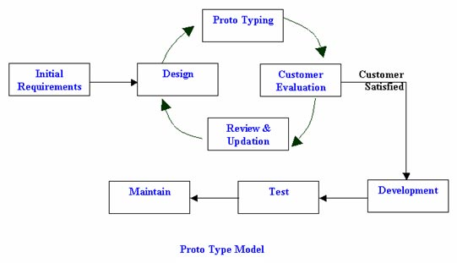

**1**Prototype Model

## PROJECT WORKFLOW

Using the CkEditor tool, templates is created and listed in the view page. User choose the templates and fill the templates and at backend side templates i.e. in HTML form is is templated using templating tool Jinja. After templating , through regex the list of parameters generated after that dynamic from generated. it is converted into final pdf format using the WeasyPrint modules found in python.

2Workflow of an Application Generator

**WeasyPrint**

WeasyPrint converts HTML/CSS documents to PDF. WeasyPrint is a visual rendering engine for HTML and CSS that can export to PDF. It aims to support web standards for printing.

**Jinja**

Jinja is one of the most used template engines for Python. It is inspired by Django's templating system but extends it with an expressive language that gives template authors a more powerful set of tools. On top of that it adds sandboxed execution and optional automatic escaping for applications where security is important. Eg.

{% extends "home/header.html" %}

{% block content %}

<ul>

{% for template in templates %}

{{ user.name }}

{% endfor %}

</ul>

{% endblock %}

**Portable Document Format (PDF)**

**PDF** is a file format used to present and exchange documents reliably, independent of software, hardware, or operating system. Invented by Adobe, PDF is now an open standard maintained by the International Organization for Standardization (ISO). PDFs can contain links and buttons, form fields, audio, video, and business logic. They can also be signed electronically and are easily viewed using free Acrobat Reader DC software.

# SYSTEM DESIGN

Sublime Text is a sophisticated text editor for code, markup and prose.   
Django is a high-level Python Web framework that encourages rapid development and clean, pragmatic design.Due to ridiculously fast, reassuringly secure and exceedingly scalable, we choose Django.

MySQL is the most popular Open Source Relational SQL(structured query language) database management system. MySQL is one of the best RDBMS(Relational Database Management System ) being used for developing web-based software applications. We setup the database MySQL for our project.

This tutorial will give you quick start with MySQL and make you comfortable with MySQL programming.

Bootstrap makes front-end web development faster and easier. It's made for folks o all skill levels, devices of all shapes, and projects of all sizes. So we created the frontend part using Bootstrap.

The different software that we used during the development of the project are:

Bootstrap

SUBLIME TEXT / PYCHARM

Django 1.9

Python3.5

Mysql Server

Mysql python client

The hardware requirements are as listed below:

*A development computer with software installed.

*Apache Server Installation with PC

*256 MB Ram

*20 GB hard disk



## BLOCK DIAGRAM



Block Diagram of Application Generator

3Block Diagram of an Application Generator

Using the manually collected data. Django framework create the template and stored in templates table, the regex will identify the parameter or variable required for template. Regex plays vital role in our system. We have identified pattern “{{variable name}}” in template content by using regex ie “/\{\{\w+\}\}/”. Regex is in compile form so that system will be fast. We have consider performance parameter while developing the System. As for security we have used protection from XSS attrack and we have used crsf token concept in every form in system. There is middleware for securing POST method in system. We do not have to write the raw query instead handled by the ORM (object-relational Mapping). Object-relational mapping (ORM, O/RM, and O/R mapping tool) in computer science is a programming technique for converting data between incompatible type systems in object-oriented programming languages. This creates, in effect, a "virtual object database" that can be used from within the programming language. User select the templates i.e templates of curriculum vitae,resume and cover letter. And finally based on the selected templates pdf (portable document format ) is generated.

## ER DIAGRAM



4ER Diagram of an application Generator

ER Diagram of application Generator

An entity-relationship diagram (ERD) is a graphical representation of an information system that shows the relationship between people, objects, places, concepts or events within that system. An ERD is a [data modeling](http://searchdatamanagement.techtarget.com/definition/data-modeling) technique that can help define business processes and can be used as the foundation for a [relational database](http://searchsqlserver.techtarget.com/definition/relational-database).

Admin , user and template are the three entities having relationship creates and select. Entity admin has the attributes username and password. Admin creates the templates having the attributes name ,content, price and is_published. User select the templates displayed in the index page having the attributes username , email_address ,first_name and last_name.

## USE CASE DIAGRAM

USE CASE diagram of Application Generator

5 USE CASE diagram of an Application Generator

In software and systems engineering, a **use case** is a list of actions or event steps, typically defining the interactions between a role (known in the Unified Modeling Language as an actor) and a system, to achieve a goal. The actor can be a human or other external system.

Admin and user have the functionalities showing above in the fig. As admin first creates the templates of curriculum vitae,resume and cover letter. These templates are displayed in the index page and user selects the templates and fill the templates and finally admin generated the pdf of the selected templates.

# FUNCTIONAL AND NON-FUNCTIONAL REQUIREMENTS

In systems engineering and **requirements** engineering, a **non-functional requirement** is a **requirement** that specifies criteria that can be used to judge the operation of a system, rather than specific behaviors. They are contrasted with **functional requirements** that define specific behavior or functions.

Following are the different functional and non-functional requirements that are related to this project:



## FUNCTIONAL REQUIREMENT

1. User Registration
2. Template Selection
3. Filling Template
4. Generates PDF(Portable Document Format)

## NON-FUNCTIONAL REQUIREMENT

1. One time Authorization
2. Creation of template based on the Regex defined
3. Scalability
4. Security
5. Efficiency
6. Testability

# RESULTS AND DISCUSSION

'Application Generator' solved the issues mentioned above with ease and provided an excellent application to the user with just entering the required details even if the user is unknown of the letter formats. The previous system where based on Generation of CV and Nepal based system were not into existence. It solely solve the problem faced by individual while doing their job in government offices.

The web application provides services for the tedious task of writing application The users can have the softcopy of their application which are required in government bodies.

# CONCLUSION

Don’t Repeat Yourself. Generic application can’t be written multiple time by many guys this cause loss of useful time. So Application Generator will generate the generic application using available template. 'Application Generator' solved the issues mentioned above with ease and provided an excellent application to the user with just entering the required details even if the user is unknown of the letter formats.

# LIMITATIONS AND FUTURE WORK

* Virtual private server
* Esewa integration
* Design improvements
* User can’t create own templates
* Can’t install via Cpanel or Zpanel
* Needs VPS ( increase operating cost )
* Internet

# REFERENCE

[1] www.weasyprint.readthedocs.io/en/latest

[2] www.w3schools.com/bootstrap

[3] www.ckeditor.com/demo

[4] <http://project-proposal.casual.pm/>

[5] www.documents.rec.org/publications/ProposalWriting.pdf

# APPENDIX

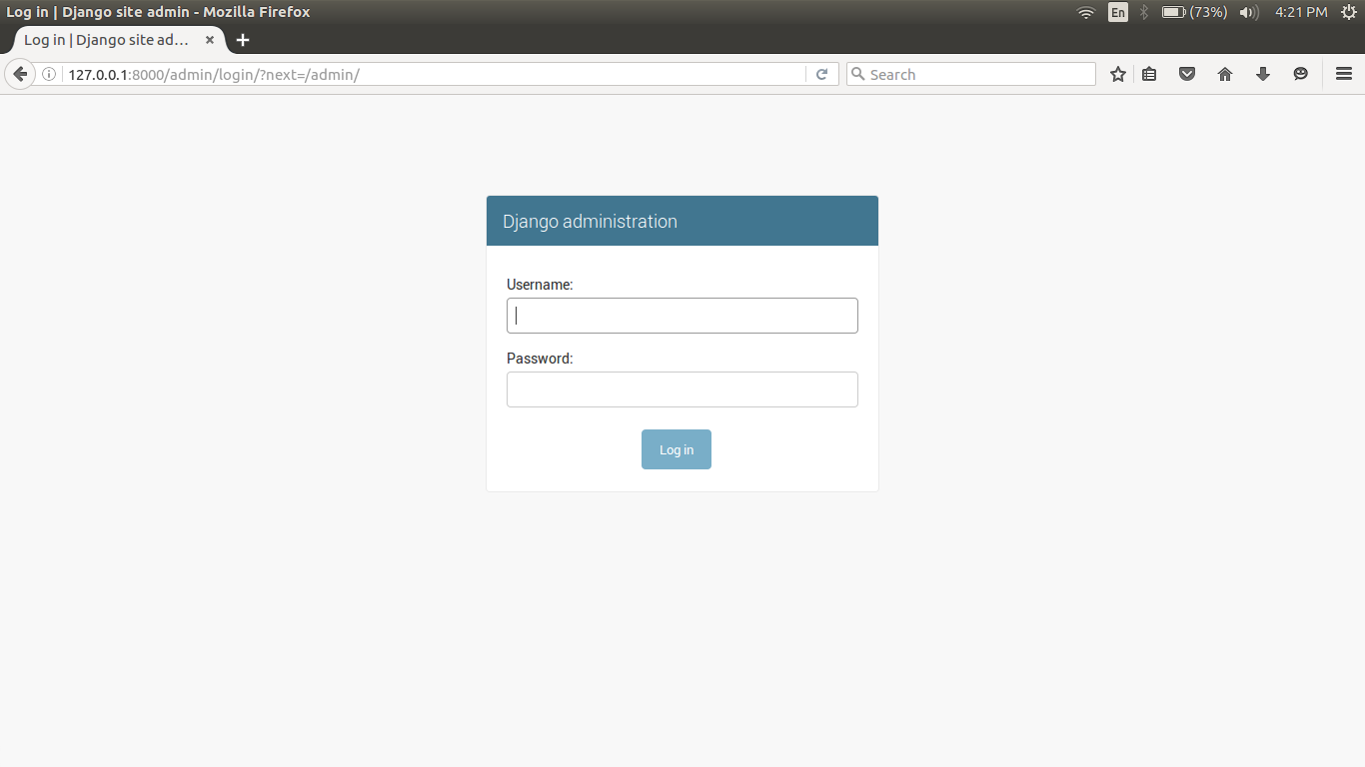

Admin Login

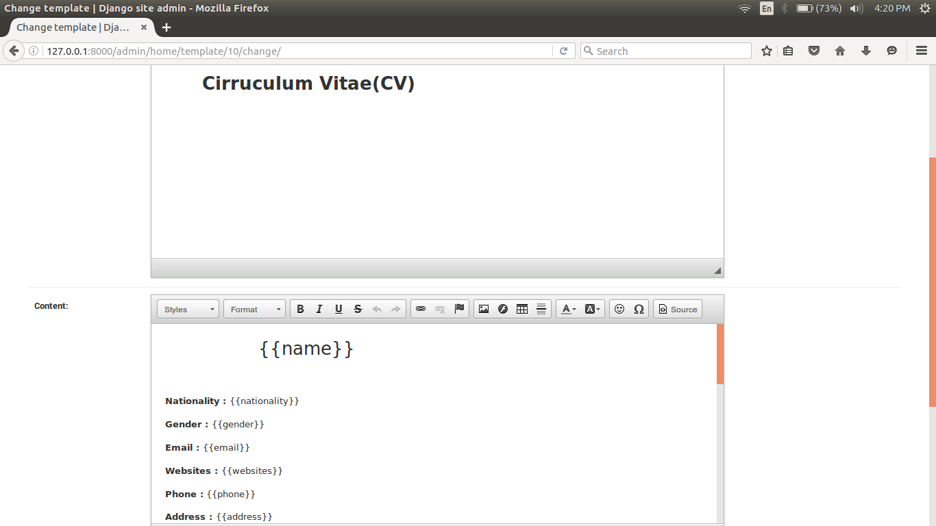

Admin Dashboard

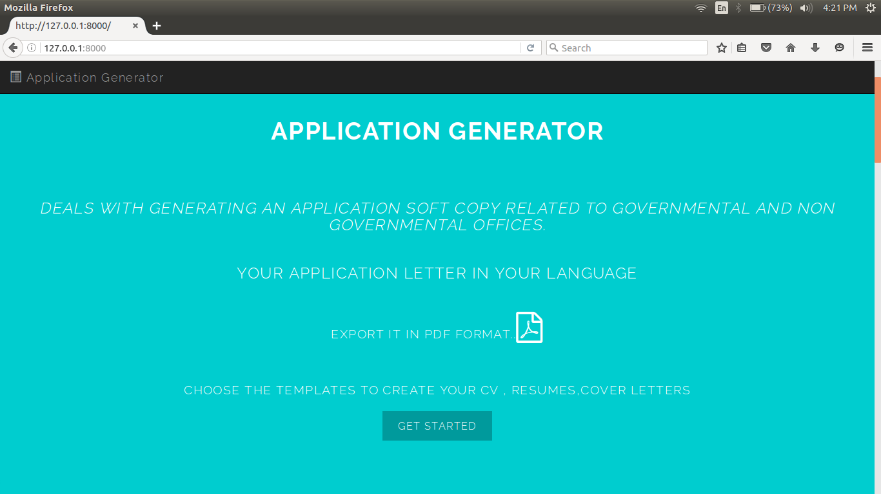

Home Page I

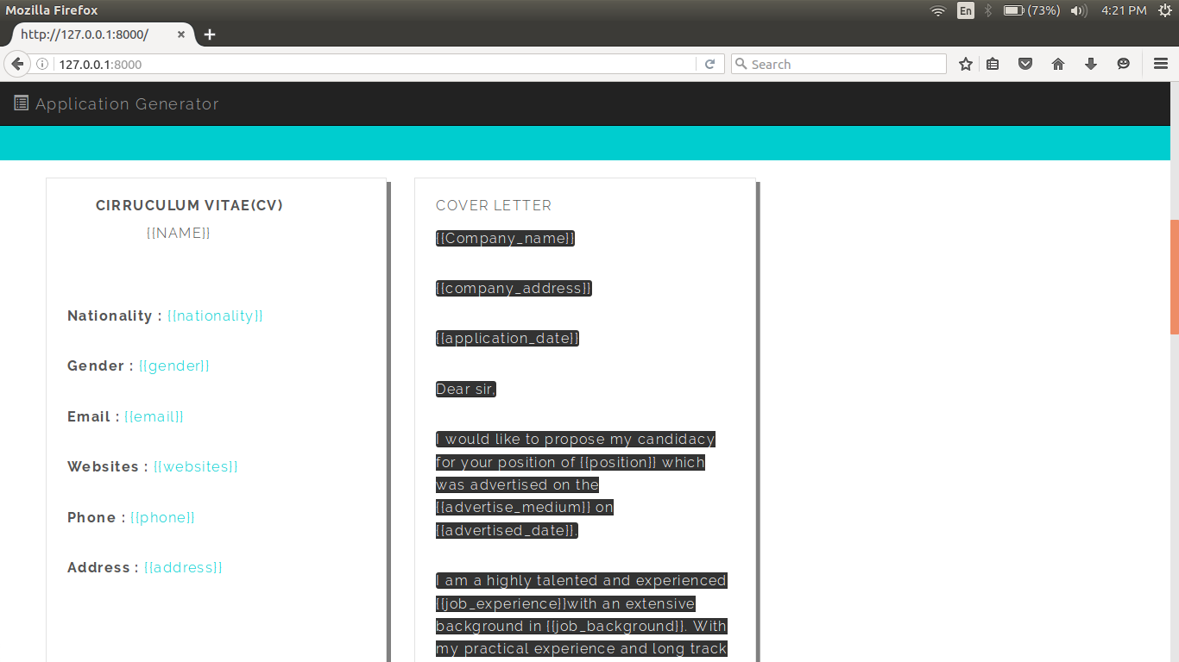

Home Page II

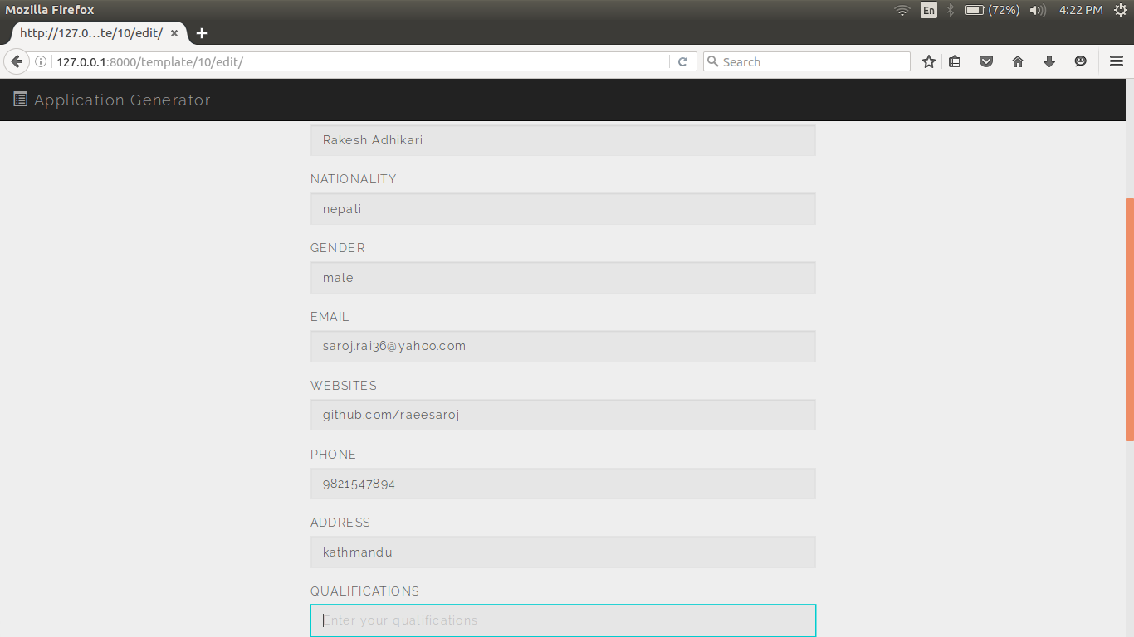

Edit Template

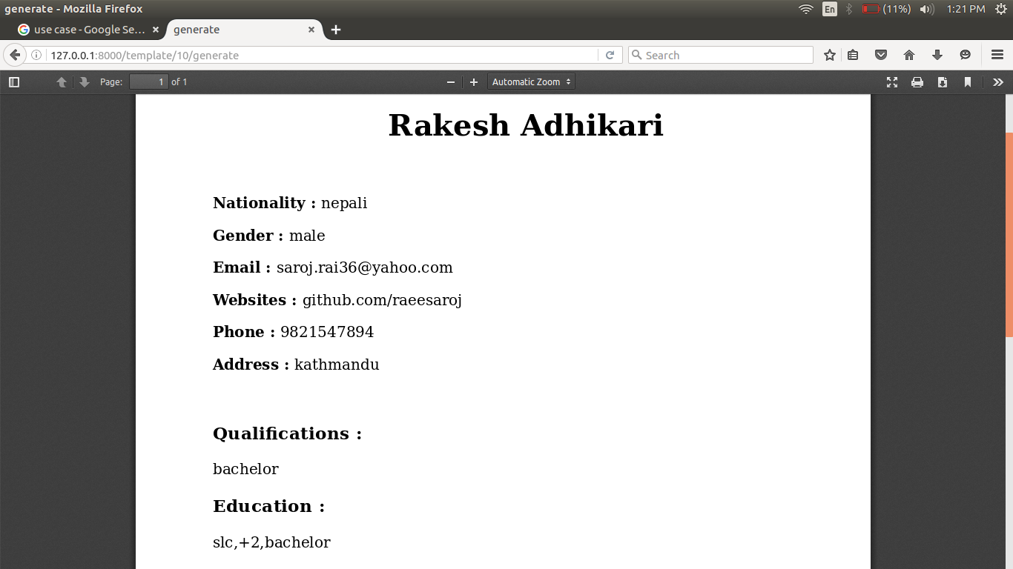

PDF Generation