目录

2017 September 1 Friday 1

(1) End-to-end 3D face reconstruction with deep neural network (cvpr17) 1

(2) Learning Detailed Face Reconstruction from a Single Image (cvpr17) 2

(3) DenseReg: Fully Convolutional Dense Shape Regression In-the-Wild (cvpr17) 4

(4) Fast 3D Reconstruction of Faces with Glasses (cvpr17) 4

(5) Automated 3D Face Reconstruction from Multiple Images using Quality Measures (cvpr17) 4

2017 September 2 Saturday 6

(1) Regressing Robust and Discriminative 3D Morphable Models with a very Deep Neural Network (arXiv) 6

(2) What does 2D geometric information really tell us about 3D face shape (arXiv) 6

(3) Towards Large-Pose Face Frontalization in the Wild (arXiv) 6

(4) Deep Face Feature for Face Alignment and Reconstruction (arXiv) 7

(5) Joint Face Alignment and 3D Face Reconstruction with Application to Face Recognition (arXiv) 7

(6) How far are we from solving the 2D & 3D Face Alignment problem? (and a dataset of 230,000 3D facial landmarks) (arXiv) 7

(7) Pix2Face: Direct 3D Face Model Estimation (arXiv) 7

2017 October 7 Saturday 8

(1) 3D Face Reconstruction by Learning from Synthetic Data (cvpr16) 8

# **2017 September 1 Friday**

1. End-to-end 3D face reconstruction with deep neural network (cvpr17)

pipeline:

3D Morphable Model

S = S¯ + $U^{d}$· $a^{d}$ + $U^{e}$· $a^{e}$

Network

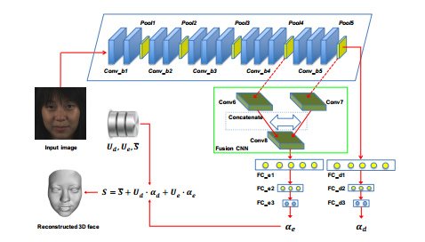

VGG-Face (blue box): learn generic features corresponding to low-level facial structures

Fusion-CNN (green box): are forced to learn expression specific features.

Loss Function

difference between the predicted 3D face and the ground truth

consequence:

Dataset

FRGC2 database [21], the BU-3DFE database [31], and the UHDB31 database [29]

Sequence (mm)

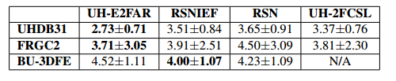

summary:

old network structure

small learning rate: mini-batch size and the initial learning rate set to 32 and 0.0001

no code

single image

1. Learning Detailed Face Reconstruction from a Single Image (cvpr17)

pipeline:

3D Morphable Model

Pose and Geometry

parallel weak perspective projection

Network

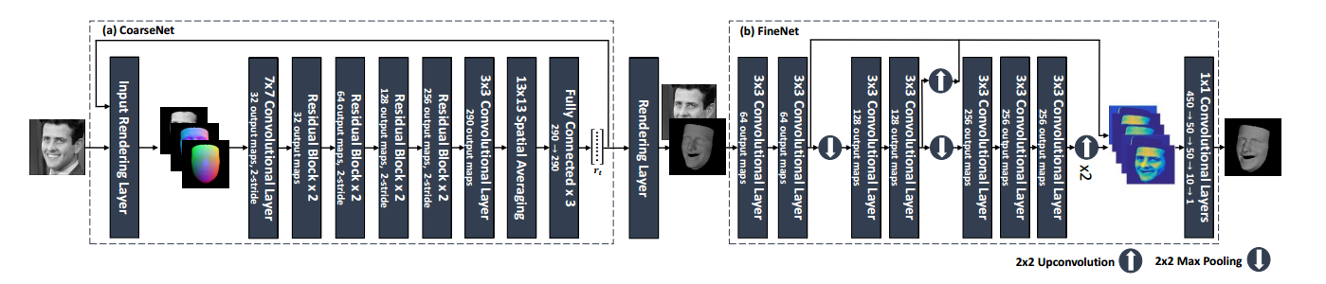

Coarse:

ResNet-101

Feedback:

different types of feedback channels would emphasize different features of the current state

Feedback1: average normalized face model’ projection(initial)

+ average face model’ normalized projection

也是一个获取额外数据的方法·

Feedback2: normal values of average normalized face model

Loss Function

Geometry Mean Square Error

Fine:

Render layer:

representing the geometry as a depth map，the pixel may correspond to two vertex, choose the close ibe

z~ = λ0z0 + λ1z1 + λ2z2;

VGG-Face

consequence:

Dataset

FRGC2 database [21]

Sequence

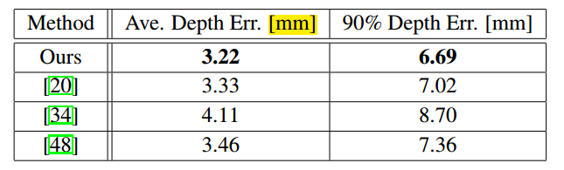

summary:

old network structure

new structure - depth map

no code

single image

1. DenseReg: Fully Convolutional Dense Shape Regression In-the-Wild (cvpr17)

pipeline:

consequence:

summary:

1. Fast 3D Reconstruction of Faces with Glasses (cvpr17)

pipeline:

Segmentation of Eyeglasses

Heatmap for 3D Reconstruction

?

consequence:

Dataset

self-synthetic Data

summary:

idea

1. Automated 3D Face Reconstruction from Multiple Images using Quality Measures (cvpr16)

pipeline:

The core element of this algorithm and the focus of our paper is a quality measure that judges a reconstruction without information about the true shape

Instead, we argue that in many real-world applications more than one image of a person is available, so an automated algorithm can exploit redundant data from multiple images to gain robustness and reliability

An algorithm for selecting and combining reconstructions of different facial regions (segments) from different input images into a single 3D face

3D Morphable Model

reconstructs individual 3D shapes from multiple single images of one person, judges their quality and then combines the best of all results

3D Morphable Model

Fitting the model to an image is essentially a minimization of the image distance

Newton-Iter

Quality Measures

Image distance, Mahalanobis Distance, Euclidean Distance, Normal Distance

consequence:

Dataset

self-data

summary:

idea

# **2017 September 2 Saturday**

1. Regressing Robust and Discriminative 3D Morphable Models with a very Deep Neural Network (cvpr17)

pipeline:

consequence:

summary:

code: http://www.openu.ac.il/home/hassner/projects/CNN3DMM/

1. What does 2D geometric information really tell us about 3D face shape (arXiv)

pipeline:

SHAPE-FROM-LANDMARKS

describe a novel method for fitting a 3D morphable model to a set of 2D landmarks

consequence:

dataset

none

summary:

overview

1. Towards Large-Pose Face Frontalization in the Wild (arXiv)

pipeline:

Gan

Face Frontalization Generative Adversarial Network (GAN), termed as FF-GAN, to generate neutral head pose face images

consequence:

summary:

idea

1. Deep Face Feature for Face Alignment and Reconstruction (arXiv)

pipeline:

3D Morphable Model

Deep Face Feature Training

consequence:

summary:

single image

1. Joint Face Alignment and 3D Face Reconstruction with Application to Face Recognition (arXiv)

pipeline:

consequence:

dataset

BU3DFE [5], AFLW [9], and AFLW2000 3D [10] databases.

sequence

summary:

1. How far are we from solving the 2D & 3D Face Alignment problem? (and a  
   dataset of 230,000 3D facial landmarks) (arXiv)

pipeline:

consequence:

summary:

new dataset

1. Pix2Face: Direct 3D Face Model Estimation (arXiv)

pipeline:

consequence:

summary:

# **2017 October 4 Wednesday**

1. A Morphable Model For The Synthesis Of 3D Faces(sig07)

pipeline:

**Morphable 3D Face Model**

represent the geometry of a face with a shape-vector $S= {(x_{1},y_{1},z_{1},……x_{m},y_{m},z_{m})}^{T}$ that contains the X; Y; Z coordinates of its n vertices

represent the texture of a face by a texture-vector $T= {(r_{1},g_{1},b_{1},……r_{m},g_{m},b_{m})}^{T}$, that contains the R; G; B color values of the n corresponding vertices

A morphable face model was then constructed using a data set of m exemplar faces, each represented by its shape-vector $S^{i}$ and texture vector $T^{i}$ ($S^{i} and T^{i}$) here represent face

$$S_{model}= \overline{S}+ \sum_{i=1}^{m-1}{a^{i} s^{i}}$$

$$T_{model}= \overline{T}+ \sum_{i=1}^{m-1}{B^{i} T^{i}}$$

To quantify plausibility of being faces., estimated the probability distribution for the coefficients  
ai and bi from our example set of faces

Averages of shape $\overline{S}$ and texture $\overline{T}$

The covariance matrices $c^{S}$ and $c^{t}$ computed over the shape and texture differences ${△S}^{i}$ = $S^{i}-\overline{S}$ and $△T^{i}$ = $T^{i}-\overline{T}$

A common technique for data compression known as Principal Component Analysis (PCA), and the The covariance matrices $c^{S}$ and $c^{t}$ is used for (PCA)

Estimated the probability distribute on for the coefficients ai and bi from our example set of faces

$$p\vec{(a)} \sim exp⁡[-\frac{1}{2} \sum_{i=1}^{m-1}{{(a^{i}/σ^{i})}^{2}} ]$$

$σ^{i}$ being the eigenvalues of the shape covariance matrix $c^{S}$

**Others Disincline**

consequence:

summary:

# **2017 October 7 Saturday**

1. 3D Face Reconstruction by Learning from Synthetic Data (cvpr16)

pipeline:

*As an alternative, we propose to generate random, yet nearly photo-realistic, facial images for which the geometric form is known.*

First, a network reconstructs the geometry based on the image as a whole. Second, it can  
implicitly model different rendering methods, and third, it can be incorporated into real-time face reconstruction systems

**The Face Model**

$$S= u_{S}+ A_{id}a_{id}+ A_{exp}a_{exp}$$

$$T= u_{T}+ A_{T}a_{T}$$

**Learning Framework**

**Iteration Formulation**

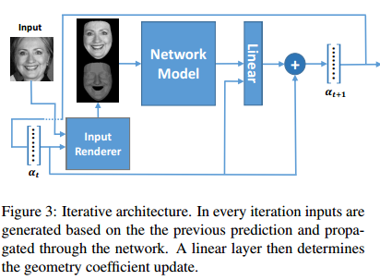

At every iteration, a new geometry vector, *αt*, is predicted and used to update the shading image and the masking of the input image

What is $a_{t}$? seems like $a_{id} and a_{exp}$

**Training Criterion**

Instead, the criterion is defined as the MSE between the geometries themselves:  
*L* (*x; y*) = $||(A_{id}{|A}_{exp⁡})$*x – (|*

Where *x* is the output of the network, and *y* is the known geometry

Network

ResNet[11]

where the input is of size 200x200x2

why not 224?

**Others** **Disincline**

consequence:

summary:

# **2017 October 11 Wednesday**

1. 3D Face Model for Pose and Illumination Invariant Face Recognition (avss09)

pipeline:

This model  
not only allows development of 3DMM based image  
analysis algorithms but will also permit new practices  
that were impossible before:

To address these two restrictions we  
provide both the training data set (the BFM) and the  
model fitting results for several standard image data  
sets (CMU-PIE, FERET and UND)

The training data set for the BFM  
consists of face scans of 100 female and 100 male persons, most of them Europeans. The age of the persons  
is between 8 and 62 years with an average of 24.97 years  
and the weight is between 40 and 123 kilogram with an  
average of 66.48 kilogram (Fig. 2)

$$S= {(x_{1},y_{1},z_{1},……x_{m},y_{m},z_{m})}^{T}$$

$T= {(r_{1},g_{1},b_{1},……r_{m},g_{m},b_{m})}^{T}$,

1. **Confusing**

consequence:

summary:

1. Morphable Face Models - An Open Framework (arXiv)

pipeline:

**Gaussian Process Morphable Models (GPMMs)  
unify a variety of non-rigid deformation models with B-splines  
and PCA models as examples**

**(i) We present a strategy and modeling  
technique for face registration that considers symmetry, multiscale and spatially-varying details.**

**(ii) We release an  
open-source software framework for registration and modelbuilding, demonstrated on the publicly available BU3D-FE  
database.**

***Gaussian Processes for Face Registration***

$Γ_{T}=\left\{x+u\left(x\right)\right|x ∈ Γ_{R} \}$

$u∼GP(μ,k)$

Conceptually, the registration problem is now cast  
as the MAP problem’

$arg \max_{u}p(u|Γ_{T},Γ_{R}){=} arg \max_{u}p(u)p(Γ_{T}|u,Γ_{R})$

For the likelihood function we define the distance between a point *x* and the target  
surface as

$$p\left(Γ_{T} | u,Γ_{R}\right)=$$

This leads to a parametric model $\check{u}\left(a,x\right)$ of the form

$\check{u}\left(a,x\right)≔ μ\left(x\right)+$

For this work, an implementation of LBGFS [22] was used

$$p\left(Γ_{T}\right)=$$

*Combining Kernels*

*A Shape Prior tailored for Face Registration*

consequence:

summary:

# **2017 October 12 Thursday**

1. BFM project investigate

pipeline:

consequence:

summary:

1. PMM project investigate

pipeline:

consequence:

summary: