
SKEE 3223 – 07 MICROPROCESSOR
SEMESTER 2024/2025-1

SMART PARKING SYSTEM

SUPERVISED BY:
DR. NURUL ASHIKIN BINTI ABDUL KADIR

GROUP MEMBERS:
Item | Full Name | Roles | Photo | Matric. No | Section
1. | DUL JIA XIN | Code Developer |  | A23KE0401 | 7
2. | OOI PEI XIN | Researcher  and Circuit Designer |  | A23KE0461 | 7
3. | SELINA CHENG JIA YING | Hardware Developer |  | A23KE0470 | 7
4. | WENNIE LIM | Project Manager |  | A23KE0355 | 7
Youtube Link: https://youtu.be/z2rG7ZfbP-E
Github Link: https://github.com/Selina630/Smart-Parking-System-.git
TABLE OF CONTENT

PROJECT ABSTRACT 3
LIST OF COMPONENTS USED 4
FLOWCHART 6
CIRCUIT DIAGRAM 7
HARDWARE BUILT WITH LABELING 8
DESIGN EXPLANATION 11
DESIGN FUNCTIONALITY 12
RESULTS 16
CONCLUSION 18
REFERENCE 19

PROJECT ABSTRACT
Parking in tight spaces is a common challenge, particularly in urban areas where space is limited. This project introduces a Smart Parking Assistance System utilizing the STM32F411CEU6 Black Pill microcontroller, KY-032 IR obstacle sensors, and four IR sensor module to enhance driver safety and convenience during parking. The system offers real-time obstacle detection and intuitive feedback, reducing the likelihood of collisions and ensuring efficient parking manoeuvres.
The KY-032 IR obstacle sensor detects objects using infrared reflection, while the IR sensor module provides additional accuracy in identifying parking spaces. The microcontroller processes sensor data and triggers audio and visual alerts to assist drivers. A buzzer emits beeping sounds with increasing frequency as an obstacle gets closer, while LED indicators display different colours—yellow for successful parking and red for detected obstacles.
The system is designed to be modular and scalable, allowing for future enhancements such as Bluetooth integration for mobile connectivity or data logging for performance analysis. The STM32F411CEU6 Black Pill microcontroller was selected for its compact size, low power consumption, and high processing capabilities, ensuring reliable performance in embedded applications.
By replacing traditional ultrasonic sensors with cost-effective IR-based detection, this system provides an accessible and efficient solution for parking assistance. It enhances driver awareness, minimizes parking-related accidents, and contributes to better space utilization in crowded environments.

LIST OF COMPONENTS USED
- Infrared (IR) Sensor
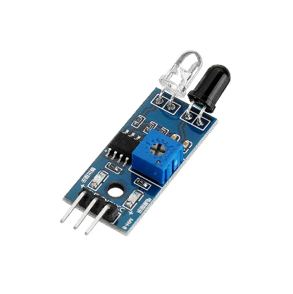
- Infrared (IR) Obstacle Avoidance Sensor
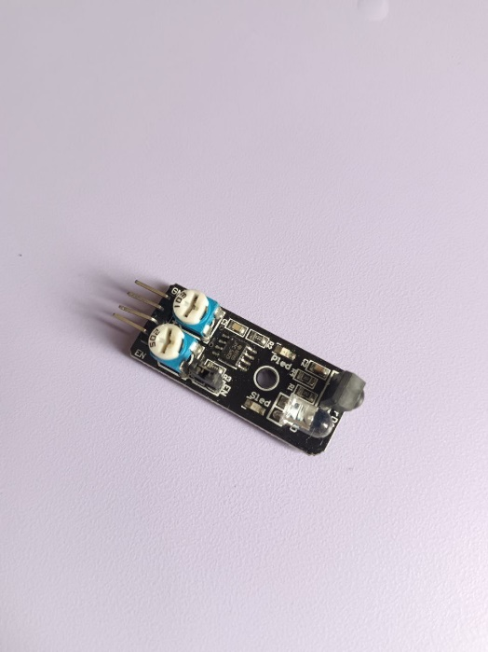

- LED
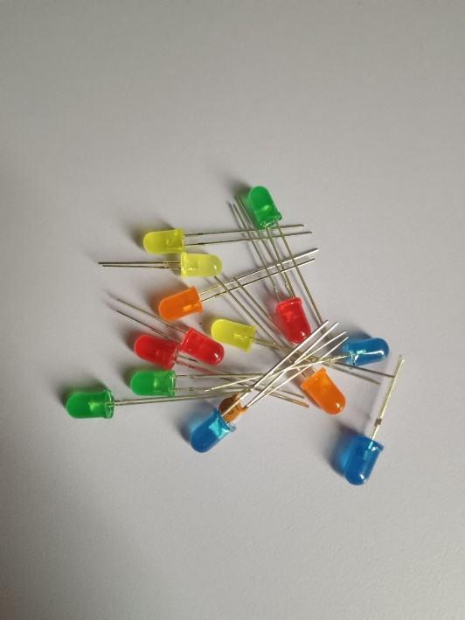
- Buzzer
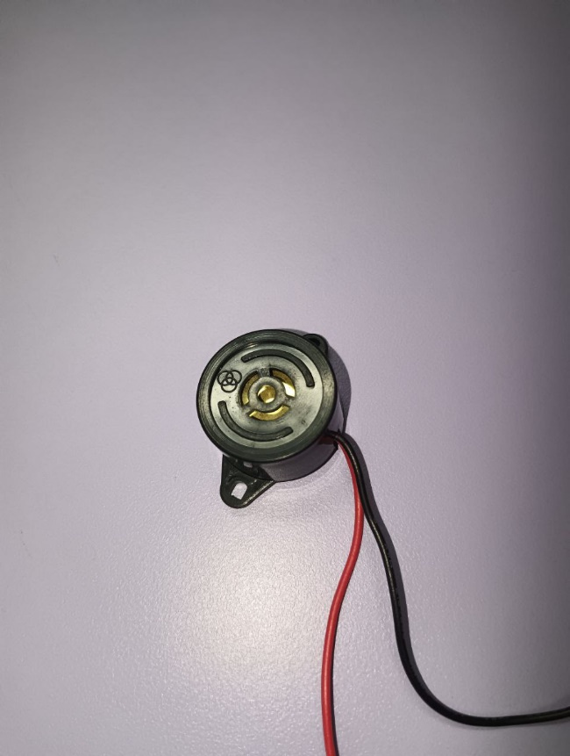

- Blackpill STM32F411CEU6 Microcontroller
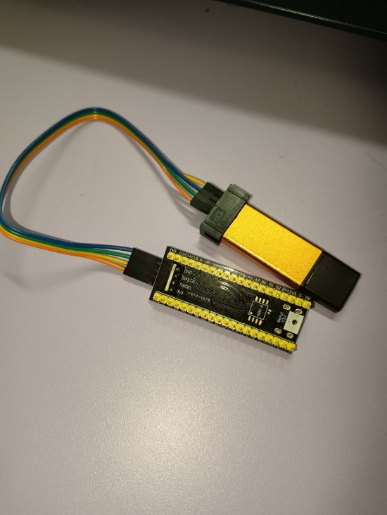
- Resistor
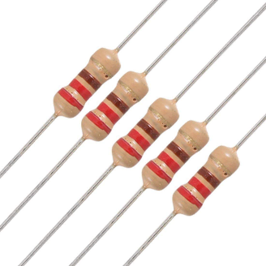
- Jumper
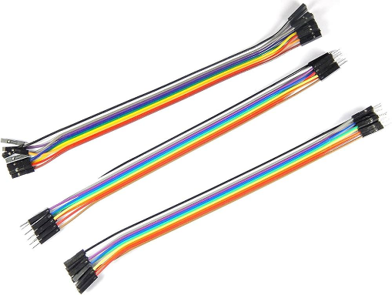
- Breadboard
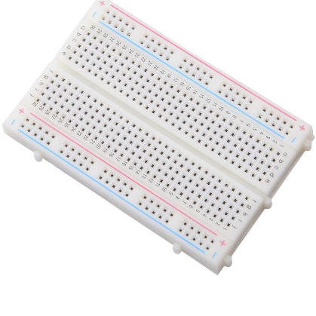

FLOWCHART
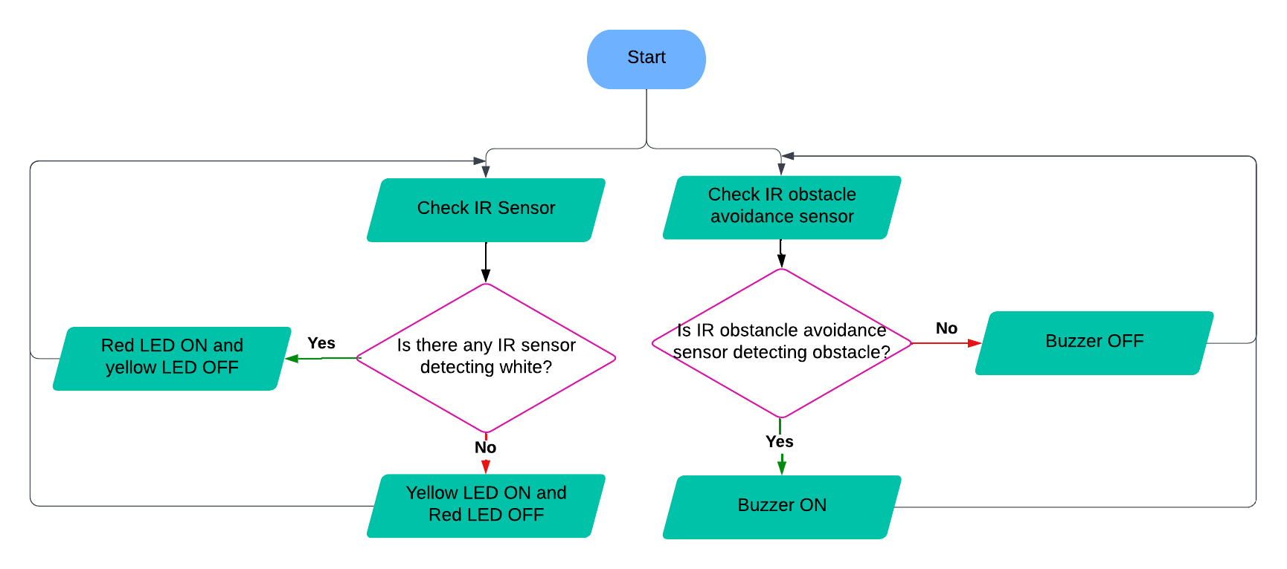

CIRCUIT DIAGRAM
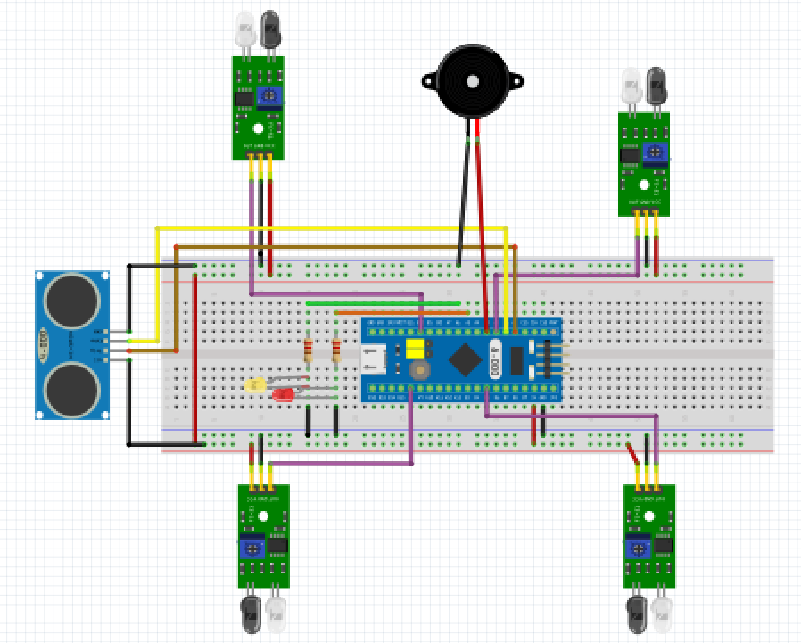
Remarks:
Due to unavailability of some components in the Fritzing parts library, they are each replaced with component that performs similar function in the circuit diagram:
In actual design | In circuit diagram
Black pill | Blue pill
IR obstacle avoidance sensor | Ultrasonic sensor

Component | Pin
IR Sensor (1) | A1
IR Sensor (2) | A2
IR Sensor (3) | A3
IR Sensor (4) | A4
IR obstacle avoidance sensor | A5
Buzzer | A6
Yellow LED | A0
Red LED | A7

HARDWARE BUILT WITH LABELING
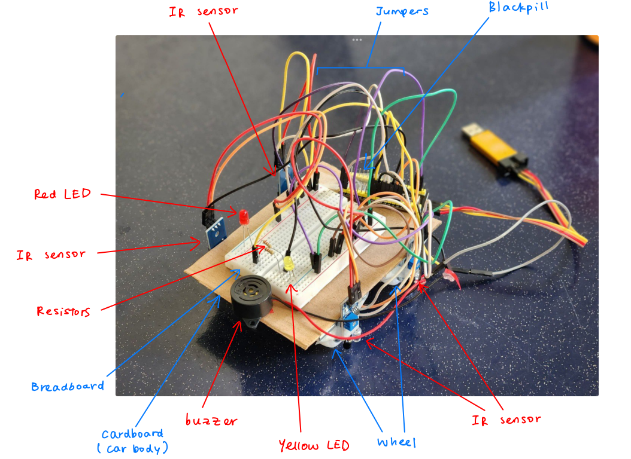
Figure: Hardware with label
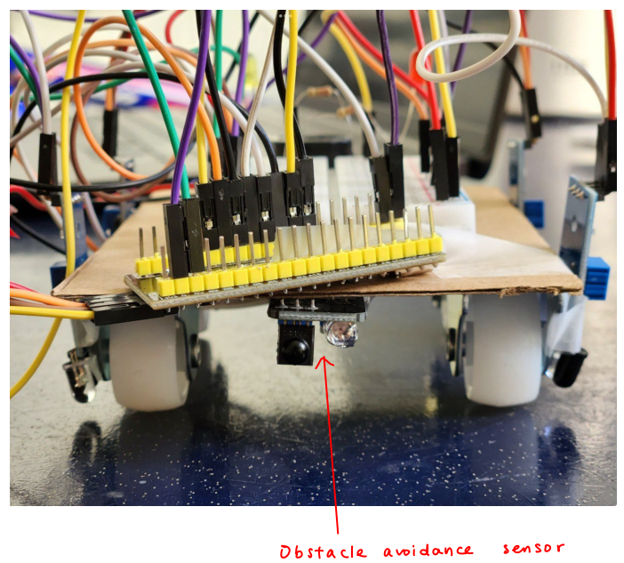
Figure: Hardware back view

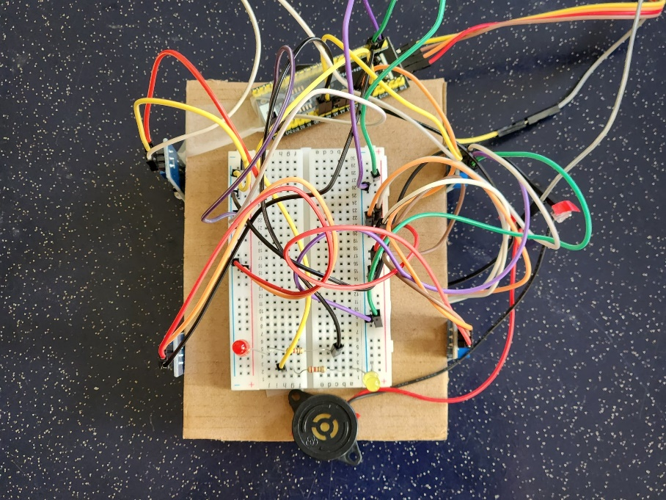
Figure: Hardware top view
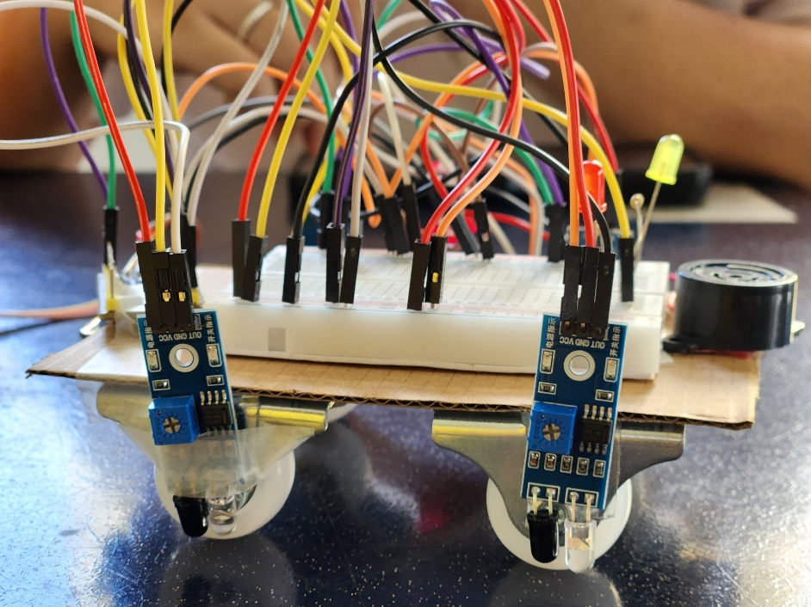
Figure: Hardware right side view
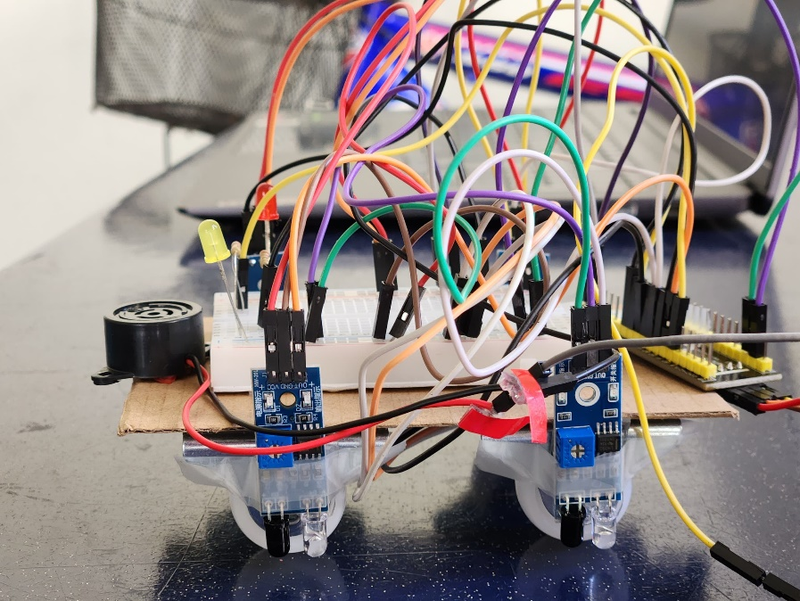
Figure: Hardware left side view

DESIGN EXPLANATION
We are designing a smart parking system that uses four IR sensors and an ultrasonic sensor to ensure proper parking and obstacle detection.
- Parking Detection: Four IR sensors are positioned at each tyre of the car to determine if the car is parked correctly within the designated parking lines.
- If any IR sensor detects a white line, it indicates incorrect parking, and a red LED will light up.
- If all four IR sensors detect a black surface, it confirms that the car is parked correctly within the parking box, and a yellow LED will light up.
- Obstacle Detection: An ultrasonic sensor is used to detect obstacles near the car. If an obstacle is detected within a predefined distance, a buzzer will sound as a warning.

This system ensures accurate parking and enhances safety by avoiding nearby obstacles.

DESIGN FUNCTIONALITY
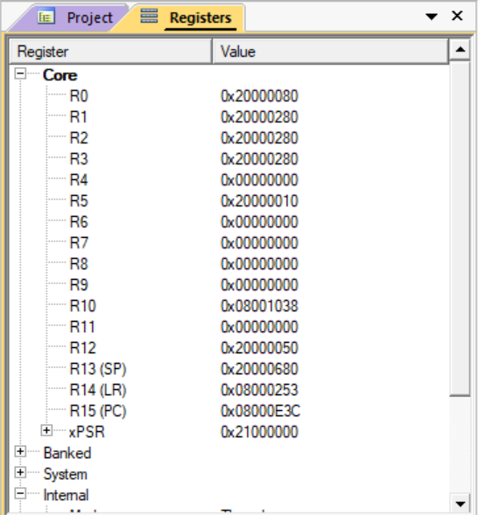
Figure: I/O Registers window

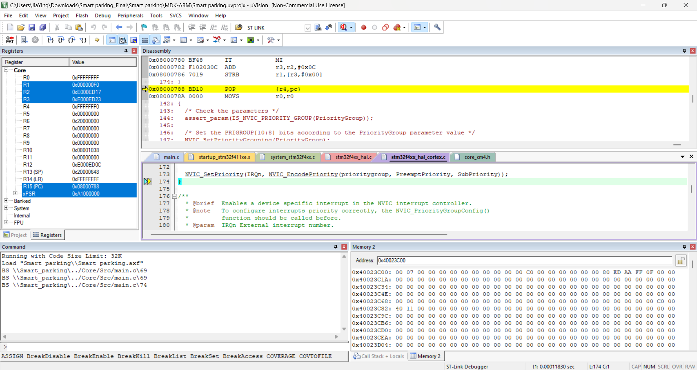Figure: Memory window

Code Explanation

- Reading IR Sensors and Making Decisions Based on Their State

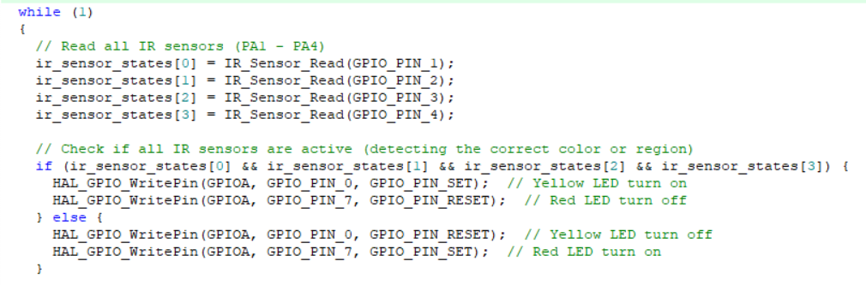
- These lines read the states of four IR sensors connected to pins PA1 to PA4.
- Each sensor detects a specific region, and the results are stored in the ir_sensor_states array.


- If all IR sensors detect the black region, the system turns on the yellow LED (GPIO_PIN_0) and turns off the red LED (GPIO_PIN_7).
- If at least one sensor does not detect black region, the red LED turns on while the yellow LED turns off, indicating an error or misalignment.

- Detecting an Obstacle Using KY-032 Sensor

- This line reads the state of the KY-032 obstacle detection sensor connected to PA5.
- The sensor determines if an obstacle is present in front of the system.

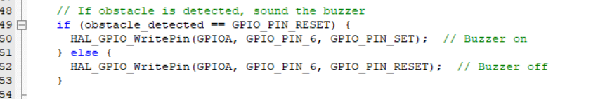
- If the KY-032 sensor detects an obstacle (GPIO_PIN_RESET state), the system turns on the buzzer (GPIO_PIN_6) to alert the user.
- If no obstacle is detected, the buzzer remains off.

- Initializing IR Sensors

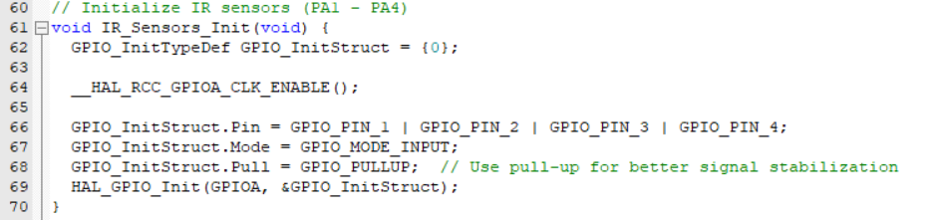
- This function initializes the IR sensors on PA1-PA4 as input pins with pull-up resistors.
- Pull-up resistors ensure stable readings by preventing floating values.

- Reading KY-032 Sensor and IR Sensor States

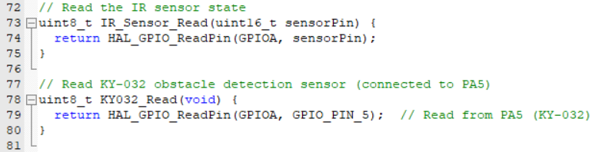
- This function reads the state (HIGH or LOW) of a specific IR sensor connected to a given GPIO pin.
- This function reads the state of the KY-032 obstacle detection sensor.

- Handling Error

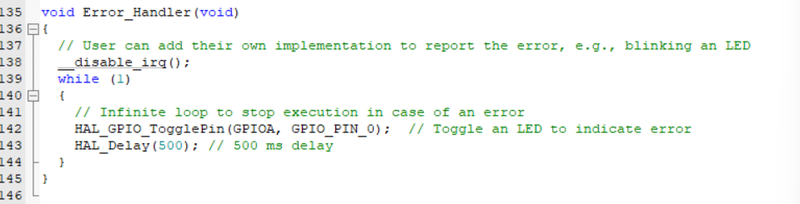
- If an error occurs, this function disables interrupts and enters an infinite loop, continuously toggling an LED (GPIO_PIN_0) to visually indicate an error.

HARDWARE PROTOTYPE
The car body is represented by a cardboard, and the breadboard is placed above it. The IR sensors are installed at the bottom part of car body near each of the four tyres. The IR obstacle avoidance sensor is placed at rear part of the car. To demo car parking and obstacle detection, a carboard parking lot with black paint and some white line parking spaces is built.

RESULTS
Parking Detection Test:
Situation 1
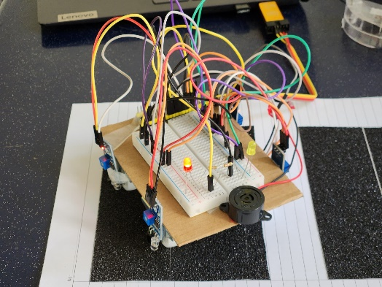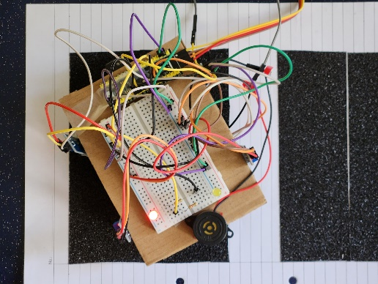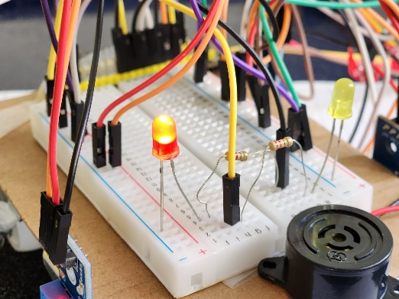
Figure: Unsuccessful parking
The car is not parked inside the parking space, white line is detected by some of the IR sensors. Red LED is turned ON while yellow LED is turned OFF, which indicates parking is not successful.
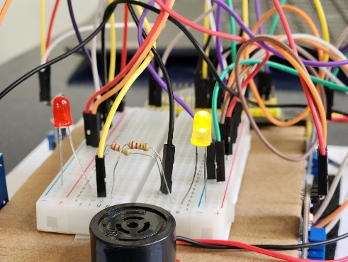
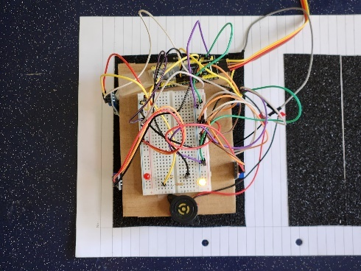
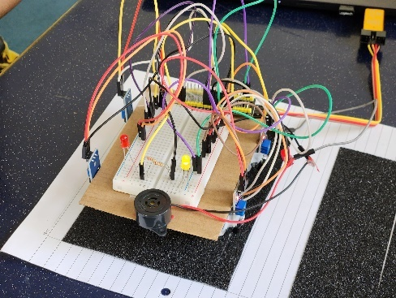
Situation 2
Figure: Successful parking
The car is fully parked inside the parking space, no white line is detected by all of the IR sensors. Yellow LED is turned ON while red LED is turned OFF, which indicates parking is successful.

Obstacle Detection Test:
Situation 1
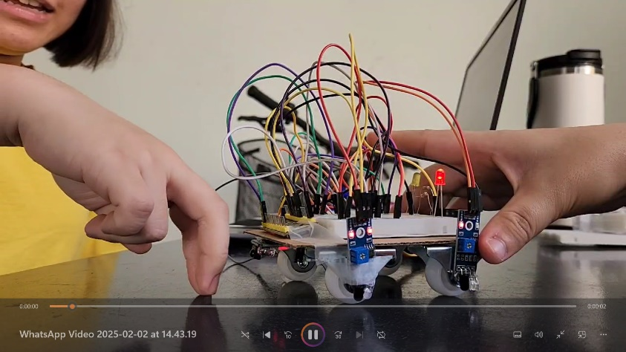
Figure: Obstacle is present at the back of car
There is an obstacle at the back of car and is detected by the IR obstacle avoidance sensor. This triggers the buzzer to start beeping.
Situation 2
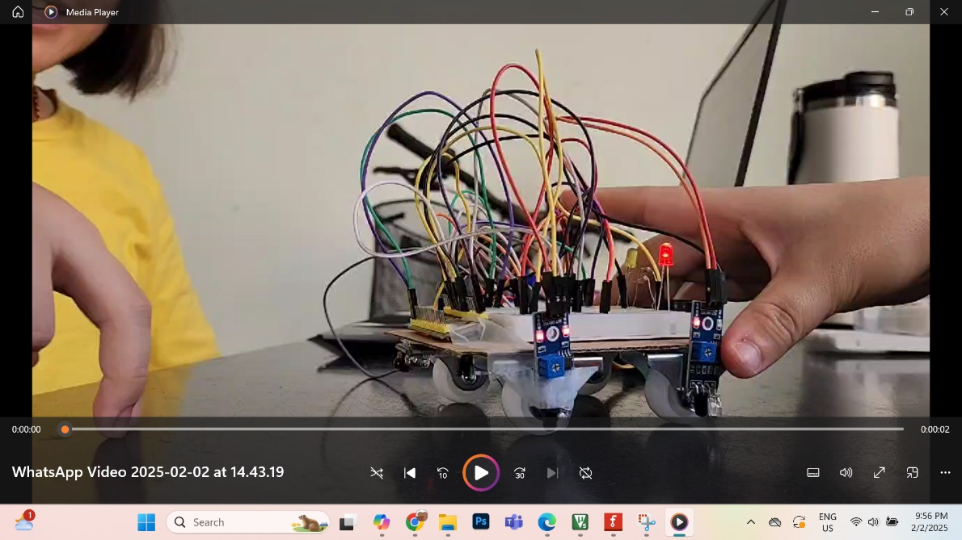
Figure: Obstacle is not present/ far away from car
There is no obstacle at the back of car and nothing is detected by the IR obstacle avoidance sensor. Buzzer remains at OFF state.

CONCLUSION
The Smart Parking Assistance System provides an efficient and cost-effective solution to ease drivers in parking cars and rear obstacle detection. The IR sensors are integrated for parking validation and an IR obstacle avoidance sensor is used for rear object detection. This gives reliable real-time feedback to assist drivers. The yellow and red LED indicators provide clear visual cues, while the buzzer enhances safety by alerting users to nearby obstacles.
From testing results in the demonstration, the system performs accurately in detecting parking alignment and obstacles, and gives the expected output. In a nutshell, this project gives the idea for a scalable and adaptable smart parking system, which contributes to safer and more efficient parking solutions.

REFERENCE
- MACFOS. (2020, May 19). IR sensor Working Principle and Applications | Robu.in. Robu.in | Indian Online Store | RC Hobby | Robotics. https://robu.in/ir-sensor-working/
- Learn Coding with Arduino IDE– IR Obstacle Avoidance Sensor «osoyoo.com. (2017). Osoyoo.com. https://osoyoo.com/2017/07/24/obstacle-avoidance-sensor/
- MACFOS. (2023, March 17). Interfacing IR Sensor With STM32 Discovery Board - Robu.in | Indian Online Store | RC Hobby | Robotics. Robu.in | Indian Online Store | RC Hobby | Robotics. https://robu.in/interfacing-ir-sensor-with-stm32-discovery-board/
- IR Obstacle Avoidance Sensor Module. (2025). Pixel Electric Company Limited. https://www.pixelelectric.com/sensors/light-sound/pir-ir-sensor/ir-obstacle-avoidance-sensor-module/
- How to Interface Passive Buzzer with STM32. (2024, July 13). ControllersTech. https://controllerstech.com/interface-passive-buzzer-with-stm32/
- Magdy, K. (2020, June 2). STM32 GPIO Write Pin Digital Output LAB - GPIO HAL. DeepBlue. https://deepbluembedded.com/stm32-gpio-write-pin-digital-output-lab/
- admin. (2020, June 8). IR Sensor Module | How IR Sensor Module Works» ElectroDuino. ElectroDuino. https://www.electroduino.com/what-is-ir-sensor-module-how-ir-sensor-module-works/
- ‌ IR Sensor Circuit, Connection Diagram, Project. (2023). ETechnoG - Electrical, Electronics, and Technology. https://www.etechnog.com/2021/06/ir-sensor-circuit-connection-diagram.html

