JPMC Take Home Project
Customer Income Classification & Segmentation Analysis
U.S. Census Bureau Data (1994-1995)
By Jiaxu He
February 18, 2026

Executive Summary

Objective:
This project develops a classification model to identify high-income individuals and a segmentation model to segment customers for targeted marketing using U.S. Census Bureau data from 1994-1995.

Approach:
In this project, we analyzed data with 199,523 records across 42 demographic, employment, and financial variables. Multiple machine learning algorithms were tested, with Gradient Boosting selected as the final classification model after hyperparameter tuning. And K-Means clustering with PCA as final segmentation model.

Outcome:
The model achieved 95% population-weighted accuracy with a ROC-AUC of 0.95, demonstrating strong overall performance and ranking ability.

For the minority class (high earners representing 6.2% of the population), the model achieved an F1-score of 0.62, with 60% precision and 64% recall. Showing the ability to correctly identifies 6 out of 10 individuals it predicts as high earners while capturing about two-thirds of all actual high earners.

On the segmentation side, customer segmentation revealed four distinct groups: Full-time working adults with the highest proportion of high income (9.3% of the group population), Part-time workers, Arm Forces, and Children.

Business Impact:
Marketing teams can use this model to focus resources on individuals most likely to be high earners, improving campaign efficiency. The segment profiles provide a framework for targeting product offerings and messaging to different customer groups based on age, employment patterns and income potential.

Data Exploration
The initial dataset contains 199,523 records with 42 variables. We performed several exploratory data analysis steps in below:

- Target Variable Distribution:
From this step we found out that the income distribution showed significant class imbalance, with 93.8% of individuals earning less than $50K and only 6.2% earning more than $50K. This imbalance requires special handling in model training later.

- Identifying Missing Values:
Three types of potential missing patterns were identified:

- Null values: 874 records found only in “Hispanic origin” variable. These are confirmed to be missing values and we’ll drop them.

- Question marks values: Found in 8 columns, primarily migration-related variables (about 50% missing) and country of birth related fields. These were kept as an "Unknown" category since tree-based models can treat them as valid categories and potentially use them as predictive signals.

- "Not in universe" values: Present in many of the categorical variables and could take up to 90%+ of the proportion in the variable. These were not missing data but valid responses indicating non-applicability.

For example, "Not in universe" for “reason for unemployment” could be the person has never experienced unemployment, they are either working or haven’t started work yet (children). So we will keep them.

- Outlier Detection:
Using z-score analysis (threshold of |z| > 3), we examined outliers in numerical variables. The most notable finding was in the business ownership variable (8.1% outliers), followed by wage per hour (2.5%) and capital losses (1.9%).

Given that these outliers represent legitimate cases—such as business owners, high earners, and investors—and that tree-based models are robust to outliers, we retained all values in the dataset for identifying high-income individuals.

Feature Engineering

After completing data exploration and dropping the missing values, we move on to prepare the features for model training through several feature engineering steps.

1. Categorical Variable Encoding:
To convert object and string based categorical variables to numerical variables for model compatibility, we applied label encoding to all categorical features to transform text labels into integer values.

2. Correlation Analysis:
We examined correlations across all variables to understand both how features related to income and whether features show collinearity.
The correlation with income shows the variables such as weeks worked per year, capital gains, and employer size had the strongest relationships to the target.
Looking at correlations between features, we found relatively low multicollinearity throughout the dataset. Most variables showed weak to moderate relationships with each other.

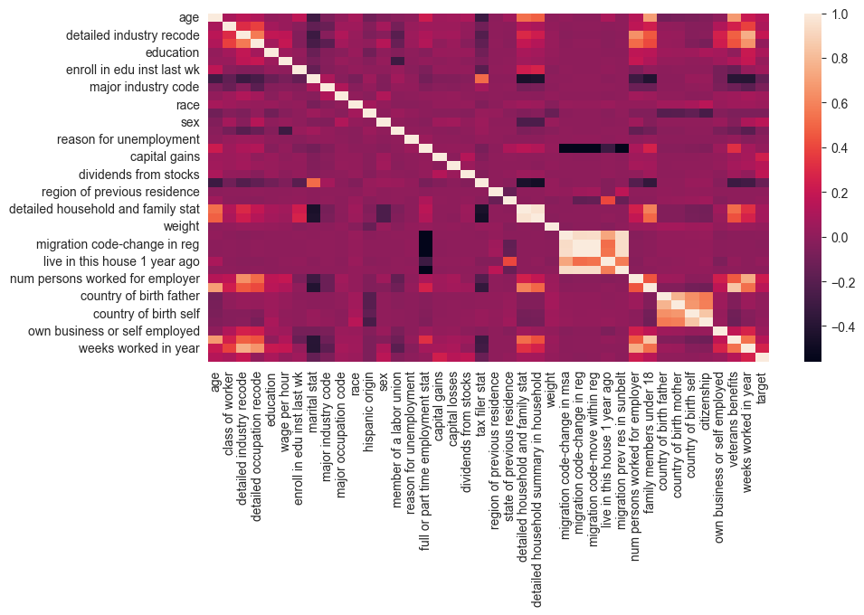

3. Feature Selection:
While correlation analysis showed several variables with weak relationships with each other, we retained these features because tree-based models can handle multicollinearity and discover non-linear patterns that simple correlation might miss.

On the other hand, two variables were removed from the analysis. The "year" column contained only values of 94 and 95. And the "fill inc questionnaire for veteran's admin" variable due to 99% of values being "Not in universe," providing minimal value for model.

4. Feature Standardization:
For the classification model, features were used in their original/encoded form without scaling since tree-based models are invariant to feature scales.
For the customer segmentation model using K-Means clustering, all features were standardized using StandardScaler to ensure equal contribution from each variable.

Income Classification Modeling
1. Model Train-Validation-Test Split:
The dataset was divided into three subsets using stratified sampling to preserve the same income class distribution across all splits. The training set (60%) was used for model learning, the validation set (20%) for hyperparameter tuning, and the test set (20%) was used for final performance evaluation. Survey sample weights were split alongside the features to maintain population representation in each subset.

2. Model Selection:
In this project we evaluated four machine learning algorithms to identify the best approach for income classification: Logistic Regression, Random Forest, Gradient Boosting and XGBoost.

All models were configured to handle class imbalance. We used “weights” variable from the dataset as the sample_weight parameter during training for all models to ensure they learned population-level patterns. In addition, Logistic Regression and Random Forest used balanced class weights, XGBoost used “scale pos weight” to handle imbalance target variable.

3. Initial Model Comparison:
Models were trained on the training set and evaluated on the validation set. Gradient Boosting stood out as the strongest performer with an F1-score of 0.55, followed by Random Forest. Logistic Regression and XGBoost showed poor precision-recall balance, making them the weaker candidates for this imbalanced classification task.
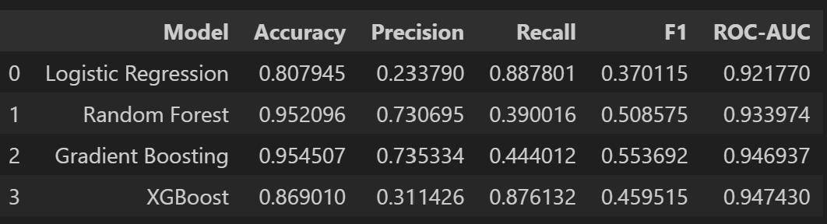

4. Hyperparameter Optimization:
We applied Randomized Search CV to tune Gradient Boosting and Random Forest, exploring 20 random parameter combinations each with 3-fold cross-validation. After optimization, both models were evaluated on the validation set with the best parameters. In addition, we have also tried a list of classification thresholds to optimize model performance on this imbalanced data.

As a result, Gradient Boosting model achieved optimal performance at threshold 0.3 with F1 score of 0.625, precision of 60%, and recall of 64%. Random Forest peaked at a higher threshold of 0.75 with F1 score of 0.580, precision of 53%, and recall of 64%. The better F1 score Gradient Boosting model show along side better precision and recall make it the final model we will use for the test dataset.

5.Model Evaluation on Test Set.
The final model was evaluated on the test set (20% records) using population weights. Results closely matched validation performance, confirming there is no overfitting or underfitting on the training set.
Test Set Results:
- Macro F1-score: 0.80, Precision: 79%, Recall: 81%
- High-income class (minor class): Precision 60%, Recall 64%, F1 0.62
- Low-income class (major class): Precision 98%, Recall 97%, F1 0.97
- ROC-AUC: 0.953, weighted accuracy: 95%

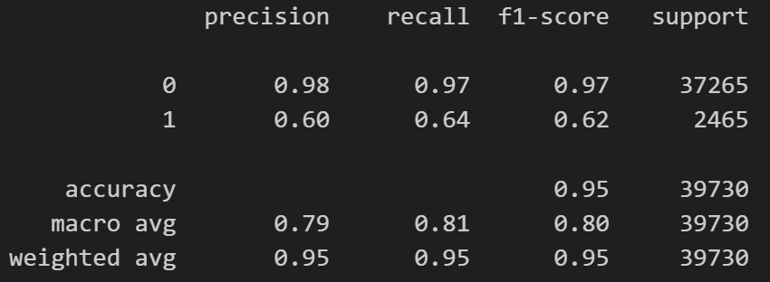

6. Classification Summary:
The Gradient Boosting model successfully addressed the income prediction challenge despite heavy class imbalance. With macro F1 of 0.80, the model achieves balanced performance across both classes. For the high-income population, the model achieves F1-score of 0.62, demonstrating effective identification while balancing precision and coverage. The ROC-AUC of 0.953 and consistent validation-to-test performance confirm the model is generalized for production use to classify high income populations.

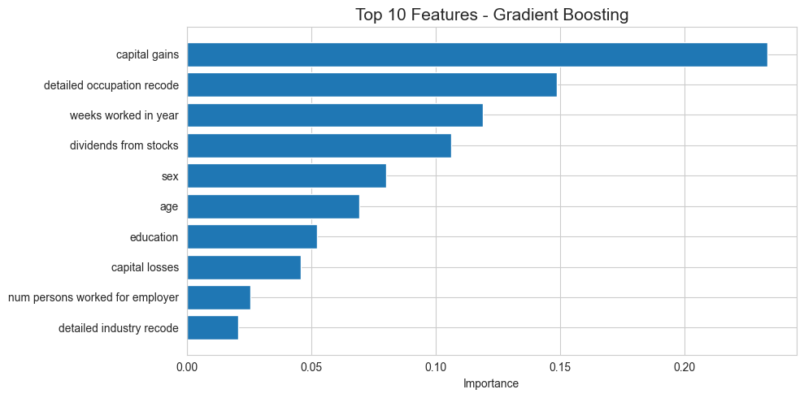

From feature importance point of view, the model's predictions are primarily driven by financial and employment indicators. Such as capital gains, occupation, weeks worked per year, Investment income (dividends from stocks. Demonstrating that wealth indicators are key drivers of high-income classification.

Customer Segmentation Modeling
1. Feature Engineering
As mentioned earlier in the report, all features were standardized using StandardScaler to ensure equal contribution from each variable before fitting into the segmentation model.

2. Modeling
Three clustering approaches were evaluated: K-Means, K-Means with PCA dimensionality reduction, and DBSCAN. We also used elbow method and silhouette score to find the optimal number of clusters. Testing k from 2 to 10, silhouette scores peaked at k=4 with a score of 0.182, while the elbow method showed diminishing returns beyond 4 clusters. These factors confirmed 4 as the optimal segmentation.
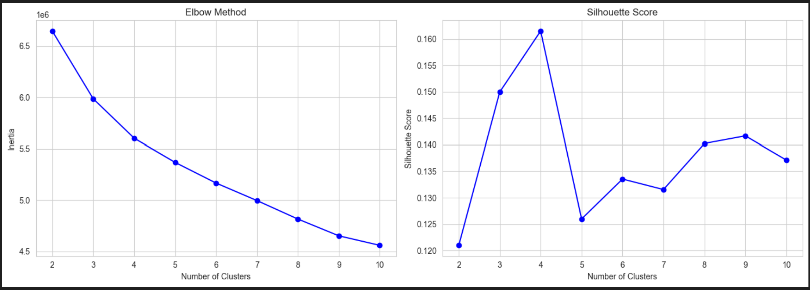

For PCA method we identified the minimum components required to retain 90% variance and reduced 38 features into 23 components.

For the model result, DBSCAN was excluded first due to excessive noise points and fragmented cluster structure. K-Means with PCA outperformed standard K-Means, achieving silhouette score of 0.182 compared to 0.161, while reducing computational complexity through dimensionality reduction. So we used K-Means with PCA as our final model.

3. Segmentation Results:
The analysis identified four distinct customer segments with varying income potential:

Segment 1 - Armed Forces (60,952 individuals, 30.7%):
Average age: 44.8 years, employment stat: Children or Armed Forces (100%)
High-income rate: 8.6%
Average weeks worked: 32.6 per year

Segment 2 - Full-time Working Adults (65,266 records, 32.9%):
Average age: 44.1 years, employment stat: Full-time schedules (55.2%)
High-income rate: 9.3%
Average weeks worked: 32.7 per year

Segment 3 - Part-time & Irregular Workers (18,471 individuals, 9.3%):
Average age: 42.1 years
High-income rate: 5.5%
Average weeks worked: 25.2 per year – indicates not full-time workers

Segment 4 - Children & Dependents (53,960 individuals, 27.2%):
Average age: 8.5 years – young age
High-income rate: 0%
Education: Children
Class of worker: Not in universe (99.1 %)

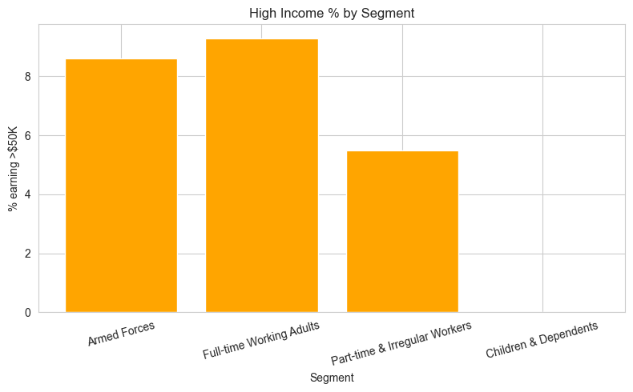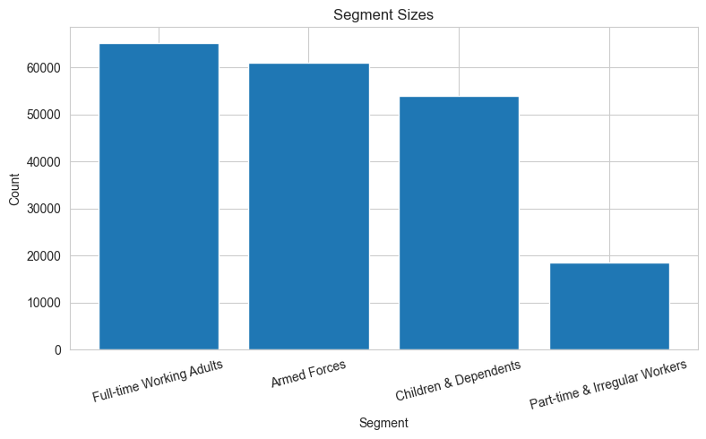
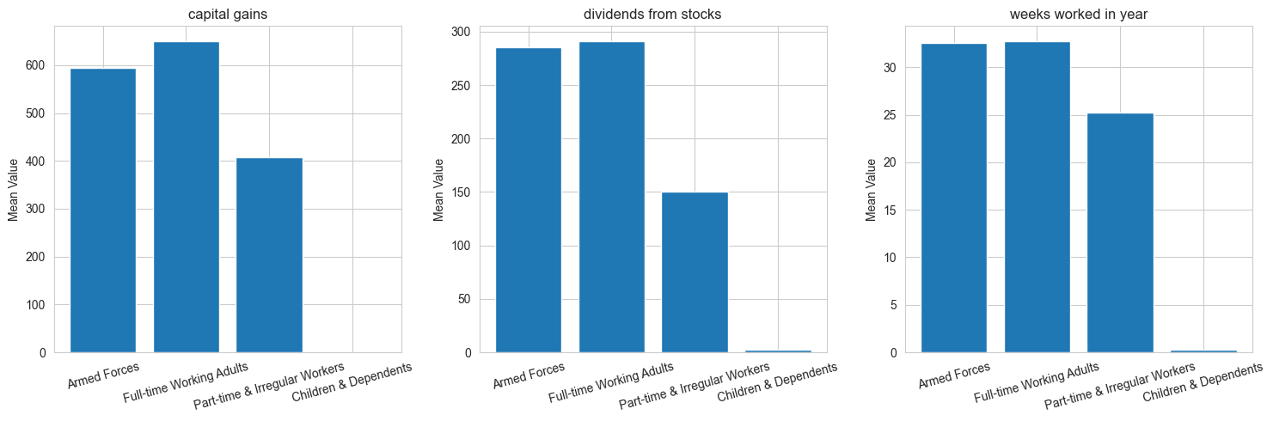

PCA Visualization Chart four segments:
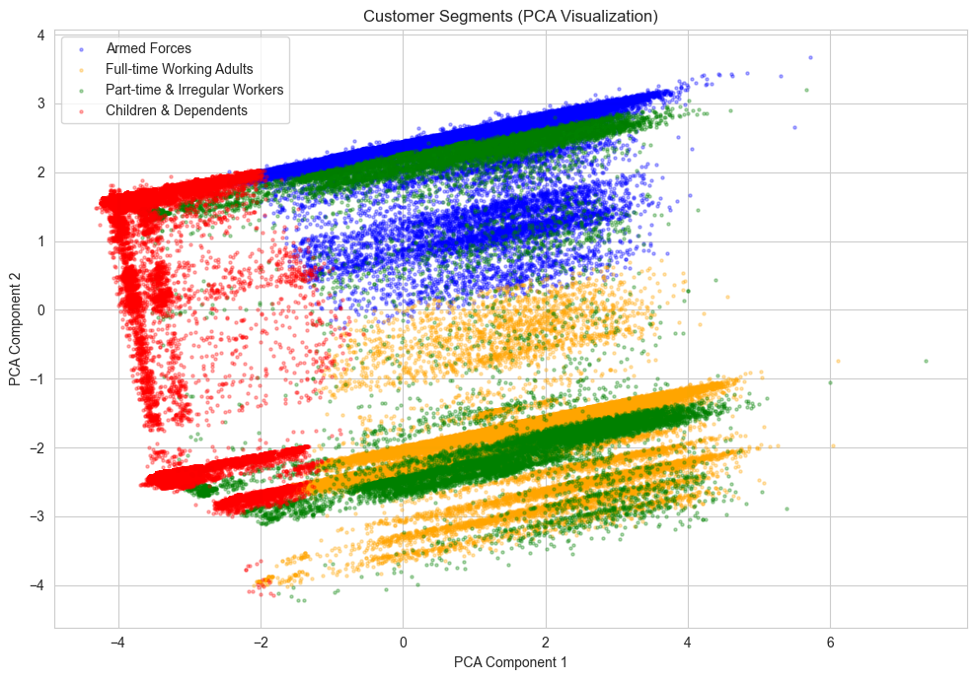

4. Segmentation Summary

The K-Means clustering with PCA identified four interpretable customer segments driven by employment patterns. Three segments—Armed Forces, Full-time Working Adults, and Children & Dependents—show clear separation in the PCA visualization, while Part-time Workers display more overlap, reflecting the diverse and mixed nature of irregular employment. From a business perspective, Segments 1 and 2 represent the primary high-income targets providing differentiation for segment-specific marketing strategies.

5. Marketing Insights based on the Segmentation

Based on the segmented groups from the model, retail clients can integrate segment assignments into their systems to personalize marketing campaigns, product recommendations, and promotional offers.

Retail Client could focus advertising premium products and office essentials on Segment 2 Full-time Working Adults, which has the highest income potential at 9.3%. Segment 1 Armed Forces, with 8.6% high income, would prefer veterans theme product and military-specific discounts. For segment 3 Part-time & Irregular Workers clients could prompt budget-friendly products. For Segment 4 Children & Dependents, marketing could focus on educational products, kid/teenage related products, and children discounts. This segmentation enables efficient resource allocation by concentrating on high value offers with the highest income potential.

Conclusion

This analysis successfully developed a machine learning solution for income prediction and customer segmentation using U.S. Census data. The Gradient Boosting classifier achieved macro F1-score of 0.80 and ROC-AUC of 0.953, demonstrating strong performance despite class imbalance. For the high-income target population, the model achieved F1-score of 0.62, balancing precision and recall effectively for practical marketing applications.

The K-Means clustering with PCA identified four distinct customer segments driven by employment patterns: Full-time Working Adults, Armed Forces, Part-time Workers, and Children & Dependents. This segmentation enables tailored marketing strategies, with premium products targeted at the top two segments while value-oriented and educational offerings address the remaining groups.

Both models are ready for deployment: the classification model for income prediction, and the segmentation model for campaign personalization and product positioning.

References
Scikit-learn Documentation. (2024). Selecting the Number of Clusters with Silhouette Analysis. https://scikit-learn.org/stable/auto_examples/cluster/plot_kmeans_silhouette_analysis.html

Scikit-learn Development Team. (2024). User Guide: Class Weight. https://scikit-learn.org/stable/modules/generated/sklearn.ensemble.RandomForestClassifier.html

365 Data Science. (2024). How to Combine PCA & K-Means Clustering in Python. https://365datascience.com/tutorials/python-tutorials/pca-k-means/

