# CoCo User Guide

the colony counter ImageJ macro  
author: Jia Xuan Leong  
*updated 2021.02.10*

## Experimental Setup

This is an example of a standard bacterial growth experiment which CoCo was optimized for. CoCo can also be used as a standard counter of colonies on agar plates.

**At least 45 ml of media should be poured into a standard square Petri plate, to make up a depth of 6 mm. If you are using standard round Petri plates this will be around 20 ml of media.** This is to enable better contrast between colonies and background when the plates are scanned later. Ensure the surface of the agar is thoroughly dry, to facilitate the “flow” of bacterial suspension droplets down the agar later (see image below).

An example bacterial growth experiment that CoCo was optimized for is as follows:

1. 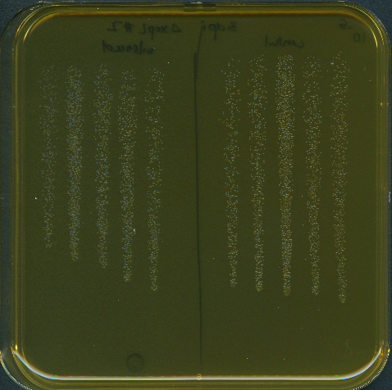Make dilutions of bacteria suspension and technical replicates using a multi-channel pipette and a 96-well plate.
2. Using a multi-channel pipette, take up 10 ul of bacteria from each well.
3. Tilt the plate towards you at a 45 degree angle, and gently pipette the bacteria on to the plate. The bacterial suspension should flow downwards and create lanes. Tilt the plate so that the lanes do not merge.
4. Once the lanes dry on to the agar, place the lid back onto the plate and allow bacteria to grow.

## Image acquisition

A scanner is recommended for imaging. Plates should be placed without their lids, and with the top of the agar facing the scanner. A **BLACK** background must be used behind the plate to enable sufficient contrast between the colonies and the background. See the example scanned image available in the GitHub Repository.

Resolution of 300dpi was found to be sufficient, however 720dpi is recommended especially for small colonies. Please save all image files as TIFF.

## Install the macro

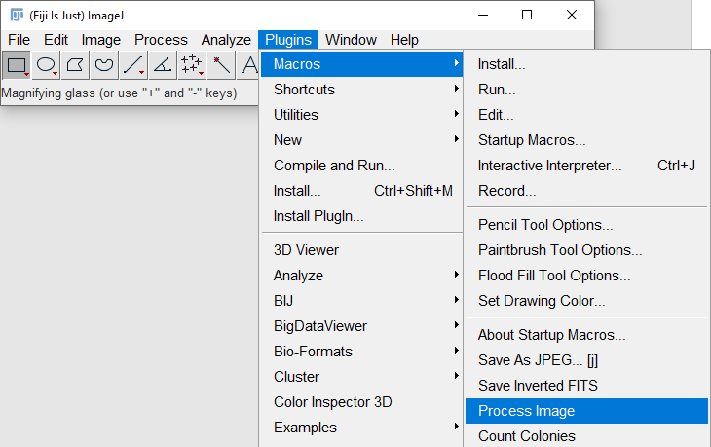**Option 1:**

This is quicker, but needs to be repeated every time FIJI is started up.  
  
In the ImageJ toolbar, Plugins > Macros > Install > Select CoCo.ijm

**Option 2:**

This permanently installs the macros to your ImageJ toolbar so you do not have to re-install it every time FIJI starts up.

1. Find your ImageJ directory, under the macros folder, open StartupMacros.ijm in Notepad (or your word editor of choice)
2. Open CoCo.ijm in Notepad (or your word editor of choice)
3. Copy the contents of CoCo.ijm to the end of StartupMacros.ijm.

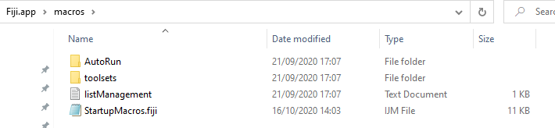

## Run the macro

1. Open your image containing colonies to be counted.
2. Locate and select the **Process Image** command.  
   Alternatively, the macro has been assigned the keyboard shortcut **F1**, simply press this key with the ImageJ toolbar in focus and the macro will run.
3. You will be given the chance to crop your image if needed
   * To crop, select relevant area then press Ctrl + Shift + X
4. Your image will now be processed to facilitate colony counting.
5. Locate and select the **Count Colonies** command, then run it.   
   Alternatively, use shortcut **F2**.
6. 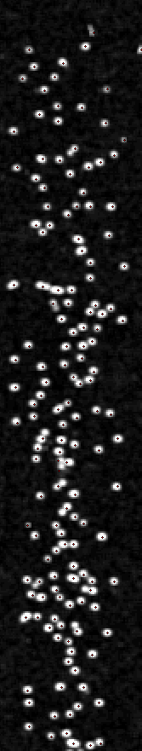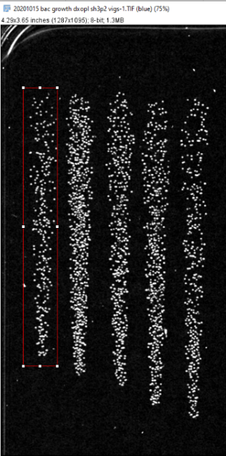Select and name the area of interest when prompted. Please input a value for prominence, which is the parameter that ImageJ’s “Find Maxima” function uses to define bright spots. Typical values range from 10 – 35 for densely packed colonies, up to 100 - 120 for colonies spaced further apart.   
   To reduce background noise, increase prominence. To increase detection of small/faint colonies, decrease prominence.
7. Automatically detected colonies will be marked by a red dot.
8. You can now manually correct the detected colonies. Use the *left mouse click* to select more colonies, and   
   *Ctrl +Click*to remove colonies**.** Tick the checkbox when you are done.
9. The counted colonies will be printed into your Log window. **Do not close this window until you are done!!!**
10. Run the **Count Colonies** command as many times as needed.
11. When colony counting is complete, save the Log file.
12. Import into excel as a CSV (comma-separated values) file.