Stream

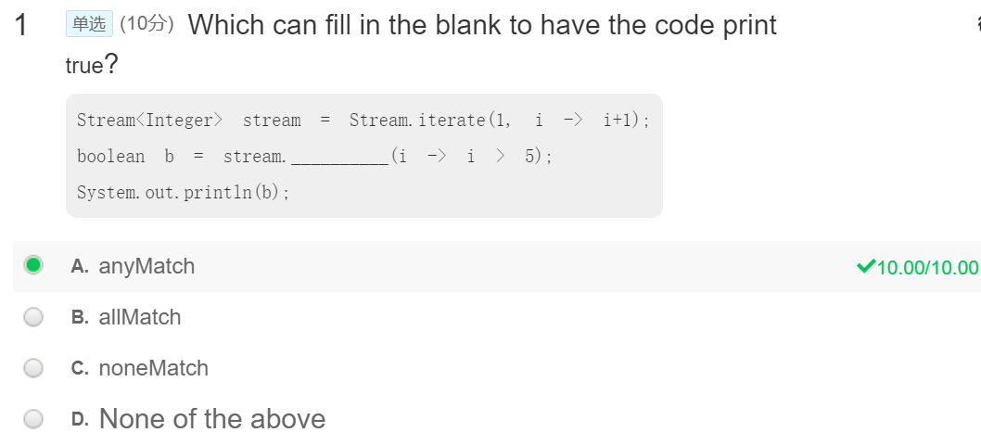

不能是all，因为2不大于5；不能是noneMatch, 因为除了前面几个，后面的都大于5.

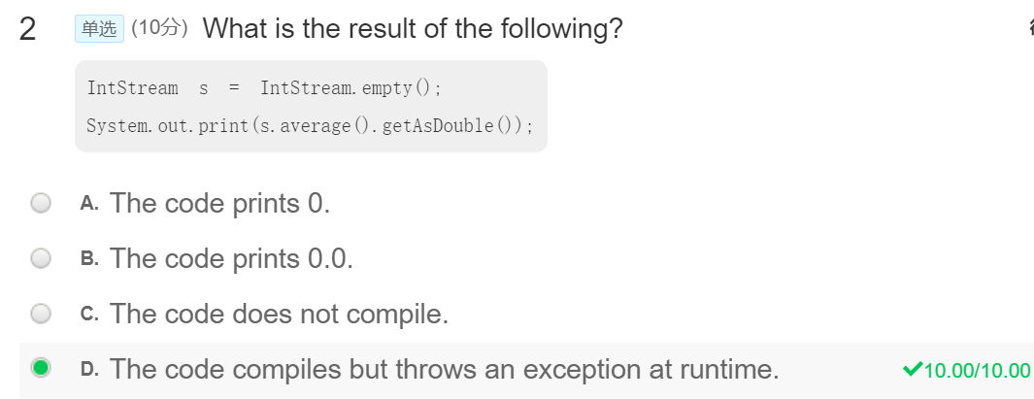

NoSuchElementException，s is already an empty stream, if we call average(), it could not have return value.

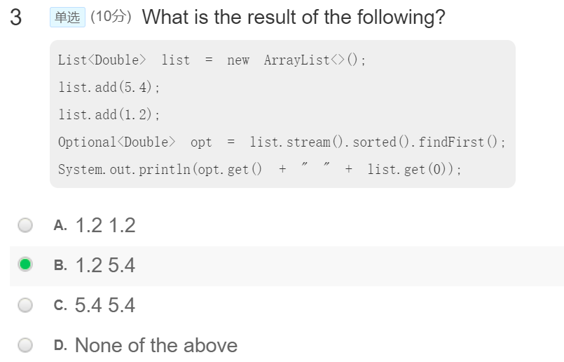

Using stream will not change the order in List.

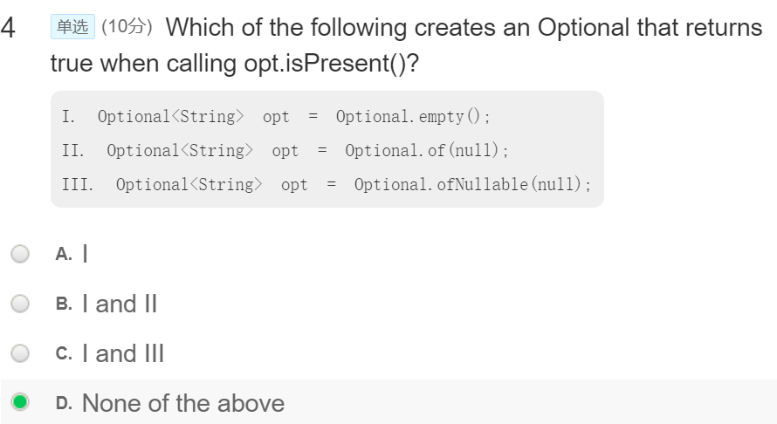

Pay attention to the usage of Optional.

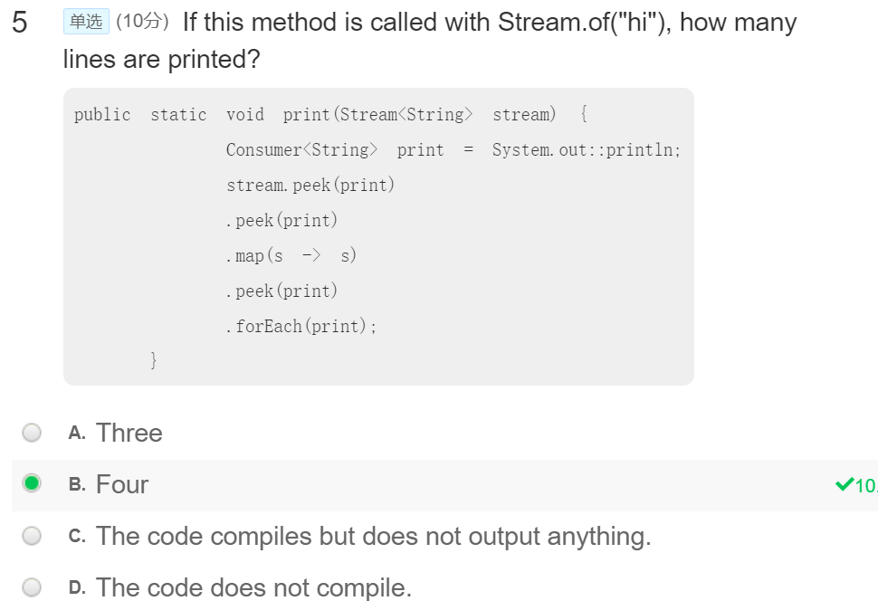

Pay attention, the Consumer<String> print = System.out :: println; is only a method, meaning the following will calls the method, it does not matter the times. Peek() is a method that will not change the stream but will execute the method in peek.

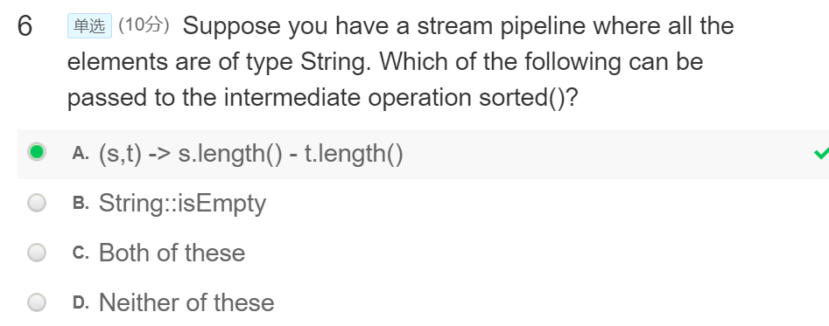

String :: isEmpty() is a non-static method, it could not be referenced from a static context.

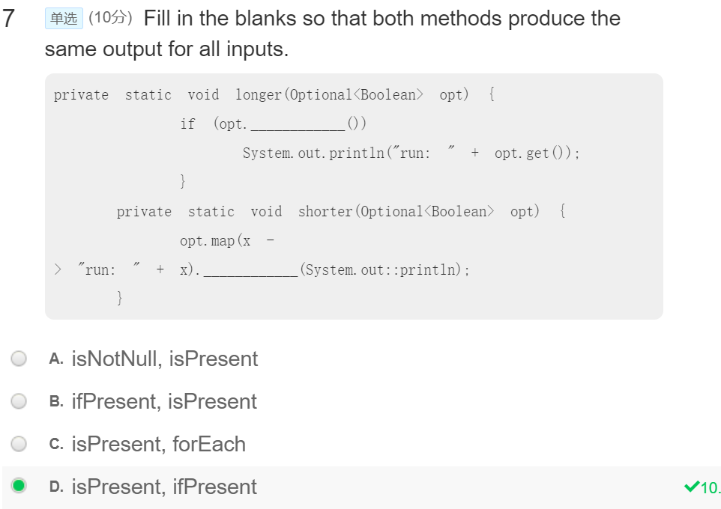

??? Ask others ???

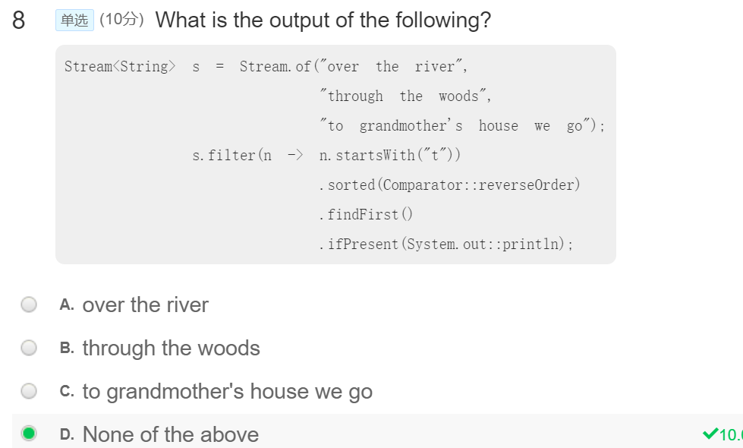

??? ASK others ???

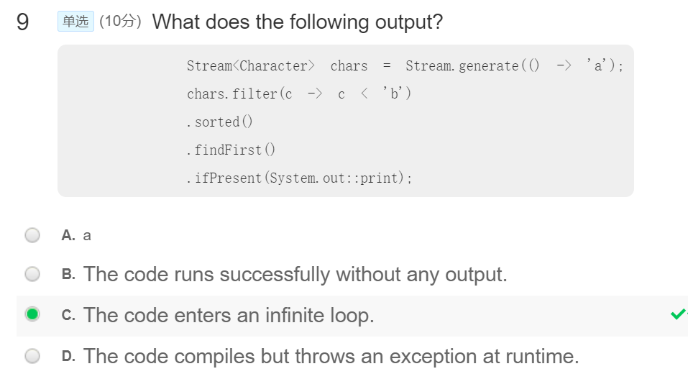

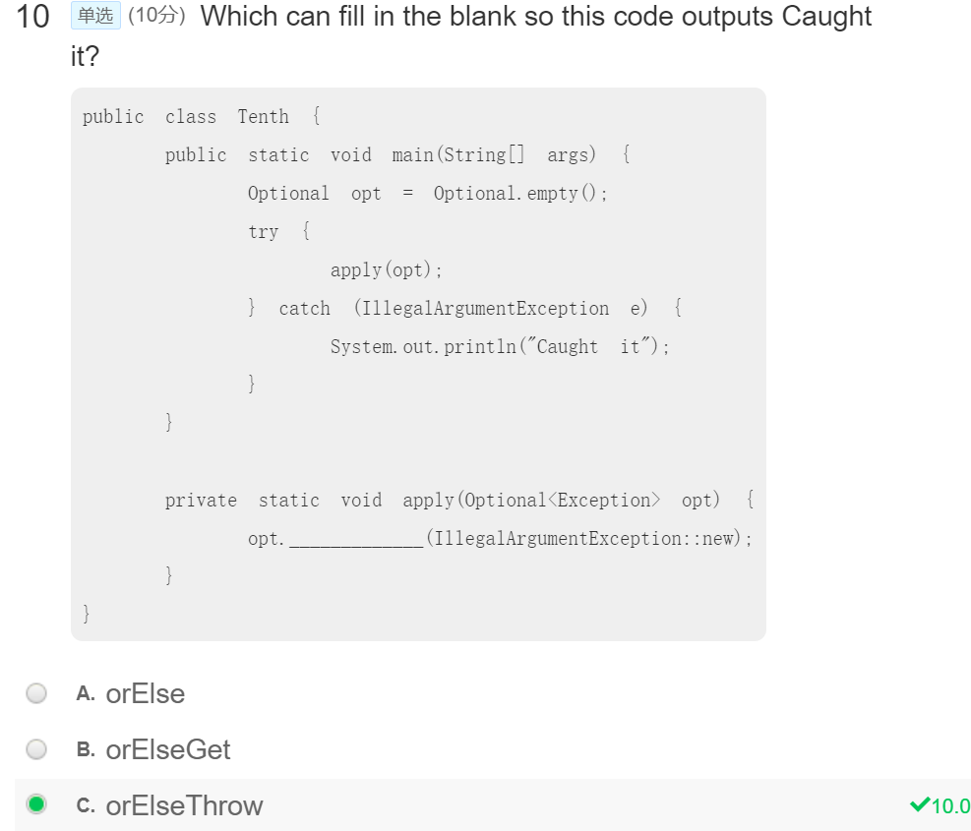

Pay attention to the usage of Optional.