**CS 577 – Spring 2015**

**Programming Project 3**

**The Small World Problem**

**Other model by my own:**

I designed a new algorithm --- Hypercube. I came out this idea from the idea of “topology, routing, and packaging of efficient large-scale networks”. In the real world, it is widely used in the networks, between routers and terminals (such as data center servers). And this algorithm makes it easier to contact different nodes together. The graph could be in n-bit k-dimension numbers.

One dimension (n-bit) hypercube has n fully connected nodes. Assume we have a k-dimension hypercube, then we duplicate it to get n copies. Then we fully connect the n nodes in the n copies which are at the same position. Then these n copies form a (k+1)-dimension hypercube.

Example:

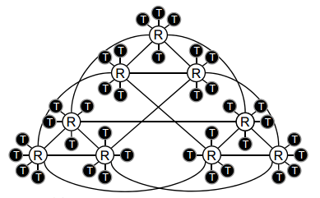

The white nodes R in this figure form a 3-dimension hypercube, each dimension has 3 nodes.

In this report, I vary the dimension k from 1 to 3, and n from 5 to 15 to study its density, connectivity, and connected path length.

**Study:**

1. **Edge density**

*How the edge density changes with the initial population n0, and the maximum number m of new edges per sage.*

*Test with similar value δ (larger value are better connected)*

**1.1 independent Edges**

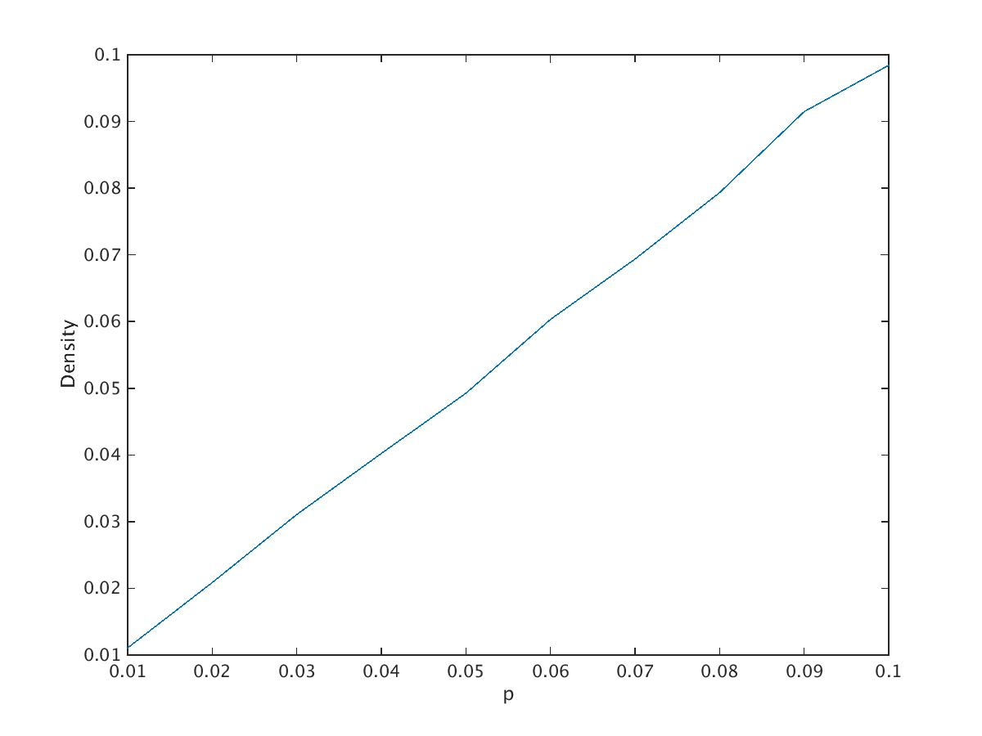

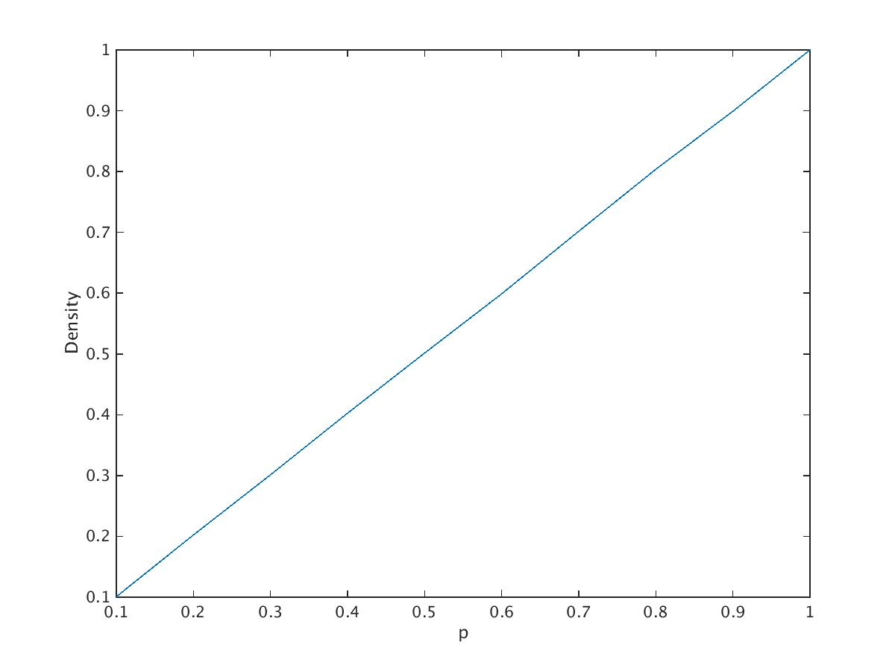

The goal: how the edge density changes with Pr(head) --- variation p (“edgeness” probability)

This plot generated by 20 nodes, with probabilities (to add a node by the numbers) from 0 to 0.1 with step size 0.01 ---1st plot and from 0.1 to 1, increased by step size 0.1 --- 2nd plot. From the plot, the density increase as the probabilities increase.

Conclusion: the edge density closed the value of p.

**1.2 Local Preference**

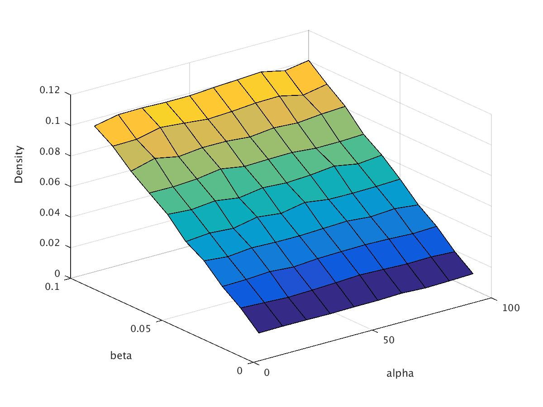

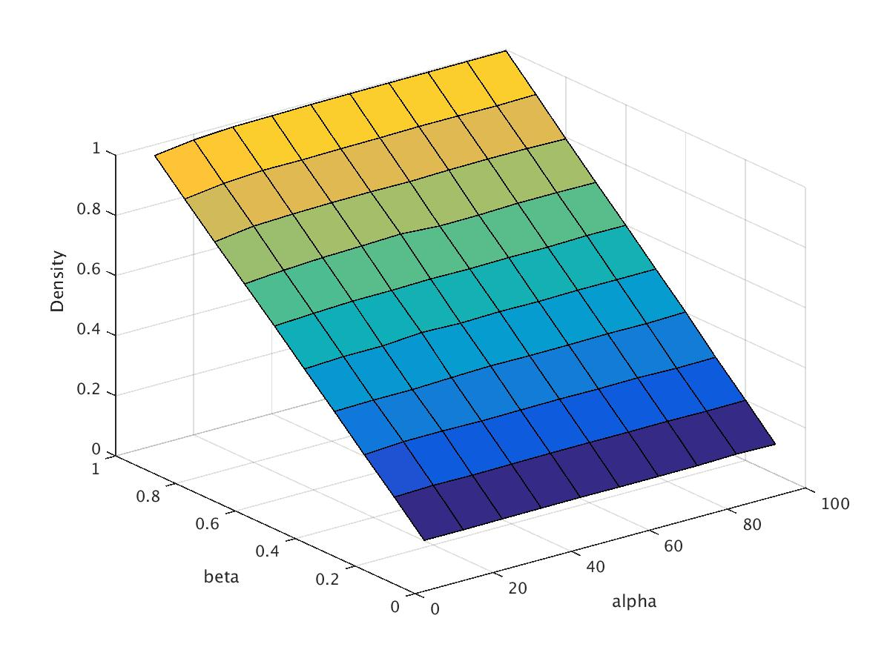

The goal: how the edge density changes with 2 parameters: beta and alpha

(Known: Beta controls the overall number of edges, alpha controls the mix of long and short edges)

The plot generated by 100 nodes with betas chosen from 1 to 100 with step size 10 and alpha chosen from 1 to 10 with step size 1. From the plot, we see that for a fixed alpha, the edge density increases as beta increases. And For a fixed beta, the edge density increase as alpha increase, which is because (d / (L * alpha)) decreases as alpha increases, then the negative power of e increase.

Conclusion: The edge density increase as the beta or alpha increase. [In direct proportion], and increase when we increase both beta and alpha.

**1.3 Preferential Attachment**

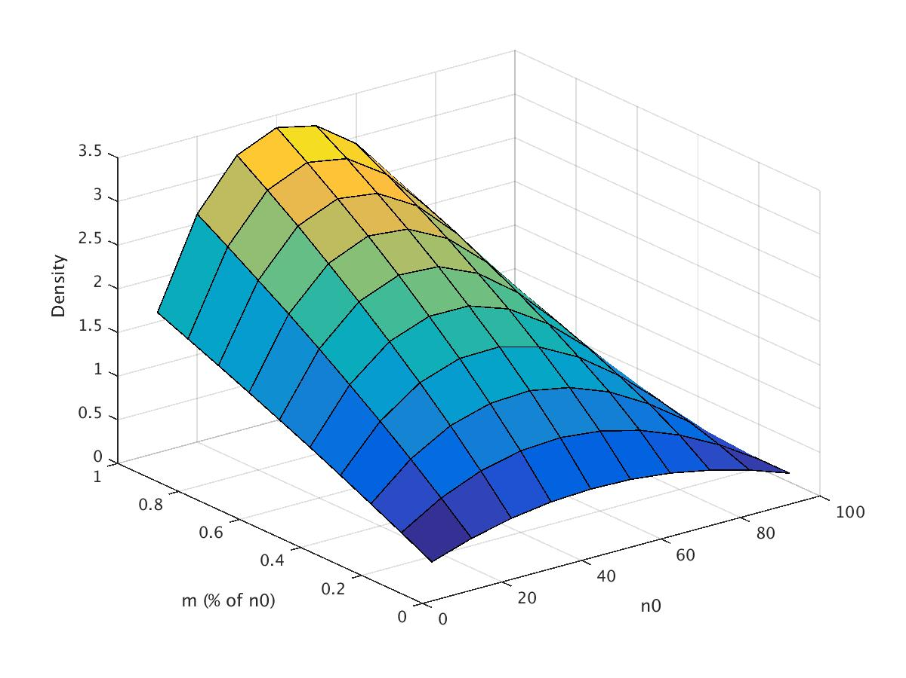

The goal: how the edge density changes with the 2 parameters: initial population n0, and the maximum number m of new edges per stage.

The initial population is the graph has n0/2 edges. The plot generates by 100 nodes, with n0 chosen by a certain percentage of the total number of node in each experience, here, we define it to be 10%. i.e, n0 = 10% * n. And m chosen from a certain percentage of the initial population n0 in each experience, also defined as 10%, i.e, m = 10% * n0. From the plot, we see that with a fixed n0, edge density increases as m increase, and we a fixed m, n0’s increases also causes the edge density increase.

**1.4 Hypercube**

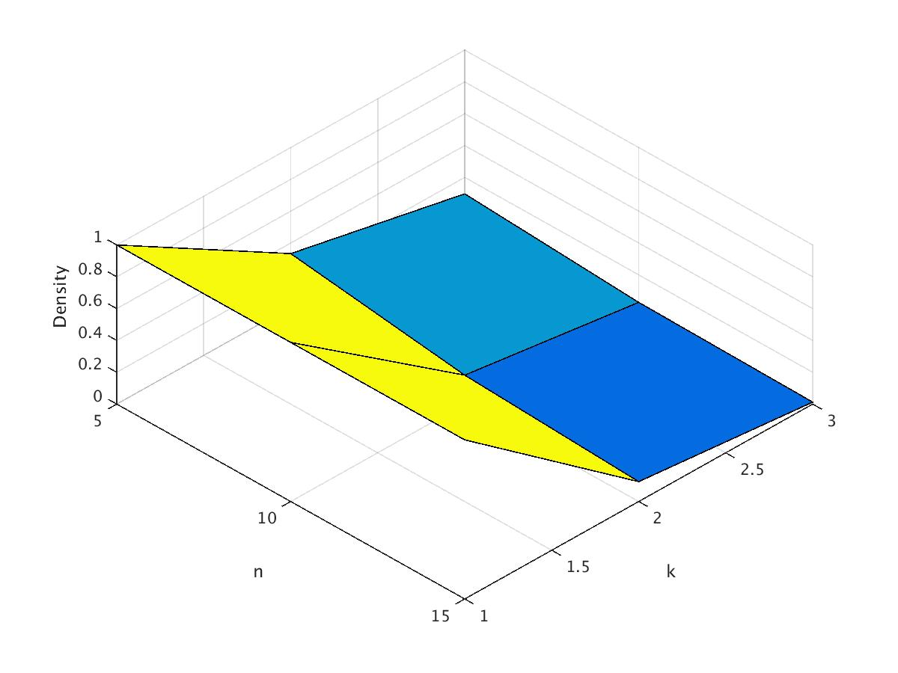

The goal: the relationship with edge density and the # of dimension of hyper and # of nodes.

The plot is generated by 9 nodes, with the dimension from 1 to 3, and # of nodes chosen from 5 to 15, increased with step size 5. For a fixed dimension number, edge density preforms almost the same. And as we could see from the plot, edge density increases as the # of dimension decrease, and the slope shows that the edge density increase more with a same increase speed of the # of dimension.

1. **Connectivity**

*The algorithm used to test this hypothesis:*

We define:

Connectivity = # of connected pairs / # of total pairs

*How dense does the graph have to be before full connectivity appears?*

**2.1 independent Edges**

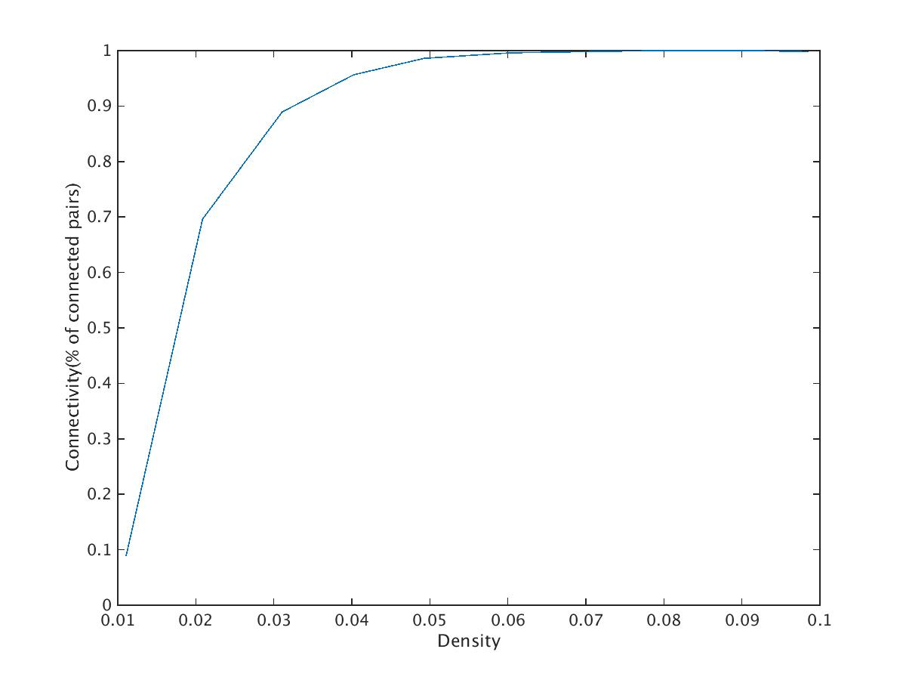

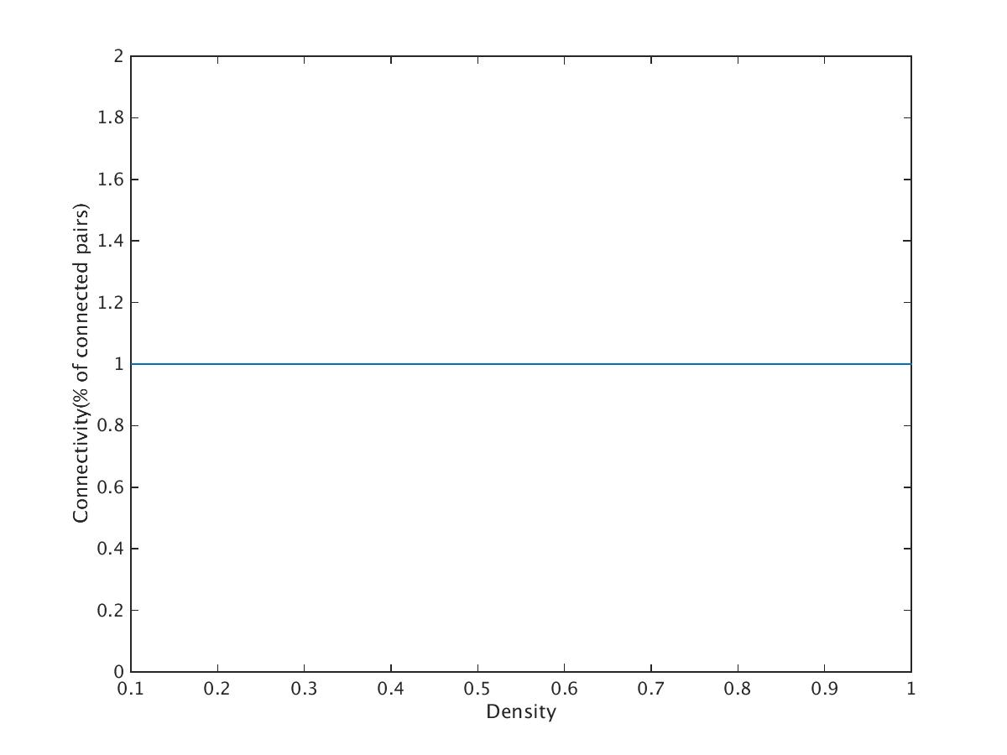

From the plot, we see that the connectivity (% of connected pairs) increases as edge densities increase until the edge density gets almost around 0.055. And then keep the connectivity almost 1.

**2.2 Local Preference**

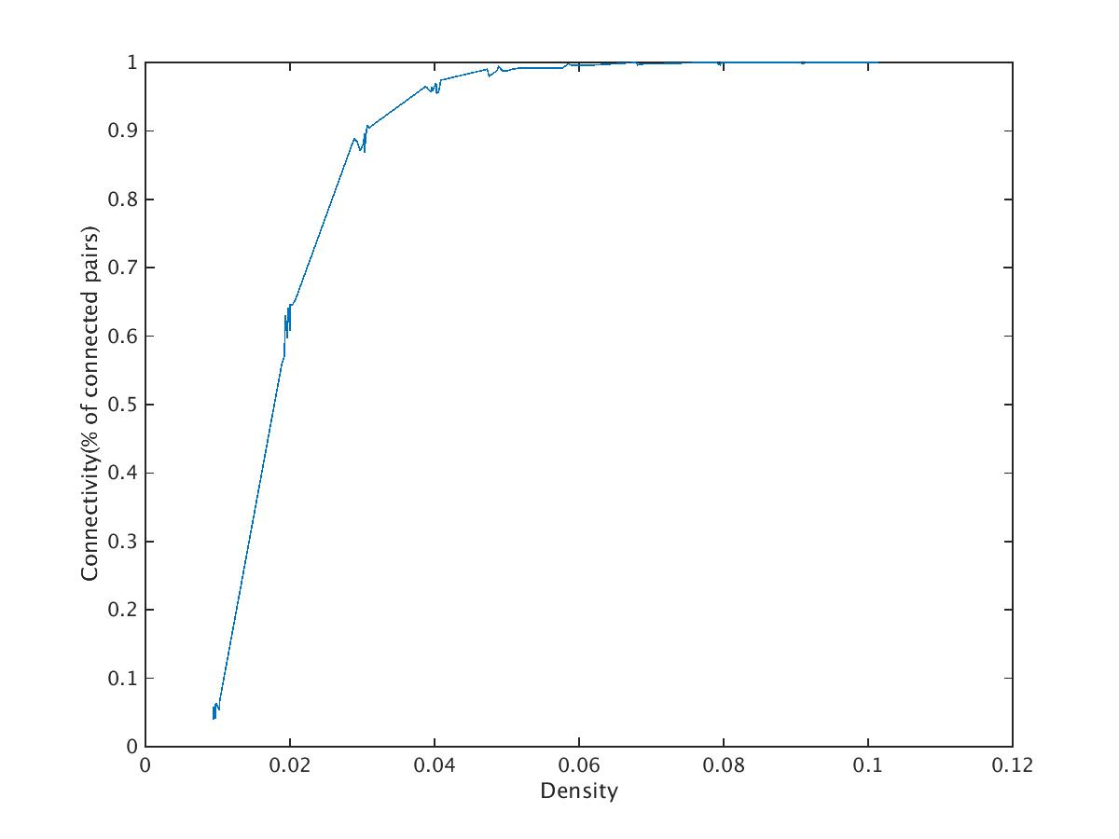

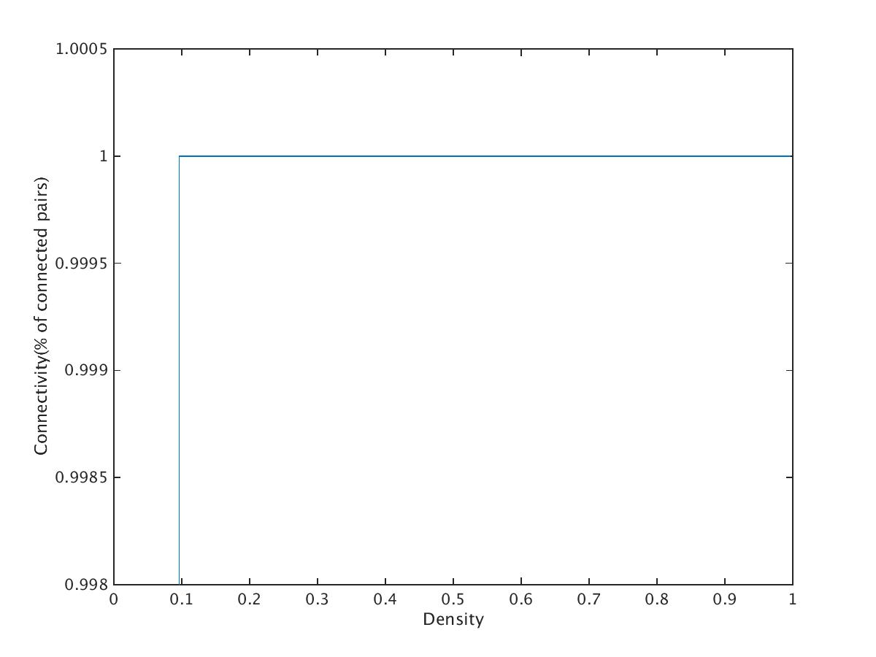

The plot generated by 100 nodes with betas chosen from 1 to 100 with step size 10 and alpha chosen from 1 to 10 with step size 1. From the plot, we could see that for small edge density (0 to 0.1), as the edge density increase, the connectivity (% of connected pairs of the total edges) increases almost linearly until a large percentage value (0.1) of connectivity be reached.

**2.3 Preferential Attachment**

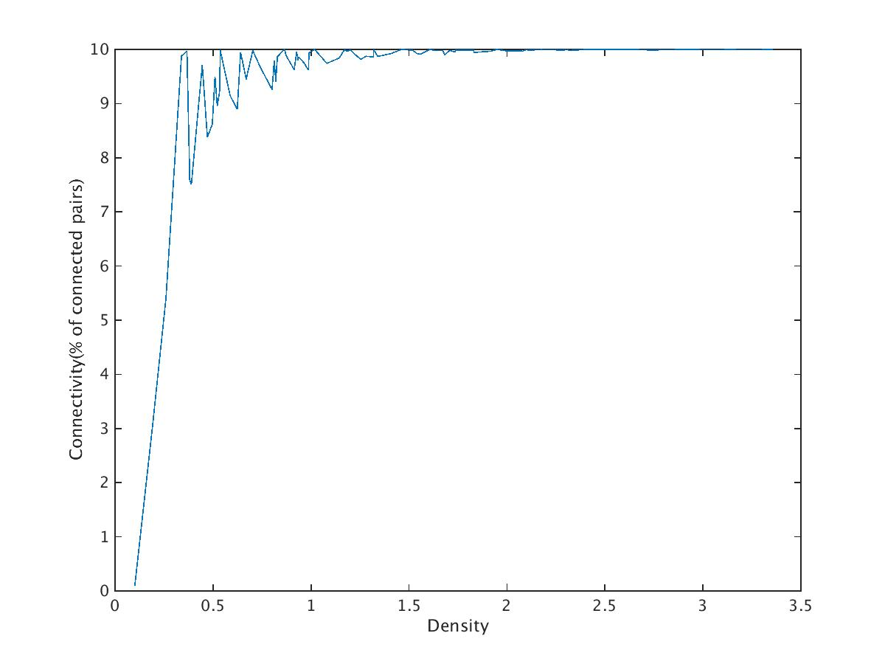

Both of these two plots are generated by 100 nodes, with n0 10% of the total number of node in each experience. And m 10% of the initial population n0 in each experience, also defined as 10%.

From the plot, we conclude that as the edge density and the connectivity are in direct proportion, and connectivity increases almost linearly as the edge density increases, until the connectivity reaches a large value (close to 1), where the density is around 0.5.

**2.4** **Hypercube**

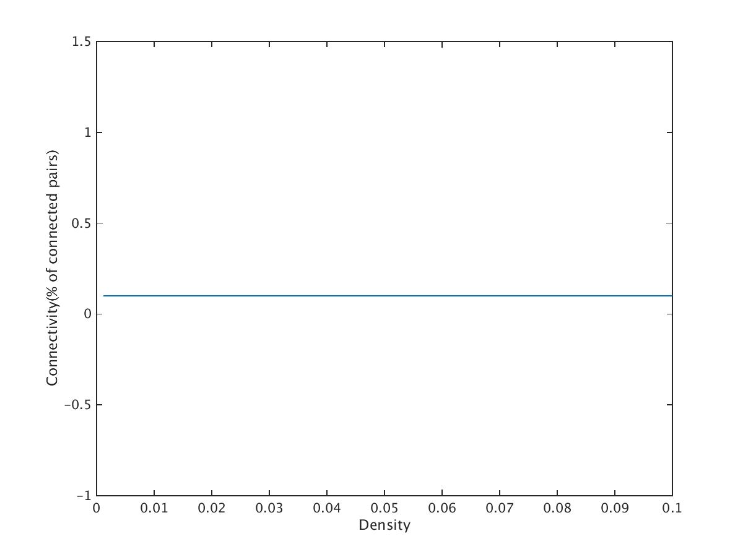

As show in the equation, the connectivity of hypercube is a fixed number depends on n and k. And from the plot, we see that the connectivity is around 0.1.

1. **Short Paths (in a random graph setting)**

*The chance of a successful connection*

*The distribution of path lengths*

*We modify Dijkstra’s algorithm.*

**3.1 Independent Edges**

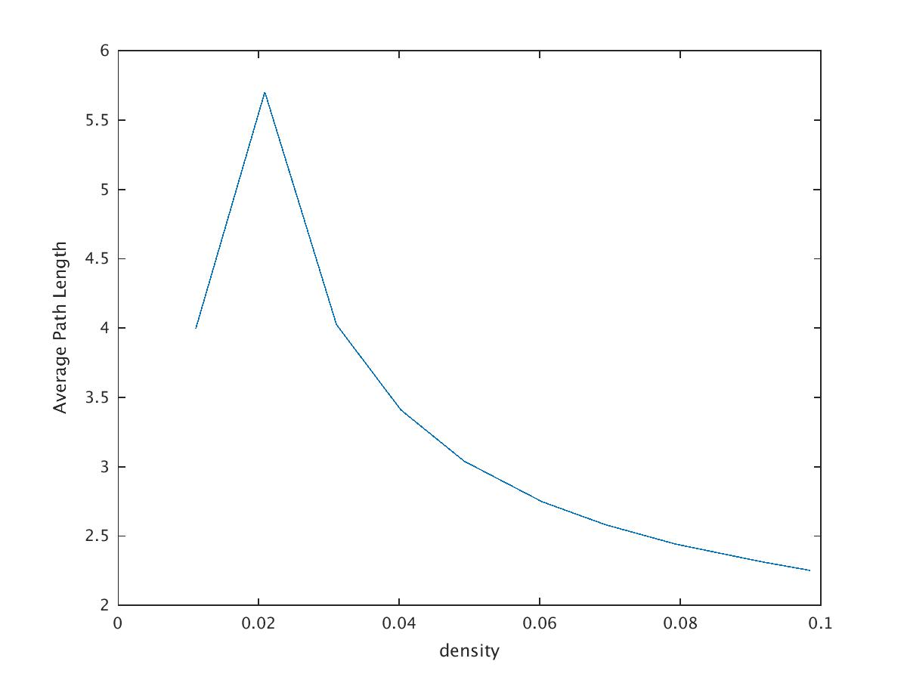

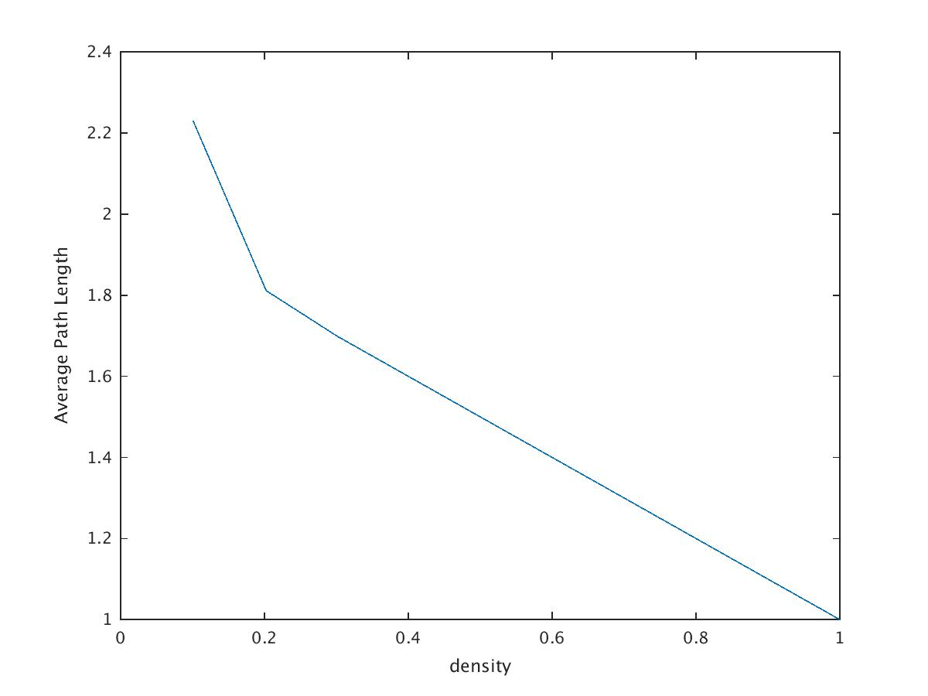

This plot is generated by 20 nodes, from edge density chosen from 0.1 to 1 with step size 0.1, and 0 to 0.1 with step size 0.01. From the plot, we see that the average path length and the edge density are in inverse proportion. And from the first figure, we see that the largest number of the average path length is less than 6.

**3.2 Local Preference**

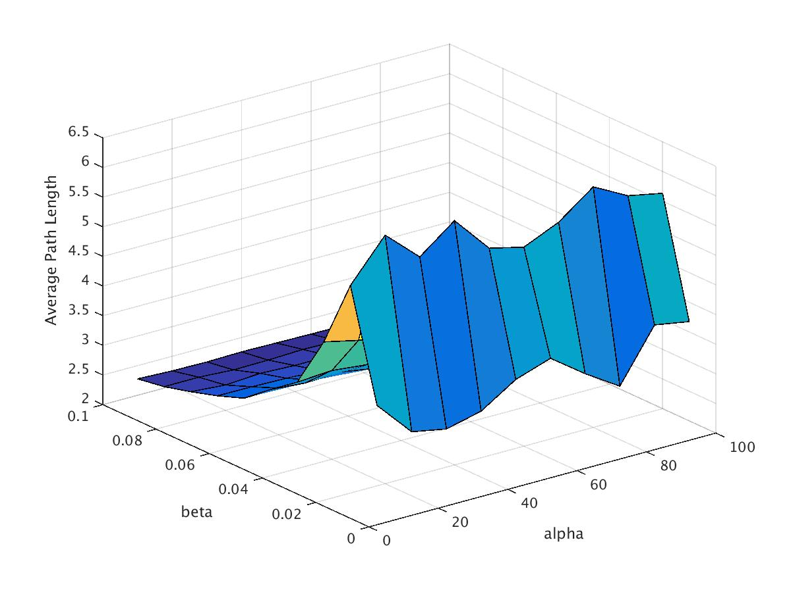

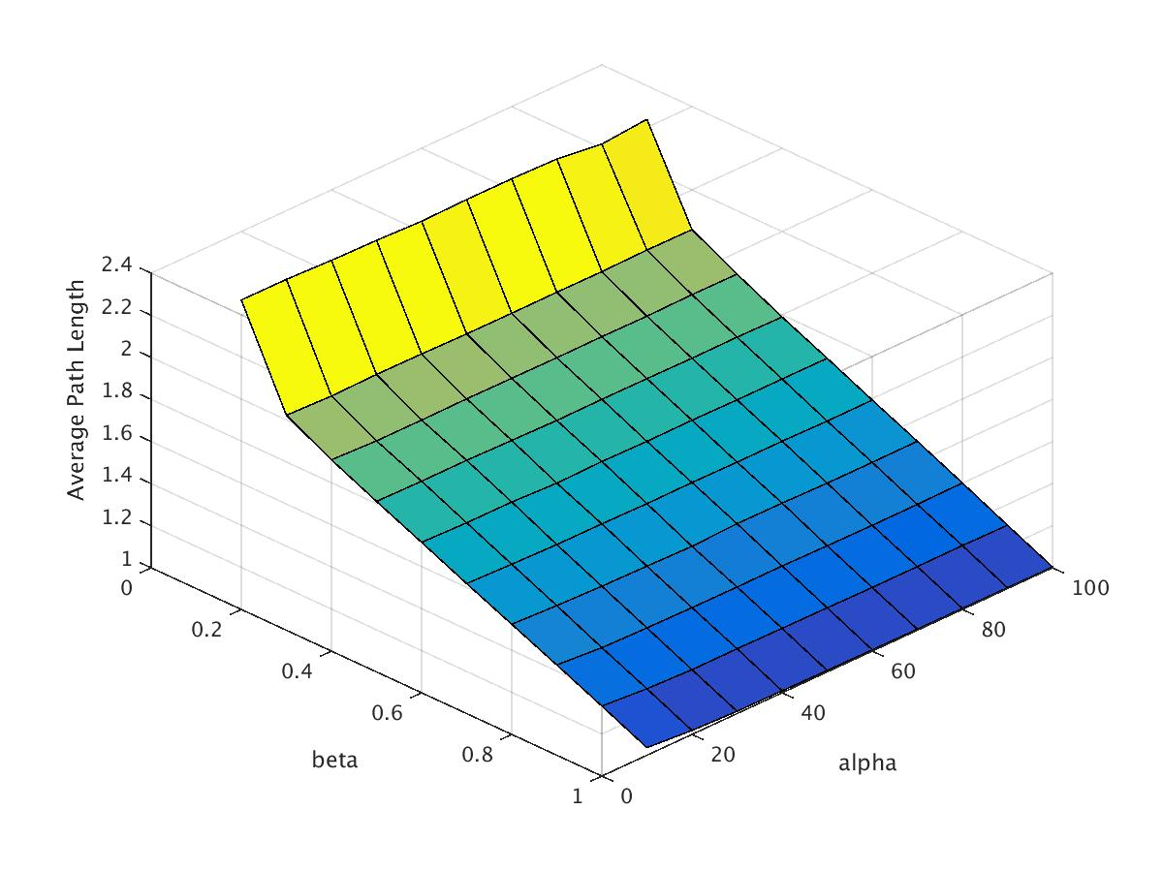

The plots generated by 200 nodes with betas chosen from 1 to 100 with step size 10 and alpha chosen from 1 to 10 with step size 1, and betas chosen from 0 to 0.1 with step size 0.001 with the same alpha. From the plot, we see that with a fixed alpha, the average path length and beta are in inverse proposition (for beta larger than 0.1), and for beta from 0 to 0.1, then density is very small, which makes it hard to form long path length. And the largest number of the average path length is less or equal to 6.

**3.3 Preference Attachment**

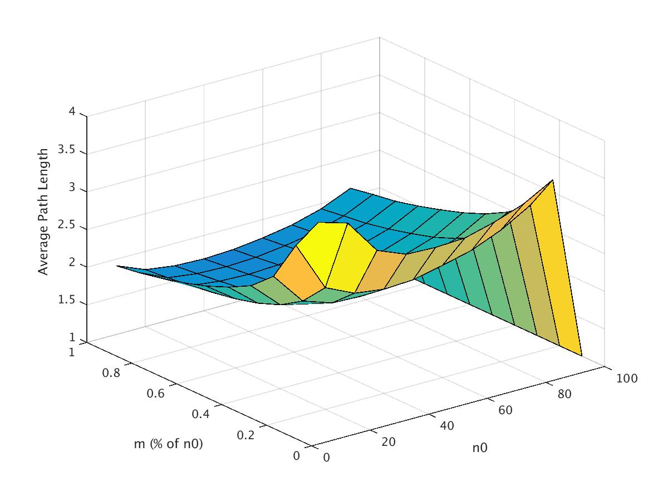

Both of these two plots are generated by 100 nodes, with n0 10% of the total number of node in each experience. And m 10% of the initial population n0 in each experience, also defined as 10%.

From the plot, we conclude that the largest number of the average path length is less or equal to 4.

ccc

**2.4 Hypercube**

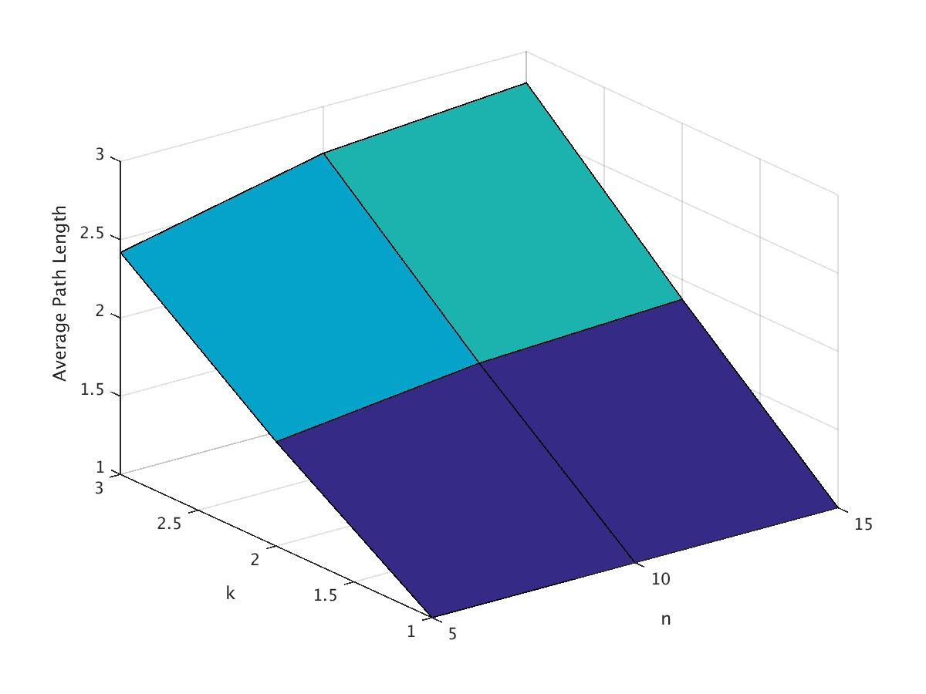

The plot is generated by 9 nodes, with the dimension from 1 to 3, and # of nodes chosen from 5 to 15, increased with step size 5.

From the plot, we see that with a fixed value n, the average path length increase as the increase of k. And with a fixed value k, the average path length increase as the increase of n.

Conclusion, the average path length increase as the n and/or k increase.

Based on the 4 plots, we conclude that the average path length is les or equal to 6.