LAB REPORT
Doubly Linked List in Python
Addition, Insertion, Deletion, Searching, Updating and Basic Operations

Course | Data Structures and Algorithms Using Python
Lab No. | Lab 03
Student Name | Jiayu Yang （ID 20253801028）
Student ID | 2025-AI-002
Submission Date | 21 October 2026

1-1. Objective
The objective of this lab is to practice fundamental Doubly linked list operations in Python, including traversal, addition, insertion, deletion, searching, updating, aggregation, sorting and reversing. The lab also
demonstrates how these operations can be combined into a menu-driven Doubly Linked List Management System.

1-2. Software / Environment

Programming Language | Python 3.x
Editor / IDE | Editor
Data Structure | Python Doubly Linked list
File Name | 20253801028_Doubly_Linked_List_operations.py

2-1. Doubly Listed List class definitions.
Doubly Linked List Class program
class Node:
def __init__(self, data):
self.data = data
self.prev = None
self.next = None

class DoublyLinkedList:
def __init__(self):
self.head = None
self.tail = None

def append(self, value):
new = Node(value)
if self.head is None:
self.head = self.tail = new
else:
new.prev = self.tail
self.tail.next = new
self.tail = new

def display_forward(self):
current = self.head
while current is not None:
print(current.data, end=" <-> " if current.next else "")
current = current.next
print()

def display_backward(self):
current = self.tail
while current is not None:
print(current.data, end=" <-> " if current.prev else "")
current = current.prev
print()

def prepend(self, value):
new = Node(value)
if self.head is None:
self.head = self.tail = new
else:
new.next = self.head
self.head.prev = new
self.head = new

def insert_at(self, index, value):
if index < 0:
return False
if index == 0:
self.prepend(value)
return True
current = self.head
position = 0
while current is not None and position < index:
current = current.next
position += 1
if position != index:
return False
if current is None:
self.append(value)
return True
new = Node(value)
before = current.prev #
new.prev = before
new.next = current
before.next = new
current.prev = new
return True

Figure 1. Doubly Listed List class definitions

2-2. Doubly Listed List class definitions、DoublyLinkedList() and MAIN MENU.
Requirement: Place all indented methods above inside Doubly Linked List. Run the code below after the Node and Doubly Linked List class definitions. Then, into main_menu, 1. into
Python code

def main_menu():
first = Node(10)
second = Node(20)
first.next = second
second.prev = first
print(first.next.data) # 20
print(second.prev.data) # 10

dll = DoublyLinkedList()
for number in [10, 20, 30]:
dll.append(number)
dll.display_forward() # 10 <-> 20 <-> 30
dll.display_backward() # 30 <-> 20 <-> 10

dll.prepend(5)
dll.display_forward() #5 <-> 10 <-> 20 <-> 30
dll.insert_at(2, 15)
dll.display_forward() #5 <-> 10 <-> 15 <-> 20 <-> 30

dll.delete_first()
dll.display_forward() # 10 <-> 15 <-> 20 <-> 30
dll.delete_last()
dll.display_forward() # 10 <-> 15 <-> 20
print("searched index: ",dll.search(20)) #searched index: 2
dll.update_at(2, 25)
dll.display_forward()
dll.delete_value(25)
dll.display_forward()
print("count: ",dll.count()) #count: 2
dll.reverse()
dll.display_forward() # 30 <-> 25 <-> 10 <-> 5

print(" 1. Entry Main Doubly Linked List_management")
print(" 2. Remove precisely the selected node")
print(" 3. Insert after the first matching node")
print(" 4. Find the middle node")
print(" 5. Remove duplicate values")
while True:
opt = input("\nPlease select task number: ")
if opt == "1":
main_list_management(dll)
elif opt == "2":#challenge delete_at
index = int(input("Enter index to delete: "))
if dll.delete_at(index):
dll.display_forward()
else:
print("delete at failed")
elif opt == "3": #challenge delete_at
value = int(input("Enter find value: "))
newValue = int(input("insert newValue: "))
dll.insert_after(value,newValue)
dll.display_forward()
elif opt == "4": #challenge find_middleNode
dll.find_middleNode()
dll.display_forward()
elif opt == "5": #challenge remove_duplicate
dll.remove_duplicate()
dll.display_forward()

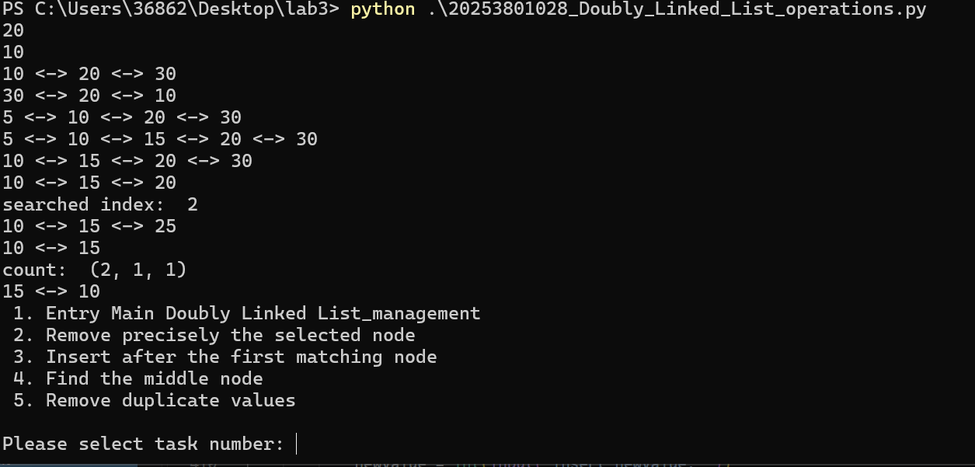

Figure 2. DoublyLinkedList() and main_menu
Action:select task number 1 into Doubly Linked List Management System,..... .

2-3. Doubly Linked List Management System
Function Doubly Linked List Management System task1-15
Python code
def main_list_management(dLinedList):

print("DOUBLY LINKED LIST MANAGEMENT")
print(" 1. Display Forward")
print(" 2. Display Backward")
print(" 3. Insert at Beginning")
print(" 4. Insert at End")
print(" 5. Insert at Index")
print(" 6. Delete First")
print(" 7. Delete Last")
print(" 8. Delete by Value")
print(" 9. Delete by Index")
print("10. Search Value")
print("11. Update by Index")
print("12. Count Nodes")
print("13. Sum / Min / Max / Average")
print("14. Reverse List")
print("15. Exit")
while True:
opt = input("\nPlease select task number: ")
if opt == "1":
dLinedList.display_forward()
elif opt == "2":
dLinedList.display_backward()
elif opt == "3":
val = int(input("Enter element at start: "))
dLinedList.prepend(val)
dLinedList.display_forward()
elif opt == "4":
val = int(input("Enter element at end: "))
dLinedList.append(val)
dLinedList.display_forward()
elif opt == "5":
index = int(input("Enter index: "))
val = int(input("Enter element: "))
if dLinedList.insert_at(index,val):
dLinedList.display_forward()
else:
print("insert failed,index error")
elif opt == "6":
dLinedList.delete_first()
dLinedList.display_forward()
elif opt == "7":
dLinedList.delete_last()
dLinedList.display_forward()
elif opt == "8":
value = int(input("Enter value to delete: "))
if dLinedList.delete_value(value):
dLinedList.display_forward()
else:
print("delete at failed")
elif opt == "9":
index = int(input("Enter index to delete: "))
if dLinedList.delete_at(index):
dLinedList.display_forward()
else:
print("delete at failed")
elif opt == "10":
val = int(input("Enter element to search: "))
if dLinedList.search(val) != -1:
print("search value success")
else:
print("search value failed")
elif opt == "11":
index = int(input("Enter data to index: "))
val = int(input("Enter element to add: "))
if dLinedList.update_at(index,val):
print("update value success")
else:
print("update value failed")
elif opt == "12":
dLinedList.display_forward()
print("count_nodes:", dLinedList.count())
elif opt == "13":
dLinedList.display_forward()
print("get_max value:", dLinedList.get_max())
print("get_min value:", dLinedList.get_min())
print("total_value:", dLinedList.get_sum())
print("average_value:", dLinedList.get_average())
elif opt == '14':
dLinedList.display_forward()
dLinedList.reverse()
dLinedList.display_forward()
elif opt == "15":
print("Exit APP")
break
else:
print("Invalid option, try again.")
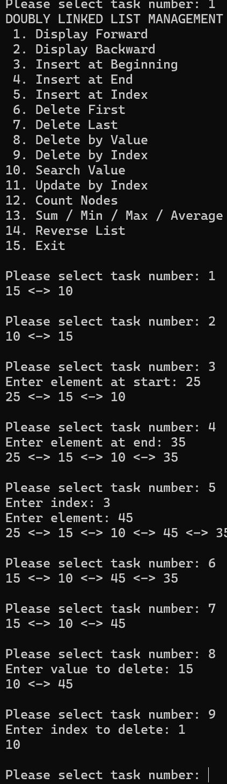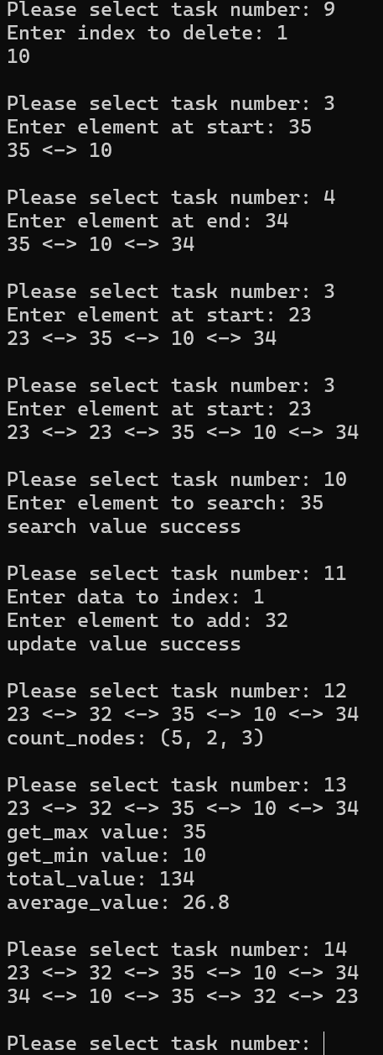
Figure 2. Doubly Linked List Management System task1-15
- Test Cases
For the definitions Doubly Linked List[10, 20, 30, 40, 60]
- FUNCTION Task5 Insertion value 11, index 7, insert failed,index error
- FUNCTION Task3 Insertion value 11, index 3, output [10, 20, 30,11, 40, 60]
- FUNCTION Task5 Search value 50, search value failed
- FUNCTION Task5 Search value 30, search value success
- FUNCTION Task6 Update Index 1, value 55, update value success
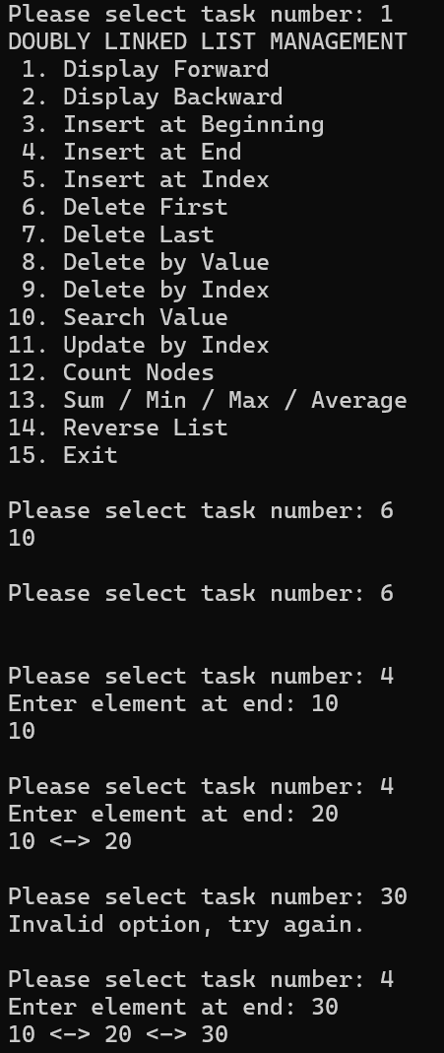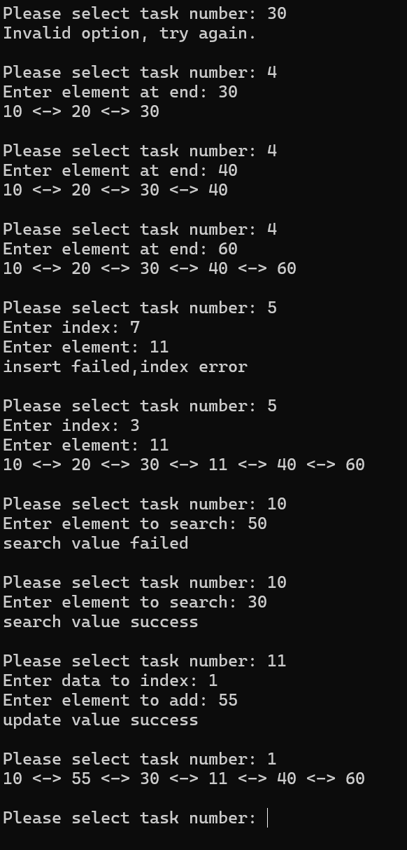

Test | Operation | Input | Expected | Status
1 | Insert | Value11 at Index 7 | insert failed,index error | Pass
2 | Insert | Value11 at Index 3 | [10, 20, 30,11, 40, 60] | Pass
3 | Search | 50 | search value failed | Pass
4 | Search | 30 | search value success | Pass
5 | Update | Index 1, Value 55 | update value success | Pass

- Lab tasks

attachment with 20253801028_Doubly_Linked_List_operations.py and Section. 2 Screenshots showing program execution

Advanced Task - Link Manipulation
Inserting a node N between two existing nodes A (before) and B (after) requires exactly four reference assignments:
N.prev = A
N.next = B
A.next = N
B.prev = N
Before: A <-> B (A.next = B, B.prev = A)
After: A <-> N <-> B (all four links above updated)
Missing any one of the four assignments leaves the chain broken: the new node would be unreachable from one side, or the neighbours would still point at each other and skip N.
Reversing the list swaps prev and next for every node. After the sweep, each node's old next (towards the tail) has become its prev, so the old head now points nowhere forward and the old tail points nowhere backward. Exchanging head and tail is therefore mandatory: the old tail is the new first node and the old head is the new last node. Without the exchange, head would reference the last node and forward traversal would print nothing useful.
Forward traversal after a correct reverse equals the previous backward traversal, which the program confirms with verify_links.

