LAB REPORT

Array Operations in Python
Addition, Insertion, Deletion, Searching, Updating and Basic Operations

Course | Programming Fundamentals
Lab No. | Lab 01
Student Name | Jiayu Yang （ID 20253801028）
Student ID | 2025-AI-002
Submission Date | 17 September 2026

1-1. Objective
The objective of this lab is to practice fundamental array/list operations in Python, including traversal, addition, insertion, deletion, searching, updating, aggregation, sorting and reversing. The lab also
demonstrates how these operations can be combined into a menu-driven Array Management System.

1-2. Software / Environment

Programming Language | Python 3.x
Editor / IDE | Editor
Data Structure | Python list
File Name | 20253801028_array_operations.py

2-1. Task 1 - LAB MAIN MENU、 Create and Display an Array
Requirement: Function Task1 Accept 10 integer values, store them in a list, and display the complete list, first element and last element.
Python code

def task1():
print("\n===== Task1: Create and Display an Array =====")
numbers = []
print("Input 10 elements:")
numbers = list(map(int, input().split()))
print("Array:", numbers)
print("First element:", numbers[0])
print("Last element:", numbers[9])
return numbers
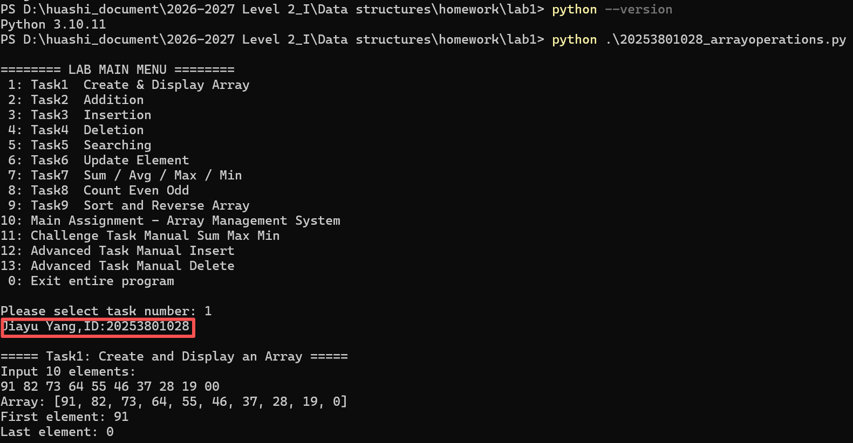

Figure 1. execution for Task 1
Result: The program correctly stored ten integers and accessed the first and last positions using list indexing.

2-2. Task 2 -6 -Addition, Insertion,Deletion,Search and Update
Function Task2 demonstrates adding an element to the end of the list, Function Task3 inserting an element at a selected index, and Function Task4 deleting an element using its index.Function Task5 searches for a user-provided value. If the value exists, its index is reported. Function Task6 selected element is then replaced by a new value.
Python code
def task2(array):
print("\n===== Task2: Addition =====")
print("Before:", array)
new_val = int(input("Enter value: "))
array.append(new_val)
print("After:", array)

def task3(array):
print("\n===== Task3: Insertion =====")
length = len(array)
val = int(input("Value: "))
idx = int(input("Index: "))
if idx>length:
print("Invalid index")
else:
array.insert(idx, val)
print(array)

def task4(array):
print("\n===== Task4: Deletion =====")
del_idx = int(input("Enter index to delete: "))
array.pop(del_idx)
print(array)

def task5(array):
print("\n===== Task5: Searching =====")
search_val = int(input("Enter value: "))
if search_val in array:
pos = array.index(search_val)
print(f"Element found at index {pos}")
else:
print("Element not found")

def task6(array):
print("\n===== Task6: Update an Element =====")
idx = int(input("Index: "))
new_val = int(input("New value: "))
array[idx] = new_val
print(array)
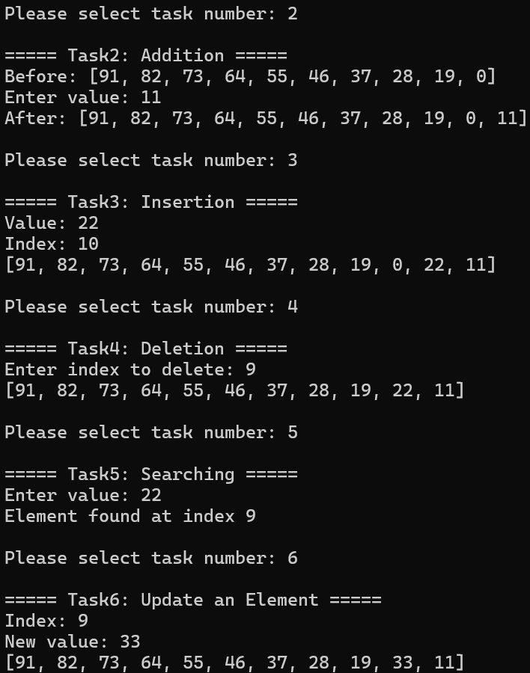
Figure 2. Addition ,insertion and deletion,Search and update output

2-3. Task 7-9 - Sum and Average,Count Even and Odd, Sort and Reverse an Array
Function Task7 calculate the sum, average, maximum, minimum, and Function Task8 number of even and odd values. Function TASK9 Ascending order,then reverse the array
Python code

def task7(array):
print("\n===== Task7: Sum and Average =====")
total = sum(array)
average = total / len(array)
maximum = max(array)
minimum = min(array)
print("Sum:", total)
print("Average:", average)
print("Maximum:", maximum)
print("Minimum:", minimum)

def task8(array):
print("\n===== Task8: Count Even and Odd Numbers =====")
even_count = 0
odd_count = 0
for i in range(10):
v = array[i]
if v % 2 == 0:
even_count += 1
else:
odd_count += 1
print("Array:", array)
print("Even numbers:", even_count)
print("Odd numbers:", odd_count)

def task9(array):
print("\n===== Task9: Sort and Reverse an Array =====")
print("Original:")
print(array)
array.sort()
print("Sort:")
print(array)
array.reverse()
print("Reverse:")
print(array)
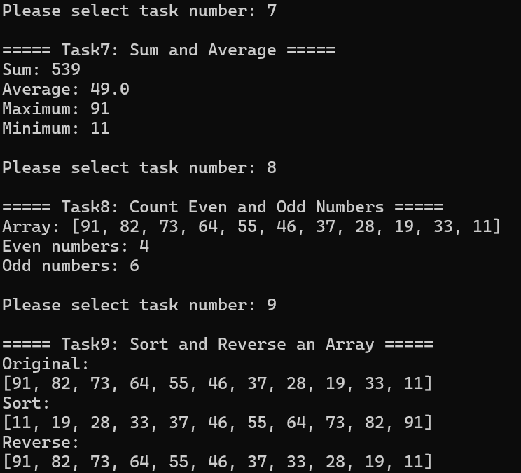
Figure 3. Sum and Average,Count Even and odd ,Ascending order,then Reverse execution output

2-4. Task - Challenge Task Manual Sum Max 、Insert and delete
Function challenge_task Manual sum/max/min (no built‑in functions), and function advanced_manual_insert Manual Insertion (no insert()). function advanced_manual_delete Manual Deletion (no pop/remove/del)
def challenge_task(array):
print("\n===== Challenge Task: Manual sum/max/min (no built‑in functions) =====")
print("Test array:", array)
total = 0
for num in array:
total = total + num
max_val = array[0]
min_val = array[0]
for n in array:
if n > max_val:
max_val = n
if n < min_val:
min_val = n
average = total / len(array)
print("Manual Sum:", total)
print("Manual Max:", max_val)
print("Manual Min:", min_val)
print("Manual Average:", average)

def advanced_manual_insert(array):
print("\n===== Advanced Task: Manual Insertion (no insert()) =====")
insert_index = int(input("Index: "))
insert_value = int(input("Value: "))
new_arr = []
for i in range(len(array)):
if i == insert_index:
new_arr.append(insert_value)
new_arr.append(array[i])
print("Original:", array)
print("After manual insert:", new_arr)

def advanced_manual_delete(array):
print("\n===== Advanced Task: Manual Deletion (no pop/remove/del) =====")
delete_index = int(input("Index: "))
new_arr = []
for i in range(len(array)):
if i != delete_index:
new_arr.append(array[i])
print("Original:", array)
print("After manual delete:", new_arr)

- Test Cases
For the default array[10, 20, 30, 40, 60]
- FUNCTION Task1 Create & Display Array[91,82,73,64,55,46,37,28,19,00].
- FUNCTION Task3 Insertion value 11, index 12, Invalid index, insert failed
- FUNCTION Task3 Insertion index 22, value 8, output[91,82,73,64,55,46,37,28,22,19,00]
- FUNCTION Task5 Search value 20,Element not found
- FUNCTION Task5 Search value 37,Element found at index 6
- FUNCTION Task6 Update Index3,value 33,output [91,82,73,33,55,46,37,28,22,19,00]

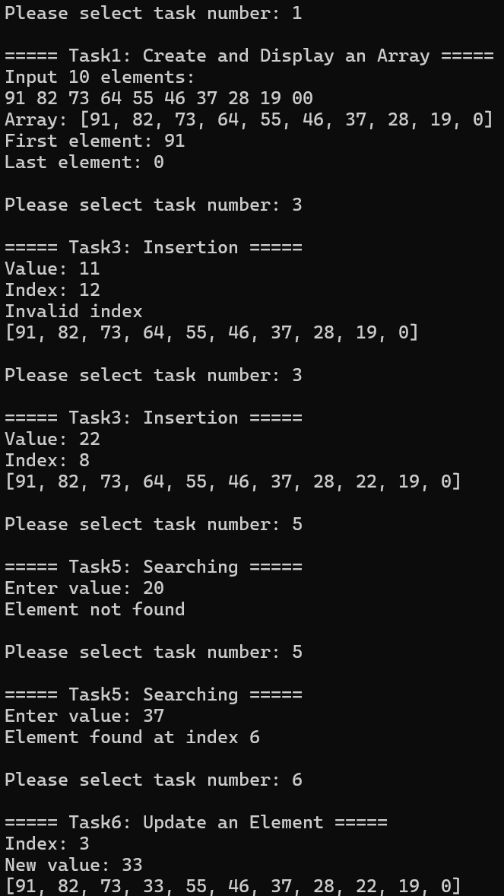
Test | Operation | Input | Expected | Status
2 | Insert | value11 at Index 12 | Invalid index | Pass
3 | Insert | Value22 at Index 8 | [91,82,73,64,55,46,37,28,22,19,00] | Pass
4 | Search | 20 | Element not found | Pass
5 | Search | 37 | Element found at index 6 | Pass
6 | Update | Index 3,Value 33 | [91,82,73,33,55,46,37,28,22,19,00] | Pass

- Lab tasks

attachment with 20253801028_array_operations.py and Section. 2 Screenshots showing program execution

5.Main Array Management System
A menu-driven program was developed to integrate the main operations. The program continues running until the user selects Exit and validates indexes before insertion, deletion or updating.
Final integrated program
def main_menu():
numbers_array = [10, 20, 30, 40, 60]
print("\n======== LAB MAIN MENU ========")
print(" 1: Task1 Create & Display Array")
print(" 2: Task2 Addition")
print(" 3: Task3 Insertion")
print(" 4: Task4 Deletion")
print(" 5: Task5 Searching")
print(" 6: Task6 Update Element")
print(" 7: Task7 Sum / Avg / Max / Min")
print(" 8: Task8 Count Even Odd")
print(" 9: Task9 Sort and Reverse Array")
print("10: Main Assignment - Array Management System")
print("11: Challenge Task Manual Sum Max Min")
print("12: Advanced Task Manual Insert")
print("13: Advanced Task Manual Delete")
print(" 0: Exit entire program")
while True:
opt = input("\nPlease select task number: ")
if opt == "1":
numbers_array = task1()
elif opt == "2":
task2(numbers_array)
elif opt == "3":
task3(numbers_array)
elif opt == "4":
task4(numbers_array)
elif opt == "5":
task5(numbers_array)
elif opt == "6":
task6(numbers_array)
elif opt == "7":
task7(numbers_array)
elif opt == "8":
task8(numbers_array)
elif opt == "9":
task9(numbers_array)
elif opt == "10":
main_array_management(numbers_array)
elif opt == "11":
challenge_task(numbers_array)
elif opt == "12":
advanced_manual_insert(numbers_array)
elif opt == "13":
advanced_manual_delete(numbers_array)
elif opt == "0":
print("Program finished.")
break
else:
print("Invalid option, try again.")

if __name__ == "__main__":
main_menu()

Figure 4. Example execution of the Main Array Management System

6. Answers to the questions
Q1. What is an array?
Answer: An array is a data structure that stores a collection of elements (values or variables), each identified by an index or key. Elements are stored in contiguous memory locations and can be accessed directly by their index.
Q2. What is the Python data structure commonly used as an array?
Answer: In Python, the list is the most commonly used data structure that behaves like an array. It is a dynamic, ordered collection of items that can be accessed by index.
Q3. What does an index represent?
Answer: An index is an integer that represents the position of an element within the array. It allows direct access to a specific element. In Python, indices start from 0.
Q4. What is the first index of a Python list?
Answer: The first index of a Python list is 0 (zero-based indexing). The last element can be accessed with index -1.
Q5. What is the difference between append() and insert()?
Answer: append() adds an element at the END of the list (index len(list)). insert(index, value) adds an element at a SPECIFIED index position, shifting subsequent elements to the right.
Q6. What is the difference between remove() and pop()?
Answer: remove(value) deletes the FIRST occurrence of a given value from the list. pop(index) removes and returns the element at the given index (defaults to the last element if no index is specified).
Q7. What does len() do?
Answer: len() is a built-in function that returns the number of elements (length) in a list or other collection.
Q8. What does index() do?
Answer: index(value) returns the index of the FIRST occurrence of the specified value in the list. If the value is not found, it raises a ValueError.
Q9. How can an existing array element be updated?
Answer: An existing element can be updated by assigning a new value to its index position, e.g., list[index] = new_value.
Q10. How can an element be searched in an array?
Answer: Use the 'in' operator to check if an element exists (if value in list), and use list.index(value) to find its position. For manual search, iterate through the array and compare each element.
Q11. What happens if an invalid index is accessed?
Answer: Accessing an invalid index (out of range) raises an IndexError exception. For example, accessing list[10] when the list has only 5 elements will cause IndexError: list index out of range.
Q12. What is the difference between sorting and reversing an array?
Answer: Reversing (reverse()) simply reverses the order of elements as they are (e.g., [1,3,2] -> [2,3,1]). Sorting (sort()) rearranges elements in ascending or descending order based on their values (e.g., [3,1,2] -> [1,2,3])

