- Open
- New Project 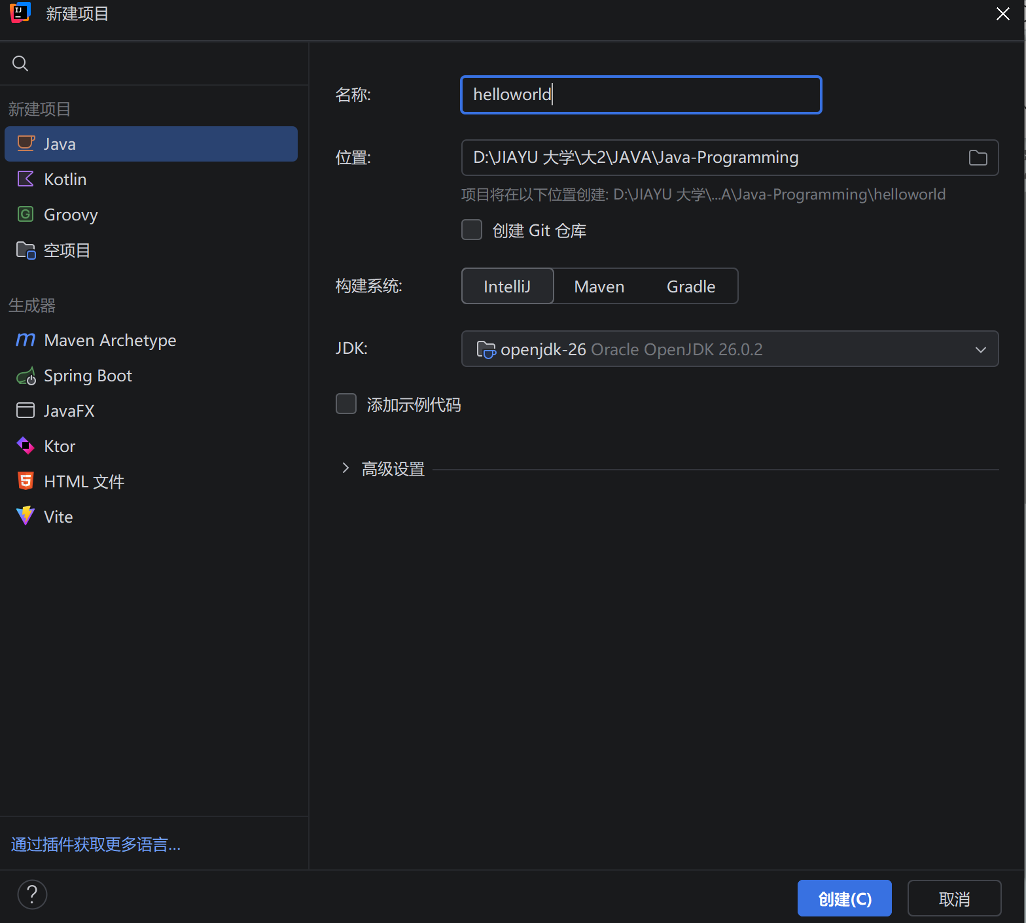
- NewJavaclass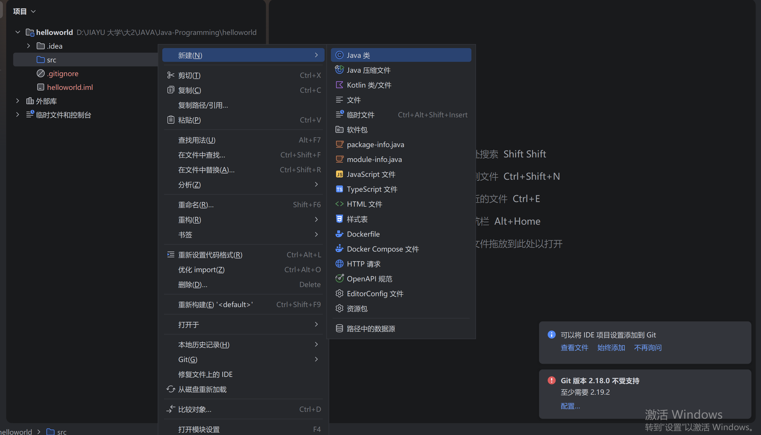
- Input class name(helloworld)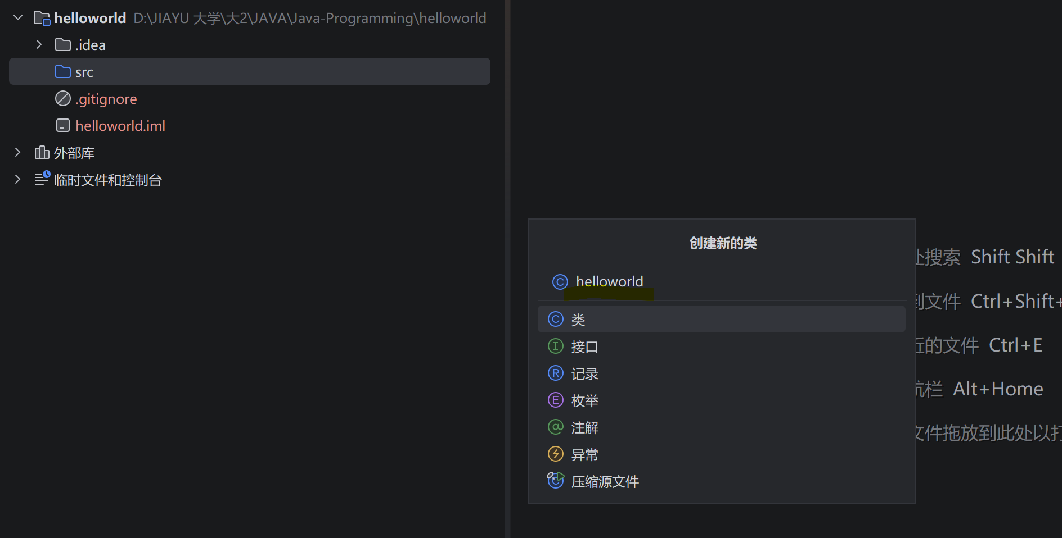
- Input the main function into the class, then run(compile then run), will output Hello World! To the console.
public static void main(String[] args) {
System.out.println("Hello World!");
}
6.